CSCI 2100E Spring 2020 | Student Name: _____________  Student Id: _______________

Lab Exercise #7
Lab exercises are always due 2 weeks after day of the lab.

Please fill in the lab sheet and submit the completed Word doc file to blackboard. Places you need to fill in or work on are marked in red.

Demo - A Question on ADT
This question appeared in 2019 final exam. Your instructor will explain some important concepts of ADT.

---

7. [Custom ADT Implementation] Colleen, a programmer working in your team, is implementing a Set ADT for an application. There are only two operations - adding a key to the set, and checking if a key is in the set. The possible keys are integers from 1 to 1000. Each set is expected to have a maximum size of n = 100. Adding the same key to the Set ADT is not considered an invalid operation, and total number of such cases m are infrequent in the application (m << n). Being in a rush, she avoided using a hash table and uses an array to implement it instead, as shown below:

#include <stdio.h>
#include <stdlib.h>

int keys[200];
int cursor = 0;

void addKey(int key) {
keys[cursor] = key;
cursor++;
if (cursor >= 200) {
printf("Cannot add anymore; exiting...");
exit(1);
}
}

int checkMembership(int key) {
int i;
for (i=0;i<cursor;i++) {
if (keys[i] == key) return 1; // 1 means key is a member of the set
}
return 0; // 0 means it is not a member
}

int main()
{
addKey(301);
addKey(55);
addKey(62);
addKey(301);
printf("%d\n", checkMembership(301));
return 0;
}

a) Using a picture, show the content of the array “keys” after we have added 301, 55, 62, 7, 301 to the set. Since the array is long, use "..." to skip elements that are not meaningful. (4%)
b) What is the Big-O notation for time-complexity of each of the two operations in Colleen’s implementation? State your assumptions. (6%)
Add:1 Check:n
c) As team leader of Colleen, would you accept her Set ADT implementation? If no, why not? If yes, state ONE non-trivial advantage of his implementation and ONE disadvantage compared to the standard hash table implementation. (4%)
- problem: the size of array is limited.
d) In Colleen’s program the size of the array “keys” is set to be 200. Using your knowledge learned in this course or otherwise, how would you justify this maximum array size? Is it a good choice? (3%)
---

NOTE: The above past paper question is for illustration only. You don't need to answer the questions when you submit the lab. You are encouraged to try though!

Problem 1 [Recursion as Tree]
A Tree is not a very intuitive data structure for beginners. In reality, there are many abstract data that can best be expressed as trees. For instance, recursion.

When we use recursion to find fibonacci number, we will do something like this:

unsigned int fibonacci(unsigned int n) {
if (n < 2)
return n;
else
return fibonacci(n - 1) + fibonacci(n - 2);
}

Below is a visualization of the total recursions done for n = 5 via a recursion tree. Behold!

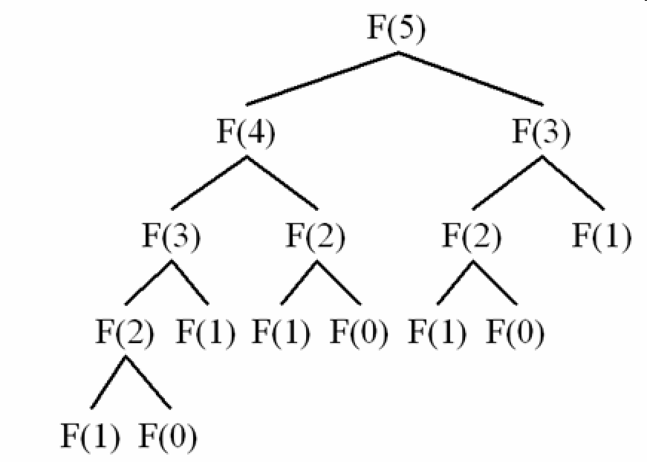
(image from stackoverflow)

As you can see, recursion trees can help visualize how many recursive calls we are making!

Using the picture above and Internet or otherwise, please find out the total number of recursion nodes in the corresponding recursion tree for the following n:

n | 5 | 6 | 7
Total number of nodes in recursion tree | 15 | 25 | 41

From the above result, please ESTIMATE a good Big-O notation for the recursive fibonacci C function. In previous lecture notes we had a very loose bound of O(n!). I think you can make a better guess with the above data:

fibonacci is O( 2^n )

(Note: You don't need to calculate. Just estimate from the table above; Don't give me a floating point number because I know you looked it up!)

Problem 2 [Recursion as Tree, Part 2]

Using the recursion tree estimation method in Problem 1, find the average time and worst time for a typical quick sort implementation. You can go for a quick sort video if you forgot about quick sort. State your assumptions and show a table/list of a few data points you have used, and your conclusion. Does your estimate agree with the "official" results?

Hint: For estimating average time, use a somewhat normal, common case. For estimating worst time, find a worst possible case. Assuming we will sort in ascending order, Which of the follow will be a worst case, and which will be a common case?

- Totally unsorted random numbers
- A list sorted in ascending order already
- A list sorted in descending order

Quicksort selects a pivot element at each step, which should ideally divide the array into 2 parts of almost equal size. Then we recursively call our algorithm on those 2 parts, after placing the pivot.

In the worst case, out of the 2 parts, one part contains 0 elements, which means in each iteration, the pivot fits on one of the ends only, due to which remaining array is of size (n-1)
So for the size of n elements array, in this case, we make: (n-1) + (n-2) + (n-3) + .. 1 check in total quick sort algorithm, which if you sum up, will be of order O(N^2)

The worst case can be of a list sorted in descending order, or in ascending order, because in these cases if we always chose the rightmost or leftmost element as pivot, we are left with next array of size (n-1).

For normal cases, the array is assumed to be broken into two equal partitons. The main task of quicksort is done in partitioning only..

For 1 array of size n => N
For 2 array of size (n/2) => 2 * (N/2)
For 4 array of size (n/4) => 4 * (4/2)
and so on..

So there will be total logN levels above, and in each step we almost do O(N) work... So Total result comes to be: O(NLogN) in average cases.

Thus, my estimate agree with the "official" results.

Problem 3 [Set via Hashing]
As mentioned in the lecture, a hash table can be used to implement a Set ADT. Let's try to use the template below to implement a Set with double hashing. Here we assume the Set contains names with 3 characters long. Since it is a Set, we do not need to have an explicit value for each key. We will use a token value of 1 if a name belongs to the Set.

Let's reuse the exact hash functions we have seen in example in Part 7 of the lecture notes, page 3. As a reminder, we had the following hash function for the string s of length n on a table size m = 10:

h(s) = (s[0] * 31^{n-1} + s[1] * 31^{n-2} + … s[n-1]) % m

For the double hashing we will use the following second hash function (we want to avoid 0 for an obvious reason):

h₂(s) = (s[0] * 37^{n-1} + s[1] * 37^{n-2} + … s[n-1]) % 7 + 1

where 7 is a random prime number we picked. By definition, for double hashing, when collision happens, we will pick the next index for probing by the formula:

(h(s) + i * h₂(s)) % m

for i = 1...m-1 consecutively.

#include <stdio.h>
#include <stdlib.h>
#include <string.h>

#define HASHTABLE_SIZE 10

typedef struct {
char key[4]; // in this example, key is always 3 characters long!
int value; // since we are implementing a set, value is 1 or 0
} KeyValuePair;

void printHashtable(KeyValuePair* table[]) {
// print out the hash table so that you will see if you have done
// things correctly!

int i;
for (i=0;i<HASHTABLE_SIZE;i++) {
if (table[i] == NULL) {
printf("%2d: -\n",i);
} else {
printf("%2d: <%s,%d>\n",i,table[i]->key,table[i]->value);
}
}
}

int hashFunc(char key[]) {
// we assume key is always 3 characters long and always valid characters!

// TODO implement
return 0;
}

int hashFunc2(char key[]) {
// same assumption as hashFunc

// TODO implement
return 1;
}

void insert(KeyValuePair* table[], char key[]) {
// insert a key and value
printf("inserting %s to the set...\n",key);
int hash = hashFunc(key);
int index = hash;
if (table[index] != NULL) {
printf("collision! we should use double hashing this time\n");

// TODO implement
// HINT: int newIndex = (index + hashFunc2(key) * i) % HASHTABLE_SIZE;

return;
} else {
// add the new key-value pair to the correct position
printf("Entry inserted at position %d\n",index);
KeyValuePair* newEntry = (KeyValuePair*) malloc(sizeof(KeyValuePair));
strcpy(newEntry->key,key);
newEntry->value = 1;
table[index] = newEntry;
}
}

int lookup(KeyValuePair *table[], int key) {
// look up a key and return 1 if it is in the set, 0 otherwise
int hash = hashFunc(key);
int index = hash;
if (table[index] != NULL) {
if (strcmp(table[index]->key,key) == 0)
return 1;
else
// collision happened? should we do something?

// TODO implement

return 0;
} else {
return 0;
}
}

int main()
{

KeyValuePair* hashtable[HASHTABLE_SIZE] = {NULL};

insert(hashtable,"Ted");
insert(hashtable,"Joe");
insert(hashtable,"May");
insert(hashtable,"Ken");
insert(hashtable,"Bob");

printHashtable(hashtable);

printf("Lookup %s - result: %d\n", "Ted", lookup(hashtable,"Ted"));
printf("Lookup %s - result: %d\n", "Joe", lookup(hashtable,"Joe"));
printf("Lookup %s - result: %d\n", "Bob", lookup(hashtable,"Bob"));
printf("Lookup %s - result: %d\n", "Ken", lookup(hashtable,"Ken"));
return 0;
}

If done correctly, you should get the following output:

0: <Ken,1>
1: -
2: -
3: -
4: -
5: <Ted,1>
6: <Joe,1>
7: <May,1>
8: -
9: <Bob,1>
Lookup Ted - result: 1
Lookup Joe - result: 1
Lookup Bob - result: 1
Lookup Ken - result: 1

Please paste your code here:

#include <stdio.h>
#include <stdlib.h>
#include <string.h>

#define HASHTABLE_SIZE 10

typedef struct {
char key[4]; // in this example, key is always 3 characters long!
int value; // since we are implementing a set, value is 1 or 0
} KeyValuePair;

void printHashtable(KeyValuePair* table[]) {
// print out the hash table so that you will see if you have done
// things correctly!

int i;
for (i=0;i<HASHTABLE_SIZE;i++) {
if (table[i] == NULL) {
printf("%2d: -\n",i);
} else {
printf("%2d: <%s,%d>\n",i,table[i]->key,table[i]->value);
}
}
}

int pw(int a,int b){
int k=1;
while(b--)
k=k*a;
return k;
}

int hashFunc(char key[]) {
int i,l,h=0;
l = strlen(key);
for(i=0;i<l;i++)
{
if(i != l-1)
h+=key[i]*pw(31,l-(i+1));
else
h+=key[i];
}
h = h % (HASHTABLE_SIZE);
return h;
}

int hashFunc2(char key[]) {
int i,l,h=0;
l = strlen(key);
for(i=0;i<l;i++)
{
if(i != l-1)
h+=key[i]*pw(37,l-(i+1));
else
h+=key[i];
}
h = h % 7;
h = h + 1;
return h;
}

void insert(KeyValuePair* table[], char key[]) {
// insert a key and value
printf("inserting %s to the set...\n",key);
int hash = hashFunc(key);
int index = hash;
if (table[index] != NULL) {
printf("collision! we should use double hashing this time\n");
int i = 1;
while (i < HASHTABLE_SIZE)
{
int newIndex = (index + hashFunc2(key) * i) % HASHTABLE_SIZE;
if (table[newIndex] == NULL )
{
printf("Entry inserted at position %d\n",newIndex);
KeyValuePair* newEntry = (KeyValuePair*) malloc(sizeof(KeyValuePair));
strcpy(newEntry->key,key);
newEntry->value = 1;
table[newIndex] = newEntry;
break;
}
i++;
}
return;
} else {
// add the new key-value pair to the correct position
printf("Entry inserted at position %d\n",index);
KeyValuePair* newEntry = (KeyValuePair*) malloc(sizeof(KeyValuePair));
strcpy(newEntry->key,key);
newEntry->value = 1;
table[index] = newEntry;
}
}
int lookup(KeyValuePair *table[], char key[]) {
// look up a key and return 1 if it is in the set, 0 otherwise
int hash = hashFunc(key);
int index = hash;
if (table[index] != NULL) {
if (strcmp(table[index]->key,key) == 0)
return 1;
else{
int i = 1;
while (i < HASHTABLE_SIZE)
{
int newIndex = (index + hashFunc2(key) * i) % HASHTABLE_SIZE;
if (table[newIndex] !=NULL)
{
if (strcmp(table[newIndex]->key,key) == 0)
return 1;
}
i++;
}
}
return 0;
} else {
return 0;
}
}

int main()
{

KeyValuePair* hashtable[HASHTABLE_SIZE] = {NULL};

insert(hashtable,"Ted");
insert(hashtable,"Joe");
insert(hashtable,"May");
insert(hashtable,"Ken");
insert(hashtable,"Bob");

printHashtable(hashtable);

printf("Lookup %s - result: %d\n", "Ted", lookup(hashtable,"Ted"));
printf("Lookup %s - result: %d\n", "Joe", lookup(hashtable,"Joe"));
printf("Lookup %s - result: %d\n", "Bob", lookup(hashtable,"Bob"));
printf("Lookup %s - result: %d\n", "Ken", lookup(hashtable,"Ken"));
return 0;
}

Please finish other Lab Exercises if you haven't already!

