Decision architecture for maintained biodiversity data products
Keeping the reasons for consequential content decisions recoverable, from governing principle to current data state
Glenn Ehmke
Further authors to be confirmed
2026-11-07
Abstract (provisional)
Maintained biodiversity data products, such as national species lists, assessment datasets and spatial layers, change continually as classifications, evidence and uses change. Versioning, audit logs and change tables can show what changed between states. They rarely preserve why a consequential change was made, which evidence was considered, which governing statement applied, or whether the authorised change was implemented as intended. We describe a decision architecture that keeps these elements recoverable. It distinguishes governing principles, policies and rules; architecture decision records that explain system design; open decision cases; attributed evidence, assessments and contributions; independent review; content decision records that close substantive questions; implementation and verification records; audit and provenance; concept lineage; and authoritative current data state. Four proportionate routes, from mechanical maintenance to a full decision case, keep the recording effort commensurate with the consequence of a change. Correction, reconsideration and supersession add records rather than rewriting them, so that rapid reversal remains intelligible. The architecture is principally a decision- and evidence-provenance framework: it records which evidence assessments entered a decision, but it does not itself appraise evidence or determine taxonomic warrant. We illustrate it through the maintenance of a national working list of Australian birds built over a governed global taxonomy, where adoption decisions are operational dispositions rather than taxonomic determinations, and consider how regional adoption or dissent records might supply existing global-list processes. That regional-to-global interface is a proposition for collaborator review, not an accepted AviList function. A data-sensitivity workflow provides a comparative application that independently separates identity from assessment content and authored from inherited state, although it does not implement content decision records. Range-layer decisions are a prospective extension. Throughout, we distinguish what has been piloted from what remains designed or proposed.
Table of contents

1. Rationale

1.1 State shows what changed, not why
Biodiversity data products are often presented as states: a checklist at a particular date, a monitoring dataset, or a set of spatial layers compiled against a defined taxonomy. Versioning such products makes it possible to establish what changed between releases.
However, versioning or audit logs do not necessarily explain why a change occurred, which evidence was considered, whether the change followed an existing rule or required judgement, or how the decision was translated into the released data. These omissions become more consequential as a product is maintained over time. A later user may be able to identify that a name, rank, identifier or relationship changed without being able to recover the question that was considered or the basis on which it was resolved.
Several different records are commonly called “the log”, and they answer different questions. A version comparison shows how one release differs from another. An audit log records which row was changed, by whom or by what process, and when. A history or temporal table shows what a record said on a given date. Data provenance records where a value came from and through what transformation. None of these records why a person or committee chose one treatment over another. The failure runs in both directions. An audit trail cannot distinguish a deliberate determination from a typographical correction or a bulk reload; a decision record, however well reasoned, cannot show that the data now match the decision. The two need to be linked rather than merged [CITE: data provenance, audit trails and versioning in scientific-data stewardship].

1.2 Why national implementation creates its own decisions
The distinction is particularly important for a national Working List built over a governed global taxonomy. A global list supplies a taxonomic baseline, but it cannot resolve every matter involved in its national implementation. Changes have to be compared with existing data, identifiers and operational products. Some are straightforward to implement. Others expose ambiguity in taxonomic identity, interrupt a time series, affect the interpretation of observations, or risk obscuring a unit that remains relevant to assessment or management. These are not reasons to alter a taxonomic conclusion for a preferred conservation outcome. They are reasons to make the operational adoption decision explicit, reviewable and reversible [CITE: governed global-list principles; conservation-neutral taxonomy].
The point matters beyond taxonomy. Unstable or poorly governed classifications have consequences for conservation listing, legislation and the comparability of evidence through time (Garnett and Christidis 2017). Proposals for governed global species lists have accordingly emphasised that decisions about list composition should be transparent, archived and traceable (Garnett et al. 2020), and criteria have since been proposed for assessing the quality of species-list governance (Garnett et al. 2026). A national working list does not take over that taxonomic governance, but it makes consequential decisions of its own. Its adoption of a global treatment, the timing of that adoption and the handling of records collected under earlier concepts all affect the evidence built on the list. They warrant comparable transparency at the level at which they are made.

1.3 Decision architecture
A maintained list therefore needs more than a sequence of releases. It needs a durable relationship among the principles that explain why classes of decisions matter, the policies and rules that govern them, the evidence and contributions considered in a particular case, the resulting content decision, and the implementation of that decision in data. This is referred to here as decision architecture.
Its purpose is not to impose a formal case on every change. It is to ensure that the record is proportionate to the significance of the decision, and that a consequential judgement is not reduced retrospectively to an unexplained mutation.
Stated as a single proposition, maintained biodiversity data products require a recoverable connection among five things: their governing principles, policies and rules; the evidence and deliberation entering consequential content decisions; the decisions themselves; the implementation and verification of those decisions; and the authoritative current state of the data. A later reader of a consequential change should be able to recover:
- the question that was decided, and the entities and taxonomy version it concerned;
- the principle, policy and rule that governed it;
- the evidence considered, including material challenges and who supplied them;
- who was authorised to decide, and whether the decision was independently reviewed;
- the disposition, its rationale and the uncertainty that remained;
- what would justify reconsidering it; and
- how, and whether, the decision reached the released data.
The remainder of the paper develops this proposition. Section 2 separates decision provenance from evidence assessment. Section 3 introduces a three-level framework of governing statements, and Section 4 the records that keep design, deliberation, authorisation, implementation and state distinct. Section 5 sets out four proportionate routes, and Section 6 how decisions are corrected, reconsidered and superseded. Section 7 applies the architecture to a national working list, and Section 8 considers a possible interface between regional implementation and global list governance. Section 9 compares a data-sensitivity workflow, Section 10 considers range layers as a prospective extension, and Section 11 states what has and has not been tested.
The components are not new. Decision records are established practice in software architecture, provenance models are established in data management, and taxonomic committees have long recorded their rulings. The contribution argued here is the recoverable connection among these components in a maintained biodiversity data product, and its application to national adoption of a governed global taxonomy.

1.4 Relationship to the companion data-product paper
This paper and its companion answer different questions. A working list and its range layers describes the linked national data products: what biological and spatial entities they represent, how they are related and how they support defined applications. Its decision-architecture account is intentionally compact. The present paper develops the governing and record architecture in detail: how principles, policies and rules relate to evidence, assessment, authorisation, implementation, verification and authoritative data state.
The papers are therefore linked but not sequential chapters. The data-product paper can be read and submitted independently; this paper supplies the fuller account of how consequential judgements are made recoverable. Conversely, the present argument is grounded in the Working List application but is intended to be testable in other maintained biodiversity products. The regional-to-global interface considered below is one such test. It remains a provisional proposition requiring governance advice and is not necessary to the companion paper’s data architecture.

2. Decision provenance and evidence assessment

2.1 Two functions that are often conflated
Decision architecture is principally a provenance system. It records which evidence entered a decision, where that evidence came from, which version or taxonomic frame it described, how it was interpreted, which governing statement applied, what was decided, and how the decision was later implemented. This differs from evidence assessment. Critical appraisal, risk-of-bias tools and evidentiary-warrant approaches ask whether evidence is reliable, sufficient or capable of supporting a scientific conclusion.
Evidence-to-Decision frameworks extend that evaluation towards a recommendation. These functions are closely related to decision provenance, but they are not interchangeable [CITE: critical appraisal and risk-of-bias methods; Evidence-to-Decision frameworks; decision provenance].
The nearest neighbour is the Evidence-to-Decision family. Some of its conservation applications document how and why a management decision was made, and so perform part of the function described here. The difference is one of emphasis rather than kind. An Evidence-to-Decision framework structures the move from evidence to a recommendation. The architecture described here is concerned with what happens around and after that move in a maintained product: which governing statement was cited, how the decision relates to earlier and later decisions on the same entity, whether it was implemented, and what the product contained as a result. An Evidence-to-Decision output could therefore populate a decision case. It would not replace the closure, implementation and state records that follow.

2.2 Evidence assessment as an upstream object
A taxonomic warrant provides a useful example. A warrant analysis may test whether morphological, genetic, behavioural or geographic evidence supports recognition of a taxon. A Working List may then use that analysis as evidence in an adoption decision. The adoption record should preserve the warrant’s identity and conclusion, note any material interpretation or challenge, and explain the operational disposition. It should not present the Working List as having repeated the scientific assessment merely because the assessment is cited. Conversely, a scientifically well-supported treatment does not remove the need to record how it was implemented where identity, timing or information continuity remain consequential.
This boundary is important because it places apparently overlapping work in a complementary sequence:
evidence assessment (e.g. taxonomic warrant) → attributed evidence → operational decision → implementation and verification
The sequence does not imply that every assessment leads to a discretionary decision. It establishes where responsibility changes. The assessment owns the scientific claim. The decision record owns the disposition taken by the maintained product. The implementation record shows whether the data were changed as authorised. Keeping these objects separate allows one to be corrected without silently rewriting the others.
Not every adoption question arrives with a completed assessment. Often the national implementer must itself assemble the published evidence, note where it is incomplete and reach an operational view. The decision record can then preserve the evidence relied on, its source and version, the strength attributed to it and the reasoning applied. That remains a record of how the maintained product reasoned, not a formal appraisal of the underlying science, and it should be presented as such.

2.3 Proposed action, evidentiary verdict and local disposition
The separation becomes concrete when a decision record keeps three things apart that are easily collapsed into a single field. The first is the upstream proposed action: what the external list or proponent proposes, recorded in its own vocabulary (for example, that two taxa be treated as one). The second is the evidentiary verdict: what the relevant assessment concluded about that proposal, which may be that the evidence supports it, does not support it, or is indeterminate. The third is the local disposition: what the maintained product will do, such as adopt the change, retain the current treatment pending further evidence, or adopt with a recorded concept mapping.
Keeping the three apart allows a national list to decline or delay an upstream change without implying that the taxonomy has been refuted, and to reverse a local adoption without claiming that the evidence has changed when only its interpretation has. The verdict belongs to whoever performed the assessment. The disposition belongs to the maintained product. Where the product’s own decision case supplied the assessment, the record should say so.
The same boundary appears in the data-sensitivity application considered in Section 9. There, an assessment of a taxon’s sensitivity to a harm and its exposure to that harm is the upstream evidence object. How a particular product then handles the affected records is a separate, scoped decision. Neither the assessment framework nor its outputs is the decision architecture; the architecture records how they were used.

3. Principles, policies and rules

3.1 Three levels of governing statement
Decisions are easier to interpret when the statement governing them is also explicit. Three levels are useful.
A principle states the enduring scientific or normative reason. In the Working List, one such principle is that conservation preference must not determine taxonomic status. This safeguards the scientific basis of the list while leaving room to address the operational consequences of adopting a change.
A policy states the adopted position and its scope. A policy may provide, for example, that implementation can be deferred briefly where a change creates a material identity or continuity problem, without disputing the underlying taxonomic conclusion. It should identify the responsible authority, the discretion available and the conditions under which an exception may apply.
A rule translates the policy into a condition or required action. The provisional Working List rule Operational consequence review illustrates this level. Where adopting a taxonomic change could obscure a conservation-dependent unit or interrupt assessment or action continuity, explicit consultation and concept mapping are required before implementation. The conservation consequence triggers review; it does not select the taxonomic outcome.
The levels are complementary rather than alternative names for the same thing. A principle should change rarely, and its wording can be stated publicly with little qualification. A policy changes when the product’s circumstances or authority change. A rule may need to be refined frequently as cases expose ambiguities in its trigger or required action. Separating them lets a rule be amended without appearing to abandon the principle it serves.
The illustration is deliberately small. Operational consequence review is one of a handful of provisional governing statements used in the Working List pilot. Their classification across the three levels has not been completed, and they are not presented here as a policy system.

3.2 Why governing statements need their own register
This hierarchy is simple, but it avoids a recurring problem in decision records: a rule may be adopted inside an architectural decision and thereafter remain citable only by reference to the record that created it. The data-sensitivity application considered below reached precisely this state. Its principles and rules are recoverable from the decision log, but do not yet exist as a separate governing-statements register. A maintained register would give each statement a stable identifier, exact wording, scope, authority, status, effective date and supersession history, while retaining a link to the architectural record through which it was adopted.
The distinction is between legislative history and current law. An architecture decision record explains why a rule was introduced and what alternatives were considered. The register states what the rule says now and since when. A content decision cites the register entry, at the version in force when the decision was made. When a pattern of content decisions shows that a rule is unclear or produces unintended results, the remedy is a new architecture decision that amends the rule, followed by a new register entry; the earlier content decisions remain interpretable because they cite the version they applied.
No such register yet exists for the Working List. Its form and maintenance home remain open, and the paper does not depend on a particular implementation. What it depends on is the requirement that the operative wording of a governing statement be citable independently of the record that adopted it.

4. Records and the questions they answer

4.1 Why decision records suit maintained biological data
No single record can adequately represent design, deliberation, authorisation, implementation and current state without becoming ambiguous.
Architecture Decision Record (ADR) practice is well suited to a maintained biological dataset because it can preserve rationale across a large number of individually addressable decisions while classifications, evidence and linked data products continue to change. Its append-only history makes correction and reversal intelligible: a later treatment can supersede an earlier one without erasing the information, uncertainty or rule under which the earlier decision was made. The format is also proportionate. A routine determination can remain short, while a consequential decision can link to richer evidence and reasoning. Stable identifiers and fields support indexing and structured storage, while linked narrative retains context that would be difficult to reduce to fixed fields alone. Decision records do not resolve scientific uncertainty, replace implementation checks or constitute an evidence assessment; they preserve how an authorised interpretation was reached and how it later changed.
ADRs did not originate the idea that design rationale should be recorded. Software-architecture research had already treated design decisions and their rationale as first-class knowledge whose loss is a central maintenance problem. Nygard’s widely adopted formulation recorded the context, decision, status and consequences of a single significant decision in a short text file, and kept a superseded record visible rather than deleting it. Later Markdown templates made alternatives, decision-makers, consulted parties and confirmation more explicit [CITE: Jansen and Bosch 2005; Tyree and Akerman 2005; Nygard 2011; Kopp et al. 2018 (MADR); Ahmeti et al. 2024 on practice]. The empirical base for the practice is smaller than its popularity might suggest: action research has found benefits for documentation culture and knowledge transfer, while also finding that usefulness depends on keeping records where people will write and find them. The transferable lesson is modest. Small, structured, append-only records improve continuity when they are kept close to practice; they do not guarantee that every consequential decision is recorded or that its rationale is sound.

4.2 Design records and governing rules
An Architecture Decision Record (ADR) and a governing rule consequently answer different questions. The ADR explains why a rule or system design was introduced. The rule is the operative statement cited when a content decision is made. Treating the ADR as the permanent home of both objects preserves legislative history of a kind, but makes current rules unnecessarily difficult to identify and apply [CITE: ADR and general decision-record practice].

4.3 Cases, content decision records and implementation
A decision case is a working dossier. It defines the question, identifies affected entities and versions, assembles evidence and contributions, records material challenges, and supports review. It is necessarily mutable while the matter remains open.
Contributions to a case are retained in the contributor’s own words and are not rewritten into the voice of the person preparing the assessment. Recording that a contribution has been addressed means that the assessment responded to it, not that the contributor agreed. Responses to consultation are also distinct from independent review: a consultation response is made against a case that is still changing, whereas review is meaningful only when it is bound to a named, fixed version of the assessment, and a contributor cannot independently review an assessment to which they contributed.
A Content Decision Record (CDR; provisional term) closes the substantive question. It records the disposition, rationale, authority, uncertainty, relevant governing statements and any trigger for reconsideration. It should be stable once issued. Later correction or a different judgement is recorded through an explicit correction, addendum or superseding decision rather than by rewriting the original conclusion.
A CDR adopts the discipline of an ADR (stable identity, concise context and outcome, rationale, attribution, explicit relationships and supersession) but applies it to a different object. An ADR records why the decision-making system, workflow or rule was designed as it was. A CDR records what that system authorised in one substantive instance, under a named governing statement, for named entities at a stated version. Generic decision-record templates can already hold such a decision; one widely used Markdown template briefly renamed itself to cover “any” decision before returning to its architectural focus [CITE: MADR project documentation and release history]. The separate label is therefore a functional distinction rather than a claim about terminology. Content decisions are potentially far more numerous than design decisions, they cite governing statements rather than adopting them, they concern particular entities and versions, and their reconsideration changes what the product contains rather than how the system works. CDR is a working term in this project, not an external standard.
A CDR is a closure record, not a transcript. It summarises and cites the case rather than reproducing the deliberation. Not every case ends in a CDR. A case may be deferred, with a stated condition for reopening, or withdrawn; neither produces an authorising record, and there is no provisional CDR. A proportionate route may also produce a CDR without a preceding case (Section 5).
An implementation record states what was changed to give effect to the decision. This remains distinct from the decision because authorisation and execution can diverge: a decision may await implementation, implementation may be incomplete, or a mechanically successful update may not produce the intended state.
Verification is a further act. Successful execution shows that an update ran; verification shows that the resulting state matches what was authorised. Recording who verified, which data state was checked and what was found, including any residue that could not be implemented, prevents a partially applied decision from being represented as complete.

4.4 Decision, implementation, audit, provenance and state
The domain state is the current content of the maintained product. It answers what is present now. Audit and provenance records answer how a value or entity reached that state, while concept lineage records relationships among taxonomic entities through splits, lumps, replacement and reinterpretation. These records support a decision architecture but do not replace the rationale for a judgement.
The distinction is functional rather than technological. A database trigger can record that a class value changed from one code to another, and an ingest process can record the file, operator and time associated with that change. Those records establish execution history. They cannot show whether the class boundary was scientifically contested, which interpretation was authorised, or why an exception was accepted. Conversely, a CDR can preserve the judgement and its rationale but cannot prove that every affected row, geometry or derivative was changed correctly. Implementation, audit and verification complete that link.
An attributed assessment is another neighbouring object. Several people may assess the same subject, using different evidence or versions, without creating several authorised decisions. Each assessment should retain its assessor, date, evidence frame, method version and stated uncertainty. A synthesis can identify agreement and disagreement, while the CDR states which assessment versions informed the disposition. This prevents a decision record from implying consensus merely because a single outcome was authorised.
Two clarifications follow. First, the decision record is not the authoritative data. The domain tables remain the source of what the product contains; a CDR records what was authorised and why. A system that derives current state by replaying decision records conflates the two and loses the ability to detect a data change that no decision authorised. Second, lineage is not the same as temporal versioning. Versioning shows what a record said at a given time. A split or lump changes the relationships among concepts, and those relationships need to be recorded explicitly. A persistent identifier is necessary but not sufficient: it has a meaning only within a stated taxonomy version, and the identity of a unit can change while its identifier does not.
The distinctions can appear elaborate when listed together, although most already exist in some form in maintained data systems. The practical issue is not whether every object must become a separate database table. It is whether a later reader can distinguish the question considered, the authority for the answer, the action taken and the resulting state. Database design should follow that conceptual distinction. Separate identifiers linked by explicit relationships are preferable to one identifier serving simultaneously as evidence item, decision and mutation event.
Table 1 summarises the objects and the question each answers.
Table 1: Records in the decision architecture and the question each answers. The table describes conceptual distinctions, not a required set of database tables.
Record | Question it answers | Lifecycle
Principle, policy or rule | What governs this class of decision, at what level and under what authority? | Versioned; superseded rather than silently edited
Architecture decision record (ADR) | Why was the system, workflow or governing rule designed or changed this way? | Append-only; superseded by a later ADR
Decision case | What question is open, about which entities and versions, with what evidence and unresolved matters? | Mutable while open; fixed versions for review
Evidence item or contribution | Who supplied what, citing which source, and has it been addressed? | Append-only; attributed in the contributor’s words
Attributed assessment or evidentiary verdict | What did an assessor conclude, using which evidence, method and version? | Separately versioned; several assessments may concern the same subject or case
Independent review | Did an appropriately independent person check this exact version, and with what result? | One record per review, bound to one fixed case version
Content decision record (CDR; provisional) | What disposition was authorised, under which rule, on what rationale, with what uncertainty and reconsideration trigger? | Stable once issued; corrected, extended or superseded by new records
Implementation and verification record | What was changed to give effect to the decision, and does the result match what was authorised? | Separate from authorisation; carries residue and verification status
Audit and provenance | What mechanically changed, by what process, and where did a value come from? | Written by the system or pipeline; carries no human intent
Concept lineage | How are taxonomic entities related through split, lump, replacement or reinterpretation? | Explicit, versioned relationships
Domain state | What does the product contain now, or at a given release? | Authoritative current and historical state

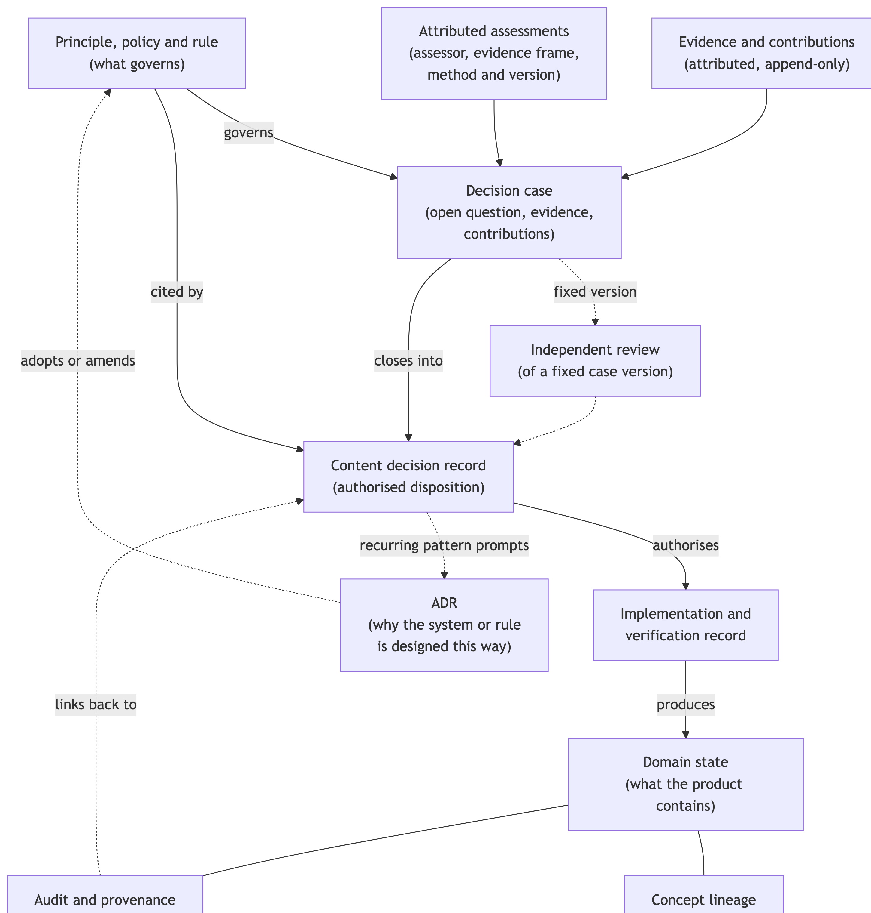
Figure 1: Relationships among the principal records. Solid arrows show the ordinary path from a governing statement to verified data state; dashed arrows show supporting or feedback relationships. Evidence, review, audit and lineage sit beside the path rather than being merged into it. Independent review and the link from implementation back to an authorising decision are designed but not yet exercised in the Working List pilot (Section 11).

5. Proportionate routes from maintenance to decision
The architecture would fail if every spelling correction or reordered row required a formal case.
Four routes are proposed to keep the record proportionate. Table 2 summarises them, and Figure 2 shows how a change is directed among them.

5.1 Mechanical maintenance
Mechanical maintenance covers deterministic corrections and presentation or ordering changes that do not alter taxon concept, circumscription, rank, status, relationship or substantive interpretation. A capitalisation correction or revised sort order may still have consequences for joins and downstream products, so it requires an implementation and audit record. It does not require a CDR merely because a database changed.
The category is deliberately narrower than “minor change”. A spelling change that affects nomenclature, matching or concept identity is not mechanical. The route is appropriate only where the correct result follows from an identified authority or schema, no material discretion or precedent is introduced, the change can be verified and reversed, and any uncertainty promotes the matter to a richer route. A mechanical change needs its own audit or provenance identifier and, where relevant, a reference to the source or rule that authorised it. It does not need a decision identifier.

5.2 Routine rule-based change
A routine content change follows an accepted rule or authoritative reconciliation and involves little discretion. The outcome should be recorded in structured form, with the governing authority and implementation traceable, but neither an open case nor a prose CDR will normally add value. Routine does not mean inconsequential. It means the judgement has already been made at the rule level and the present task is its consistent application.

5.3 Case-free authorisation
Some changes require a durable judgement but not an extended process of evidence assembly and consultation. A short CDR can record the question, rule, evidence, authority and conclusion without constructing a larger decision dossier. This route is conceptually useful but remains less well tested in current Working List practice. Its clearest justification comes from settings in which substantive determinations are made routinely by a small team and stored directly as data: there, the absence of any record of who decided, when and why is a gap that a short authorisation record can close without imposing case machinery (Section 9).

5.4 Full decision case
A full case is warranted where a decision is contested, uncertain, precedent-setting, costly to reverse, or consequential across several products. It may include open consultation, a reasoned default proposal, independent review of a fixed evidence version, and explicit consideration of conflicts or uncertainty. The additional work should reflect the expected value of further information rather than an assumption that more process is always safer [CITE: proportional review and value-of-information reasoning].
Two consultation forms have been used. An open-question consultation seeks alternatives and evidence without a preferred outcome. A default-proposal consultation circulates a reasoned proposal with a resolution date, so that a straightforward decision can proceed unless a material challenge or new evidence is received. In the second form, silence is not agreement and is not evidence. It is only a procedural condition that allows a proposal whose affirmative rationale is already sufficient to progress. Where review is not triggered, the record should state why direct progression was proportionate.
Table 2: Four proportionate routes. A matter may be promoted to a fuller route as its implications become clear, but should not be moved to a lighter route once disagreement has emerged.
Route | Typical trigger | Records produced | Review expectation
Mechanical maintenance | Deterministic correction or presentation change with no change to concept, rank, status or interpretation | Implementation and audit or provenance record citing the authorising source or schema | None beyond verification of the change
Routine rule-based change | Low-discretion application of an accepted rule or authoritative reconciliation | Structured determination or implementation record citing the rule | Consistency checks; promotion if the rule does not fit
Case-free authorisation | A durable substantive judgement that needs no extended evidence assembly or consultation | Short CDR; implementation record | Proportionate; reason for direct progression recorded
Full decision case | Contested, uncertain, precedent-setting, costly to reverse or consequential across products | Decision case, attributed contributions, review where triggered, CDR, implementation record | Consultation; independent review of a fixed version where triggered

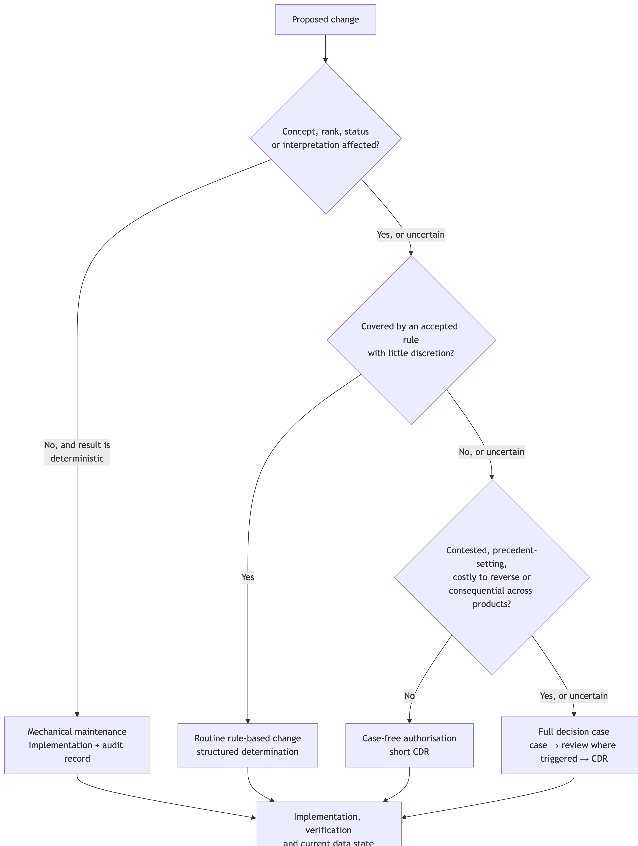
Figure 2: Directing a proposed change among the four proportionate routes. Each question is answered against the applicable governing statements; any uncertainty sends the change to the next, fuller route. Promotion runs in one direction only.
A matter can move from a lighter route to a fuller one as its implications become clear. The reverse should be treated cautiously. Reclassifying a judgement as mechanical after disagreement has emerged would remove precisely the provenance the architecture is intended to preserve.
The partition is itself a decision with consequences. In the largest exercise to date, comparison of a new global release with the Working List, a large reconciliation produced only a small number of cases; the remainder were handled mechanically or by rule. That partition was made sensibly but was not written down as a rule when it was applied. A product that uses proportionate routes should record the criteria by which changes were directed among them, so that a reader can see why a given change did not receive a case.

6. Correction, reconsideration and supersession

6.1 Changing a decision without rewriting it
Taxonomic and biodiversity data change quickly, and an operational treatment may need to be reconsidered soon after adoption. This does not make the original decision record redundant. It makes its preservation more important.
Four actions are routinely conflated and should be kept apart. A correction fixes a clerical or metadata error without changing the substantive decision; it is recorded as a dated correction event and the original remains visible. An amendment changes a supporting part of a decision without a new determination, with a recorded reason and authority. An addendum adds subsequent evidence or guidance to a decision without changing its disposition. A reconsideration reopens the substantive question because of new evidence, a changed rule or a changed taxon concept; it opens a linked new case and may end in a superseding CDR. Before an earlier decision is reused for a new question, the taxon concept it concerned should be checked. If the concept has changed, the new concept does not silently inherit the earlier decision.

6.2 A rapid reconsideration sequence
The Working List pilot has exercised the following general sequence:
request for input → expert contribution → rapid synthesis → formal decision record → correction → superseding decision record
A question was put to people with relevant expertise. A contribution was received and attributed. The available evidence was synthesised quickly and a formal decision record authorised a disposition. A contributor then corrected a material detail on which the decision had relied. The question was reconsidered, and a new decision record superseded the first. Both records remain, and the earlier one was not edited. Implementation and verification then follow the superseding record.
The original record describes what was known and authorised at the time. If a contributor corrects a material detail, or a different interpretation becomes better supported, a new record can supersede the first without erasing it. A later reader can then distinguish a genuine change of judgement from a clerical correction, undocumented reversal or accidental data change.
This is especially valuable where one taxonomic interpretation affects observations, persistent identifiers, range layers and assessments. Rapid change remains operationally possible, but it does not become ahistorical. The architecture therefore supports reversibility in two senses: data can be returned to an earlier valid state where necessary, and the reasoning that produced each state remains recoverable.
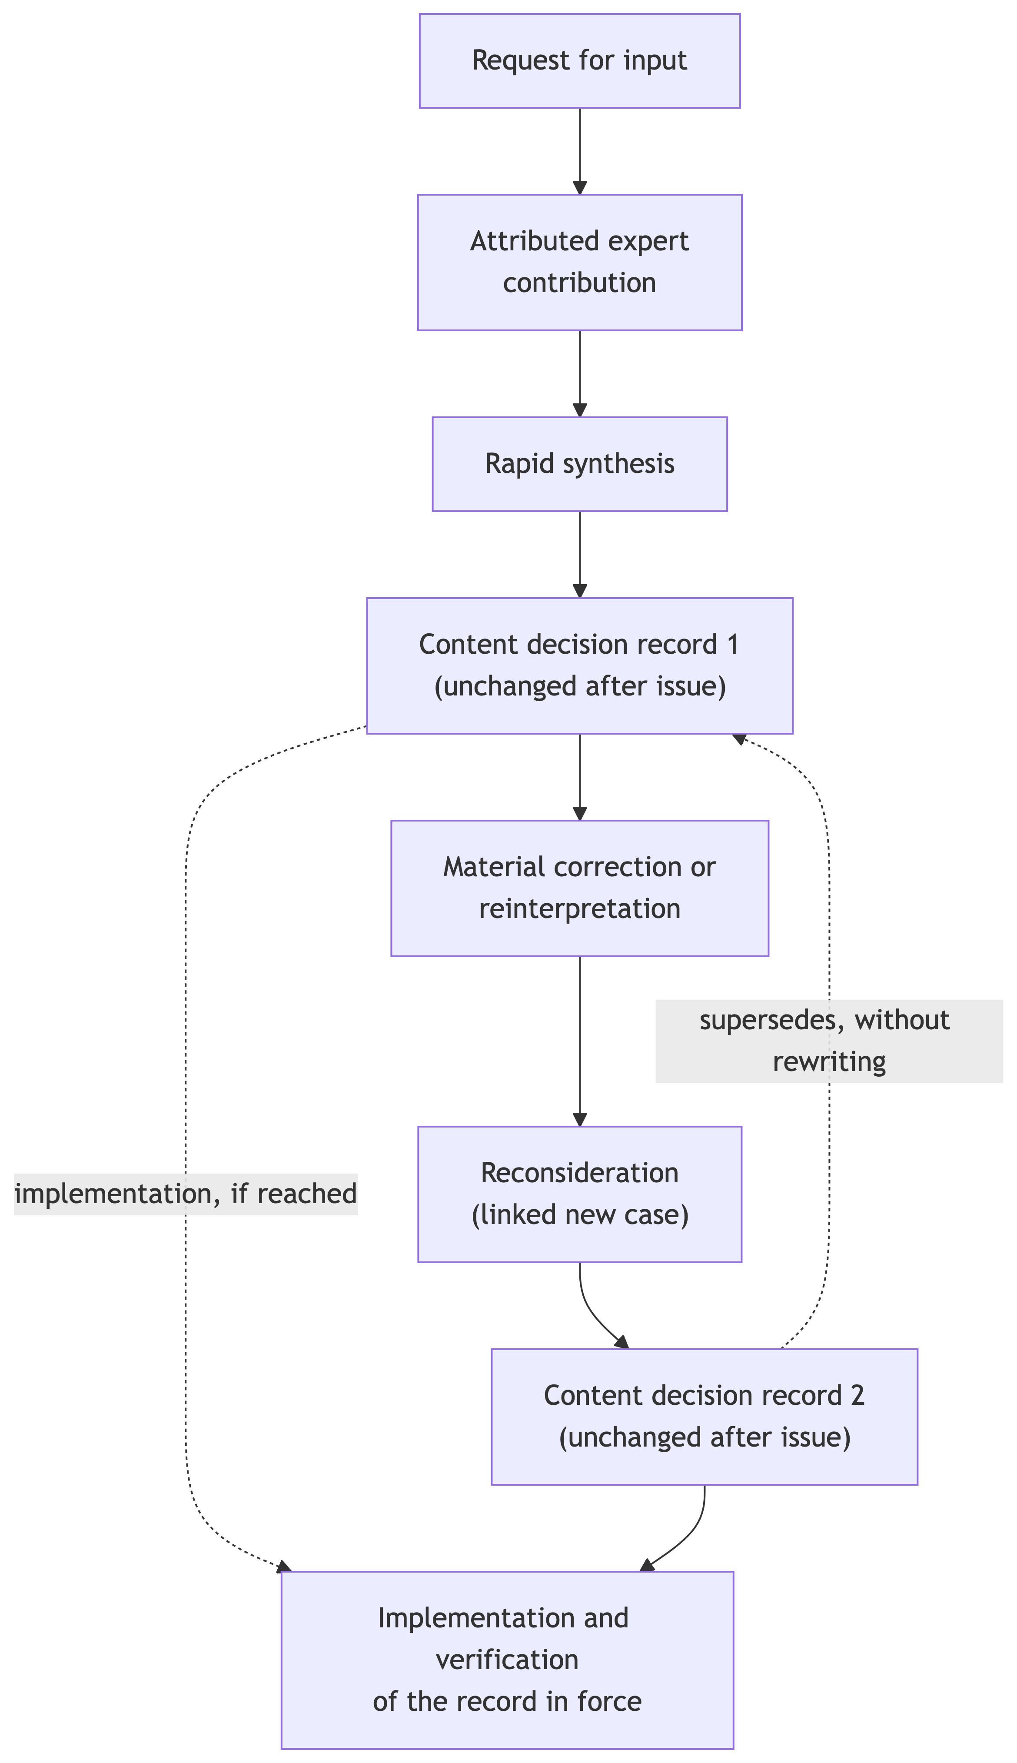
Figure 3: Rapid reconsideration and supersession. The original and superseding decision records are separate, unchanged records joined by a labelled supersession relationship; the earlier record is not edited. Implementation and verification update the operational state from whichever record is in force.
Supersession has limits that are easier to see once it is practised. Where one decision covered several taxa on the basis of a shared question, later evidence may bear on only one of them. Whether such a decision should be partly reconsidered, or split retrospectively into separate decisions, is not yet settled. Similarly, one contribution may bear on several open cases at once, and the record needs to be able to associate it with each rather than filing it against only one.

7. Application to a Working List

7.1 What a Working List decides
A Working List [CITE: main paper] is an applied national inventory built over a governed global taxonomic baseline. Its task is not to maintain an independent national taxonomy. It establishes which taxa are within scope, maintains persistent identity across changing treatments, resolves species and subspecies into operational units, and links those units to observations, assessments and spatial products. This creates decisions that are taxonomically informed without all being taxonomic determinations.
For Australian birds, the global baseline is AviList, a unified global checklist produced by a working group that brought together the major global bird lists (Rheindt et al. 2025). The Working List adopts AviList at species level and adds what national applications require: national scope, persistent identifiers, a complete set of operational units including subspecies, and the links that allow observations, extinction-risk assessments and range layers to refer to the same biological units through change. The companion paper describes that system; here the concern is with the decisions its maintenance requires.
Comparison with a new global release will ordinarily produce a large mechanical and routine layer: name corrections, changes already covered by an accepted reconciliation rule, and transformations whose authority is clear. A smaller set will require judgement about identity, implementability or continuity. A still smaller set may expose a material challenge requiring consultation and a reasoned record. The four routes make this variation visible rather than treating every changed row as equivalent.

7.2 Operational adoption is not taxonomic determination
 Note 1: Taxonomic determination versus operational adoption decision
A taxonomic determination concludes whether a taxon should be recognised, and with what circumscription and rank. It belongs to taxonomists and, for a governed global list, to that list’s governance. An operational adoption decision concerns what a maintained product does with a treatment: whether to implement it now or after concept mapping, how to relate existing records to the new units, and whether to retain a unit provisionally while evidence or spatial attribution is reconciled. A conservation consequence may trigger examination and consultation. It may not select the taxonomic outcome.

Governed global lists are expected to be science-based and free of non-taxonomic considerations (Garnett et al. 2020). A national list that delays or qualifies implementation of a global treatment must therefore be clear about what it is doing. Its reasons are about continuity, visibility, implementability and unresolved evidence: whether records collected under an earlier concept can be attributed to the new units, whether a split can be resolved spatially, whether a lump would make a unit of assessment or management invisible in national data. These are legitimate operational concerns. They are not grounds for preferring one taxonomy over another.
Two consequences follow for the record. The first is that the burden of an information-reducing change sits with its proponent. Where implementing a treatment would remove a distinction that national data currently carry, the pilot’s working default has been that the proposer supplies, or identifies, the evidence and concept mapping needed to implement it; the maintainer is not expected to infer a boundary from incomplete descriptions. The second is that a decision to retain a current treatment is not a refutation of the alternative. The record states the upstream proposal, any evidentiary verdict and the local disposition separately (Section 2.3), and names the condition under which the question will be reopened.

7.3 Information continuity, persistent identity and reversibility
The Working List’s architecture makes three things recoverable that a national user needs when classifications change. Information continuity is preserved when a change does not silently remove the ability to distinguish units that observations, trends or assessments depend on. Where a change would remove that ability, the record shows what was lost, what mapping was used and whether the loss is reversible. Persistent identity is preserved when an identifier continues to denote the same biological unit, and when a change in circumscription that alters what an unchanged identifier denotes is recorded rather than hidden. For that reason downstream datasets need to record the list release against which their identifiers were assigned. Reversibility is preserved when a superseded treatment can be restored without reconstruction, because the earlier decision, its rationale and the pre-change data state remain available.
The implementation layer is where these properties are most easily lost. A reasoned adoption decision is incomplete as an operational act until the intended data state has been produced and verified. In the Working List, routine transformations are applied through checked, reversible processes that preserve a recoverable pre-change state, record each affected entity and retain unresolved residue. The link from a CDR to such a transformation, however, has been designed but not yet exercised: no pilot CDR has yet authorised a transformation end to end.

8. A provisional regional-to-global decision interface
 Proposition for collaborator and governance review
This section tests whether a structured regional adoption or dissent record could provide useful input to existing global-list processes. It does not identify a missing AviList pathway, propose a parallel taxonomic authority or describe an accepted AviList function. Its relevance, terminology and relationship to current Regional Advisory Group and Taxonomic Committee practice require advice from participants in those processes.

8.1 Implementation as a source of evidence
The relationship between a global list and a regional Working List need not run in one direction. Regional implementation can expose biological evidence, unresolved concept mappings and consequences of information loss that were not apparent when a global treatment was adopted. This does not require a parallel taxonomic authority. AviList already provides Regional Advisory Groups, accepts proposals from the wider ornithological community and charges its Taxonomic Committee with considering discrepancies between global, regional and national lists. The open question is therefore not whether a regional pathway exists, but whether evidence and experience arising during implementation can enter that pathway in a sufficiently structured and recoverable form [CITE: AviList Terms of Reference; AviList Regional Advisory Groups and proposal pathway]. This question connects directly to Garnett et al.’s governance indicators for community support and local and regional inclusion, which respectively ask whether taxonomists and users can participate in continuing list curation and whether regional perspectives are formally enabled through the governance arrangements (Garnett et al. 2026). Process transparency is also relevant: an interface is useful only if the route from regional observation to global consideration, and the disposition of that contribution, can be recovered.

8.2 A regional decision record as an interface object
A regional CDR could provide one such interface. It can identify the AviList treatment and version considered, the local disposition, the affected taxon concepts and persistent identifiers, the evidence and contributors relied upon, the governing regional principles or policies, and the effects of implementation on observations, ranges and assessments. Where the record exposes new or overlooked biological evidence, it could be supplied to the relevant Regional Advisory Group and, if warranted, developed into a formal taxonomic proposal or assessment. A later global decision would then flow back into the Working List as a new reconciliation event rather than silently replacing the regional record.
The separation of evidence types is essential. Regional observations, diagnosability, geographic structure or other biological information may bear directly on a taxonomic proposition. Operational consequences—such as the loss of spatial resolution, interruption of a time series or remapping of an assessment—show why a decision matters and may justify consultation or priority for review, but do not determine taxonomic status. Similarly, a principle such as preservation of recordable resolution may justify a provisional regional treatment while evidence is assembled; it is not itself a species-delimitation criterion. A conservation consequence can trigger examination without selecting the outcome.
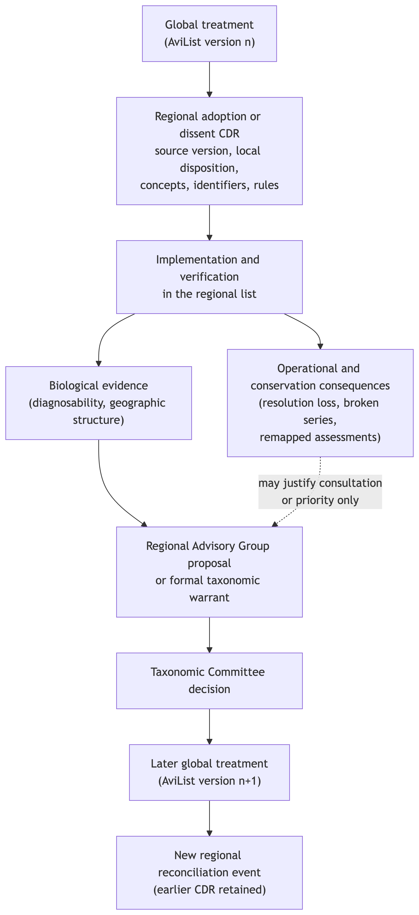
Figure 4: A possible regional-to-global interface. A regional adoption or dissent record preserves what the regional implementer encountered and decided. Only biological evidence (left branch) is a candidate input to existing global proposal and review processes; operational and conservation consequences (right branch) may justify consultation or priority but do not determine taxonomic status. The interface is a proposition for discussion with AviList participants, not an accepted AviList function.
On this account, the CDR does not replace a taxonomic warrant. It acts as a provenance and routing object between practical implementation and formal assessment: preserving what a regional user encountered, what it decided locally, which part of the record may constitute relevant biological evidence, and what remains unresolved. Whether such a record would be useful to AviList, and how it could align with the Australasian Regional Advisory Group and Taxonomic Committee proposal processes, requires confirmation through AviList’s governance processes.
The proposition is a test rather than a recommendation. It would be supported if regional records of this kind made contributions easier to evaluate, or made the disposition of regional evidence easier to recover. It would be weakened if existing proposal formats already carry the necessary information, or if the cost of structuring regional records exceeded their value to the global process. Neither outcome would affect the Working List’s own need to record its adoption decisions.

9. Data sensitivity as a comparative application

9.1 What the comparison tests
The data-sensitivity workflow provides a useful second application because it developed independently of the Working List pilot and concerns a different class of decision. Its object is the handling of biodiversity occurrence data where disclosure may create a risk of harm. It is not an implemented CDR system. Rather, it demonstrates several of the conceptual separations on which the broader architecture depends.
The question it can answer is narrow but useful: do the separations argued for above arise only in taxonomic adoption, or do they appear when a different team, maintaining a different kind of determination, builds a system over the same identities? The workflow was designed before the record vocabulary of this paper existed, and its records were not written to fit it. That makes it a fairer test than a second application designed to the same template.

9.2 Separations the second application reached independently
First, its decision log already separates system design from taxon-level assessment. Its architecture decision records adopt rules, define data structures or record corrections. Individual sensitivity assessments remain authored table state with recorded rationales. One record comes closest to a content-decision function because it resolves, taxon by taxon, what historical assessment rows refer to under a later taxonomy. Another records a product-specific application decision with its own scope and authority, and states explicitly that it is not a general exemption. Neither requires the historical records to be retrospectively renamed as CDRs.
Second, the workflow distinguishes taxonomic identity from assessment validity. Establishing which current taxon an inherited row refers to does not establish that the row’s sensitivity assessment remains correct for the current concept. The system can flag a mismatch, preserve the taxonomy version against which the identity was understood, and prevent an unresolved edit from being written silently. It cannot decide whether the substantive assessment remains valid. That remains a human evidentiary question.
Third, directly authored values remain distinct from inherited or effective values. A displayed subspecies value may have been inherited from its parent species; it should not be written back as though it were assessed directly at subspecies level. Similarly, a generated review workbook is a controlled surface for inspecting and proposing changes, not the authoritative store. These distinctions are generalisable to other hierarchical biodiversity data in which identity, state and displayed interpretation change at different rates.
A further principle is worth stating because it is cheap and general. When an edited review surface is ingested, the system refuses to guess: it aborts if an edited taxon still carries an unresolved identity flag, takes a dated backup regardless, and never proposes a resolution itself. The system may detect an inconsistency, but it must not decide it.
Table 3: Separations shared by the two applications. The data-sensitivity column describes record functions only; no categories, thresholds or assessments are implied.
Separation | Working List application | Data-sensitivity application
Design record versus content decision | ADRs govern the list and its workflows; content decisions are cases and CDRs | ADRs govern the assessment system; taxon assessments are authored data with rationales
Governing statement versus adopting record | Provisional governing statements; no register yet | Rules adopted inside ADRs; no separate register
Identity frame versus content validity | Release-anchored identifiers; concept lineage | Assessments anchored to a list edition; resolving identity does not re-validate content
Authored versus inherited state | Operational units across ranks | Subspecies inherit species values in a view; inherited values are not written back as authored
Authoritative state versus review surface | Consultation briefs are not the record of decision | Generated review workbooks are not the authoritative store
Assessment versus downstream application | Adoption decision versus implementation in linked products | Assessment versus a scoped decision on how one product handles assessed records
Determination provenance | Cases and CDRs record who decided, on what evidence and under which rule | Backups and change logs show that a value changed, not who decided or why

9.3 The assessment framework as upstream evidence
The substantive assessment framework also illustrates the boundary between evidence and decision provenance. A 2017 vulnerability framework developed by G. Ehmke adapts established risk-management and climate-vulnerability principles to this problem. Sensitivity to a specified harm and exposure to that harm establish vulnerability. A third consideration, stored locally as utility but more clearly described as protective efficacy, asks whether spatial generalisation, restriction or withholding is likely to reduce exposure or harm. This is not the analytical utility of released data, and it is not a third constituent of vulnerability. Weston et al. (2012), which reviews flight-initiation distances, may supply evidence about disturbance sensitivity in particular assessments; it is not the source of the framework [CITE: risk-management and climate-vulnerability sources in Ehmke 2017; Weston et al. 2012 where an assessment example requires it].
The formulation has clear structural precedent. Exposure and sensitivity are the core of established climate-vulnerability assessment, and published guidance on sensitive species data, as well as at least one published decision procedure for publishing biodiversity data, weighs the risk and impact of harm against the value of release [CITE: climate-vulnerability framework sources; GBIF current guidance on generalising sensitive species occurrence data; Tulloch et al. 2018]. Its possible distinctiveness lies in its practical application: in treating protective efficacy as a separate test of the proposed intervention, in expecting sensitivity and exposure to vary across a range, and in separating identity, assessment, inheritance, review and downstream product decisions in a working system. It is not proposed here as a new general theory.
The three considerations do not yet generate a category mechanically. Their value scale and any category-derivation rule remain open. Nor has the proposed precautionary handling of occurrence records identified only to species been endorsed. These limitations prevent the data-sensitivity material from supporting a complete methods paper at present. They do not prevent it from serving as a comparative application of the record architecture. Nor has the effectiveness of restriction or generalisation been evaluated, in this workflow or, as far as the sources inspected show, in the guidance it draws on.

9.4 What the second application does not test
Its strongest lesson may be institutional rather than technical. Governing statements were adopted inside ADRs, but no separate register now presents those rules as current, citable objects. System provenance is comparatively strong; determination provenance is weaker, because backups can show that a value changed without preserving a complete account of who decided, against which evidence and under which rule. The workflow therefore shows both the value of the proposed separations and the cost of omitting them.
The workflow has no open decision case, no attributed deliberation, no independent external review and no unchanged closure record. An external review path has been designed, including a mode that withholds existing values so that reviewers are not anchored by them, but it has not been used. These absences are as informative as the separations it achieved. They are the components that a decision architecture adds, and the data-sensitivity setting, in which a team of assessors maintains determinations directly as data, is where a short authorisation record would most obviously help.

9.5 Multiple assessments and later evidence
The comparison also exposes a requirement that is easy to miss where a database retains only one current assessment row for each taxon. Assessment and decision have different cardinalities. Several assessors may independently assess the same subject; one assessment may be reviewed more than once; and one authorised product decision may rely on several assessment versions. Disagreement should therefore remain visible as attributed evidence, not be resolved by overwriting one row with another. Separate CDRs are warranted only where authorised scopes or dispositions differ, not merely because assessors disagree.
Evidence may also arrive after a CDR has been issued. A later assessment cannot be appended to the closed record as though it informed the original decision. It should be registered as a new dated contribution linked to the subject, case and CDR, then triaged according to its consequence. A confirmatory assessment extends the evidence lineage without changing the current disposition. A material challenge reopens the case for review while the issued CDR remains in force. If the authorised outcome changes, a new CDR supersedes the earlier one; the earlier record remains an accurate statement of what was decided on the evidence then available. Correction of an error in the historical record follows the correction mechanism rather than being disguised as new evidence.
This requirement is conceptually settled but not implemented in the current data-sensitivity schema, which retains one overwritable assessment row per taxon and does not preserve assessor, version, review or decision authority as separate relations. That limitation does not prevent the record architecture from being stated. It does prevent current database state from being presented as a complete assessment history.

10. Transferability and range layers

10.1 Why the architecture may apply to spatial data
Range-layer decisions provide an important prospective extension. Construction of accepted range representations involves principles about comparability and fitness for purpose, policies about method selection and evidence, and rules governing candidate completeness, range class, adjudication and validation. It would nevertheless be a mistake to create a CDR for every selected polygon, parameter or routine spatial operation. Fine-grained provenance belongs principally in the species schema and technical workflow. A CDR is more likely to add value where a grouped rule, precedent-setting interpretation, contested exception or durable methodological judgement governs many later operations.
The general record pattern may transfer even though the evidence and consequences differ. Spatial decisions draw on reporting rates, survey effort, temporal occupancy, spatial configuration, competing candidate geometries and expert interpretation, rather than on taxonomic descriptions. One distinction from the Working List pilot is likely to carry across directly: representational precision is not biological accuracy. A stored geometry always records an explicit boundary, whereas the biological boundary it represents may be uncertain or gradational. That uncertainty belongs in provenance, metadata, confidence or explicit alternatives, and a decision record about a range should say which of these it used. Working List rules should not, however, be imported directly into spatial practice.

10.2 Where spatial audit ends and a content decision begins
The relevant boundary is not spatial versus non-spatial. It is the distinction between applying an already authorised rule and making a substantive judgement about what the accepted range product should represent. Executing a settled construction procedure, recording parameter values, intersecting geometry with a mask, propagating an accepted class or publishing a verified derivative belong principally in technical provenance, database audit and implementation records. Those records should make the operation reproducible and link it to the rule or decision that authorised it; they do not require a CDR for every geometry.
A CDR becomes more plausible where the judgement changes interpretation or establishes precedent: selecting or amending a grouped rule; deciding that available evidence supports more than one primary range class; adjudicating whether recurring low-use distribution is infrequent rather than vagrant; accepting an expert-supported boundary where statistical evidence remains equivocal; or authorising a material exception to the normal construction path. In each case the accepted geometry or class remains authoritative domain state. The CDR records the judgement, governing statement, evidence and reconsideration trigger; it does not become the spatial table itself.
The Working List provides a direct point of contact. A proposed implementation condition is that a taxonomic treatment should not be adopted operationally until the affected biological units can be represented sufficiently for linked observations and ranges. That statement still requires exact wording, authority and classification as principle, policy or rule. If adopted, a taxonomic CDR could cite the condition, while a related spatial decision records the boundary, composite attribution or unresolved state that enables, delays or qualifies implementation. This is a candidate interface, not a settled range-layer procedure.

10.3 Why it remains prospective
This proposition cannot be tested until representative range exemplars are complete. Vagrancy, recency and the distinction between primary and secondary range classes are likely candidates, but their methodological content remains owned by range formalisation. The absence of a completed range-layer implementation does not prevent the Working List-centred argument from being drafted. It limits the strength of any claim that the architecture has already generalised across the full integrated data system.
At present, spatial adjudication in the range layers is recorded mainly as free-text rationale on a small number of working geometries, and there is no provenance-preserving path from an accepted spatial decision to the published range. Developing a range-layer decision architecture would require settling which spatial judgements warrant a durable record, how grouped decisions relate to per-taxon geometry, and how a recorded decision reaches an accepted layer. That is substantial methodological work rather than additional writing, and it is not attempted here.

11. Boundaries and maturity
The proposed architecture is at different levels of maturity. Its basic record distinctions are supported by existing practice, and the Working List pilot has exercised consultation, reconsideration and supersession. The four-route proportionality model has plausible examples, but not all routes have been tested equally. The principle–policy–rule hierarchy has been accepted conceptually, although its operational register has not been established. Public terminology for the CDR remains provisional.
Decision cases, attributed contributions, reconsideration and supersession have been exercised in the Working List pilot. Independent review of a fixed evidence version, case-free authorisation and end-to-end verification from CDR to implemented data remain designed rather than fully tested. There is no production CDR database. The pilot also showed that a spreadsheet register specified in advance was not used once consultation began; cases and closure records were kept as documents. That finding concerns storage rather than the record distinctions, which the pilot otherwise supported, but it means that structured records of contributions and case events were not kept consistently. Table 4 states the position element by element.
Table 4: Maturity of the architecture’s elements at November 2026. “Practised” means exercised in a pilot, not evaluated.
Element | Status | Note
Separation of design records, cases, content decisions, implementation and state | Practised | Exercised in the Working List pilot; supported independently by the data-sensitivity application
Principle–policy–rule framework | Accepted conceptually | Existing statements not yet classified across the three levels
Governing-statements register | Proposed | Form and maintenance home undecided
Decision cases and attributed contributions | Practised | Structured contribution records not kept consistently
Default-proposal consultation | Partly practised | No case has yet closed on the silence condition
Independent review of a fixed version | Designed | Not exercised; role separation incomplete at pilot scale
Content decision records | Practised | Pilot records only; no production database
Correction and amendment | Designed | Not exercised
Addendum, reconsideration and supersession | Practised | Earlier records retained unchanged
Case-free authorisation | Designed | Not exercised in the Working List
Implementation of routine changes | Practised | Checked, reversible transformations with retained residue
CDR-to-implementation link and verification | Designed | No pilot CDR has yet authorised a transformation
Regional-to-global interface | Proposed | Requires confirmation through AviList processes
Data-sensitivity comparison | Practised separations | No case, attributed deliberation, independent review or closure record
Multiple attributed assessments and post-decision evidence | Conceptually specified | Current data-sensitivity schema cannot retain the required assessment history
Range-layer audit/CDR boundary | Prospective | Candidate distinctions drafted; requires testing against range exemplars and formalisation

Other limitations are more immediate. The pilot has been coordinated by a small number of people; role separation is incomplete; some controls exist only as designs; and the literature comparison with committee rulings, generic decision records, Evidence-to-Decision frameworks and decision provenance still requires full-text verification. These limitations should be stated directly. The contribution is a reasoned architecture grounded in emerging practice, not an evaluation of a mature institutional system.
At the pilot’s scale, some designed controls are not merely untested but structurally hard to exercise. Where the coordinator, the assessor and the decision authority are the same person, and the principal contributors are few, independent review and conflict management cannot yet be demonstrated. That is a limitation of the pilot rather than of the design, but it means the paper can describe these controls only as architecture.

12. Discussion

12.1 Transparency without burden
Maintained biodiversity products are often judged by the quality of their current data and the frequency of release. Both matter, but neither is sufficient where the product embodies recurring scientific and operational judgement. A list can be technically versioned while the reasons for its changes remain dispersed across correspondence, code and individual memory. Decision architecture provides a way to preserve those reasons without making every maintenance action burdensome.
Transparency in this sense is not publication of everything. Some deliberation involves personal communications, unpublished work or sensitive information. The architecture keeps the visibility of a deliberation separate from the sensitivity of the biological data it concerns: a case about a taxon whose locations are protected may itself be openly visible, and a case about an unrestricted taxon may need restricted handling of its contributions. What must be recoverable is the chain from governing statement to evidence, disposition and data state. Who may see each link is a separate decision.

12.2 Decision volume and proportionality
Taxonomic maintenance generates many decisions. Global lists release revisions regularly, and a national list must respond to each, while also handling its own scope changes, new evidence and corrections. The architecture is useful only if the effort of recording stays roughly in proportion to the consequence of what is decided. Most changes should pass through the mechanical and routine routes with no more than an implementation record and a citation of the governing rule. A small number warrant cases. The value of the routes depends on the criteria for directing changes among them being recorded and applied consistently; otherwise proportionality becomes a convenient way of leaving difficult decisions undocumented.
High volume also places demands on retrieval. A large number of decision records is not evidence of good practice. Records are useful only if the record in force for an entity, and the chain of records it superseded, can be found quickly. That is an argument for stable identifiers, explicit supersession links and periodic synthesis, rather than for longer records.

12.3 Uncertainty and reversibility
Biological classifications are revisable, and a split may later be reversed and then reinstated. A decision architecture does not resolve that uncertainty. It records it. Each record preserves the information, rule and rationale operative when it was made, and supersession makes the current authority explicit without implying that earlier decisions were errors. This is what allows a maintainer to act on the best current interpretation without treating it as irreversible, and allows a contributor to raise a consequential detail without first reconstructing how the earlier decision was reached.
The same property cuts the other way. A record that is easy to supersede could encourage frequent reversal. The safeguards are the reconsideration triggers stated in the original record, the requirement that a reconsideration open a linked case, and the burden placed on whoever proposes an information-reducing change.

12.4 Implementation cost
The architecture has costs. Someone has to classify changes, open and close cases, maintain a register of governing statements and verify implementation. The pilot suggests that the conceptual distinctions are cheap to maintain once understood, while the structured infrastructure around them (registers, linked identifiers and verification records) is where effort accumulates. A product adopting the approach should therefore begin with the distinctions and add infrastructure only where volume or consequence requires it. A database is not a precondition. It is a later means of enforcing links that can first be maintained in plain text.

12.5 Generality
The data-sensitivity application suggests that these distinctions are not confined to taxonomic adoption. It separates system design, governing rules, authored determinations, inherited state, review surfaces and product-specific applications, even though it did not begin with the same record vocabulary. Range-layer work may provide a further application once its exemplars and methodological decisions are sufficiently mature.
Nothing in the architecture is specific to birds or to taxonomic lists. Any maintained product in which substantive determinations are made repeatedly, against changing evidence and identities, and consumed by other systems faces the same need to distinguish the question, the authority, the action and the resulting state. Extinction-risk assessment datasets, trait databases and spatial products are plausible candidates. Whether the distinctions remain useful in those settings is an empirical question that this paper does not answer.
The relationship to existing practice should also be stated plainly. Decision records, provenance models, committee rulings and per-taxon assessment systems all predate this work. The architecture described here draws on each of them, and its value, if any, lies in how they are connected in a maintained product and in the separations that connection makes visible [CITE: Review B — decision-record, provenance and checklist-governance precedents].

12.6 Conclusion
For the Working List, this architecture clarifies the distinction between using a global taxonomy and maintaining a national working view. It allows external scientific assessments to enter as evidence without turning an adoption record into a competing taxonomic determination. It permits a decision to be reconsidered quickly without erasing its earlier basis. It also makes implementation part of the evidentiary chain: a reasoned decision is incomplete as an operational act until the intended data state has been produced and verified.
The immediate value of the framework is consequently practical. It provides a means of maintaining complex biodiversity data under rapid change while retaining scientific accountability and the capacity to reverse course. Its broader value will depend on whether the distinctions remain useful when tested by collaborators, additional cases and other maintained biodiversity products.

Availability of materials
This paper reports no new dataset. The Working List to which the architecture is applied is described in a companion paper (in preparation) and will be released as a separately versioned data product. A longer explanatory review of ADR lineage, record fields and current applications is maintained as a technical resource and is intended to be made available as linked material; operational templates and pilot records are not released with this paper. Supplementary Material is planned and will contain fuller field tables, route criteria, supersession mechanics and a public mapping of the data-sensitivity comparison.

References
Garnett, Stephen T, Olaf Bánki, Saroj Kanta Barik, et al. 2026. “Measuring the Quality of Species List Governance.” BioScience 76 (3): 254–68. https://doi.org/10.1093/biosci/biaf071.
Garnett, Stephen T., Les Christidis, Stijn Conix, et al. 2020. “Principles for Creating a Single Authoritative List of the World’s Species.” PLOS Biology 18 (7): e3000736. https://doi.org/10.1371/journal.pbio.3000736.
Garnett, Stephen, and Les Christidis. 2017. “Taxonomy Anarchy Hampers Conservation.” Nature 546 (May): 25–27. https://doi.org/10.1038/546025a.
Rheindt, Frank E., Paul F. Donald, David B. Donsker, et al. 2025. “AviList: A Unified Global Bird Checklist.” Biodiversity and Conservation 34 (10): 3359–76. https://doi.org/10.1007/s10531-025-03120-y.

