**Station 1—John Dalton**

1766-1844

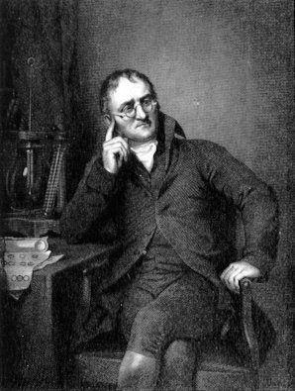John Dalton was an English chemist. His ideas formed the atomic theory of matter. Here are his ideas:

1. All elements are composed (made up) of atoms. It is impossible to divide or destroy an atom.

2. All atoms of the same elements are alike. (One atom of oxygen is like another atom of oxygen.)

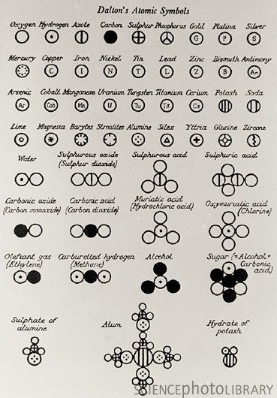3. Atoms of different elements are different. (An atom of oxygen is different from an atom of hydrogen.)

4. Atoms of different elements combine to form a compound. These atoms have to be in definite whole number ratios. For example, water is a compound made up of 2 atoms of hydrogen and 1 atom of oxygen (a ratio of 2:1). Three atoms of hydrogen and 2 atoms of oxygen cannot combine to make water.

**Station 2—J.J. Thompson (Gas tube experiment)**

Late 1800s

J.J. Thompson was an English scientist. He discovered the electron when he was experimenting with gas discharge tubes. He noticed a movement in a tube. He called the movement cathode rays. The rays moved from the negative end of the tube to the positive end. He realized that the rays were made of negatively charged particles that he called electrons. His theory also has been called the “plum-pudding” model of the atom.

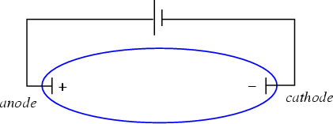

**Station 5—Lord Ernest Rutherford**

1871-1937

Ernest Rutherford conducted a famous experiment called the gold foil experiment. He took a thin sheet of gold foil. He used special equipment to shoot alpha particles (positively charged particles) at the gold foil. Most particles passed straight through the foil like the foil was not there. Some particles went straight back or were deflected (went in another direction) as if they had hit something. The experiment shows:

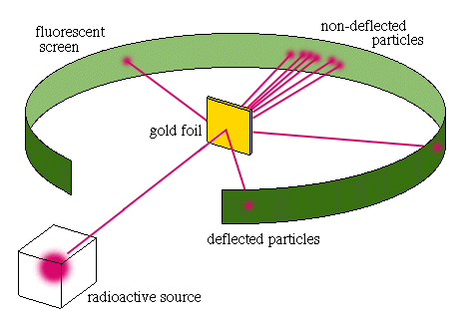• Atoms are made of a small positive nucleus; positive nucleus repels (pushes away) positive alpha particles;

• Atoms are mostly empty space.

**Station 3—Niels Bohr**

Early 1900s

Niels Bohr was a Danish physicist. He proposed a model of the atom that is similar to the model of the solar system. The electrons go around the nucleus like planets orbit around the sun. All electrons have their energy levels – a certain distance from the nucleus. Each energy level can hold a certain number of electrons.

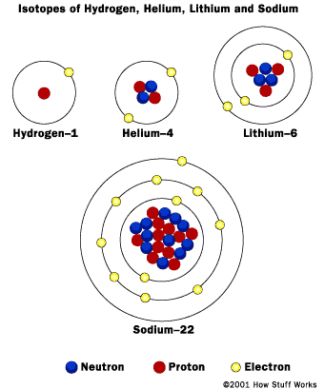Level 1 can hold 2 electrons

Level 2 – 8 electrons

Level 3 – 18 electrons

Level 4 – 32 electrons

The energy of electrons goes up from Level 1 to other levels. When electrons release (lose) energy they go down a level. When electrons absorb (gain) energy, they go to a higher level.

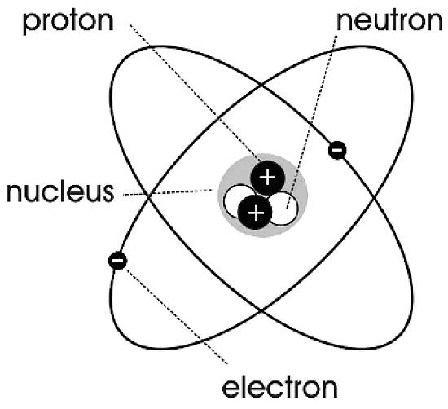**Station 4—James Chadwick**

1932

Since Thomson's discovery of the electron in 1897, scientists had realized that an atom must contain a positive charge to counterbalance the electrons' negative charge. In 1919, as a byproduct of his experiments on the splitting of atomic nuclei, Rutherford discovered the proton, which constitutes the nucleus of a hydrogen atom. Although Rutherford proposed the existence of a neutral subatomic particle in 1920, the actual discovery was made by English physicist James Chadwick, a former student of Rutherford, in 1932.

Chadwick found that:

1. When working with isotopes, the mass of atom was not always exactly the same. This was due to the presence of another particle in the nucleus called a neutron.

2. A neutron has about the same mass as a proton.

3. A neutron has no electrical charge (is neutral).

**Station 6—Structure of the Atom**

Scientists described the atom as having a small central region containing over 99% of its mass. This region is called the nucleus. Around the nucleus move very small particles called electrons, which have an electrical charge of -1.

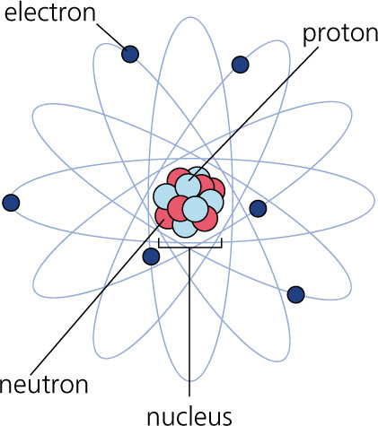**Part of the atom:**

1. The nucleus contains two type of particles: protons and neutrons, and makes up the mass of the atom.

2. Protons have a positive charge (+1) and identify the element.

3. Neutrons have no charge or are neutral.

4. Electrons have a negative (-1) charge and are located around the nucleus in an area called the electron cloud.

**Two numbers** are used to describe the components of an atom.

1. The atomic number is the number of protons in an atom. The number of protons is the identifying characteristic of an atom and DOES NOT change. The atomic number is found on the periodic table.

2. The mass number is equal to the number of protons and neutrons in the nucleus.

**ACT-CORE Atomic Theory Gallery Walk—Student Page**

Name _____________________________________________________

**Directions: At each station, you will find information about the scientific discoveries related to the modern atomic theory. Read the information provided and answer the questions below.**

**Station1—John Dalton**

1. What is the name of his theory? ______________________________________________________

2. What are elements made of? ______________________________________________________

3. According to Dalton’s theory, why are carbon and oxygen different elements? ___________________________

_____________________________________________________________________________________________

4. The ratio of atoms in HCl is

a. 1:3 b. 2:1 c. 1:1

***5. Which of Dalton’s theories are no longer true? _______________________________________________________________________________***

***(answer this after you get all the information from other station)***

**Station 2—J.J. Thompson (Gas tube experiment)**

1. What did J.J. Thompson discover? ______________________________________________________

2. What is the charge of an electron?______________________________________________________

3. What are cathode rays made of?________________________________________________________

4. Why do electrons move from the negative end of the tube to the positive end? ___________________________ _____________________________________________________________________________________________

**Station 3—James Chadwick**

1. What did Chadwick discover?________________

2. What is the charge of a neutron?______________

3. Where can you find a neutron?________________

4. How did Chadwick know that neutrons must exist in the nucleus? ________________________________

_____________________________________________________________________________________________

**Station 4—Lord Ernest Rutherford**

1. What is the charge of an alpha particle?______________________________________________________

2. Why is Rutherford’s experiment called the gold foil experiment? __________________________________ ________________________________________________________________________________________

3. What happened to the alpha particles as they hit the gold foil?___________________________________ ________________________________________________________________________________________

4. How did he know that the nucleus was positively charged? __________________________________________ ____________________________________________________________________________________________

**Station 5—Niels Bohr**

1. Why could Bohr’s model be called a planetary model of the atom? _____________________________________ _____________________________________________________________________________________________

2. How many electrons can the fourth energy level hold?

______________________________________________________

3. Would an electron have to absorb or release energy to jump from the second energy level to the third energy level? ______________________________________________________

**Station 6—Structure of the Atom**

1. What do scientists call the center region of an atom?_________

2. What can be found in the nucleus of an atom?_______________

3. Where can you find electrons in an atom?_________

4. And what is the charge of an electron?_________

5. What does the atomic number of an element tell you? __________________________________________

6. Where do you find the atomic number? ____________________________________

7. Does the atomic number of an atom change?__________________________

8. Why or why not? ________________________________________________________________________

9. What is the formula to find the mass number?_________________________________________________