**Milestone Three Document**

Gabriel Glenn and Jack Petry

**Design Patterns**

**Command Pattern** – The client sends request and responds. These are created as objects that are easily extensible.

**Prototype Pattern** – Our response and request classes are all abstracted to the same objects. This allows the user or later programmers to easily add both responses and request without changing the source code.

**Updated UML**

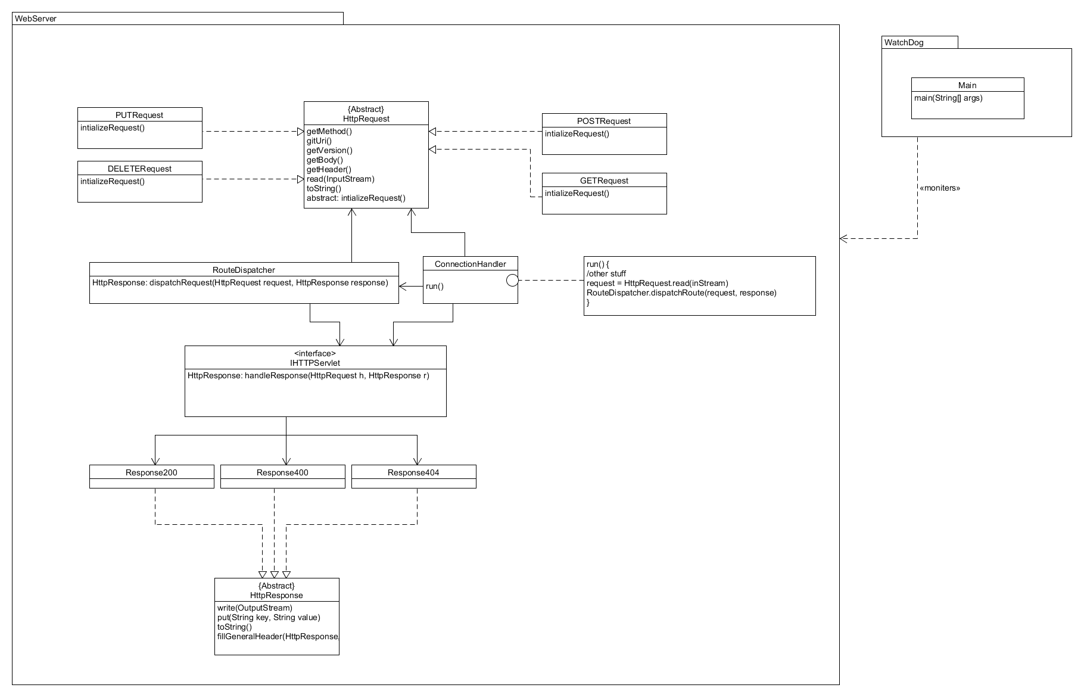

**Change Log**

**IHttpServlet** – and extensible interface that allows user to create their own Servlets. These servlets uniquely handle requests based on the user’s implementation.

**RouteDispatcher –** loads new Servlet plugins and maps their routes. Also handles incoming requests dispatching them to the correct servlet.

**Watchdog** – monitors our server to make sure that it is servicing requests. If it cannot be requested to or doesn’t respond in a reasonable amount of time, it restarts the server. Certainly a large number of requests are lost by doing this but it is better than it entirely crashing and stopping functioning.

**Resource Manager** – The resource management in the system prevents any single user from consuming too many resources from the server. This allows the system to work more fairly and to keep running under higher stress loads

**Possible Improvements**

Currently RouteDispatcher both loads and dispatches requests. Those two jobs should be separated.

Currently adding request classes requires naming convention that follows [request name in uppercase] + Request. A proxy protecting the server could help to protect against DDOS. Adding a larger set of operations and responses would make the server better as well. Also, probably could make the request reflection area more robust.

**Feature list**

GET, POST, PUT, and DELETE – (Jack) the user can choose how and where each of these requests are handled

Servlet Creation – (Jack) allows the user to create their own unique Servlet

Dispatch Requests-(Gabe) Allows the user to dynamically add servlets and access them via their browser

Watchdog – (Gabe) monitors the web server and turns it on if it’s disconnected

Resource Manager – Allocates a set amount of resources per user in order to more fairly accommodate all of the users fairly

**Architectural Evaluation**

|  |  |  |  |  |
| --- | --- | --- | --- | --- |
| **Test** | **Metric** | **Stress** | **Result Before Improvements** | **Result After Improvements** |
| Denial of Service  (Performance) | Miss Rate | 50 requests per second of a 10 Megabyte file for 20 seconds | 448 requests were lost | 44 requests were lost |
| Large File Request  (Performance) | Average Request Time | 40 requests per second for a 10 Megabyte file and a 10 Kilobyte file | 34.87 connections per second | 37.21  Connections per  second |
| Denial of Service  (Availability) | RTT of a request while server is under stress | 50 requests per second for a 10 Megabyte file | 3.28 seconds RTT for request of a 10 Kilobyte file | 21 ms RTT for request of a 10 Kilobyte file |
| Server Throttled to Death (Availability) | Server Downtime | 60 requests per second for a 10 Megabyte file | Infinite downtime | Restarts with at most 5 seconds of downtime |
| Denial of Service  (Security) | Latency of a request while the server is under DOS | 60 requests per second for a 10 Megabyte and a 10 Kilobyte | It crashed | 23 ms RTT for request of a 10 Kilobyte file |
| Data Source Integrity  (Security) | Amount of Data Logged | Send a normal level of requests say 30 per second from multiple users | Zero data is logged | Every request is now logged |

**Concrete Scenario Diagrams**

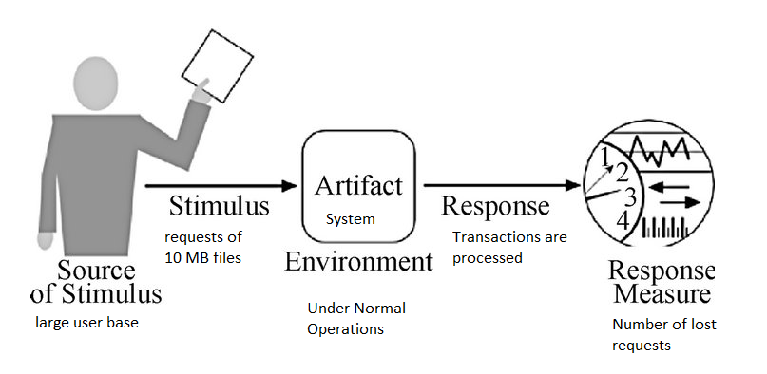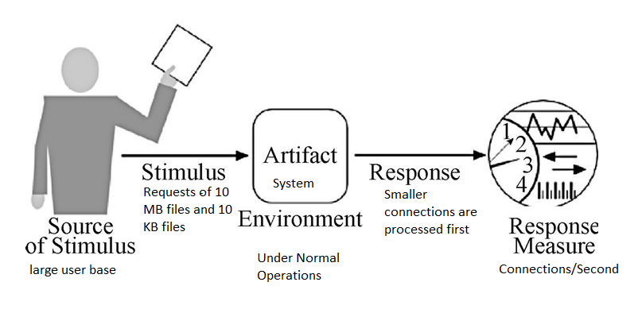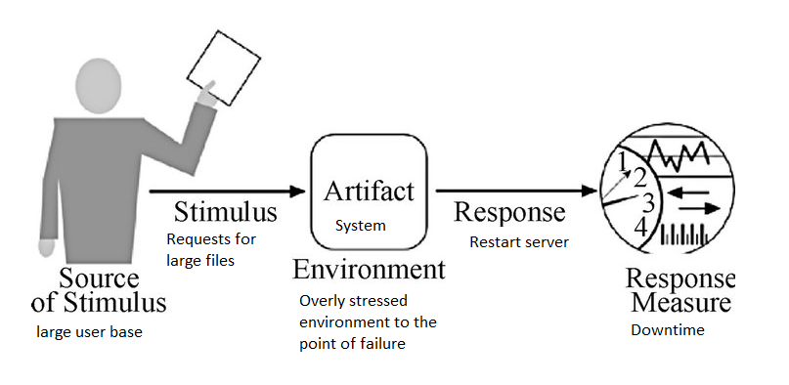

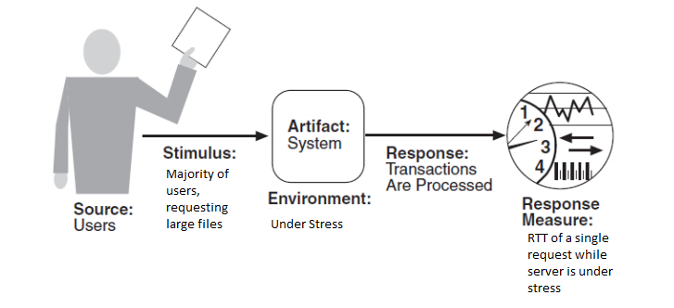

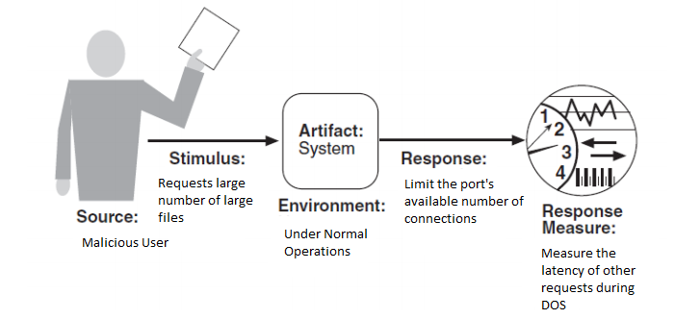

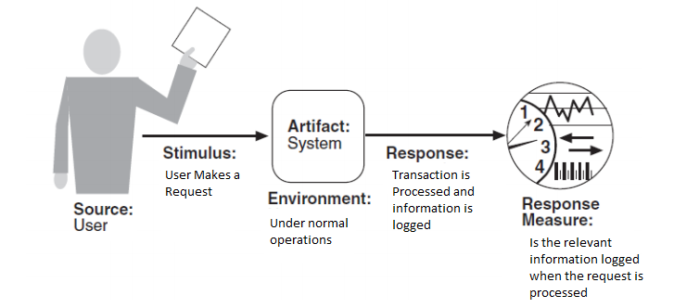

**Improvement Tactics**

All – Limiting sockets per host. This prevents any user from either uninternationally and maliciously consuming too many system resources. This helps prevent DOS attacks and improves performance for typical users.

Performance – Prioritizing smaller files. We set up our server to prioritize smaller files in ordr to reduce average wait time. In a typlical environment, most users will be using the smaller files and people won’t mind waiting a little longer in order to get really big files.

Availability – Watchdog. We developed a watchdog service in order to restart our system if it comes down.

Security – Logging. We implemented basic logging functionality in order to make security threats identifiable and retracable so the authority can remedy the problem.

**Test Report – MS1**

POST test

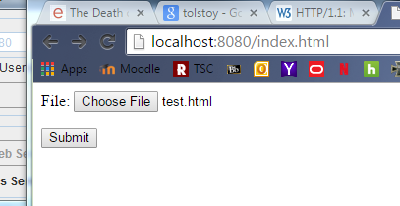

Submitting test.html

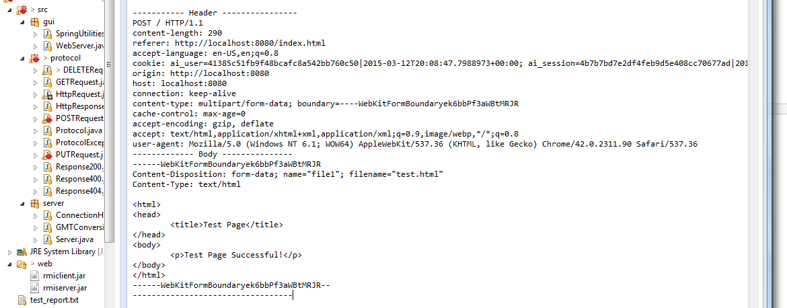

This is the request the server received after the submit button is pressed

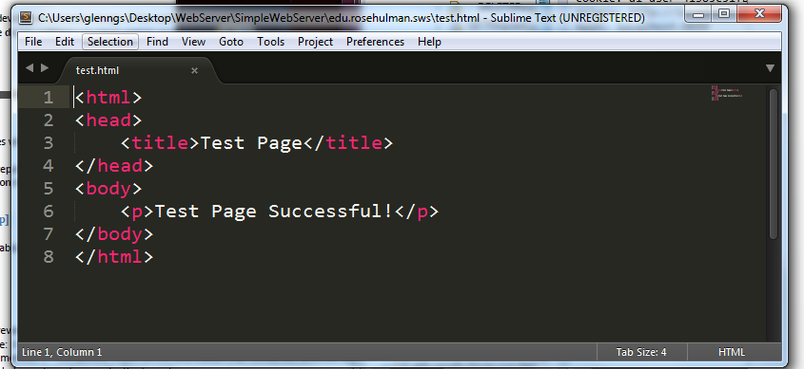

This is the file in the root dir that the request posted to

PUT Test

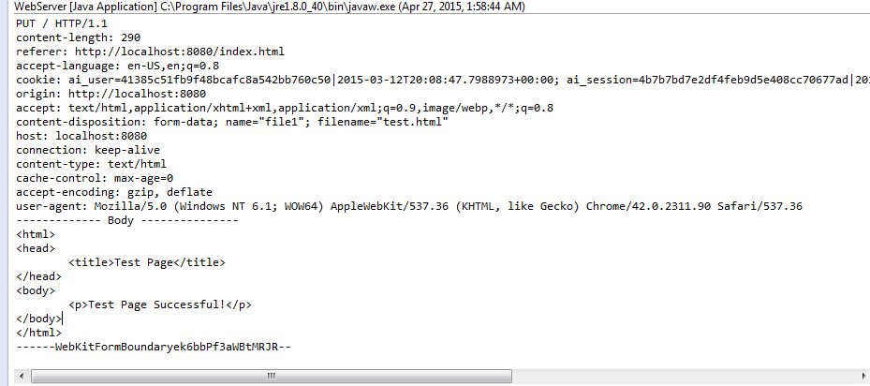

Working with the same file we again have the request reaching the server

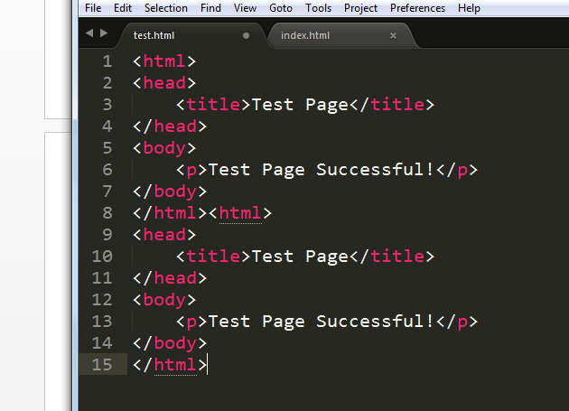

And here we have the result

DELETE Test

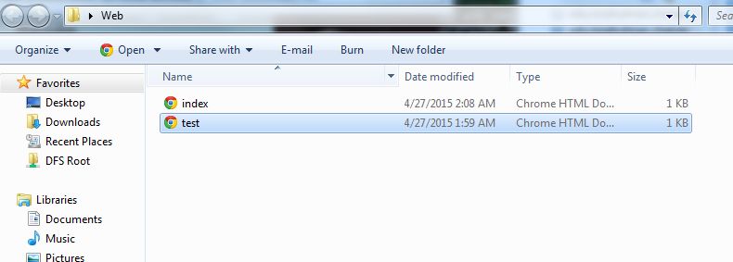

There is the file we are going to delete

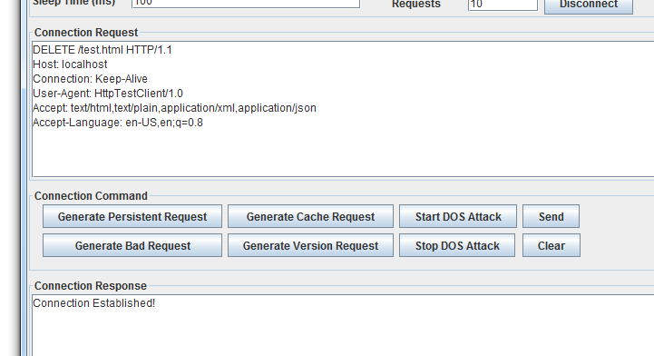

Here is the request

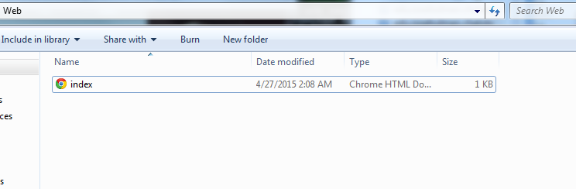

And now it has been deleted

**Test Report - MS 2**

Start the server. In the directory where the server is running, there either initially needs to be basic.jar which is the creation of the TestServlet project or you need to add it after it starts running (and it will be automatically added).

GET.

There are a couple of different pages for GET.

Go to <http://localhost:8080/basic/BasicServlet?testWord=ThisIsMyTest>

Gives a response like the following:

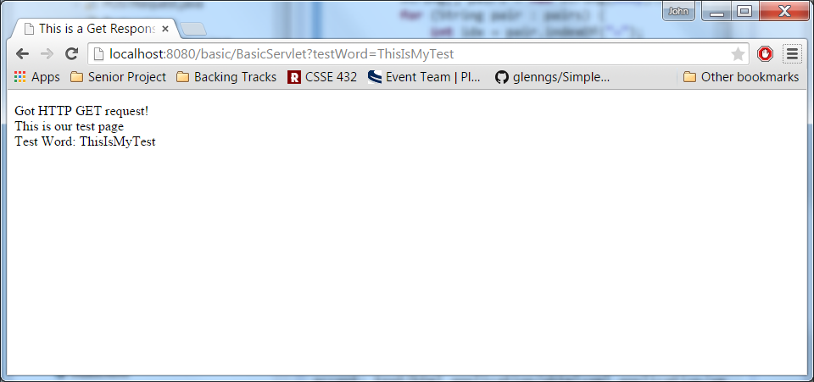

Another page that we have serves static GET content and useful for testing the POST command.

<http://localhost:8080/basic/GetTest>

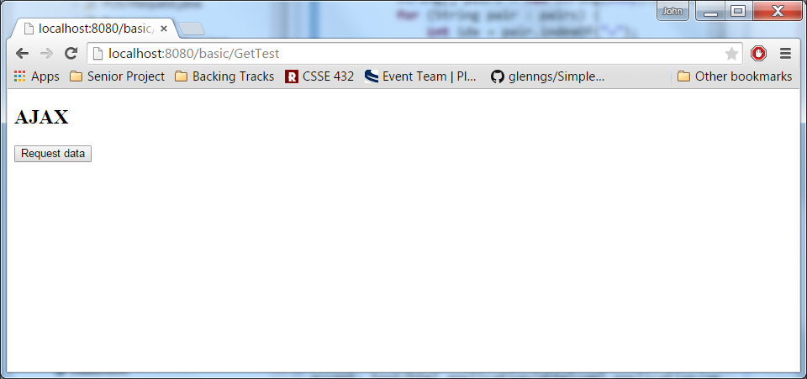

POST.

The POST command can be tested using the button of the last page.

It uses an ajax call like the following.

xmlhttp.open("POST","http://localhost:8080/basic/PostTest",true);

xmlhttp.setRequestHeader("Content-type","application/x-www-form-urlencoded");

xmlhttp.send("word1=Jack&word2=Best&filename=test.txt");

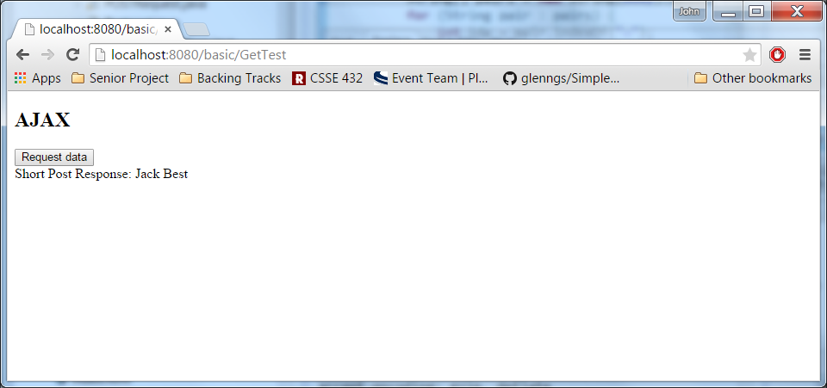

It also creates a file (test.txt) that has the same response contents.

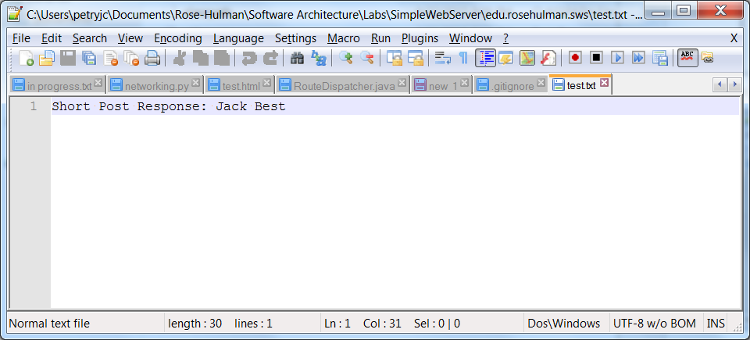

PUT.

The PUT command can easily be tested using POSTMAN.

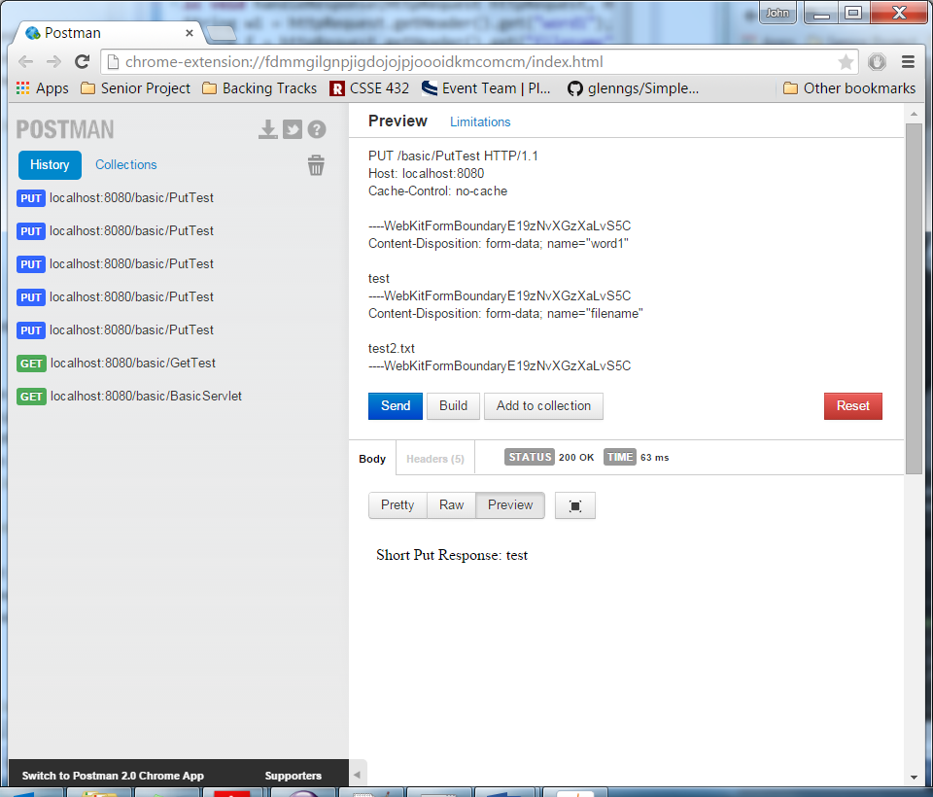

It also creates a file (test2.txt)

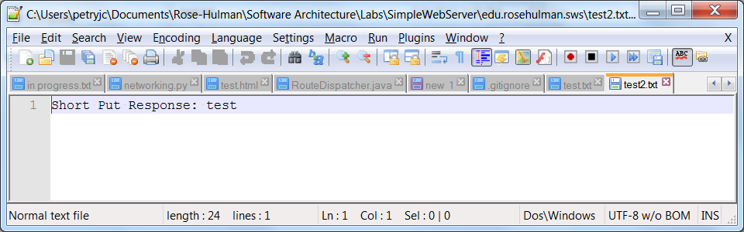

If you do the put again. It appends because I thought that would be nice of the servlet to do.

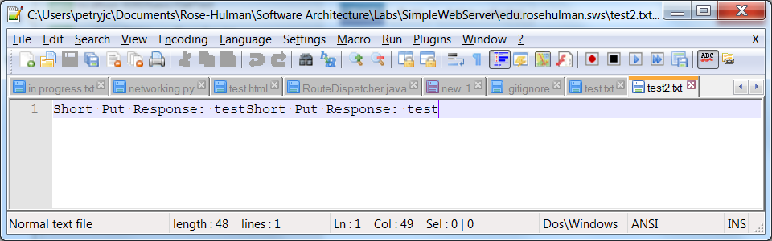

DELETE

DELETE can also be easily tested using POSTMAN.

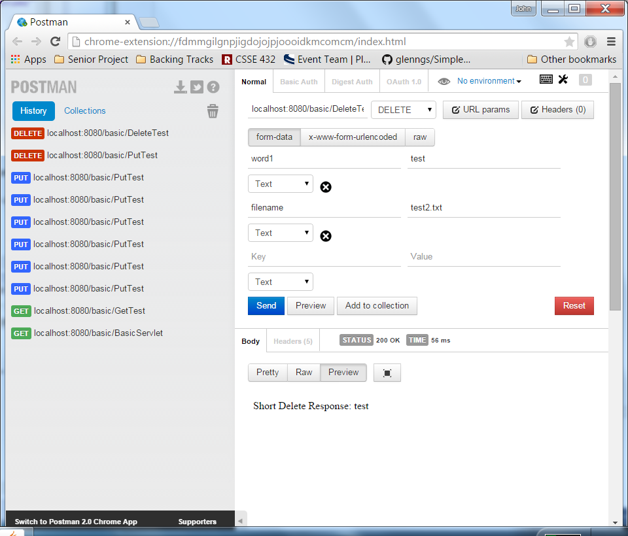

It also deleted the given file because I thought that sounded cool. (Notice test2.txt is gone)

