MASTER BRAND SYSTEM

Wellbeing Studio
Brand & experience style guide
Aligning CYA websites, member experiences and marketing with the Wellbeing Studio brand.
WELLBEING TEAL | WARM OCHRE | SOFT MIST

STATUS Working style standard based on supplied screenshots and confirmed typography. Screenshot-derived colour values should be validated against production design files before being frozen as final brand assets.

Version 1.0 | 25 July 2026
HOW TO USE THIS GUIDE

One system, expressed consistently
This guide makes Wellbeing Studio (WS) the master experience brand. CYA may continue to appear where corporate provenance, contracting or legacy recognition matters, but it should no longer introduce a separate visual language.
BRAND DECISION Lead with Wellbeing Studio. Use CYA as an endorsed corporate identifier—not as a competing customer-facing design system.

Guide map
Section | What it governs
1. Brand foundation | Architecture, promise, personality and experience principles
2. Visual identity | Colour, type, logo behaviour, imagery, icons and graphic style
3. Digital system | Layout, navigation, components, responsive behaviour and accessibility
4. Verbal identity | Voice, messaging, naming, CTA and editorial rules
5. Marketing system | Campaigns, social, email, presentations, documents and print
6. CYA alignment | Migration rules, co-branding, examples and exceptions
7. Governance | Ownership, approvals, asset control and rollout

Non-negotiables
- Urbanist for headings and high-impact display type; Open Sans for body, navigation, UI labels and long-form reading.
- Deep teal carries brand recognition; warm ochre signals action and emphasis; white and mist create calm space.
- Rounded cards, soft elevation, generous spacing and natural imagery establish the experience.
- Every page has one clear primary action. Gold is reserved for that action—not used as decoration everywhere.
- Plain, encouraging language replaces corporate jargon, hype and clinical claims.
- All digital work must meet WCAG 2.2 AA, including contrast, keyboard access, focus states and captions/transcripts.
01 · BRAND FOUNDATION

A calm, practical wellbeing companion

Recommended brand promise
PROMISE Simple, credible practices that help people feel and work better—wherever they are.

Brand role
WS turns workplace wellbeing into an accessible, repeatable experience. The brand should feel warmer than a corporate benefits platform, more practical than a lifestyle publisher and more grounded than a wellness trend.

Personality
We are | How it appears | We are not
Calm | Space, steady rhythm, reassuring language | Passive, vague or overly muted
Practical | Short steps, clear benefits, useful CTAs | Preachy or theoretical
Human | Real people, natural moments, conversational copy | Stock-corporate or performative
Credible | Qualified guidance, specific claims, accessible sources | Clinical, alarmist or overpromising
Inclusive | Choice, flexibility and varied bodies/contexts | Prescriptive or one-size-fits-all
Optimistic | Small achievable progress | Relentlessly upbeat or dismissive

Experience principles
- Make the next helpful action obvious.
- Reduce pressure: invite participation and offer choices.
- Use small, repeatable practices rather than transformation promises.
- Balance warmth with clarity; calm design must still be easy to scan.
- Connect every story, resource or campaign to a practical wellbeing benefit.

Brand hierarchy
Recommended architecture: Wellbeing Studio is the lead customer-facing brand. Corporate Yoga Australia (CYA) is the organisation or endorsed service provider. Program, campaign and content names sit below WS.
Level | Naming pattern | Example
Master brand | Wellbeing Studio | Wellbeing Studio
Endorsement | by / from Corporate Yoga Australia | Wellbeing Studio by Corporate Yoga Australia
Program | Descriptive, benefit-led name | Wellbeing Reset Program
Campaign/theme | Seasonal or action-led | Winter Wellbeing
Content | Plain descriptive title | A simple reset for winter wellbeing

02 · VISUAL IDENTITY

Colour: grounded, warm and spacious
The palette is derived from the supplied WS screenshots. Use the values below as implementation tokens, with final confirmation against the production design source or CSS before formal brand lock-off.
Token | Hex | Primary use | Usage guidance
Wellbeing Teal | #17535B | Headings, brand anchors, links | Core recognition colour; aim for 15–25% of a layout
Deep Teal | #103F45 | Hover, dark text, overlays | Use when stronger contrast or depth is needed
Warm Ochre | #BD964A | Primary CTA, kickers, selected states | Use sparingly; generally one dominant gold action per view
Soft Mist | #F4F6F5 | Page background, quiet sections | Default background behind white cards
White | #FFFFFF | Cards and clean surfaces | Preserve generous white space
Ink | #253336 | High-emphasis body copy | Use for dense or important text
Body Grey | #596467 | Body copy and metadata | Check contrast at small sizes
Divider | #DDE5E3 | Borders and separators | Quiet structure only
Action Aqua | #39AEB8 | Bullets, focus cues, small indicators | Accent only; do not compete with gold CTA
Error | #A33B3B | Errors and destructive states | Pair with icon and text, never colour alone

Colour proportions
- 60–70% white and Soft Mist: calm, breathable surface area.
- 15–25% Wellbeing Teal: headings, anchors and information hierarchy.
- 5–10% image colour: natural warmth and human context.
- 3–5% Warm Ochre: actions and micro-emphasis.
- Less than 2% Action Aqua or semantic colours: status and navigation cues.

Do / avoid
Do | Avoid
Use teal text on white/mist for the core branded look. | Large gold paragraphs or gold body text.
Use gold for the primary button and small uppercase kickers. | Multiple gold buttons of equal weight in one component.
Keep backgrounds quiet so imagery and actions can lead. | Gradients, saturated rainbow palettes or dark pages by default.
Check contrast using actual text size and weight. | Assuming brand colours automatically pass accessibility.

02 · VISUAL IDENTITY

Typography: friendly confidence
Role | Typeface / weight | Desktop | Mobile | Line height
Display / hero | Urbanist ExtraBold | 52–64 px | 38–44 px | 0.95–1.05
H1 | Urbanist Bold | 40–48 px | 32–36 px | 1.05–1.12
H2 | Urbanist Bold | 28–36 px | 25–30 px | 1.10–1.18
H3 / card title | Urbanist SemiBold | 20–24 px | 19–22 px | 1.15–1.25
Kicker / eyebrow | Open Sans Bold, uppercase | 11–12 px | 11 px | 1.35; +0.08 em tracking
Body large | Open Sans Regular | 18 px | 17 px | 1.55–1.65
Body | Open Sans Regular | 16 px | 16 px | 1.55–1.65
Small / metadata | Open Sans Regular | 13–14 px | 13–14 px | 1.45–1.55
Button / nav | Open Sans Bold | 13–15 px | 14–16 px | 1.2; +0.03 em tracking

Rules
- Use sentence case for headings. Reserve all caps for short kickers, labels and compact buttons.
- Keep body measure around 55–75 characters per line; avoid full-width paragraphs.
- Use no more than three weights per page: Regular, SemiBold/Bold and ExtraBold for hero use.
- Do not use Urbanist for long paragraphs or fine-print content.
- Use real text—not text baked into images—for all functional and editorial content.
FONT FALLBACK Web: Urbanist → Arial → sans-serif; Open Sans → Arial → sans-serif. Documents: if Open Sans is unavailable, use Arial while retaining the same hierarchy and spacing.

Logo and naming behaviour
Use the approved WS wordmark as the lead mark once supplied. Until final logo assets are confirmed, treat the name as a protected wordmark zone and do not typeset improvised logo variants.
- Preferred lock-up: Wellbeing Studio lead mark, with a small “by Corporate Yoga Australia” endorsement.
- Clear space: at least the cap height of the word “Studio” on all sides.
- Minimum digital width: 140 px for WS alone; 200 px for an endorsed lock-up.
- Use one-colour teal on light surfaces and white on dark photographic overlays.
- Never stretch, outline, shadow, rotate, recolour individual parts or place the mark over busy imagery.
02 · VISUAL IDENTITY

Imagery and graphic language

Photography direction
- Real people in believable work, home and studio environments.
- Natural light, warm neutrals, timber, greenery and tactile textures.
- Moments of participation, pause, connection and recovery—not forced poses.
- A mix of wide contextual images and intimate detail shots.
- Represent varied ages, genders, body types, abilities, roles and work settings.
- Crop with space for copy; use a dark teal or neutral overlay only when required for text contrast.

Avoid
- Overly polished stock imagery, exaggerated smiles and uniform corporate teams.
- Spiritual clichés, pseudo-scientific imagery or transformation before/after tropes.
- Clinical hospital imagery unless the content specifically requires it.
- Images implying that yoga flexibility, body shape or fitness equals wellbeing.

Shape, depth and iconography
Element | Standard
Corners | Cards 16–22 px; buttons 10–14 px; media 12–18 px. Keep a consistent radius family.
Elevation | Soft, wide shadow: 0 8px 24px rgba(16,63,69,.08). Avoid hard black shadows.
Borders | 1 px Divider (#DDE5E3); use to define nested cards and form fields.
Icons | Simple rounded line icons, 1.75–2 px stroke; teal by default, gold only for action/selection.
Play control | White circular control with clear contrast, minimum 48 × 48 px touch target.
Bullets | Small aqua dot where branded emphasis helps; standard semantic bullets elsewhere.

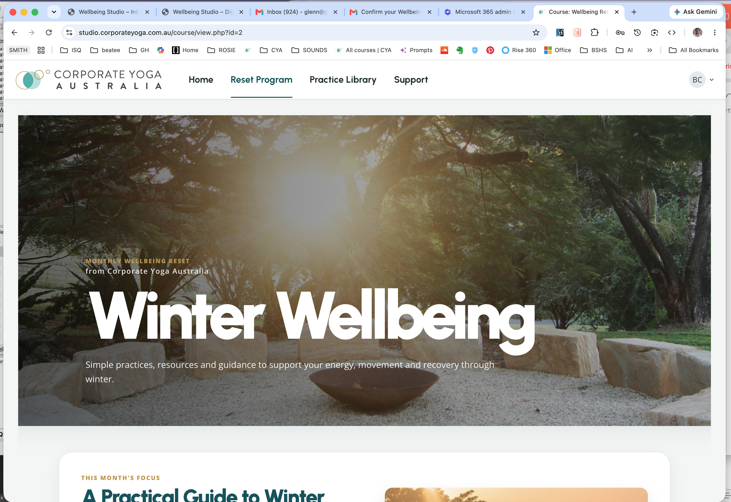
Reference treatment: immersive natural hero imagery, white display type, gold kicker and mist-backed card system.
03 · DIGITAL EXPERIENCE SYSTEM

Design calm journeys, not content warehouses

Page shell
Layer | Recommended rule
Header | White, compact and sticky only when useful. WS mark left; 4–6 primary destinations; utility/account right.
Hero | One benefit-led headline, one short supporting sentence, one primary CTA. Use image-led hero selectively.
Content | 12-column desktop grid; max content width 1200–1280 px; 24–32 px gutters.
Sections | Alternate white and Soft Mist; 64–96 px vertical padding desktop, 40–64 px mobile.
Cards | Group related actions; use consistent radius, padding and elevation. Avoid card-within-card beyond one level.
Footer | WS lead identity, essential links, contact/privacy/accessibility and CYA endorsement.

Spacing system
Use a 4 px base unit. Preferred steps: 4, 8, 12, 16, 24, 32, 48, 64, 80 and 96 px. Most component padding should be 16, 24 or 32 px. Do not invent one-off gaps unless content genuinely requires them.

Responsive breakpoints
Range | Layout behaviour
0–599 px | Single column; 20 px page margins; stack media before/after copy according to task; full-width primary CTA.
600–899 px | Two-column cards where readable; 32 px margins; simplify navigation.
900–1199 px | Desktop navigation; 8- or 12-column composition; 40–56 px margins.
1200 px+ | Max-width container; increase whitespace, not uncontrolled line length.

Core templates
- Campaign landing page: hero → monthly focus → featured practice → live session → resources → support.
- Practice library: category heading → filter/sort → media cards → saved/favourite state → pagination or progressive load.
- Article/resource: title and summary → reading time → image → clear sections → practical checklist → related action.
- Program home: welcome → next best action → schedule → toolkit → progress/support.
- Corporate service page: business challenge → WS approach → outcomes/proof → program options → consultation CTA.
03 · DIGITAL EXPERIENCE SYSTEM

Component standards
Component | Specification | Content rule
Primary button | Gold fill, Deep Teal or white text only if contrast passes; 48 px min height; 10–14 px radius | Verb-led, 2–5 words: Start your reset
Secondary button | White or transparent, teal border/text; same height as primary | Use for lower-priority adjacent action
Text link | Teal, underlined on hover/focus and where context is ambiguous | Specific destination, not “click here”
Content card | White, 16–22 px radius, subtle border/shadow, 24–32 px padding | One purpose, one primary next step
Media card | 16:9 or 4:3 image, category kicker, short title, metadata, action/save state | Title ideally under 55 characters
Form field | Visible label, 48 px min height, 1 px border, 12 px radius | Help text before error; error explains resolution
Alert | Icon + label + message; semantic colour plus text | Never communicate status with colour alone
Tabs/filters | Clear selected state; keyboard operable; scrollable only with affordance | Use plain category names

Interaction states
- Hover: deepen teal or gold by one tone and gently lift cards by 1–2 px; never rely on motion alone.
- Focus: 3 px high-contrast ring with 2 px offset; do not remove native focus without a superior replacement.
- Pressed: reduce shadow and shift by 1 px to indicate activation.
- Disabled: lower emphasis but maintain legibility; explain why the action is unavailable where needed.
- Loading: preserve layout; use meaningful progress or skeletons; do not trap focus.
- Success/error: pair colour with icon, heading and next action.

Accessibility baseline
Requirement | Standard
Contrast | WCAG AA: 4.5:1 normal text; 3:1 large text and UI boundaries. Test gold buttons carefully.
Keyboard | All functions reachable and operable; logical order; visible focus; no keyboard traps.
Touch | Minimum 44 × 44 px target; preferred 48 px for key actions.
Motion | Respect prefers-reduced-motion; avoid autoplay; no essential information conveyed only through animation.
Media | Captions for video; transcript for audio/video; descriptive titles; pause/stop controls.
Images | Useful alt text based on purpose; empty alt for purely decorative images.
Structure | One H1 per page, ordered headings, landmarks, labels, meaningful link names and error summaries.
Language | Plain English, Australian spelling, explain specialised terms and avoid ableist framing.

04 · VERBAL IDENTITY

Warm, useful and quietly motivating

Voice principles
Principle | Write like this | Not like this
Supportive | Choose the practice that feels useful today. | You should complete every session.
Practical | Try this two-minute reset between meetings. | Optimise your holistic wellbeing journey.
Clear | Join live on Monday at 12 pm AEST. | Experience our next transformative activation.
Grounded | Regular movement may help reduce stiffness. | This practice will eliminate stress.
Human | No pressure to do it all. | Users must adhere to the program cadence.
Positive | Small daily habits can make a difference. | Stop neglecting your health.

Message hierarchy
- Benefit: what will this help the person feel, do or understand?
- Action: what is the smallest clear next step?
- Reassurance: how do we reduce pressure or uncertainty?
- Detail: timing, duration, level, facilitator and format.
- Proof: credible source, expertise or evidence where relevant.

Editorial mechanics
- Use Australian English: wellbeing, organisation, personalise and programme only where organisational convention requires it; prefer “program” for digital product naming already in use.
- Use sentence case for headings and buttons; title case is reserved for proper program names.
- Write dates as 24 July 2026; times as 12 pm AEST; use an en dash for ranges.
- Prefer active voice and verbs at the start of CTAs.
- Keep paragraphs to 2–4 sentences online and front-load the important information.
- Avoid exclamation marks in routine messages; one may be appropriate for genuine celebration.
- Do not make medical claims. Use qualified wording and include professional-help guidance when content warrants it.

CTA library
Purpose | Preferred | Avoid
Start | Start your monthly reset | Submit
Join | Join the live session | Register now!!!
Watch | Start the practice | Consume content
Read | Read the guide | Learn more
Download | Download the welcome pack | Click here
Support | Contact support | Raise a ticket
Return | Return to the program | Go back

05 · MARKETING SYSTEM

Build recognition through repetition
Marketing should look and sound like an extension of the product experience. Reuse the same palette, type roles, image direction, card geometry and copy principles across every channel.

Campaign anatomy
- Theme: a focused human need or seasonal context (for example, Winter Wellbeing).
- Promise: one practical outcome expressed without hype.
- Hero action: one primary commitment—join, start, read or download.
- Content pillars: movement, mindfulness, recovery, connection and practical workplace support.
- Cadence: launch → weekly useful content → live moment → reminder → recap/evergreen follow-up.
- Measurement: attention, qualified engagement, activation, participation, repeat use and support demand.

Channel rules
Channel | Layout and copy standard
Email | 600–680 px body; one H1; single primary gold CTA above the fold; 16 px minimum copy; plain-text version; descriptive subject and preheader.
LinkedIn | Lead with a human insight; 1:1 or 4:5 image; short caption; one action; WS visual identity leads, CYA endorsement is secondary.
Instagram | 4:5 preferred for feed; safe margins for overlays; carousel uses one idea per slide; captions add meaning rather than repeat the image.
Digital ads | Benefit + recognisable brand + single action. Avoid dense text and unsupported outcome claims.
Presentations | WS cover and section dividers; Urbanist headings, Open Sans body; no more than one message per slide; cite evidence.
Documents/PDFs | Mist/white base, teal headings, gold labels and restrained callouts; readable when printed in greyscale.
Print/signage | Use short messages, high contrast and ample clear space; include a human-readable URL or QR code with destination label.

Campaign naming
- Use benefit-led, everyday language: Winter Wellbeing, Mindful Monday, Strong Posture Reset.
- Keep seasonal campaigns flexible enough to house practices, articles and live sessions.
- Avoid internally focused acronyms, over-clever puns and names that imply guaranteed health outcomes.
05 · MARKETING SYSTEM

Reusable content patterns

Monthly focus module
- Kicker: THIS MONTH’S FOCUS FOR [MONTH]
- Headline: benefit-led, ideally 5–9 words.
- Body: 35–70 words explaining context and value.
- Image: warm, natural, with clear subject and quiet crop.
- CTA: one action such as Start your monthly reset.

Practice card
- Category kicker: PILATES / MINDFULNESS / BREATHWORK.
- Title: specific practice and benefit; under 55 characters.
- Metadata: facilitator · category · outcome or duration.
- Thumbnail: consistent aspect ratio; play control centred; poster frame represents the practice.
- Optional save control: heart/bookmark with accessible name and selected state.

Live session module
- State day, date, time and time zone before the title.
- Name the session and presenter; briefly state what participants will do.
- Use one Join live session button; add calendar action as secondary.
- After the event, replace the live state with Watch the replay or View related resources.

Example campaign copy
HEADLINE A practical guide to winter wellbeing
Winter can affect energy, motivation and mood. Explore simple ways to stay well, build resilience and support your wellbeing through the colder season.
PRIMARY CTA Start your monthly reset

Email subject patterns
- Your July wellbeing reset
- A simple practice for a busy week
- Join us Monday: a 15-minute mindful reset
- New in your practice library
06 · CYA ALIGNMENT

Move from two visual brands to one experience

Recommended co-branding model
DEFAULT Wellbeing Studio leads. Corporate Yoga Australia appears as a small endorsement in the header, footer, legal area, procurement material or service credentials—not as a second masthead.
Context | Brand presentation
Member portal / wellbeing content | WS lead identity. “By Corporate Yoga Australia” in footer or account/about area.
Public WS marketing | WS lead identity. CYA endorsement only where trust/provenance adds value.
Corporate sales and tenders | WS proposition supported by CYA credentials, legal entity and delivery capability.
Legacy CYA URL | Visually migrate to WS; explain relationship once; provide clear path to WS programs/services.
Invoices, contracts and privacy | Use correct legal CYA entity prominently enough for clarity; do not compromise legal requirements.
Facilitator material | WS participant-facing template; CYA operating details where necessary.

Migration rules
- Inventory every CYA and WS touchpoint, asset, domain, template and channel.
- Classify each as customer experience, corporate/legal, sales/procurement or internal operations.
- Apply WS visual tokens to all customer experience and marketing surfaces.
- Replace dual mastheads with a single WS lead identity and consistent endorsement.
- Rewrite duplicated or conflicting messages into the WS voice and content hierarchy.
- Redirect or cross-link legacy pages deliberately; do not leave two competing versions live.
- Measure confusion, task completion, engagement and support contacts after migration.

Before → after examples
Before | Aligned WS treatment
CYA logo dominates a wellbeing member page. | WS is the lead mark; CYA appears as a quiet endorsement.
Corporate navigation and program navigation compete. | One task-led WS navigation: Home, Program, Practice library, Support.
Multiple teal, blue and gold variants. | Use the documented token palette and semantic roles.
Generic “Learn more” buttons. | Use action-specific CTAs such as Start the practice.
Formal corporate copy. | Use concise, supportive WS language with operational detail second.
Square, flat content blocks. | Use mist background, white rounded cards, consistent padding and soft depth.

06 · CYA ALIGNMENT

Website conversion blueprint

Header
- Replace the CYA-dominant masthead with the approved WS lead mark.
- Retain “by Corporate Yoga Australia” as small endorsement text where appropriate.
- Reduce main navigation to high-value tasks and keep account controls visually separate.
- Use the teal active-state underline seen in the screenshots consistently.

Homepage / portal
- Lead with a human benefit and the current seasonal or program focus.
- Surface the next live moment and next best action early.
- Use white cards on mist, organised by purpose: focus, live, toolkit, practices and support.
- Avoid repeating the same module or CTA in multiple places without a distinct reason.

Practice library
- Use consistent media cards and group by meaningful category.
- Add accessible filters for duration, need/outcome, format and facilitator where the catalogue warrants it.
- Use a clear saved state and preserve selections across visits where consent and privacy allow.
- Provide captions/transcripts and meaningful poster frames for every practice.

Public marketing site
- Explain the WS offer in plain terms before listing programs or capabilities.
- Separate participant benefits from employer outcomes but keep both in the same voice.
- Use proof carefully: client stories, participation data and facilitator expertise with context.
- Make the primary conversion path clear: book a conversation, explore the program or access the studio.
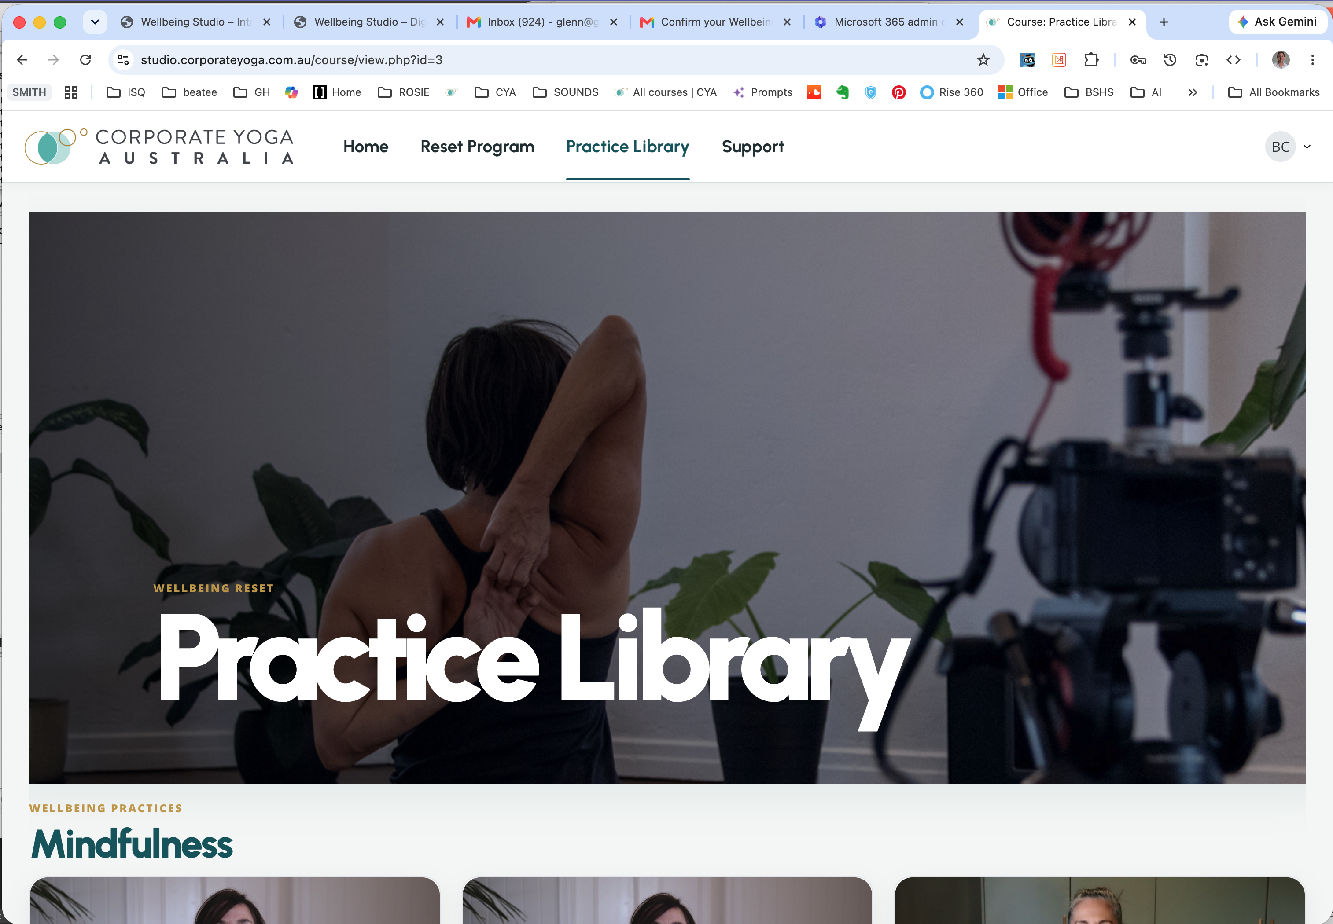
Reference treatment: WS styling applied within a CYA shell. The migration goal is to make the WS identity lead consistently and reduce the visual competition in the masthead.
07 · GOVERNANCE AND ROLLOUT

Protect the system without slowing the work

Ownership
Role | Accountability
Brand owner | Approves strategy, architecture, voice and identity changes.
Design system owner | Maintains tokens, components, accessibility and coded documentation.
Content owner | Maintains voice, terminology, editorial calendar and claims review.
Channel owners | Apply templates, test outputs and flag recurring needs.
Legal / clinical reviewer | Reviews legal entity presentation, privacy and health-related claims when required.
Delivery partners | Use approved assets and do not recreate logos, colours or templates.

Single source of truth
- One approved logo package: SVG, PNG and print-ready formats, including endorsement lock-ups.
- One token file for colour, type, spacing, radius, shadow and semantic states.
- One shared component library and one marketing template library.
- A named asset owner, version numbers, changelog and archive of retired assets.
- Templates carry a review date and owner; outdated downloads are removed, not left alongside current versions.

Approval levels
Change | Approval
Using an approved template with new content | Channel owner
New page using existing components | Design system + content owner
New campaign visual pattern | Brand owner
New colour, typeface, logo variant or master component | Brand owner + design system owner
Health claim, crisis guidance, privacy/legal text | Relevant specialist reviewer

Suggested 90-day rollout
Phase | Focus | Outputs
Weeks 1–2 | Confirm | Approve architecture; confirm exact colours and logo assets; inventory touchpoints.
Weeks 3–5 | Foundation | Token library, logo lock-ups, web components, copy patterns and templates.
Weeks 6–9 | Priority migration | WS public site, portal shell, email, social and sales presentation.
Weeks 10–12 | Scale and retire | Remaining assets, redirects, staff training, QA, archive old templates.
Ongoing | Govern | Quarterly audit, accessibility review, analytics and controlled improvements.

08 · READY-TO-USE QA

Pre-publish checklist

Brand
☐ WS is the lead customer-facing identity.
☐ CYA endorsement is correctly placed and not competing with WS.
☐ Only approved logo artwork, palette tokens and font roles are used.

Content
☐ The audience, benefit and next action are immediately clear.
☐ Copy uses the WS voice, Australian English and specific CTA labels.
☐ Claims are supportable and reviewed where necessary.

Design
☐ Hierarchy works without relying on colour alone.
☐ Spacing, radius, card depth and image treatment match the system.
☐ There is one clear primary action per view or component.

Accessibility
☐ Contrast passes; headings are ordered; landmarks and labels are correct.
☐ Keyboard, focus, touch targets and error handling have been tested.
☐ Alt text, captions, transcripts and reduced-motion behaviour are provided.

Responsive and quality
☐ Tested at mobile, tablet and desktop widths with real content.
☐ No clipping, awkward wraps, layout shifts or inaccessible overlays.
☐ Performance, links, analytics, forms and confirmation states are verified.
DEFINITION OF DONE A piece is aligned only when its identity, language, interaction and accessibility all feel like part of the same Wellbeing Studio experience.
APPENDIX

Implementation tokens
Use these as a starting point for CSS/design tokens. Confirm the screenshot-derived colour values and approved logo assets before publishing as the permanent production standard.
Token | Value
--ws-colour-teal | #17535B
--ws-colour-teal-dark | #103F45
--ws-colour-gold | #BD964A
--ws-colour-mist | #F4F6F5
--ws-colour-white | #FFFFFF
--ws-colour-ink | #253336
--ws-colour-body | #596467
--ws-colour-divider | #DDE5E3
--ws-colour-aqua | #39AEB8
--ws-font-heading | 'Urbanist', Arial, sans-serif
--ws-font-body | 'Open Sans', Arial, sans-serif
--ws-radius-control | 12px
--ws-radius-card | 20px
--ws-shadow-card | 0 8px 24px rgba(16, 63, 69, .08)
--ws-container-max | 1280px
--ws-focus-ring | 0 0 0 3px rgba(57, 174, 184, .45)

Source note
This guide was developed from the 17 supplied WS/CYA portal screenshots dated 5 July 2026 and the typography direction provided on 25 July 2026. The public WS website URL was supplied as context but could not be inspected from the working environment. Logo specifications, exact production colour values and any formal legal naming requirements should be confirmed during brand lock-off.

