**ISO/WD 19156(E)**

ISO/TC 211/WG 9

Secretariat: SIS

**Geographic information — Observations, measurements and samples**

Informations géographiques — Observations, mesures et échantillons

WD stage

Warning for WDs and CDs

This document is not an ISO International Standard. It is distributed for review and comment. It is subject to change without notice and may not be referred to as an International Standard.

Recipients of this draft are invited to submit, with their comments, notification of any relevant patent rights of which they are aware and to provide supporting documentation.

COPYRIGHT PROTECTED DOCUMENT

© ISO 2021

All rights reserved. Unless otherwise specified, no part of this publication may be reproduced or utilized otherwise in any form or by any means, electronic or mechanical, including photocopying, or posting on the internet or an intranet, without prior written permission. Permission can be requested from either ISO at the address below or ISO’s member body in the country of the requester.

ISO copyright office  
Ch. de Blandonnet 8 • CP 401  
CH-1214 Vernier, Geneva, Switzerland  
Tel.  + 41 22 749 01 11  
Fax  + 41 22 749 09 47  
Email: copyright@iso.org  
Website: www.iso.org

Published in Switzerland

Contents

Foreword iv

1 Scope 1

2 Normative references 1

3 Terms and definitions 1

4 Content 1

5 Abstract Observation core package 1

5.1 Abstract Observation core overview 1

5.2 Defining tables 4

6 Abstract Sample core package 12

6.1 Abstract Sample core overview 12

6.2 Defining tables 14

7 Basic Observations package 19

7.1 Basic Observations overview 19

7.2 Defining tables 23

8 Basic Samples package 31

8.1 Basic Samples overview 31

8.2 Defining tables 33

9 Conceptual Observation schema package 41

9.1 Conceptual Observation schema overview 41

9.2 Defining tables 41

10 Conceptual Sample schema package 42

10.1 Conceptual Sample schema overview 42

10.2 Defining tables 42

11 Examples package 43

11.1 Examples overview 43

11.2 BasicFeaturesOnly package 45

11.2.1 BasicFeaturesOnly overview 45

11.3 Codelist realizations package 46

11.3.1 Codelist realizations overview 46

11.3.2 Defining tables 47

11.4 Collections package 49

11.4.1 Collections overview 49

11.4.2 Defining tables 49

11.5 ModelConsistency package 50

11.5.1 ModelConsistency overview 50

11.6 SamplingCascade package 52

11.6.1 SamplingCascade overview 52

11.6.2 Defining tables 53

11.7 ModelConsistency — Gender package 54

11.7.1 ModelConsistency — Gender overview 54

11.7.2 Defining tables 56

Bibliography 57

Foreword

ISO (the International Organization for Standardization) is a worldwide federation of national standards bodies (ISO member bodies). The work of preparing International Standards is normally carried out through ISO technical committees. Each member body interested in a subject for which a technical committee has been established has the right to be represented on that committee. International organizations, governmental and non-governmental, in liaison with ISO, also take part in the work. ISO collaborates closely with the International Electrotechnical Commission (IEC) on all matters of electrotechnical standardization.

The procedures used to develop this document and those intended for its further maintenance are described in the ISO/IEC Directives, Part 1. In particular the different approval criteria needed for the different types of ISO documents should be noted. This document was drafted in accordance with the editorial rules of the ISO/IEC Directives, Part 2 (see www.iso.org/directives).

Attention is drawn to the possibility that some of the elements of this document may be the subject of patent rights. ISO shall not be held responsible for identifying any or all such patent rights. Details of any patent rights identified during the development of the document will be in the Introduction and/or on the ISO list of patent declarations received (see www.iso.org/patents).

Any trade name used in this document is information given for the convenience of users and does not constitute an endorsement.

For an explanation on the voluntary nature of standards, the meaning of ISO specific terms and expressions related to conformity assessment, as well as information about ISO’s adherence to the World Trade Organization (WTO) principles in the Technical Barriers to Trade (TBT) see the following URL: www.iso.org/iso/foreword.html.

This document was prepared by Technical Committee ISO/TC 211, *Geographic information/Geomantics*.

Any feedback or questions on this document should be directed to the user’s national standards body. A complete listing of these bodies can be found at www.iso.org/members.html.

**Geographic information — Observations, measurements and samples**

# 1 Scope

This document provides descriptions to the ISO 19156 models.

# 2 Normative references

There are no normative references in this document.

# 3 Terms and definitions

No terms and definitions are listed in this document.

ISO and IEC maintain terminological databases for use in standardization at the following addresses:

* ISO Online browsing platform: available at <http://www.iso.org/obp>
* IEC Electropedia: available at <http://www.electropedia.org>

# 4 Content

# 5 Abstract Observation core package

## 5.1 Abstract Observation core overview

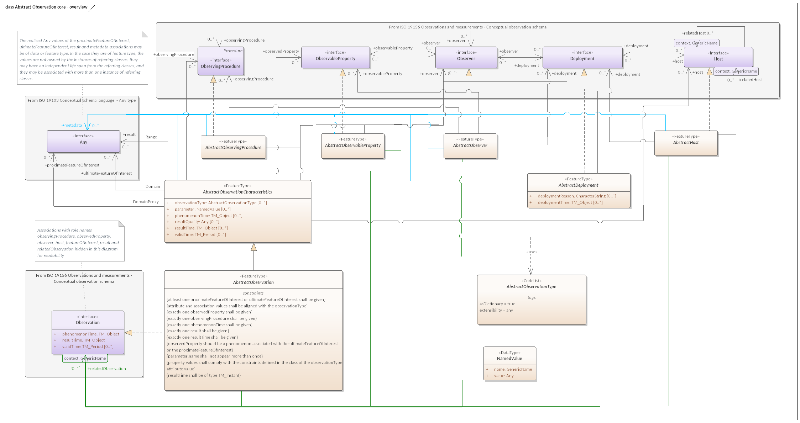

Figure 1 — Abstract Observation core — overview

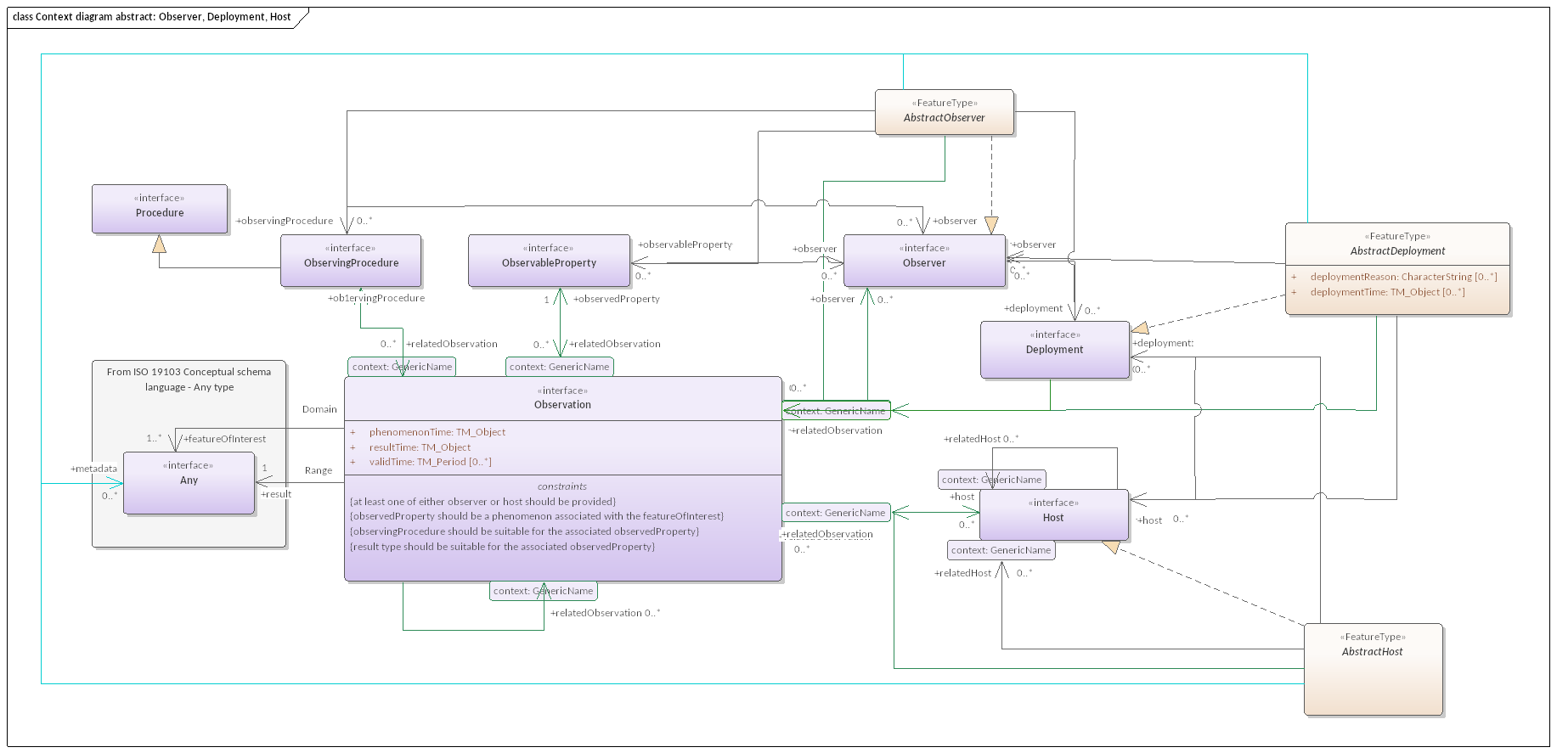

Figure 2 — Context diagram abstract: Observer, Deployment, Host

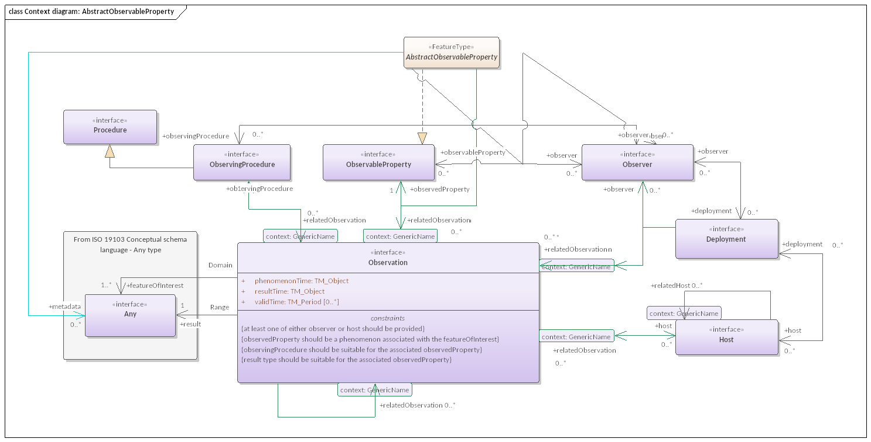

Figure 3 — Context diagram: AbstractObservableProperty

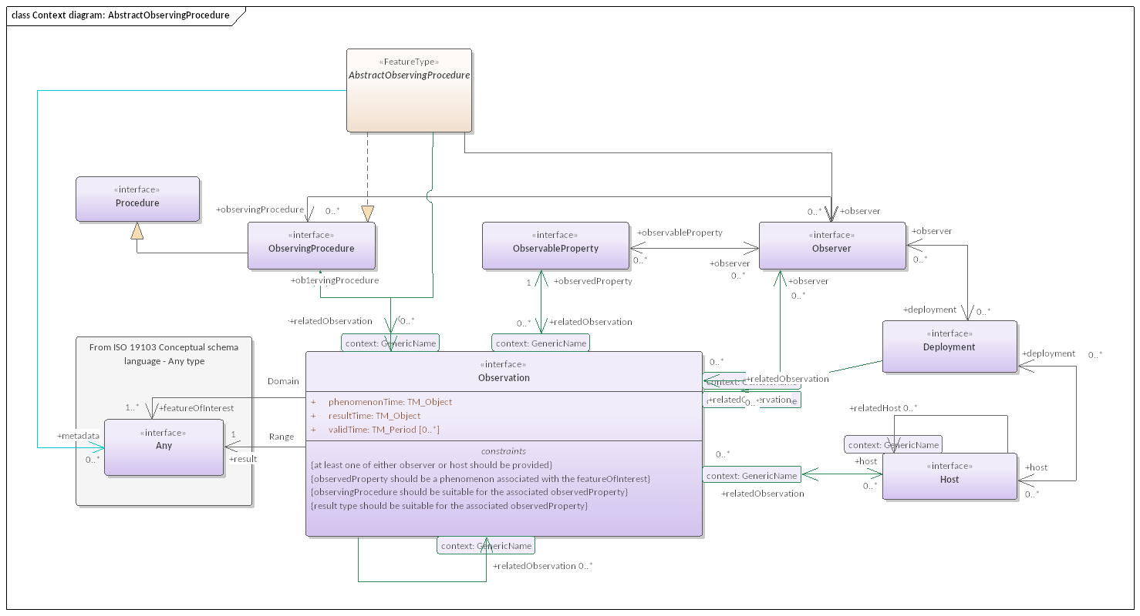

Figure 4 — Context diagram: AbstractObservingProcedure

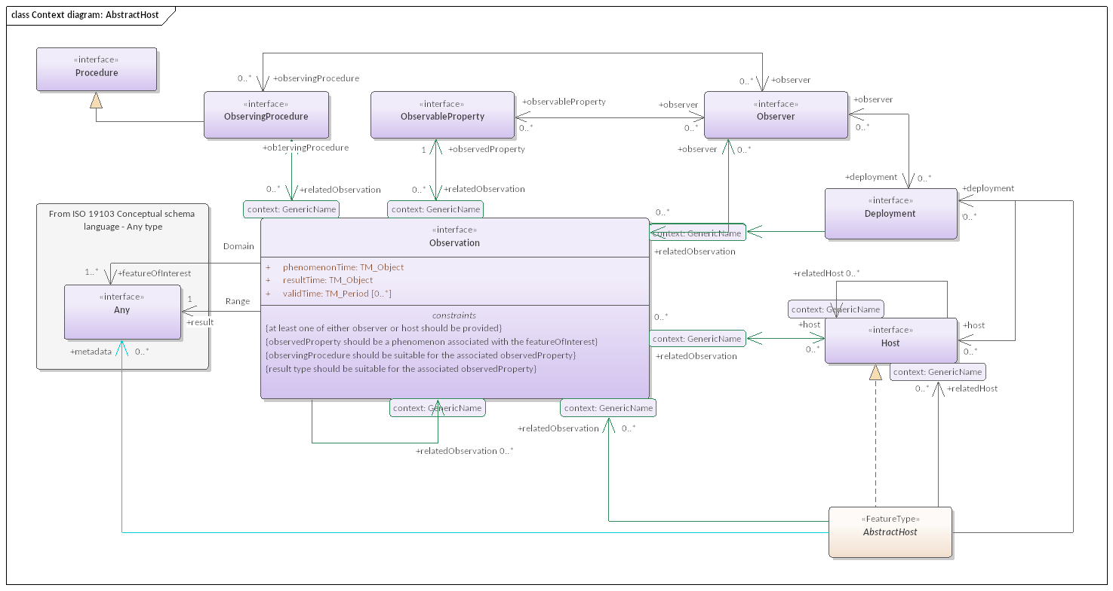

Figure 5 — Context diagram: AbstractHost

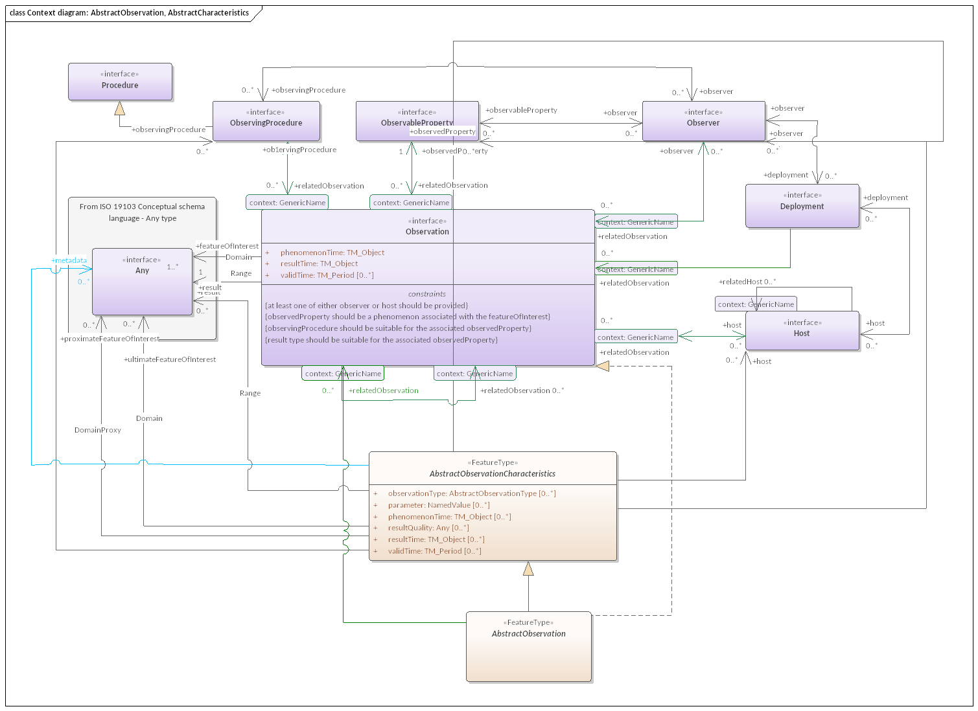

Figure 6 — Context diagram: AbstractObservation, AbstractCharacteristics

## 5.2 Defining tables

Table 1 — Elements of “Abstract Observation core::AbstractHost” (class)

|  |  |  |  |  |
| --- | --- | --- | --- | --- |
| **Name:** | AbstractHost | | | |
| **Definition:** | A FeatureType realization of Conceptual Observation Schema:Host | | | |
| **Stereotype:** | FeatureType | | | |
| **Generalization of:** | Host | | | |
| **Abstract:** | True | | | |
| **Associations:** | *Association with* | *Obligation* | *Maximum occurrence* | *Provides* |
| Any | C | * | metadata |
| Deployment | C | * | deployment |
| Host | C | * | relatedHost |
| Observation | C | * | relatedObservation |
| Host | C | * | host |
| **Public attributes:** | (none) | | | |
| **Constraints:** | (none) | | | |

Table 2 — Elements of “Abstract Observation core::AbstractObservableProperty” (class)

|  |  |  |  |  |
| --- | --- | --- | --- | --- |
| **Name:** | AbstractObservableProperty | | | |
| **Definition:** | A FeatureType realization of Conceptual Observation Schema:ObservableProperty intended as a parent class for all ObservableProperty realizations based on General Feature Model as defined in ISO 19109 | | | |
| **Stereotype:** | FeatureType | | | |
| **Generalization of:** | ObservableProperty | | | |
| **Abstract:** | True | | | |
| **Associations:** | *Association with* | *Obligation* | *Maximum occurrence* | *Provides* |
| Observer | C | * | observer |
| Any | C | * | metadata |
| ObservableProperty | C | * | observedProperty |
| Observation | C | * | relatedObservation |
| **Public attributes:** | (none) | | | |
| **Constraints:** | (none) | | | |

Table 3 — Elements of “Abstract Observation core::AbstractObservation” (class)

|  |  |  |  |  |
| --- | --- | --- | --- | --- |
| **Name:** | AbstractObservation | | | |
| **Definition:** | A FeatureType realization of Conceptual Observation Schema:Observation intended as a parent class for all Observation realizations based on General Feature Model as defined in ISO 19109 | | | |
| **Stereotype:** | FeatureType | | | |
| **Inheritance from:** | AbstractObservationCharacteristics | | | |
| **Generalization of:** | Observation | | | |
| **Abstract:** | True | | | |
| **Associations:** | *Association with* | *Obligation* | *Maximum occurrence* | *Provides* |
| Observation | C | * | relatedObservation |
| Observation | C | * | relatedObservation |
| **Public attributes:** | (none) | | | |
| **Constraints:** | at least one proximateFeatureOfInterest or ultimateFeatureOfInterest shall be given | | | |
| attribute and association values shall be aligned with the observationType | | | |
| exactly one observedProperty shall be given | | | |
| exactly one observingProcedure shall be given | | | |
| exactly one phenomenonTime shall be given | | | |
| exactly one result shall be given | | | |
| exactly one resultTime shall be given | | | |
| observedProperty should be a phenomenon associated with the ultimateFeatureOfInterest or the proximateFeatureOfInterest | | | |
| parameter.name shall not appear more than once | | | |
| property values shall comply with the constraints defined in the class of the observationType attribute value | | | |
| resultTime shall be of type TM_Instant | | | |

Table 4 — Elements of “Abstract Observation core::AbstractObservationCharacteristics” (class)

|  |  |  |  |  |  |  |
| --- | --- | --- | --- | --- | --- | --- |
| **Name:** | AbstractObservationCharacteristics | | | | | |
| **Definition:** | set of common characteristics used for describing an Observation or a collection of Observations. | | | | | |
| **Stereotype:** | FeatureType | | | | | |
| **Generalization of:** | AbstractObservation, ObservationCharacteristics | | | | | |
| **Abstract:** | True | | | | | |
| **Associations:** | *Association with* | | | *Obligation* | *Maximum occurrence* | *Provides* |
| Any | | | C | * | proximateFeatureOfInterest |
| Host | | | C | * | host |
| Any | | | C | * | metadata |
| Any | | | C | * | ultimateFeatureOfInterest |
| ObservingProcedure | | | C | * | observingProcedure |
| ObservableProperty | | | C | * | observedProperty |
| Observer | | | C | * | observer |
| Any | | | C | * | result |
| **Public attributes:** | *Name* | *Definition* | *Derived* | *Obligation* | *Maximum occurrence* | *Data type* |
| observationType | Information providing further detail on the type of Observations being described. |  | C | * | AbstractObservationType |
| parameter | arbitrary event-specific parameter relevant to one or more Observations. NOTE This might be an environmental parameter, an instrument setting or input, or an event-specific sampling parameter that is not tightly bound to either the feature-of-interest or to the observation procedure. NOTE Parameters that are tightly bound to the procedure can be recorded as part of the procedure description. The AbstractObservingProcedure is a generic or standard procedure, rather than an event-specific process. In this context, parameters bound to the observation act, such as instrument settings, calibrations or inputs, local position, detection limits, asset identifier, operator, may augment the description of a standard procedure. EXAMPLE A time sequence of observations of water quality in a well might be made at variable depths within the well. While these can be associated with specimens taken from the well at this depth as the features-of-interest, a more common approach is to identify the well itself as the feature-of-interest, and add a “samplingDepth” parameter to the observation. The sampling depth is of secondary interest compared to the temporal variation of water quality at the site. |  | C | * | NamedValue |
| phenomenonTime | time that the Result applies to the characteristic of the FeatureOfInterest being observed. NOTE 1 The phenomenonTime is often the time the Sample has been taken. NOTE 2 This is often the time of interaction by a sampling Procedure or observation Procedure with a real-world feature. NOTE 3 If the result is the average of multiple samples taken at different times, then the phenomenonTime is the time interval over which these measurements were taken. |  | C | * | TM_Object |
| resultQuality | Information pertaining to the data quality of the result |  | C | * | Any |
| resultTime | instant of time when the result of the Observation became available. EXAMPLE 1 The resultTime typically corresponds to when the Procedure associated with the Observation was completed. For some observations this is identical to the phenomenonTime. However, there are important cases where they differ. EXAMPLE 2 Where a measurement is made on a specimen in a laboratory, the phenomenonTime is the time the specimen was retrieved from its host, while the resultTime is the time the laboratory procedure was applied. EXAMPLE 3 The resultTime also supports disambiguation of repeat measurements made of the same property of a feature using the same procedure. EXAMPLE 4 Where sensor observation results are post-processed, the resultTime is the post-processing time, while the phenomenonTime is the time of initial interaction with the world. EXAMPLE 5 Simulations may be used to estimate the values for phenomena in the future or past. The phenomenonTime is the time that the result applies to, while the resultTime is the time that the simulation was executed. |  | C | * | TM_Object |
| validTime | The time interval during which the result is assumed to be applicable for use. NOTE This attribute is commonly required in forecasting applications. |  | C | * | TM_Period |
| **Constraints:** | (none) | | | | | |

Table 5 — Elements of “Abstract Observation core::AbstractObservationType” (class)

|  |  |
| --- | --- |
| **Name:** | AbstractObservationType |
| **Definition:** | an empty codelist parent class for Observation classification schemes. All codelists used for classifying Observations SHALL be specialized from this class. |
| **Stereotype:** | CodeList |
| **Generalization of:** | ObservationTypeByResultType |
| **Abstract:** | True |
| **Associations:** | (none) |
| **Public attributes:** | (none) |
| **Constraints:** | (none) |

Table 6 — Elements of “Abstract Observation core::AbstractObserver” (class)

|  |  |  |  |  |
| --- | --- | --- | --- | --- |
| **Name:** | AbstractObserver | | | |
| **Definition:** | A FeatureType realization of Conceptual Observation Schema:Observer intended as a parent class for all Observer realizations based on General Feature Model as defined in ISO 19109 | | | |
| **Stereotype:** | FeatureType | | | |
| **Generalization of:** | Observer | | | |
| **Abstract:** | True | | | |
| **Associations:** | *Association with* | *Obligation* | *Maximum occurrence* | *Provides* |
| Any | C | * | metadata |
| Observer | C | * | observer |
| ObservingProcedure | C | * | observingProcedure |
| ObservableProperty | C | * | observableProperty |
| Deployment | C | * | deployment |
| Observation | C | * | relatedObservation |
| **Public attributes:** | (none) | | | |
| **Constraints:** | (none) | | | |

Table 7 — Elements of “Abstract Observation core::AbstractObservingProcedure” (class)

|  |  |  |  |  |
| --- | --- | --- | --- | --- |
| **Name:** | AbstractObservingProcedure | | | |
| **Definition:** | A FeatureType realization of Conceptual Observation Schema:ObservingProcedure intended as a parent class for all :ObservingProcedure realizations based on General Feature Model as defined in ISO 19109 | | | |
| **Stereotype:** | FeatureType | | | |
| **Generalization of:** | ObservingProcedure | | | |
| **Abstract:** | True | | | |
| **Associations:** | *Association with* | *Obligation* | *Maximum occurrence* | *Provides* |
| Observation | C | * | relatedObservation |
| Observer | C | * | observer |
| Any | C | * | metadata |
| ObservingProcedure | C | * | observingProcedure |
| **Public attributes:** | (none) | | | |
| **Constraints:** | (none) | | | |

Table 8 — Elements of “Abstract Observation core::NamedValue” (class)

|  |  |  |  |  |  |  |
| --- | --- | --- | --- | --- | --- | --- |
| **Name:** | NamedValue | | | | | |
| **Definition:** | The class *NamedValue* provides for a generic soft-typed parameter value. NamedValue shall support two attributes. | | | | | |
| **Stereotype:** | DataType | | | | | |
| **Abstract:** | True | | | | | |
| **Associations:** | (none) | | | | | |
| **Public attributes:** | *Name* | *Definition* | *Derived* | *Obligation* | *Maximum occurrence* | *Data type* |
| name | the meaning of the named value. Value should be taken from a well-governed source if possible. EXAMPLES When used as the value of an Observation:;parameter, the name might take values like ‘procedureOperator’, ‘detectionLimit’, ‘amplifierGain’, ‘samplingDepth’. |  | M | 1 | GenericName |
| value | the value of the parameter. The type Any should be substituted by a suitable concrete type, such as CI_ResponsibleParty or Measure. |  | M | 1 | Any |
| **Constraints:** | (none) | | | | | |

Table 9 — Elements of “Abstract Observation core::From ISO 19103 Conceptual schema language  — Any type” (class)

|  |  |
| --- | --- |
| **Name:** | From ISO 19103 Conceptual schema language  — Any type |
| **Definition:** |  |
| **Stereotype:** | interface |
| **Abstract:** | False |
| **Associations:** | (none) |
| **Public attributes:** | (none) |
| **Constraints:** | (none) |

Table 10 — Elements of “Abstract Observation core::From ISO 19156 Observations and measurements — Conceptual observation schema” (class)

|  |  |
| --- | --- |
| **Name:** | From ISO 19156 Observations and measurements — Conceptual observation schema |
| **Definition:** |  |
| **Stereotype:** | interface |
| **Abstract:** | False |
| **Associations:** | (none) |
| **Public attributes:** | (none) |
| **Constraints:** | (none) |

Table 11 — Elements of “Abstract Observation core::From ISO 19103 Conceptual schema language — Any type” (class)

|  |  |
| --- | --- |
| **Name:** | From ISO 19103 Conceptual schema language — Any type |
| **Definition:** |  |
| **Stereotype:** | interface |
| **Abstract:** | False |
| **Associations:** | (none) |
| **Public attributes:** | (none) |
| **Constraints:** | (none) |

Table 12 — Elements of “Abstract Observation core::From ISO 19103 Conceptual schema language — Any type” (class)

|  |  |
| --- | --- |
| **Name:** | From ISO 19103 Conceptual schema language — Any type |
| **Definition:** |  |
| **Stereotype:** | interface |
| **Abstract:** | False |
| **Associations:** | (none) |
| **Public attributes:** | (none) |
| **Constraints:** | (none) |

Table 13 — Elements of “Abstract Observation core::From ISO 19103 Conceptual schema language — Any type” (class)

|  |  |
| --- | --- |
| **Name:** | From ISO 19103 Conceptual schema language — Any type |
| **Definition:** |  |
| **Stereotype:** | interface |
| **Abstract:** | False |
| **Associations:** | (none) |
| **Public attributes:** | (none) |
| **Constraints:** | (none) |

Table 14 — Elements of “Abstract Observation core::From ISO 19156 Observations and measurements — Conceptual observation schema” (class)

|  |  |
| --- | --- |
| **Name:** | From ISO 19156 Observations and measurements — Conceptual observation schema |
| **Definition:** |  |
| **Stereotype:** | interface |
| **Abstract:** | False |
| **Associations:** | (none) |
| **Public attributes:** | (none) |
| **Constraints:** | (none) |

Table 15 — Elements of “Abstract Observation core::From ISO 19103 Conceptual schema language — Any type” (class)

|  |  |
| --- | --- |
| **Name:** | From ISO 19103 Conceptual schema language — Any type |
| **Definition:** |  |
| **Stereotype:** | interface |
| **Abstract:** | False |
| **Associations:** | (none) |
| **Public attributes:** | (none) |
| **Constraints:** | (none) |

# 6 Abstract Sample core package

## 6.1 Abstract Sample core overview

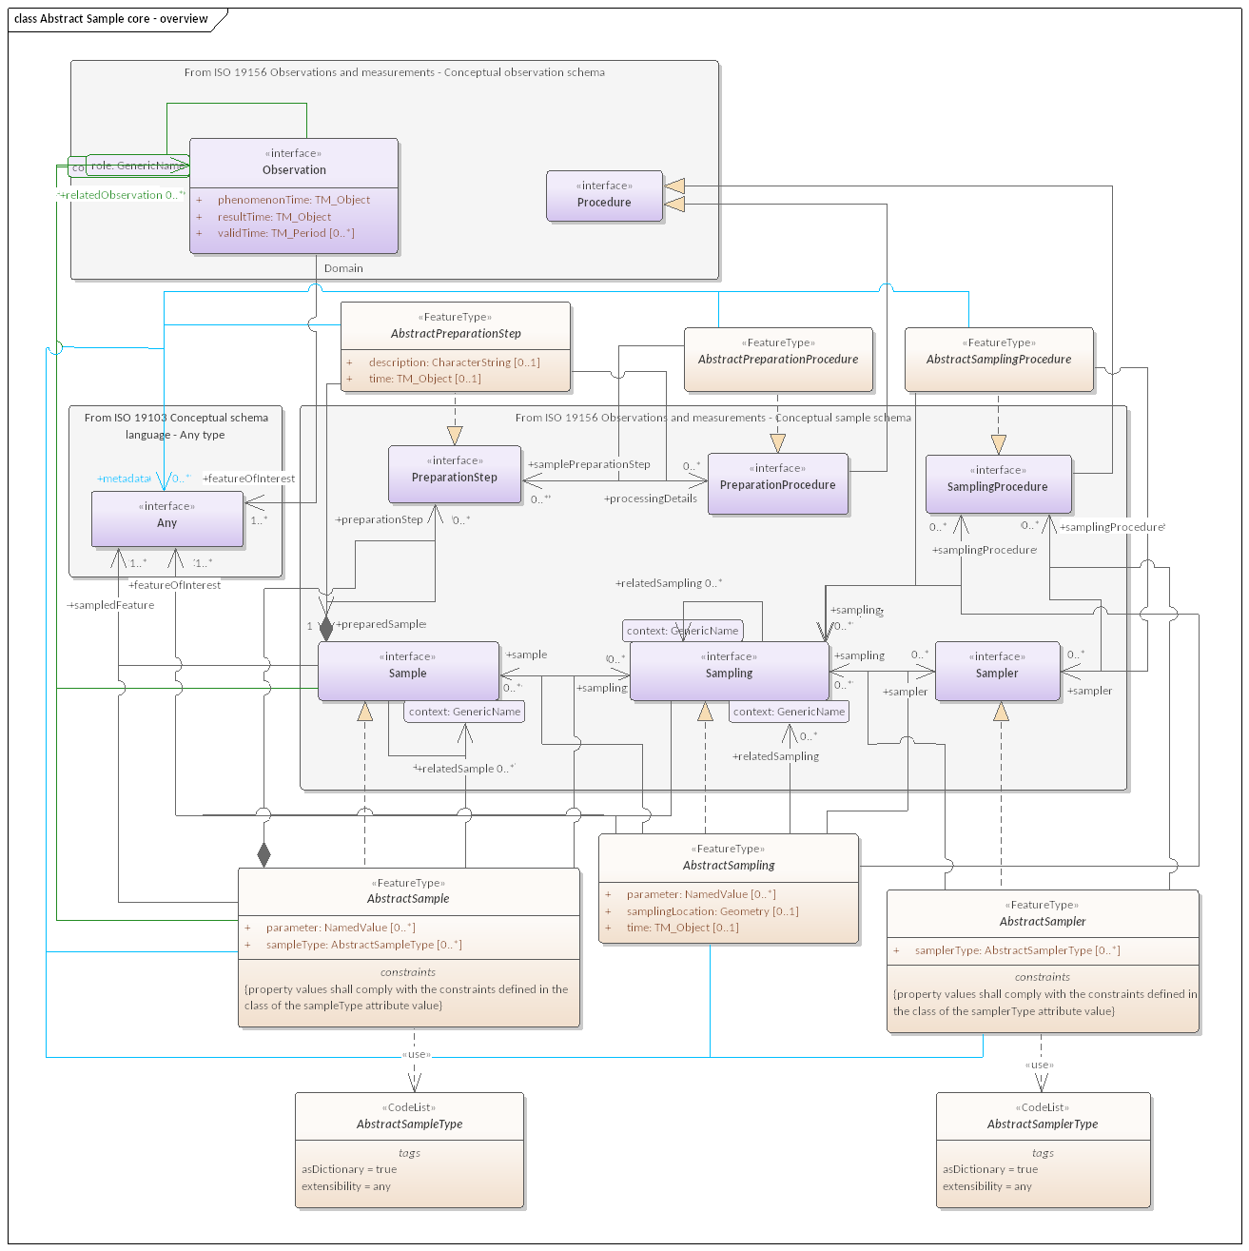

Figure 7 — Abstract Sample core — overview

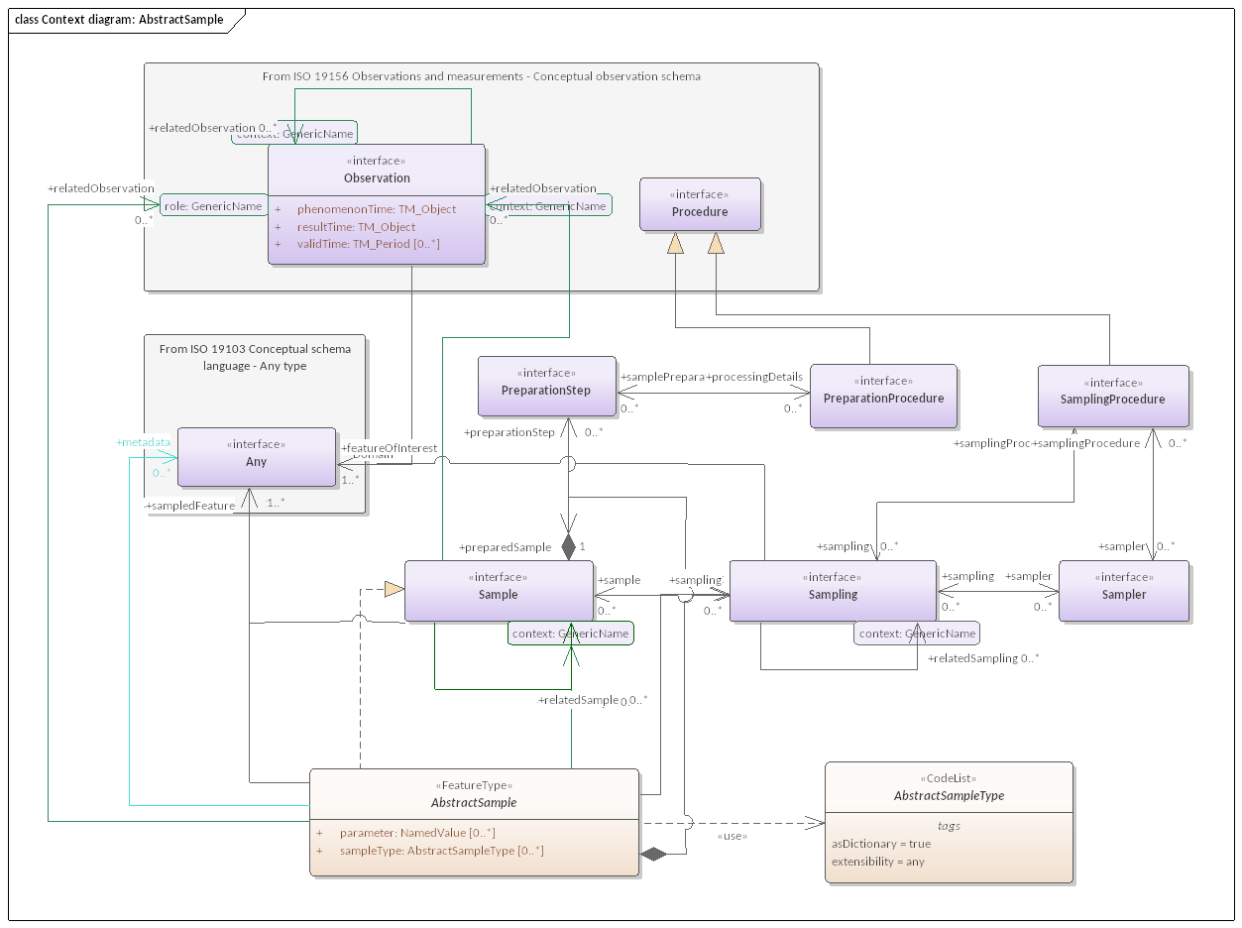

Figure 8 — Context diagram: AbstractSample

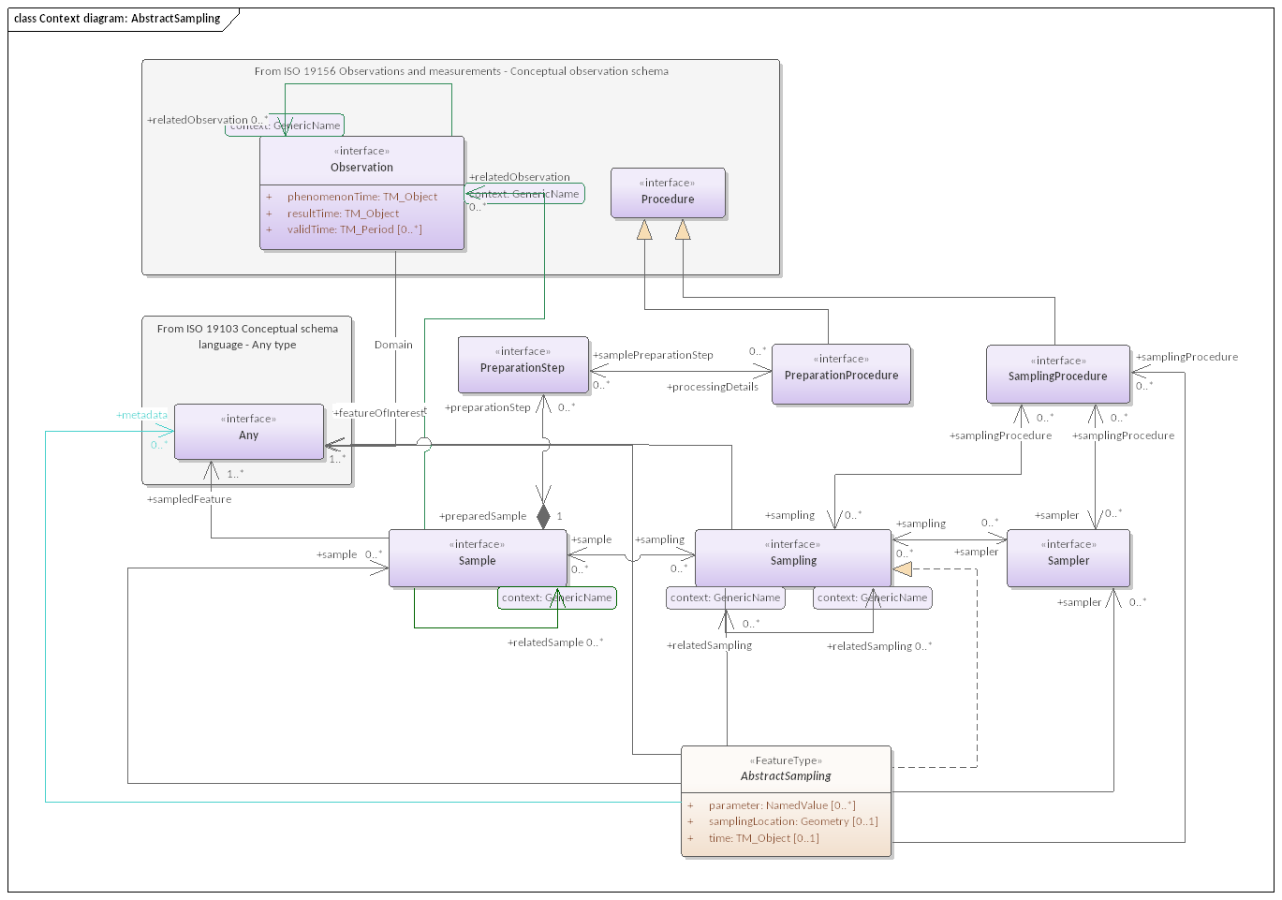

Figure 9 — Context diagram: AbstractSampling

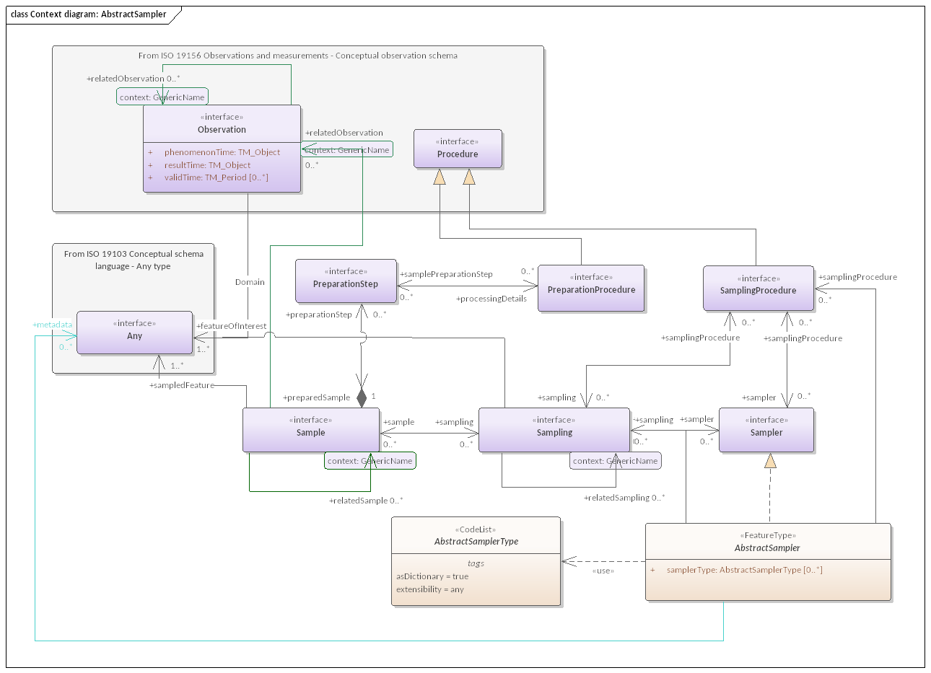

Figure 10 — Context diagram: AbstractSampler

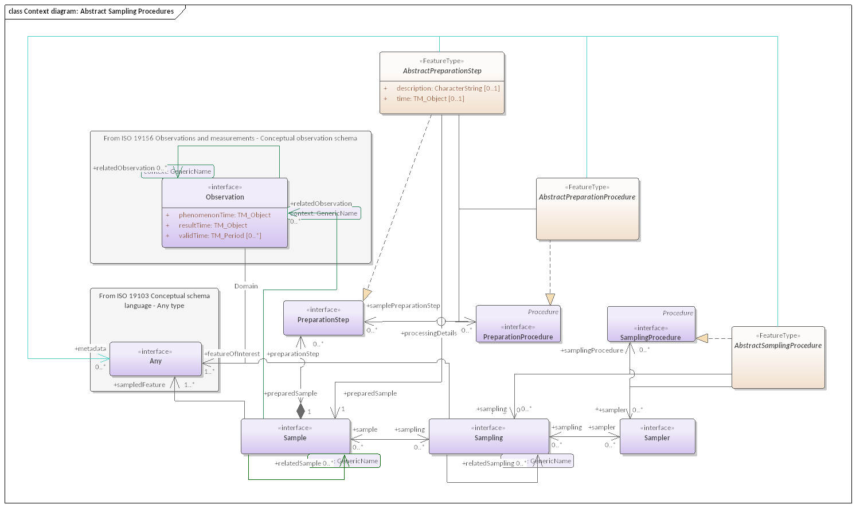

Figure 11 — Context diagram: Abstract Sampling Procedures

## 6.2 Defining tables

Table 16 — Elements of “Abstract Sample core::AbstractPreparationProcedure” (class)

|  |  |  |  |  |
| --- | --- | --- | --- | --- |
| **Name:** | AbstractPreparationProcedure | | | |
| **Definition:** | A FeatureType realization of Conceptual Sample Schema:PreparationProcedure intended as a parent class for all PreparationProcedure realizations based on General Feature Model as defined in ISO 19109 | | | |
| **Stereotype:** | FeatureType | | | |
| **Generalization of:** | PreparationProcedure | | | |
| **Abstract:** | True | | | |
| **Associations:** | *Association with* | *Obligation* | *Maximum occurrence* | *Provides* |
| Any | C | * | metadata |
| PreparationStep | C | * | samplePreparationStep |
| PreparationProcedure | C | * | processingDetails |
| **Public attributes:** | (none) | | | |
| **Constraints:** | (none) | | | |

Table 17 — Elements of “Abstract Sample core::AbstractSample” (class)

|  |  |  |  |  |  |  |
| --- | --- | --- | --- | --- | --- | --- |
| **Name:** | AbstractSample | | | | | |
| **Definition:** | A FeatureType realization of Conceptual Sample Schema:Sample intended as a parent class for all Sample realizations based on General Feature Model as defined in ISO 19109 | | | | | |
| **Stereotype:** | FeatureType | | | | | |
| **Generalization of:** | Sample | | | | | |
| **Abstract:** | True | | | | | |
| **Associations:** | *Association with* | | | *Obligation* | *Maximum occurrence* | *Provides* |
| PreparationStep | | | C | * | preparationStep |
| Observation | | | C | * | relatedObservation |
| Sampling | | | C | * | sampling |
| Any | | | C | * | metadata |
| Any | | | M | * | sampledFeature |
| Sample | | | M | 1 | preparedSample |
| Sample | | | C | * | relatedSample |
| **Public attributes:** | *Name* | *Definition* | *Derived* | *Obligation* | *Maximum occurrence* | *Data type* |
| parameter | arbitrary event-specific parameter relevant to the **Sample** |  | C | * | NamedValue |
| sampleType | type of **Sample** according to a community agreed typology. |  | C | * | AbstractSampleType |
| **Constraints:** | property values shall comply with the constraints defined in the class of the sampleType attribute value | | | | | |

Table 18 — Elements of “Abstract Sample core::AbstractSampler” (class)

|  |  |  |  |  |  |  |
| --- | --- | --- | --- | --- | --- | --- |
| **Name:** | AbstractSampler | | | | | |
| **Definition:** | A FeatureType realization of Conceptual Sample Schema:Sampler intended as a parent class for all Sampler realizations based on General Feature Model as defined in ISO 19109 | | | | | |
| **Stereotype:** | FeatureType | | | | | |
| **Generalization of:** | Sampler | | | | | |
| **Abstract:** | True | | | | | |
| **Associations:** | *Association with* | | | *Obligation* | *Maximum occurrence* | *Provides* |
| SamplingProcedure | | | C | * | samplingProcedure |
| Sampler | | | C | * | sampler |
| Any | | | C | * | metadata |
| Sampling | | | C | * | sampling |
| **Public attributes:** | *Name* | *Definition* | *Derived* | *Obligation* | *Maximum occurrence* | *Data type* |
| samplerType | type of **Sampler** according to a community agreed typology |  | C | * | AbstractSamplerType |
| **Constraints:** | property values shall comply with the constraints defined in the class of the samplerType attribute value | | | | | |

Table 19 — Elements of “Abstract Sample core::AbstractSamplerType” (class)

|  |  |
| --- | --- |
| **Name:** | AbstractSamplerType |
| **Definition:** | an empty codelist parent class for Sampler classification schemes. All codelists used for classifying Samplers SHALL be specialized from this class. |
| **Stereotype:** | CodeList |
| **Generalization of:** | SamplerClassification |
| **Abstract:** | True |
| **Associations:** | (none) |
| **Public attributes:** | (none) |
| **Constraints:** | (none) |

Table 20 — Elements of “Abstract Sample core::AbstractSampleType” (class)

|  |  |
| --- | --- |
| **Name:** | AbstractSampleType |
| **Definition:** | an empty codelist parent class for Sample classification schemes. All codelists used for classifying Samples SHALL be specialized from this class. |
| **Stereotype:** | CodeList |
| **Generalization of:** | SampleTypeByGeometryType, SampleTypeByMaterialClass |
| **Abstract:** | True |
| **Associations:** | (none) |
| **Public attributes:** | (none) |
| **Constraints:** | (none) |

Table 21 — Elements of “Abstract Sample core::AbstractSampling” (class)

|  |  |  |  |  |  |  |
| --- | --- | --- | --- | --- | --- | --- |
| **Name:** | AbstractSampling | | | | | |
| **Definition:** | A FeatureType realization of Conceptual Sample Schema:Sampling intended as a parent class for all Sampling realizations based on General Feature Model as defined in ISO 19109 | | | | | |
| **Stereotype:** | FeatureType | | | | | |
| **Generalization of:** | Sampling | | | | | |
| **Abstract:** | True | | | | | |
| **Associations:** | *Association with* | | | *Obligation* | *Maximum occurrence* | *Provides* |
| SamplingProcedure | | | C | * | samplingProcedure |
| Any | | | C | * | metadata |
| Sampler | | | C | * | sampler |
| Sampling | | | C | * | relatedSampling |
| Sampling | | | C | * | sampling |
| Any | | | M | * | featureOfInterest |
| Sample | | | C | * | sample |
| **Public attributes:** | *Name* | *Definition* | *Derived* | *Obligation* | *Maximum occurrence* | *Data type* |
| parameter | arbitrary event-specific parameter relevant to the **Sampling** |  | C | * | NamedValue |
| samplingLocation | location information pertaining to the **Sampling** |  | C | 1 | Geometry |
| time | time of the **Sampling** |  | C | 1 | TM_Object |
| **Constraints:** | (none) | | | | | |

Table 22 — Elements of “Abstract Sample core::AbstractSamplingProcedure” (class)

|  |  |  |  |  |
| --- | --- | --- | --- | --- |
| **Name:** | AbstractSamplingProcedure | | | |
| **Definition:** | A FeatureType realization of Conceptual Sample Schema:SamplingProcedure intended as a parent class for all SamplingProcedure realizations based on General Feature Model as defined in ISO 19109 | | | |
| **Stereotype:** | FeatureType | | | |
| **Generalization of:** | SamplingProcedure | | | |
| **Abstract:** | True | | | |
| **Associations:** | *Association with* | *Obligation* | *Maximum occurrence* | *Provides* |
| Any | C | * | metadata |
| SamplingProcedure | C | * | samplingProcedure |
| Sampling | C | * | sampling |
| Sampler | C | * | sampler |
| **Public attributes:** | (none) | | | |
| **Constraints:** | (none) | | | |

Table 23 — Elements of “Abstract Sample core::From ISO 19156 Observations and measurements — Conceptual sample schema” (class)

|  |  |
| --- | --- |
| **Name:** | From ISO 19156 Observations and measurements — Conceptual sample schema |
| **Definition:** |  |
| **Stereotype:** | interface |
| **Abstract:** | False |
| **Associations:** | (none) |
| **Public attributes:** | (none) |
| **Constraints:** | (none) |

# 7 Basic Observations package

## 7.1 Basic Observations overview

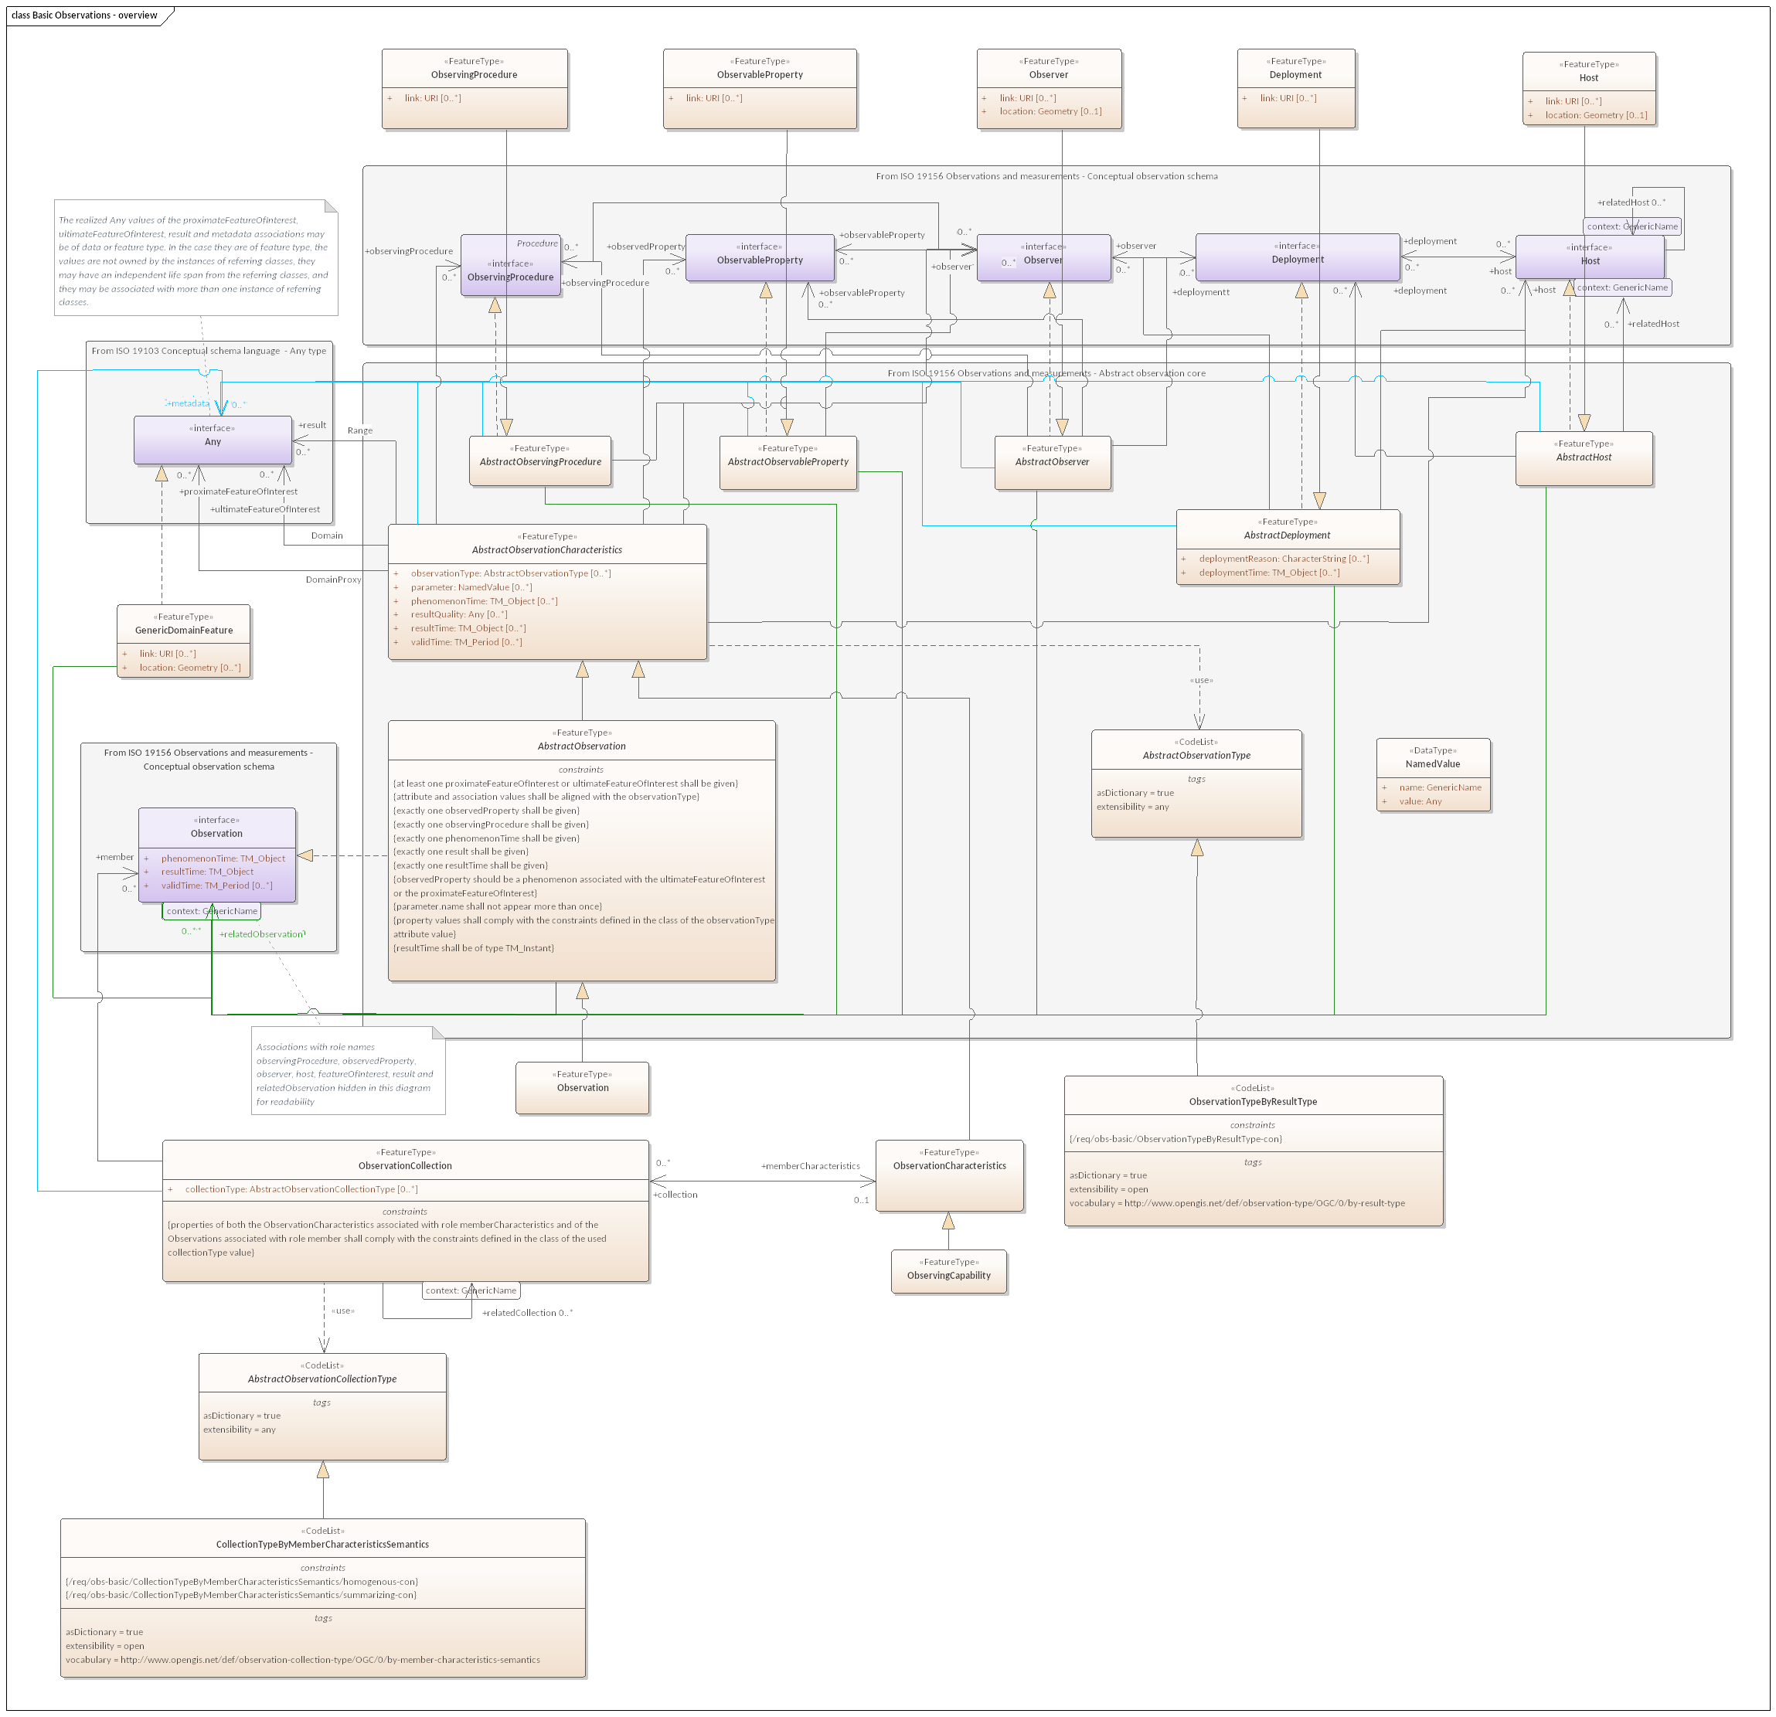

Figure 12 — Basic Observations — overview

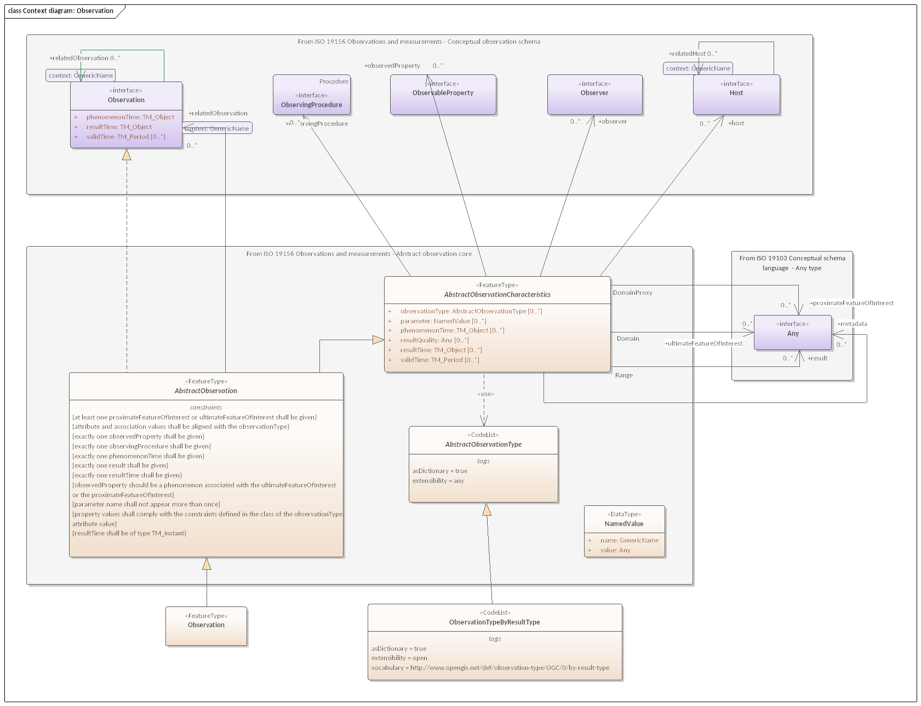

Figure 13 — Context diagram: Observation

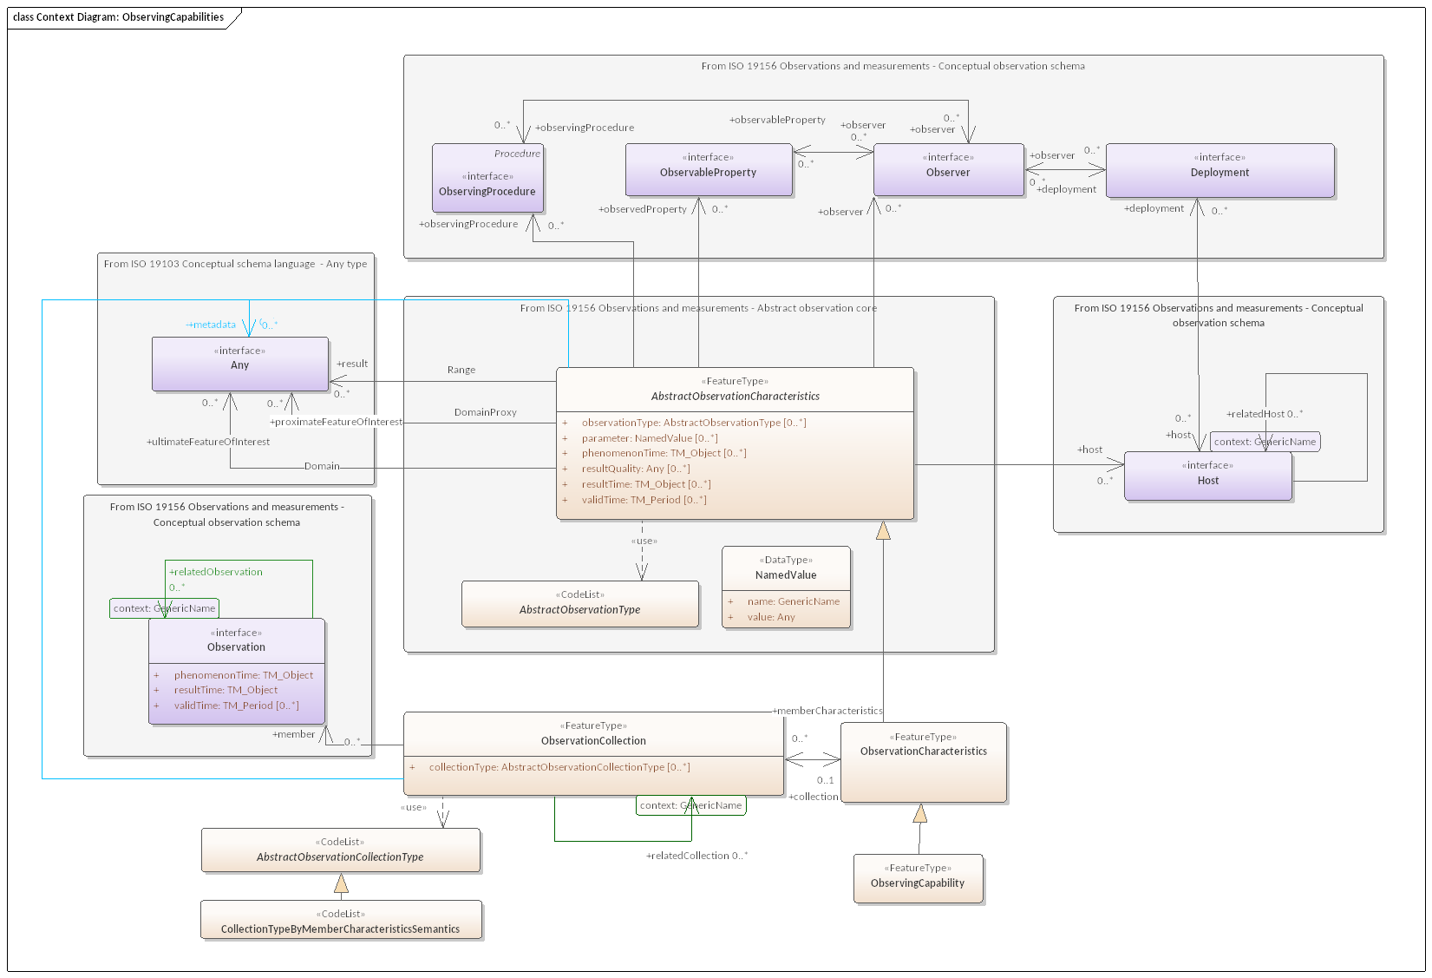

Figure 14 — Context Diagram: ObservingCapabilities

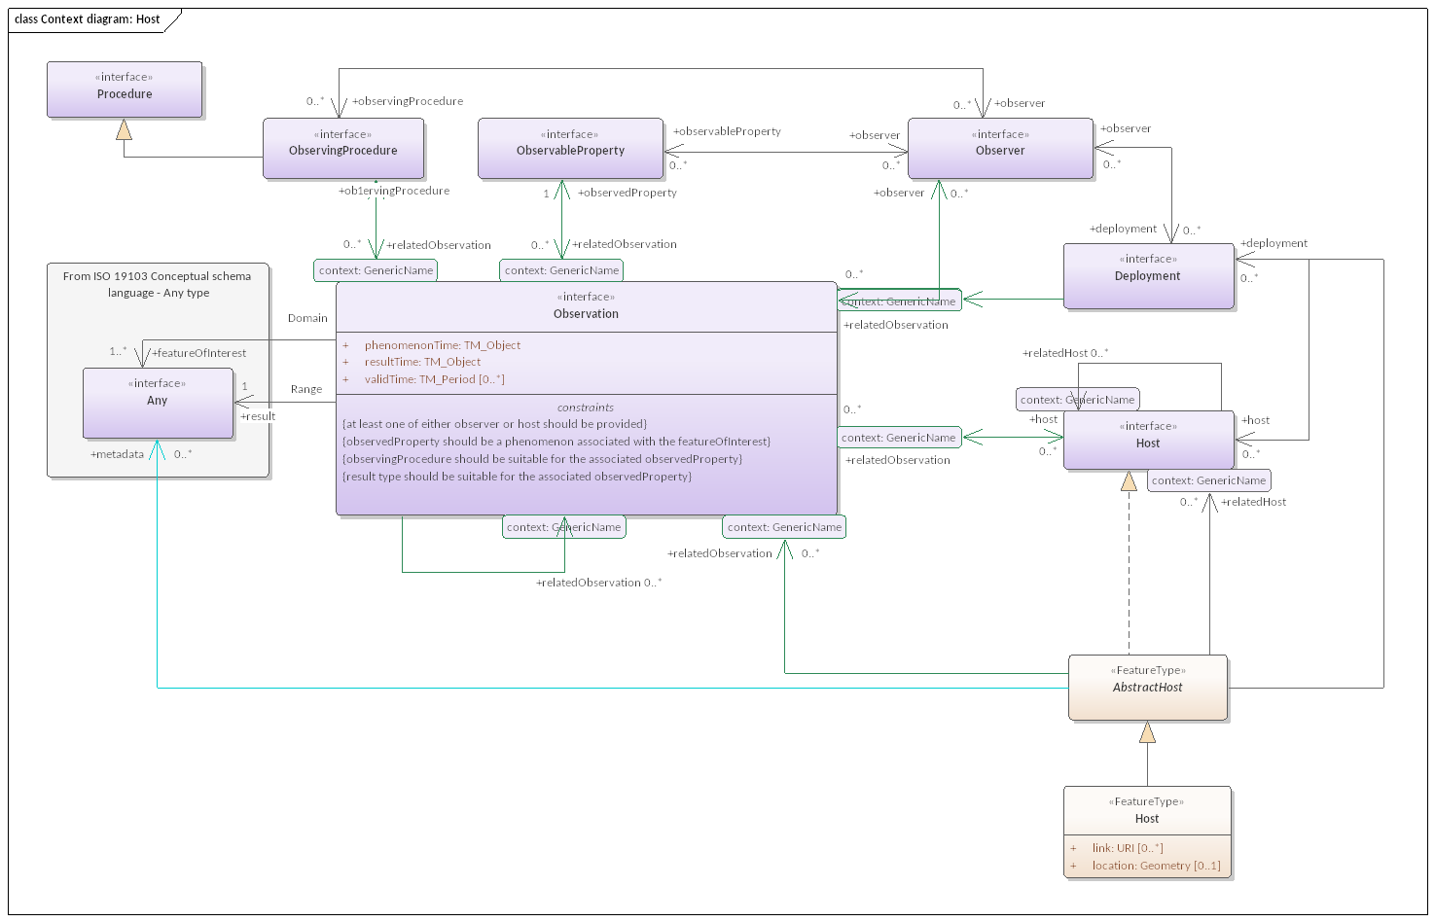

Figure 15 — Context diagram: Host

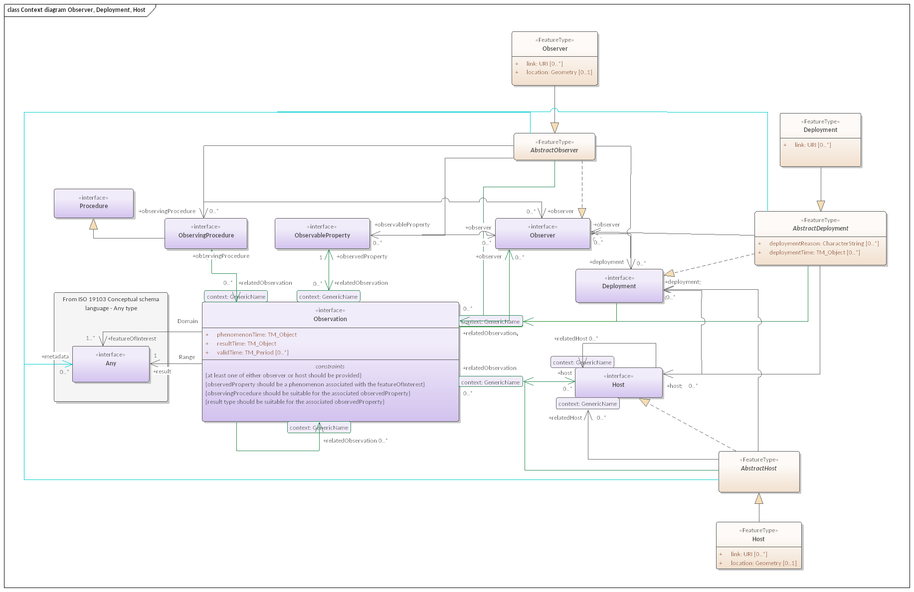

Figure 16 — Context diagram Observer, Deployment, Host

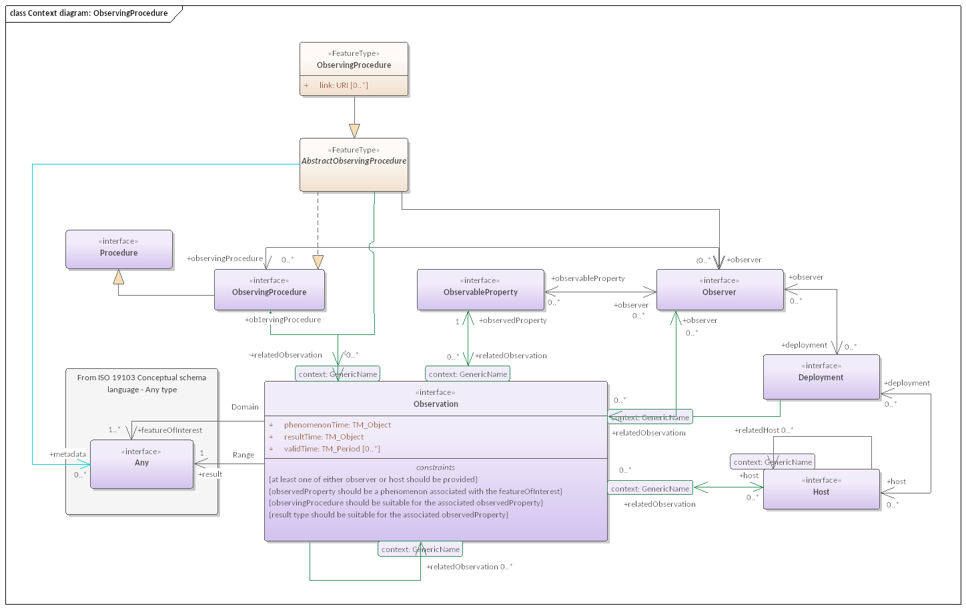

Figure 17 — Context diagram: ObservingProcedure

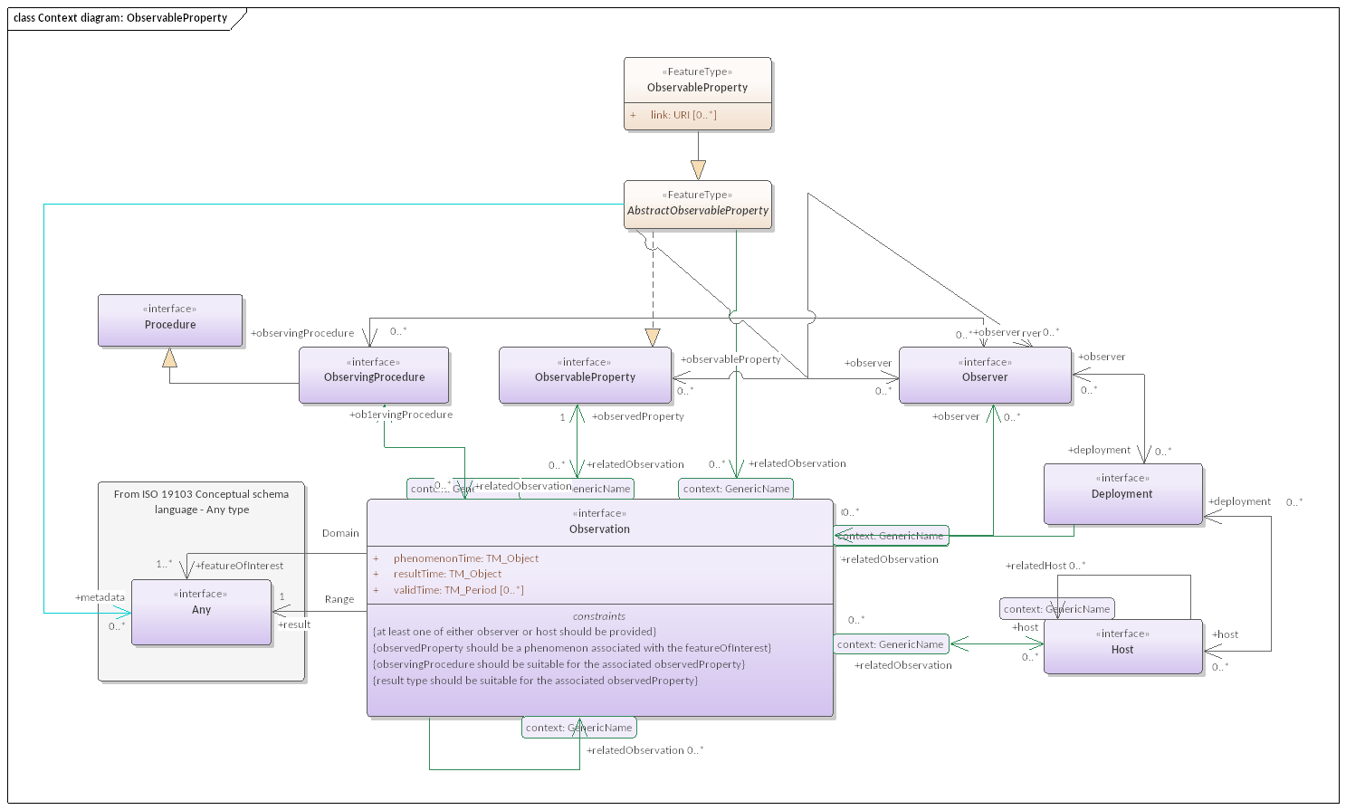

Figure 18 — Context diagram: ObservableProperty

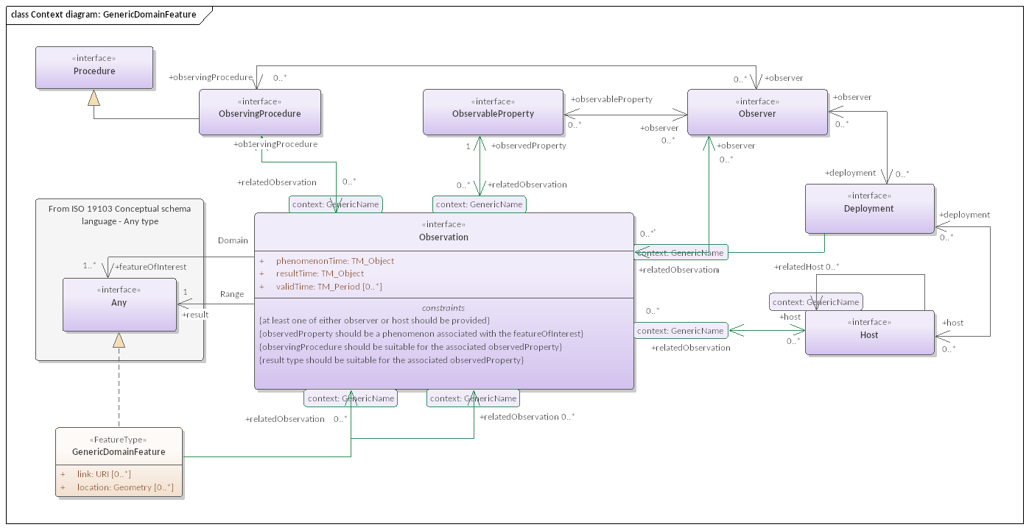

Figure 19 — Context diagram: GenericDomainFeature

## 7.2 Defining tables

Table 24 — Elements of “Basic Observations::AbstractObservationCollectionType” (class)

|  |  |  |  |  |
| --- | --- | --- | --- | --- |
| **Name:** | AbstractObservationCollectionType | | | |
| **Definition:** | an empty codelist parent class for ObservationCollection classification schemes. All codelists used for classifying ObservationCollections SHALL be specialized from this class. | | | |
| **Stereotype:** | CodeList | | | |
| **Generalization of:** | CollectionTypeByMemberCharacteristicsSemantics | | | |
| **Abstract:** | True | | | |
| **Associations:** | *Association with* | *Obligation* | *Maximum occurrence* | *Provides* |
| ObservationCollection | C | * | collection |
| **Public attributes:** | (none) | | | |
| **Constraints:** | (none) | | | |

Table 25 — Elements of “Basic Observations::CollectionTypeByMemberCharacteristicsSemantics” (class)

|  |  |
| --- | --- |
| **Name:** | CollectionTypeByMemberCharacteristicsSemantics |
| **Definition:** | ObservationCollection classification scheme based on how the properties of the ObservationCharacteristics associated with role memberCharacteristics shall be related to the corresponding properties of the Observations associated with role member |
| **Stereotype:** | CodeList |
| **Inheritance from:** | AbstractObservationCollectionType |
| **Abstract:** | True |
| **Associations:** | (none) |
| **Public attributes:** | (none) |
| **Constraints:** | /req/obs-basic/CollectionTypeByMemberCharacteristicsSemantics/homogenous-con |
| /req/obs-basic/CollectionTypeByMemberCharacteristicsSemantics/summarizing-con |

Table 26 — Elements of “Basic Observations::Deployment” (class)

|  |  |  |  |  |  |  |
| --- | --- | --- | --- | --- | --- | --- |
| **Name:** | Deployment | | | | | |
| **Definition:** | Concrete class for expressing a realization of Conceptual Observation Schema:Deployment interface based on General Feature Model as defined in ISO 19109 | | | | | |
| **Stereotype:** | FeatureType | | | | | |
| **Inheritance from:** | AbstractDeployment | | | | | |
| **Abstract:** | True | | | | | |
| **Associations:** | (none) | | | | | |
| **Public attributes:** | *Name* | *Definition* | *Derived* | *Obligation* | *Maximum occurrence* | *Data type* |
| link | Additional descriptive resources pertaining to a feature. |  | C | * | URI |
| **Constraints:** | (none) | | | | | |

Table 27 — Elements of “Basic Observations::GenericDomainFeature” (class)

|  |  |  |  |  |  |  |
| --- | --- | --- | --- | --- | --- | --- |
| **Name:** | GenericDomainFeature | | | | | |
| **Definition:** | A concrete featureType to be utilized as **featureOfInterest** of an *Observation.*NOTE: This type is foreseen as a placeholder for specialized domain features in order to enable rapid prototyping. | | | | | |
| **Stereotype:** | FeatureType | | | | | |
| **Abstract:** | True | | | | | |
| **Associations:** | *Association with* | | | *Obligation* | *Maximum occurrence* | *Provides* |
| Any | | | C | * | metadata |
| Observation | | | C | * | relatedObservation |
| **Public attributes:** | *Name* | *Definition* | *Derived* | *Obligation* | *Maximum occurrence* | *Data type* |
| link | Additional descriptive resources pertaining to a feature. |  | C | * | URI |
| location | Location information pertaining to a feature*.* |  | C | * | Geometry |
| **Constraints:** | (none) | | | | | |

Table 28 — Elements of “Basic Observations::Host” (class)

|  |  |  |  |  |  |  |
| --- | --- | --- | --- | --- | --- | --- |
| **Name:** | Host | | | | | |
| **Definition:** | Concrete class for expressing a realization of Conceptual Observation Schema:Host interface based on General Feature Model as defined in ISO 19109 | | | | | |
| **Stereotype:** | FeatureType | | | | | |
| **Inheritance from:** | AbstractHost | | | | | |
| **Abstract:** | True | | | | | |
| **Associations:** | (none) | | | | | |
| **Public attributes:** | *Name* | *Definition* | *Derived* | *Obligation* | *Maximum occurrence* | *Data type* |
| link | Additional descriptive resources pertaining to a feature. |  | C | * | URI |
| location | Location information pertaining to a feature*.* |  | C | 1 | Geometry |
| **Constraints:** | (none) | | | | | |

Table 29 — Elements of “Basic Observations::ObservableProperty” (class)

|  |  |  |  |  |  |  |
| --- | --- | --- | --- | --- | --- | --- |
| **Name:** | ObservableProperty | | | | | |
| **Definition:** | Concrete class for expressing a realization of Conceptual Observation Schema:ObservableProperty interface based on General Feature Model as defined in ISO 19109 | | | | | |
| **Stereotype:** | FeatureType | | | | | |
| **Inheritance from:** | AbstractObservableProperty | | | | | |
| **Abstract:** | True | | | | | |
| **Associations:** | (none) | | | | | |
| **Public attributes:** | *Name* | *Definition* | *Derived* | *Obligation* | *Maximum occurrence* | *Data type* |
| link | Additional descriptive resources pertaining to a feature. |  | C | * | URI |
| **Constraints:** | (none) | | | | | |

Table 30 — Elements of “Basic Observations::Observation” (class)

|  |  |
| --- | --- |
| **Name:** | Observation |
| **Definition:** | Concrete class for expressing a realization of Conceptual Observation Schema:Observation interface based on General Feature Model as defined in ISO 19109 |
| **Stereotype:** | FeatureType |
| **Inheritance from:** | AbstractObservation |
| **Abstract:** | True |
| **Associations:** | (none) |
| **Public attributes:** | (none) |
| **Constraints:** | (none) |

Table 31 — Elements of “Basic Observations::ObservationCharacteristics” (class)

|  |  |  |  |  |
| --- | --- | --- | --- | --- |
| **Name:** | ObservationCharacteristics | | | |
| **Definition:** | set of common characteristics used for describing one or more Observation | | | |
| **Stereotype:** | FeatureType | | | |
| **Inheritance from:** | AbstractObservationCharacteristics | | | |
| **Generalization of:** | ObservingCapability | | | |
| **Abstract:** | True | | | |
| **Associations:** | *Association with* | *Obligation* | *Maximum occurrence* | *Provides* |
| ObservationCollection | C | * | collection |
| **Public attributes:** | (none) | | | |
| **Constraints:** | (none) | | | |

Table 32 — Elements of “Basic Observations::ObservationCollection” (class)

|  |  |  |  |  |  |  |
| --- | --- | --- | --- | --- | --- | --- |
| **Name:** | ObservationCollection | | | | | |
| **Definition:** | A collection of *Observation*s | | | | | |
| **Stereotype:** | FeatureType | | | | | |
| **Abstract:** | True | | | | | |
| **Associations:** | *Association with* | | | *Obligation* | *Maximum occurrence* | *Provides* |
| ObservationCharacteristics | | | C | 1 | memberCharacteristics |
| ObservationCollection | | | C | * | relatedCollection |
| Observation | | | C | * | member |
| Any | | | C | * | metadata |
| ObservationCollection | | | C | * | relatedCollection |
| **Public attributes:** | *Name* | *Definition* | *Derived* | *Obligation* | *Maximum occurrence* | *Data type* |
| collectionType | information on the type of the **ObservationCollection** |  | C | * | AbstractObservationCollectionType |
| **Constraints:** | properties of both the ObservationCharacteristics associated with role memberCharacteristics and of the Observations associated with role member shall comply with the constraints defined in the class of the used collectionType value | | | | | |

Table 33 — Elements of “Basic Observations::ObservationTypeByResultType” (class)

|  |  |
| --- | --- |
| **Name:** | ObservationTypeByResultType |
| **Definition:** | Observation classification scheme based on the type of its result property |
| **Stereotype:** | CodeList |
| **Inheritance from:** | AbstractObservationType |
| **Abstract:** | True |
| **Associations:** | (none) |
| **Public attributes:** | (none) |
| **Constraints:** | /req/obs-basic/ObservationTypeByResultType-con |

Table 34 — Elements of “Basic Observations::Observer” (class)

|  |  |  |  |  |  |  |
| --- | --- | --- | --- | --- | --- | --- |
| **Name:** | Observer | | | | | |
| **Definition:** | Concrete class for expressing a realization of Conceptual Observation Schema:Observer interface based on General Feature Model as defined in ISO 19109 | | | | | |
| **Stereotype:** | FeatureType | | | | | |
| **Inheritance from:** | AbstractObserver | | | | | |
| **Abstract:** | True | | | | | |
| **Associations:** | (none) | | | | | |
| **Public attributes:** | *Name* | *Definition* | *Derived* | *Obligation* | *Maximum occurrence* | *Data type* |
| link | Additional descriptive resources pertaining to a feature. |  | C | * | URI |
| location | Location information pertaining to a feature*.* |  | C | 1 | Geometry |
| **Constraints:** | (none) | | | | | |

Table 35 — Elements of “Basic Observations::ObservingCapability” (class)

|  |  |
| --- | --- |
| **Name:** | ObservingCapability |
| **Definition:** | Information on **Observation**(s) that could potentially be provided. |
| **Stereotype:** | FeatureType |
| **Inheritance from:** | ObservationCharacteristics |
| **Abstract:** | True |
| **Associations:** | (none) |
| **Public attributes:** | (none) |
| **Constraints:** | no result shall be given |
| no resultTime shall be given |

Table 36 — Elements of “Basic Observations::ObservingProcedure” (class)

|  |  |  |  |  |  |  |
| --- | --- | --- | --- | --- | --- | --- |
| **Name:** | ObservingProcedure | | | | | |
| **Definition:** | Concrete class for expressing a realization of Conceptual Observation Schema:ObservingProcedure interface based on General Feature Model as defined in ISO 19109 | | | | | |
| **Stereotype:** | FeatureType | | | | | |
| **Inheritance from:** | AbstractObservingProcedure | | | | | |
| **Abstract:** | True | | | | | |
| **Associations:** | (none) | | | | | |
| **Public attributes:** | *Name* | *Definition* | *Derived* | *Obligation* | *Maximum occurrence* | *Data type* |
| link | Additional descriptive resources pertaining to a feature. |  | C | * | URI |
| **Constraints:** | (none) | | | | | |

Table 37 — Elements of “Basic Observations::From ISO 19103 Conceptual schema language  — Any type” (class)

|  |  |
| --- | --- |
| **Name:** | From ISO 19103 Conceptual schema language  — Any type |
| **Definition:** |  |
| **Stereotype:** | interface |
| **Abstract:** | False |
| **Associations:** | (none) |
| **Public attributes:** | (none) |
| **Constraints:** | (none) |

Table 38 — Elements of “Basic Observations::From ISO 19156 Observations and measurements — Conceptual observation schema” (class)

|  |  |
| --- | --- |
| **Name:** | From ISO 19156 Observations and measurements — Conceptual observation schema |
| **Definition:** |  |
| **Stereotype:** | interface |
| **Abstract:** | False |
| **Associations:** | (none) |
| **Public attributes:** | (none) |
| **Constraints:** | (none) |

Table 39 — Elements of “Basic Observations::From ISO 19103 Conceptual schema language — Any type” (class)

|  |  |
| --- | --- |
| **Name:** | From ISO 19103 Conceptual schema language — Any type |
| **Definition:** |  |
| **Stereotype:** | interface |
| **Abstract:** | False |
| **Associations:** | (none) |
| **Public attributes:** | (none) |
| **Constraints:** | (none) |

Table 40 — Elements of “Basic Observations::From ISO 19156 Observations and measurements — Abstract observation core” (class)

|  |  |
| --- | --- |
| **Name:** | From ISO 19156 Observations and measurements — Abstract observation core |
| **Definition:** |  |
| **Stereotype:** | interface |
| **Abstract:** | False |
| **Associations:** | (none) |
| **Public attributes:** | (none) |
| **Constraints:** | (none) |

Table 41 — Elements of “Basic Observations::From ISO 19156 Observations and measurements — Conceptual observation schema” (class)

|  |  |
| --- | --- |
| **Name:** | From ISO 19156 Observations and measurements — Conceptual observation schema |
| **Definition:** |  |
| **Stereotype:** | interface |
| **Abstract:** | False |
| **Associations:** | (none) |
| **Public attributes:** | (none) |
| **Constraints:** | (none) |

Table 42 — Elements of “Basic Observations::From ISO 19156 Observations and measurements — Conceptual observation schema” (class)

|  |  |
| --- | --- |
| **Name:** | From ISO 19156 Observations and measurements — Conceptual observation schema |
| **Definition:** |  |
| **Stereotype:** | interface |
| **Abstract:** | False |
| **Associations:** | (none) |
| **Public attributes:** | (none) |
| **Constraints:** | (none) |

Table 43 — Elements of “Basic Observations::From ISO 19103 Conceptual schema language — Any type” (class)

|  |  |
| --- | --- |
| **Name:** | From ISO 19103 Conceptual schema language — Any type |
| **Definition:** |  |
| **Stereotype:** | interface |
| **Abstract:** | False |
| **Associations:** | (none) |
| **Public attributes:** | (none) |
| **Constraints:** | (none) |

Table 44 — Elements of “Basic Observations::From ISO 19103 Conceptual schema language — Any type” (class)

|  |  |
| --- | --- |
| **Name:** | From ISO 19103 Conceptual schema language — Any type |
| **Definition:** |  |
| **Stereotype:** | interface |
| **Abstract:** | False |
| **Associations:** | (none) |
| **Public attributes:** | (none) |
| **Constraints:** | (none) |

Table 45 — Elements of “Basic Observations::From ISO 19156 Observations and measurements — Abstract observation core” (class)

|  |  |
| --- | --- |
| **Name:** | From ISO 19156 Observations and measurements — Abstract observation core |
| **Definition:** |  |
| **Stereotype:** | interface |
| **Abstract:** | False |
| **Associations:** | (none) |
| **Public attributes:** | (none) |
| **Constraints:** | (none) |

Table 46 — Elements of “Basic Observations::From ISO 19156 Observations and measurements — Abstract observation core” (class)

|  |  |
| --- | --- |
| **Name:** | From ISO 19156 Observations and measurements — Abstract observation core |
| **Definition:** |  |
| **Stereotype:** | interface |
| **Abstract:** | False |
| **Associations:** | (none) |
| **Public attributes:** | (none) |
| **Constraints:** | (none) |

Table 47 — Elements of “Basic Observations::From ISO 19156 Observations and measurements — Conceptual observation schema” (class)

|  |  |
| --- | --- |
| **Name:** | From ISO 19156 Observations and measurements — Conceptual observation schema |
| **Definition:** |  |
| **Stereotype:** | interface |
| **Abstract:** | False |
| **Associations:** | (none) |
| **Public attributes:** | (none) |
| **Constraints:** | (none) |

# 8 Basic Samples package

## 8.1 Basic Samples overview

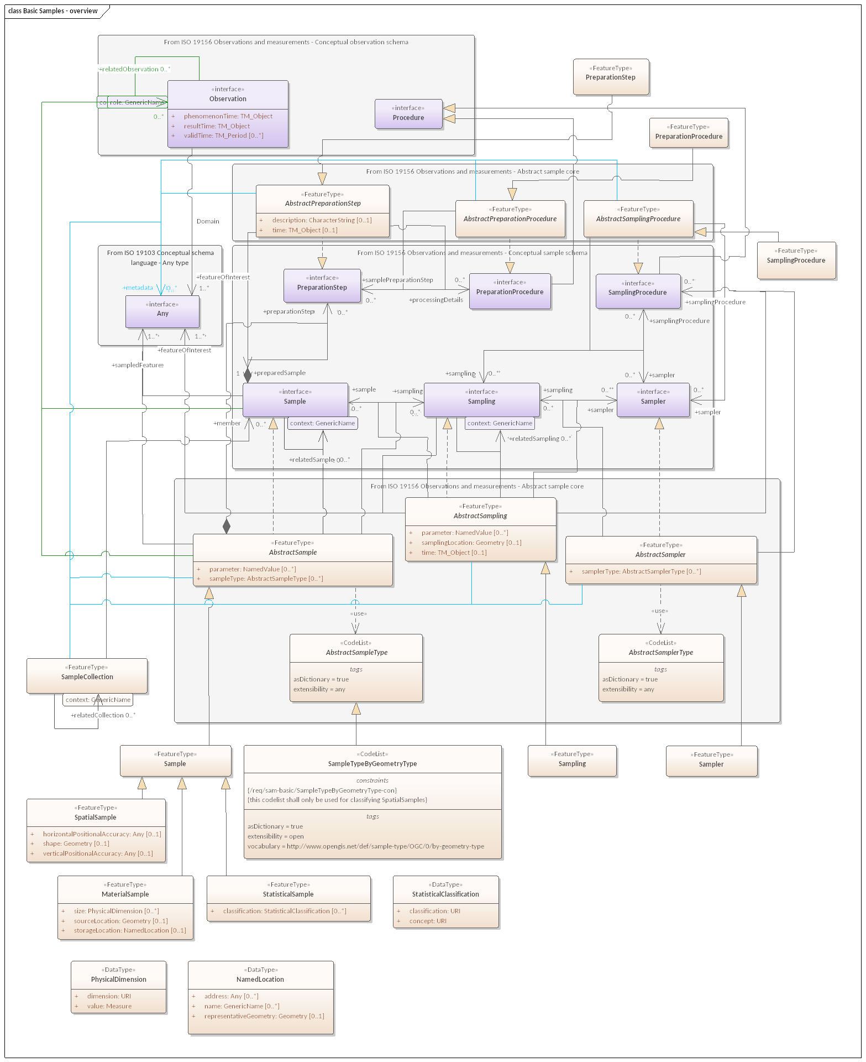

Figure 20 — Basic Samples — overview

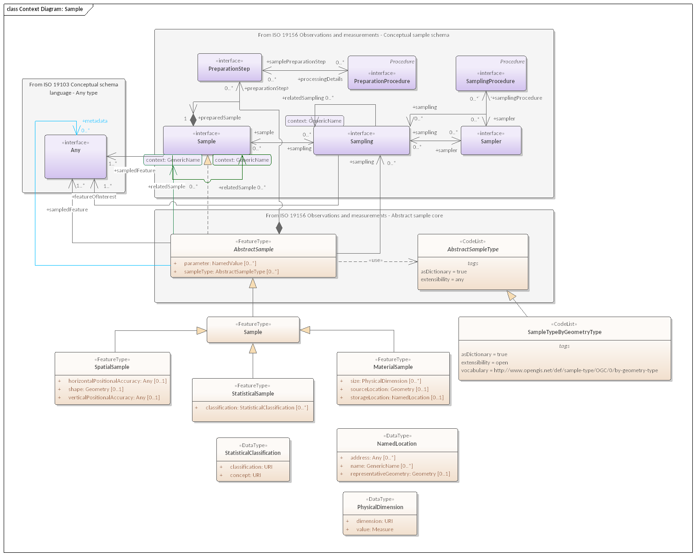

Figure 21 — Context Diagram: Sample

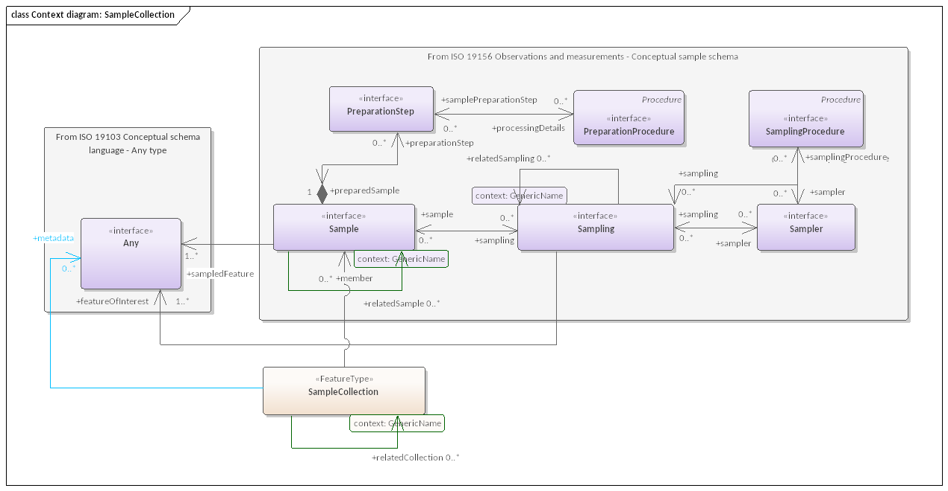

Figure 22 — Context diagram: SampleCollection

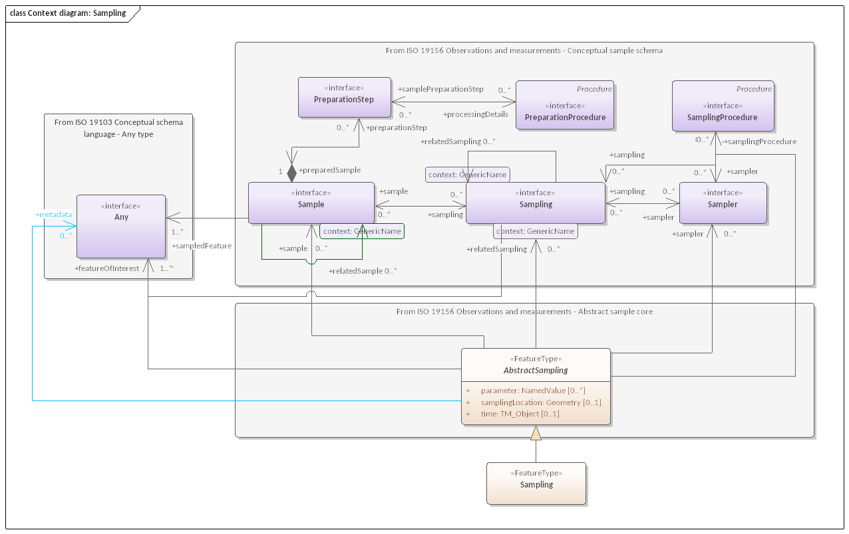

Figure 23 — Context diagram: Sampling

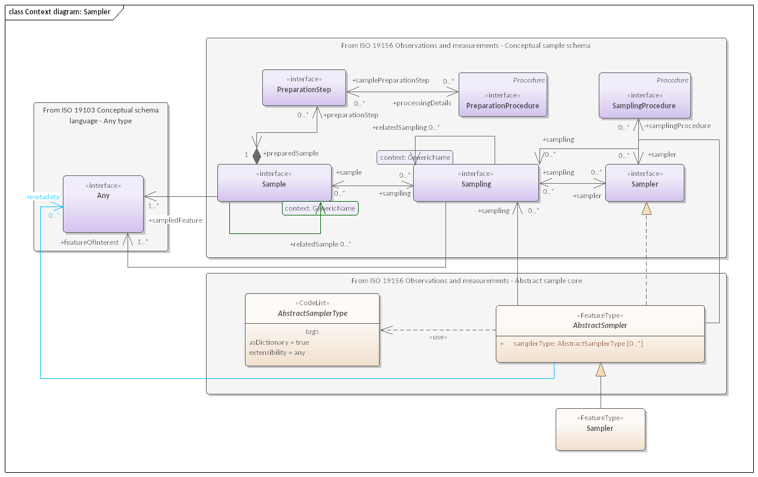

Figure 24 — Context diagram: Sampler

## 8.2 Defining tables

Table 48 — Elements of “Basic Samples::MaterialSample” (class)

|  |  |  |  |  |  |  |
| --- | --- | --- | --- | --- | --- | --- |
| **Name:** | MaterialSample | | | | | |
| **Definition:** | A **MaterialSample** is a physical, tangible **Sample**. NOTE 1 MaterialSamples that are curated and preserved are sometimes known as ‘specimens’. NOTE 2 MaterialSamples can be destroyed in connexion with the observation act. NOTE 3 A MaterialSample is a physical Sample of a FeatureOfInterest, obtained for Observation(s) normally carried out ex-situ, sometimes in a laboratory. | | | | | |
| **Stereotype:** | FeatureType | | | | | |
| **Inheritance from:** | Sample | | | | | |
| **Abstract:** | True | | | | | |
| **Associations:** | (none) | | | | | |
| **Public attributes:** | *Name* | *Definition* | *Derived* | *Obligation* | *Maximum occurrence* | *Data type* |
| size | a physical extent of the MaterialSample |  | C | * | PhysicalDimension |
| sourceLocation | location from where the **MaterialSample** was obtained. TODO: Note text in spec |  | C | 1 | Geometry |
| storageLocation | location of a **MaterialSample**. NOTE The storageLocation may be a location such as a shelf in a warehouse or a drawer in a museum. |  | C | 1 | NamedLocation |
| **Constraints:** | (none) | | | | | |

Table 49 — Elements of “Basic Samples::NamedLocation” (class)

|  |  |  |  |  |  |  |
| --- | --- | --- | --- | --- | --- | --- |
| **Name:** | NamedLocation | | | | | |
| **Definition:** | A location identified by its name, address, spatial geometry or a combination of any of these three | | | | | |
| **Stereotype:** | DataType | | | | | |
| **Abstract:** | True | | | | | |
| **Associations:** | (none) | | | | | |
| **Public attributes:** | *Name* | *Definition* | *Derived* | *Obligation* | *Maximum occurrence* | *Data type* |
| address | An **address** used for identifying a **NamedLocation** |  | C | * | Any |
| name | A **name** used for identifying a **NamedLocation.** |  | C | * | GenericName |
| representativeGeometry | A geometry used for providing a representative spatial location of a **NamedLocation** |  | C | 1 | Geometry |
| **Constraints:** | (none) | | | | | |

Table 50 — Elements of “Basic Samples::PhysicalDimension” (class)

|  |  |  |  |  |  |  |
| --- | --- | --- | --- | --- | --- | --- |
| **Name:** | PhysicalDimension | | | | | |
| **Definition:** | A dataType for the provision of various size quantities | | | | | |
| **Stereotype:** | DataType | | | | | |
| **Abstract:** | True | | | | | |
| **Associations:** | (none) | | | | | |
| **Public attributes:** | *Name* | *Definition* | *Derived* | *Obligation* | *Maximum occurrence* | *Data type* |
| dimension | name of the **PhysicalDimension** about which a **value** is provided. |  | M | 1 | URI |
| value | The **value** of the **PhysicalDimension**. |  | M | 1 | Measure |
| **Constraints:** | (none) | | | | | |

Table 51 — Elements of “Basic Samples::PreparationProcedure” (class)

|  |  |
| --- | --- |
| **Name:** | PreparationProcedure |
| **Definition:** | Concrete class for expressing a realization of Conceptual Sample Schema:PreparationProcedure interface based on General Feature Model as defined in ISO 19109 |
| **Stereotype:** | FeatureType |
| **Inheritance from:** | AbstractPreparationProcedure |
| **Abstract:** | True |
| **Associations:** | (none) |
| **Public attributes:** | (none) |
| **Constraints:** | (none) |

Table 52 — Elements of “Basic Samples::PreparationStep” (class)

|  |  |
| --- | --- |
| **Name:** | PreparationStep |
| **Definition:** | Concrete class for expressing a realization of Conceptual Sample Schema:PreparationStep interface based on General Feature Model as defined in ISO 19109 |
| **Stereotype:** | FeatureType |
| **Inheritance from:** | AbstractPreparationStep |
| **Abstract:** | True |
| **Associations:** | (none) |
| **Public attributes:** | (none) |
| **Constraints:** | (none) |

Table 53 — Elements of “Basic Samples::Sample” (class)

|  |  |
| --- | --- |
| **Name:** | Sample |
| **Definition:** | Concrete class for expressing a realization of Conceptual Sample Schema:Sample interface based on General Feature Model as defined in ISO 19109 |
| **Stereotype:** | FeatureType |
| **Inheritance from:** | AbstractSample |
| **Generalization of:** | MaterialSample, SpatialSample, StatisticalSample |
| **Abstract:** | True |
| **Associations:** | (none) |
| **Public attributes:** | (none) |
| **Constraints:** | (none) |

Table 54 — Elements of “Basic Samples::SampleCollection” (class)

|  |  |  |  |  |
| --- | --- | --- | --- | --- |
| **Name:** | SampleCollection | | | |
| **Definition:** | A collection of *Sample*s | | | |
| **Stereotype:** | FeatureType | | | |
| **Abstract:** | True | | | |
| **Associations:** | *Association with* | *Obligation* | *Maximum occurrence* | *Provides* |
| Any | C | * | metadata |
| Sample | C | * | member |
| SampleCollection | C | * | relatedCollection |
| SampleCollection | C | * | relatedCollection |
| **Public attributes:** | (none) | | | |
| **Constraints:** | (none) | | | |

Table 55 — Elements of “Basic Samples::Sampler” (class)

|  |  |
| --- | --- |
| **Name:** | Sampler |
| **Definition:** | Concrete class for expressing a realization of Conceptual Sample Schema:Sampler interface based on General Feature Model as defined in ISO 19109 |
| **Stereotype:** | FeatureType |
| **Inheritance from:** | AbstractSampler |
| **Abstract:** | True |
| **Associations:** | (none) |
| **Public attributes:** | (none) |
| **Constraints:** | (none) |

Table 56 — Elements of “Basic Samples::SampleTypeByGeometryType” (class)

|  |  |
| --- | --- |
| **Name:** | SampleTypeByGeometryType |
| **Definition:** | SpatialSample classification scheme based on the geometry type of its shape attribute |
| **Stereotype:** | CodeList |
| **Inheritance from:** | AbstractSampleType |
| **Abstract:** | True |
| **Associations:** | (none) |
| **Public attributes:** | (none) |
| **Constraints:** | /req/sam-basic/SampleTypeByGeometryType-con |
| this codelist shall only be used for classifying SpatialSamples |

Table 57 — Elements of “Basic Samples::Sampling” (class)

|  |  |
| --- | --- |
| **Name:** | Sampling |
| **Definition:** | Concrete class for expressing a realization of Conceptual Sample Schema:Sampling interface based on General Feature Model as defined in ISO 19109 |
| **Stereotype:** | FeatureType |
| **Inheritance from:** | AbstractSampling |
| **Abstract:** | True |
| **Associations:** | (none) |
| **Public attributes:** | (none) |
| **Constraints:** | (none) |

Table 58 — Elements of “Basic Samples::SamplingProcedure” (class)

|  |  |
| --- | --- |
| **Name:** | SamplingProcedure |
| **Definition:** | Concrete class for expressing a realization of Conceptual Sample Schema:SamplingProcedure interface based on General Feature Model as defined in ISO 19109 |
| **Stereotype:** | FeatureType |
| **Inheritance from:** | AbstractSamplingProcedure |
| **Abstract:** | True |
| **Associations:** | (none) |
| **Public attributes:** | (none) |
| **Constraints:** | (none) |

Table 59 — Elements of “Basic Samples::SpatialSample” (class)

|  |  |  |  |  |  |  |
| --- | --- | --- | --- | --- | --- | --- |
| **Name:** | SpatialSample | | | | | |
| **Definition:** | a geospatial **Sample**. NOTE When observations are made to estimate properties of a geospatial feature, in particular where the value of a property varies within the scope of the feature, a SpatialSample is used. Depending on accessibility and on the nature of the expected property variation, the SpatialSample may be extensive in one, two or three spatial dimensions. EXAMPLE   * Typically an Observation ‘site’ or ‘station’ connotes the ‘world in the vicinity of the site (or station)’, so the observed properties relate to the physical medium at the station, and not to any physical artifact such as a mooring, buoy, benchmark, monument, well, etc. * Some common names for SpatialSample used in various application domains include Borehole, Flightline, Interval, Lidar Cloud, Map Horizon, Microscope Slide, Mine Level, Mine, Observation Well, Profile, Pulp, Quadrat, Scene, Section, ShipsTrack, Spot, Station, Swath, Trajectory, Traverse, etc. | | | | | |
| **Stereotype:** | FeatureType | | | | | |
| **Inheritance from:** | Sample | | | | | |
| **Abstract:** | True | | | | | |
| **Associations:** | (none) | | | | | |
| **Public attributes:** | *Name* | *Definition* | *Derived* | *Obligation* | *Maximum occurrence* | *Data type* |
| horizontalPositionalAccuracy | The positional accuracy of the horizontal component of the Geometry of the **SpatialSample**. |  | C | 1 | Any |
| shape | Geometry of the *SpatialSample.*NOTE The shape of the SpatialSample is the context for domain decomposition. EXAMPLE Logs of different properties along a well or borehole might use different intervals, and sub-samples might be either spatially instantaneous, or averaged in some way over an interval. The position of the samples can be conveniently described in terms of offsets in a linear coordinate reference system that is defined by the shape of the well axis. |  | C | 1 | Geometry |
| verticalPositionalAccuracy | The positional accuracy of the vertical component of the Geometry of the **SpatialSample** |  | C | 1 | Any |
| **Constraints:** | (none) | | | | | |

Table 60 — Elements of “Basic Samples::StatisticalClassification” (class)

|  |  |  |  |  |  |  |
| --- | --- | --- | --- | --- | --- | --- |
| **Name:** | StatisticalClassification | | | | | |
| **Definition:** | a dataType for the provision of information on statistical classifications. | | | | | |
| **Stereotype:** | DataType | | | | | |
| **Abstract:** | True | | | | | |
| **Associations:** | (none) | | | | | |
| **Public attributes:** | *Name* | *Definition* | *Derived* | *Obligation* | *Maximum occurrence* | *Data type* |
| classification | The explicit **classification class** pertaining to the classification concept described by the **StatisticalClassification**. EXAMPLE The classification for a statistical classification could be:   * Age Brackets: [0-10], [10-20] * Genders: Male, Female, Other * Color: Red, Green, Blue |  | M | 1 | URI |
| concept | The **concept** by which a **StatisticalClassification** is to be performed. EXAMPLE The concept for a statistical classification could be age, gender, color, size etc. |  | M | 1 | URI |
| **Constraints:** | (none) | | | | | |

Table 61 — Elements of “Basic Samples::StatisticalSample” (class)

|  |  |  |  |  |  |  |
| --- | --- | --- | --- | --- | --- | --- |
| **Name:** | StatisticalSample | | | | | |
| **Definition:** | a statistical subset of a feature-of-interest, defined for the purpose of creating **Observation**(s). NOTE 1 StatisticalSamples usually apply to populations or other sets, of which certain subset may be of specific interest. EXAMPLE The male or female subset of a population. | | | | | |
| **Stereotype:** | FeatureType | | | | | |
| **Inheritance from:** | Sample | | | | | |
| **Abstract:** | True | | | | | |
| **Associations:** | (none) | | | | | |
| **Public attributes:** | *Name* | *Definition* | *Derived* | *Obligation* | *Maximum occurrence* | *Data type* |
| classification | a criterion by which the subset was defined |  | C | * | StatisticalClassification |
| **Constraints:** | (none) | | | | | |

Table 62 — Elements of “Basic Samples::From ISO 19156 Observations and measurements — Abstract sample core” (class)

|  |  |
| --- | --- |
| **Name:** | From ISO 19156 Observations and measurements — Abstract sample core |
| **Definition:** |  |
| **Stereotype:** | interface |
| **Abstract:** | False |
| **Associations:** | (none) |
| **Public attributes:** | (none) |
| **Constraints:** | (none) |

Table 63 — Elements of “Basic Samples::From ISO 19156 Observations and measurements — Conceptual sample schema” (class)

|  |  |
| --- | --- |
| **Name:** | From ISO 19156 Observations and measurements — Conceptual sample schema |
| **Definition:** |  |
| **Stereotype:** | interface |
| **Abstract:** | False |
| **Associations:** | (none) |
| **Public attributes:** | (none) |
| **Constraints:** | (none) |

Table 64 — Elements of “Basic Samples::From ISO 19156 Observations and measurements — Abstract sample core” (class)

|  |  |
| --- | --- |
| **Name:** | From ISO 19156 Observations and measurements — Abstract sample core |
| **Definition:** |  |
| **Stereotype:** | interface |
| **Abstract:** | False |
| **Associations:** | (none) |
| **Public attributes:** | (none) |
| **Constraints:** | (none) |

Table 65 — Elements of “Basic Samples::From ISO 19156 Observations and measurements — Abstract sample core” (class)

|  |  |
| --- | --- |
| **Name:** | From ISO 19156 Observations and measurements — Abstract sample core |
| **Definition:** |  |
| **Stereotype:** | interface |
| **Abstract:** | False |
| **Associations:** | (none) |
| **Public attributes:** | (none) |
| **Constraints:** | (none) |

Table 66 — Elements of “Basic Samples::From ISO 19103 Conceptual schema language — Any type” (class)

|  |  |
| --- | --- |
| **Name:** | From ISO 19103 Conceptual schema language — Any type |
| **Definition:** |  |
| **Stereotype:** | interface |
| **Abstract:** | False |
| **Associations:** | (none) |
| **Public attributes:** | (none) |
| **Constraints:** | (none) |

# 9 Conceptual Observation schema package

## 9.1 Conceptual Observation schema overview

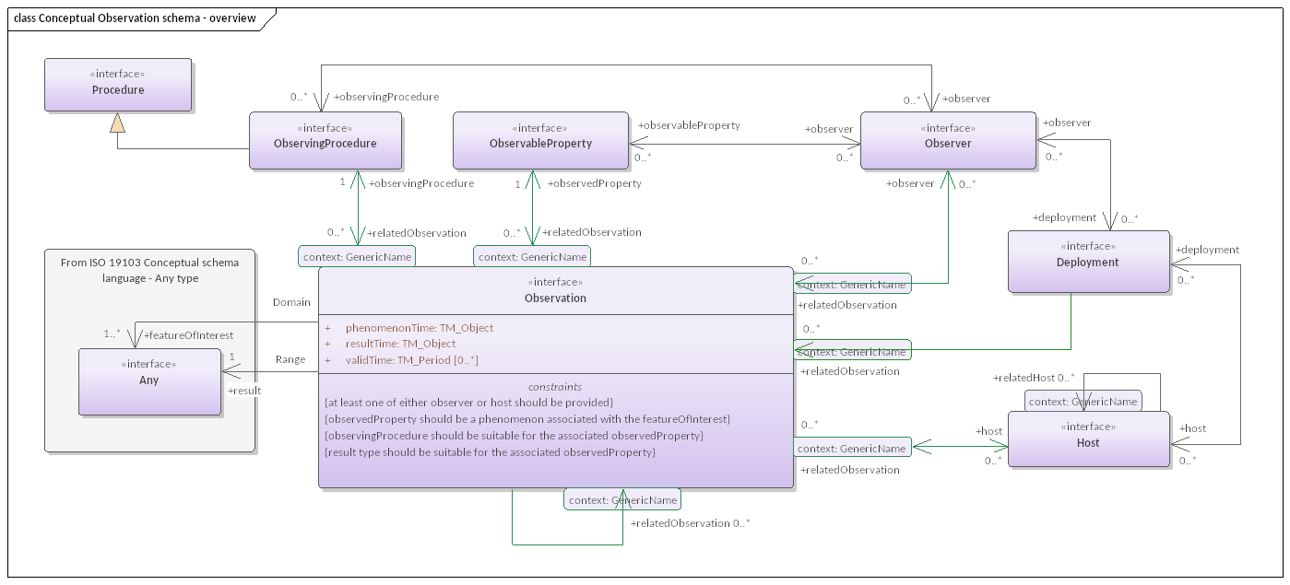

Figure 25 — Conceptual Observation schema — overview

## 9.2 Defining tables

Table 67 — Elements of “Conceptual Observation schema::From ISO 19103 Conceptual schema language — Any type” (class)

|  |  |
| --- | --- |
| **Name:** | From ISO 19103 Conceptual schema language — Any type |
| **Definition:** |  |
| **Stereotype:** | interface |
| **Abstract:** | False |
| **Associations:** | (none) |
| **Public attributes:** | (none) |
| **Constraints:** | (none) |

# 10 Conceptual Sample schema package

## 10.1 Conceptual Sample schema overview

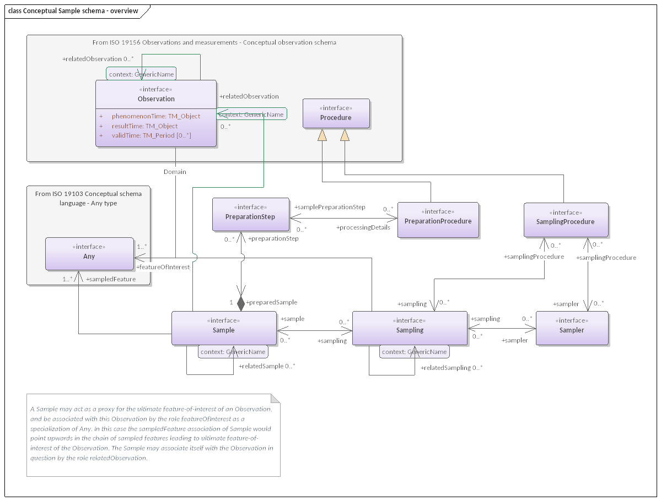

Figure 26 — Conceptual Sample schema — overview

## 10.2 Defining tables

Table 68 — Elements of “Conceptual Sample schema::From ISO 19156 Observations and measurements — Conceptual observation schema” (class)

|  |  |
| --- | --- |
| **Name:** | From ISO 19156 Observations and measurements — Conceptual observation schema |
| **Definition:** |  |
| **Stereotype:** | interface |
| **Abstract:** | False |
| **Associations:** | (none) |
| **Public attributes:** | (none) |
| **Constraints:** | (none) |

Table 69 — Elements of “Conceptual Sample schema::From ISO 19103 Conceptual schema language — Any type” (class)

|  |  |
| --- | --- |
| **Name:** | From ISO 19103 Conceptual schema language — Any type |
| **Definition:** |  |
| **Stereotype:** | interface |
| **Abstract:** | False |
| **Associations:** | (none) |
| **Public attributes:** | (none) |
| **Constraints:** | (none) |

# 11 Examples package

## 11.1 Examples overview

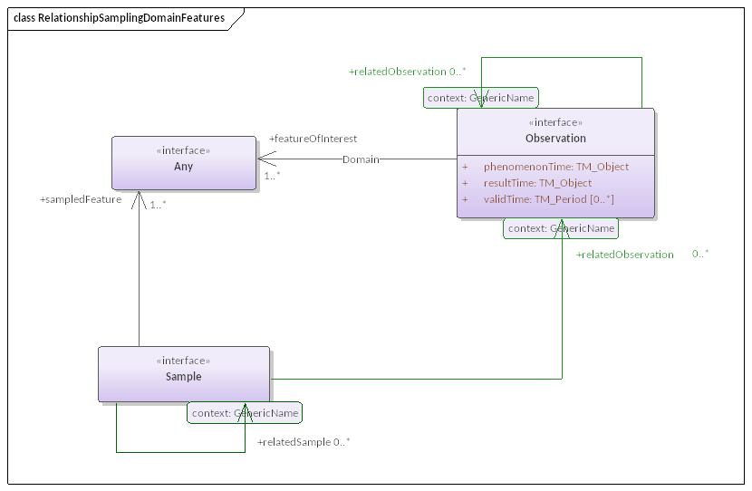

Figure 27 — RelationshipSamplingDomainFeatures

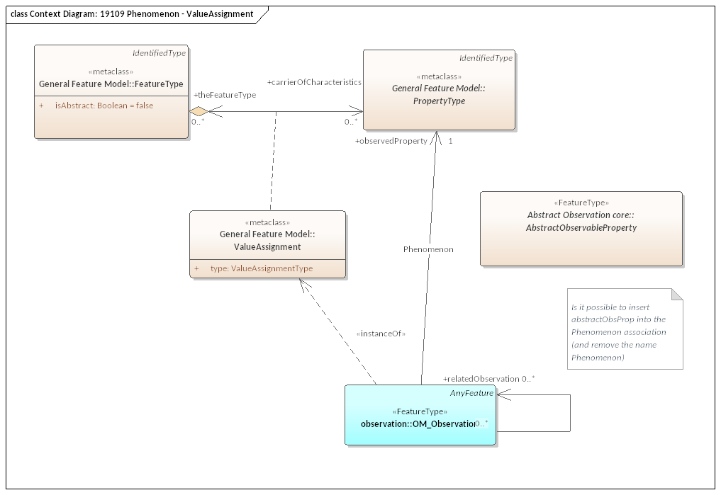

Figure 28 — Context Diagram: 19109 Phenomenon — ValueAssignment

The Examples package is organized into 6 packages:

1. BasicFeaturesOnly package
2. Codelist realizations package
3. Collections package
4. ModelConsistency package
5. SamplingCascade package
6. ModelConsistency — Gender package

## 11.2 BasicFeaturesOnly package

### 11.2.1 BasicFeaturesOnly overview

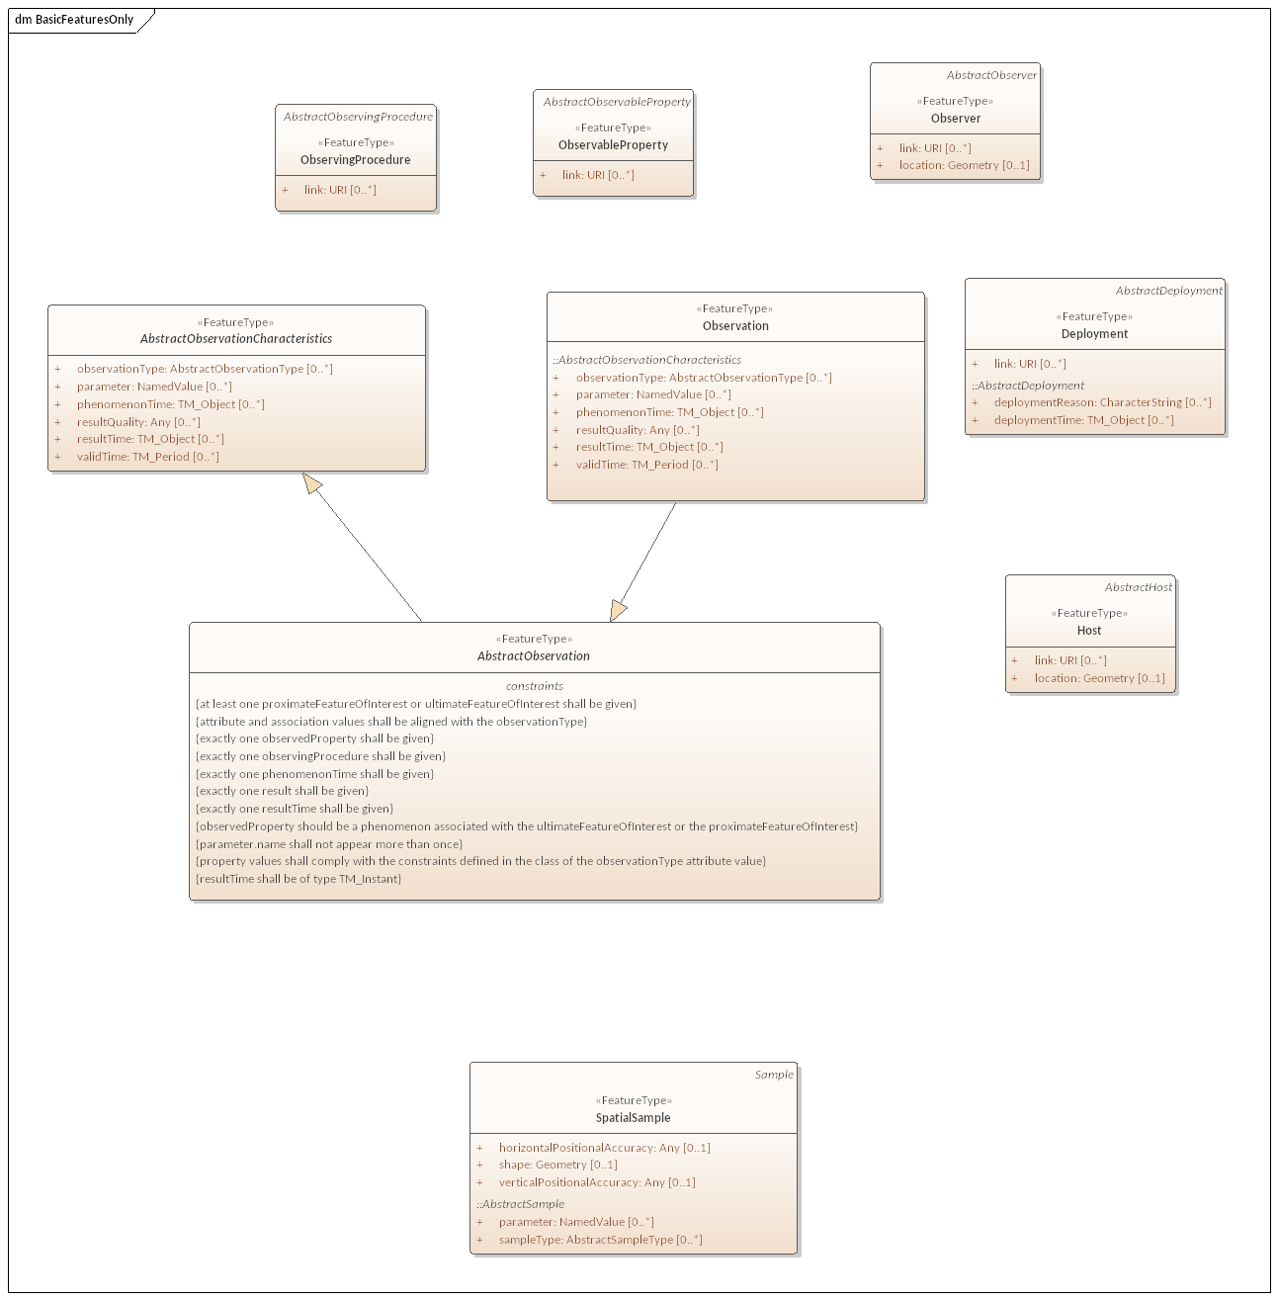

Figure 29 — BasicFeaturesOnly

## 11.3 Codelist realizations package

### 11.3.1 Codelist realizations overview

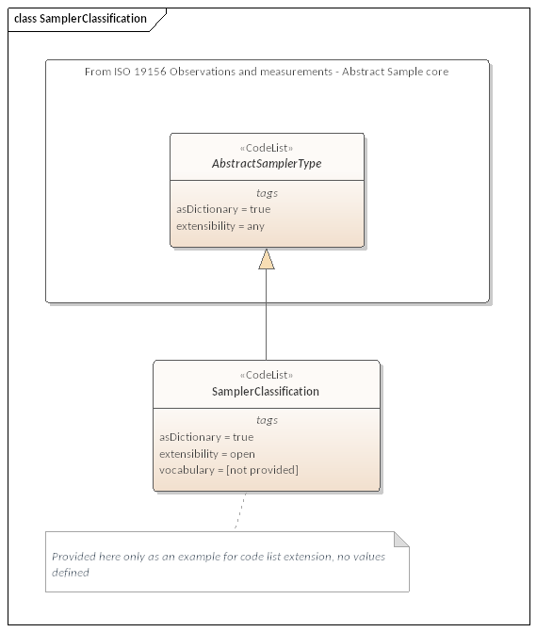

Figure 30 — SamplerClassification

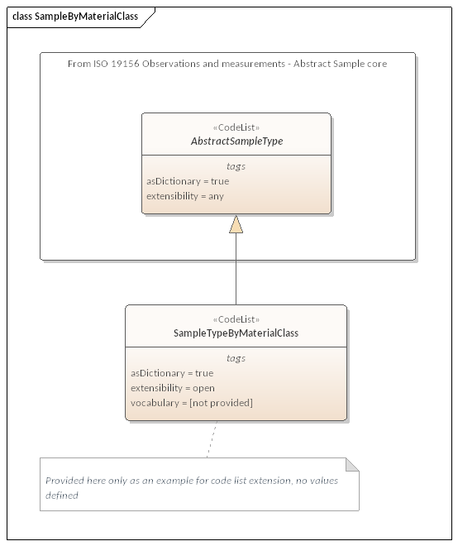

Figure 31 — SampleByMaterialClass

### 11.3.2 Defining tables

Table 70 — Elements of “Codelist realizations::SamplerClassification” (class)

|  |  |
| --- | --- |
| **Name:** | SamplerClassification |
| **Definition:** |  |
| **Stereotype:** | CodeList |
| **Inheritance from:** | AbstractSamplerType |
| **Abstract:** | True |
| **Associations:** | (none) |
| **Public attributes:** | (none) |
| **Constraints:** | (none) |

Table 71 — Elements of “Codelist realizations::SampleTypeByMaterialClass” (class)

|  |  |
| --- | --- |
| **Name:** | SampleTypeByMaterialClass |
| **Definition:** | AirSample, WaterSample, RockSample, etc. |
| **Stereotype:** | CodeList |
| **Inheritance from:** | AbstractSampleType |
| **Abstract:** | True |
| **Associations:** | (none) |
| **Public attributes:** | (none) |
| **Constraints:** | (none) |

Table 72 — Elements of “Codelist realizations::From ISO 19156 Observations and measurements — Abstract Sample core” (class)

|  |  |
| --- | --- |
| **Name:** | From ISO 19156 Observations and measurements — Abstract Sample core |
| **Definition:** |  |
| **Stereotype:** | interface |
| **Abstract:** | False |
| **Associations:** | (none) |
| **Public attributes:** | (none) |
| **Constraints:** | (none) |

## 11.4 Collections package

### 11.4.1 Collections overview

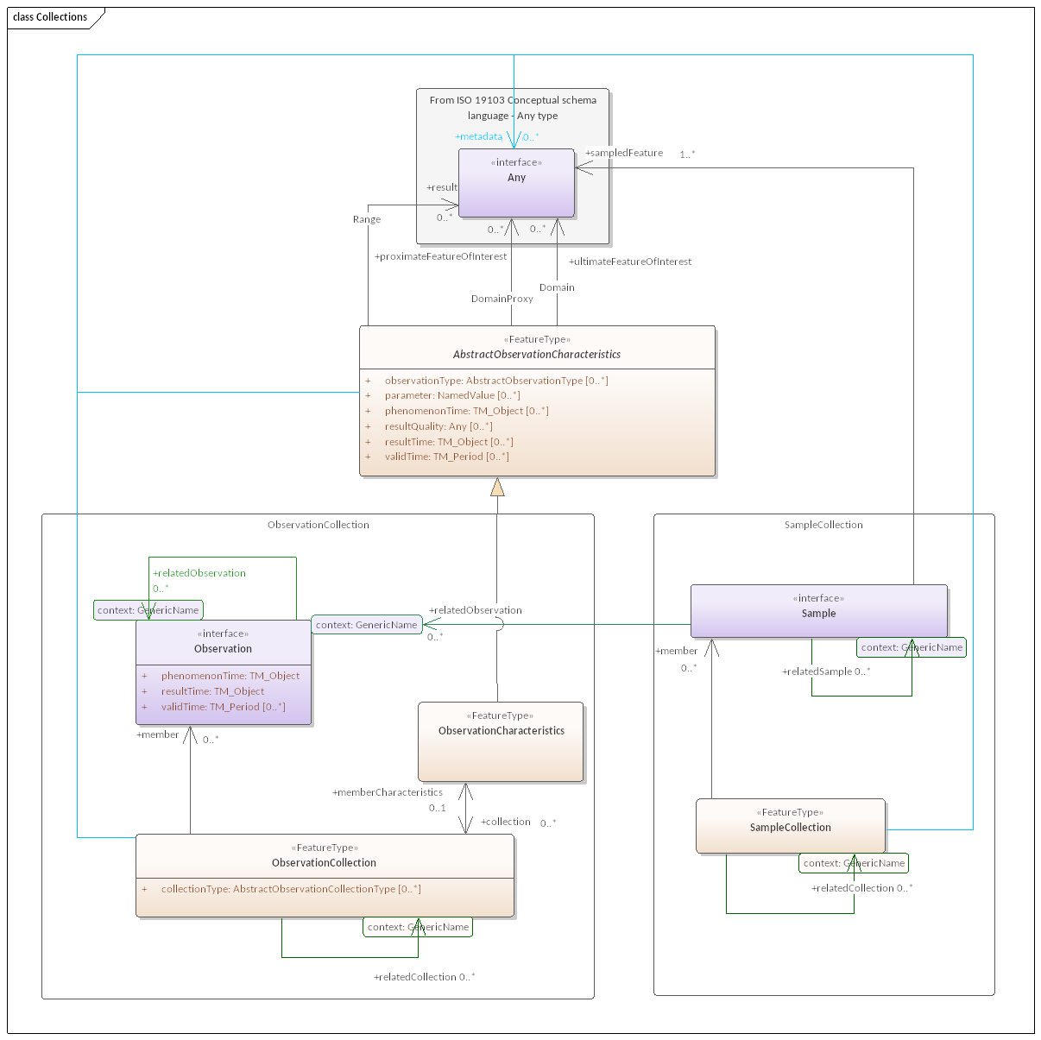

Figure 32 — Collections

### 11.4.2 Defining tables

Table 73 — Elements of “Collections::ObservationCollection” (class)

|  |  |
| --- | --- |
| **Name:** | ObservationCollection |
| **Definition:** |  |
| **Stereotype:** | interface |
| **Abstract:** | False |
| **Associations:** | (none) |
| **Public attributes:** | (none) |
| **Constraints:** | (none) |

Table 74 — Elements of “Collections::SampleCollection” (class)

|  |  |
| --- | --- |
| **Name:** | SampleCollection |
| **Definition:** |  |
| **Stereotype:** | interface |
| **Abstract:** | False |
| **Associations:** | (none) |
| **Public attributes:** | (none) |
| **Constraints:** | (none) |

## 11.5 ModelConsistency package

### 11.5.1 ModelConsistency overview

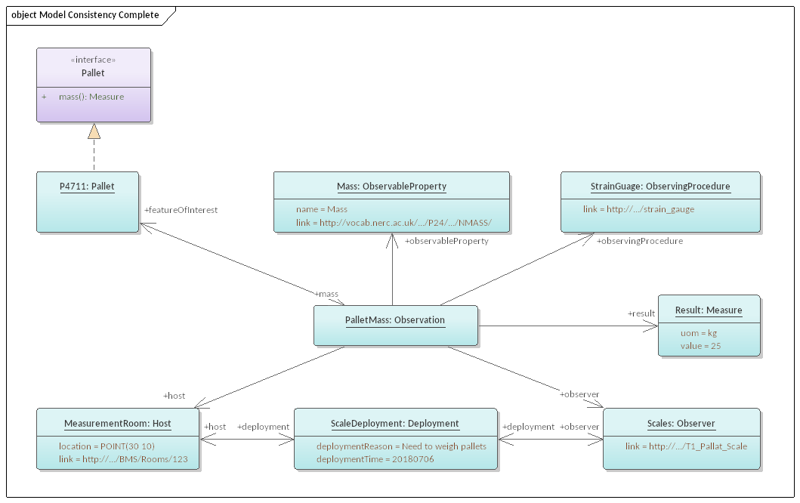

Figure 33 — Model Consistency Complete

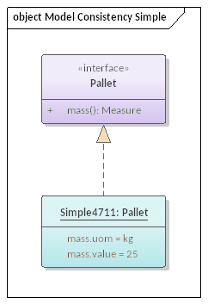

Figure 34 — Model Consistency Simple

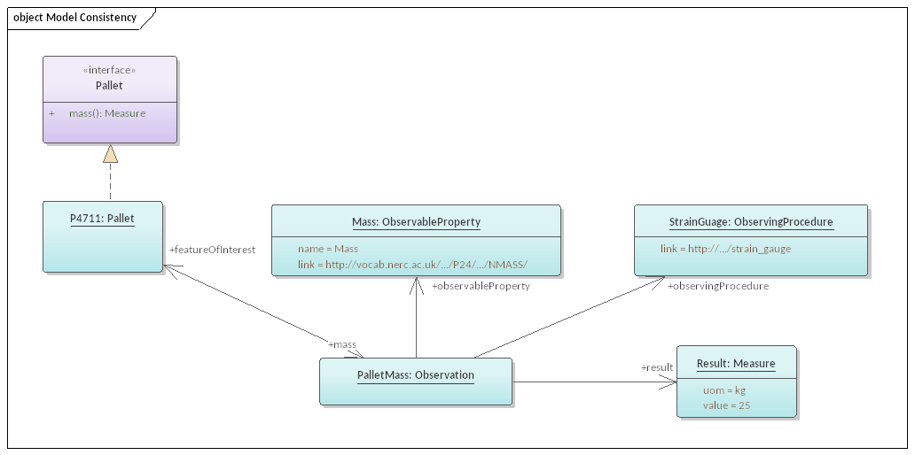

Figure 35 — Model Consistency

## 11.6 SamplingCascade package

### 11.6.1 SamplingCascade overview

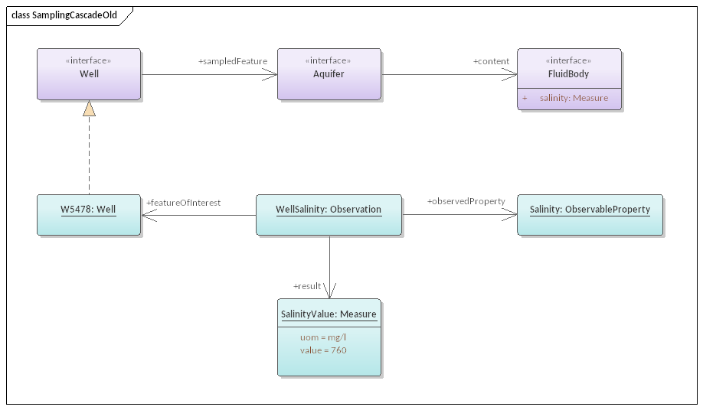

Figure 36 — SamplingCascadeOld

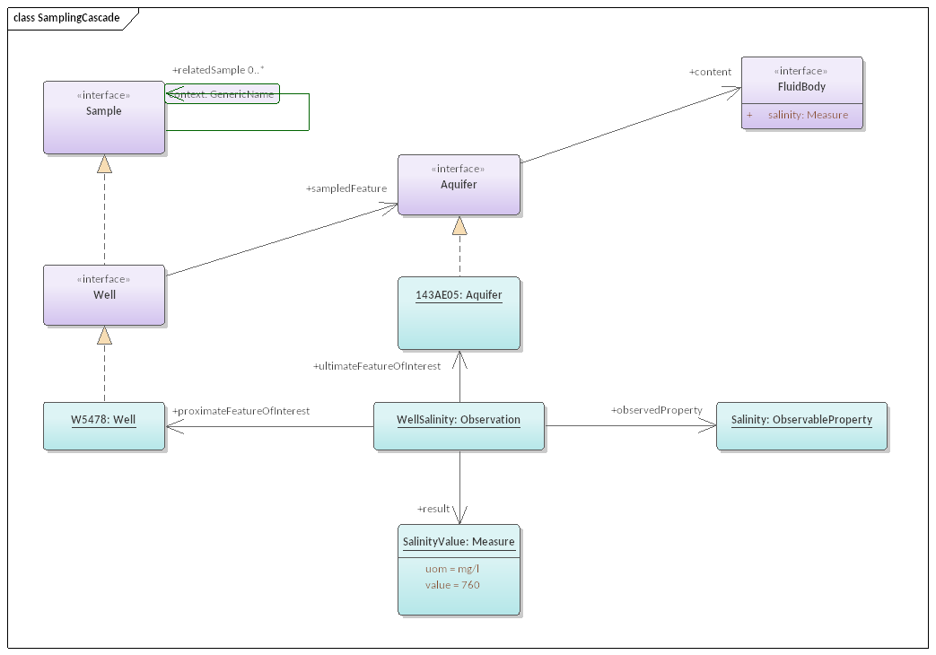

Figure 37 — SamplingCascade

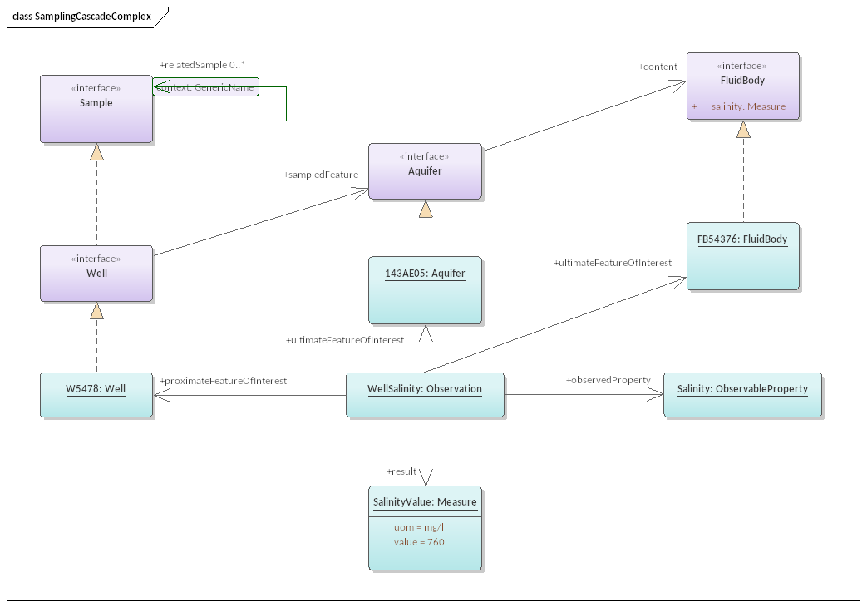

Figure 38 — SamplingCascadeComplex

### 11.6.2 Defining tables

Table 75 — Elements of “SamplingCascade::W32564” (class)

|  |  |
| --- | --- |
| **Name:** | W32564 |
| **Definition:** |  |
| **Stereotype:** | FeatureType |
| **Abstract:** | True |
| **Associations:** | (none) |
| **Public attributes:** | (none) |
| **Constraints:** | (none) |

## 11.7 ModelConsistency — Gender package

### 11.7.1 ModelConsistency — Gender overview

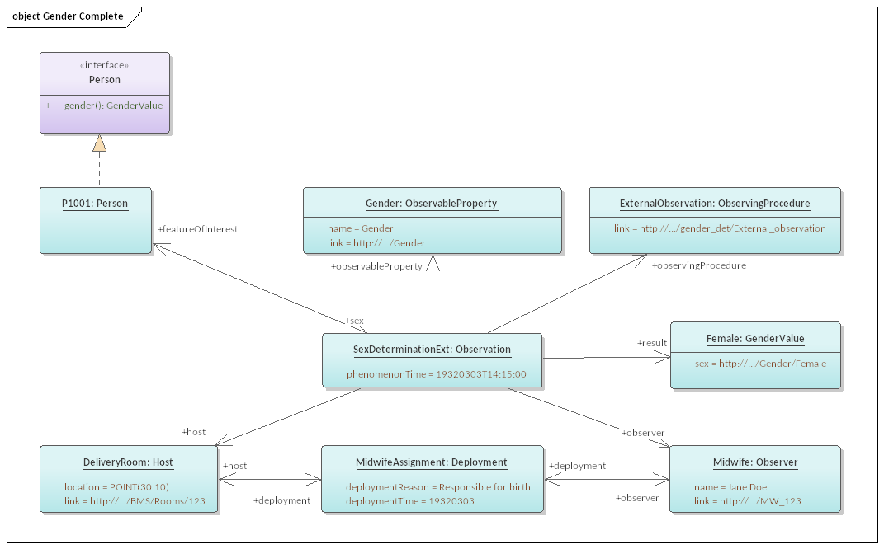

Figure 39 — Gender Complete

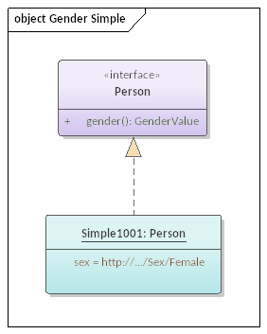

Figure 40 — Gender Simple

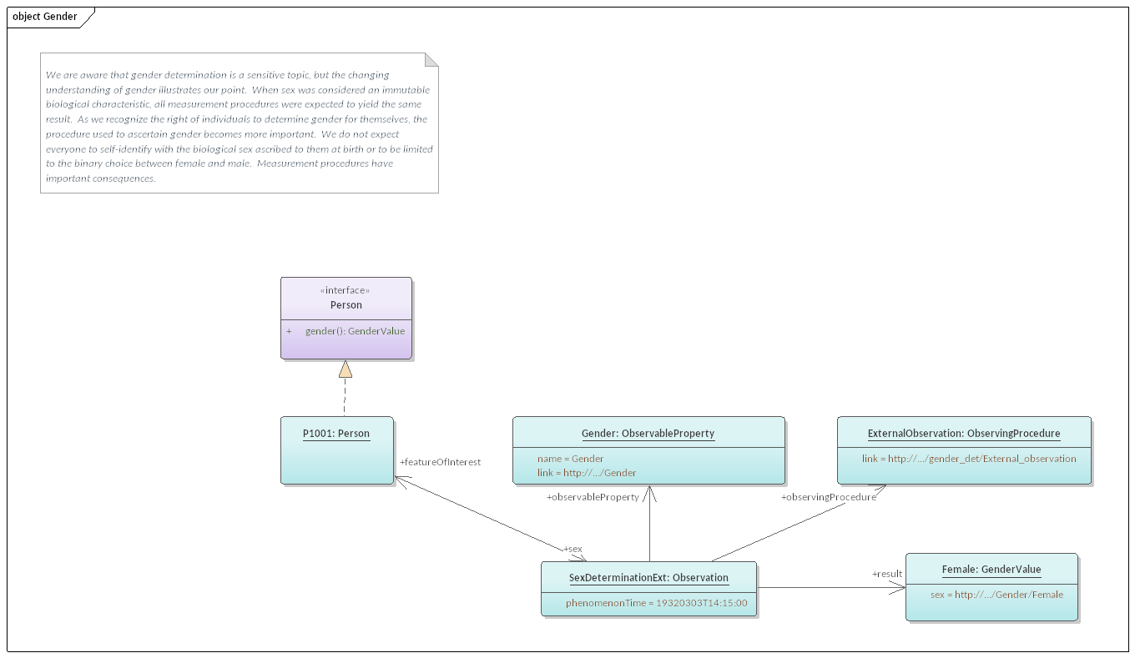

Figure 41 — Gender

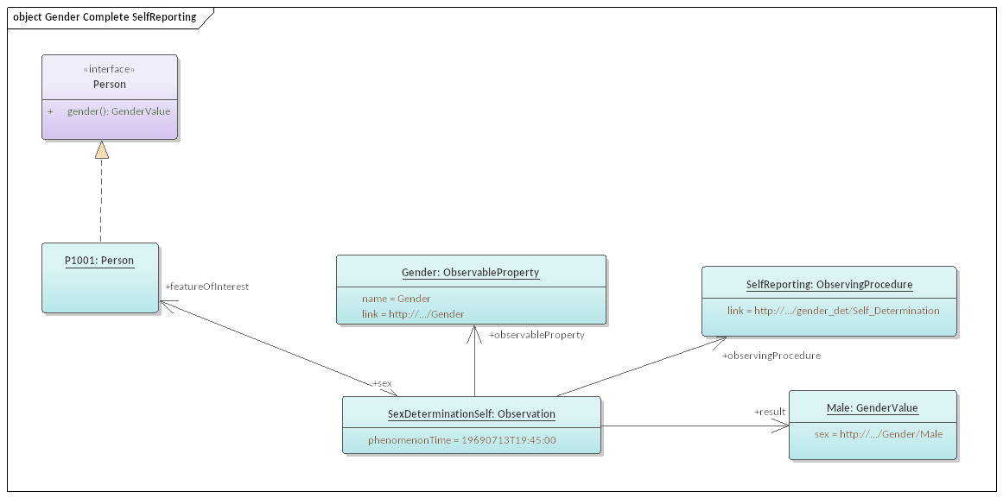

Figure 42 — Gender Complete SelfReporting

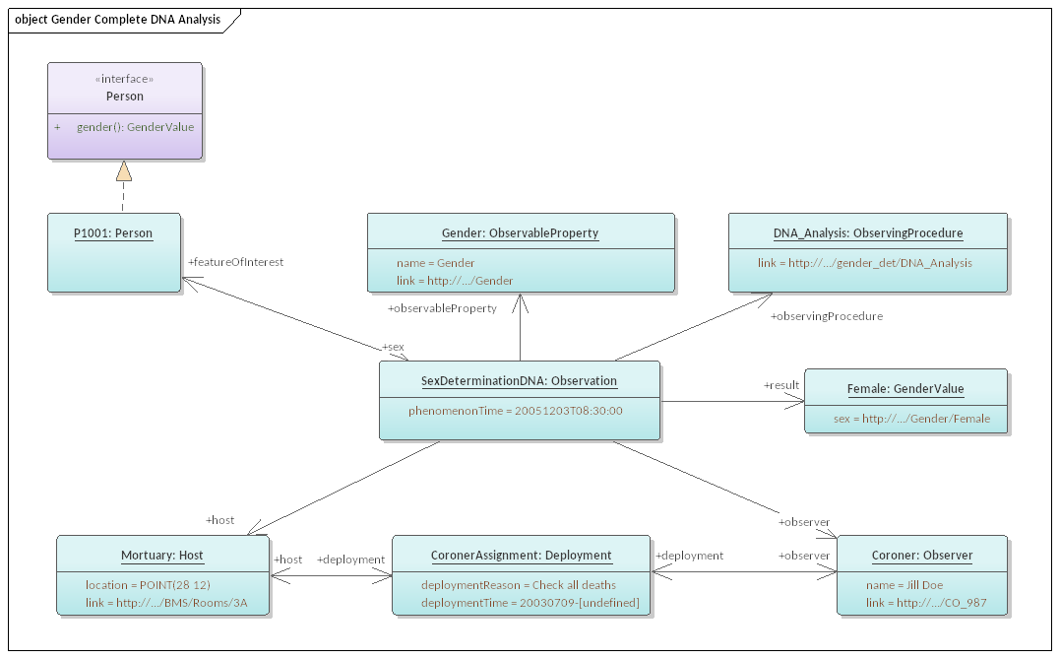

Figure 43 — Gender Complete DNA Analysis

### 11.7.2 Defining tables

Table 76 — Elements of “ModelConsistency — Gender::GenderValue” (class)

|  |  |  |  |  |  |  |
| --- | --- | --- | --- | --- | --- | --- |
| **Name:** | GenderValue | | | | | |
| **Definition:** |  | | | | | |
| **Stereotype:** | interface | | | | | |
| **Abstract:** | True | | | | | |
| **Associations:** | (none) | | | | | |
| **Public attributes:** | *Name* | *Definition* | *Derived* | *Obligation* | *Maximum occurrence* | *Data type* |
| sex |  |  | M | 1 | String |
| **Constraints:** | (none) | | | | | |

Bibliography