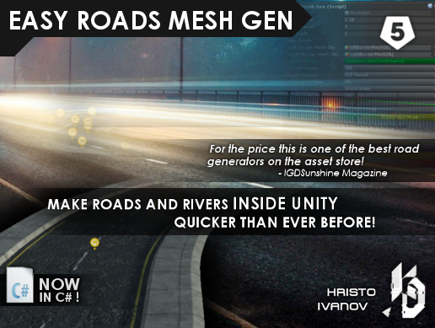

EASY ROADS MESH GEN

v2018

By Hristo Ivanov

ASP: Kris Development

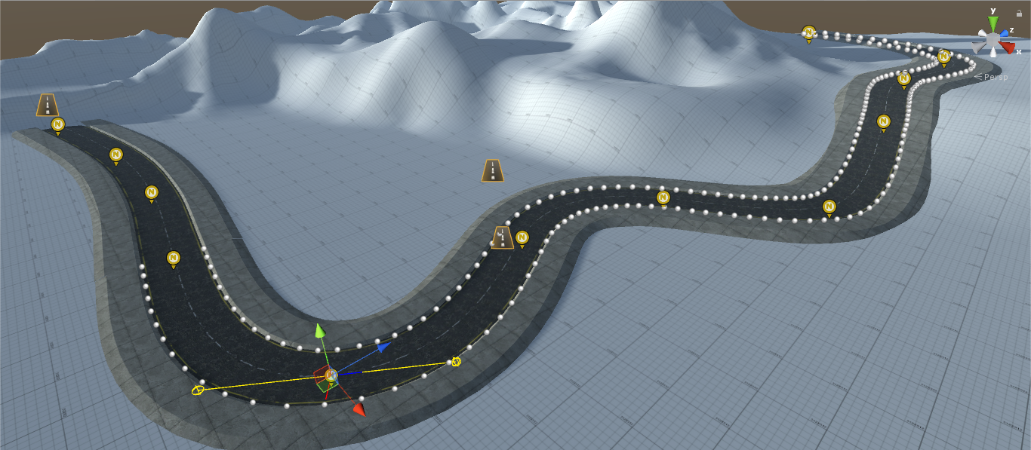

Introduction

Create roads and rivers without the need of 3D modeling software!

Easy Roads Mesh Gen allows for very fast and easy creation of roads and rivers inside Unity. It has easy to use, simple and organized interface which improves the workflow.

Just drag the navigation points where you want them and the tool will do the rest. Pick your own texture and apply it on top.

Instructions:

To use this tool you need to create an empty game object.

Assign the MeshGen.cs component to the empty object and click "Begin" to skip the built-in tutorial.

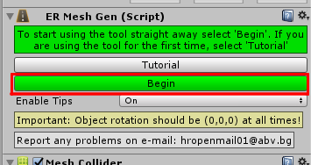

This will open up the Mesh Gen interface and will create one Navigation Point (Nav Point) in the scene.

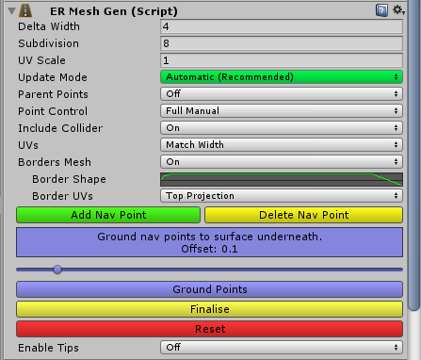

To extend the array of Nav Points click "Add Nav Point".

Use "Delete Nav Point" to delete the last added point.



The "Update Mode" menu changes the way the mesh is being updated (manually, vertices only, real time or automatically).

It is highly recommended to use “Automatic” as this option has the benefits of “Realtime” and runs only when the object is selected, which increases performance.

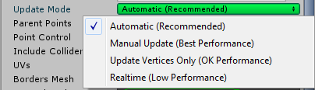

"Parent points" will make any future point a child of the previous, which can make easier modifying the general shape of the mesh, however it is not recommended when working with scaled Nav Points.

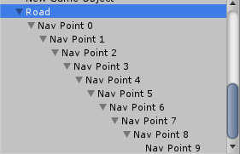

"Delta Width" represents the width of the generated mesh. Think of it as the width of the road.

"Include Collider" will create mesh collider and update it every time the mesh is updated

The "Ground Points" button will move all the nav points to the surface of whatever object lies underneath, while keeping the specified offset. This is useful for roughly shaping roads on large terrain.

"Point Control" will change the way the points behave in the scene. The Full Manual option will let the user rotate and manually modify each point while Automatic will rotate the points based on their position.

"UVs" control the way the texture is being drawn on top of the mesh.

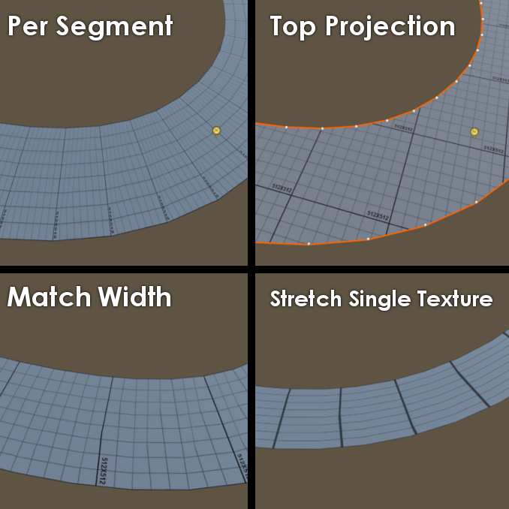

Road Borders:

There’s an option to generate road borders to use as sidewalks or to help connect the road better with the environment.

To enable them set “Borders Mesh” to ‘’On”

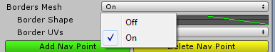

“Border Shape” allows you to practically draw the shape of the sidewalk/border to fit your needs. The curve represents a vertical section of the border mesh.

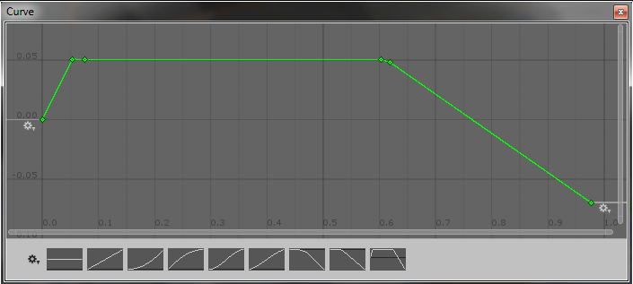

Right click anywhere on the coordinate window and select “Add Key” to create a new point, which you can drag around to modify the shape of the border mesh.

Final Steps:

"Finalize" will remove the script and delete all Nav Points leaving only the generated mesh. Use that if you are sure you no longer need to make changes to the generated mesh. This way you won’t need to worry about future version changes in the tool.

The package also includes "RiverFlow.cs" script which is used to create river-like effect by offsetting the coordinates of the material.

Porting Guide v2018

As of version v2018 the tool is completely ported to C#. The new C# scripts are put in a differently named folder “EasyRoadsMeshGen_CS” to avoid problems with the old package.

There are two ways to convert from the old JavaScript tool to the C# version.

**The first way** of converting is to completely remove the “EasyRoadsMeshGen” folder from your project, which will make all the objects that have previously had the MeshGen.JS script show up a “Missing” warning. After that you reimport the package from the Asset Store. Then you simply drag the ERMeshGen.CS script on top of the script slot of the message.

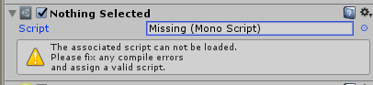

**The second way** is to delete the old MeshGen.JS script on your GameObject and add the ERHelper.CS script to it alongside ERMeshGen.CS. Then you will need to setup the road’s width, subdivision, UV scale, etc. and after that go to the ERHelper.CS component and click “Fix Nav Points” which will assign all the existing child Nav Points to the navPoint array (as long as they haven’t been renamed manually). The downside of doing things this way is that you will have to manually set the road parameters, however unlike the first way, you won’t be forced update all of the Game Objects that use the old scripts, which allows you to gradually switch to the new package as you use it.

FAQ: <https://forum.unity.com/threads/easy-roads-mesh-gen-faq-by-kris-development.469553/#post-3245339>

Report any problems with the tool at

[hropenmail01@abv.bg](mailto:hropenmail01@abv.bg)

or at

[krisdevmail@gmail.com](mailto:krisdevmail@gmail.com)