A GIS Flow Data Model

Alan Glennon and Michael Goodchild
National Center for Geographic Information and Analysis
University of California, Santa Barbara

Original: 12 October 2004
Revised: 18 April 2005

Introduction

Geographic change often is manifested through the collective movements of people, materials, and ideas. Flows represent the aggregate movement of these collectives. Depicting flows and movement on maps present an ongoing challenge to cartographers (Tufte 2001). While maps have portrayed geographic flows since at least the mid-1800s (Minard 1869, Tufte 2001), computer techniques for mapping geographic flows began developing in the 1970s and 1980s (Tobler 1987). Computers’ ability to store large amounts of data offers great potential, yet poses many challenges for optimally storing, visualizing, and analyzing flow information. In 1987, Waldo Tobler designed the Flow Mapper computer program as a method to quickly map discrete, node-to-node flows (Tobler 2003). In 2003, Flow Mapper was updated to operate as a standalone program within Microsoft Windows (Center for Spatially Integrated Social Science (CSISS) 2004).

Flow Mapper offers a generic template for mapping flows, however it is not directly integrated with other GIS software. Developing flow mapping functionality within a customizable Geographic Information System (GIS) offers increased flexibility for users working with flow-oriented projects. ArcGIS—a widely-used GIS—offers a generic, but customizable spatial database, visualization, and analytical platform. Incorporating methods for standardized flow mapping and analysis within ArcGIS promises new tools that can be tailored by a large user community.

This paper describes an effort to integrate flow mapping and analytical capabilities into ArcGIS. This objective will be approached by developing a generic GIS database template for flow information. With this generic data model, common functionalities like flow path representation and net flow calculation will be developed. The successful outcome will be a Flow Data Model, a standardized ArcGIS database organization for flows.

ArcGIS Data Models
The ArcGIS software suite, developed by ESRI, is the most widely used GIS (ESRI 2004). ArcGIS data models are intended to provide template spatial database designs and encourage consistency in the design of databases used for similar purposes.

The data models are intended to: 1) assist users unfamiliar with GIS data types to identify how information is stored for their discipline, 2) organize data in a standardized way for specific user groups, 3) provide users with a common database design template that can be populated with their project data, and 4) promote an environment where discipline-specific functionality can be more easily developed and used (ESRI 2004).

When ad hoc database designs are used, they usually must be reorganized—often including detailed examination of project metadata—for them to be integrated into new projects. Using the standardized organization of data model template, previous project data can be more easily integrated into new projects. Over twenty ArcGIS data models have been created, including hydrology, geology, census data, street addresses, transportation, and telecommunications (Maidment 2002, Arctur and Zeiler 2004). A basic data model consists of an object model diagram showing the classes and relationships of the database, an explanation of the design, and a digital geodatabase template for ArcGIS (ESRI 2004).

Flow Data Model Project History

1987—Waldo Tobler creates the original Flow Mapper program.

2003—CSISS funds Waldo Tobler and David Jones to update Flow Mapper. The program uses input location coordinates and a table of interaction between coordinates. The program represents gross, net, or bi-directional flow with volume-scaled bands and arrows (Tobler 2003).

February 2004—Michael Goodchild begins supervision of Ph.D. student Alan Glennon to work on a flow data model for ArcGIS. In addition to the basic model, the intent is to integrate the capabilities of Flow Mapper into ArcGIS.

March–April 2004—Goodchild and Glennon develop use cases, design Unified Modeling Language (UML) schematics for the cases, and implement them in ArcGIS.

May 2004—Goodchild and Glennon examine commonalities among the use cases and create a generic model in UML. The original use cases are then re-implemented with respect to the generic model.

June 2004—Programming begins on software to support the generic data model. The Flow Data Model Tools is designed to offer basic import, export, cartographic, and analytic functionality.

January 2005—Prototype Flow Data Model Tools source code made available online at the Center for Spatially Integrated Social Science website: http://www.csiss.org

February 2005 to April 2005—Various coding issues resolved. GIScience article about implications of object-oriented concepts and geographic data models underway.

Approach
The procedure for the development of the flow data model consisted of seven steps:

- outlining use cases;
- developing UML diagrams of the use cases;
- implementing the use cases in ArcGIS;
- distilling the use cases into a generic model and representing it in UML;
- re-implementing the use cases with the generic model;
- examining the results of the generic model; and
- revising the generic model.

The model could be expanded indefinitely as additional use cases are applied. However, for the prototype project, the flow data model will be considered complete when it: 1) provides a structure to hold flow information for three use cases, including the ability to handle network and node-to-node flow, and 2) incorporates the capabilities, particularly with respect to cartographic representation, of Flow Mapper into ArcGIS.

Use Cases
In an effort to characterize common database organization of flows, three diverse use cases were developed. The cases were chosen to include node-to-node flows, flows along networks, and a situation where node-to-node and network flows occur in proximity. These cases include: human migration in the United States (node-to-node flow), Minard’s map of Napoleon’s March on Moscow (flow along a network), and subsurface flow routes in a karst watershed (network and node-to-node flows).

Human Migration
The human migration use case used an interaction table from the 2000 Census to map the net migration of the twenty largest state-to-state migrations (Table 1). The case exhibited node-to-node flow. The case required input and output locations, as well as a magnitude for the flow. Typically, the flow would be cartographically represented as a thicker line for larger magnitude values. The human migration case represented the flow type handled by Flow Mapper. Flow Mapper operates by loading an interaction table and representing its values as lines with respect to the from-to index locations. Since interaction table operations are not native to ArcGIS, import capabilities will be necessary to translate interaction tables into this project’s ArcGIS data model. Examples of additional node-to-node flow cases can be found on CSISS Flow Mapper website: http://www.csiss.org/clearinghouse/FlowMapper/

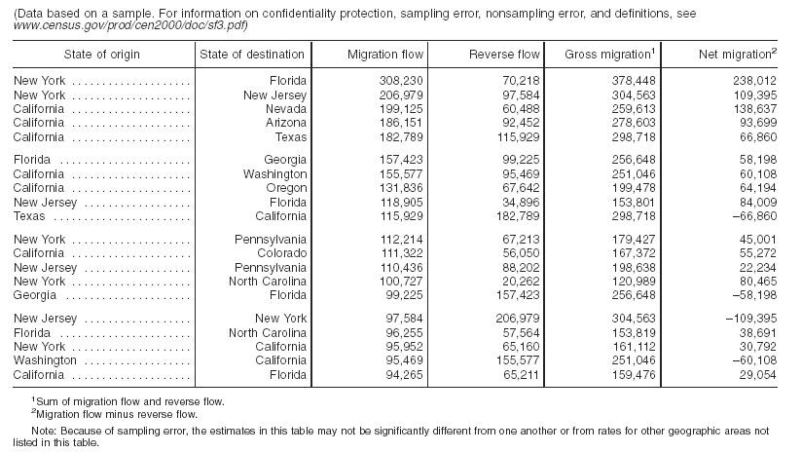
Table 1. The 20 Largest State-to-State Migration Flows: 1995-2000 (U.S. Census Bureau, 2003).

Minard’s map of Napoleon’s March on Moscow
Charles Joseph Minard’s map of Napoleon’s march on Moscow represents flow along a known network (Figure 1). The map shows the path and attenuation of Napoleon’s army in its 1812-1813 Russian Campaign (Minard 1869). Minard uses proportional line thickness to track the diminishing size of the army. The army starts with 422,000 individuals and returns with 10,000. The army’s decreasing size highlights the need for the flow data model to incorporate changes in quantity through space. Additionally, the map shows two troop detachments that diverge and converge along the course of the campaign. A binary shading scheme represents the troops’ advance and retreat. City names and longitude lines provide spatial reference. The map has been lauded for its elegant, concise display of information (Tufte 2001). The Minard map required separating the map into its component parts and outlining their relationships in a manner that would convey the same message as the original. Best practices and the implications of developing GIS databases through map deconstruction in this manner is a topic that should be further explored. Note: Additional information about the Minard can be found on the CSISS Classics website: http://www.csiss.org/classics/content/58

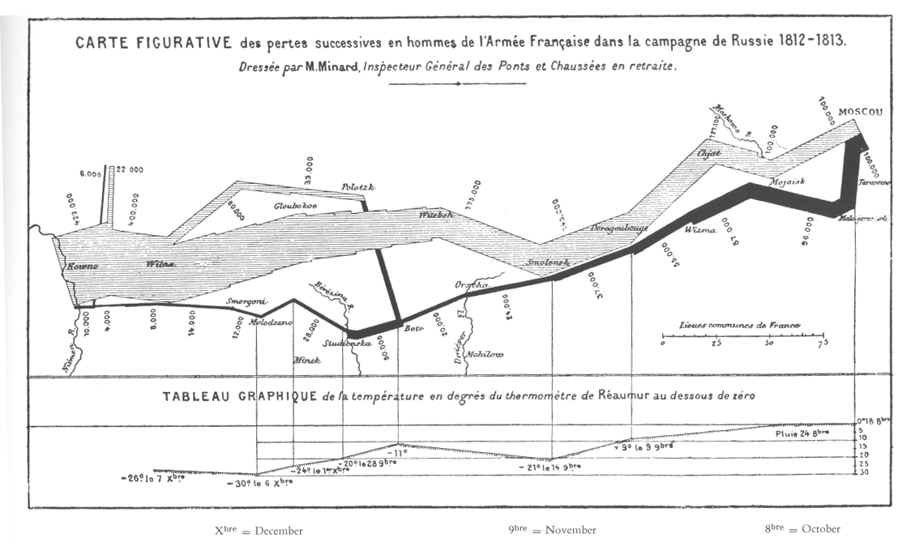
Figure 1. Napoleon’s March to Moscow, 1812-1813 (Minard 1869).

Subsurface Flow Routes in a Karst Watershed
The karst use case was selected because it exhibits two kinds of flows: flows along a network—in this case, mapped cave streams—and node-to-node flows. Node-to-node flow occurs where only the input and output of a subterranean flow route is known. Commonly, in hydrologic studies of karst watersheds, a dye trace experiment is conducted to determine the output of a karst flow path. A dye injection location is the input node and the dye’s realized destination becomes the output node for the flow. In short, while some karst streams follow known networks, others follow uncertain paths (Ford and Williams 1989). The data for the use case are Kentucky Geological Survey’s karst watershed maps for the Campbellsville and Beaver Dam 30 x 60 quadrangles (Ray and Currens 1998a, 1998b). The maps portray both mapped and dye-traced flow routes of the watershed draining Mammoth Cave, Kentucky (Figure 2).

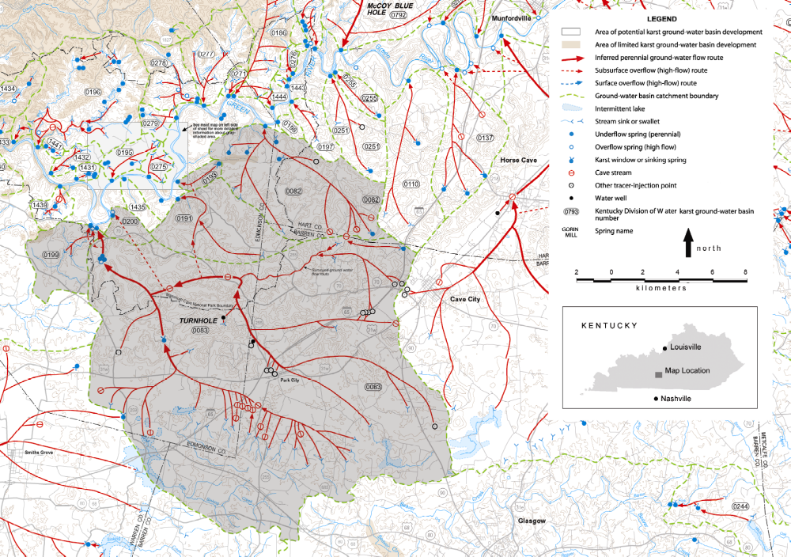
Figure 2. Karst Flow Routes at Mammoth Cave, Kentucky (Glennon and Groves 2002: modified from Ray and Currens 1998a, 1998b).

Assessing Commonalities within the Use Cases
Two situations are exhibited in the use cases: a condition where a flow follows a known path, and the condition where the exact path is either unknown, unmapped, or non-applicable, but input and output nodes are known.

In order to represent a geographic flow, the flow’s geometry and magnitude must be characterized. The data model requires the flow’s origin and destination be defined. In addition, a description of the magnitude of flow must be known: the magnitude can be a constant or a function of the flow’s length. The magnitude refers to the number of people, materials, or ideas moving from one location to another. Since this magnitude may change along the length of its flow, the flow data model should allow flexibility for magnitude to be assigned either as a constant or a function of the flow’s length.

The Generic Model
Taking the commonalities of these use cases, a generic model was developed in UML (Figure 3). UML is a diagrammatic notation for modeling systems using object-oriented concepts (Larman 1998). Definitions of the various components are defined below (see: Components of the Generic Model). The elements are organized into relationship and feature classes.

The relationship classes hold pointers to the geometry of the flow (pointers to input and output location, directionality, and length) and magnitude of items that are flowing. The feature classes hold coordinate and position information for points and polylines. For example, when a flow follows along a polyline, a component of the flow (networkreach) contains an attribute that references the appropriate polyline.

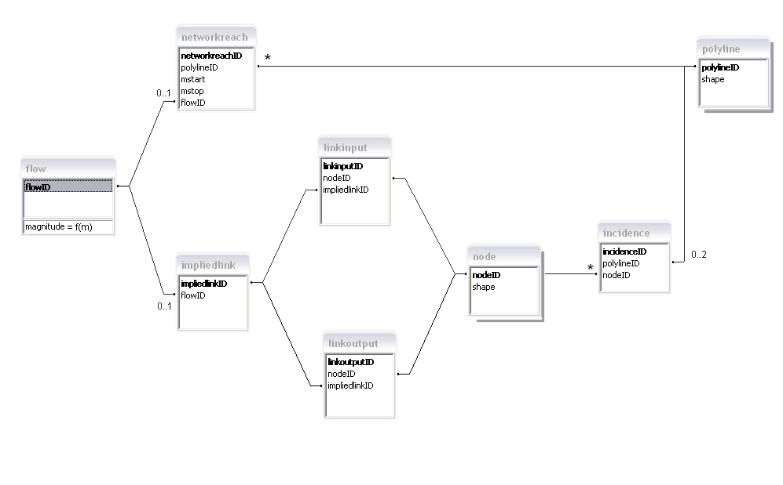
Figure 3. Flow Data Model

Implicit Data
Directionality and length are not directly assigned as attributes in any portion of the model. However, the relationship between the networkreach and polylines assign these values for the network flow case. The relationship between the impliedlink, nodeinput, nodeoutput, and nodes defines the directionality and length of node-to-node (non-network) flow.

In the network flow case, the following topology defines the process for determining length and directionality. As cartographic functionalities are added to the model, the values will likely be included as attributes of the derived polyline classes. Polylines possess a length, m; from the direction the polyline is created, the polyline begins at m_{origin}=0 and ends at m_{endpoint}=(total length of the polyline). In the case of a network flow (a networkreach), the flow starts at m₁ (called mstart) and ends at m₂ (called mstop) on the same polyline. In the model, a flow cannot span more than one polyline. The length of the flow is denoted by ∆m = (m₂ - m₁). If ∆m is positive, the flow follows along the direction of the polyline; if ∆m is negative, then the flow follows opposite the direction of the polyline. For node-to-node flow, the flow length is the euclidean distance between nodes. The direction can be determined by assessing the input and output node coordinates.

Components of the Generic Model
The following are definitions for the various classes and attributes presented in the flow data model.

RELATIONSHIP CLASSES

FLOW
Flow is the class that holds the quantity of the flow. This class’s association with a networkreach or impliedlink provide a flow’s length and direction.

Attributes:
flowID is a unique numeric identifier for an individual flow.

Method:
magnitude is a method that calculates a quantity based on a function of the polyline m. The magnitude is the amount of items flowing; allowing magnitude to change along the length of the flow allows for accumulation and attenuation. Conversely, the magnitude can also be assigned a constant if the amount stays consistent along the flow length.

NETWORKREACH
Networkreach is the class that refers to the geometry information for flows along a network. A network reach is able to follow the entire length or a portion of a polyline’s length.

Attributes:
networkreachID is a unique numeric identifier for an individual network reach.
polylineID refers to a single polyline along which the flow travels.
mstart is the location along the polyline where the flow begins.
mstop is the location along the polyline where the flow ends.
flowID refers to a single flow associated with the above attributes.
IMPLIEDLINK
ImpliedLink is the class that contains information for flows that travel uncertain routes between an input and an output node. An impliedlink stores flows that are not along networks.

Attributes:
impliedlinkID is a unique numeric identifier for an individual impliedlink.
flowID refers to a single flow associated with the impliedlink.

LINKINPUT
Linkinput is a relationship class that associates a single node with the input of an impliedlink.

Attributes:
linkinputID is a unique numeric identifier for an individual linkinput.
nodeID refers to a single node.
impliedlinkID refers to a single impliedlink object.

LINKOUTPUT
Linkoutput is a relationship class that associates a single node with the output of an impliedlink.

Attributes:
linkoutputID is a unique numeric identifier for an individual linkoutput.
nodeID refers to a single node that acts an input to the non-network flow.
impliedlinkID refers to a single impliedlink object.

INCIDENCE
Incidence is a relationship class that associates polylines and nodes. A single incidence refers to only one polyline and one node. When a node is linked to more than one polyline via incidences, the node becomes an intersection of polylines. The incidence relationship class provides a means of creating a variable number of intersections without changing the number of polyline or node attributes.

Attributes:
incidenceID is a unique numeric identifier for an individual incidence.
polylineID refers to a single polyline to be associated with a single node.
nodeID refers to a single node to be associated with a single polyline.

FEATURE CLASSES

NODE
Node is a single coordinate point (typically a x,y pair).

Attributes:
nodeID is a unique numeric identifier for an individual node.
shape is the coordinate location information for the point.

POLYLINE
Polyline is a feature representing a line containing one or more line segments.

Attributes:
polylineID is a unique numeric identifier for an individual polyline.
shape is the geometric information for the polyline.

Implementing the Generic Model on the Use Cases

Human Migration
The implementation of the human migration case include the components of the model that reference node-to-node flow (Figures 4 and 5). Thus, the impliedlink, linkinput, linkoutput, flow, and node classes are used. The components referring to polylines and network flow are inactive in this case.

Subsurface Flow Routes in a Karst Watershed
Since the karst routes follow both network and node-to-node paths, all classes of the model are used (Figures 6 and 7). For this initial ArcGIS implementation, an example, idealized case of the hybrid flow regime was created.

Napoleon’s March on Moscow
The Minard map uses the network components of the model: networkreach, polyline, incidence, node, and flow classes. Items specific to the case included the necessity to create an additional class to represent the advance or retreat of the army. Additionally, several nodes were associated with place names; an additional class was created to relate names with those nodes (Figures 8 and 9). The magnitude method has not yet been implemented, and will need to be developed in order to fully re-create the Minard map faithfully within the data model. For the current ArcGIS implementation, the flow lines were represented as differing line widths with respect to the mean magnitude along the flow.

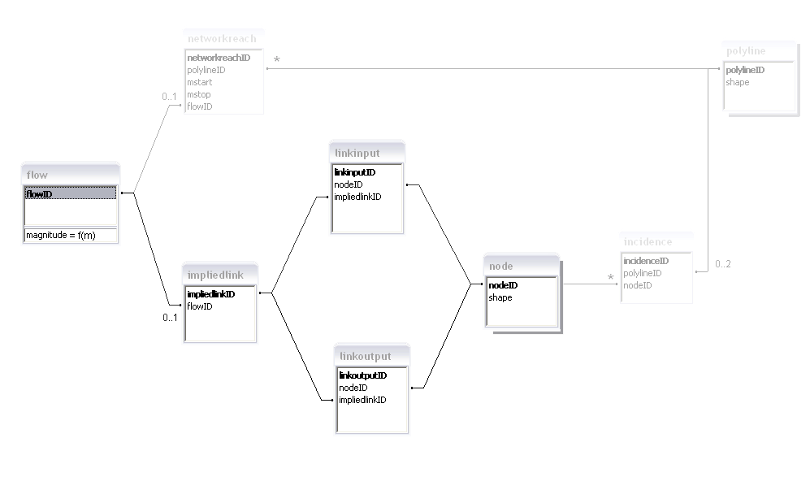
Figure 4. Active Model Components in the Human Migration Use Case.
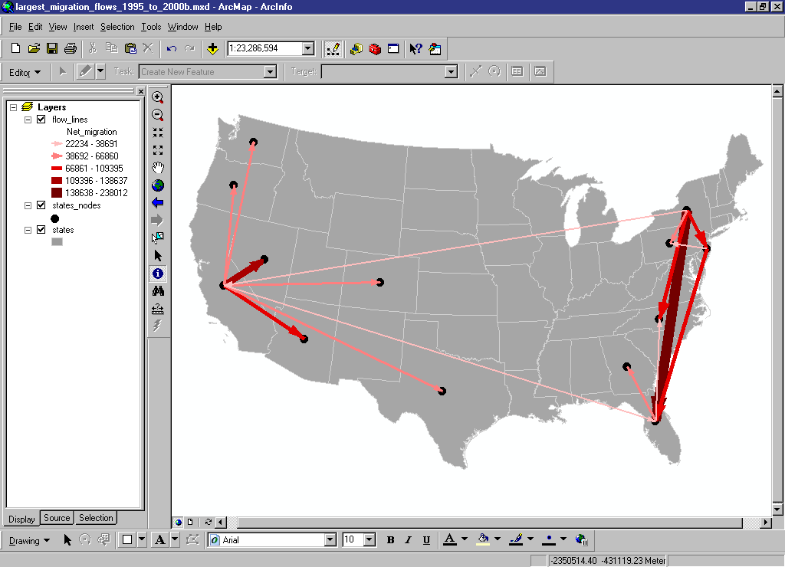
Figure 5. ArcGIS Implementation of the Human Migration Use Case (based on Census 2000).
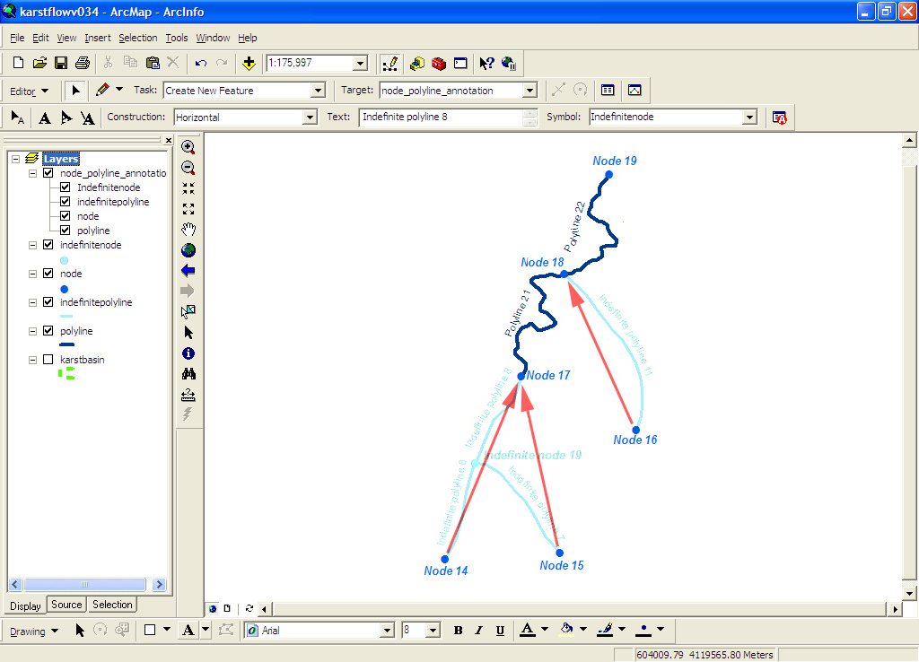
Figure 6. Active Model Components in the Karst Flow Route Use Case.
Figure 7. ArcGIS Implentation of the Karst Flow Use Case.
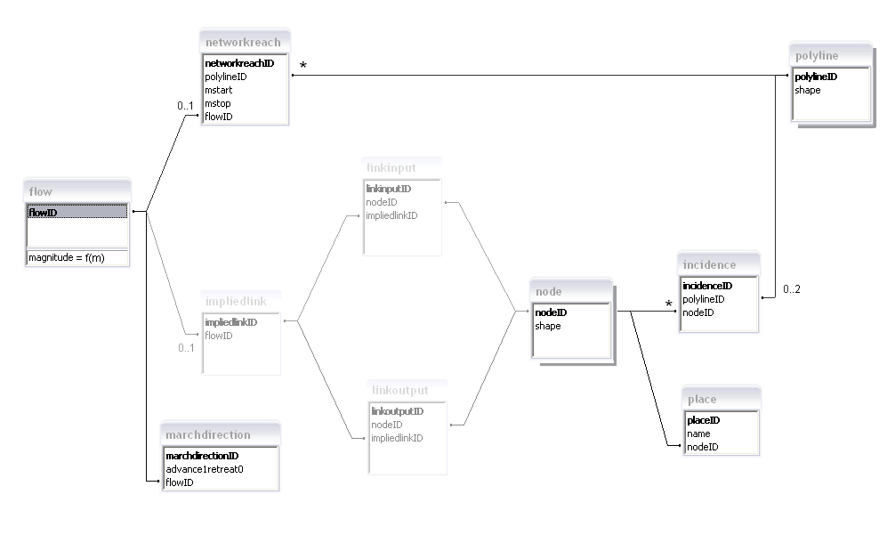
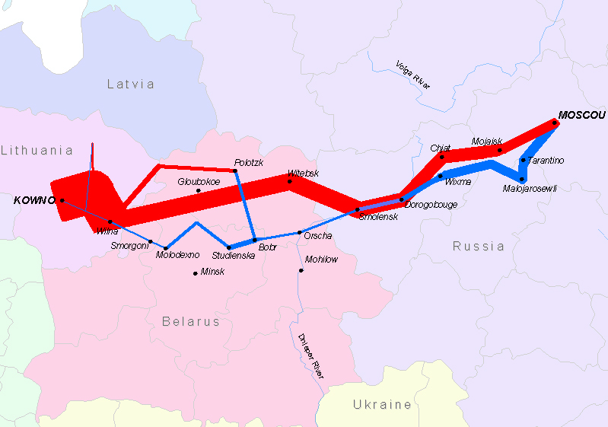
Figure 8. Active Model Components of the Minard Map Use Case.
Figure 9. ArcGIS Implementation of Napoleon’s March on Moscow (based on Minard 1869).
Ongoing and Future Work

The implementation of the use cases with the generic model demonstrated the need for software to interact with the model and provide cartographic representation. The model is able to store flow information, but does not depict the flow lines themselves. The project’s next step will be to add that cartographic functionality. Once flow line drawing is operational, the flow data model will have integrated the primary capabilities of Flow Mapper into ArcGIS. Visual Basic will be used to extract directionality and length information from the database, create polylines, and represent the flows on the map. Functionality to represent flow volume via line thickness or color gradient will also be developed. Additionally, the ability for magnitude to operate as a function of flow length will be implemented.

(April 18, 2005 note: prototype software to interact with the Flow Data Model has been created for ArcGIS. The source code can be found online at: www.csiss.org).

A future useful capability of the model would be to allow node-to-node flow paths to be influenced by a field attribute. For instance, in the karst example, a straight line is a typical way for the computer to depict a flow between input and output nodes. Under many circumstances, though, karst scientists map those flows with less-direct, curvilinear paths. The reason is that the uncertain paths of the karst flow follow trends in the potentiometric surface (water table). Karst streams flow toward and along troughs in the potentiometric surface. Using water well data, a water table map can be created. If the karst flow lines were able to react to the constraints of the highs and lows of the water table, the resulting paths would rarely be straight.

Lastly, the Network Analyst Extension, the Hydrology Data Model (ArcHydro), and Transportation functionalities may offer insightful ways to represent collective motion tracks. Given ongoing enhancements by ESRI and the GIS user community, new functionalities should be assessed, and, as appropriate, included into the model.

References

Arctur, D. and M. Zeiler. 2004. Designing Geodatabases: Case Studies in GIS Data Modeling. Redlands, California: ESRI Press, in press.

Center for Spatial Integrated Social Science. 2004. Tobler’s Flow Mapper, website introduction and description of functionalities. http://csiss.ncgia.ucsb.edu/clearinghouse/FlowMapper/

ESRI. 2004. Data Models. http://support.esri.com/index.cfm?fa=downloads.dataModels.gateway, posted February 9, 2004.

Ford, D.C. and P.W. Williams. 1989. Karst Geomorphology and Hydrology. London: Unwin Hyman.

Glennon, J.A. and C. Groves. 2002. An examination of perennial stream drainage patterns within the Mammoth Cave watershed. Journal of Cave and Karst Studies, vol. 64, pp. 82-91.

Larman, C. 1998. Applying UML and Patterns: An Introduction to Object-Oriented Analysis and Design. Upper Saddle River, New Jersey: Prentice Hall.

Maidment, D.R. 2002. ArcHydro: GIS for Water Resources. Redlands, California: ESRI Press.

Minard, C.J. 1869. Carte Figurative des pertes successives en hommes de l'Armée Française dans la campagne de Russie 1812-1813. Paris: Réginer et Dourdet.

Ray, J.A. and J.C. Currens. 1998a. Mapped karst ground-water basins in the Campbellsville 30 x 60 minute quadrangle. Lexington: Kentucky Geological Survey.

Ray, J.A. and J.C. Currens. 1998b. Mapped karst ground-water basins in the Beaver Dam 30 x 60 minute quadrangle. Lexington: Kentucky Geological Survey.

Tobler, W. 1987. Experiments in movement mapping by computer. The American Cartographer, 14:2. pp.155-163.

Tobler, W. 2003. Movement Mapping, unpublished paper, http://csiss.ncgia.ucsb.edu/clearinghouse/FlowMapper/MovementMapping.pdf

Tufte, E. 2001. The Visual Display of Geographic Information, 2nd ed. Cheshire,
Connecticut: Graphic Press.

United States Census Bureau. 2003. State to State Migration Flows: 1995-2000, CENSR-8. Washington, D.C, U.S. Department of Commerce.

