Design Help – Firehouse 3b4

3 Bedroom and 4 Baths

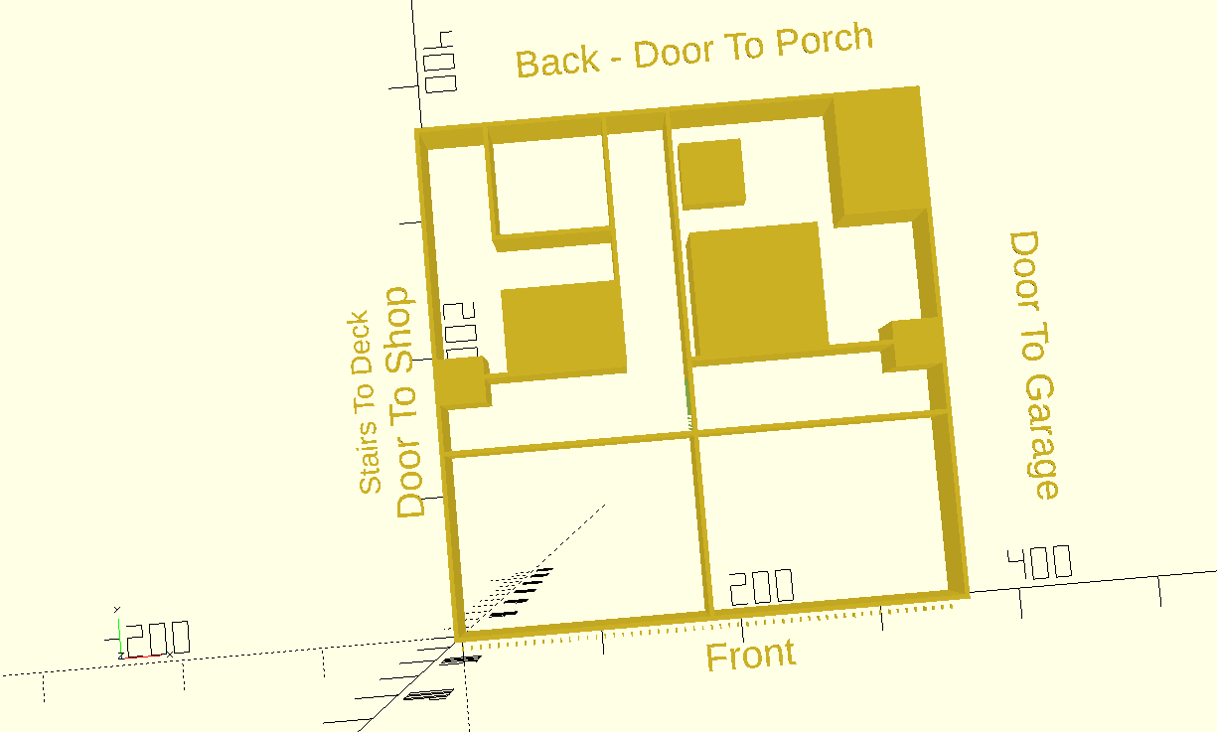

Sizing:

Main Rooms are 27 feet x 27 feet.

Wall thickness in this is assumed 6 inches (May vary based on sip manufacturer choice;

Front and Sides of house are .5 + 27 + .5 + 27 + .5 = 55.5 feet

scalefactor = 6.35; // scale factor - 1 foot eq 1/4 inch

elevatorsize = 5 feet

Eleveator is on garage side, and is sunk into wall. In hallway is cabinets that are expected to be 2.5 feet.

The elevator may exit on top floor to bedroom or hallway.

On groundfloor exit only to hallway.

3 Master Suites

2 suites upstairs and 1 suite down stairs

Each consists of bedroom, dual isle walk-in closet, bathroom, and sitting room.

Walk in closet is 14 x 14 feet.

Bathroom is 9 x 13 feet

Internal stairs is spiral and is 5 x 5 feet.

3 doors on ground floor to exterior.

1 on left to workshop/and external stairs.

1 on right to garage/car parking

1 in back to porch.

Hallways between left-right is 5 feet wide + 2.5 feet of cabinets.

Hallway to porch is 5 feet wide.

Front right side of ground floor is business office

Front left side of ground floor is yogo studio

Door to yogo studio is opposite spiral stairs

Door to business office is opposite elevator.

The T Structure on back of house is utility area for hvac, plumbing, fresh air etc.

Outdoor equipment for house will be in area between workshop and house.

Top Floor

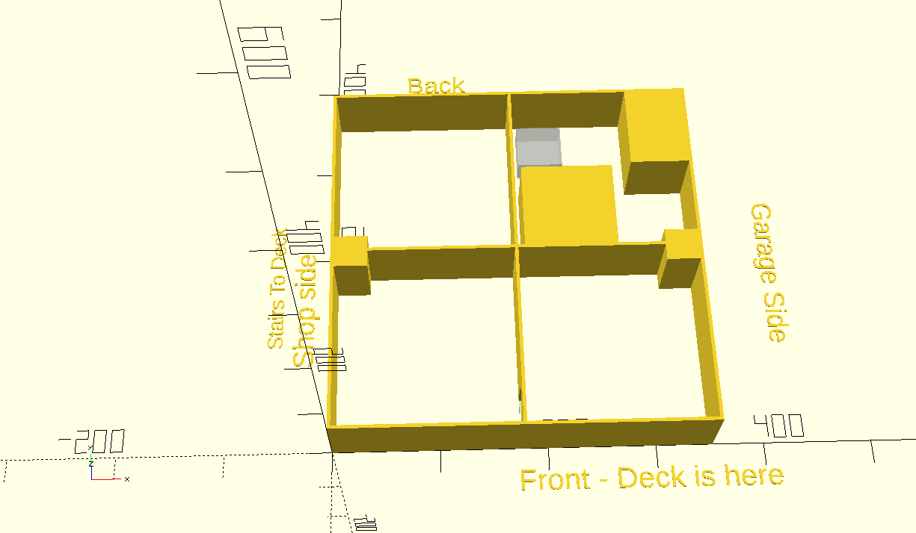

Upstairs consists of 4 rooms, 27 feet x 27 feet per side.

Two back room are master suite configs, example is shown on garage side.

The garage side is kitchen dinning room, with kitchen on inner wall.

A double wide door connects kitchen side to living room side. Wheel Chair capable.

There is a wheel chair capable door to the front deck on both sides. (Kitchen and Den)

The door to master suite is between elevator and walk in closet on one side, and between spiral stairs and walk in closet on other. (Two bedrooms are mirror image)

Pantry cabinets are on wall between kitchen and master suite on garage side.

Display cabinets are in living room and master suite wall on workshop side

Walk In Closet Design

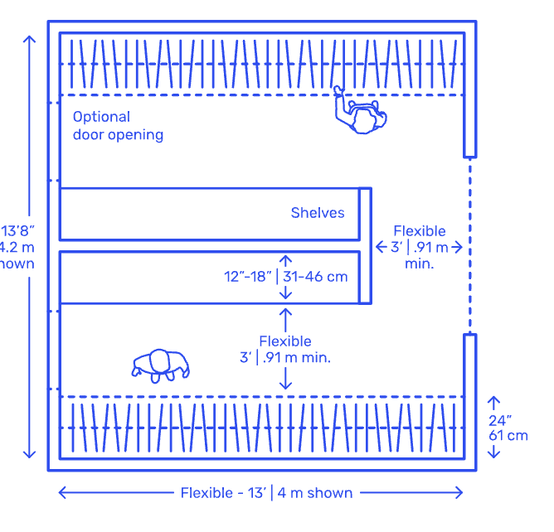

Reference:

<https://www.dimensions.com/element/split-double-sided-walk-in-closets>

Bathroom Design

Bathroom is 9 feet by 13.

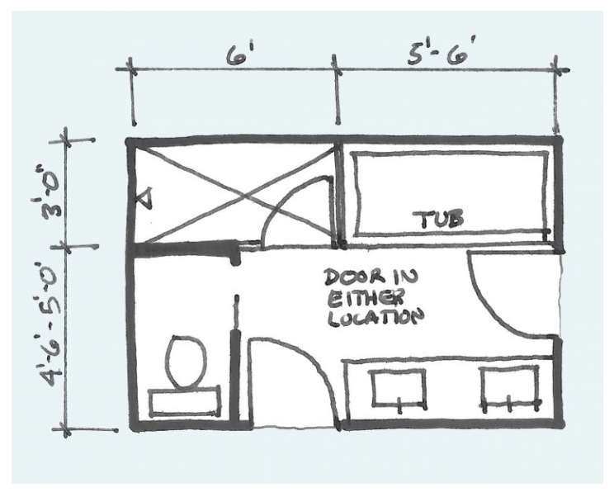

Tub is 6 Foot.

Shower is 4 x 6 feet.