Glen H. Piper  
Sam Houston State University  
Box 2192  
Huntsville, TX 77341-2192

To Whom It May Concern:

I am writing this letter of recommendation on behalf of Michael Alcantar, in support of his application for admissions t​o the Information Assurance and Security, Master of Science program at Sam Houston State University​.

I met Michael in my capacity as the IT@Sam Service Desk Manager. I have known Michael for almost three years, during which time he has distinguished himself as an exemplary employee of the Service Desk and the University. His dedication, attention to detail, and internal drive to succeed have set him apart and helped him earn promotion from a Tech I to a Tech II position at the Service Desk. He has a bright future, as he is committed to learning, improvement, and helping those around him succeed.

Michael has been a proud graduate of SHSU and an exemplar of SHSU' motto, "The measure of a life is its service." Michael has dedicated himself to serving the University community through his work at the Service Desk, providing skilled and knowledgeable technical support and being an outstanding teammate/member of the Service Desk team.

It is a logical next step, then, for Michael to further his skills and expertise through the pursuit of this degree. Michael has proven an ability to balance work and school, using both to positively inform each other, while completing his undergraduate degree, and I have the utmost confidence that the same will be true in the pursuit of this graduate degree. This program will enhance his ability to perform his job duties, and his job should provide many interesting examples to illustrate what is learned in the classroom.

I am happily available for further discussion of Michael's qualifications should the need/opportunity arise. I give Michael Alcantar my strongest recommendation, as your program and his cohort will benefit at least as much from his participation and contributions as he will benefit from participating in, and completing this graduate degree program.

Sincere Regards,

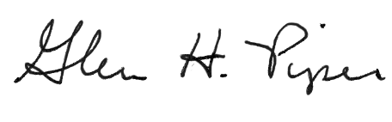

Glen H. Piper