ANZ (LK = local kurtosis)

|  |  |  |  |  |  |  |  |  |
| --- | --- | --- | --- | --- | --- | --- | --- | --- |
| Window | a | b | a+b | Kurtosis (implied by GARCH pars) | RMSE  (between Kurtosis and LK) | Stdev(LK) | Mean(LK) | LL |
| 100 | 0.0754 | 0.7119 | 0.7873 | 3.0925 | 1.3945 | 1.2988 | 3.6004 | -10365 |
| 200 | 0.0896 | 0.7842 | 0.8737 | 3.2182 | 1.2827 | 1.0848 | 3.9028 | -10412 |
| 300 | 0.0922 | 0.8175 | 0.9097 | 3.3287 | 1.1660 | 0.9127 | 4.0543 | -10434 |
| 400 | 0.0894 | 0.8439 | 0.9333 | 3.4238 | 1.1927 | 0.8599 | 4.2503 | -10450 |
| 500 | 0.0824 | 0.8723 | 0.9547 | 3.5437 | 1.1771* | 0.7550 | 4.4469 | -10468 |
| 600 | 0.0750 | 0.8940 | 0.9693 | 3.6861 | 1.1978 | 0.7421* | 4.6264 | -10480 |
| 700 | 0.0702 | 0.9068 | 0.9770 | 3.8326 | 1.2353 | 0.8184 | 4.7580 | -10488 |
| 800 | 0.0691 | 0.9110 | 0.9801 | 3.9628 | 1.2243 | 0.8652 | 4.8292 | -10491 |
| 900 | 0.0674 | 0.9158 | 0.9832 | 4.1237 | 1.2127 | 0.9207 | 4.9130 | -10496 |
| 1000 | 0.0653 | 0.9208 | 0.9861 | 4.3406 | 1.2472 | 1.0038 | 5.0810 | -10499 |
| 1100 | 0.0646 | 0.9233 | 0.9879 | 4.5900 | 1.2814 | 1.1027 | 5.2428 | -10502 |
| 1200 | 0.0647 | 0.9241 | 0.9888 | 4.8209 | 1.3230 | 1.2188 | 5.3360 | -10502 |
| T | 0.0645 | 0.9283 | 0.9927 | 7.0631 | 1.5360 | - | 8.5991 | -10505 |
| No target | 0.0658 | 0.9282 | 0.9939 | 10.5825 | 1.9834 | - |  | -10505 |
|  |  |  |  |  |  |  |  |  |
| 500 | 0.0795 | 0.8752 | 0.9547 | 3.5 |  |  |  |  |
|  | 0.0835 | 0.8665 | 0.95 | 3.5 |  |  |  |  |
| 500 | 0.1052 | 0.8495 | 0.9547 | 4 |  |  |  |  |
|  | 0.1104 | 0.8396 | 0.95 | 4 |  |  |  |  |
| 500 | 0.1215 | 0.8332 | 0.9547 | 4.5 |  |  |  |  |
|  | 0.1275 | 0.8225 | 0.95 | 4.5 |  |  |  |  |

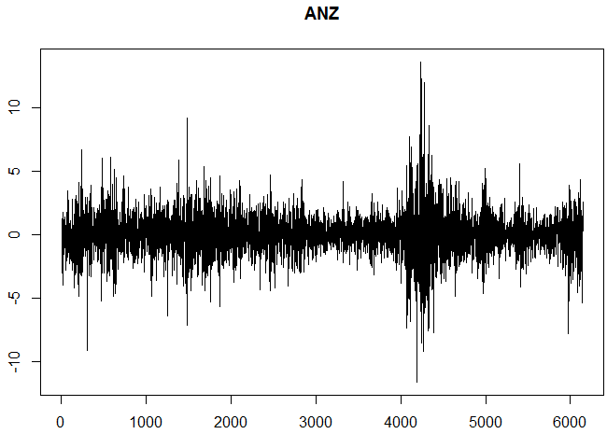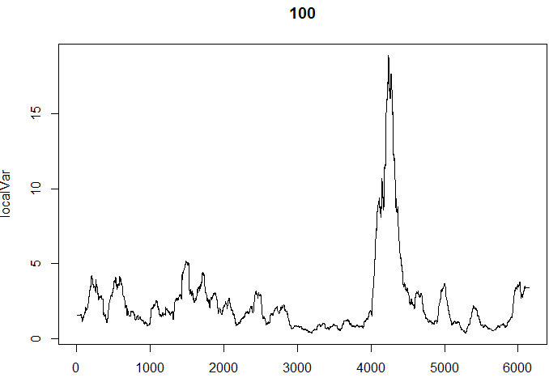 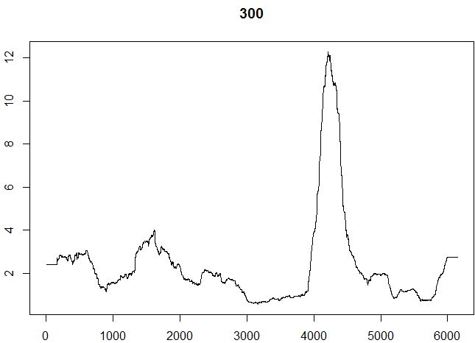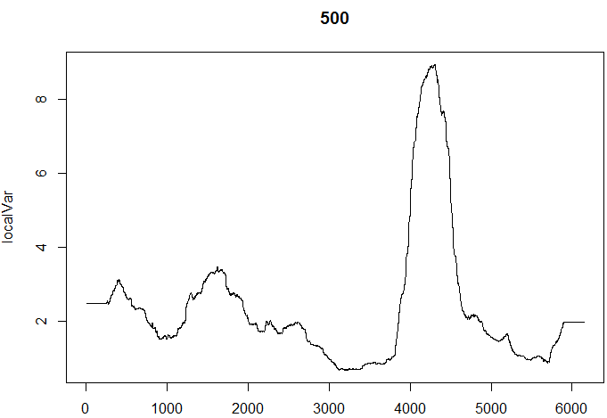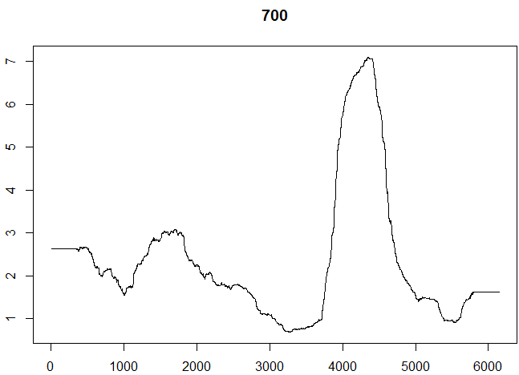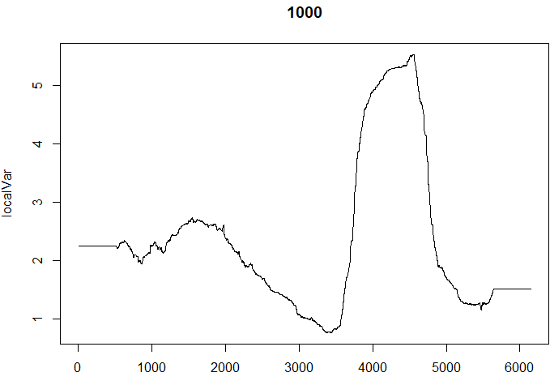

CBA

|  |  |  |  |  |  |  |  |  |
| --- | --- | --- | --- | --- | --- | --- | --- | --- |
| Window | a | b | a+b | Kurtosis | RMSE | Stdev(LK) | Mean(LK) | LL |
| 100 | 0.0708 | 0.7673 | 0.8381 | 3.1047 | 1.4428 | 1.3063 | 3.7175 | -9307 |
| 200 | 0.0845 | 0.8275 | 0.9120 | 3.2785 | 1.3877 | 1.1560 | 4.0464 | -9350 |
| 300 | 0.0870 | 0.8420 | 0.9292 | 3.3742 | 1.2184 | 0.9146 | 4.1793 | -9359 |
| 400 | 0.0875 | 0.8554 | 0.9428 | 3.4793 | 1.2132 | 0.8226 | 4.3711 | -9370 |
| 500 | 0.0873 | 0.8653 | 0.9527 | 3.5934 | 1.1095 | 0.6541 | 4.4897 | -9380 |
| 600 | 0.0868 | 0.8745 | 0.9613 | 3.7418 | 1.0026 | 0.5330 | 4.5910 | -9389 |
| 700 | 0.0865 | 0.8797 | 0.9662 | 3.8714 | 0.9289 | 0.5143* | 4.6449 | -9394 |
| 800 | 0.0874 | 0.8808 | 0.9682 | 3.9687 | 0.8655 | 0.5287 | 4.6539 | -9397 |
| 900 | 0.0881 | 0.8821 | 0.9701 | 4.0731 | 0.8817 | 0.5537 | 4.7593 | -9400 |
| 1000 | 0.0876 | 0.8862 | 0.9738 | 4.2657 | 0.8418* | 0.5879 | 4.8683 | -9404 |
| 1100 | 0.0873 | 0.8896 | 0.9769 | 4.5057 | 0.8513 | 0.6686 | 5.0328 | -9408 |
| 1200 | 0.0874 | 0.8918 | 0.9791 | 4.7617 | 0.8466 | 0.7804 | 5.0902 | -9410 |
| T | 0.0894 | 0.8954 | 0.9849 | 6.4154 | 2.1333 | - | 8.5487 | -9406 |
| No target | 0.0886 | 0.8955 | 0.9841 | 6.0001 | 2.5485 | - |  | -9406 |
|  |  |  |  |  |  |  |  |  |
| 700 | 0.0992 | 0.8708 | 0.97 | 4.5 |  |  |  |  |
| 1000 | 0.0992 | 0.8708 | 0.97 | 4.5 |  |  |  |  |
|  | 0.1087 | 0.8613 | 0.97 | 5 |  |  |  |  |
|  |  |  |  |  |  |  |  |  |

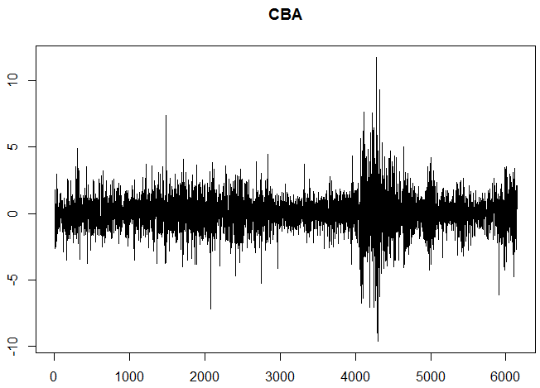 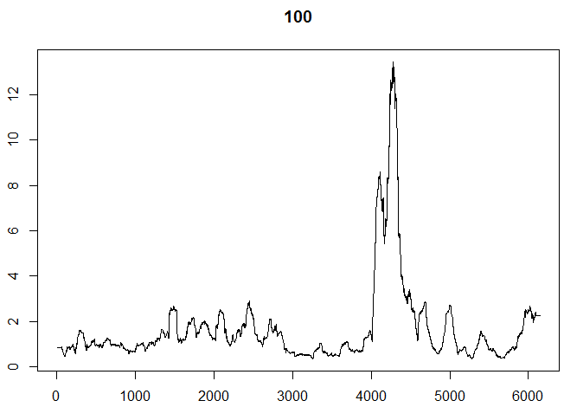 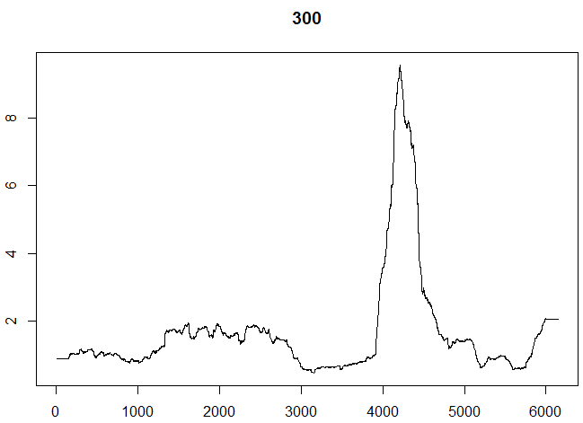 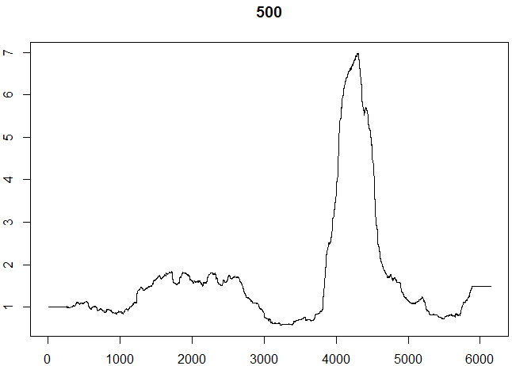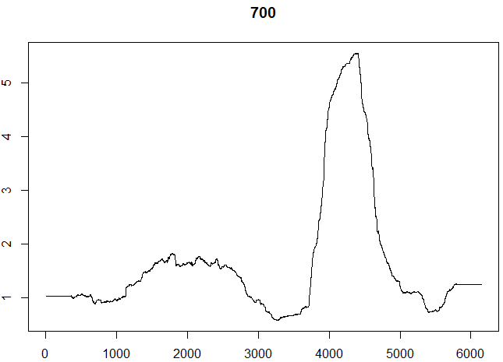 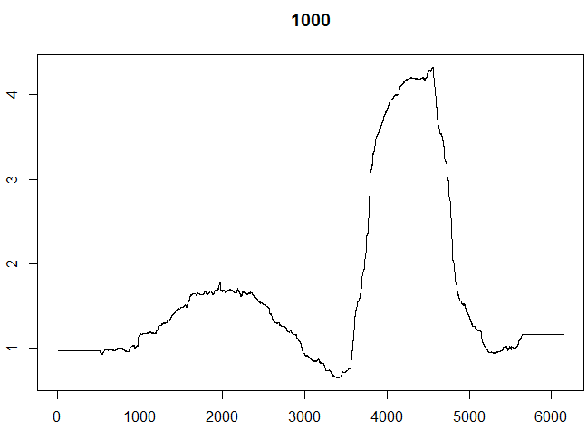

NAB

|  |  |  |  |  |  |  |  |
| --- | --- | --- | --- | --- | --- | --- | --- |
| Window | a | b | a+b | Kurtosis | RMSE | Stdev(LK) | LL |
| 100 | 0.0539 | 0.7834 | 0.8373 | 3.0594 | 3.0799 | 2.8760 | -9913 |
| 200 | 0.0767 | 0.7911 | 0.8678 | 3.1499 | 3.9520 | 3.6319 | -9955 |
| 300 | 0.0840 | 0.8190 | 0.9029 | 3.2482 | 4.6164 | 4.1282 | -9993 |
| 400 | 0.0873 | 0.8316 | 0.9188 | 3.3252 | 5.0908 | 4.4588 | -10012 |
| 500 | 0.0869 | 0.8485 | 0.9354 | 3.4129 | 5.1545 | 4.3729 | -10029 |
| 600 | 0.0860 | 0.8600 | 0.9456 | 3.4874 | 5.0864 | 4.1747 | -10038 |
| 700 | 0.0862 | 0.8659 | 0.9521 | 3.5675 | 4.8355 | 3.8300 | -10041 |
| 800 | 0.0886 | 0.8651 | 0.9538 | 3.6319 | 4.6534 | 3.5469 | -10045 |
| 900 | 0.0897 | 0.8668 | 0.9565 | 3.6983 | 4.7192 | 3.5516 | -10046 |
| 1000 | 0.0911 | 0.8689 | 0.9600 | 3.8062 | 4.6239* | 3.4254* | -10048 |
| 1100 | 0.0901 | 0.8748 | 0.9649 | 3.9228 | 4.8610 | 3.5885 | -10055 |
| 1200 | 0.0894 | 0.8794 | 0.9689 | 4.0595 | 4.9574 | 3.6750 | -10059 |
| T | 0.0948 | 0.8849 | 0.9798 | 5.4394 | 6.6285 | - | -10048 |
| No target | 0.0920 | 0.8855 | 0.9775 | 4.8453 | 7.2225 | - | -10048 |

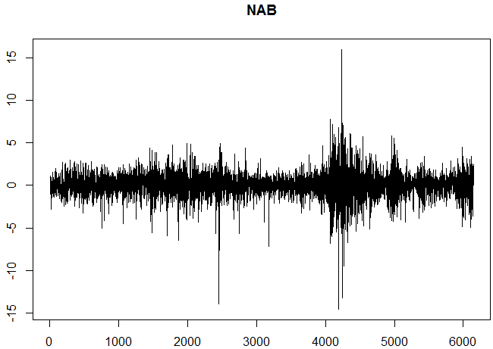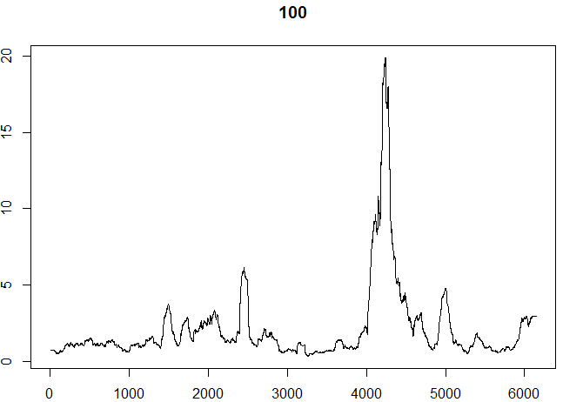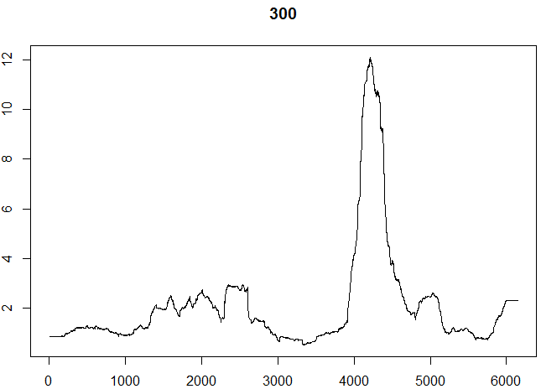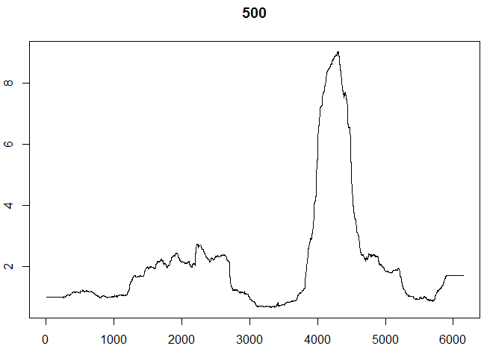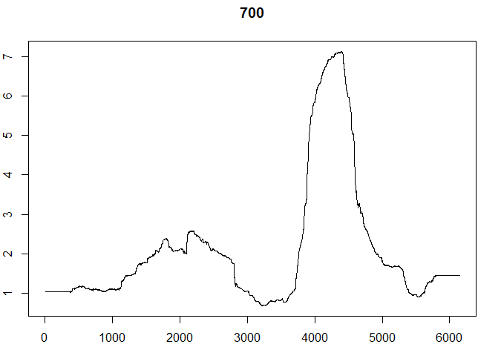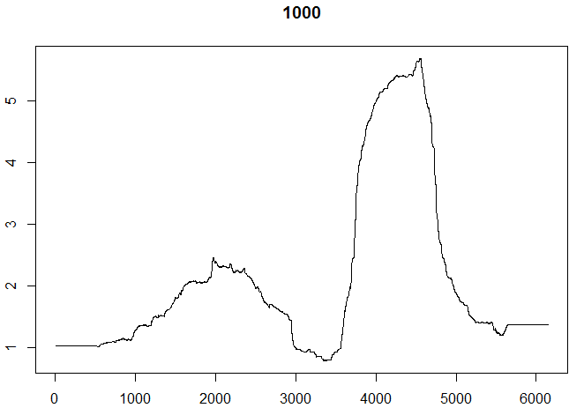

WBC

|  |  |  |  |  |  |  |  |
| --- | --- | --- | --- | --- | --- | --- | --- |
| Window | a | b | a+b | Kurtosis | RMSE | Stdev(LK) | LL |
| 100 | 0.0623 | 0.7406 | 0.8029 | 3.0669 | 1.0501 | 1.0019 | -10239 |
| 200 | 0.0771 | 0.8245 | 0.9016 | 3.2034 | 1.0870 | 0.9949 | -10292 |
| 300 | 0.0775 | 0.8590 | 0.9364 | 3.3241 | 1.0579 | 0.9442 | -10315 |
| 400 | 0.0730 | 0.8850 | 0.9576 | 3.4420 | 1.0786 | 0.9483 | -10330 |
| 500 | 0.0695 | 0.8999 | 0.9695 | 3.5753 | 0.9840 | 0.8419 | -10337 |
| 600 | 0.0686 | 0.9062 | 0.9748 | 3.7013 | 0.7308 | 0.6027 | -10342 |
| 700 | 0.0665 | 0.9130 | 0.9796 | 3.8401 | 0.6513 | 0.5700* | -10346 |
| 800 | 0.0662 | 0.9153 | 0.9814 | 3.9349 | 0.6234* | 0.5790 | -10348 |
| 900 | 0.0660 | 0.9170 | 0.9829 | 4.0394 | 0.6792 | 0.6464 | -10350 |
| 1000 | 0.0655 | 0.9197 | 0.9852 | 4.2385 | 0.7440 | 0.7313 | -10353 |
| 1100 | 0.0650 | 0.9220 | 0.9868 | 4.4245 | 0.7553 | 0.7524 | -10356 |
| 1200 | 0.0647 | 0.9234 | 0.9881 | 4.6422 | 0.8038 | 0.8015 | -10357 |
| T | 0.0656 | 0.9252 | 0.9908 | 5.6401 | 0.8974 | - | -10358 |
| No target | 0.0663 | 0.9251 | 0.9914 | 6.1388 | 0.3988 | - | -10358 |

