Ex1: Simple

Before trying to make input decks for serpent and mcnp it is important to make sure these programs are running properly. Try running the simple input decks provided. These are not identical, so you don’t need to worry about the results, it’s just to see if the programs are running.

For mcnp, navigate to the simple-mcnp folder in the command prompt/ terminal and then use the command:

/opt/mcnp61/MCNP_CODE/bin/mcnp6 i=deck.txt

For Serpent, navigate to the simple-serpent folder and use:

/opt/serpent/Serpent-2.1.25/sss2 deck.txt

Ex2: G1

Next we want to make Godiva sphere input decks, run them, and compare the results.

Make the sphere shown below. Set all temperatures and libraries to 300K or as close to as possible. Use the endfb7 libraries. Set an initial source guess at the origin of 10,000 neutrons, and use 200 inactive cycles and 400 active cycles to run.

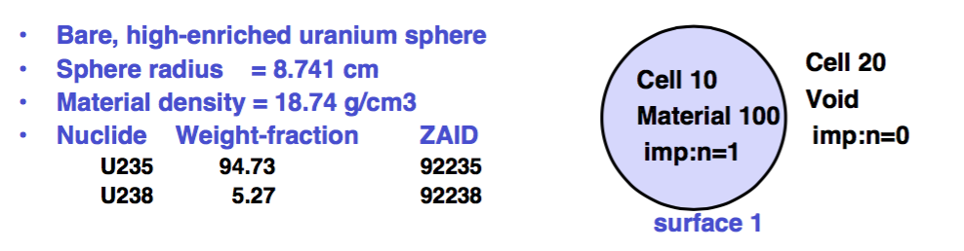

To do this, open up the decks provided and fill in using the comments as guide lines. For more help, reference the serpent manual and the mcnp slides. These problems are listed in the mcnp slides with some slight differences.

Hints:

* mcnp uses c for comments. Serpent uses %
* Mcnp uses MeV for the units on temperature. Serpent uses Kelvin.
* Info on libraries is listed in the docs folder of serpent (sss_ace_endfb7.pdf) and at the end of the mcnp manual.
* Positive surface defficn

Ex3: G2

Copy the G1 folders to G2 folders and change the initial source guess from being at the origin to being evenly distributed through the sphere. In mcnp this is done using SDEF instead of KSRC in the data card. In serpent this is done by specifying a cell source in the src.

Ex4: Puc1

Now we are going to do a slightly more challenging geometry. Here we have a can filled part way with liquid fuel. There are lots of ways to make this geometry. For now, lets use 2 cylinders with an infinite plane intersecting them.



Mat 100:

Material density = 9.927e-2 atoms/b-cm

ZAID Atom Fraction

1001 6.007e-2

8016 3.654e-2

7014 2.3611e-3

94239 2.7682e-4

Mat 200:

Material density = 8.636e-2 atoms/b-cm

ZAID Atom Fraction

26056 1

Put an initial source point in at the origin like g1 and use the same 10,000 neutrons, 200 inactive cycles, and 400 active cycles. It may be easiest to start with the G1 files and edit the geometries and materials as needed.

hint:

* It most be specified that the hydrogen and oxygen are bonded in mat 100 by using lwtr.lib in both serpent and mcnp

**Didn’t finish? Don’t have a key? Try Remote Login**

If you want to access Jeff Kings computer lab remotely you can while on campus or connected to the vpn.  Use the ssh command in terminal.

The host names are (Mac/Windows names):  
  
Silverbolt/Motormaster  
Slingshot/Wildrider  
Fireflight/Breakdown  
Airraid/Deadend  
Afterburner/Blot  
Lightspeed/Sinnertwin  
Strafe/Rippersnapper  
Silverbolt/Motormaster  
Slingshot/Wildrider  
  
To connect, on the Mines campus you can just do  
  
ssh <username>@ <computerName>  
  
e.g. I would do  
  
ssh trider@Airraid

If you want to move files between your computer and King’s computers use the command scp in terminal. The file must be compressed before moving.

scp <location of file on your computer> <location on kings computer you want it located>

for example to move the Day1 materials I used:

scp /Users/tessahennigh/Desktop/Computational_Reactor/Day1.zip trider@nosecone:nuclear/Computational

After connecting with ssh, add nohup before your command, and > output.txt & at the end.

HH220-computer:~/yourfolder$ nohup ../../[...]/sss2 input.txt > output.txt &

This will launch the command in the background, not tied to a terminal. The > output.txt prints the output that would normally appear in the terminal to a file named output.txt.

Then you can exit the terminal, and your calculations will go on in the server (as long as nobody manually turn off the computer in hh220).

If you want to cancel the job for some reason, enter 'top' in the terminal, note the number of the process, PID (91234 for example). Then, type 'kill 91234' to stop the process.

If you want to check where it's at, you can do 'tail -20 output.txt' (print the last 20 lines of the output file).

I also recommend to check the 'top' command before starting your job, to check if anyone else is running anything at the same time (you'll see a bunch of random Mac hardware process, but look out for sss2 or mcnp6 or other).

**Want a key instead?**

If you want a key to HH220 go to the Hill Hall office and ask for a form to request a key. You will need to fill this out, get it signed by Jeff King, return it to the HH office and then get a key printed by the campus lock smith.