**图像配准作业**

**自动化64张晟2160504107**

**一．手动标点：**

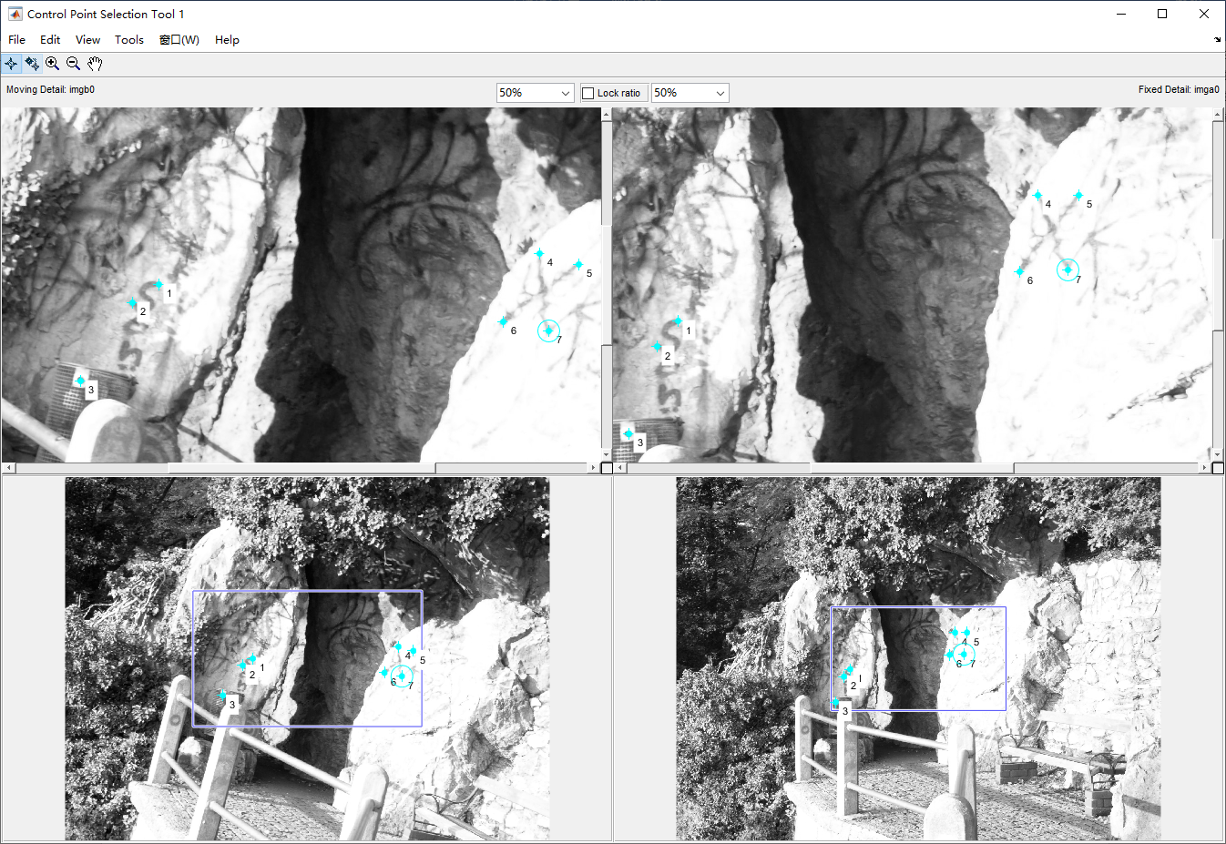

**二．输出两幅图中对应点的坐标：**

fixedPoints =

1.0e+03 *

1.309500000000000 1.447500000000000

1.263500000000000 1.503500000000000

1.201500000000000 1.695500000000000

2.099500000000000 1.171500000000000

2.189500000000000 1.171500000000000

2.059500000000000 1.339500000000000

2.165500000000000 1.335500000000000

movingPoints =

1.0e+03 *

1.079850095785440 1.043999521072797

1.021822318007663 1.084018678160919

0.907767720306513 1.256101053639846

1.916250478927203 0.975966954022988

2.002291666666666 0.999978448275862

1.836212164750958 1.126038793103448

1.936260057471264 1.146048371647509

**三．计算转换矩阵：**

计算转换矩阵H可利用MATLAB中的相应函数进行计算。

H=0.965966552615429 -0.249745221448456 0

0.270044719906046 0.978791967105633 0

-15.5433495893418 695.228355158347 1

**四．输出转换之后的图像：**

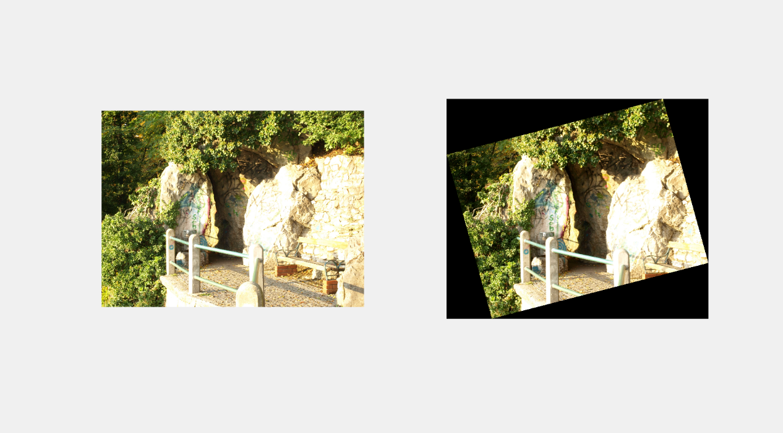

**五．代码示例：**

imga=imread('Image A.jpg');

imgb=imread('Image B.jpg');

imga0=rgb2gray(imga);

imgb0=rgb2gray(imgb);

cpselect(imgb0,imga0)

tform=cp2tform(movingPoints,fixedPoints,'affine');

Iout=imtransform(imgb,tform);

subplot(1,2,1),imshow(imga);

subplot(1,2,2),imshow(Iout);

p=getframe(gcf);

imwrite(p.cdata,['total.bmp']);

**六．心得体会：**

图像配准运用了图像的仿射变换方法，通过选取配对点并构造函数找出综合最优的变换矩阵。图像配准是数字图像处理的基本方法之一，有着广泛的应用。