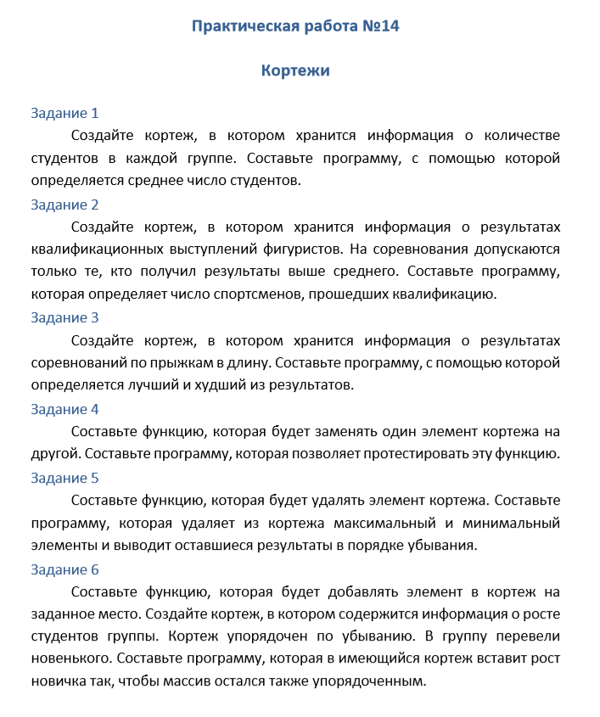

import random as r

# Задание 1

a =[]

for i in range(18):

a.append(r.randint(21, 30))

a = tuple(a)

sum1 = 0

for j in range(1,18):

sum1 += a[j]

print("Среднее кол-во студентов в группе>>", sum1 // j)

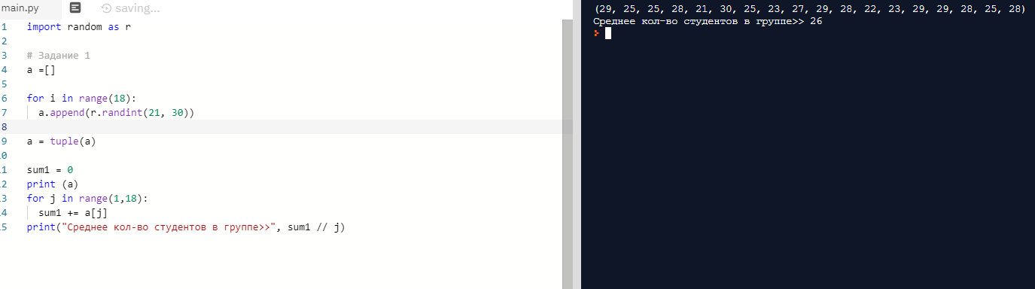

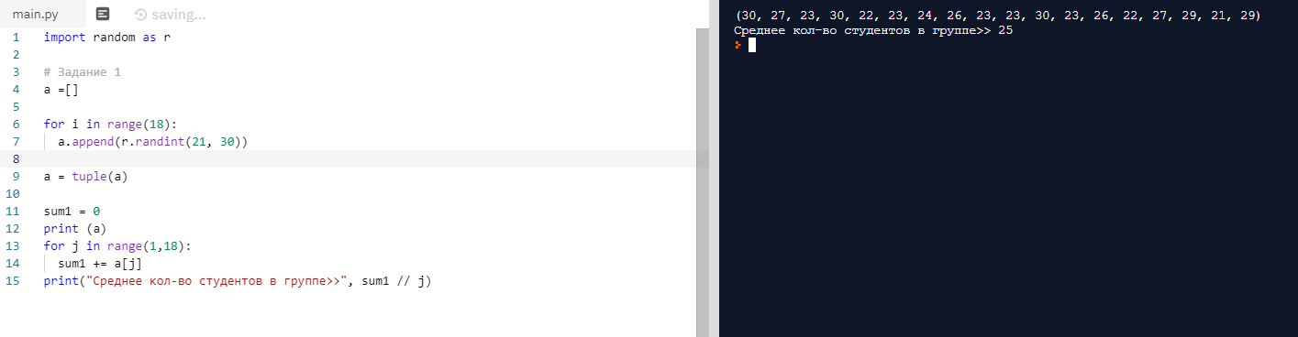

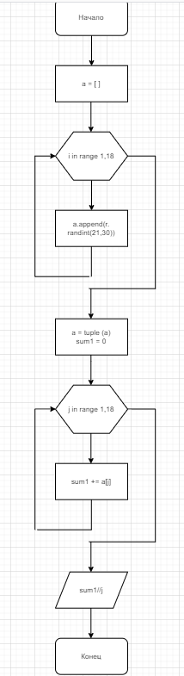

# Задание 2

a =[]

for i in range(18):

a.append(r.randint(0, 10))

a = tuple(a)

sum1 = 0

for j in range(18):

sum1 += a[j]

print(a)

middlemark = sum1 // j

print("Средний балл фигуристок>>", middlemark)

empty = 0

for k in range(18):

if a[k] > middlemark:

empty += 1

print ("Количество фигуристок прошедших квалификацию --->",empty)

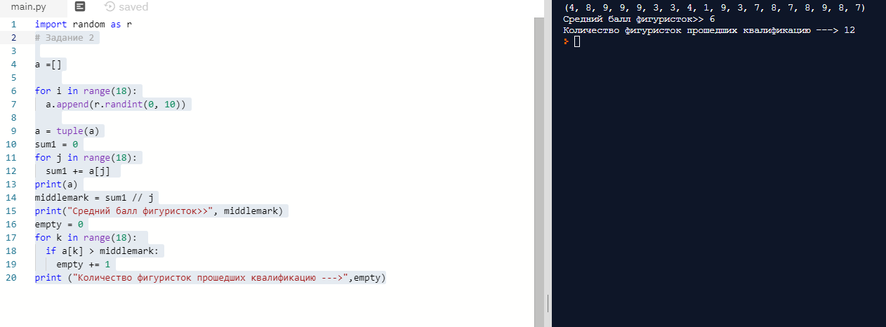

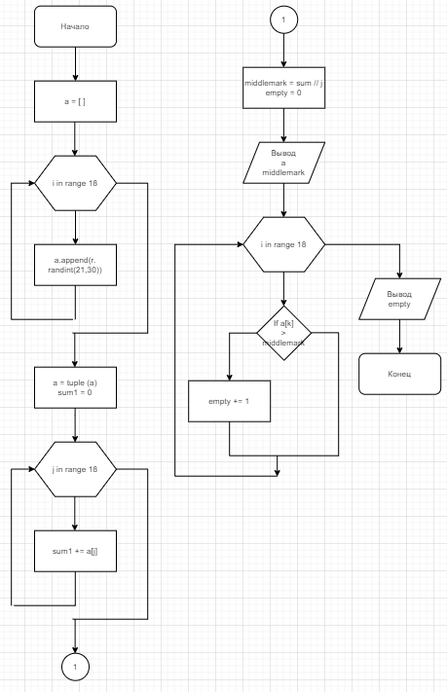

# Задание 3

a =[]

for i in range(18):

a.append(round(r.uniform(0, 3.73), 3))

a = tuple(a)

sum1 = 0

best = 0

worse = a[0]

for j in range(18):

if best < a[j]:

best = a[j]

if worse > a[j]:

worse = a[j]

print(a)

print("Лучший результат-->", best)

print("Худший результат-->", worse)

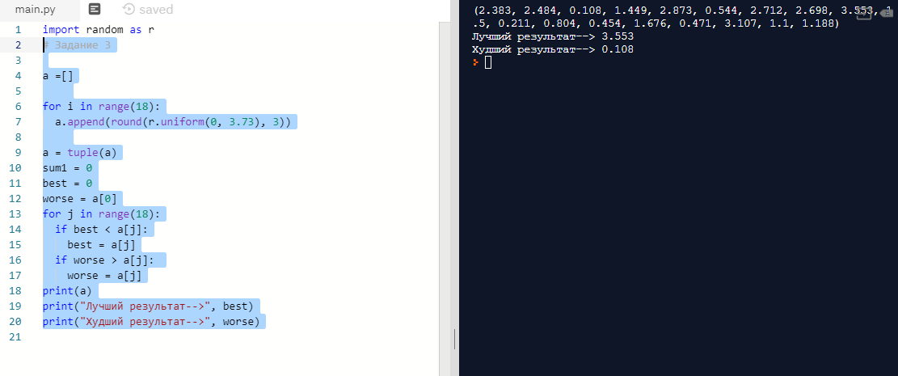

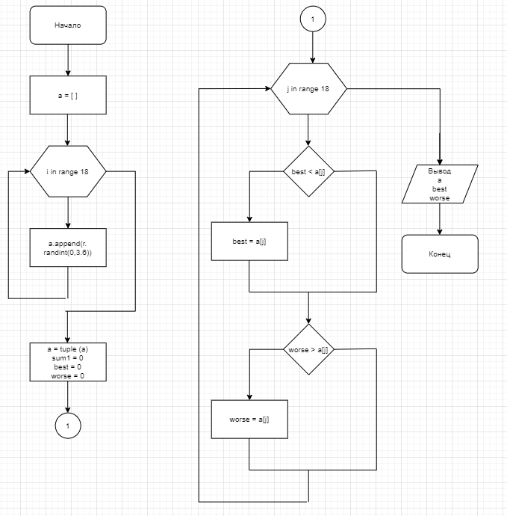

# Задание 4

def exchange(a1, find1, item1):

a2 = list (a1)

id = 0

for i in range(len(a2)):

if (a2[i] == find1):

id = i

break

if id == 0:

return "Такого элемента нет:(";

a2.pop(id)

a2.insert(id, item)

a1 = tuple (a2)

return tuple(a1)

a = []

for i in range(5):

a.append(r.randint(-50, 50))

a = tuple(a)

print (a)

find = int(input("Введите заменяеймый элемент>> "))

item = int(input("На что вы хотите заменить его?> "))

b = exchange(a, find, item)

print(b)

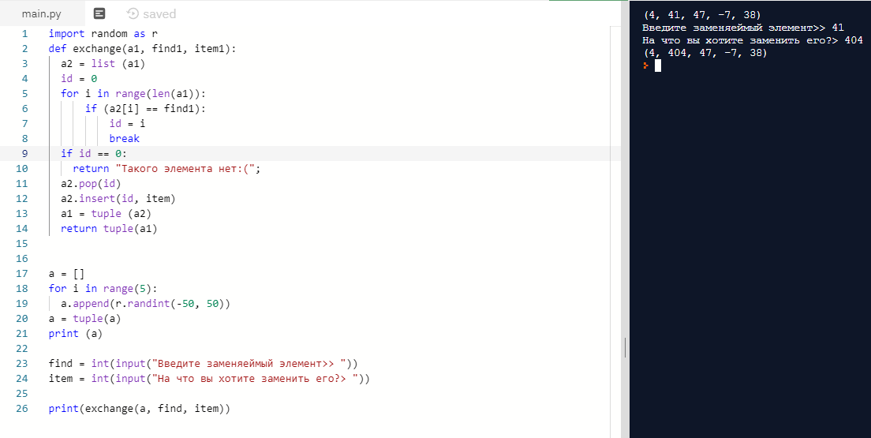

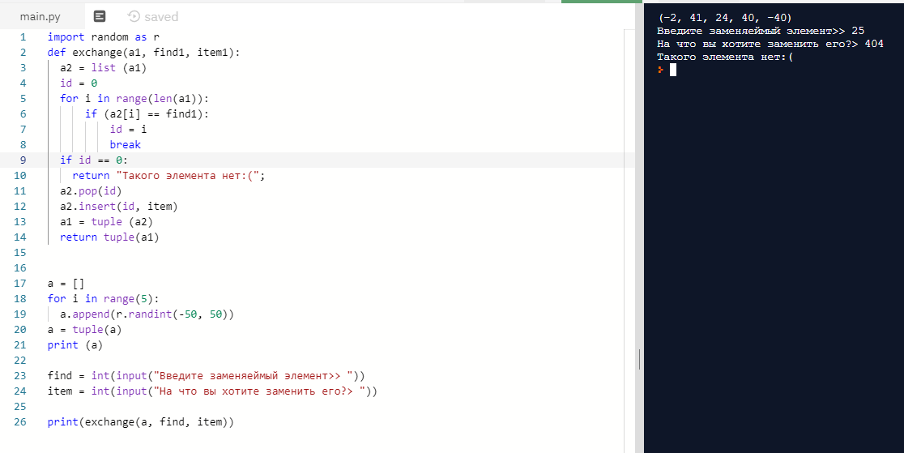

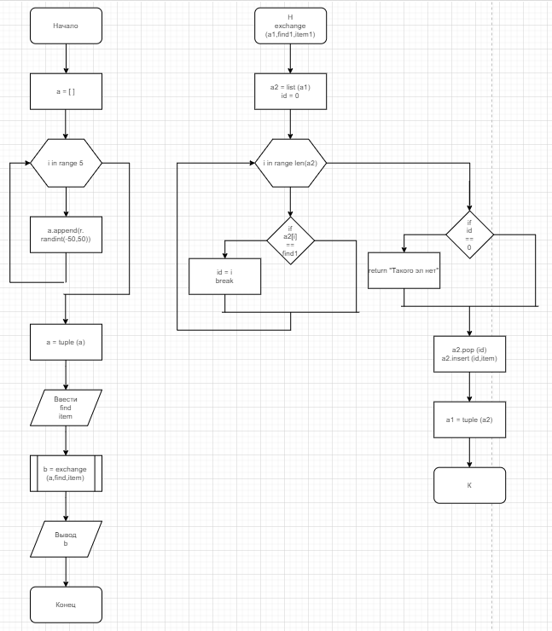

def delete (a1, max1, min1):

b = list(a1)

b.remove(max1)

b.remove(min1)

a1 = tuple (b)

return a1

import random as r

a = []

max = 0

min = 20

for i in range(5):

rand = r.randint(0, 20)

a.append (rand)

if max < rand:

max = rand

if min > rand:

min = rand

a = tuple (a)

print(a)

a = list(a)

a = delete(a, max, min)

a = tuple (a)

print(a)

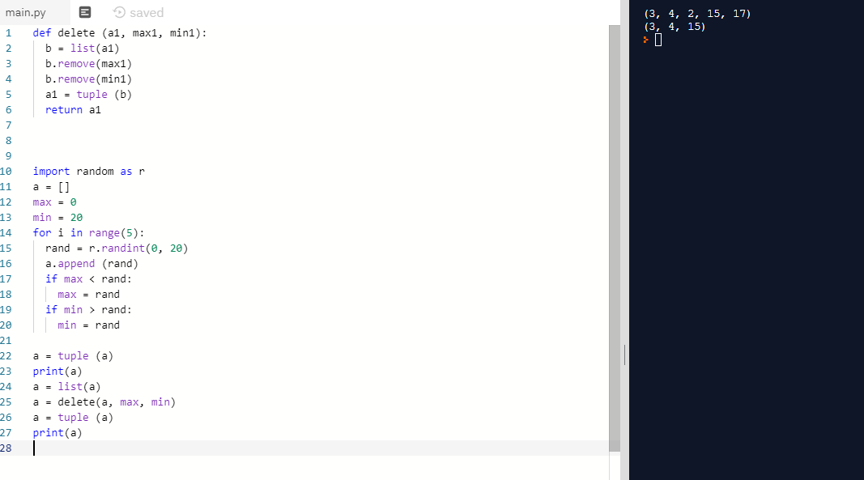

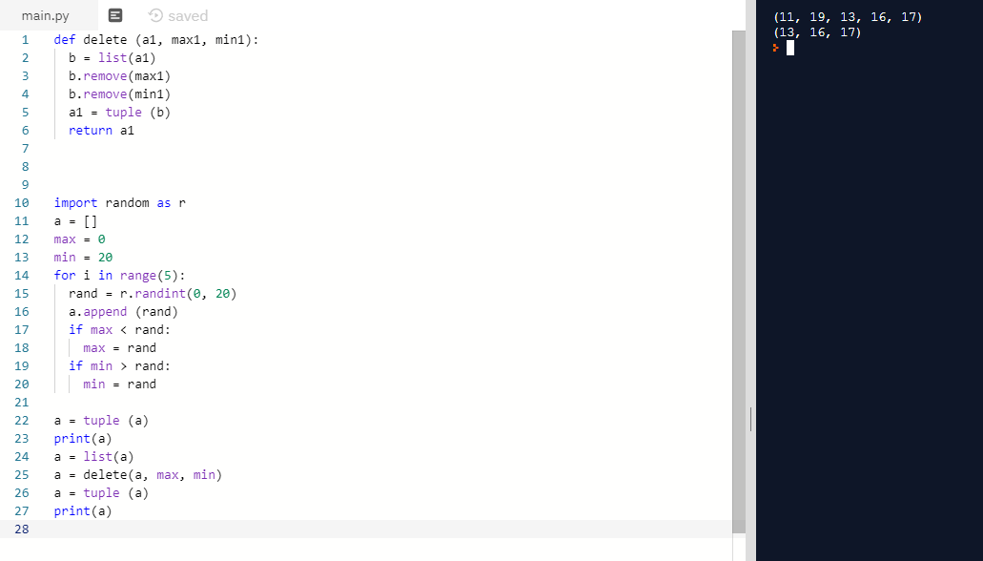

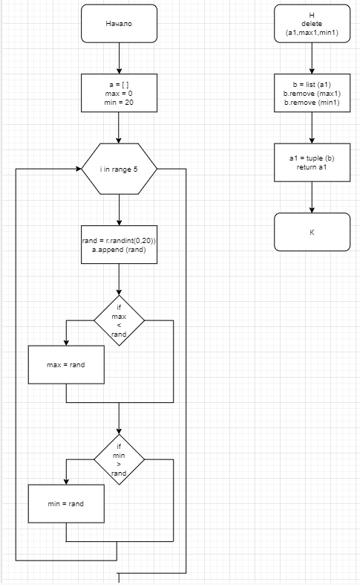

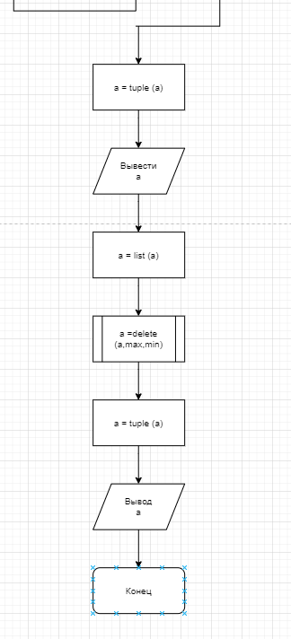

def apend (a1, rost1, index1):

a1 = list(a1)

b1 = []

for i in range (len(a1)):

if index1 > i:

b1.append (a[i])

elif (index == i):

b1.append (rost)

else:

b1.append (a[i-1])

b1.append (a1[4])

b1 = tuple (b1)

return b1

import random as r

a = []

for i in range(5):

a.append (r.randint(120,200))

rost = int(input("Enter rost -->"))

index = int(input("Enter index ot 0 do 4 -->"))

a.sort ()

a = tuple (a)

print(a)

a = list(a)

a = apend(a, rost, index)

a = tuple (a)

print(a)

