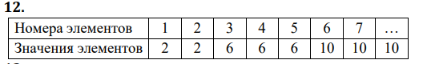

a = int (input('Enter number => '))

b = 2

c = 0

i = 0

d = 2

e = 0

while (i < a):

while (c < d):

if (e < a):

i += 1

c += 1

e += 1

print (b)

else:

c = d

i = a

d += 1

b += 4

c = 0

