Extract from SE95 Data Sheet:

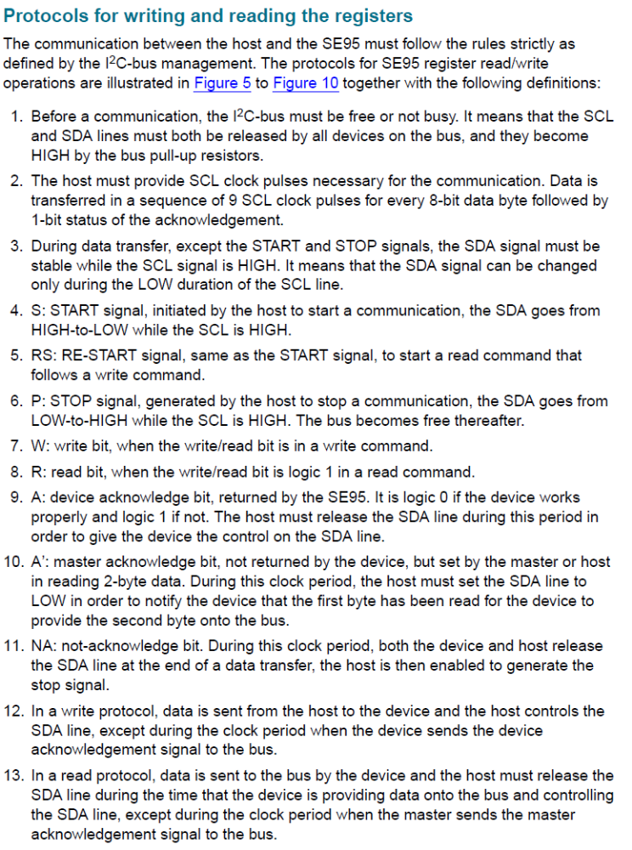

14. Slave may ‘stretch’ a clock pulse by holding it low (even though the Master has released it back to high) if it needs more time to prepare data. Otherwise, Master always controls clock signal.
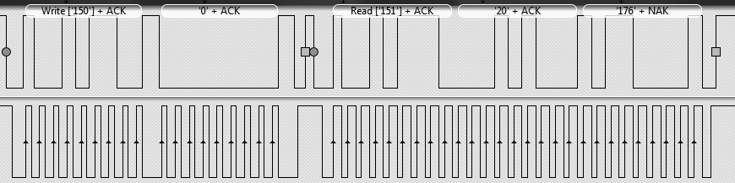

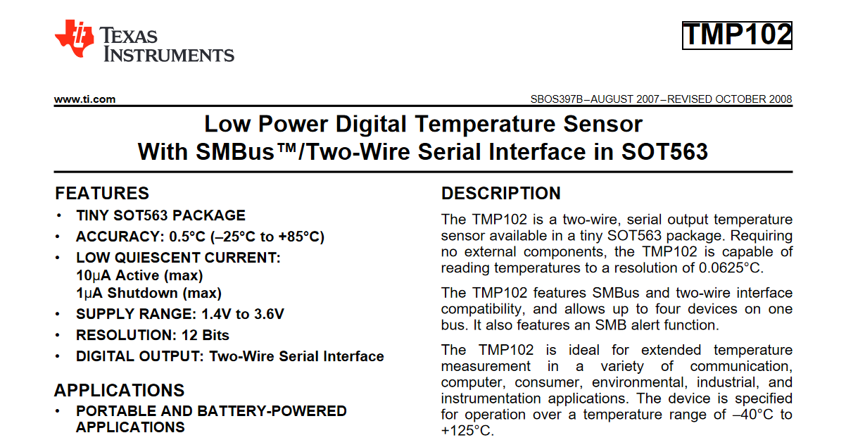
12 bit temperature resolution for TMP 102 temperature sensor stated in the datasheet.

