Registration Captures: Step-by-Step Procedure
Table of Contents

Registration captures: step-by-step procedure
Audience: the robot technician who will set up the board, program the robot, and record the captures. No knowledge of the registration math is needed. Two people are referred to throughout: the technician (you), who sets up the board, programs the robot and records the captures; and the engineer, who runs the analysis and answers questions about the setup. Where a step says “run”, a computer with Python and this repository is needed (appendix B says how to set it up); the engineer can run those steps for you if you send the files.
What you are producing: two folders of sensor capture files (.mc), one group of files per robot pose, each folder with a small table (the manifest) that says, for every file, exactly where the robot had put the board. The two folders come from the same list of poses, driven in two different ways (section 6): one ignoring the robot’s gear backlash and one trying to make its effect the same at every pose. The registration software works out from each folder where the sensor is relative to the robot, and the engineer compares the two. If the table is wrong, the registration is wrong, so most of this procedure is about getting the table right.
This procedure follows the stage-1 calibration capture procedure of the depth calibration project (repository depth_calibration_from_spherical_target, file docs/procedures/stage1_capture_procedure.docx; “the stage-1 procedure” below) in its layout and its tools; the board, its adapter and its tool frame are the same (section 1 repeats the board specification). A stage-1 board can be used as it is. The spheres and the three-ball nest are not needed here. You do not need to have read the stage-1 procedure; where this document points to it, it is for extra detail only.
Terminology: in this project “registration” means finding the transform between the sensor and the robot (the extrinsic parameters); “calibration” means finding the sensor’s own internal parameters. This procedure is about registration only.
Figures: figure 1 (section 3) shows the board on the flange and its tool frame; figure 2 (section 4) shows the two numbers the software reports for every pose; figure 3 (section 5) shows an example pose plan; figure 4 (section 6) shows the two ways of driving to a pose.

1. Equipment
Item | Requirement | Notes
Sensor | The 3D sensor to be registered, rigidly mounted; it must not move during the whole session | Mount on a stiff bracket, not a tripod; mark its position so a bump is noticed
Robot | Six-axis industrial robot, absolute positioning accuracy 0.1 mm or better over the working volume, with a 50 mm or larger ISO flange | A robot calibrated by its maker (“absolute accuracy” option) is needed; repeatability alone is not enough
Board | Flat plate 200 mm x 150 mm, at least 6 mm thick, front face matte and light gray, flat to 0.05 mm after finishing | Ground aluminum tooling plate or float glass, matte-painted; ask the supplier for a flatness report (stage-1 procedure, appendix A, lists suppliers). Thickness is not a stiffness matter (a 6 mm plate sags about 0.002 mm under its own weight); it only has to survive the finish and the mounting flat. Do not bead-blast a plate thinner than about 10 mm: peening one face bows it. Paint over the ground or glass surface instead, and check the flatness after painting and mounting, not before
Board adapter | Plate that bolts to the flange with the dowel pins and holds the board with its front face perpendicular to the flange axis and its center on the flange axis | Three-point mounting (two dowels and a clamp) so the board goes back in the same place
Dial indicator with magnetic base | 0.01 mm resolution | Board runout check
Depth gauge or calipers | 0.02 mm resolution | Board offset D
Capture computer | Runs the sensor’s capture software and writes one .mc file per capture; the files must be named by pose id (section 2 says how) | At least 10 GB free per 1,000 frames
Appendix A lists the software tools used in sections 4 to 8 and their options; appendix B says how to install them.

2. Before anything else
Words used throughout. A capture is one shot of the sensor; it produces one frame of 3D points, stored as one .mc file. Several captures are taken at each robot position without moving the robot (five per pose in the plan of section 5), so one pose gives several files. A pose is one position and orientation of the board; every pose has a short name, its pose id (for example boot01 or b_z0650_t24_a090_05), which appears in the robot program, in the pose log and in the file names. The board’s normal is the direction perpendicular to its front face, pointing out of the face toward the sensor. The pose log is the text table in which the robot program records the pose it reached (section 7), and the manifest is the table the software builds from the pose log and the capture files.
The session folder. Make one working folder for the session (for example reg_2026-10-05/) and keep everything in it:
- session_notes.txt (below);
- boot/ for the six captures of section 4, with boot_pose_log.csv and boot.json next to it;
- plan/ for the pose plan of section 5;
- captures_A/ and captures_B/ for the two capture runs of section 6, with pose_log_A.csv and pose_log_B.csv next to them.
Every command in this document is typed in that folder and names files relative to it.
File names. Each capture file must be named <pose_id>_Index<nn>.mc, where pose_id is the id of the pose it was taken at and nn counts the frames of that pose from 00 (boot01_Index00.mc; b_z0650_t24_a090_05_Index00.mc to ..._Index04.mc). Set the capture software’s file-name prefix to the pose id before each pose, or, if the software insists on its own names, rename the files afterwards, before building the manifest. A file that is not named this way cannot be matched to a pose and is left out.
Sensor. Switch the sensor on and leave it running for at least 30 minutes before the first capture, and leave it running for the whole session. Note the time it was switched on.
Fix the sensor’s exposure and gain to the values that will be used in production. Write them down. Do not use automatic exposure.
Switch off or block any sunlight or lamps that fall on the board. Room light is fine if it is constant.
Robot. Confirm with the engineer what the robot base frame is (which frame the robot’s position readout is in). Every pose in this procedure is recorded in that frame. Do not change the active base frame during the session.
Leave the controller’s backlash compensation (if it has such a setting) exactly as it is in production, and write down what it is set to. Do not change it between the two sub-procedures of section 6.
Session notes. Record in a text file (session_notes.txt): date, sensor serial number, exposure and gain, robot model and controller software version, the active base frame name, the backlash compensation setting, the board certificate (flatness), room temperature, and anything unusual.
Software. Before the first command of section 4, do appendix B once on the computer that will run the tools: install the two packages and run the self-test. Every command in this document is then typed in a terminal opened in the session folder, with the environment of appendix B.4 active (the prompt starts with (.venv)). The table below is the whole of what gets run, in order; each row points to the section that gives the full command and explains its output. Any row can be run by the engineer instead, if you send the files it reads.
When | Command | Reads | Writes | Section
Once, before section 4 | install and self-test | the two repositories | the environment .venv | appendix B
After the six boot captures | sphcal.cli.make_manifest | boot_pose_log.csv, boot/ | boot/manifest.csv | 4, step 4
Right after that | planereg.capture.bootstrap | boot/manifest.csv | boot.json (rough sensor position) | 4, step 4
Before programming the robot | planereg.capture.plan_poses | boot.json, one boot capture | plan/poses.csv, plan_summary.txt, plan.png | 5
After each sub-procedure (A, then B) | sphcal.cli.make_manifest | pose_log_A.csv, captures_A/ (same for B) | captures_A/manifest.csv | 7
Right after that, board still mounted | planereg.capture.check_captures | the manifest, boot.json, the pose log | captures_A/check.json and a verdict | 8
Each command is run as python3 -m <command> <options>; the sections give the options.

3. Mounting the board and its tool frame
The board’s “tool frame” is a coordinate frame at the center of the board’s front face, with its z axis pointing straight out of the face (along the board’s normal, toward the sensor when the board faces it), x along the long edge, y along the short edge. The robot must report the board’s pose in this frame. This is the same frame as TOOL_BOARD of the stage-1 procedure; if it is already defined on this robot with this board and adapter, check it (steps 2 and 3) and reuse it. Figure 1 shows the parts, the measurements of steps 2 and 3, and the tool frame.
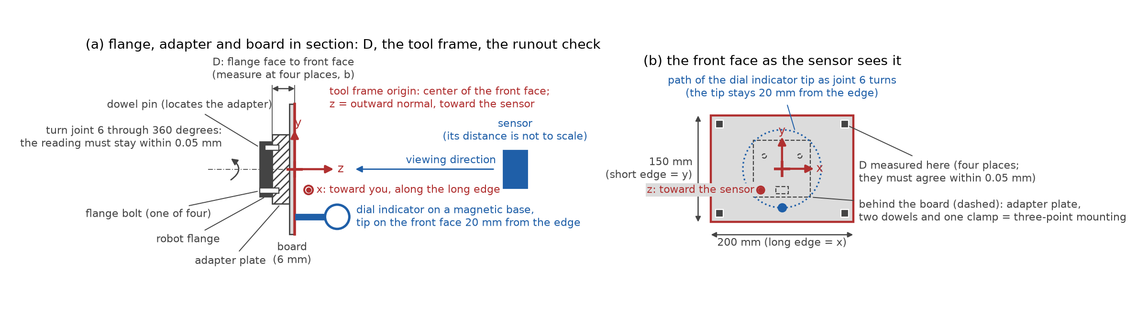
mounting
Figure 1. (a) The flange, the doweled adapter plate and the board in section, with the distance D from the flange face to the board’s front face, the tool frame at the center of the front face (z out of the face toward the sensor, x along the long edge) and the dial indicator of the runout check. (b) The front face as the sensor sees it: the tool frame axes, the path of the indicator tip while joint 6 turns, the four places where D is measured, and the three-point mounting hidden behind the board.
- Mount the board adapter and the board on the flange with the dowel pins.
- Runout check (figure 1a): fix the dial indicator to the table with its tip on the board’s front face about 20 mm from an edge. Slowly rotate the flange about its own axis (robot joint 6) through 360 degrees. The reading must stay within 0.05 mm. If it does not, the board face is not perpendicular to the flange axis: shim the adapter and repeat.
- Measure the distance from the flange face to the board’s front face with a depth gauge or calipers at four places around the board (figure 1b); they should agree within 0.05 mm. Record the average as D.
- Measure the board’s width and height with calipers and record them. The half-sizes go in the pose log (100 and 75 mm for the recommended board).
- Define the tool frame in the robot (figure 1): position (0, 0, D) from the flange, orientation: z along the flange axis pointing out of the board, x along the board’s long edge. How to set x: with the robot’s “tool orientation by points” function, teach a point at the center of the long edge, or enter the rotation about z that aligns x with the long edge, after measuring with a square against the adapter. An error of a few degrees in x is harmless (the board is symmetric); an error in z is not.
- Save as TOOL_BOARD and write the numbers in the session notes.
If the controller cannot define a tool frame and can only report the flange pose, log the flange pose instead and write “flange pose logged, D = … mm” in the session notes. The software then has to move every logged pose forward by D along the flange’s z axis: add --target-offset-mm D (D in millimeters) to every bootstrap and check command in sections 4 and 8, and the engineer adds it to the analysis. Do not mix the two kinds of pose in one session.

4. Finding where the sensor is (rough)
The software works out the exact position of the sensor from the captures. It only needs a rough idea first, so that the planned poses land in the sensor’s field of view and so that the software knows where to look for the board in each capture. This step takes six captures of the board at hand-chosen poses.
What the software does with a capture, and the words it uses. In every capture it looks for the board (segmentation: finding the flat patch of points that is the board, among whatever else is in view) and fits a plane to those points. How far the points scatter about that plane is the plane residual (in mm; a clean matte board gives a fraction of a millimeter). From the logged robot pose and the current idea of where the sensor is, it also predicts where the board plane should be in the sensor’s view. The difference between the predicted plane and the measured plane is reported as two numbers (figure 2): the normal residual, the angle between the two planes in degrees, and the offset residual, the distance between them at the board’s center in millimeters. Once the sensor’s position has been solved from all the poses together, the two residuals of each pose say how well that pose agrees with the solution; a pose whose robot position was logged wrongly stands out by a large residual. The valid fraction of a pose is the share of its frames in which the board was found.
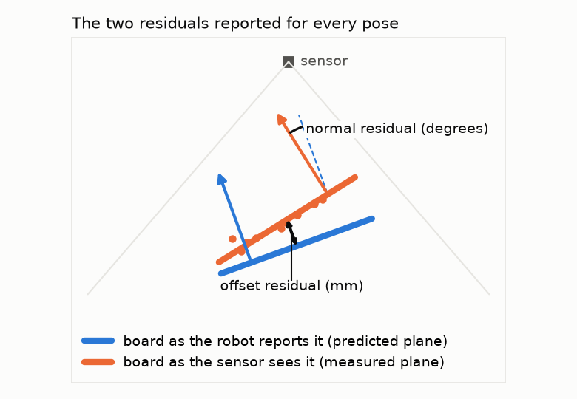
residuals
Figure 2. The two residuals reported for every pose: the angle between the board as the robot reports it and the board as the sensor sees it (normal residual), and the distance between the two planes at the board’s center (offset residual).
The steps. Directions such as “top edge” and “left edge” mean the edge nearest the top or the left of the sensor’s picture as the capture software shows it. If the software has no live view, take a capture and open it in the software’s viewer, or send the first file to the engineer, to see which way is up.
- Create the folder boot/. With TOOL_BOARD active, jog the board to a point roughly in front of the sensor, about 600 mm away, near the middle of the picture, facing the sensor squarely. Check on the capture computer’s live view that the whole board is visible with margin and that nothing else flat and large is closer to the sensor than the board (a tabletop between the sensor and the board, for instance, must be out of the picture or farther away than the board).
- Record one capture into boot/ as boot01_Index00.mc. Read the robot’s reported tool pose (position and orientation, in the base frame) from the pendant and write it as the first pose line of boot_pose_log.csv, in the format of section 7 (read section 7 now: the file needs a header line, and one line per pose with the pose id boot01, the board half-sizes, the position and the orientation in the form your controller shows). The joint-angle columns are not needed for these six poses.
- Tilt the board about 20 degrees so that its top edge comes toward the sensor, keeping its center near the middle of the picture; capture boot02 and log the pose. Then about 20 degrees the other way, bottom edge toward the sensor (boot03); then 20 degrees with the left edge toward the sensor (boot04); then the right edge (boot05). Finally move the board about 250 mm farther from the sensor, facing it squarely (boot06). Six poses, tilted in four directions and at two distances, one capture each.
- Build the manifest and run the bootstrap (section 2 says where to type this):
python3 -m sphcal.cli.make_manifest --pose-log boot_pose_log.csv \
--captures boot/ --format csv --out boot/manifest.csv
python3 -m planereg.capture.bootstrap --manifest boot/manifest.csv \
--out boot.json
The bootstrap prints one line per pose with the board it found (how many pixels, how flat), and after solving, each pose’s normal and offset residual against the solution. They should be a fraction of a degree and a millimeter or two at most; a disagreement of several degrees or tens of millimeters means a pose was copied wrongly, the tool frame’s z axis is wrong (section 3, step 5), or the board was not the closest flat surface in that capture. It also prints the “normal spread” of the six poses, a number between 0 and 0.58 that says how differently the board was tilted from pose to pose: it must be at least 0.05 (the tilts above give about 0.15). boot.json is the rough sensor position; the next steps read it.

5. The pose plan
The plan is the list of board poses the robot will visit. It is made by a program, the plan tool, from the rough sensor position of section 4, the sensor’s field of view (read from one of the bootstrap captures) and the measured board half-sizes. Three words describe each planned pose:
- the standoff: the distance from the sensor to the board’s center, measured along the sensor’s viewing axis (the line out of the middle of the picture);
- the tilt: the angle between the board’s normal and the sensor’s viewing axis; 0 means the board faces the sensor squarely;
- the azimuth: for a tilted board, which edge leans toward the sensor, as an angle in the board’s own plane: 0 is the top edge toward the sensor, 90 the right edge, 180 the bottom edge, 270 the left edge (“top” and “left” as in the sensor’s picture, section 4).
Run the plan tool:
python3 -m planereg.capture.plan_poses --sensor-in-base boot.json \
--camera boot/boot01_Index00.mc --board-half-size-mm 100 75 --out plan/
(Use your board’s half-sizes in place of 100 75.) It writes three files: the pose list plan/poses.csv for the robot program, a report plan/plan_summary.txt (explained below), and a picture plan/plan.png (figure 3 shows the picture for the default settings). The plan with the default settings is:
The board at three standoffs from the sensor (550, 750 and 950 mm), at a 3 x 3 grid of lateral positions covering 50 percent of the field at each standoff, facing the sensor and tilted by 0, 15 and 30 degrees, the tilted poses at the four azimuths (top, right, bottom and left edge toward the sensor): 9 orientations at each of 27 positions. Tilted boards that would leave the field of view are dropped automatically. About 20 percent of the poses are marked as held out in poses.csv (column holdout, value 1): capture them like all the others; the software keeps them aside for checking the result instead of fitting with them.
What the plan tool prints. Besides the three files, the tool prints a plain-text summary to the screen and saves the same text as plan/plan_summary.txt. It is not something you fill in; it is the tool’s report on the plan it just made. The block below is that report for the default settings, a 640 x 480 sensor and a nominal sensor position (your own run shows the same layout with your numbers). Read it before handing the plan to the robot programmer:
- The table gives, for every standoff and tilt, how many poses were planned, how many were dropped because a board corner would fall too near the image edge, how many are kept, and how many of those are tagged held out. A few dropped poses are normal; if a whole row is dropped, the board is too large for that standoff in this sensor’s field, and the line after the table says which option to change.
- normal spread says how well the tilts cover all directions; the registration refuses a set below 0.05. The default plan gives about 0.28. similarity spread matters only for the optional scale analysis and must exceed 0.01.
- The predicted ... RMS error lines are the registration error to expect if the sensor’s planes are good to 0.2 degrees and 0.2 mm; they are an order of magnitude, not a promise. The second quality block repeats the numbers for the poses that are not held out, which is the set the engineer fits.
- The last two lines are the size of the job: the number of poses, and the number of pose visits and capture files once both sub-procedures (section 6) have been run. Check them against the time and disk space available before starting.
Send plan_summary.txt to the engineer with the other deliverables (section 9). The example below is also kept as figures/plan_example_summary.txt.
Registration pose plan
Sensor-to-base transform: matrix from boot.json
Camera: 640 x 480 px, half field 24.9 x 19.2 deg
Board half size: 100 x 75 mm; lateral grid 3 x 3 at fill 0.5; edge margin 10 px
Approach pose: retreat 40 mm along the board's -z, rotation 3 deg about the board's
x axis
Poses per standoff and tilt:
standoff_mm tilt_deg planned dropped kept held out
550 0.0 9 0 9 3
550 15.0 36 0 36 9
550 30.0 36 8 28 4
750 0.0 9 0 9 1
750 15.0 36 0 36 9
750 30.0 36 0 36 5
950 0.0 9 0 9 0
950 15.0 36 0 36 7
950 30.0 36 0 36 9
8 poses were dropped because a board corner would come within 10 px of the image
edge; use a smaller --lateral-fill, smaller tilts, a smaller board or larger
standoffs to keep more of them.
Quality of the plan, all planned poses (235 poses):
normal spread 0.2850 (registration minimum 0.05)
similarity spread 0.1306 (registration minimum 0.01)
predicted rotation RMS error 0.0458 deg
predicted translation RMS error 0.0458 mm
(assumed noise: normals 0.2 deg, offsets 0.2 mm; an order of magnitude, good to
a factor of about two)
Quality of the plan, poses not held out (188 poses):
normal spread 0.2822 (registration minimum 0.05)
similarity spread 0.1289 (registration minimum 0.01)
predicted rotation RMS error 0.0517 deg
predicted translation RMS error 0.0517 mm
(assumed noise: normals 0.2 deg, offsets 0.2 mm; an order of magnitude, good to
a factor of about two)
Largest incidence angle (board normal against the line of sight): 30.0 deg
Total: 235 poses, 47 tagged held out (seed 0).
Both sub-procedures together: 2 x 235 poses = 470 pose visits; x 5 frames = 2350
capture files.
The pose budget. This is the first run: a few hundred poses are enough to find out whether the robot’s pose errors or the sensor’s plane errors dominate. The plan summary gives the registration error to expect from the plan if the sensor’s planes are good to 0.2 degrees and 0.2 mm; if the engineer’s analysis of the first run calls for a larger set, a second run of 1,000 or more poses is planned with --target-pose-count, not before.
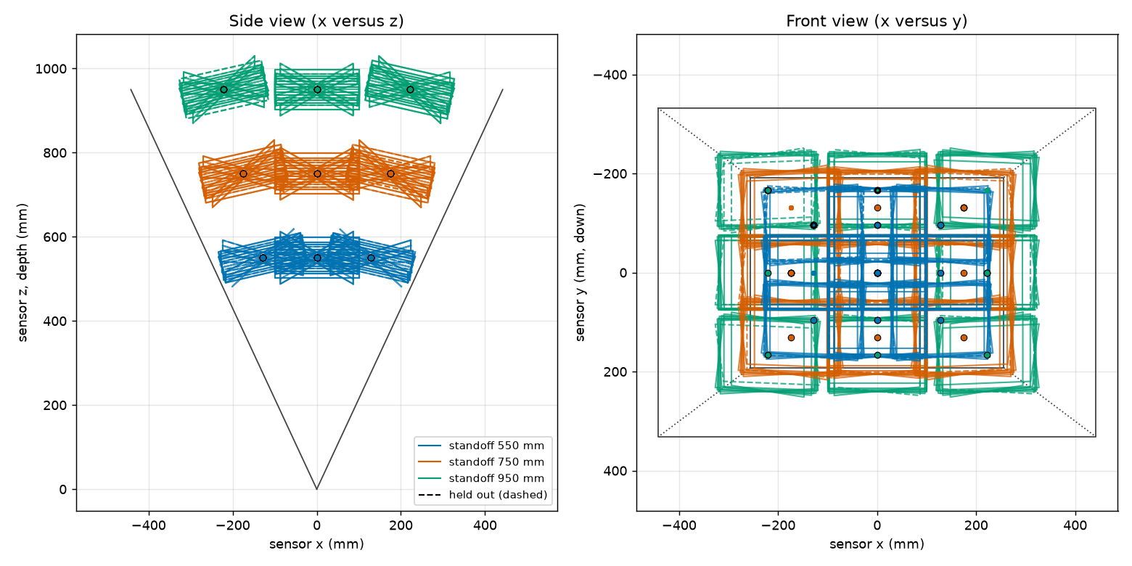
plan
Figure 3. The planned board centers for the default settings, in the sensor’s frame: side view (left) and front view (right), with the field of view drawn. One color per standoff; held-out poses have an outline.
The columns of poses.csv. Every row is one pose. The robot program needs the pose id, the target pose, and (for sub-procedure B of section 6) the approach pose; the other columns are bookkeeping.
Columns | Meaning
pose_id | The pose’s name; it goes in the pose log and in the file names
kind, radius_mm | Always board and empty (the stage-1 tools also plan spheres)
half_width_mm, half_height_mm | The board half-sizes you gave
holdout | 1 for a held-out pose, 0 otherwise; capture both alike
base_x_mm, base_y_mm, base_z_mm | Position of the board tool frame in the base frame, mm
r00 … r22 | Its orientation as a 3 x 3 rotation matrix, row by row (r01 is row 0, column 1)
quat_w, quat_x, quat_y, quat_z | The same orientation as a unit quaternion, scalar part first (w is never negative)
rotvec_x_deg, rotvec_y_deg, rotvec_z_deg | The same orientation as a rotation vector: direction = axis, length = angle in degrees
sensor_x_mm, sensor_y_mm, sensor_z_mm | The board center as seen from the sensor (for the picture; not needed by the robot)
standoff_mm, tilt_deg, azimuth_deg | What the pose was planned as (see above)
approach_x_mm, approach_y_mm, approach_z_mm | Position of the approach pose for sub-procedure B
approach_r00 … approach_r22, approach_quat_w … approach_quat_z, approach_rotvec_x_deg … approach_rotvec_z_deg | Its orientation, in the same three forms
Use whichever orientation form your robot program accepts; all three describe the same rotation (tool frame to base frame). Hand the file to whoever writes the robot program, or import it directly if the controller can read CSV.

6. The two sub-procedures
Every pose is captured twice, in two separate runs over the whole plan, with the sensor and the board untouched between them. Figure 4 shows the difference. Read section 7 (the pose log) before writing the robot program: the program has to write that file.
Triggering the captures. Each robot program outline below has a step “trigger the capture of 5 frames”. How this is done depends on the capture software: by a digital output of the robot wired to the capture computer, by a network command, or by the operator pressing a key when the robot program shows a prompt and waits. Any of the three is fine; what matters is that the capture is taken after the settling wait, before the robot moves on, and that the file-name prefix for the captures of that pose is the pose id (section 2). If the operator triggers by hand, the program should wait for a confirmation before moving on.
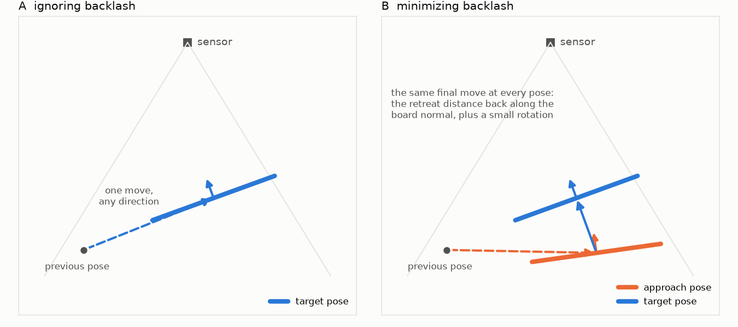
approach
Figure 4. Left: sub-procedure A drives straight onto each target pose. Right: sub-procedure B drives to the approach pose first, then makes the same final move onto the target at every pose. (The approach rotation is exaggerated in the drawing.)
Sub-procedure A, “ignoring backlash”. Uses only the target pose of each row of poses.csv; the approach columns are ignored. Robot program outline, for each row:
- Move to the target pose with one joint move, from wherever the robot is.
- Wait 1.5 seconds for vibration to settle.
- Trigger the capture of 5 frames; file names <pose_id>_Index00.mc to <pose_id>_Index04.mc, in the folder captures_A/.
- Read the robot’s actual reported tool pose (not the commanded one, the reported one) and, if the controller gives them, the six joint angles; append them to the pose log pose_log_A.csv (section 7).
- Move on.
When the last pose of A is done, and before starting B, build the manifest of captures_A/ (section 7) and run the check on it (section 8), while the board is still mounted and flagged poses can be re-captured cheaply.
Sub-procedure B, “minimizing backlash”. The idea: gear backlash means the flange can sit on either side of a small dead band after a move, depending on which way each joint last moved. Approaching every target pose with the same final move makes the last motion of each joint the same at every pose, as far as the geometry allows, so the dead band is taken up the same way each time and its effect is constant instead of random. The approach pose in the plan is the target pose moved back 40 mm along the board’s own normal (away from the sensor) and turned 3 degrees about the board’s long edge; the final move is therefore the same 40 mm advance and 3 degree turn at every pose. Robot program outline, for each row:
- Move to the approach pose with a joint move, from wherever the robot is.
- Wait 0.5 seconds.
- Make a linear move onto the target pose, at the same speed for every pose, without stopping or reversing on the way. If the controller offers a “fine” or “exact stop” positioning mode for the end of a move, use it here and in sub-procedure A alike.
- Wait 1.5 seconds for vibration to settle.
- Trigger the capture of 5 frames; file names as above, in the folder captures_B/.
- Read the reported tool pose and, if available, the joint angles at the target, and append them to pose_log_B.csv; if the controller can also report the joint angles at the approach pose, log those in the approach_j1..approach_j6 columns. The check tool uses them to confirm that each joint’s final motion had the same direction at every pose.
- Move on.
When the last pose of B is done, build the manifest of captures_B/ and run the check on it, as after A.
Use the same speed and acceleration settings in both sub-procedures. Do all of A, then all of B (or the other way round); do not interleave, and do not move the sensor or remount the board between them. At about 8 seconds per pose in A and 12 in B, the robot time for the default plan (section 5 gives the exact pose count) is about 80 minutes in all; plan on about three hours including the setup and the checks.

7. Recording the poses: the pose log
The capture software writes the sensor data; the robot’s pose has to be recorded separately, by the robot program, in a text table called the pose log. There is one pose log per capture folder (boot_pose_log.csv, pose_log_A.csv, pose_log_B.csv). It is a CSV file (comma-separated values, one header line, then one line per pose) with these columns:
pose_id, kind, radius_mm, half_width_mm, half_height_mm,
x_mm, y_mm, z_mm, rotation_type, r1, r2, r3, r4, ..., r9,
j1, j2, j3, j4, j5, j6, approach_j1, ..., approach_j6
(one header line in the file; it is broken here only to fit the page)
- pose_id: exactly the id from poses.csv (or boot01..boot06 in section 4), which is also the start of the file names.
- kind: board. radius_mm: empty.
- half_width_mm, half_height_mm: half the measured board size.
- x_mm, y_mm, z_mm: the reported tool position in the base frame.
- rotation_type and r1..r9: the reported tool orientation, in whatever form the controller gives, named by one of the words in the table below. Only as many r columns as the form needs are filled; the header may stop at the last one used (r4 for a quaternion, r3 for angles, r9 for a matrix).
- j1..j6 and approach_j1..approach_j6: the joint angles in degrees, if the controller reports them; otherwise leave the columns out entirely.
rotation_type | r1, r2, r3, … | Typical controller
quaternion_wxyz | w, x, y, z | ABB (its quaternion is in this order)
quaternion_xyzw | x, y, z, w | some vision and ROS systems
euler_zyx_deg | A, B, C | KUKA (A, B, C in degrees)
fixed_xyz_deg | W, P, R | FANUC (W, P, R in degrees)
euler_xyz_deg | a, b, c | controllers reporting X-Y-Z Euler angles
rotvec_deg | x, y, z (length = angle in degrees) | Universal Robots; its rotation vector is in radians, multiply the three numbers by 57.2958
matrix | the 3 x 3 rotation matrix, row by row (9 numbers) | any controller that shows a matrix
If your controller is not in the table, ask the engineer which word applies; naming the form wrongly makes every pose disagree with the solution (section 8).
Example line, one line in the file, broken here only to fit the page (the first part is the pose, the second the six joint angles at the target and the six at the approach pose):
b_z0650_t24_a090_05,board,,100.0,75.0,850.11,-12.70,470.55,euler_zyx_deg,-91.3,19.8,0.4,,
12.1,-35.6,88.2,3.4,41.0,-8.7,11.9,-36.0,88.9,3.1,40.5,-8.4
After each sub-procedure, the manifest is built from its pose log and its capture folder:
python3 -m sphcal.cli.make_manifest --pose-log pose_log_A.csv \
--captures captures_A/ --format csv --out captures_A/manifest.csv
python3 -m sphcal.cli.make_manifest --pose-log pose_log_B.csv \
--captures captures_B/ --format csv --out captures_B/manifest.csv
The tool matches every file to its pose id, converts the orientation to the standard matrix form, and complains, by name, about any pose without files, any file without a pose, and any missing size. A poses.csv from the plan tool is also accepted directly as the pose log if your robot program cannot write one; then the commanded poses stand in for the reported ones, which is acceptable only for a robot with absolute accuracy better than 0.1 mm, and it defeats the purpose of sub-procedure B. Extra columns such as the joint angles are carried along unchanged.
Optional extra: if the capture software can be given the robot’s pose at capture time, let it write the pose into each file’s header as well, under the key robotPose, as a 4 x 4 matrix (16 numbers, row by row: rotation in the top-left 3 x 3, position in the right column, last row 0 0 0 1), tool frame to base frame. The engineer can then cross-check the pose log against the headers. It does not replace the pose log: the tools above read the log.

8. Checking the captures before the analysis
Run the quick check on each folder as soon as its captures are complete, while the robot and the board are still set up:
python3 -m planereg.capture.check_captures --manifest captures_A/manifest.csv \
--sensor-in-base boot.json --pose-log pose_log_A.csv --out captures_A/check.json
python3 -m planereg.capture.check_captures --manifest captures_B/manifest.csv \
--sensor-in-base boot.json --pose-log pose_log_B.csv --out captures_B/check.json
It prints one line per pose and a verdict. Things it flags, and what they mean (the words are those of section 4):
- Low valid fraction (below 50 percent of frames): the board was not read; check exposure, or the board was outside the field.
- Board touching the image border: the board is partly out of view; the pose is unusable, re-plan it slightly inward.
- Segmentation failed: the software could not find a flat surface of the board’s size facing the sensor where the pose says it should be; the pose was copied wrongly, or something flat is closer to the sensor than the board (a cable, a hand, the table), or the board is outside the field.
- Plane residual above 1 mm: the board surface read by the sensor is not flat to the sensor; a shiny spot or a dirty board, or an exposure problem.
- Normal residual above 1 degree or offset residual above 1 mm against the solved registration: either the robot pose was copied wrongly for that pose, or, if it affects every pose with one tilt direction, the board tool frame’s orientation is wrong (section 3, step 5), or the rotation type in the pose log is misnamed; or, if it grows steadily across the volume, the robot’s base frame or its absolute accuracy is off.
- Normal spread below 0.05: the tilts were not varied enough (should not happen with the plan’s defaults).
- Joint sign consistency (sub-procedure B, when joint angles were logged): for each joint, the fraction of poses whose final motion had the majority direction. A joint far below 100 percent means the approach move did not standardize that joint’s backlash over part of the workspace; tell the engineer, it affects how the two folders are compared.
Re-capture flagged poses after fixing the cause; do not delete the lines from the log, add corrected lines with a new pose id (for example b_z0650_t24_a090_05r). The check tool’s exit code is 0 when nothing is flagged, 1 when something is, and 2 when it cannot read the manifest.

9. Deliverables checklist
- captures_A/ and captures_B/ with all .mc files, named <pose_id>_Index<nn>.mc
- pose_log_A.csv and pose_log_B.csv, with the joint-angle columns when the controller reports them
- captures_A/manifest.csv and captures_B/manifest.csv produced by make_manifest without errors
- captures_A/check.json and captures_B/check.json with no flags, or a note explaining each remaining flag
- plan/poses.csv, plan/plan_summary.txt, plan/plan.png as used
- boot.json, boot_pose_log.csv and the bootstrap captures in boot/
- session_notes.txt with: sensor serial, warm-up time, exposure and gain, base frame name, backlash compensation setting, board D and runout reading, whether the flange pose was logged instead of TOOL_BOARD (section 3), board dimensions and certificate, TOOL_BOARD values, temperature, robot speed and acceleration settings, the order the sub-procedures were run in and their times
- Photos of the setup: sensor mount, the board on the flange, the workspace behind the board as the sensor sees it

10. Things that spoil a session
- Moving or bumping the sensor. If it happens, everything after it is a new session, and both sub-procedures must be repeated.
- Changing exposure, gain, the base frame, the speed settings, or the backlash compensation mid-session or between the sub-procedures.
- Using the commanded pose instead of the reported pose in the log.
- A loose adapter: check the dowels are seated and the runout (section 3, step 2) before each sub-procedure.
- Fingerprints or gloss on the board: wipe with isopropyl alcohol; a shiny spot returns a bright highlight and a bad read.
- Something flat and large closer to the sensor than the board, in the picture. The software looks for the closest large flat surface when it has no better information; keep the foreground clear.
- In sub-procedure B, stopping, reversing, or slowing on the final move, or approaching some poses without the approach pose. Every pose must get the same final move.
- Mixing up the two pose logs, or capturing B into the A folder.

Appendix A. Software reference
The tools live in this repository under python/planereg/ (the capture package) and use the sibling repository depth_calibration_from_spherical_target (the sphcal package) for reading the capture files and building the manifest. Every tool prints its help with --help.
Output of python3 -m planereg.capture.plan_poses --help:
usage: plan_poses.py [-h] --sensor-in-base PATH [--camera PATH]
[--fov-deg H V] [--image-size W H]
[--board-half-size-mm HALF_WIDTH HALF_HEIGHT]
[--standoffs-mm STANDOFFS_MM [STANDOFFS_MM ...]]
[--tilts-deg TILTS_DEG [TILTS_DEG ...]]
[--azimuths-deg AZIMUTHS_DEG [AZIMUTHS_DEG ...]]
[--lateral-fill LATERAL_FILL]
[--lateral-positions NX NY]
[--edge-margin-px EDGE_MARGIN_PX]
[--approach-retreat-mm APPROACH_RETREAT_MM]
[--approach-rotation-deg APPROACH_ROTATION_DEG]
[--holdout-fraction HOLDOUT_FRACTION] [--seed SEED]
[--target-pose-count N]
[--noise-normal-deg NOISE_NORMAL_DEG]
[--noise-offset-mm NOISE_OFFSET_MM]
[--frames-per-pose FRAMES_PER_POSE] --out DIR
Plan the robot poses of a registration session: board poses at several
standoffs, lateral positions, tilts and azimuths, each with an approach
pose for the minimizing-backlash sub-procedure. Writes poses.csv,
plan_summary.txt and plan.png.
options:
-h, --help show this help message and exit
--sensor-in-base PATH
JSON with {"matrix": [16 floats, row-major 4x4
sensor-to-base]} (the bootstrap tool writes this)
or sphcal's {"bootstrap": [{"pose_id", "base_xyz",
"sensor_xyz"}, ...]}
--camera PATH .mc capture file whose header gives fx, fy, cx, cy
and whose array gives the image size
--fov-deg H V full horizontal and vertical field of view in
degrees (with --image-size)
--image-size W H image width and height in pixels
--board-half-size-mm HALF_WIDTH HALF_HEIGHT
half the long edge and half the short edge
(default (100.0, 75.0))
--standoffs-mm STANDOFFS_MM [STANDOFFS_MM ...]
sensor-z depths of the board centers (default
(550.0, 750.0, 950.0))
--tilts-deg TILTS_DEG [TILTS_DEG ...]
board tilts away from facing the sensor; 0 is
planned once per position (default (0.0, 15.0,
30.0))
--azimuths-deg AZIMUTHS_DEG [AZIMUTHS_DEG ...]
azimuths of the tilt axis in the board plane, 0 =
board x axis (default (0.0, 90.0, 180.0, 270.0))
--lateral-fill LATERAL_FILL
fraction of the half field covered by board
centers at each standoff (default 0.5)
--lateral-positions NX NY
board positions across the field: columns and rows
(default (3, 3))
--edge-margin-px EDGE_MARGIN_PX
board corners must project this far inside the
image (default 10.0)
--approach-retreat-mm APPROACH_RETREAT_MM
retreat of the approach pose along the board's own
-z (default 40.0)
--approach-rotation-deg APPROACH_ROTATION_DEG
rotation of the approach pose about the board's
own x axis (default 3.0)
--holdout-fraction HOLDOUT_FRACTION
fraction of the poses tagged as held out (default
0.2)
--seed SEED seed of the random held-out subset
--target-pose-count N
choose the lateral grid so that the plan has about
N poses (overrides --lateral-positions)
--noise-normal-deg NOISE_NORMAL_DEG
assumed normal noise for the error prediction
(default 0.2)
--noise-offset-mm NOISE_OFFSET_MM
assumed offset noise for the error prediction
(default 0.2)
--frames-per-pose FRAMES_PER_POSE
frames captured per pose, for the capture counts
(default 5)
--out DIR output directory
Output of python3 -m planereg.capture.bootstrap --help:
usage: bootstrap.py [-h] --manifest PATH --out PATH
[--min-valid-fraction MIN_VALID_FRACTION]
[--border-margin-px BORDER_MARGIN_PX]
[--target-offset-mm TARGET_OFFSET_MM]
[--min-pose-count MIN_POSE_COUNT]
[--min-normal-spread MIN_NORMAL_SPREAD]
[--max-rms-normal-deg MAX_RMS_NORMAL_DEG]
[--max-rms-offset-mm MAX_RMS_OFFSET_MM]
[--max-normal-deg MAX_NORMAL_DEG]
[--max-offset-mm MAX_OFFSET_MM]
Find the sensor roughly in the robot base frame from four or more hand-
jogged board captures (manifest made by sphcal's make_manifest): segment
the board in each, register, print the table and the transform, and write
the JSON that the plan tool reads.
options:
-h, --help show this help message and exit
--manifest PATH manifest CSV or JSON
--out PATH JSON file to write
--min-valid-fraction MIN_VALID_FRACTION
a pixel must be valid in this fraction of a pose's
frames (default 0.5)
--border-margin-px BORDER_MARGIN_PX
warn when the board mask comes this close to the
image border (default 4)
--target-offset-mm TARGET_OFFSET_MM
distance from the logged frame's origin to the
board's front face along its +z, in mm; 0 when the
logged frame is the board tool frame, the plate
thickness D when the flange pose was logged
(default 0.0)
--min-pose-count MIN_POSE_COUNT
fewest segmented poses the registration may use
(default 4)
--min-normal-spread MIN_NORMAL_SPREAD
smallest accepted spread of the board normals
(default 0.05)
--max-rms-normal-deg MAX_RMS_NORMAL_DEG
largest accepted RMS normal residual (default 1.0)
--max-rms-offset-mm MAX_RMS_OFFSET_MM
largest accepted RMS offset residual (default 5.0)
--max-normal-deg MAX_NORMAL_DEG
largest accepted normal residual of a single pose
(default 2.0)
--max-offset-mm MAX_OFFSET_MM
largest accepted offset residual of a single pose
(default 10.0)
Output of python3 -m planereg.capture.check_captures --help:
usage: check_captures.py [-h] --manifest PATH [--sensor-in-base PATH]
[--pose-log PATH]
[--plane-rms-warn-mm PLANE_RMS_WARN_MM]
[--min-valid-fraction MIN_VALID_FRACTION]
[--border-margin-px BORDER_MARGIN_PX]
[--target-offset-mm TARGET_OFFSET_MM]
[--normal-residual-warn-deg NORMAL_RESIDUAL_WARN_DEG]
[--offset-residual-warn-mm OFFSET_RESIDUAL_WARN_MM]
[--outlier-rounds OUTLIER_ROUNDS]
[--joint-sign-warn-fraction JOINT_SIGN_WARN_FRACTION]
[--out PATH]
Quick check of a capture set before the long registration: valid pixels,
border contact of the board mask, plane fit residuals, agreement of each
pose with the registration of the set, conditioning of the set, and (with
a pose log) the joint motion signs.
options:
-h, --help show this help message and exit
--manifest PATH manifest CSV or JSON
--sensor-in-base PATH
rough sensor-to-base JSON (the bootstrap tool's
output); enables the predicted region
--pose-log PATH pose log CSV with the joint columns j1..j6 and
approach_j1..approach_j6 (optional)
--plane-rms-warn-mm PLANE_RMS_WARN_MM
flag a pose whose plane fit RMS exceeds this
(default 1.0)
--min-valid-fraction MIN_VALID_FRACTION
flag a pose valid in a smaller fraction of its
frames (default 0.5)
--border-margin-px BORDER_MARGIN_PX
flag a board mask within this many pixels of the
border (default 4)
--target-offset-mm TARGET_OFFSET_MM
distance from the logged frame's origin to the
board's front face along its +z, in mm; 0 when the
logged frame is the board tool frame, the plate
thickness D when the flange pose was logged
(default 0.0)
--normal-residual-warn-deg NORMAL_RESIDUAL_WARN_DEG
flag a pose whose normal residual exceeds this
(default 1.0)
--offset-residual-warn-mm OFFSET_RESIDUAL_WARN_MM
flag a pose whose offset residual exceeds this
(default 1.0)
--outlier-rounds OUTLIER_ROUNDS
leave out up to this many poses (the worst per
round) from the registration, so that one wrong
pose does not flag the others (default 3; 0 keeps
every pose)
--joint-sign-warn-fraction JOINT_SIGN_WARN_FRACTION
warn about a joint whose majority-sign fraction is
below this (default 0.9)
--out PATH write a JSON report here
Output of python3 -m sphcal.cli.make_manifest --help:
usage: make_manifest.py [-h] --pose-log PATH --captures DIR
[--format {csv,json}] --out PATH [--strict]
Build the capture manifest from a pose log (CSV) and a directory of .mc
capture files. The poses.csv written by plan_poses is accepted as a pose
log.
options:
-h, --help show this help message and exit
--pose-log PATH CSV with pose_id, kind, radius_mm, half_width_mm,
half_height_mm, x_mm, y_mm, z_mm, rotation_type,
r1..r4 (rotation_type: none, quaternion_wxyz,
quaternion_xyzw, euler_zyx_deg, euler_xyz_deg,
fixed_xyz_deg, rotvec_deg, matrix)
--captures DIR directory of .mc files named
<pose_id>_Index<frame>.mc
--format {csv,json} manifest format
--out PATH manifest file to write
--strict treat warnings (missing or unmatched captures, non-
unit quaternions) as errors

Appendix B. Installing and running the software, step by step
These steps follow appendix C of the stage-1 procedure; the only difference is that two repositories are installed, sphcal first and planereg second. Allow about 20 minutes. Nothing here needs administrator rights.
B.1 Install Python 3.10 or newer (stage-1 procedure, appendix C.1).
B.2 Get the code: unzip the two archives the engineer sent, or clone the two repositories, side by side, somewhere without spaces in the path, for example C:\cal\depth_calibration and C:\cal\plane_plane_registration on Windows or ~/cal/depth_calibration and ~/cal/plane_plane_registration on Linux.
B.3 Open a terminal in plane_plane_registration/python (stage-1 procedure, appendix C.3). Check with dir (Windows) or ls (Linux) that pyproject.toml is listed.
B.4 Make a private Python environment and install both packages into it:
python3 -m venv .venv
.venv\Scripts\activate (Windows)
source .venv/bin/activate (Linux)
python3 -m pip install -e ../../depth_calibration (sphcal, by its path)
python3 -m pip install -e ".[figures,test]"
The prompt now starts with (.venv); activate it again in every new terminal.
B.5 Run the self-test, still in plane_plane_registration/python:
python3 -m pytest -q tests/test_capture_tools.py
It must end with a line like N passed in 20s. Any line containing FAILED or ERROR means the installation is not right; copy the whole output into a text file and send it to the engineer. Do not start capturing until this passes.
B.6 Run the tools as python3 -m planereg.capture.<tool> (and python3 -m sphcal.cli.make_manifest) followed by their options, as in sections 4 to 8. With the environment active this works from any folder, so open the terminal in the session folder of section 2 and give file names relative to it, as the commands in this document do. A message starting with ERROR: means the tool stopped and wrote nothing; it says what is wrong and which pose or file it concerns. A message starting with WARNING: means the tool finished but something should be looked at.
B.7 If something goes wrong: the stage-1 procedure’s appendix C.7 applies unchanged (No module named sphcal or No module named planereg means the environment is not active or the install step was skipped).

