Spirit1 module

Overview:

Module was built around Spirit1 IC (low power sub 1GHz transceiver):
http://www.st.com/web/catalog/sense_power/FM1968/CL1976/SC1845/PF253167

To reduce complexity and maintain RF characteristic dedicated balun module (BALF-SPI-01D3) was used:
http://www.st.com/web/en/catalog/sense_power/FM139/CL1806/SC1508/PF259177

This balun is dedicated to 868 and 915 MHz bands.

Modules were created with TX Boost option used – this option allows 40mW output power with slightly (2dB) increased harmonic distortion comparing to 10mW option.

Finished module photo:

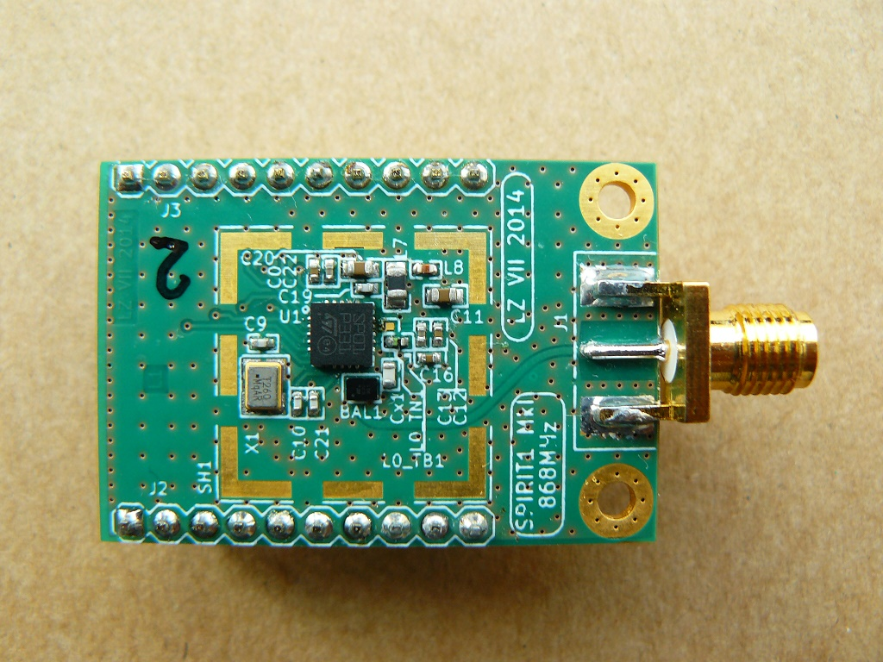

Top view:

Top view presents pin assignment:

RF TX characteristic

TX characteristics (harmonics) for CW were measured using Agilent EXA signal analyzer.
Screenshots for two modules are presented.

Frequency: 868.010 MHz
Power: 14 dBm, 25mW

Module #1:
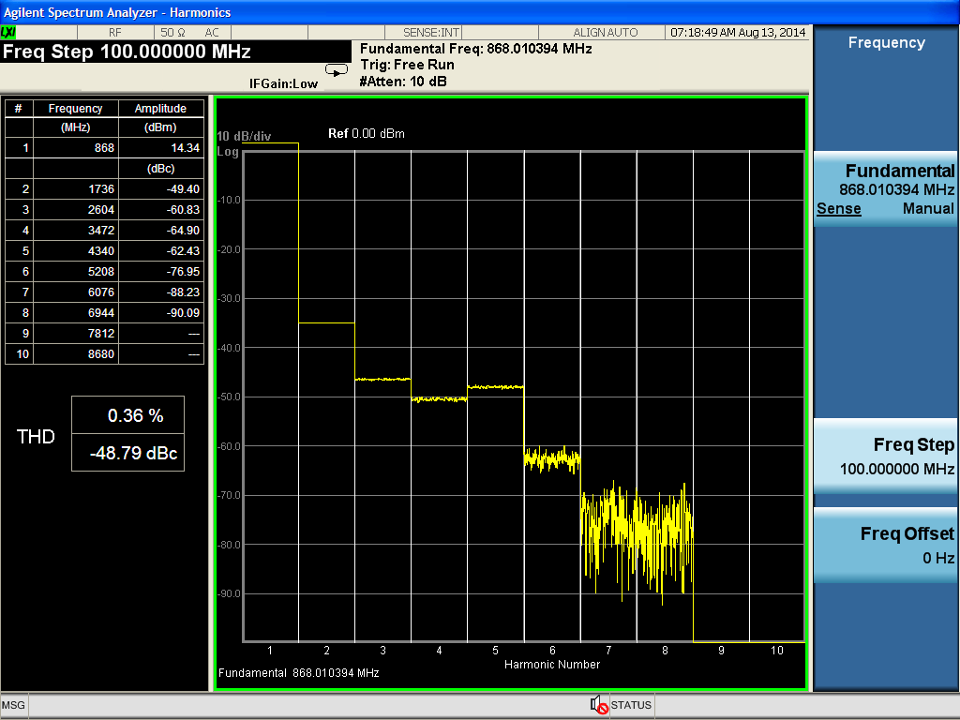

Module #2:
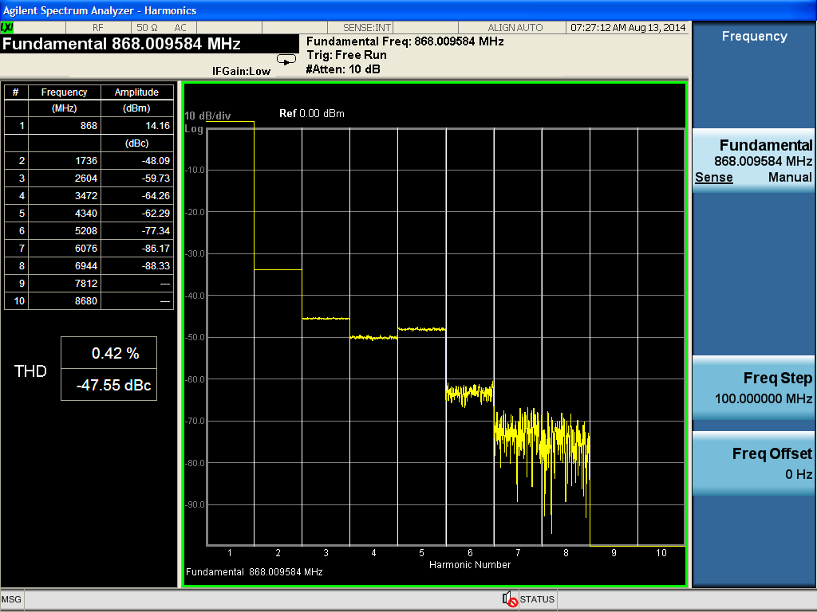

Frequency: 915.0 MHz
Power: 14 dBm, 25mW

Module #5:
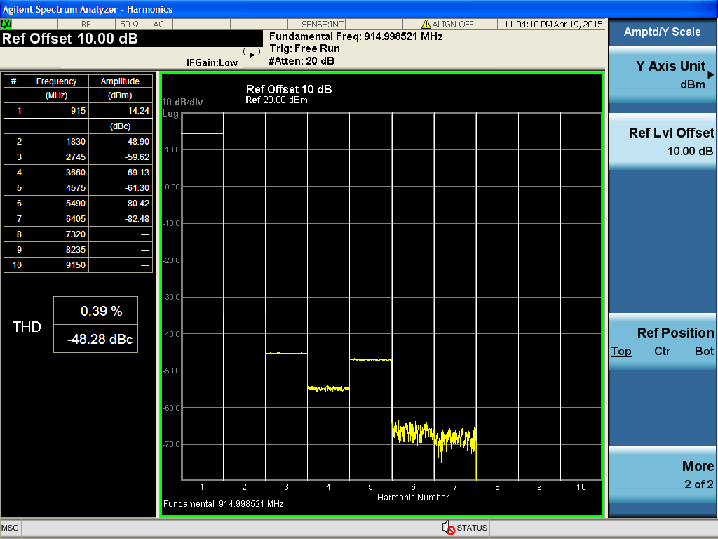

Module #6:

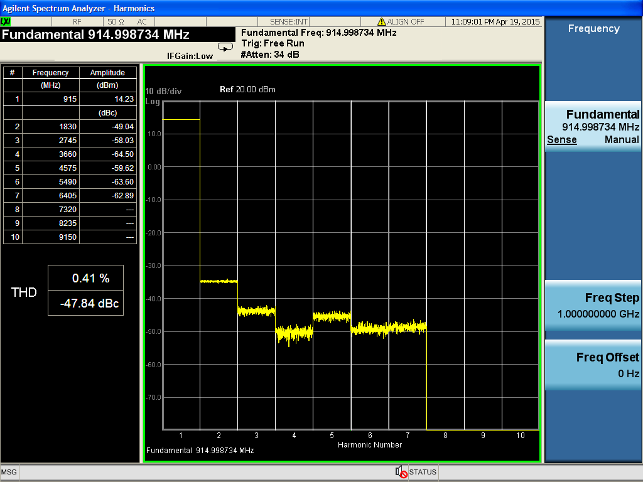

Measured values were compared with Table 14 in Spirit1 datasheet document (P_{harm}).
Second harmonic should be -50dBc instead of measured -48dBc, but after disabling TX boost option and measuring output at 10mW we measured required -50dBc value of 2nd harmonic.
This suggests that increased TX power creates some additional distortion.

RF RX characteristic:

RX characteristics were measured using R&S vector signal generator.

We measured RX sensitivity characteristic for modulation types described in Table 13 for 868MHz band.

Required sensitivity was achieved.
Please note, that modules were created with SMPS ON option which reduces power consumption in cost of RX sensitivity (1-2 dB).

