GPS module

Overview:

GPS board uses A2235H module: http://www.farnell.com/datasheets/1833178.pdf

Module can work with attached patch antenna or active GPS antenna connected by MCX connector.

Schematic:

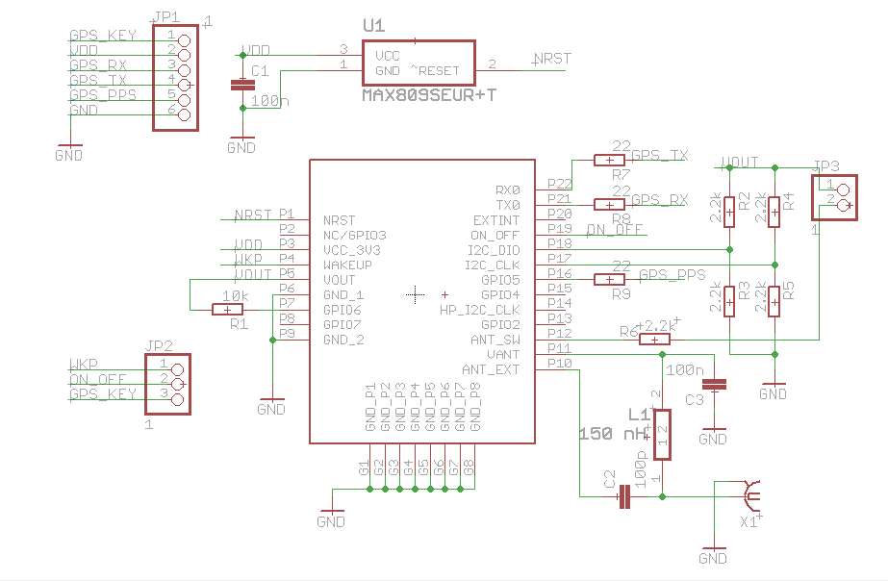

Top view:

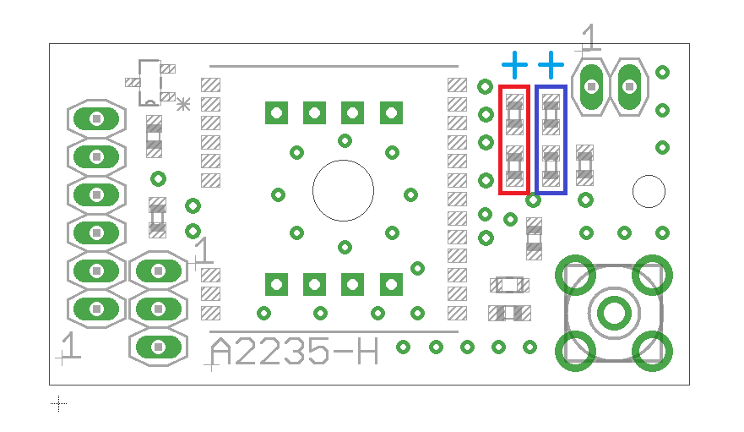
Top view presents three connectors pin alignment and position of optional resistors configuring GPS UART speed (initial):

6-pin connector (JP1):

Position of pin number 1 is visible on top-view.

1 – GPS KEY line (input) – used for controlling GPS module power state,
2 – VDD (supply) – 3.3 V supply line,
3 – GPS RX (input) – UART receive line,
4 – GPS TX (output) – UART transmit line,
5 – GPS PPS (output) – PPS line from module,
6 – GND (supply).

3-pin connector (JP2):

Power-up configuration.

1 – WKP line (output) from GPS module,
2 – ON_OFF line (input),
3 – GPS KEY line (input) – identical with JP1-1 pin.

This connector is used for selecting GPS power-up configuration. Jumper is used for selecting:

Jumper at position 1-2 – GPS will start automatically after powering up,
Jumper at position 2-3 – GPS will wait for pulse signal on ON_OFF line – should be provided by MCU.

Note:
The same pulse signal is used for enabling and disabling the chip. UART output should be checked to be sure that GPS was shut down properly.

2-pin connector (JP3):

External antenna selector.
1 – 1.8V line for supplying pin 2 (with jumper),
2 – ANT_SW (input) – logical low (or disconnected) selects internal antenna, 1.8V or VDD selects external antenna connected to MCX socket.

Jumper should be used for selecting external antenna. MCU should provide logic high signal if controlled by MCU.

Notes:
ANT_SW line is not disabling supply for active antenna attached to MCX connector when external antenna is disabled.
ANT_SW is not completely blocking signal from other (than selected) antenna – it is just attenuating by some dB other source.

Configuration resistors:
Red box shows potential position of resistors configuring GPIO0 line
Blue box shows potential position of resistors configuring GPIO1 line

Blue “+” sign shows position of 1.8V line for pull high position, the opposite is GND.
Table 4 from manual shows possible configurations:

By default, module is produced with 9600 baud rate configuration.

