GliGli’s Sequential Circuits Prophet 600 Firmware Upgrade

Table of Contents

About this Document
History of the Project
Install the New Processor and Firmware
Install Pin Jumpers
Flash the Teensy
Remove 5Volt Connector
Install the Teensy into the Prophet 600
Upgrading the Firmware
User Manual / Getting Around the New Prophet 600
Review of New Features
Settings Pages
Tune
Manual/Preset Modes
Additional Parameters Page Quick Guide
Miscellaneous Settings Page Quick Guide
Arpeggiator
Keyboard Modes
Oscillator A and B Mix
New Behaviour for Knobs
Low Frequency Oscillator
LFO Waveform
LFO Speed
LFO Target
Vibrato
Pitch Wheel
Pitch Wheel Range
Pitch Wheel Assignment
Pitch Wheel Calibration
Modulation Wheel
Wheel Depth
Wheel Target
Modulation Delay
Envelope Generator Mode
Oscillator Range Control
Midi channels
Voice defeat
Synchronisation source
Managing Sound Libraries through SysEx
Loading
Saving
Troubleshooting and Bugs
Appendix
MIDI Implementation
Resources

About this Document

This document captures all information regarding the GliGli firmware upgrade for the Sequential Circuits Prophet 600 synthesiser using a Teensy++ 2.0 USB Development Board as a drop-in replacement for the original Z80 microprocessor. This manual is for the 2.0 release.

Please understand that following these directions and completing these steps are presented at the user’s risk. The user assumes all responsibility for determining the suitability of this upgrade to their instrument and the safety of themselves and others.

History of the Project

(GliGli) I love vintage analog synthesizers, and to be honest, my dream synth would be a Prophet 5, but when I heard what the Prophet 600 was capable of tone wise, I immediately thought its major weaknesses -- the lousy computer part, software envelopes and LFO -- could become its strength with a remake; basically the whole internal synth in voltage-controlled from a nice 14bit DAC, so with a fast modern microcontroller, it could become awesome, maybe even better than a Prophet 5!

I'm a long time coder, I love embedded/bare metal stuff, electronics. Synth wise, I’ve already worked on 2 projects:
- An Atmel based two DCOs + SSM2044 monosynth:
https://github.com/gligli/anaglik-01
- A custom USB programmable wave data cartridge for the Yamaha RX5:
https://github.com/gligli/rx5usb

Before that I did a lot of embedded programming and hacking, from portable media players to modern video game consoles ( http://gligli360.blogspot.fr/ )

I started this project by making a PC emulator of the P600 digital hardware in order to learn how it worked -- and because at that point I didn't have a P600. Using a Z80 emulator library, the service manual and MiniSystem's blog, I was able to get it working to the point where I could see the CVs reacting to knob changes, envelopes and all...

Next, I scrapped the Z80 library and started writing my own C code which I compiled in a library and loaded in my P600 emulator/simulator so that it could do basic things like driving the analog synthesizer CVs, scanning the keyboard and displaying stuff on the 7-segment.

Then, I was lucky to find a mint P600 45 minutes from my town and bought it. Within a few hours, I had my C code working on it; I just had to write the Teensy low level pin interface, the rest was the same as in the simulator.

This was the point at which rewriting the firmware could really begin -- subsystem by subsystem -- including the envelopes, tuner, assigner, LFO. etc., until this version, which I hope you will enjoy as much using as I did while developing! At times it was painful too, but nothing even remotely ambitious is ever simple I guess... :)

The source code references and uses code developed by other synthesiser enthusiasts such as:
- Tom Wiltshire of Electric Druid and his work on Direct Digital Synthesis based envelope generators and LFOs.
- The XNOR MIDI Library written by Alex Norman.
- Jeff Lee of MiniSystem and his blog Prophet 600 Spirit.
- Bulghur of Motisonic provided troubleshooting/testing and documentation.
- Ramcur, Spetzle, Tohk, Wintermute303 (alpha testing)

Install the New Processor and Firmware

You will need the following items to complete this step:
- Soldering iron, clamps, solder, 22awg or similar wire
- Basic soldering skills
- Understanding of where components are located in the Prophet 600.

Note: Before you begin, back up your sound patches as a SysEx dump. The firmware upgrade includes a feature to restore patches after the firmware has been run. Because the new system does not use the original memory in the Prophet 600, your original patches will be lost as soon as you upgrade.

Source the Teensy++ 2.0 USB Development Board. Two versions exist -- choose the version with the pins pre-soldered. You can source these from the following purveyor:
http://www.pjrc.com/store/teensypp_pins.html

Other sources exist.

Install Pin Jumpers
Minor changes must be made to the Teensy before installing it into the Prophet 600. Follow the directions below:

In the following steps, you will solder four wires connecting specific pins:
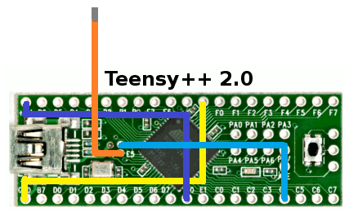

- Solder the following wires onto the pins of the Teensy. They are colour coded for easy identification.
  - GND to R: Yellow
  - E0 to 5V: Violet
  - E4 to C4: Blue
- For the final Orange wire, cut a 6cm length and solder it into the E5 hole. Lightly tin the other end; it will be plugged into the socket on the Prophet 600 computer board. The Teensy should look something like the following:
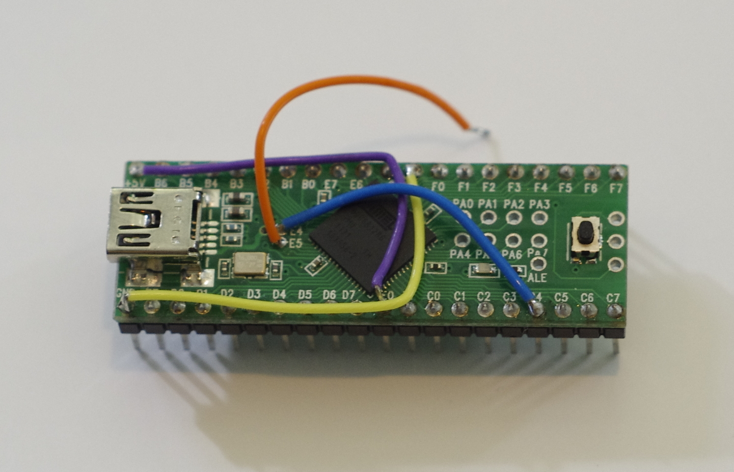

- Cut pin 30 on the Teensy. Make sure the remains of it are as small as possible.

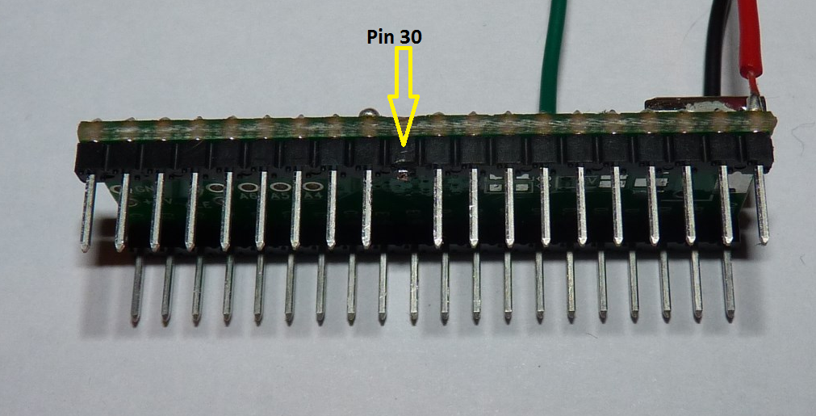

The Teensy is now ready to be flashed.

Flash the Teensy
Before you install the Teensy, you will flash the firmware on to the Teensy by completing the following steps:
- Locate the firmware file in this archive (a .hex file).
- Download the Teensy programmer from http://www.pjrc.com/teensy/teensy.exe and save it.
- Launch the programmer by double clicking the teensy.exe application. It may ask you to confirm running the file. Select Run.
- The flash application appears. Select File/Open HEX File and navigate to the location that you saved the p600firmware hex file and select it.
- Connect the Teensy board to your computer via USB. The orange LED may light. Press the button on the Teensy. Immediately, the display on the Teensy application will change indicating that it is ready to transmit the file to the Teensy.
- Select Operation/Program. The application will show a progress bar and indicate when the programming is complete.
- Disconnect the Teensy from the USB cable.
The Teensy is now ready for one final modification before it is installed in the Prophet 600.

Remove 5Volt Connector
You must make one final modification to the Teensy before installing it in the Prophet 600.

- Using a sharp knife -- such as an Xacto or other razor knife, cut the trace that connects the 5Vs from the adjacent pad. This terminates the +5V connection used to flash the board when not installed.

Install the Teensy into the Prophet 600

- If you want to be able to restore the Z80 and your sounds to your Prophet 600, back-up all of your sounds as a SysEx file dump. There are several ways to do this; instructions to do this are available online.
- Unplug and open the Prophet 600 and locate the computer board located on the bottom left side of the case next to the power transformer.

- Locate the Z80 microprocessor on the lower left hand corner of the computer board and carefully remove it using an IC extractor or nudging it up on each side until it is loose enough to pull of of the socket. Store it in a safe place on conductive foam. 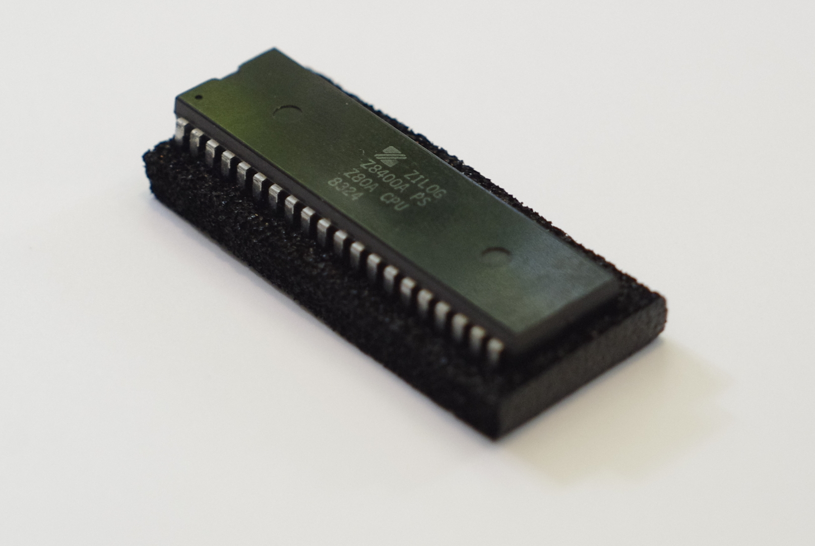
- Install the Teensy with the USB connector facing toward the back of the Prophet 600 by seating it about halfway into the socket.
- Plug the E5 wire into socket number 30 -- which will be open because it happens to be in exactly the same location that you cut the pin on the Teensy.

- Push the Teensy down into the socket to seat it securely.
- Inspect your work. Is the E5 wire properly connected? Is the Teensy oriented in the right direction? Your Teensy should look something like the following:

- Plug in the Prophet 600 and switch it on and confirm that the unit is operating. The orange LED on the Teensy will light and the tune routine will commence stepping through the 12 oscillators and 6 filters; during the tune routine the display cycle A1 through A6, b1 through b6 and F1 through F6. After approximately 20-30 seconds, a welcome message will scroll.

Congratulations! You have just confirmed that you’ve successfully install the Prophet 600 Firmware Upgrade. Because the unit has no presets upon completion of these steps, take this moment to dial up a suitable sound on the Prophet 600 with the preset mode set to “off”. Take a few moments to dial up some basic sounds on the instrument. You will promptly declare this instrument to have been sonically liberated after 30 plus years in a 4MHz Z80 regime.

The next section explains how to initialise the unit and how to get the most from the upgrade.

Upgrading the Firmware

To flash the firmware, you will need to complete the following steps:
- Make sure the Prophet 600 is turned off.
- Press both “from tape” and “to tape”, and while keeping them pressed, turn on the Prophet 600.
- The display should read “U”, the Prophet 600 is now in update mode and ready to receive a SysEx firmware upgrade.
- Using MidiOx ( http://www.midiox.com/ ) or any SysEx tool of your choice, send the SysEx upgrade file to the Prophet 600 (the file should be “p600firmware.syx”). In MidiOx configuration, make sure “Delay Between Buffers” and “Delay After F7” are at least 250 Milliseconds and “Delay After F7” is checked. Some USB-MIDI interfaces may need more than 250 Milliseconds to work fine.
- While the Prophet 600 is upgrading, the display will show a spinning segment.
- If the upgrade ends with “S” on the display, the upgrade was successful, you can power cycle the Prophet 600 and use the new firmware.
- If the upgrade ends with “E” on the display, the upgrade has failed, you have to do the upgrade procedure again until it succeeds. It is not advised to try to run the Prophet 600 in normal mode after a failed upgrade.

User Manual / Getting Around the New Prophet 600

Review of New Features

The Prophet 600 Firmware Upgrade hosts the following improvements:
- Easy-to-install non-destructive firmware drop-in replacement of the new firmware. If you ever find yourself pining for the old sound of your Prophet 600, you can remove the Teensy and restore the Z80.
- Greater resolution of many of the sound parameters with an improved refresh rate that is making the instrument much more responsive.
- Faster, smoother amplifier and filter envelope generators supporting four different modes:
  - Fast Linear.
  - Slow Linear.
  - Fast Exponential.
  - Slow Exponential.
- A new LFO function generator with a wider range from one cycle every <20 seconds> to about 60Hz with four new waveforms in addition to the original triangle and square including sine, random stepped, noise (like on the original Prophet 5, but non-periodic) and sawtooth (ramp up).
- A dedicated vibrato which can be controlled by the modulation wheel, or can start progressively after a fixed amount of time.
- Multiple keyboard modes including last/low/high note priority.
- Unison detune.
- Mix Overdrive which now allows the output from both oscillators to drive the mix VCAs A and B harder as well as the Curtis 4 pole filter resulting in new sonic possibilities.
- Pitch Wheel interval selection of plus/minus one octave, a whole tone, a minor third and a fifth.
- Pitch Wheel reassignment to the VCF and Volume or off.
- Modulation wheel intensity setting from Maximum to Medium to Minimum.
- Full Midi In control including:
  - Amp and Filter velocity sensitivity with an external keyboard controller.
  - Continuous Controllers (CC) of all sound parameters.
  - Program change (PC) to choose current preset.
  - Synchronizing the arpeggiator to MIDI clock.
- A new and improved tuning procedure.
- Octave, chromatic and free Oscillator course pitch control.
- Plus/Minus setting for Oscillator Fine Tune and Filter Envelope amount for Poly Mod and Filter.
- Assignable, Random And Up/Down Arpeggiator.
- Debounce feature that prevents unintended retriggering caused by the old keyboard.
- Organised open source code available on GitHub: https://github.com/gligli/p600fw

Settings Pages
The Prophet 600 is now organised around two menu pages through which you configure the instrument.
- The Additional Parameters Page is the default page in manual mode, and is active when pressing “to tape” in preset mode: This is the normal interaction page. The advanced sound parameters are found here such as selecting new LFO waveforms, envelope generator profiles and ranges of various controllers.
- A Miscellaneous Settings Page active when “from tape” is kept pressed: This is the page used to access various “housekeeping” parameters such as setting MIDI channels and modes and so on.

Tune
Upon first power-up, the Prophet 600 tunes itself. The “Tune” light illuminates and the display indicates the oscillator or filter being tuned from A1 through A6, b1 through b6 and F1 through F6 for Oscillator A, B and the Filter respectively. The routine takes about 20 seconds to complete depending on the tuning of your instrument.

It is normal to have to retune the instrument during the first 30 minutes of operation as the electronics warm to a stable operating temperature. To tune, simply press the tuning button as required.

Manual/Preset Modes
As with the original Prophet 600 firmware, pressing the Preset button switches between manual mode, in which the synthesiser parameters sound parameters reflect the active sonic-state of the instrument, and preset mode in which the sound is a stored patch.

You can edit a stored patch or manual patch or preset patch at any time by completing the following:
- Press the “Record” button on the keypad. It will blink.
- Press the two digit location to which you want to save the patch.
The patch is saved. It will overwrite whatever sound patch was there before.
You can cancel a patch store any time while the “Record” button is blinking by pressing record.

Additional Parameters Page Quick Guide
Below is a table summarising the Parameters and keypad buttons required to access the synthesiser additional parameters. More detailed instructions are provided after the table summary.
To select a parameter, press one of the keypad numbers once or twice, its name and value will be displayed. To edit it, used the “Speed” knob.

Miscellaneous Settings Page Quick Guide
Below is a table summarising the keypad buttons required to access the synthesiser miscellaneous settings. More detailed instructions are provided after the table summary.
To access a function, maintain “from tape” pressed and press a keypad number.

Arpeggiator

The instrument supports three arpeggiator modes:
- Arp Down/Up plays an up/down note sequence with double trigger on the lowest and highest note. For example, playing C3 C4 E4 G4 will play: C3 C4 E4 G4 G4 E4 C4 C3 C3 C4 and so on. Mathematically, it allows you to work out the time signature. Three notes results in ¾ time, notes 4/4 time, 5 notes in 5/4, etc. To play with the Arp Up/Down, press the Arp Dn/Up button on the keypad. The “Arp Dn/Up” will light continuously.
- Arp Assignable sequences the notes in the order that they are played. To play with the Arp Assignable, press the “Arp Assign” button and play the notes in the order you want them sequenced. The “Arp Assign” will light continuously.
- Arp Random plays notes played in a random order. To play the Arp Random, press the “Arp Assign” button twice until it blinks and then play the notes.

With all Arpeggiator modes, press the “Record” button on the keypad to latch or hold the notes played. Playing additional notes while in Record mode will latch addition notes to the existing sequence to a maximum of 128 notes. To clear the notes from the sequence, press the “Record” button to switch it off.

The speed is controlled by pressing “0” once on the additional parameters page and using the “Speed” knob to change it.

The foot switch input can be used to hold the arpeggiator.

Keyboard Modes

The Prophet 600 can be either in Polyphonic, Unison or Chord mode.

- The synthesizer starts in Polyphonic mode, in which any new note will be assigned to one of the 6 voices.
- If you switch “Unison track” on with no pressed key, you are in Unison mode, all 6 voices will play the same note.
- If you switch “Unison track” on with one or more pressed keys, you are in Chord mode. The pattern those keys made will now be transposed over the whole keyboard range by new notes.

The foot switch input can be used to latch a new pattern of notes.

New notes will be assigned to voices using one of those priority rules:
- “Last”: New notes will always play, the oldest notes may be stolen.
- “Low”: Only the lowest notes will play. In Unison or Chord mode, legato will be active.
- “High”: Only the highest notes will play. In Unison or Chord mode, legato will be active.

The assignment priority is controlled by pressing “7” twice on the additional parameters page and using the “Speed” knob to change it.

Oscillator A and B Mix
A new feature has been introduced that allows the VCAs into the filter to be over-driven by Oscillator A and B. In order to support this, the Oscillator A/B Mix has been reassigned to the Oscillator A Level and the Glide knob now controls the Oscillator B Level. The normalised point is at about half way or 5 on the dial. To overdrive the inputs, go all the way to 10. Because of this, the Glide speed has been reassigned to the “Glide” additional parameter (press “7” once).

New Behaviour for Knobs
The Poly Mod Filter Amount, the Filter Amount and the Detune knobs are now zero set to the midway position to allow both positive and negative values. This means that inverse envelopes can be applied to the modulations and filter controls and it is now possible to detune Oscillator B flat as well as sharp with respect to Oscillator A.

Low Frequency Oscillator

LFO Waveform
The Prophet 600 now supports six waveforms in addition to the standard Triangle and Square waves including Sine, (Saw) Ramp Up, Random, Noise. To select the desired waveform:
- For Triangle, Sine or Saw:
  - If you are in preset mode, make sure “to tape” is lit, else press it to access the additional parameters page.
  - Switch the LFO-MOD Shape button to Triangle.
  - Press the “1” button once and use the “Speed” knob to select the Triangle, Sine or Saw. The display indicates the current selection.
- For Square, Random or Noise:
  - If you are in preset mode, make sure “to tape” is lit, else press it to access the additional parameters page.
  - Switch the LFO-MOD Shape button to Square.
  - Press the “1” button once and use the “Speed” knob to select the Square, Random or Noise. The display indicates the current selection.

LFO Speed
You can control the speed range of the LFO from Slow; the default setting; to Fast by pressing “1” once on the additional parameters page and using the “Speed” knob to select either Slow of Fast.

LFO Target
You can choose to assign the LFO to only one of the two oscillators by pressing “1” twice on the additional parameters page and using the “Speed” knob to select either Oscillator A, Oscillator B or both as a target.

Vibrato
The Prophet 600 now features a dedicated pitch vibrato. You can adjust its speed by pressing “2” once and its amount by pressing “3” once on the additional parameters page.

By default, it is controlled by a modulation delay which can be adjusted by pressing “4” once on the additional parameters page.

Pitch Wheel
The Pitch Wheel Range and Assignment can now be selected and, if required, the Pitch Wheel can be calibrated.

Pitch Wheel Range
The range of the Pitch Wheel can be set to Octave, Fifth, Minor Third or Second. To set the Pitch Wheel range press the “6” twice on the additional parameters page and use the “Speed” knob to select it.

Pitch Wheel Assignment
The Pitch Wheel can be assigned to the control the Pitch (the default setting), the Filter Cutoff Frequency, Volume or Off. To select the Pitch Wheel assignment press the “6” once on the additional parameters page and use the “Speed” knob.

Pitch Wheel Calibration
The Pitch Wheel might need to be calibrated to its center position to properly sweep the full range selected. To calibrate the Pitch Wheel:
- Center the Pitch Wheel.
- While maintaining “from tape” pressed Press the “3” button on the keypad. The display will indicate that the Pitch Wheel has been calibrated.

Modulation Wheel

Wheel Depth
The range of the Modulation wheel can be set for Full, High, Half or Minimum to control the depth of modulation over the range of the wheel. To set the Modulation Wheel depth press the “3” once on the additional parameters page and use the “Speed” knob to select it.

Wheel Target
The Modulation wheel can either control the LFO or the Vibrato, the other being controlled by the modulation delay. Pressing “4” twice on the additional parameters page and using the “Speed” knob changes this.

Modulation Delay
The modulation delay can be adjusted by pressing “4” once on the additional parameters page.

Envelope Generator Mode
Four Envelope Generator (EG) modes are supported for both the Amplifier and the Filter: Fast Linear, Slow Linear and Fast Exponential and Slow Exponential which controls the response of the slope of the rise and fall of the attack, decay and release phase. To select the desired response:
For the Amplifier EG:
- If you are in preset mode, make sure “to tape” is lit, else press it to access the additional parameters page.
- Press the “5” once on the additional parameters page and use the “Speed” knob to select it.
For the Filter EG:
- If you are in preset mode, make sure “to tape” is lit, else press it to access the additional parameters page.
- Press the “5” twice on the additional parameters page and use the “Speed” knob to select it.

Oscillator Range Control
Oscillator A and B frequency ranges are now controllable in three modes: Octave (the default value), Chromatic and Free. The range remains the same but it is now possible to sweep the frequency of the oscillators with a greater degree of fine control. To select the oscillator sweep mode, press button “8” twice on the additional parameters page and use the “Speed” knob to select it.

Midi channels
Miscellaneous Settings function “1” selects the MIDI receive channel, it can be “OMNI” to receive on all channels.

Miscellaneous Settings function “2” selects the MIDI send channel. The Prophet 600 will transmit note on / note off from the keyboard or the arpeggiator, plus pitch bend and modulation wheel changes.

Voice defeat
One or more voices from the Prophet 600 can be turned off. This can be useful if e.g. they aren’t working fine.
Use Miscellaneous Settings function “5” to select a voice, and function “6” to turn it on or off.

Synchronisation source
Miscellaneous Settings function “8” allows for one of three synchronization sources to be selected for the arpeggiator:
- Internal: this is the default setting, the Prophet 600 will generate its own clock.
- MIDI: a fraction of the incoming MIDI clock will be used to clock the arpeggiator.
- Tape: you can plug any pulse clock source on the “Cassette in” jack. A fraction of it will be used to clock the arpeggiator.

Managing Sound Libraries through SysEx

Loading
Loading a SysEx library will overwrite your existing stored patches. To load a complete SysEx Library:
- Connect the instrument via MIDI.
- Load the SysEx file into a utility or into your sequencer application. Good utilities include:
  - Windows:http://www.midiox.com/
  - OSX: http://www.snoize.com/SysExLibrarian/
- Determine the appropriate transmission channel of the SysEx utility or sequencer application.
- Set the Prophet 600 receive channel to the same channel that the SysEx will be transmitted by either selecting the specific channel or simply selecting OMNI (receive on all channels).
- Transmit the data to the instrument.

Saving
Miscellaneous Settings function “6” will send a SysEx dump of all presets on MIDI out. Use your favourite SysEx utility to store it.

Troubleshooting and Bugs
This version of the firmware has been tested on many Prophet 600s. Issues may still arise in an instrument manufactured over 30 years ago operating in varied environments; components age unevenly. We invite you to submit issues and bugs but understand that in some cases issues might have to do more with the physical characteristics of the instrument than with software. Here are couple of things to think about:
- Switch the instrument off, think of your grammar school teacher and then switch it back on again. Often, this all that is needed to restore the instrument.
- Check your MIDI is properly set-up. Is it transmitting messages that might be causing the instrument to misbehave. Filter those messages.
- Check for a new hex file for an updated firmware version.
- How did the instrument operate before the upgrade? If the instrument becomes unstable, restore the original Z80 and observe the behaviour.
- Power Supply: Unstable power supplies can cause a lot of issues with digital/analogue hybrid synthesisers.
- Locked or unstable parameters: Pots can generate unstable voltages that toggle between two states. This was not an issue when the resolution on the Prophet 600 was lower, say four or six bits. However, with higher depth resolution, you might hear the artefacts of dirty or faulty pots causing slight wavering in the sound. Particularly susceptible parameters include the Pulse Width and the Filter Cutoff with a high Resonance setting. The solution is to clean the pot, change it or move the pot to a new location. You can also use a MIDI controller to set values and then store them.
- Keep abreast of changes and report issues at Github-Issues: https://github.com/gligli/p600fw/issues.

.

Appendix

MIDI Implementation

Two types of MIDI controllers are implemented:
- Continuous parameters: 0-16383 using 2 CCs, or 0-127 using only the coarse one.
- Stepped parameters: 0-127, variable number of steps. They parameters work by dividing the 0-127 range is as many zones as there is choices for the parameter. Eg: "Unison" is off for 0-63 and on for 64-127.

The Prophet 600 receives Continuous Controllers in Preset mode only.

Resources

Project Site: http://gligli.github.io/p600fw/
Issues/Bugs: https://github.com/gligli/p600fw/issues
Teensy Site: http://www.pjrc.com/teensy/index.html

