p600fw install guide

I – Prerequisites

- A soldering iron, tin, clamps and other obvious stuff, time too, which is often the hardest to find ^^.
- A "Teensy++ 2.0 USB Development Board", I strongly recommend the version that has header pins.
http://www.pjrc.com/store/teensypp_pins.html
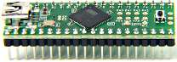

II – Programming and mounting steps

1 – Program the teensy board
- Download the teensy programmer : http://www.pjrc.com/teensy/teensy.exe
- Connect the teensy board to the PC.
- Run the programmer, this must be shown :
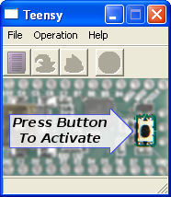

- Press the teensy board button, this must be shown :
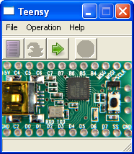
- Do File -> Open HEX file and select the p600firmware.hex file (located in this archive).
- Do Operation -> Program, this must be shown once programming is done :
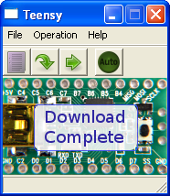
- The teensy board is now programmed, You can unplug it from the PC.

2 – Modify the teensy board

- Under the teensy board, cut the trace between 5V pads :
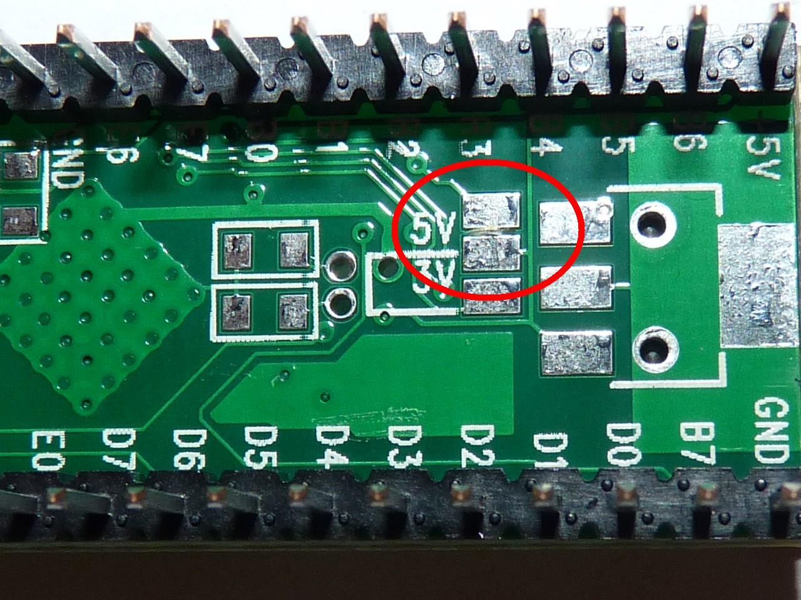

- Solder three wires, one short red on +5V, one short black on GND, and a little longer green one on E5 :
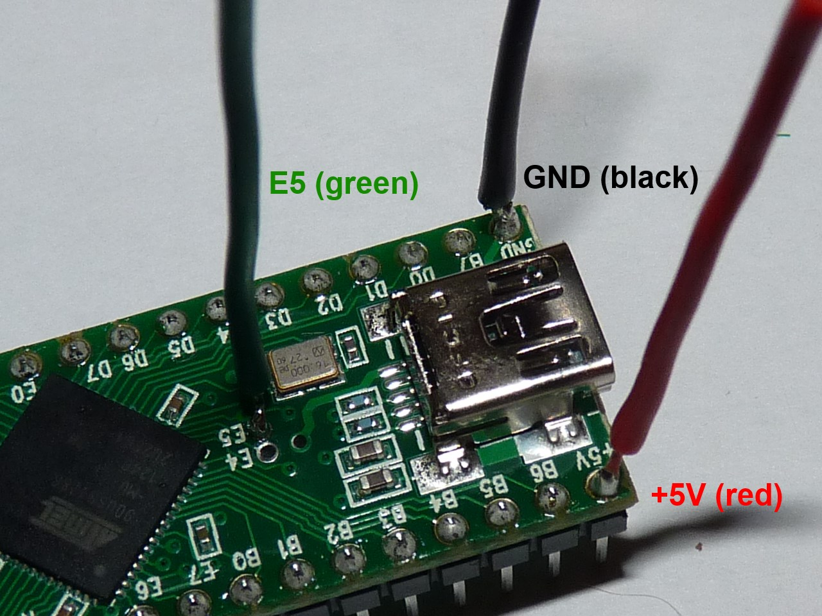

- Cut the unnamed pin between R and E6, make sure only very little is left of it ! (it might be better to unsolder it completely, but it's a bit tricky)
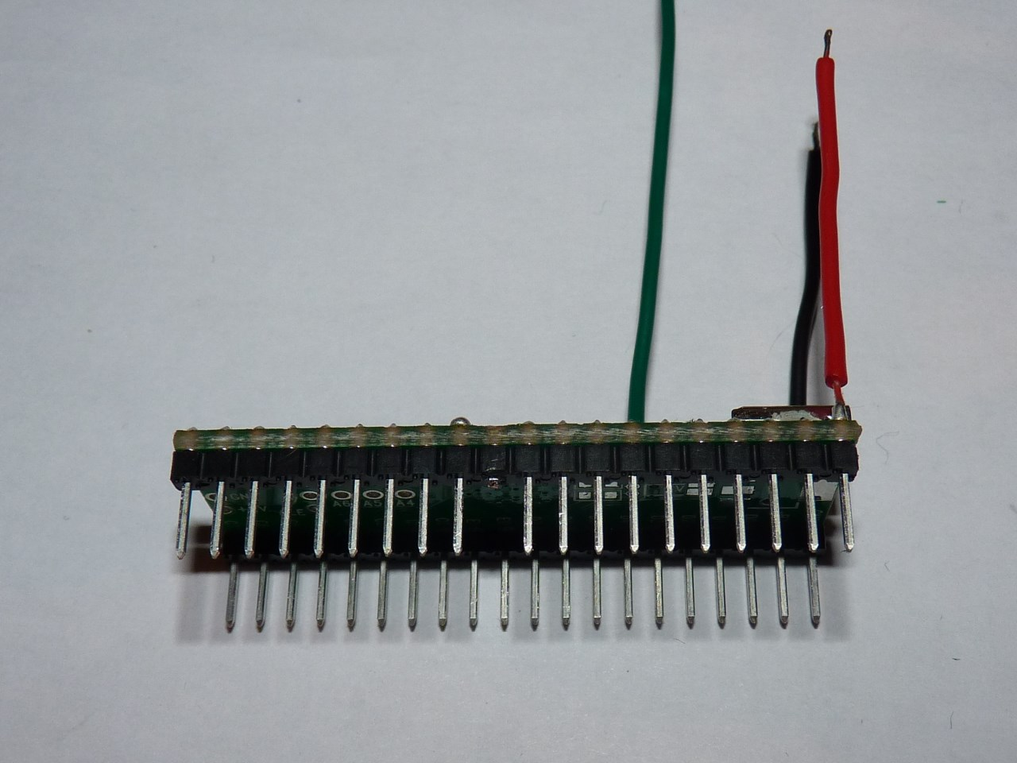
- Solder the red wire other end on pin E0, and the black wire one on R :
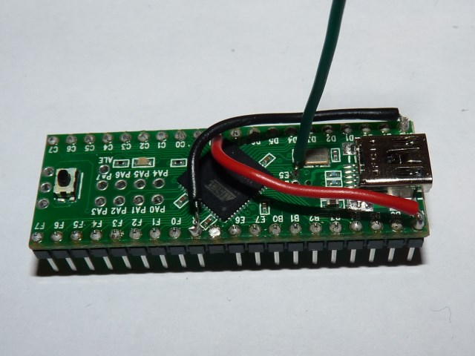
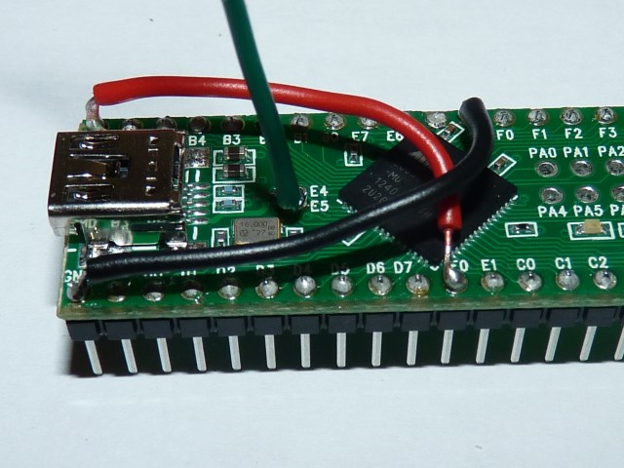

3- Install the modified teensy into the Prophet 600

- In the prophet 600, remove the Z80, preferably using an IC extractor.

- Plug the green wire in the Z80 socket at pin 30 :
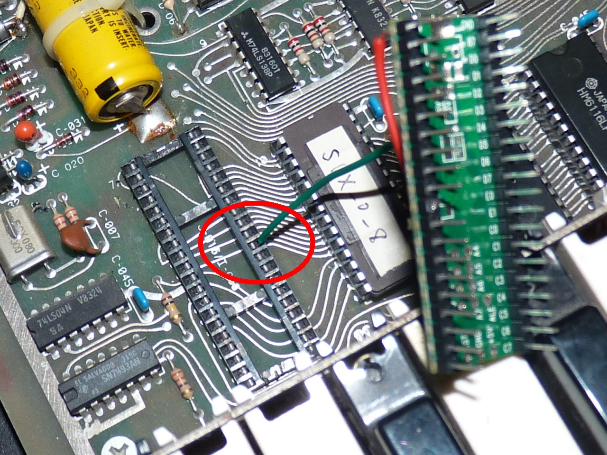

- Finally, plug the teensy, making sure the green wire is aligned with the pin that was cut before :
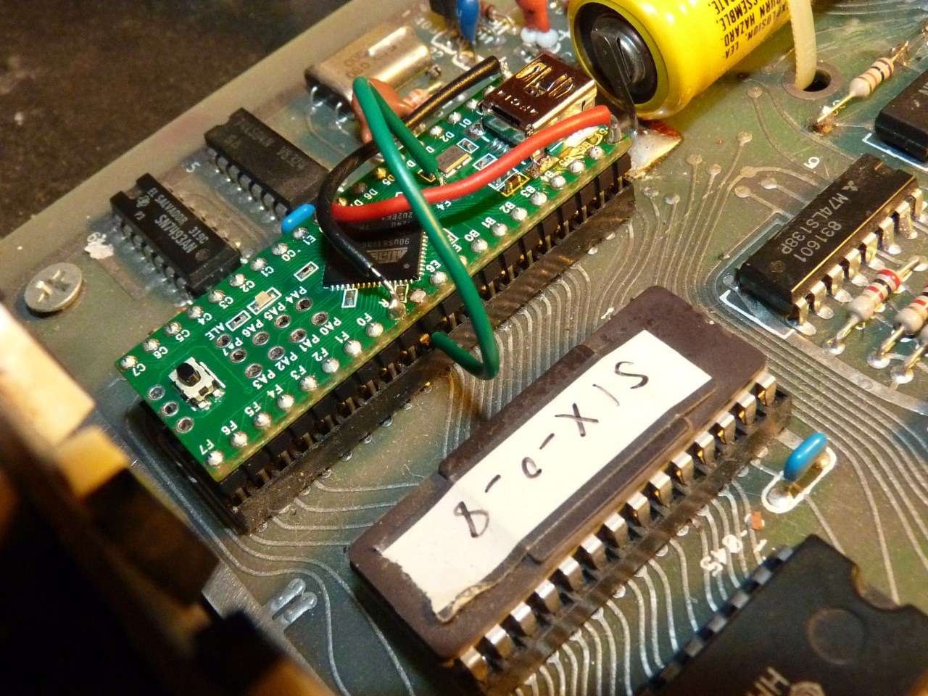
- That's all, folks !

