GliGli’s Sequential Circuits Prophet 600 Firmware Upgrade

Modification Instructions

Document version: 1.0 (13.11.201)
Separated from original comprehensive documentation

Table of Contents

About this Document 2
History of the Project 2
Install the New Processor and Firmware 4
Install Pin Jumpers 4
Flash the Teensy 5
Remove 5Volt Connector 6
Install the Teensy into the Prophet 600 6
Upgrading the Firmware 9
Resources 9

About this Document

This document captures all information regarding the GliGli firmware upgrade for the Sequential Circuits Prophet 600 synthesiser using a Teensy++ 2.0 USB Development Board as a drop-in replacement for the original Z80 microprocessor. This manual is for the 2.0 release.

Please understand that following these directions and completing these steps are presented at the user’s risk. The user assumes all responsibility for determining the suitability of this upgrade to their instrument and the safety of themselves and others.

Note on the documentation history: the User Manual (oringinally included here) has been moved to a separate document. The original instructions from GliGli in this document are unchanged. It is expected that the content of this document is independent from further software developments, unless the firmware is migrated to a different technical platform. The software information has been omitted from this document.

History of the Project

(GliGli) I love vintage analog synthesizers, and to be honest, my dream synth would be a Prophet 5, but when I heard what the Prophet 600 was capable of tone wise, I immediately thought its major weaknesses -- the lousy computer part, software envelopes and LFO -- could become its strength with a remake; basically the whole internal synth in voltage-controlled from a nice 14bit DAC, so with a fast modern microcontroller, it could become awesome, maybe even better than a Prophet 5!

I'm a long time coder, I love embedded/bare metal stuff, electronics. Synth wise, I’ve already worked on 2 projects:
- An Atmel based two DCOs + SSM2044 monosynth:
https://github.com/gligli/anaglik-01
- A custom USB programmable wave data cartridge for the Yamaha RX5:
https://github.com/gligli/rx5usb

Before that I did a lot of embedded programming and hacking, from portable media players to modern video game consoles ( http://gligli360.blogspot.fr/ )

I started this project by making a PC emulator of the P600 digital hardware in order to learn how it worked -- and because at that point I didn't have a P600. Using a Z80 emulator library, the service manual and MiniSystem's blog, I was able to get it working to the point where I could see the CVs reacting to knob changes, envelopes and all...

Next, I scrapped the Z80 library and started writing my own C code which I compiled in a library and loaded in my P600 emulator/simulator so that it could do basic things like driving the analog synthesizer CVs, scanning the keyboard and displaying stuff on the 7-segment.

Then, I was lucky to find a mint P600 45 minutes from my town and bought it. Within a few hours, I had my C code working on it; I just had to write the Teensy low level pin interface, the rest was the same as in the simulator.

This was the point at which rewriting the firmware could really begin -- subsystem by subsystem -- including the envelopes, tuner, assigner, LFO. etc., until this version, which I hope you will enjoy as much using as I did while developing! At times it was painful too, but nothing even remotely ambitious is ever simple I guess... :)

The source code references and uses code developed by other synthesiser enthusiasts such as:
- Tom Wiltshire of Electric Druid and his work on Direct Digital Synthesis based envelope generators and LFOs.
- The XNOR MIDI Library written by Alex Norman.
- Jeff Lee of MiniSystem and his blog Prophet 600 Spirit.
- Bulghur of Motisonic provided troubleshooting/testing and documentation.
- Ramcur, Spetzle, Tohk, Wintermute303 (alpha testing)

Install the New Processor and Firmware

You will need the following items to complete this step:
- Soldering iron, clamps, solder, 22awg or similar wire
- Basic soldering skills
- Understanding of where components are located in the Prophet 600.

Note: Before you begin, back up your sound patches as a SysEx dump. The firmware upgrade includes a feature to restore patches after the firmware has been run. Because the new system does not use the original memory in the Prophet 600, your original patches will be lost as soon as you upgrade.

Source the Teensy++ 2.0 USB Development Board. Two versions exist -- choose the version with the pins pre-soldered. You can source these from the following purveyor:
http://www.pjrc.com/store/teensypp_pins.html

Other sources exist.

Install Pin Jumpers
Minor changes must be made to the Teensy before installing it into the Prophet 600. Follow the directions below:

In the following steps, you will solder four wires connecting specific pins:
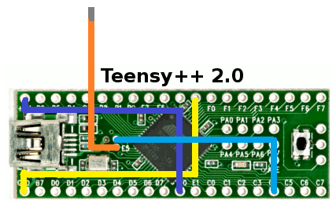

- Solder the following wires onto the pins of the Teensy. They are colour coded for easy identification.
  - GND to R: Yellow
  - E0 to 5V: Violet
  - E4 to C4: Blue
- For the final Orange wire, cut a 6cm length and solder it into the E5 hole. Lightly tin the other end; it will be plugged into the socket on the Prophet 600 computer board. The Teensy should look something like the following:
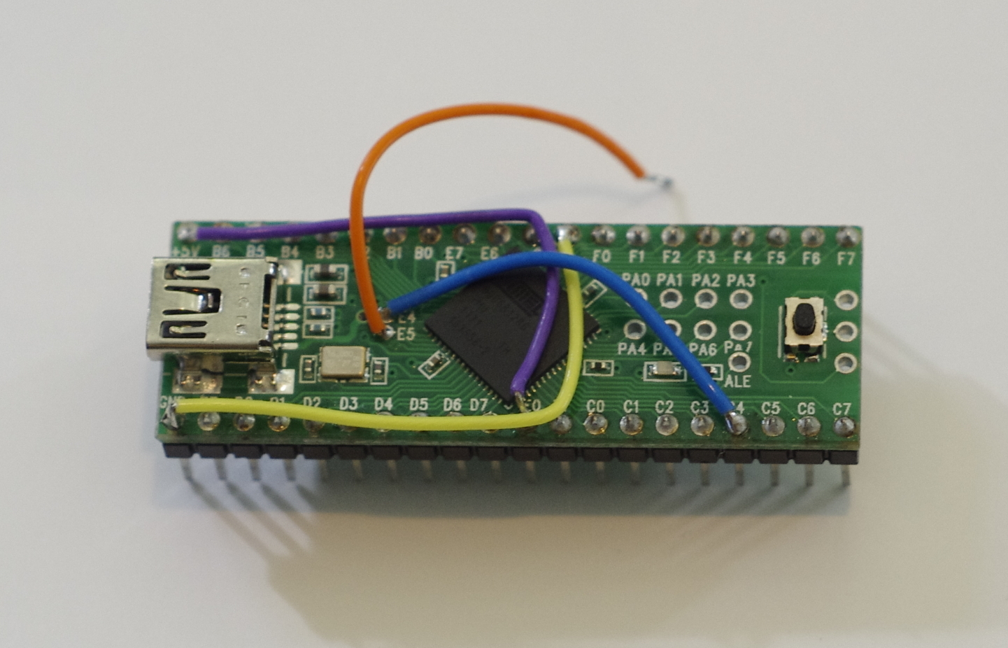

- Cut pin 30 on the Teensy. Make sure the remains of it are as small as possible.

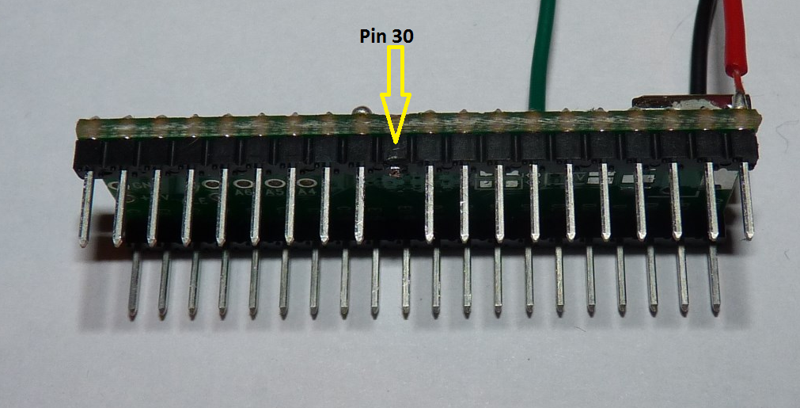

The Teensy is now ready to be flashed.

Flash the Teensy
Before you install the Teensy, you will flash the firmware on to the Teensy by completing the following steps:
- Locate the firmware file in this archive (a .hex file).
- Download the Teensy programmer from http://www.pjrc.com/teensy/teensy.exe and save it.
- Launch the programmer by double clicking the teensy.exe application. It may ask you to confirm running the file. Select Run.
- The flash application appears. Select File/Open HEX File and navigate to the location that you saved the p600firmware hex file and select it.
- Connect the Teensy board to your computer via USB. The orange LED may light. Press the button on the Teensy. Immediately, the display on the Teensy application will change indicating that it is ready to transmit the file to the Teensy.
- Select Operation/Program. The application will show a progress bar and indicate when the programming is complete.
- Disconnect the Teensy from the USB cable.
The Teensy is now ready for one final modification before it is installed in the Prophet 600.

Remove 5Volt Connector
You must make one final modification to the Teensy before installing it in the Prophet 600.

- Using a sharp knife -- such as an Xacto or other razor knife, cut the trace that connects the 5Vs from the adjacent pad. This terminates the +5V connection used to flash the board when not installed.

Install the Teensy into the Prophet 600

- If you want to be able to restore the Z80 and your sounds to your Prophet 600, back-up all of your sounds as a SysEx file dump. There are several ways to do this; instructions to do this are available online.
- Unplug and open the Prophet 600 and locate the computer board located on the bottom left side of the case next to the power transformer.

- Locate the Z80 microprocessor on the lower left hand corner of the computer board and carefully remove it using an IC extractor or nudging it up on each side until it is loose enough to pull of of the socket. Store it in a safe place on conductive foam. 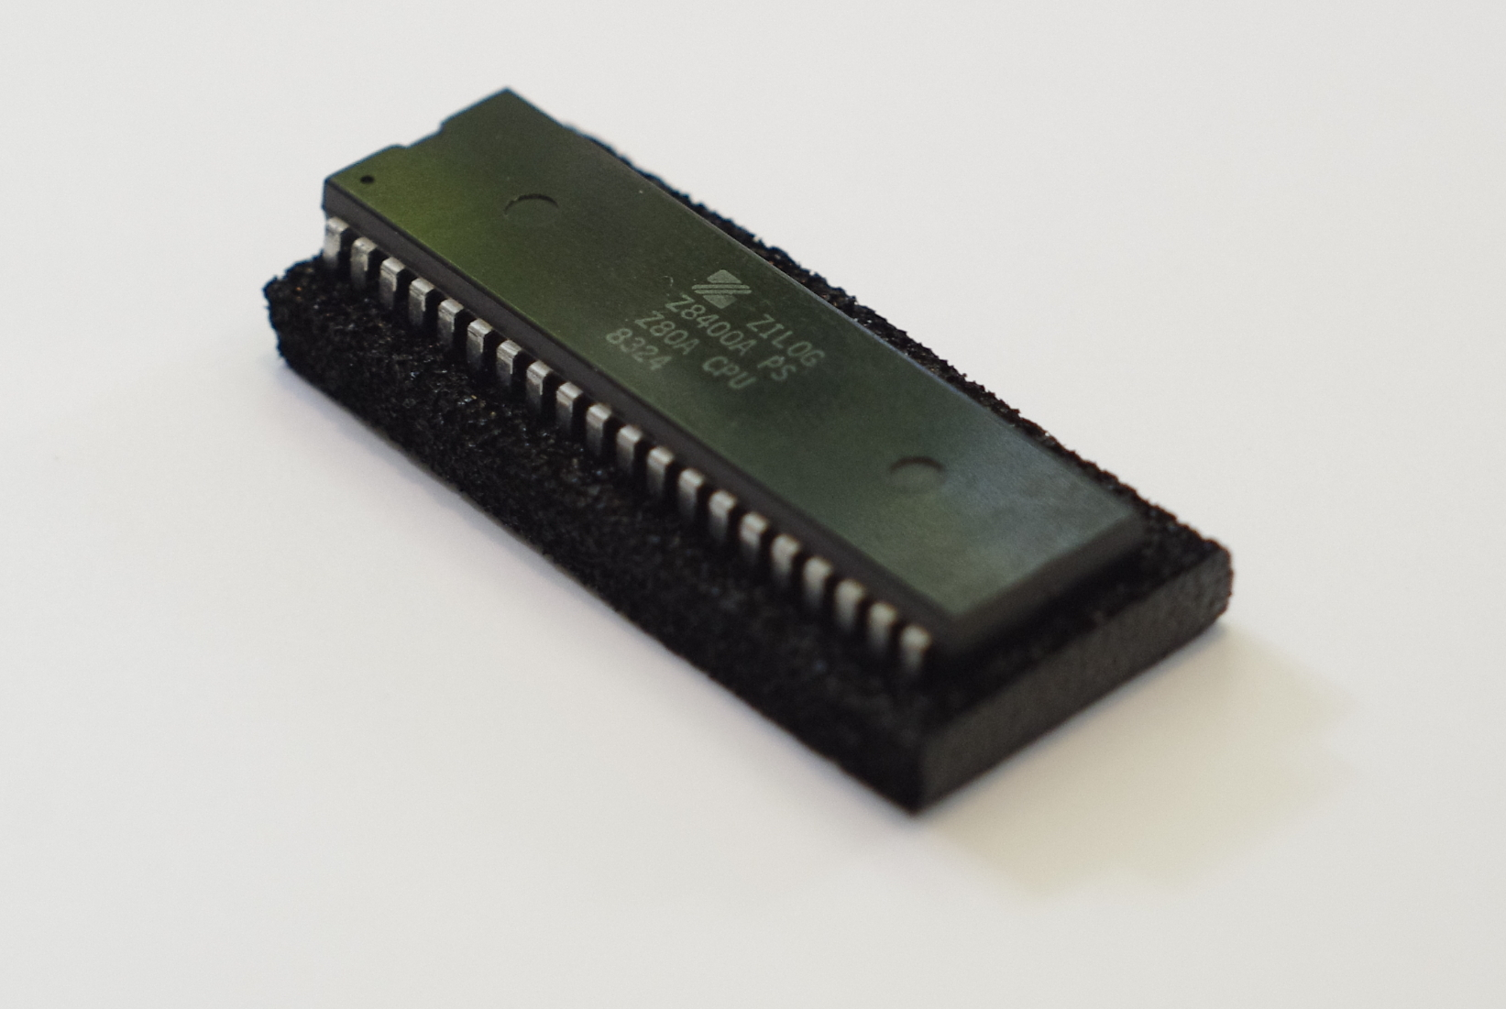
- Install the Teensy with the USB connector facing toward the back of the Prophet 600 by seating it about halfway into the socket.
- Plug the E5 wire into socket number 30 -- which will be open because it happens to be in exactly the same location that you cut the pin on the Teensy.

- Push the Teensy down into the socket to seat it securely.
- Inspect your work. Is the E5 wire properly connected? Is the Teensy oriented in the right direction? Your Teensy should look something like the following:

- Plug in the Prophet 600 and switch it on and confirm that the unit is operating. The orange LED on the Teensy will light and the tune routine will commence stepping through the 12 oscillators and 6 filters; during the tune routine the display cycle A1 through A6, b1 through b6 and F1 through F6. After approximately 20-30 seconds, a welcome message will scroll.

Congratulations! You have just confirmed that you’ve successfully install the Prophet 600 Firmware Upgrade. Because the unit has no presets upon completion of these steps, take this moment to dial up a suitable sound on the Prophet 600 with the preset mode set to “off”. Take a few moments to dial up some basic sounds on the instrument. You will promptly declare this instrument to have been sonically liberated after 30 plus years in a 4MHz Z80 regime.

The next section explains how to initialise the unit and how to get the most from the upgrade.

Upgrading the Firmware

To flash the firmware, you will need to complete the following steps:
- Make sure the Prophet 600 is turned off.
- Press both “from tape” and “to tape”, and while keeping them pressed, turn on the Prophet 600.
- The display should read “U”, the Prophet 600 is now in update mode and ready to receive a SysEx firmware upgrade.
- Using MidiOx ( http://www.midiox.com/ ) or any SysEx tool of your choice, send the SysEx upgrade file to the Prophet 600 (the file should be “p600firmware.syx”). In MidiOx configuration, make sure “Delay Between Buffers” and “Delay After F7” are at least 250 Milliseconds and “Delay After F7” is checked. Some USB-MIDI interfaces may need more than 250 Milliseconds to work fine.
- While the Prophet 600 is upgrading, the display will show a spinning segment.
- If the upgrade ends with “S” on the display, the upgrade was successful, you can power cycle the Prophet 600 and use the new firmware.
- If the upgrade ends with “E” on the display, the upgrade has failed, you have to do the upgrade procedure again until it succeeds. It is not advised to try to run the Prophet 600 in normal mode after a failed upgrade.

Resources

Project Site: http://gligli.github.io/p600fw/
Issues/Bugs: https://github.com/gligli/p600fw/issues
Teensy Site: http://www.pjrc.com/teensy/index.html

