RX5USB install guide

I – Prerequisites

- A soldering iron, tin, clamps and other obvious stuff, time too, which is often the hardest to find ^^.
- A rev2.8 (or newer) RX5USB printed circuit board, drilled and cut to proper dimensions.
- A "Teensy++ 2.0 USB Development Board", I strongly reommend the version that has header pins.
http://www.pjrc.com/store/teensypp_pins.html
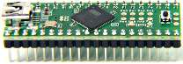
- A 4MBit flash chip : the SST39SF040, DIP-32 package.
http://www.semiconductors.boo.pl/pdf/SST39SF010A_20A_40.pdf
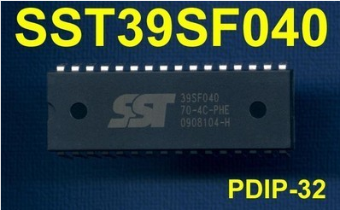
- Two large 'tulip' DIP sockets, one with 32 pins, and one with 40 pins.
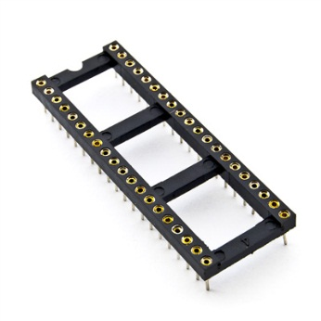
- A USB to mini-USB cable, You probably got one with Your camera / hard drive / mp3 …
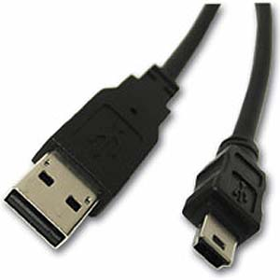
- A SPDT switch.
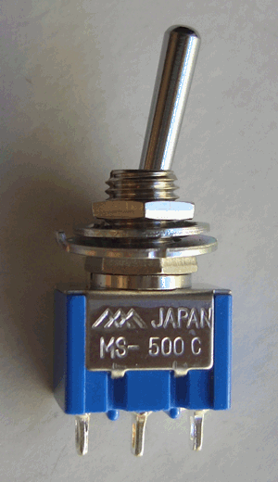
- A few basic components:
- Four 1/4W 5% resistors, one 470 ohms (yellow purple brown) and three 4.7 kilo-ohms (yellow purple red).
- One 100 nanofarads polyester capacitor.
- One 47 microfarads electrolytical capacitor, 10 volts minimum.
- Two 1N4148 diodes.
- Two 1N5817 diodes.
- One 3 millimeters LED.

II – Mounting and testing steps

1 – Program the teensy board
- Download the teensy programmer : http://www.pjrc.com/teensy/teensy.exe
- Connect the teensy board to the PC.
- Run the programmer, this must be shown :
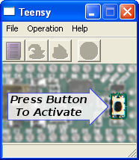
- Press the teensy board button, this must be shown :
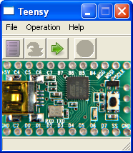
- Do File -> Open HEX file and select the rx5usb_fw.hex file (located in this archive build_files folder).
- Do Operation -> Program, this must be shown once programming is done :
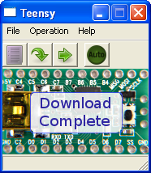
- The teensy board is now programmed, You can unplug it from the PC.

2 – Modify the teensy board
- Under the teensy board, cut the trace between 5V pads :
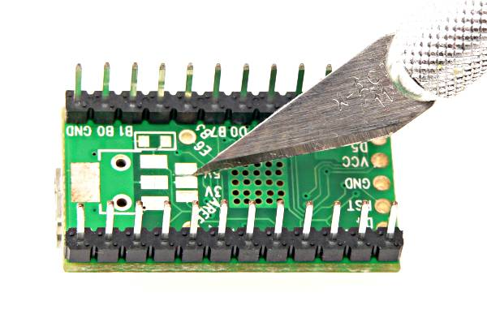
- Solder a 1N5817 diode like that :
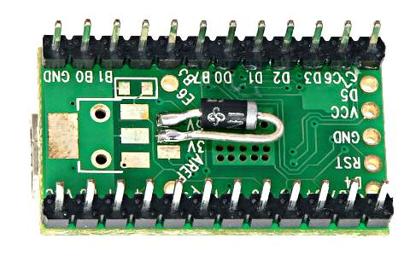

3 - Solder vias
There are 15 of them in rev2.8.

4 – Solder I.C. sockets
Some pins must be soldered on both sides of the board !

5 - Solder small components
Résistors and diodes (check the orientation).

6 - Solder everything else
LED, capacitors (check the orientation for the electrolytical one), and switch wires.

7 – Visually check for short circuits
Important step, double check power traces (thicker ones).

8 – Plug the flash chip and the teensy board
Check the orientation !

9 – Test for proper bank programming from a PC
The cartridge is now ready to work, start by testing bank programming from a PC.
If it fails, double checks everything before the next step !

10 - Tester on the RX5
If programming a bank succeeded in the previous step, there should be no risk plugging it into the RX5 !

