LAB02 – 193171

2.

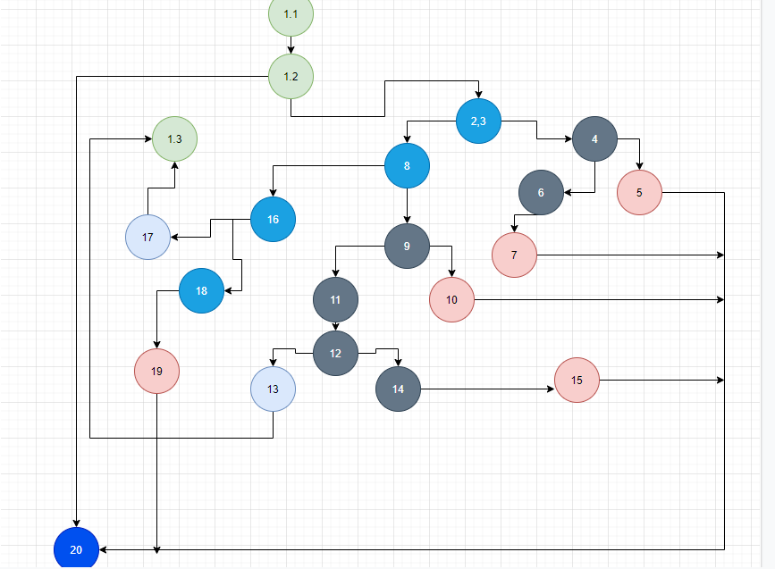

3. Цикломатската комплексност е 7 – број на ребра – број на јазли + 2

4.

4.  
if (hr < 0 || hr > 24)

|  |  |  |
| --- | --- | --- |
| COMBINATION | Test cases | branch |
| TX | -1 , 20 , 20 | 123-4 |
| FT | 25 , 20 , 20 | 123-4 |
| FF | 20 , 20 , 20 | 123-8 |

if (min < 0 || min > 59)

|  |  |  |
| --- | --- | --- |
| COMBINATION | Test cases | branch |
| TX | 23, -20 , 20 | 9-10 |
| FT | 22 , 70 , 20 | 9-10 |
| FF | 20 , 20 , 20 | 9-11 |

if (sec >= 0 && sec <= 59)

|  |  |  |
| --- | --- | --- |
| COMBINATION | Test cases | branch |
| TT | 23, 20 , 20 | 12-13 |
| FX | 20 , 20 , -20 | 12-14 |
| TF | 20 , 20 , 70 | 12-14 |

else if (hr == 24 && min == 0 && sec == 0)

|  |  |  |
| --- | --- | --- |
| COMBINATION | Test cases | branch |
| TTT | 24, 0 , 0 | 16-17 |
| TTF | 24 , 0, 20 | 16-18 |
| TFX | 24 , 20 , 20 | 16-18 |
| FXX | 25 , 20 , 20 | 16-18 |

5. Every Statement

|  |  |  |  |  |  |  |
| --- | --- | --- | --- | --- | --- | --- |
|  | -1,20,20 | 25,20,20 | 22,61,20 | 22,20,15 | 20 , 20 , 70 | 24,0,0 |
| 1.1 | * | * | * | * | * | * |
| 1.2 | * | * | * | * | * | * |
| 1.3 | * | * | * | * | * | * |
| 2 | * | * | * | * | * | ** |
| 3 | * | * | * | * | * | * |
| 4 | * | * |  |  |  |  |
| 5 | * |  |  |  |  |  |
| 6 |  | * |  |  |  |  |
| 7 |  | * |  |  |  |  |
| 8 |  |  | * | * | * | * |
| 9 |  |  | * | * | * |  |
| 10 |  |  | * |  |  |  |
| 11 |  |  |  | * | * |  |
| 12 |  |  |  | * | * |  |
| 13 |  |  |  | * |  |  |
| 14 |  |  |  |  | * |  |
| 15 |  |  |  |  | * |  |
| 16 |  |  |  |  |  | * |
| 17 |  |  |  |  |  | * |
| 18 |  |  |  |  |  | / |
| 19 |  |  |  |  |  | / |
| 20 |  |  |  | * |  | * |

5.1

Every Branch

|  |  |  |  |  |  |  |
| --- | --- | --- | --- | --- | --- | --- |
|  | 22,20,15 | -1,20,20 | 24,0,0 | 22,61,20 | 25,61,20 | 22,22,70 |
| 3-8 | * |  |  |  |  |  |
| 3-4 |  | * |  |  |  |  |
| 4-5 |  | * |  |  |  |  |
| 4-6 |  |  |  |  | * |  |
| 8-9 | * |  |  | * |  |  |
| 8-16 |  |  | * |  |  |  |
| 9-10 |  |  |  | * |  |  |
| 9-11,12 | * |  |  |  |  |  |
| 12-13 | * |  |  |  |  |  |
| 12-14 |  |  |  |  |  | * |
| 16-17 |  |  | * |  |  |  |
| 16-18 |  |  | / |  |  |  |
|  |  |  |  |  |  |  |