DBMS FINAL PROJECT (**成績管理系統**)

Q36014049 陳星谷

**Description of the Student-Score-Management system is as follow:**

1.Each student(**STUDENT)** has Name (**Name**), sex(**Sex**),grade(**Grade**) , and a identical StudentID(**Sid** ).Sudents must belong to(**BELONG_TO**) a department(**DEPARTMENT**), and can choose(**CHOOSE**) several courses(**COURSE**), on each course a student choose, he get a score(**Score**)

2.Each professor (**PROFESSOR**) has a teacherID (**Tid**), name(**Name**),sex(**Sex**),do research(**RESEARCH**) in a department

3.Each course has a course name(**Cname**) , a unique course number(**Cnumber**) ,a class location(**Location**), hold(**HOLD**) by a department, and teach(**Teach**) by a Lecture

4.Each department has a unique name(**Name**),a location(**Location**),a unique number(**Number**)

5. Students may have dependents(**DEPENDENT**), each of the dependents have dependent name (**Name**), sex (**Sex**), relationship (**Relationship**)

**STUDENT**

|  |  |  |  |  |
| --- | --- | --- | --- | --- |
| Sid | Name | Sex | Grade | Dnumber |

**DEPARMENT**

|  |  |  |
| --- | --- | --- |
| Name | Location | Number |

**PROFESSOR**

|  |  |  |  |
| --- | --- | --- | --- |
| Sex | Name | Tid | Dnumber |

**COURSE**

|  |  |  |  |  |
| --- | --- | --- | --- | --- |
| Cnumber | Cname | Location | TeacherId | Dnumber |

**CHOOSE**

|  |  |  |
| --- | --- | --- |
| Sid | Cnumber | Score |

**DEPENDENT**

|  |  |  |  |
| --- | --- | --- | --- |
| Sid | Name | Sex | Relationship |

**ER-diagram of the system**

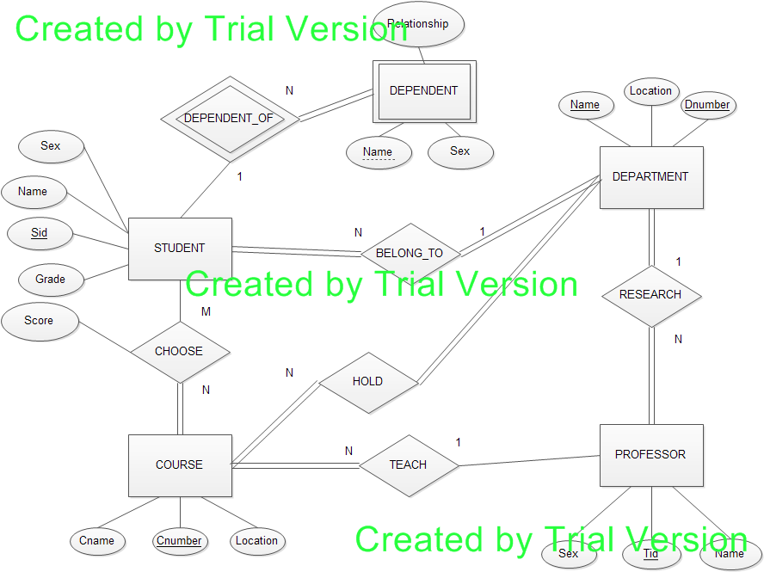

**Files of the project:**

The project consists of 3 modules **(Table.py, SQL.py, DBMS.py**), one main program (**main.py**), and demo data (**Demodata.txt**).

**Brief description of the modules :**

Table.py :

Handle basic table operation, including

1. table **creation**
2. basic relational operation ( **UNION, INTERSECTION, and Minus)**
3. table **projection** and **selection**
4. **join** of two different tables
5. conditional **group** of tables

SQL.py :

Parse the input SQL , generate instructions and using the basic operation in Table.py to generate new queried table by the description of SQL

SQL.py consists of two class : **instruction** and **querier**

**instruction** parse SQL and **querier** use the result of instruction and the function in Table.py to generated queried table

DBMS :

DBMS read the demo data from input text file, and use the information and the function of Table.py to generate basic tables. The tables are later being used in SQL.py for querying

**Basic flow:**

On executing main program, main program create a GUI for enter SQL:

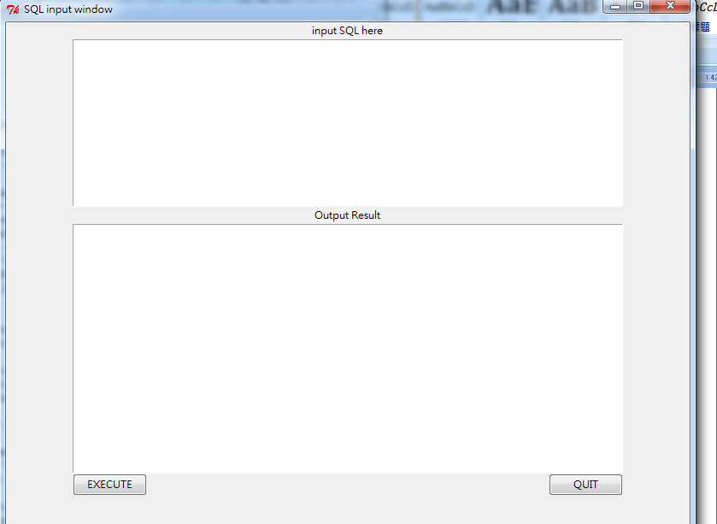

Input SQL in the upper frame, and press EXECUTE, the result will present at the lower frame.

**Examples1 (AND operation) (support join)**

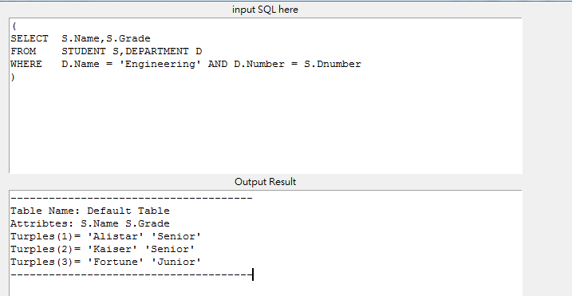

**Example2 (support *)**

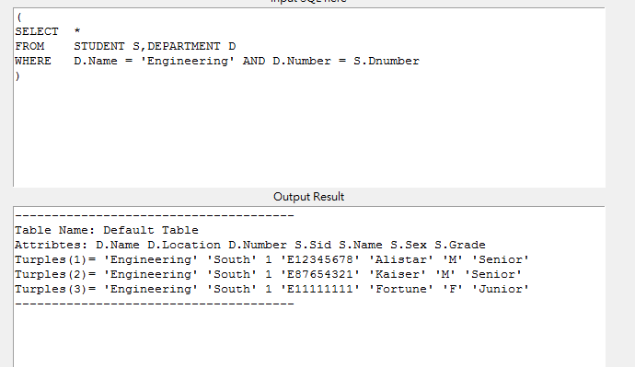

Example3 (**AND , OR**)

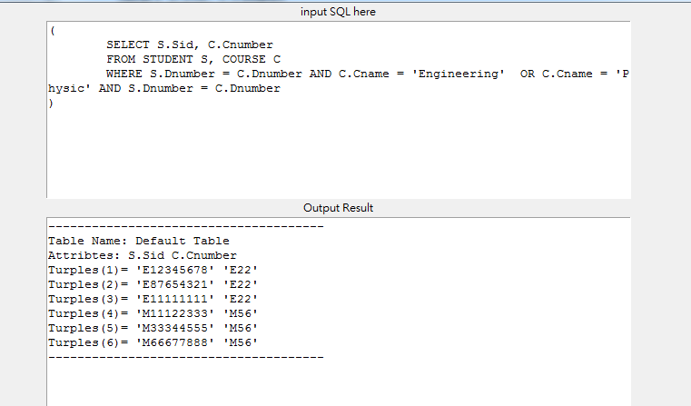

Example4 (**IN**)

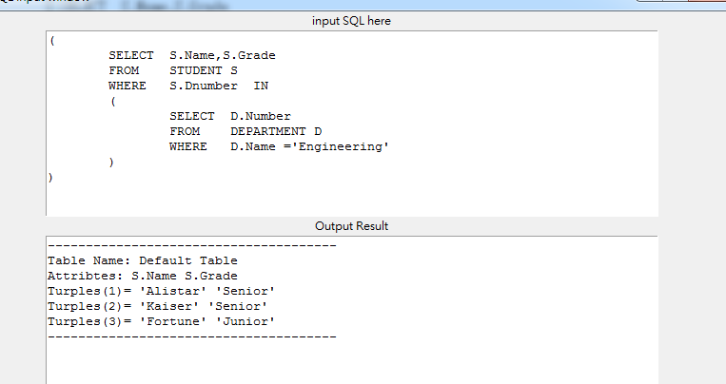

Example5(**NOT IN**)

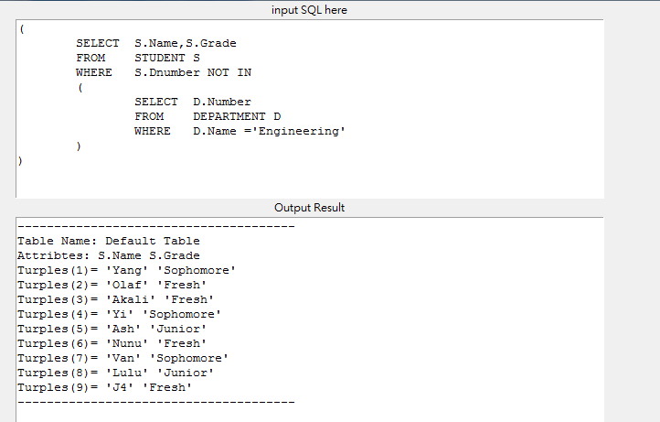

Example6 (**Nested IN**)

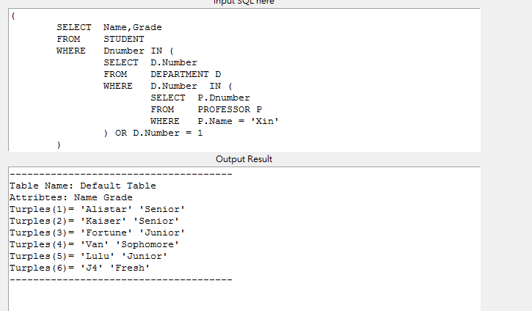

Example7 (**Aggregate**)

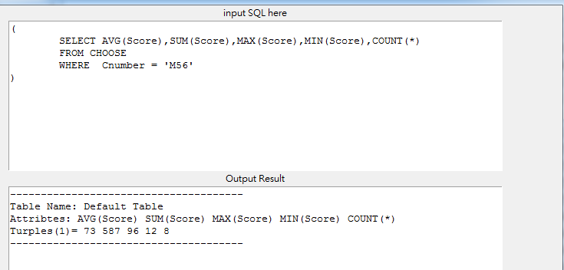

Example8 (**GROUP_BY_HAVING**)

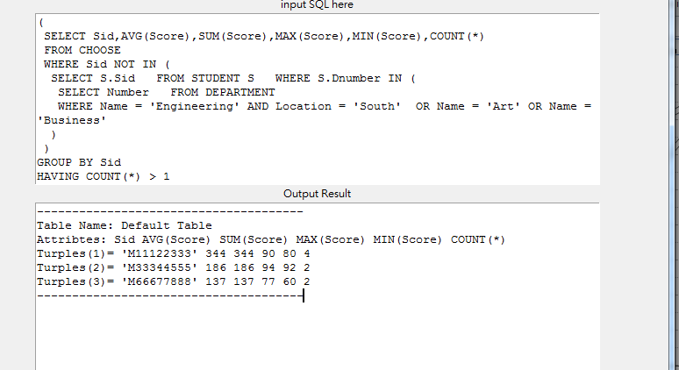

**\*All the testing SQL put in Example folder**