**Gephi visualization of co-experession network**

#### Convert Cytoscape inputs to gephi inputs ####

WGCNA will produce Cytoscape inputs for Nodes and Edges

1.Convert the Cytoscape Node cols to 'id' / 'Label' / 'module'

The 'id' col contains all the genes nodes in analysis

The 'Label' col contains the information for each gene you want to show on the network, such as postion, annotation

The 'module' col contains the color of each node detemined by WGCNA



2.Convert the Cytoscape Edge cols to 'Source' / 'Target'

The 'Source' col contains the start genes

The 'Target' col contains the linked genes



#### Use gephi to visualize ####

1. Install gephi

https://gephi.org/

2. Load Node & Edge inputs

(1) Select 'Data Laboratory' and 'Import Spreadsheet'

(2) Load Node & Edge inputs seperately and add them into same workspace

(3) Select 'undirected' for Graph Type

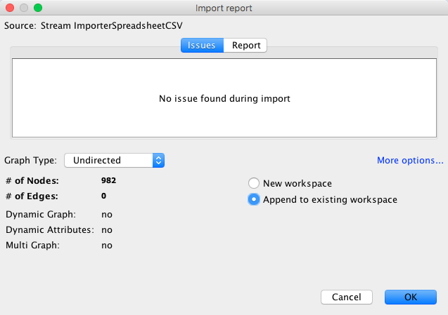

3. Click ‘Overview’ to see the rough network



4. Run ‘Yifan Hu’ method to separate each module

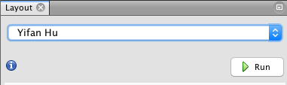

5. Run ‘Fruchterman Reingold’ Method to make network look better

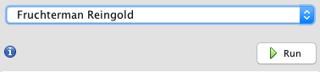

6. Adjust plot, such size of label text, size of edge lines

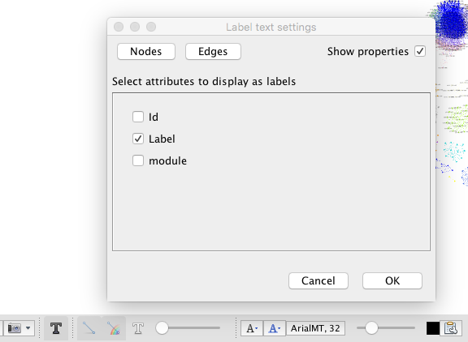

Show up label text

Edge size

Label size

Select cols want to label

7. Run ‘convert_WGCNA_color_to_hex.R’ to convert module colors to hex code

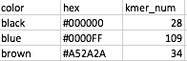

8. Color nodes of modules using gephi default colors

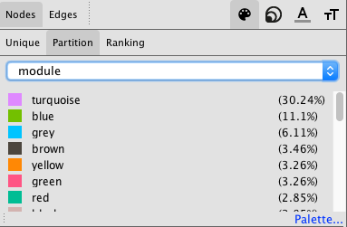

9. Right click each module color and paste the hex code of WGCNA module color to change all module colors to WGCNA module colors. After finishing, click ‘Apply’ to change the color

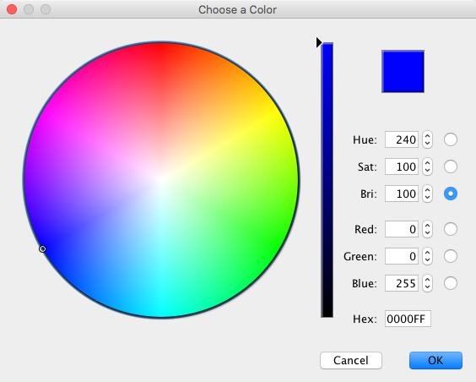

10. Click the ‘Preview’ to final adjust and export network figures