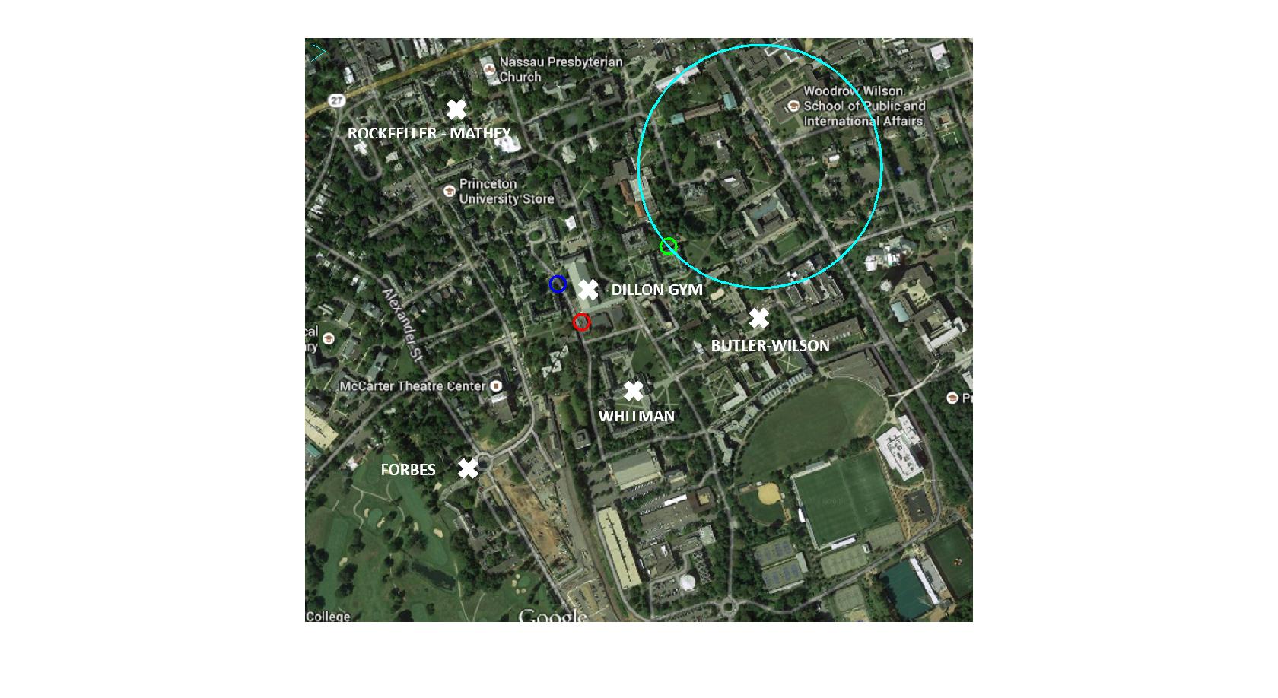

1.) Solving (1) with CXV

- Red circle (from (1), corresponds to Dillon West)
- Should not relocate (~2% change in objective fn.)

2.) Solving (1) with gradient descent algorithms
a.) Convergence took 2 iterations, though I believe it should take one as we are essentially minimizing a quadratic equation with Newton's method

b.)

3.) Relocating based on criteria (2)
- Blue circle
- Again should not move (~11% change in objective fn.)

4.) Solving (1) with additional fire hydrant constraint
- As the optimal value of (1) already satisfies the additional fire hydrant constraint (at squared distance 3.12 from [20,20]), the optimal value for the more-constrained problem will be the same as that of (1), i.e. the red circle

5.) Theater location
- Green circle
- Cyan circle marks the section of the feasible set dictated by the fire hydrant location

