# GLIP Token Whitepaper



GLIP Token Whitepaper

Version 1.0 — 2025

*Prepared for the launch of GLIP Mainnet and GLIP Coin*

GLIP Token | 2025 Page 1

# GLIP Token Whitepaper

**Abstract**

GLIP Token is an ERC-20 asset on Ethereum Mainnet (PoS) designed as the on-ramp to an independent GLIP Mainnet and its native GLIP Coin. It introduces a usage-driven fee-rebate mechanism that periodically returns a portion of network fees to the sending wallet via on-chain airdrops. The objective is to reduce effective transfer costs, encourage healthy on-chain activity, and create a more user-aligned transaction experience.

# Problem Statement

Layer-1 and Layer-2 networks still suffer from a trade-off among speed, security, and cost. Users face unpredictable fees during congestion; merchants and remittance users struggle to forecast costs; and security incidents—especially around bridges—have caused real losses. GLIP aims to deliver a practical alternative: predictable performance, strong security assumptions, and a cost-rebate system that directly benefits end users.

# GLIP Overview

Phase 1 launches GLIP as an ERC-20 for immediate liquidity and integrations. Phase 2 migrates to GLIP Mainnet via a 1:1 swap. On GLIP Mainnet, GLIP Coin powers transactions, staking, and governance. The rebate model aggregates paid fees and airdrops a configurable portion back to sender wallets each quarter, reducing lifetime transaction costs.

# Architecture

Ethereum Launch: GLIP uses Ethereum (PoS) for issuance and custody while the community grows. GLIP Mainnet: a Delegated Proof-of-Stake (DPoS) design with fast finality, EVM compatibility, and formally specified state transitions. Bridging: swaps occur via audited smart contracts with a one-way or two-way peg depending on governance outcomes and security reviews.

# Transaction & Rebate Mechanism

When a user sends a transaction, they pay a network fee. All fees are recorded on-chain and attributed to the sender address. At the end of each quarter, an on-chain distributor contract computes rebate shares for all eligible senders and executes a batched airdrop in a native token on GLIP Mainnet. The rebate percentage (e.g., R%) is set by governance within a min/max range and may vary by quarter to balance sustainability and incentives.

# Rebate Math (Illustrative)

Let F_i be the total fees paid by sender i during a quarter, and R the quarterly rebate rate. Then sender i’s rebate is Rebate_i = F_i × R, subject to eligibility rules (e.g., no sybil behaviors). If quarterly fee pool equals F, then total rebates distributed equal F × R. Any residual may accrue to an ecosystem fund per governance.

GLIP Token | 2025 Page 2

# GLIP Token Whitepaper

**Tokenomics**

Allocation: Public Sale 40%, Team & Advisors 15% (3-year vesting), Ecosystem & Partnerships 25%, Community & Staking 15%, Reserve 5%. Supply: fixed cap with no additional mint after genesis on GLIP Mainnet. Incentives: staking rewards funded from emissions schedule (if any) and protocol revenues per governance.

|  |  |
| --- | --- |
| **Category** | **Allocation** |
| Public Sale | 40% |
| Team & Advisors | 15% (3-year vesting) |
| Ecosystem & Partnerships | 25% |
| Community Rewards & Staking | 15% |
| Reserve Fund | 5% |

# Governance

Proposals cover parameter changes (e.g., R%), treasury usage, validator rules, and upgrades. Voting power is proportional to staked GLIP Coin with safeguards (quorum, timelock, emergency pause). All proposals, votes, and outcomes are recorded on-chain.

# Security

Audits: all core contracts and bridges undergo independent audits prior to mainnet. Bug Bounty: public bounty program encourages responsible disclosure. Operational Security: staged rollouts, guarded parameters, and circuit breakers to pause distribution if anomalies are detected.

# Swap & Migration

Upon GLIP Mainnet launch, ERC-20 GLIP holders can swap 1:1 into GLIP Coin via a canonical bridge. The swap contract will publish merkle roots and proofs for transparency. A deprecation schedule may be announced for the ERC-20 after sufficient migration.

# Use Cases

Peer-to-peer transfers, merchant payments with predictable net costs, remittances, and DeFi integrations that benefit from the rebate-driven activity model.

# Compliance & Disclaimers

This document is informational and not investment advice. Jurisdictional restrictions, KYC/AML requirements, and tax implications may apply. Parameters, timelines, and specifications are subject to governance and technical readiness.

GLIP Token | 2025 Page 3

# GLIP Token Whitepaper

**Roadmap**

Q4 2025: token distribution and listings;

Q1 2026: testnet;

Q3 2026: mainnet beta; Q

4 2026: swap;

2027+: ecosystem growth and governance enhancements.

# Diagram 1: GLIP Token  GLIP Coin

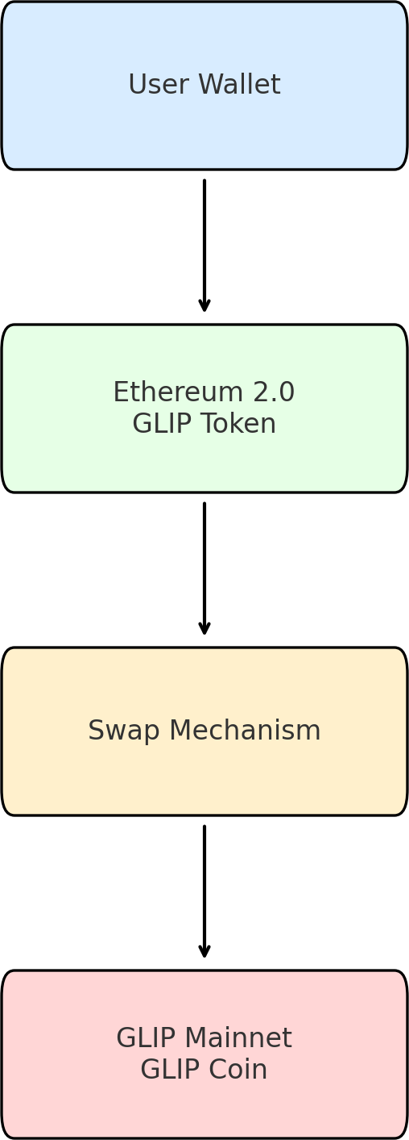

GLIP Token | 2025 Page 4

# GLIP Token Whitepaper

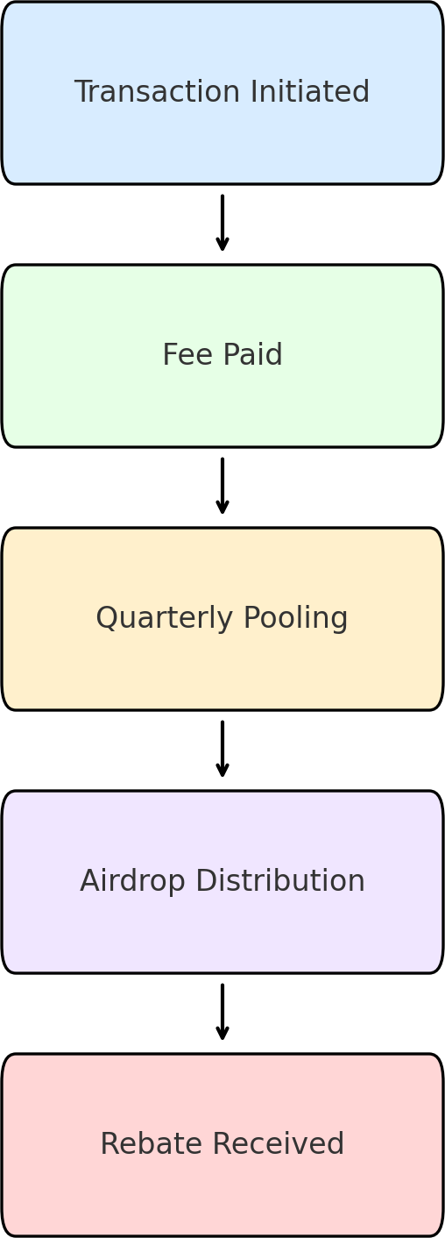

**Diagram 2: Quarterly Fee Rebate Cycle**

GLIP Token | 2025 Page 5