Testing Ptask Library
Luca Donzella and Michele Scaletti

We have created 4 types of test to use all the features offered by the library Ptask.
Test Type:
- System Test
It allows to test the system configuration such as:
- scheduler algorithm
- protocol of access to resources
- the ability to run a task on one or different core each time the task becomes active ;
- Activation Task Test
It provide the opportunity to try the three different modes of creation-activation:
- creation with activation
- creation with deferred activation
- creation with deferred activation with time offset
- Advanced Creation Test
It allows you to create a task with all parameters. It also provides the ability to change some parameters during the execution of the task.
- Handling Mode Test
It allow you to test Handling Mode Changes.

In the following pages show the screenshot of output of the various tests.
System Test 2
Scheduler Test 2
Protocol Test 3
Partitioning Test 3
Activation Test 4
Advanced Creation Test 4
Handling Mode Test 6

System Test
To compile the program test, enter into directory SystemTest/ and type: make.
Before running the tests, remember to become super-user, otherwise Linux will not allow you to create real-time tasks!

Scheduler Test
To run Scheduler Test use taskset 0x00000001 ( mask of processor #0 ).
Command example : sudo taskset 0x00000001 ./schedulerTest
Taskset is used to set or retrieve the CPU affinity of a running process given its PID or to launch a new COMMAND with a given CPU affinity.
The parameters of the task that you can insert or modify as priority , period, deadline and computation time are in the file scheduler.dat into directory SystemTest/ .
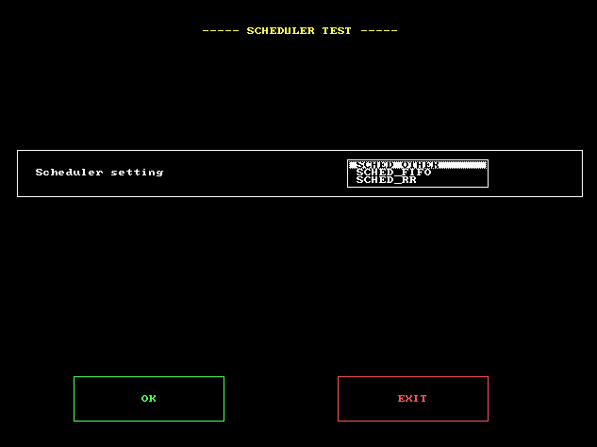 | 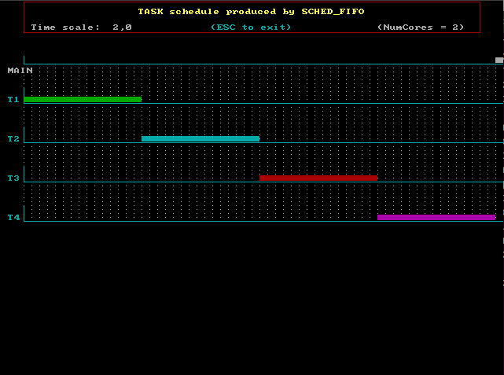
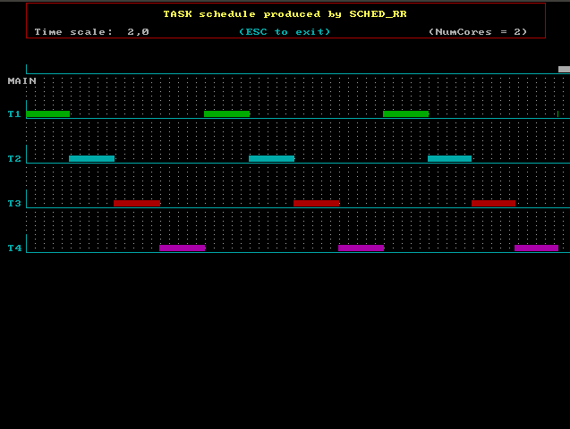 | 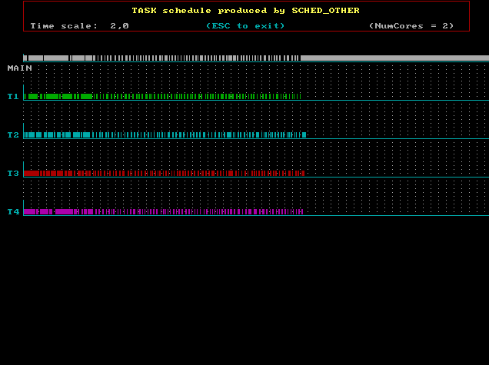

Protocol Test
To run Protocol Test use ./protocolTest.
The parameters of the task that you can insert or modify are in the file protocol.dat into directory SystemTest/ .
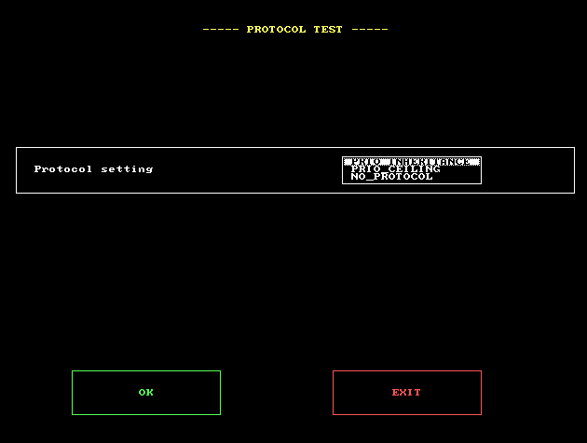 | 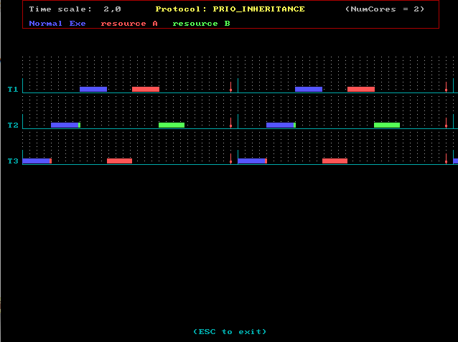
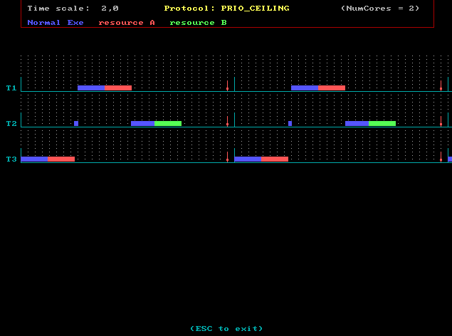 | 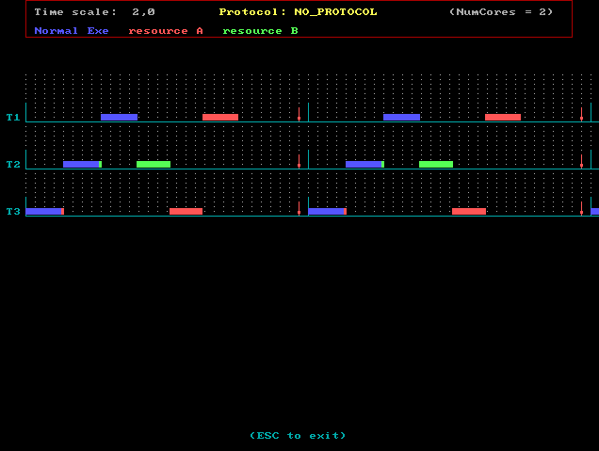

Partitioning Test
To run Partitioning Test use ./partitioningTest.
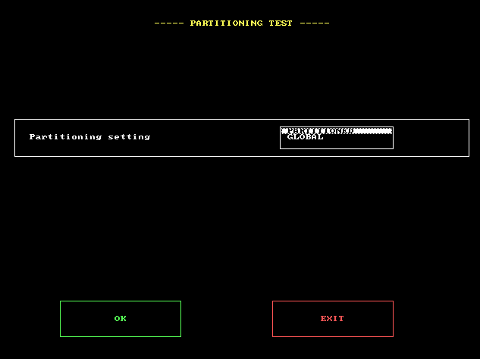 | 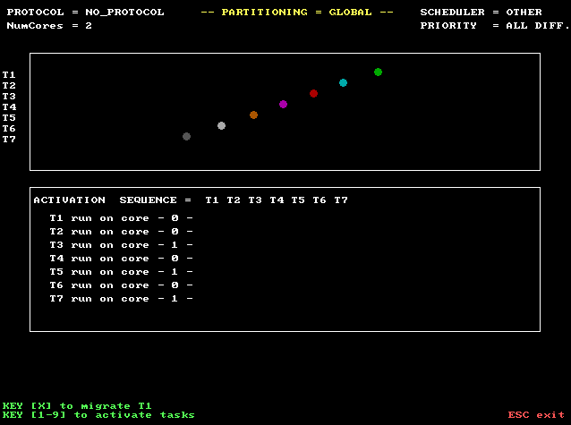  Show the system information  Show System information  In “PARTITONED” mode the core for a task is static, it's not change

Activation Test
To compile this program test, enter into directory ActivationTaskTest/ and type: make.
To run Activation Test use ./taskFunTest.
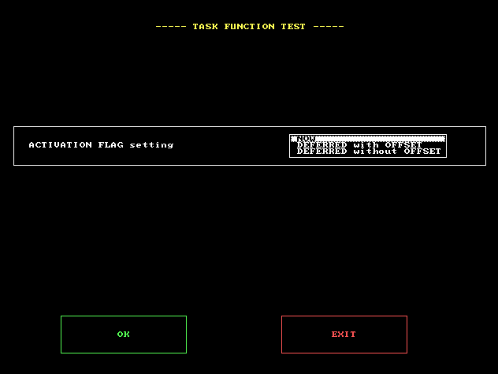 | 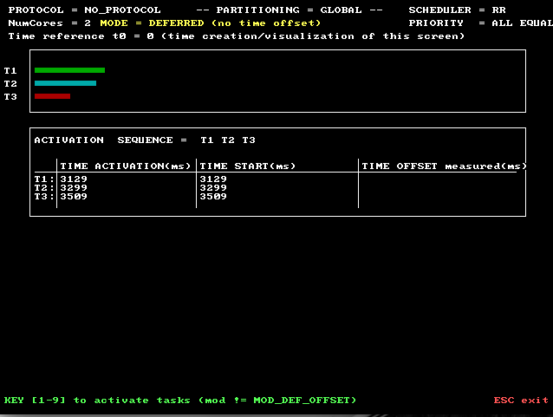

Advanced Creation Test
To compile this program test, enter into directory AdvancedTest/ and type: make.
To run Activation Test use ./taskFunTest.
The parameters of the task as : priority , period, deadline and cpu id are in the file param.dat into directory AdvancedTest/ .
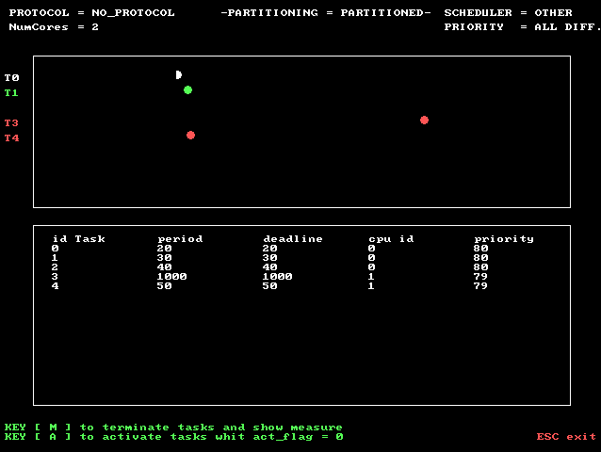 | 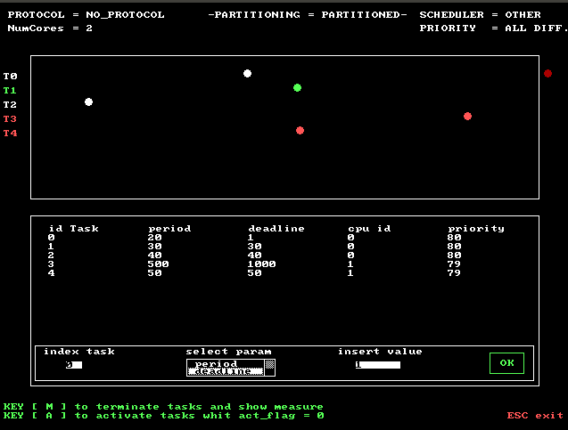

Handling Mode Test
To compile this program test, enter into directory HandlingModeTest/ and type: make.
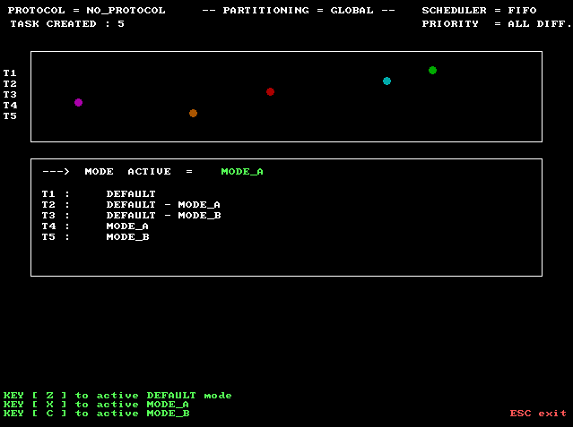
To run Handling Mode Change Test use ./modeTest.
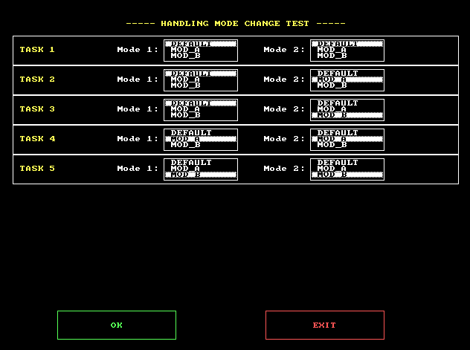
Key for change active mode
For every task you can select one or two mode
Actual active mode

