/Users/adammorrison/Desktop/Screen Shot 2018-06-05 at 18.27.48.png/Users/adammorrison/Desktop/Screen Shot 2018-06-05 at 18.09.51.png/Users/adammorrison/Desktop/Screen Shot 2018-06-05 at 18.09.51.png

**More: *Can you change the colour to something else?***

**Blue**

**Purple**

Colour

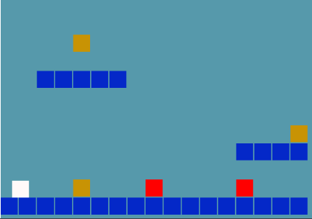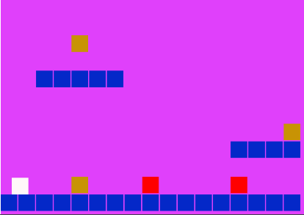/Users/adammorrison/Desktop/Screen Shot 2018-06-05 at 18.33.17.png/Users/adammorrison/Desktop/Screen Shot 2018-06-05 at 18.28.14.png

**After**

**Before**

**Before**

**After**



**More: *Can you change the velocity for moving speed?***

**Movement**

**Movement**



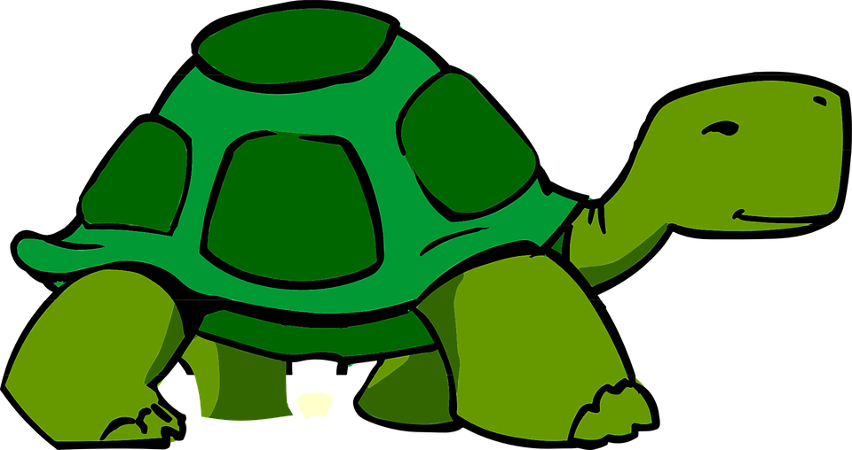

Velocity

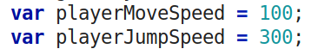

**500** = fast

**100** = slow



**More: *Run the game and try other numbers for gravity.***

Gravity

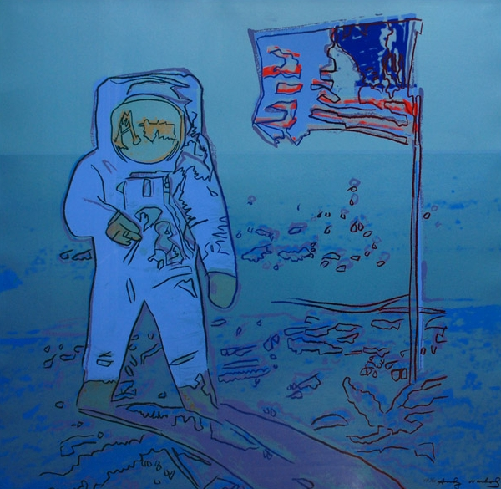

Screen%20Shot%202018-06-05%20at%2019.23.04.pngScreen%20Shot%202018-06-05%20at%2019.22.17.pngScreen%20Shot%202018-06-05%20at%2019.16.39.png

**Earth Gravity**

**Moon Gravity**

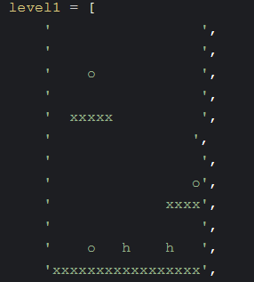

**More: *Can you create your own layout for levels 2 and 3? game?***

Layout pt1



**h = Hazard**

**x = Platforms**

**o = Coins**

**Before**

**After**



Layout pt2



**More: *Change the platforms for levels 2 and 3***

**h = Hazard**

**x = Platforms**

**o = Coins**

**Before**

**After**

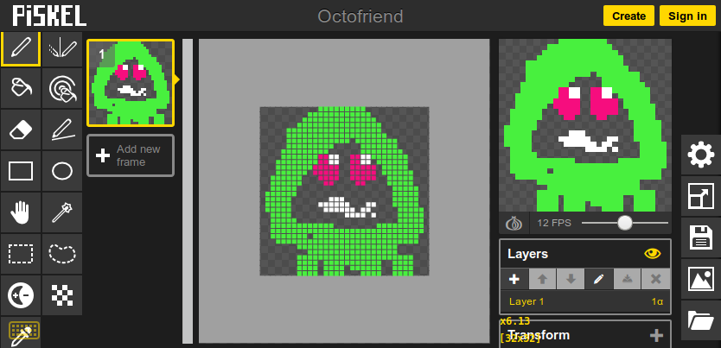

**More: *Change the red hazards and yellow bonuses***

Pixel Art

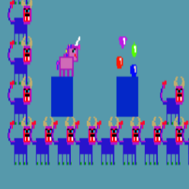

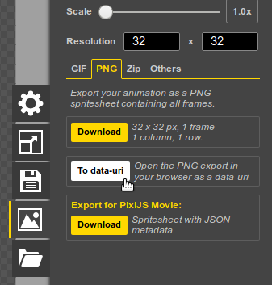

**After**

**Before**





Animated Player!

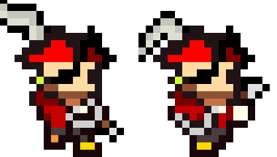



**Before**



**After**





**Before**



**After:**

Balancing