TAGUM GLOBAL MEDICAL CENTER INC
Radiology Department



TGMCI RADIOLOGY QUEUEING SYSTEM
System Documentation
Requirements | Design | Testing | User Manual

Prepared for the Radiology Department
Tagum Global Medical Center Inc

September 17, 2026

TABLE OF CONTENTS
A. BUSINESS REQUIREMENTS 1
B. USER REQUIREMENTS 3
C. SYSTEM REQUIREMENTS SPECIFICATION 5
D. ACTIVITY DIAGRAM 8
E. USE CASE DIAGRAM 10
F. CONTEXT FLOW DIAGRAM 12
G. SOFTWARE PROCESS MODEL 14
H. ARCHITECTURAL PATTERN 16
I. SYSTEM ARCHITECTURE 17
J. DATABASE DESIGN 18
K. USER INTERFACE DESIGN 21
L. USER ACCEPTANCE TEST 26
M. CERTIFICATION 29
N. REFERENCES 30
APPENDIX A. RELEASE READINESS CHECKLIST 31
APPENDIX B. IMPLEMENTATION ISSUES 32
APPENDIX C. SOFTWARE TESTING RESULTS 33
APPENDIX D. USER MANUAL 34
APPENDIX E. DEPLOYMENT AND HANDOFF 38
APPENDIX F. PROJECT RESPONSIBILITIES 39

A. BUSINESS REQUIREMENTS

Business Profile
The TGMCI Radiology Queueing System supports the Radiology Department of Tagum Global Medical Center Inc. It coordinates queue tickets for X-Ray, Ultrasound, and CT Scan and provides a shared view for reception personnel, radiology staff, administrators, and patients waiting for service. Its purpose is to organize service flow and make the current queue visible across connected workstations.

Problem Statement
Radiology queue coordination requires staff to know which tickets are waiting, which patients have been called, and which procedures have been completed. Separate or manually communicated queue records make this coordination harder when several rooms are operating. A common system is needed to issue consistent queue numbers, apply the configured category priority, and reflect service changes on a public display.

Organizational Needs
- A shared operational queue for reception and radiology staff across the local network.
- Consistent procedure selection and classification of in-patient (IPD) and out-patient (OPD) tickets.
- A patient-facing monitor showing queue codes and service status without requiring a patient account.
- Historical ticket summaries and exports for operational review.
- A controlled way to display announcements and media alongside queue information.

A. BUSINESS REQUIREMENTS continued

Objectives of the System
- Generate a procedure-specific queue number after reception selects a procedure and patient category.
- Select IPD tickets before OPD tickets within a procedure and use first-in, first-out ordering within each category.
- Allow authorized radiology staff to call a waiting ticket and complete an active service.
- Refresh staff and public queue views from a common server-side source.
- Retain issue, call, and completion events and provide date-filtered reports.
- Support announcement images, videos, and online media links with playback controls.

Scope and Limitations
The scope covers staff login, queue registration and printing, waiting and serving lists, completion, reports and Excel export, advertisement management, and the public display. The interface provides two X-Ray slots, two Ultrasound slots, and one CT Scan slot. MySQL stores operational records; media files and JSON state support announcement playback.
Clinical orders, diagnostic images, interpretation reports, billing, electronic medical records, appointment booking, and patient self-registration are outside this scope. The system does not establish clinical urgency. IPD and OPD priority is a configured queue rule that hospital personnel must validate for operational use.
This version contains implementation gaps described in Appendix B. A successful interface demonstration or playback unit test does not establish readiness for clinical operations. Network availability, server configuration, printer setup, and browser media permissions affect operation.

B. USER REQUIREMENTS

User Roles and Expectations
Table 1. User roles
Role | Responsibility
Receptionist | Select procedure and patient category, generate and print tickets, review reports, and manage permitted announcements.
Radiology staff | Operate the queue controls for calling and completing tickets. Room-specific accounts receive interface restrictions based on their names.
Administrator | Access reception, queue management, analytics, and advertisement functions.
Waiting patient | Read the public monitor and respond when the ticket number is called. No patient login is required.

User Needs and Expectations
Reception personnel need clear selections and immediate confirmation of the issued number. Radiology personnel need a current waiting list, recognizable room slots, and an unambiguous completion action. Administrators need a consolidated view and traceable records. Patients need readable codes and a clear distinction between incoming and currently served tickets.
The intended role model must be enforced by server checks as well as interface visibility. The current queue endpoints check staff roles, while specific room assignments are represented in the interface. The release tests must verify these distinctions.

B. USER REQUIREMENTS continued
Table 2. Reception and public-display requirements
ID | Category | Description
UR R1 | Authentication | Sign in with an assigned staff username and password.
UR R2 | Ticket issue | Choose X-Ray, Ultrasound, or CT Scan and IPD or OPD before generating a number.
UR R3 | Printing | View the latest ticket and print a queue slip through the browser print dialog.
UR R4 | Monitoring | See current queue status from the server and review operational reports.
UR R5 | Reporting | Filter reports by date and procedure and download an Excel report.
UR P1 | Visibility | Read incoming ticket codes and Now Serving columns on the public monitor.
UR P2 | Announcements | View announcements while waiting without signing in.

Table 3. Radiology and administrator requirements
ID | Category | Description
UR S1 | Queue control | Call the next eligible ticket for a procedure and mark active service complete.
UR S2 | Room view | Identify the appropriate X-Ray, Ultrasound, or CT Scan serving slot.
UR A1 | Oversight | Access staff workflow screens and review queue totals.
UR A2 | Media | Add or delete ads, set duration and activity, and issue playback commands.
UR A3 | Operations | Maintain staff accounts, backups, and release configuration through authorized technical procedures.

C. SYSTEM REQUIREMENTS SPECIFICATION

C.1 Functional Requirements
Table 4. Authentication and queue functions
ID | Requirement | Acceptance criterion
FR 01 | Authenticate staff using stored password hashes. | Valid credentials establish a session; invalid credentials do not.
FR 02 | Restrict ticket creation to receptionists and administrators. | Other roles receive a denied response.
FR 03 | Create a ticket from procedure and category selections. | A waiting ticket and an issued event are stored together.
FR 04 | Allocate numbers using a daily procedure counter. | Concurrent creation and date rollover do not produce ambiguous identifiers.
FR 05 | Select eligible waiting tickets using category rank and issue order. | IPD precedes OPD; older tickets precede newer tickets in the same category.
FR 06 | Allow radiology staff and administrators to call tickets. | The selected ticket becomes serving and the call is recorded.
FR 07 | Complete a currently serving ticket. | The completion timestamp and event are saved in one transaction.
FR 08 | Provide a shared queue feed. | Waiting, serving, and completed groups match persisted records.

Requirements describe the intended accepted behavior. FR 04 requires correction of the schema and code mismatch before it can be accepted. Attribution of the issued event also needs correction to use the signed-in staff member.

C. SYSTEM REQUIREMENTS continued
Table 5. Display reporting and media functions
ID | Requirement | Acceptance criterion
FR 09 | Display incoming and serving queue codes. | Public monitor updates after staff actions without a patient login.
FR 10 | Print the issued ticket. | Slip shows the issued code, procedure, patient category, and issue details.
FR 11 | Retrieve tickets by start and end dates. | Report results fall inside the selected range.
FR 12 | Export the filtered report to Excel. | Workbook values reconcile with the selected report view.
FR 13 | Manage advertisement metadata and files. | An authenticated staff user can add and delete supported content.
FR 14 | Store playback commands and settings. | Public display receives applicable mode and command changes.
FR 15 | Synchronize public-display playback and preview. | The preview follows reported media position without unnecessary restarts.
FR 16 | Record operational events. | Issue, call, and completion events reference the affected ticket and actor.

Workflow Boundaries
Waiting to Serving and Serving to Completed are exposed by the current routes. Although the schema includes skipped and cancelled values, the checked-in route set does not provide skip or cancellation actions. Staff account maintenance and a comprehensive audit administration interface are not implemented as dashboard modules.

C.2 NON FUNCTIONAL REQUIREMENTS
Table 6. Quality requirements and validation methods
ID | Category | Requirement and validation
NFR 01 | Responsiveness | Target a queue change becoming visible within five seconds on the hospital LAN. Measure end-to-end; the code polls the queue every two seconds.
NFR 02 | Usability | Staff should complete ticket selection and generation without ambiguous controls. Observe representative staff tasks during UAT.
NFR 03 | Access control | Use password hashes, authenticated staff sessions, and server-side role and room authorization. Test unauthorized requests directly.
NFR 04 | Integrity | Store related ticket and event changes transactionally. Test concurrent requests and interruption recovery.
NFR 05 | Privacy | Keep names, diagnoses, and clinical identifiers out of the public queue payload and display. Inspect responses as well as screens.
NFR 06 | Compatibility | Validate staff screens, public display, printing, and media playback on the hospital browsers and monitors.
NFR 07 | Recovery | Back up MySQL and uploaded media and demonstrate a restore to a separate environment before release.
NFR 08 | Maintainability | Keep presentation, request handling, and persistence responsibilities identifiable and document schema changes.

The targets above are acceptance criteria, not measured performance results. Browser autoplay restrictions and external media availability must be included in validation. Local queue operation and online announcements have different network dependencies.

D. ACTIVITY DIAGRAM
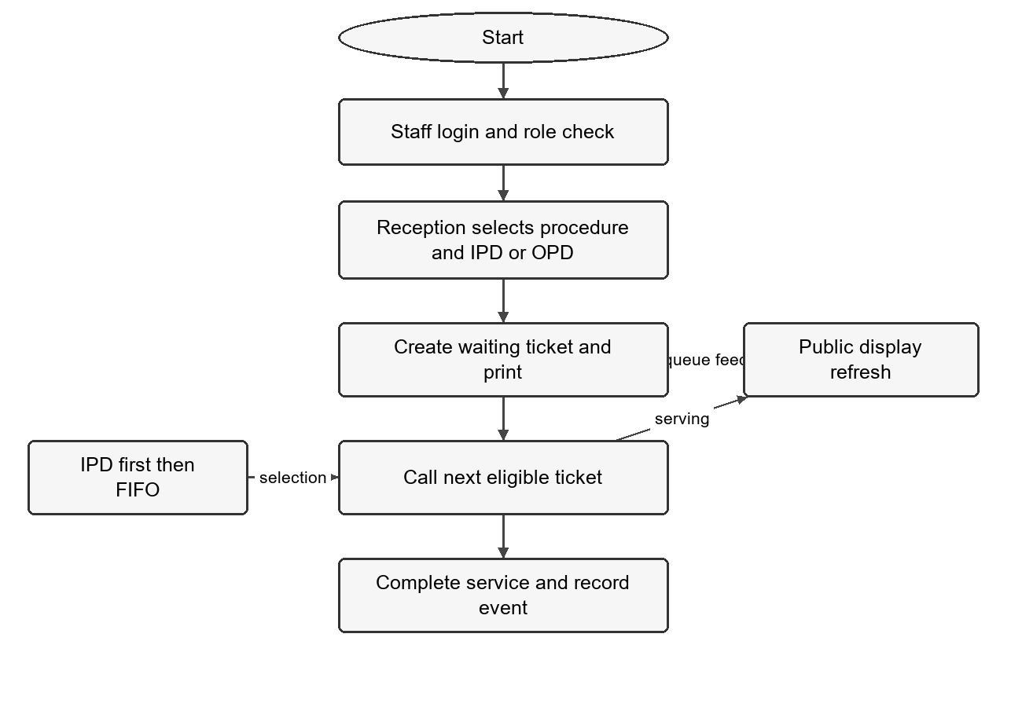
Figure 1. Ticket issue call and completion workflow
Reception selects the procedure and patient category and issues the ticket. Radiology staff call the next eligible ticket when a room is ready, perform the service, and record completion. The public display receives refreshed queue state throughout the workflow. Printing is a browser action following successful ticket creation.

D. ACTIVITY DIAGRAM continued

Main Activity Sequence
Table 7. Activity inputs and outcomes
Step | Action | Outcome
1 | Staff sign in. | Session identifies the staff role.
2 | Reception selects procedure and IPD or OPD. | Generation becomes available in the interface.
3 | Reception requests a number. | Server allocates the sequence and records a waiting ticket.
4 | Reception prints the slip. | Patient receives a visible queue code.
5 | Staff select Call next for a room. | Server chooses the highest-priority waiting ticket for that procedure.
6 | Staff select Complete after service. | Ticket becomes completed and the room can serve another ticket.
7 | Display and reports refresh. | Queue views reflect the stored changes.

Alternative and Failure Paths
Missing selections keep the generation button disabled. An unauthorized API request is rejected. An empty queue returns a no-waiting-ticket result. A completion request for a non-serving code returns an error status. A database exception rolls back the active transaction. If printing is blocked, staff must confirm the ticket was already issued before attempting another generation.
Network loss must not be interpreted as successful issue or completion. Staff should reconcile the current queue before retrying a request whose response was interrupted. A documented fallback process is required for server or power failure.

E. USE CASE DIAGRAM
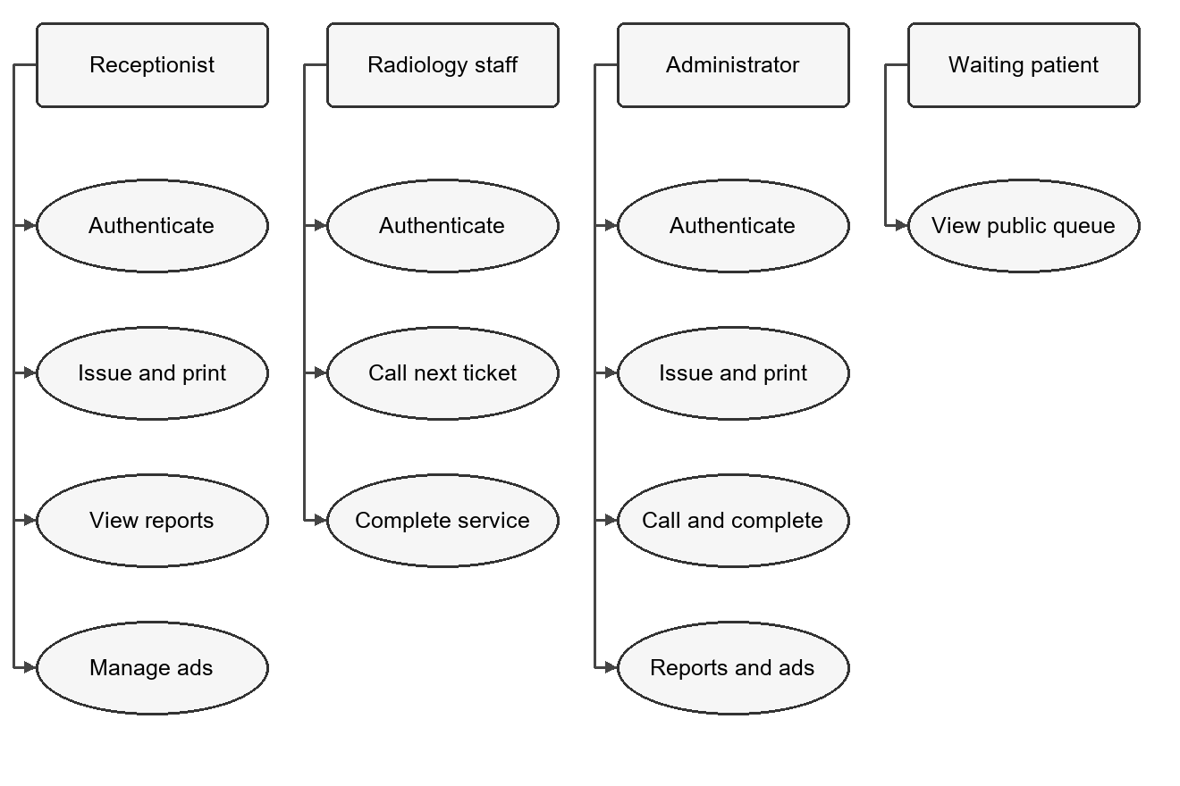
Figure 2. Primary actor interactions
The staff actors share authentication. Reception and administrators issue tickets, while radiology staff and administrators call and complete tickets. The public monitor presents queue information to waiting patients. Account administration and backup operations are technical responsibilities outside the current dashboard use cases.

E. USE CASE DESCRIPTIONS
Table 8. Core use case specifications
Use case | Precondition | Result and exception
UC 01 Staff login | An assigned staff account exists. | Session is created on successful password verification; invalid credentials remain on login.
UC 02 Issue ticket | Receptionist or administrator is signed in; reference records exist. | Waiting ticket and issued event are committed. Invalid input or database errors prevent normal success.
UC 03 Call next | Radiology staff or administrator is signed in; a waiting ticket exists. | Selected ticket becomes serving in the requested slot. Empty queue produces no selected ticket.
UC 04 Complete ticket | A serving ticket exists. | Ticket becomes completed and receives completion time and event.
UC 05 View report | Staff session is present. | Date-filtered generated and completed records are returned.
UC 06 Manage ads | Staff session is present. | Metadata and media are added or deleted; invalid upload conditions return errors.
UC 07 View public queue | Monitor can reach the application. | Incoming and Now Serving information refreshes periodically.

Room-specific authorization is an acceptance requirement beyond the current role check. The public display itself is read-only for queue transitions, but the playback reporting endpoint currently accepts playback-state writes without a staff session.

F. CONTEXT FLOW DIAGRAM
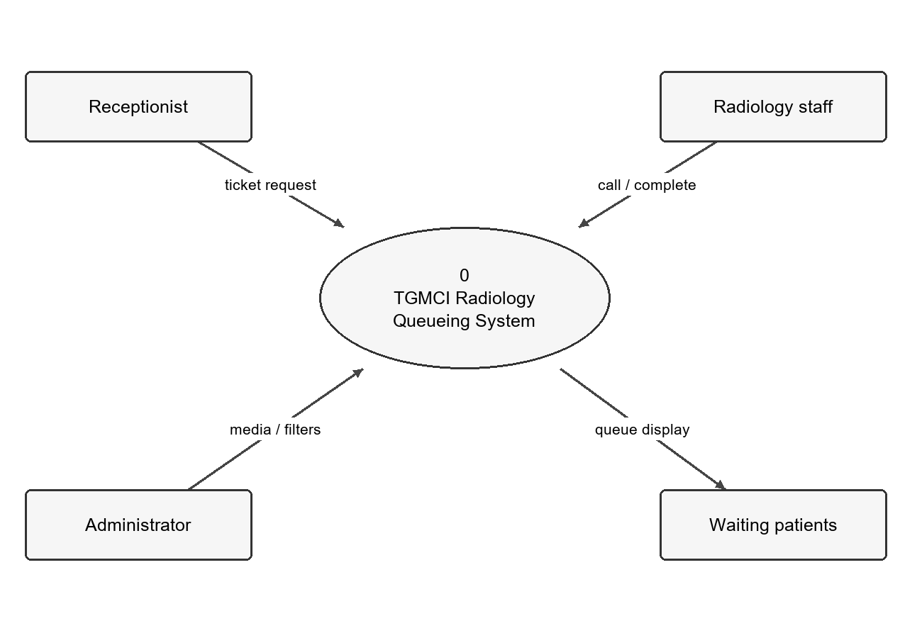
Figure 3. System boundary and external actors
Reception supplies ticket selections and receives the issued code and current queue information. Radiology staff supply call and completion commands and receive updated service state. Administrators provide media and report filters and receive metadata, status, and summaries. Waiting patients receive the rendered public queue and announcements.
MySQL and local media storage are internal components of this system boundary. Online media providers are optional external content sources; they are not responsible for queue selection or persistence.

F. LEVEL 1 DATA FLOW DIAGRAM
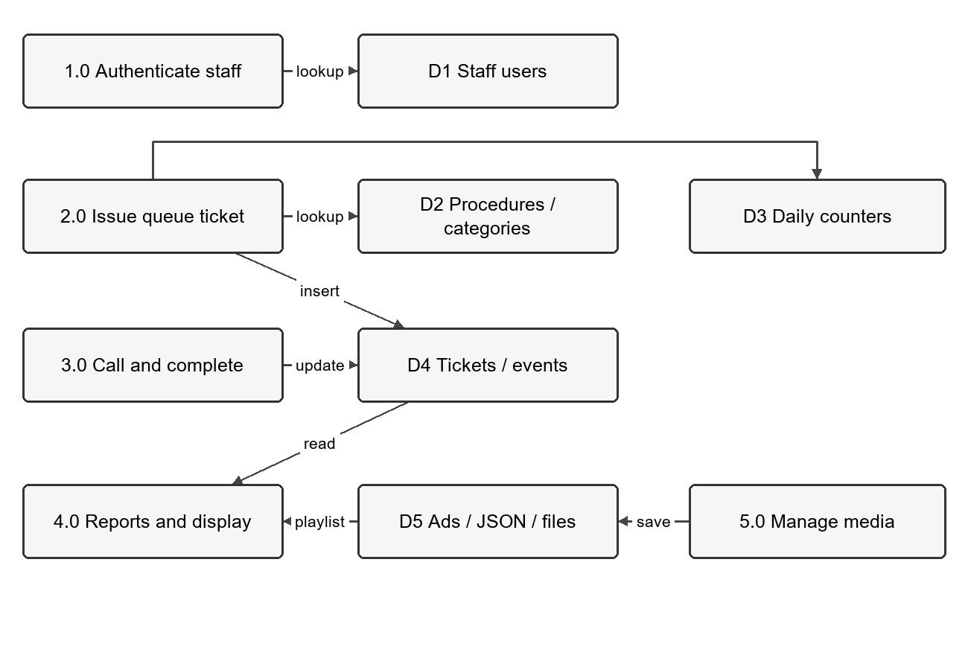
Figure 4. Processes and persistent data stores
Authentication reads staff users. Ticket issuance reads procedures and categories, updates a daily counter, and writes a ticket and event. Queue control updates ticket state and appends events. Reports and the public display read the resulting data. Advertisement management stores metadata in MySQL, content in files, and playback coordination in JSON state. Each arrow identifies a primary data dependency rather than every response message.

G. SOFTWARE PROCESS MODEL
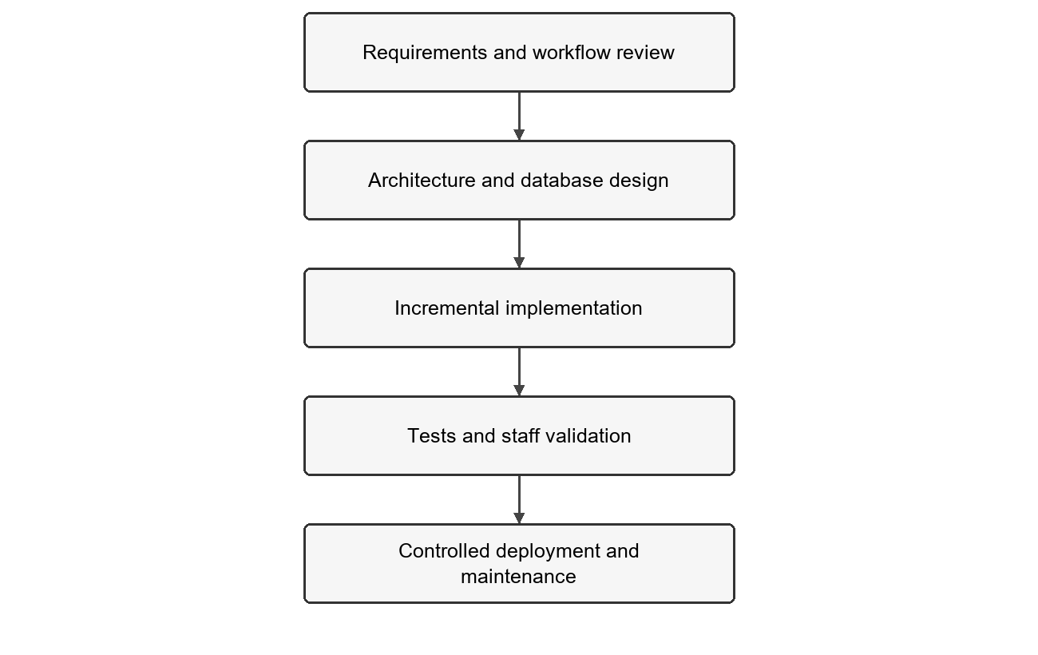
Figure 5. Proposed development and release process
An iterative development process is appropriate for this application because the repository contains successive designs and implementation changes for authentication, queue handling, reporting, and media playback. Each increment should refine a defined workflow, update the schema when needed, and validate the result before the next release. The diagram defines a repeatable process for continuing the project; it does not assert that unrecorded interviews or acceptance activities have occurred.

G. IMPLEMENTATION TECHNOLOGIES
Table 9. Technology and role
Technology | Application role
PHP 8.1 or newer | Request handling, session authentication, routing, services, and repositories. Composer declares PHP >=8.1.
HTML CSS JavaScript | Staff dashboard, public display, printing, polling, media control, and report presentation.
MySQL with PDO MySQL | Relational persistence and prepared queries. SQL scripts specify InnoDB and utf8mb4.
Custom router and autoloader | App\ classes are loaded from app/. Routes map HTTP paths to controller methods.
SheetJS browser library | Creates the downloadable Excel report; loaded from a CDN in the dashboard.
Local files and JSON | Uploaded advertisement content and playback commands, settings, and position.
Git and GitHub | Version history and repository collaboration.
Node test runner | Executes the existing JavaScript playback tests.

Development Phases
Requirements analysis defines actors and priority rules. Design identifies data relationships, API boundaries, and interface states. Implementation adds coherent workflow increments. Testing includes automated logic checks, database integration, cross-workstation behavior, and staff UAT. Deployment follows a restore rehearsal and signed acceptance. Maintenance tracks defects, backups, and changes in browser or media behavior.

H. ARCHITECTURAL PATTERN
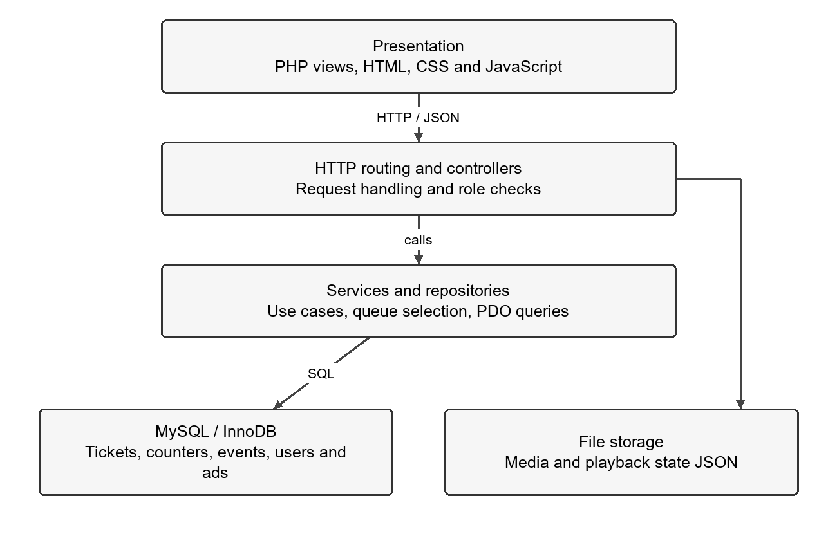
Figure 6. Layered PHP application structure
The application is a modular monolith with presentation, controller, service, and repository responsibilities. Views render PHP templates with client-side JavaScript. The router dispatches requests to controllers. Services support authentication, procedures, and ticket creation, while repositories implement persistence and some queue business logic. Controllers also perform direct file operations for media state. This is a layered design, with some responsibilities still coupled across layers.

I. SYSTEM ARCHITECTURE
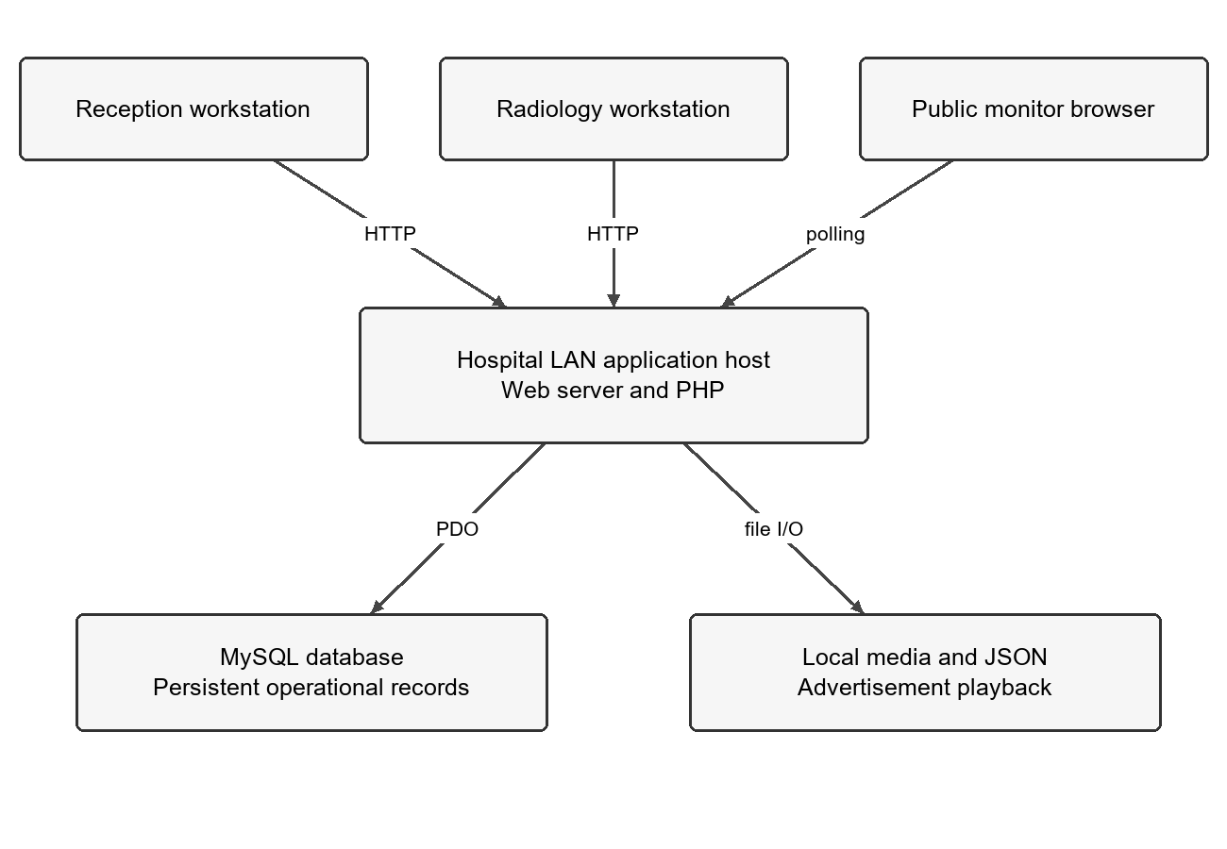
Figure 7. Target local network deployment
Staff workstations and the public monitor connect to one PHP application host on the hospital LAN. The web server document root is public/. The application accesses MySQL through PDO and reads or writes local media and JSON state. The PHP bootstrap sets Asia/Manila, and the database connection sets the session offset to +08:00. Online media and CDN resources require separate internet connectivity.
The architecture depicts the intended deployment arrangement. Server capacity, local URL, HTTPS configuration, backup location, and installation acceptance must be recorded for the actual hospital environment.

J. DATABASE DESIGN
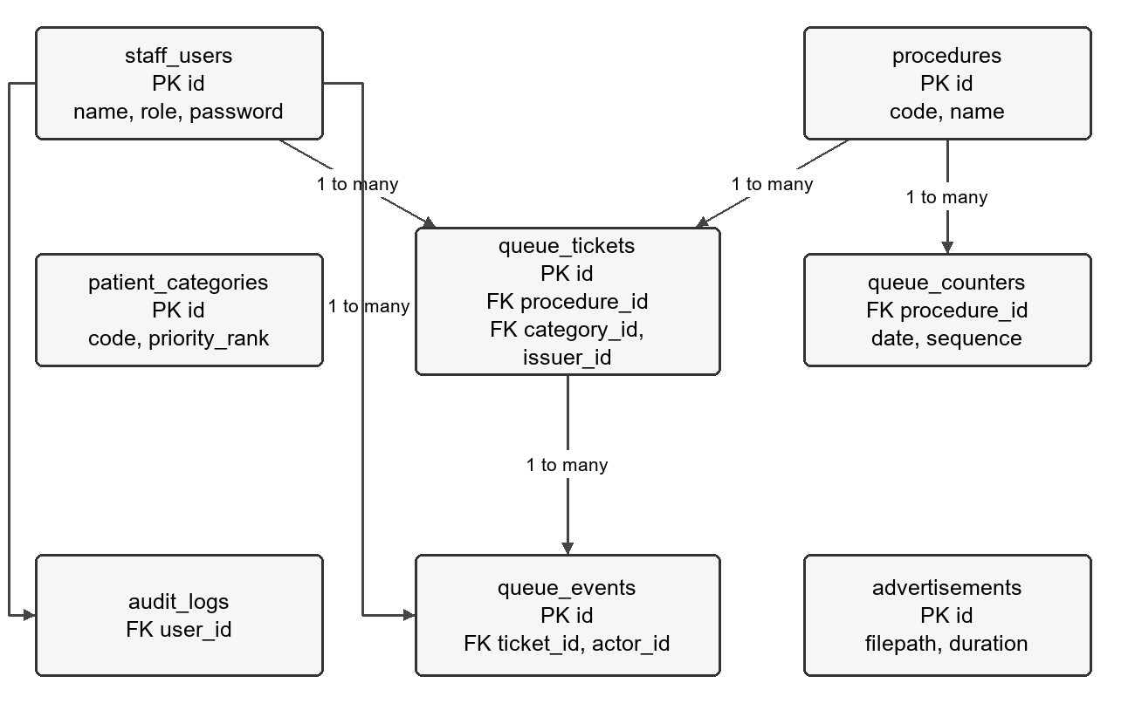
Figure 8. Relationships declared in the SQL schema
The checked-in schema contains eight tables. Procedures and categories classify tickets; staff users issue tickets and act on queue events. Daily counters allocate procedure sequences. Advertisements store media metadata. Audit logs reference staff users but do not declare an advertisement foreign key. Queue events also reference staff_users through actor_id; this additional relationship is described here to keep the diagram readable.

J. DATA DICTIONARY
Table 10. Reference and counter tables
Table | Key fields | Purpose
staff_users | id INT PK; name VARCHAR(255); role ENUM; password VARCHAR(255); timestamps | Staff identity and password hash. Roles are receptionist, radiology_staff, administrator.
procedures | id INT PK; code VARCHAR(50) UNIQUE; name VARCHAR(255); timestamps | Seed values XRAY, UT, and CT identify the supported procedures.
patient_categories | id INT PK; code VARCHAR(50) UNIQUE; priority_rank INT; timestamps | IPD rank 1 precedes OPD rank 2.
queue_counters | id INT PK; date DATE; procedure_id FK; last_sequence_number INT | Unique combination of date and procedure_id tracks daily numbering.

Table 11. Ticket fields
Field group | Definition
Identity | id INT primary key; ticket_code VARCHAR(100) declared globally unique.
Classification | procedure_id and category_id reference the corresponding lookup records; issuer_id references staff_users.
Lifecycle | status ENUM waiting, serving, completed, skipped, cancelled; issue_time defaults to current time; serving_time and completed_time are nullable.
Metadata | created_at and updated_at timestamps. The runtime additionally expects serving_slot, which is absent from the supplied SQL.

J. DATA INTEGRITY AND STORAGE
Table 12. Event advertisement and audit tables
Table | Fields and constraints
queue_events | id PK; ticket_id FK; actor_id FK; action VARCHAR(255); created_at TIMESTAMP. Records issued, called, and completed actions in the implemented flows.
advertisements | id PK; filepath VARCHAR(255); duration_seconds INT default 10; is_active BOOLEAN default true; display_order INT default 0; timestamps.
audit_logs | id PK; user_id FK; action VARCHAR(255); details TEXT; created_at TIMESTAMP. No comprehensive audit-writing workflow is shown by current controllers.

Transaction and Identifier Rules
Ticket creation locks the applicable daily counter, updates or inserts the sequence, creates the ticket, and records the issued event within a transaction. Queue call selects a waiting ticket with FOR UPDATE, then saves the serving state and event. Completion locks a serving ticket and commits its new state and event together.
The generated code uses a prefix and sequence such as XR-001. Because daily counters reset while ticket_code is globally unique, a fresh installation from the supplied SQL can encounter a next-day collision. The release design must choose date-scoped uniqueness or a date-bearing identifier and update code and tests consistently. This documentation does not apply a database migration.

File Storage
Uploaded advertisements are stored under public/storage/uploads/ads/. The storage directory holds ad_command.json, ad_settings.json, and ad_playback.json. Backups must account for both database metadata and the corresponding media files. Playback state is transient operational state, not a substitute for queue history.

K. USER INTERFACE DESIGN
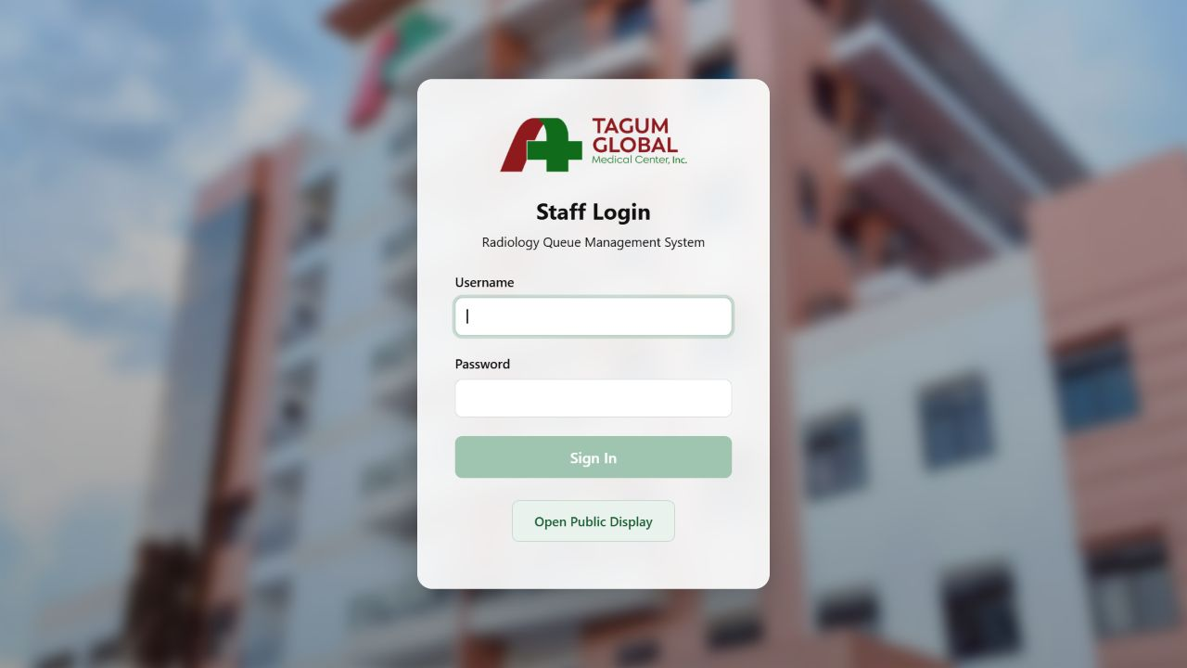
Figure 9. Staff login interface

Login and Navigation
The login screen uses the hospital logo, a background image, username and password fields, a Sign In button, and an Open Public Display link. After login, the dashboard navigation depends on the role. Receptionists and administrators can access reception and analytics; radiology staff receive the queue-management view.
Figures 9 through 15 show actual PHP templates rendered in an isolated documentation preview with empty synthetic API responses. They illustrate the interface and do not constitute production screenshots or proof of database integration.

K. RECEPTION AND QUEUE INTERFACES
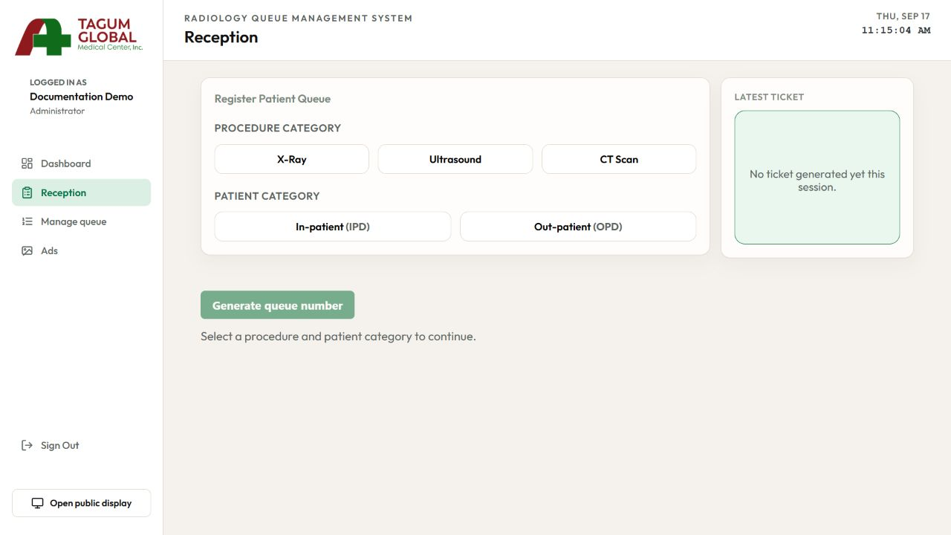
Figure 10. Reception ticket selection interface
Reception groups procedure and patient category choices before enabling Generate queue number. The Latest Ticket area confirms a successful issue and supports the printing workflow.
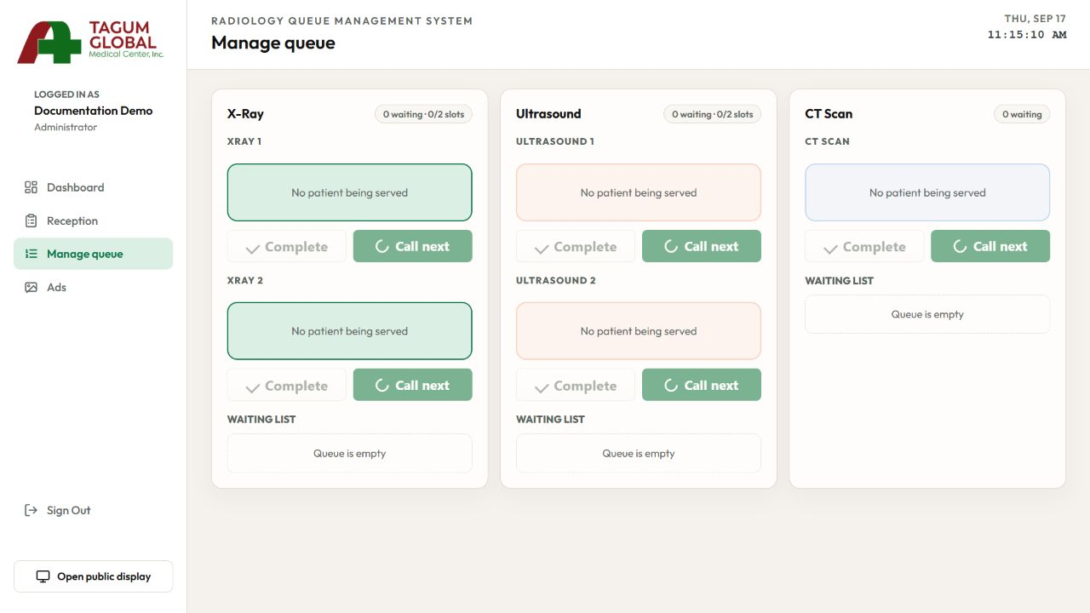
Figure 11. Queue management and serving slots
The queue view groups controls by procedure. Empty queues show inactive Call next controls; each active room provides a Complete action for its serving ticket.

K. REPORTING AND MEDIA INTERFACES
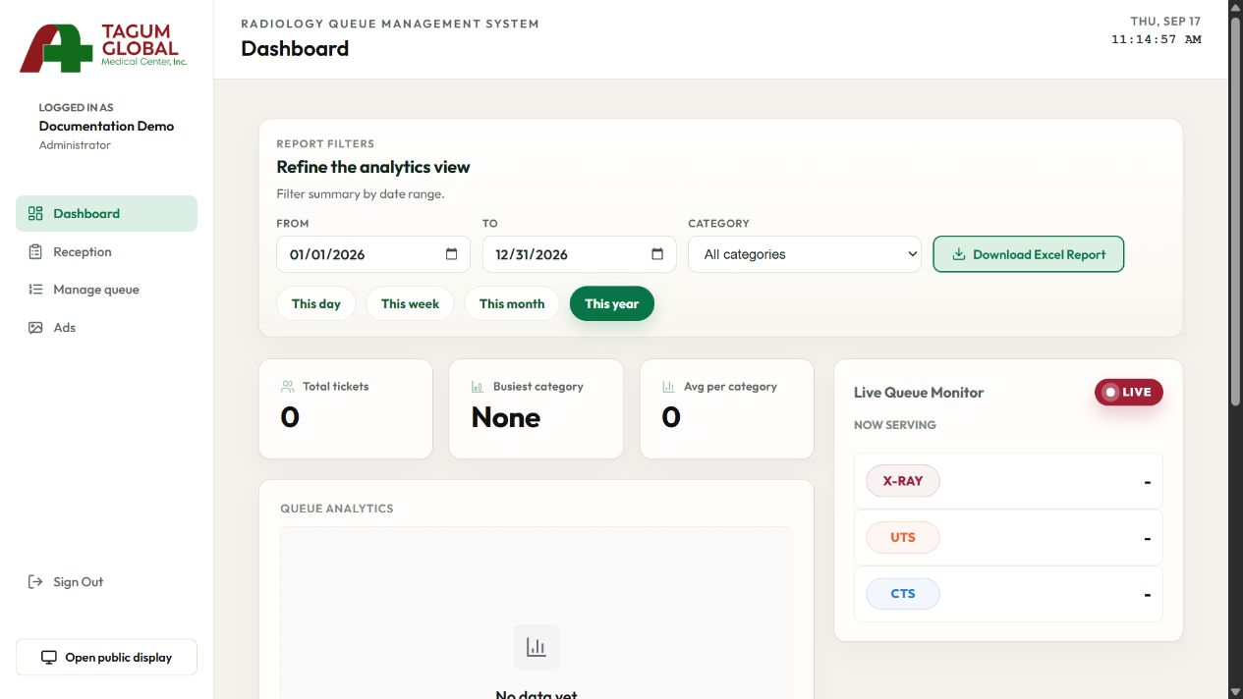
Figure 12. Analytics filters and live queue monitor
The dashboard combines date and category filters, ticket totals, charts, a live monitor, and Download Excel Report.
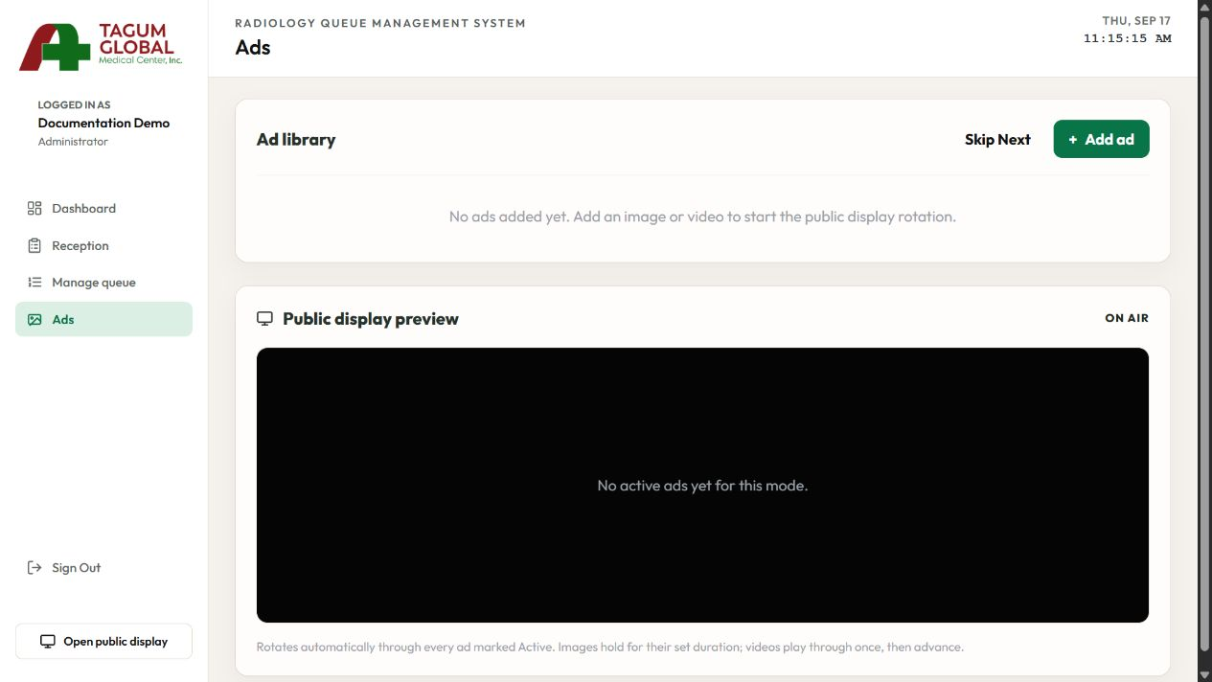
Figure 13. Advertisement library and display preview
The Ads screen includes an ad library, Add ad, Skip Next, and a public-display preview. Uploaded media and external video links are managed through the add form.

K. ROOM SPECIFIC RADIOLOGY STAFF INTERFACE
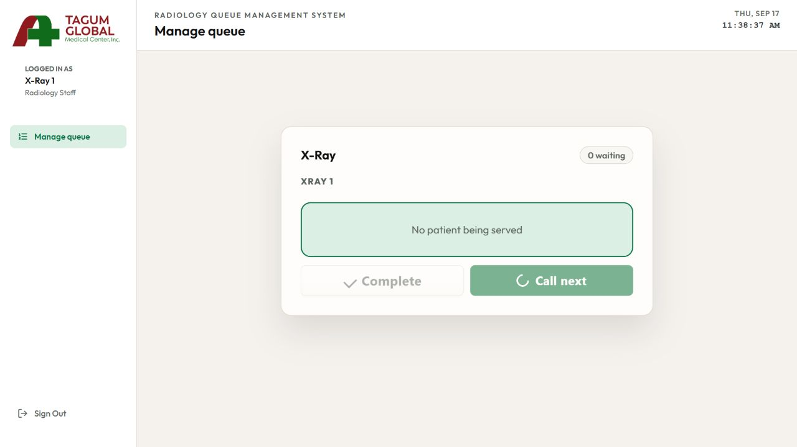
Figure 14. X-Ray 1 room-specific Manage queue interface
When a named room account signs in, the system opens Manage queue and displays only the procedure and serving slot assigned to that username. The room card contains two queue actions: Complete and Call next. Complete is enabled only while that room is serving a ticket, and Call next is enabled only when the room is idle and its procedure has a waiting ticket. The detailed waiting list is hidden for room-specific accounts.
Room account interface mapping
Login account | Visible room card | Queue actions
X-Ray 1 | X-Ray slot 1 | Complete and Call next
X-Ray 2 | X-Ray slot 2 | Complete and Call next
Ultrasound 1 | Ultrasound slot 1 | Complete and Call next
Ultrasound 2 | Ultrasound slot 2 | Complete and Call next
CT Scan | CT Scan slot 1 | Complete and Call next
Room-account navigation shows Manage queue and Sign Out. Dashboard, Reception, Ads, Open public display, other procedure cards, other room slots, and the detailed waiting list are not displayed. The general Radiology User and the administrator can see all five serving slots.
Implementation boundary. The verified restriction is enforced by the dashboard interface using the exact stored username. The queue API currently authorizes the radiology_staff role but does not independently verify the account-to-room assignment. Server-side room authorization is therefore required before the interface restriction can be treated as a security control.

K. PUBLIC DISPLAY INTERFACE
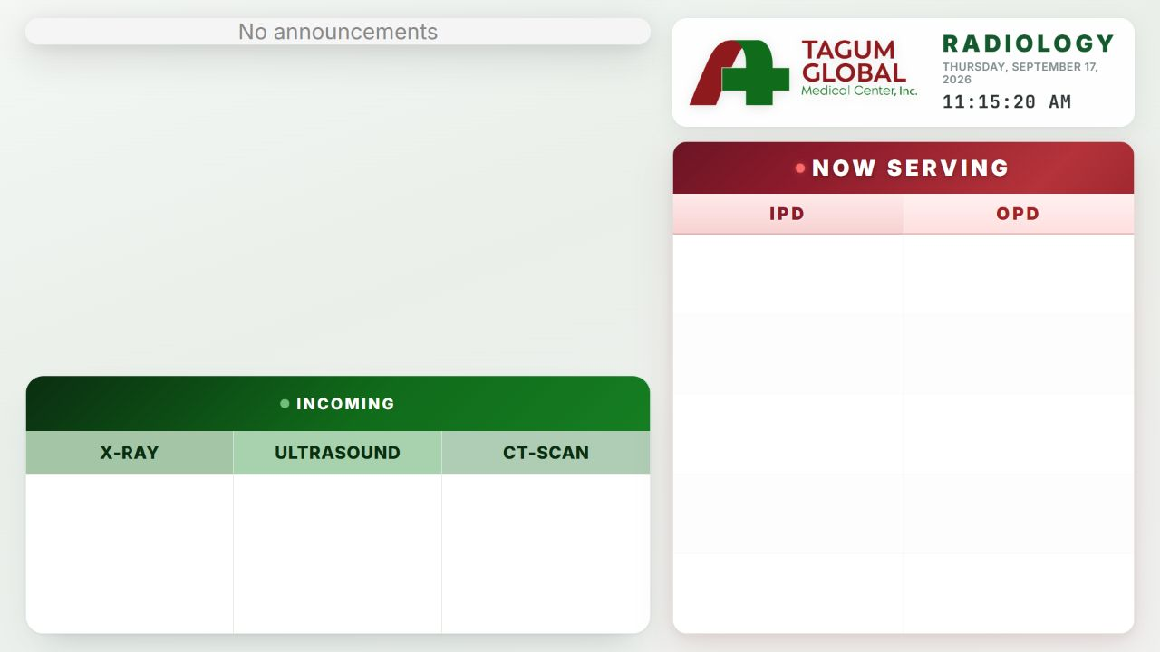
Figure 15. Public queue monitor

Display Content
The monitor combines announcements, incoming tickets by procedure, hospital branding, a clock, and Now Serving columns for IPD and OPD. It uses large text and distinct areas to support viewing at a distance. With no active media, the announcement area displays an empty-state message.

Refresh and Playback
The public queue refresh interval is two seconds. Advertisement polling is configured at 500 milliseconds, and playback reporting at 750 milliseconds. These are configured timer intervals rather than guaranteed response times. Actual latency depends on the browser, network, and server. Staff should verify audio, visibility, and playback on the installed monitor.

L. USER ACCEPTANCE TEST

Purpose and Test Preparation
User acceptance testing verifies that representative reception personnel, radiology staff, and administrators can perform the intended workflow on the hospital equipment. Use a separate test database and clearly marked test tickets. Record the application revision, schema version, browser, printer, monitor, and network environment before execution.
The following scenarios are prepared for execution. Their status is Pending until a tester records an observed result and supporting evidence. They must not be interpreted as successful hospital acceptance results.
Table 13. Authentication and ticket acceptance scenarios
ID | Test procedure | Expected result
UAT 01 | Sign in with valid and invalid credentials. | Only valid credentials open the staff dashboard.
UAT 02 | Attempt ticket creation as each role and without a session. | Only receptionists and administrators can issue tickets.
UAT 03 | Issue one ticket for each procedure and IPD/OPD combination. | Correct code, classification, waiting state, and event are saved.
UAT 04 | Issue tickets concurrently from two reception workstations. | No lost issue or duplicated number; failures are clearly reported.
UAT 05 | Repeat the first issue after a date rollover. | The new daily number is valid and historical tickets remain distinguishable.
UAT 06 | Print the generated ticket. | Slip remains legible and matches the saved ticket.

L. USER ACCEPTANCE TEST continued
Table 14. Queue report and display scenarios
ID | Test procedure | Expected result
UAT 07 | Queue OPD then IPD tickets for the same procedure. | IPD is called first; FIFO is preserved within each category.
UAT 08 | Call and complete tickets in all five room slots. | The correct slot and lifecycle timestamps are persisted.
UAT 09 | Use simultaneous calls and attempt an unauthorized room operation. | No ticket is assigned twice and room policy is enforced server-side.
UAT 10 | Observe the public display after issue, call, and completion. | Displayed codes match the server within the agreed latency target.
UAT 11 | Select report dates and procedure; download Excel. | The screen and workbook reconcile with test records.
UAT 12 | Add image/video content and an online media link. | Applicable content appears with its settings and deletion removes it from rotation.
UAT 13 | Change dashboard tabs during playback, pause manually, and return. | Background recovery preserves progress; a manual pause remains paused.
UAT 14 | Interrupt the network and restore it. | Staff can reconcile state without duplicating actions.
UAT 15 | Restore a backup into a separate environment. | Ticket history, users, and media references are recovered.

L. ACCEPTANCE RECORD
Table 15. Test execution record
Record item | Value to be completed
Test case ID | ____________________________
Tester and role | ____________________________
Execution date | ____________________________
Application and schema revision | ____________________________
Observed result | ________________________________________________________
Evidence location | ____________________________
Outcome | Pass / Fail / Blocked
Defect and retest reference | ____________________________

Acceptance Criteria
The application is eligible for acceptance when required scenarios pass, known blocking defects are corrected, report totals reconcile, authorization checks succeed, and the hospital representatives approve the operational workflow. A failed test must identify the actual observation, reproduction steps, responsible owner, and retest evidence.

Acceptance Decision
Decision: Accept / Accept subject to recorded conditions / Reject
Conditions and unresolved items: __________________________________________
Reception representative: ______________________ Date: ______________
Radiology representative: ______________________ Date: ______________
Administrator or project owner: _________________ Date: ______________

M. CERTIFICATION

System Review and Acceptance Form
Project: TGMCI Radiology Queueing System
Organization: Tagum Global Medical Center Inc
Department: Radiology
Application revision: __________________ Review date: __________________
The authorized reviewers shall complete this form after examining the system, test records, user guidance, and deployment requirements. Signing this form records the decision and any conditions stated below.
Review decision: _______________________________________________________
Approved scope: _______________________________________________________
Conditions or exclusions: _________________________________________________

Authorized hospital representative
Name: ______________________________________________________________
Signature: ______________________________ Date: _______________________

Radiology department representative
Name: ______________________________________________________________
Signature: ______________________________ Date: _______________________

Project representative
Name: ______________________________________________________________
Signature: ______________________________ Date: _______________________

N. REFERENCES
Little, J. D. C. (1961). A proof for the queuing formula: L = λW. Operations Research, 9(3), 383-387. https://doi.org/10.1287/opre.9.3.383
Luo, L., Zhang, Y., Qing, F., Ding, H., Shi, Y., & Guo, H. (2018). A discrete event simulation approach for reserving capacity for emergency patients in the radiology department. BMC Health Services Research, 18, Article 452. https://doi.org/10.1186/s12913-018-3282-8
NHS England. (n.d.-a). Demand and capacity models. Retrieved September 17, 2026, from https://www.england.nhs.uk/ourwork/demand-and-capacity/service-level-demand-and-capacity-planning/models/
NHS England. (n.d.-b). Why demand and capacity matters. Retrieved September 17, 2026, from https://www.england.nhs.uk/ourwork/demand-and-capacity/why-demand-and-capacity-matters/
Vasanawala, S. S., & Desser, T. S. (2005). Accommodation of requests for emergency US and CT: Applications of queueing theory to scheduling of urgent studies. Radiology, 235(1), 244-249. https://doi.org/10.1148/radiol.2351040289

APPENDIX A. RELEASE READINESS CHECKLIST
Table A1. Release controls
Check | Evidence required
Schema consistency | Versioned migration includes every runtime field, including serving_slot, and resolves daily numbering.
Access and attribution | Role and room checks pass; ticket events identify the signed-in issuer.
Queue correctness | Priority, FIFO, concurrency, occupied-slot, and date-rollover tests pass.
Public display | Payload contains intended queue fields only; monitor and browser behavior are validated.
Media and exports | Upload checks, playback behavior, and Excel results pass on deployed clients.
Operational recovery | Database and media backup restore is demonstrated and recorded.
Staff readiness | UAT results and the accepted manual are available to staff.
Handoff | Server ownership, support contacts, URL, credentials handoff, and acceptance are recorded.

Release date: __________________ Responsible owner: __________________
Evidence folder or register: _________________________________________________

APPENDIX B. IMPLEMENTATION ISSUES
Table B1. Issues identified by source review
Issue | Evidence and required resolution
Missing serving slot | QueueRepository reads and writes serving_slot, but the checked-in SQL omits it. Add a reviewed migration and verify a clean installation.
Daily code collision | The counter resets per date, while ticket_code is globally unique and contains no date. Align identifier generation, lookup, and uniqueness rules.
Issuer attribution | TicketController omits the session user ID when calling TicketService; the default issuer is 1. Pass and validate the authenticated issuer.
Room authorization | QueueController checks radiology_staff but does not enforce the UI room assignment. Enforce assignments on the server.
Slot occupancy | callNext accepts a slot index without an occupied-slot guard. Validate slots and concurrency at the persistence boundary.
Playback writes | The playback endpoint accepts writes without authentication. Define and enforce the intended display-writer authorization model.
Upload validation | Upload handling checks size but relies on the client filename extension. Validate allowed content types, extensions, and URL sources.
Audit coverage | Queue events exist, but broad staff/media audit logging is not implemented. Define required actions and connect them to audit persistence.

These are source-review findings, not claims about an inspected live database. Operational fixes require implementation and retesting before release approval.

APPENDIX C. SOFTWARE TESTING RESULTS

Automated Playback Tests
Execution date: September 17, 2026. Reviewed baseline: 4e024c3. Test runner: bundled Node.js using node --test against both repository test files. Observed outcome: 10 tests passed, 0 failed.
Table C1. Executed test coverage
Test group | Observed result
Background HTML video | Five tests passed: uninterrupted tab changes, background pause recovery, manual pause preservation, blocked-playback retry, and replaced/ended video handling.
Background YouTube | One test passed: background recovery with foreground pause behavior.
Playback synchronization | Four tests passed: advancing a playing position, retaining a paused position, negative clock-age handling, and correcting material drift.

Scope of the Results
These unit tests exercise JavaScript behavior with test doubles. They do not verify the MySQL schema, HTTP authentication, ticket numbering, physical printing, real YouTube availability, hospital LAN capacity, or acceptance by users. The documentation preview used empty synthetic API responses and verifies interface layout only.

Integration and User Acceptance Results
Database integration: Pending. Cross-workstation queue tests: Pending. Hospital staff UAT: Pending. Backup restore: Pending. Production deployment certification: Pending.

APPENDIX D. USER MANUAL

1. Getting Started
Open the application URL provided by the system administrator. Use the designated staff workstation for queue operations and the public monitor for patient-facing information. Confirm that the workstation can reach the application and that the printer is available before issuing tickets.

2. Staff Login
- Enter your assigned Username and Password on Staff Login.
- Select Sign In. The system opens the screen allowed for your role.
- If access fails, recheck the username and contact the designated administrator. Do not use another staff member's account.
- Use Sign Out when leaving the workstation.

3. Navigation
Table D1. Staff navigation
Area | Use
Dashboard | Review date and procedure-filtered reports, summary charts, and the live monitor.
Reception | Choose procedure and patient category and generate a queue number.
Manage queue | Call the next patient and complete service in the appropriate room.
Ads | Manage announcements and observe the display preview.
Open public display | Open the patient-facing monitor in a separate browser tab.

APPENDIX D. TICKET AND QUEUE OPERATIONS

4. Generate and Print a Ticket
- Open Reception.
- Choose X-Ray, Ultrasound, or CT Scan under Procedure Category.
- Choose In-patient (IPD) or Out-patient (OPD) under Patient Category.
- Select Generate queue number after checking both selections.
- Review Latest Ticket and complete the browser print dialog.
- Give the patient the printed ticket and direct them to watch the public monitor.
If a print window does not appear, check the browser popup and printer configuration. A print failure does not necessarily mean ticket creation failed. Confirm the latest saved ticket before generating another number.

5. Call the Next Ticket
- Open Manage queue and locate your assigned procedure and room.
- Check that the room is ready and is not already serving another ticket.
- Select Call next. The system selects from the waiting queue using IPD-first priority and FIFO within a category.
- Verify the displayed serving number and direct the patient to the correct room.
Room-specific screen. X-Ray 1, X-Ray 2, Ultrasound 1, Ultrasound 2, and CT Scan accounts see only their assigned room card. Their available queue actions are Complete and Call next; they do not see the other procedure cards or the detailed waiting list.

6. Complete Service
- Confirm that the displayed ticket is the patient whose service has finished.
- Select Complete for that room and respond to any confirmation dialog.
- Verify that the room no longer shows the completed ticket before calling the next one.
The current user interface has no supported skip or cancellation action. Use the department's authorized exception procedure and record the issue for the administrator.

APPENDIX D. REPORTS AND ANNOUNCEMENTS

7. View and Export Reports
- Open Dashboard and set the From and To dates, or select a date shortcut.
- Select a procedure under Category or retain All categories.
- Review ticket totals, charts, and the live queue monitor.
- Select Download Excel Report and open the downloaded workbook.
- Check the report period and totals before using or distributing the report.
Excel export depends on the browser report library loading successfully. If the interface reports that the library is still loading, restore the required connection or ask the administrator to check the deployment. A file download by itself does not verify report accuracy.

8. Manage Advertisements
- Open Ads and select Add ad.
- Choose the supported upload or online video option shown in the form.
- Set the applicable duration and activity options and submit the content.
- Check the ad library and public-display preview.
- Use Skip Next to advance the display when required; review content before deleting it.
Images use a configured holding duration; videos normally play through before rotation advances. Uploaded files are subject to an application size limit of 50 MB and may also be limited by PHP upload settings. Online video requires connectivity and can be affected by provider or browser playback restrictions.

APPENDIX D. DISPLAY AND TROUBLESHOOTING

9. Operate the Public Monitor
- Open the public-display link from login or the dashboard.
- Place the browser on the designated monitor and use the approved display mode.
- Verify that Incoming and Now Serving are visible at the waiting-area viewing distance.
- Verify audio and announcement playback when audio is required.
- Keep the monitor connected and recheck it after network or power interruptions.
Table D2. Common operating issues
Symptom | Action
No queue number generated | Confirm both selections. If the request failed or timed out, reconcile the latest queue state before retrying.
No ticket printout | Check popup permissions, printer selection, paper, and connectivity. Avoid issuing a duplicate solely to print.
Call next is unavailable | Check whether the waiting list is empty or your interface restricts that room. Escalate inconsistent state.
Monitor appears stale | Check network and server availability, then reload and compare with the staff view.
Announcement will not play | Check active content, browser media permission, file availability, and online connectivity where needed.
Service unavailable | Follow the department-approved manual queue fallback and record tickets for later reconciliation.

Support contact: __________________________ Local application URL: __________________________

APPENDIX E. DEPLOYMENT AND HANDOFF

Installation Sequence
- Prepare the local application host with PHP 8.1 or newer, PDO MySQL, and an appropriate MySQL service.
- Place the project in its approved directory and point the web server document root at public/.
- Configure database environment variables through the PHP process. The bootstrap does not itself load a .env file.
- Reconcile and apply the reviewed schema to a new test database before production setup. Do not import initialization SQL over existing operational data.
- Provision staff accounts through an authorized technical process and replace demonstration credentials.
- Make required media and JSON directories writable by the application account.
- Complete integration tests, backup restore, staff UAT, and the acceptance forms.

Configuration and Rename Impact
The application name is TGMCI Radiology Queueing System. The requested folder and repository name is TGMCI-Radiology-Queueing-System. Renaming the project does not rename the configured database: the existing default remains tgc_radiology_queue. Update any virtual-host document-root path or shortcuts after a successful folder rename. A repository owner must complete any GitHub rename that the connected account cannot perform.

Handoff Evidence Register
Table E1. Deployment evidence
Item | Reference
Host and application URL | ____________________________
Schema and application release | ____________________________
Backup and restore record | ____________________________
UAT and acceptance forms | ____________________________
Support owner and handoff date | ____________________________

APPENDIX F. PROJECT RESPONSIBILITIES
Table F1. Responsibility register
Responsibility | Assigned person
Project coordination and stakeholder review | ____________________________
Requirements and workflow analysis | ____________________________
Interface design and frontend implementation | ____________________________
PHP services and API implementation | ____________________________
Database schema and migration management | ____________________________
Testing and defect tracking | ____________________________
Deployment backup and technical support | ____________________________

Complete the responsibility register with the actual project team. Project biographies, photographs, signatures, and academic submission details should be supplied by the respective contributors for the final submission package.

Document Maintenance
Update the requirements, diagrams, database dictionary, screenshots, and test evidence when the implementation changes. Preserve a release-specific copy of the accepted document and record the application and schema versions used for acceptance.

