**Adding ODBC connector (windows)**

Start, Windows Administrative Tools, 64 bit ODBC

Go to the System DSN tab:

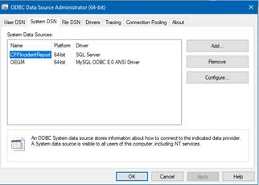

Press Add

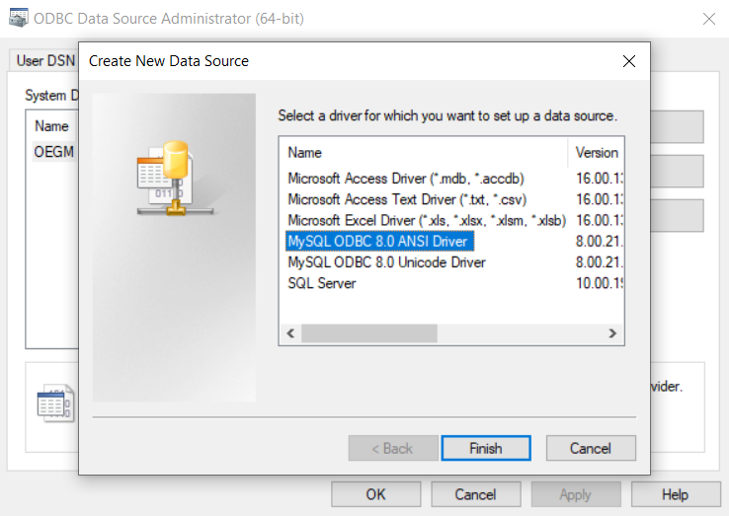

Press the MySQL ODBC 8.0 ANSI Driver and press finish

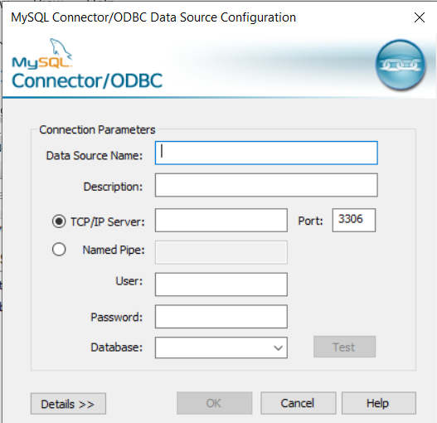

Name the Data source in “Data Source Name” (OEGM recommended)

For TCP/IP server use: “oegm.rc.duke.edu”

Use the user name “ArticleWriter” or “ArticleReader” depending on if you are given permission to edit the tables or not. For database use “Article”. For password use the password that Dr. David Gill provides.

Click Test.  You should get:

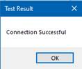

Then Press Ok and your ODBC should be added.

**Adding ODBC connector (Mac)**

These steps are very similar to Windows. Use the following link for additional guidance:

<http://dcx.sybase.com/1200/en/dbadmin/connect-s-3731160.html>

**Adding ODBC connector to Access**

Open your Access app.

Under External Data, click New Data Source

Under From Other Sources, click ODBC Database

Select “Link to the data source by creating a linked table” and click OK

On the Machine Data Source, double-click OEGM:

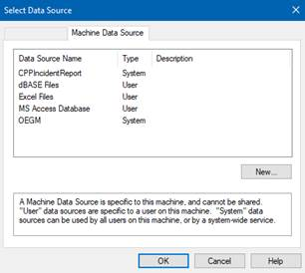

Select all tables you would like to open and click OK (Article used in this example)

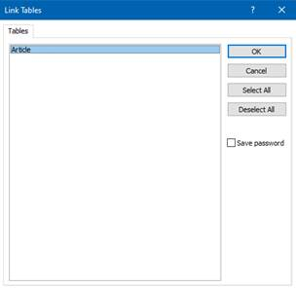

Under Tables, you should have a linked table (plus sign and globe) named “Article”

Double click the Article table:

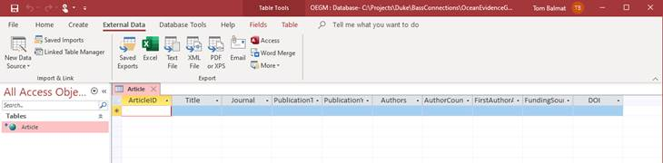

It is empty, of course, but if you specify it as the record source of a form, you can create and update Article records using that form:

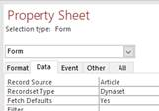

Note the * preceding the initial record in the table view above.  That indicates that records can be inserted, updated, and deleted.  If you ever have a problem creating or modifying data using a form, check to make sure that the star appears in the table view.  If missing, ODBC or SQL permissions are generally the culprit.

You should now be able bind form elements (combo boxes, text fields, etc.) to your linked table elements:

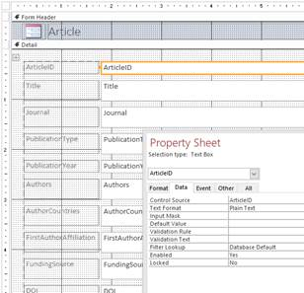.

Any records created or updated (form, not design, view) are saved in the SQL database, so that one user’s changes are visible to all users.  The SQL engine can handle dozens of simultaneous users, so throughput should not be a problem.