**RailwayStudio**

User’s guide

Contents

Contents 2

Introduction 3

Disclaimer 3

3rd party software 3

Using RailwayStudio 4

Working environment 4

Projects 4

Configuration 4

General settings 5

Plug-ins 5

Installing new plug-ins 5

Logging 6

Designing the layout 7

Elements 7

Accessory elements 7

Themes 7

Selecting the layout theme 8

Installing new themes 8

Routes 8

Designing routes 9

Create new route 9

Edit exiting route properties 10

Operating the layout 11

Digital system 11

Supported systems 11

Selecting the layout digital system 11

Installing new systems 12

Layout operations 12

Connecting and disconnecting digital system 12

Introduction

The aim to the **RailwayStudio** project is to have simple and reliable software to, basically, replace the physical switchboard control panels, maintaining manual driving of trains. And this is the big difference between **RailwayStudio** and other software which its mission is to control the traffic in the layout.

This application is ideal for small layouts and for layouts with a main single line (for example, modular layouts).

# Disclaimer

The **RailwayStudio** and also **OTC – Open Train Control** library are personal projects without any commercial plans. If you decide to use this software is under your own responsibility. **Railwaymania** and also the people working under this team name don’t offer any support and doesn’t have any plans to offer it in the future.

The source code and also the binary compiled files of this project couldn’t be used in any commercial action without express consent from **Railwaymania** member’s team.

# 3rd party software

**RailwayStudio** includes the 3rd party components listed below (with type of license):

* System.Data.SQLite 1.0.112 Public license
* Svg 2.4.3 Microsoft public license (MS-PL)
* Microsoft Entity Framework 6.4.0 Apache-2.0

Using RailwayStudio

# Working environment

**RailwayStudio** has a simple and intuitive working environment. All working panels are dockable, so we can work in a single window or in multiple separated panels (useful when working with multiple screens). It is very similar to MS Office applications.

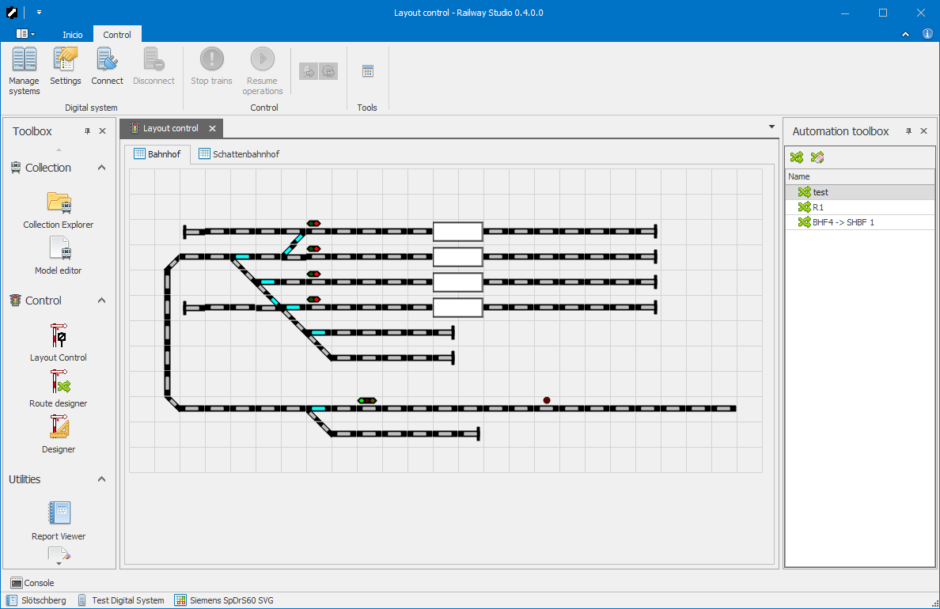

# Projects

**RailwayStudio** works with projects and each project represents a single layout. A layout is the container for all data (switchboards, trains, etc.).

**RailwayStudio** can work with a single project and cannot work with multiple layouts at same time. It means that all functionalities of the application are related to the same project (control, design, etc.).

# Configuration

**RailwayStudio** allows you to set some environment settings to personalize some functionality as you need.

Note that the described settings are always related to the working environment in the current computer, not to the loaded project.

## General settings

##### Visual aspect

You can change the **RailwayStudio** aspect by selecting one of the multiple available skins. These skins are predefined and cannot be changed by the user.

##### Load last opened project at start-up

If this option is checked, **RailwayStudio** always open the last project at start-up. If you’re working always with same layout, this option should be checked.

## Plug-ins

This tab shows all installed plug-ins. **RailwayStudio** offer two official plug-ins, as shown in the following table. Of course, the OTC open platform allows 3rd parties to develop new plug-ins.

|  |  |
| --- | --- |
| Plug-in | Description |
| Control | Contains all layout control tools (design tools, layout control, etc). |
| Collection | Contains all model railroad collection tools (explorers, editors, etc.). |

### Installing new plug-ins

1. Select **Settings** from the application menu.
2. Select the **Plug-ins** tab.

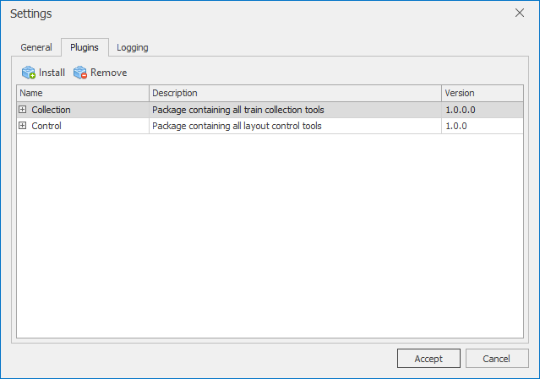

1. Select **Install** from the toolbar.
2. Browser folders and select the new plug-in file (DLL library file). The *Install new plug-in* dialogue will appear showing the package contents.

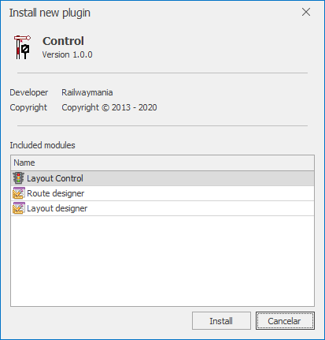

1. Press **Install** button to install the selected plug-in.

After a new plug-in is installed the *toolbox* in the main window will be updated including the new modules. Then, all modules are ready to use with the current loaded project.

## Logging

Logging allows **RailwayStudio** generate LOG files for all errors, warnings or for debugging purposes. The logger can write to text files and/or *Windows Event Log* as well.

Each logger can be configured with its own log level (*error*, *warning*, *information* and *debug*).

Layout concepts

The following schema shows all main objects used to describe a layout:

* **Project**

A project is a container for one layout, so *project* and *layout* are equivalent words.

* **Switchboard**

Switchboard is a graphical representation for the tracks, allowing control all the elements and each project has one or more switchboards. For big layouts it is possible to operate multiple switchboards (e.g. station, fiddle yard, industry, etc.).

* **Elements**

Elements allow represent and control the layout. There are multiple types of elements (single tracks, turnouts, different types of signals, etc.). Some of them could be connected to digital components to be able to control them through digital command station.

* **Accessory decoders**

Digital elements that allows controlling accessories (turnouts, signals, etc.). Accessory decoders should be connected to the digital command station in order to be able to control accessories through this software.

* **Accessory decoder outputs**

Each accessory decoder has one or more outputs to be connected to the accessory control inputs. Usually each output has a digital accessory address and some particular parameters to correctly control the accessories.

* **Accessory decoder output connections**

Each accessory decoder output should be connected to an accessory input (e.g. straight/turned in a turnout). These physical inputs are represented in the switchboard elements.

* **Feedback encoders**

Digital elements that allows receiving occupation and momentary contact information. Feedback encoders should be connected to the digital command station in order to be able to receive the appropriate signals through this software.

* **Feedback encoder inputs**

Each feedback encoder has one or more outputs to be connected to the track sensors. Each input could usually have some particular parameters.

* **Feedback encoder input connections**

Each feedback encoder input should be connected to a track sensor (e.g. consumption detector or reed contact). These sensors are implemented in some switchboard elements and should be connected to the appropriate encoder inputs.

* **Routes**

Each project could contain routes. A route is a track trace between two blocks. When a route is activated, all involved elements will be set to the appropriate state to ensure that a train can run from start block to the destination block. More than one route can be activated at same time, as long as the routes don’t have conflicting elements.

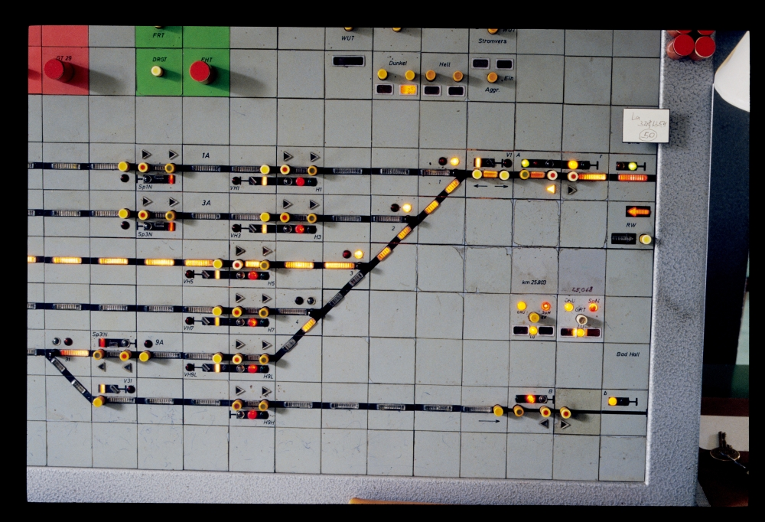

* **Route elements**

All elements included in a route. Each route element contains information about the status, switch time, etc.

Designing the layout

To design the layout, the Layout designer module will be used. This module allows graphically design the layout.

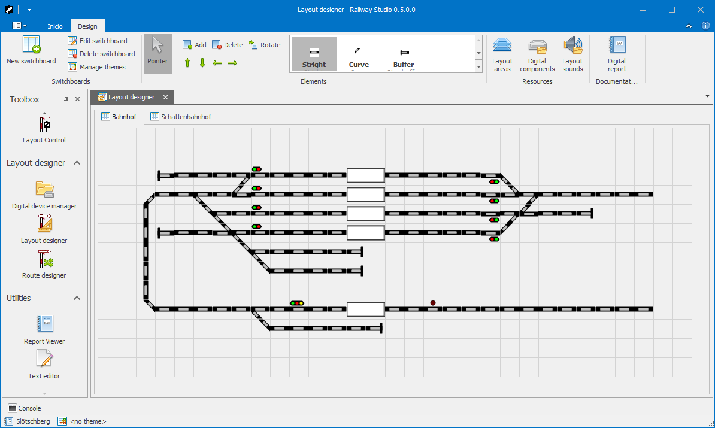

# Switchboards

The layout is graphically represented in one or more switchboards. Each switchboard contains elements placed in a grid and measured in columns and rows.

## Managing the layout switchboards

### Create a new switchboard

1. Open the **Layout design** plug-in.
2. From the toolbar, select **New switchboard**. It will open the *Switchboard editor* dialogue:

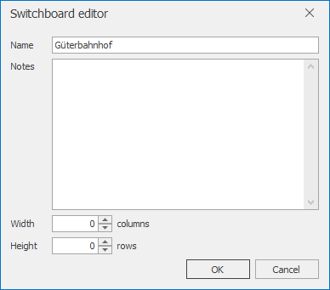

1. Specify the switchboard’s name and its measures (width and height).
2. Optionally a brief description can be provided.
3. Press **OK** to create the new switchboard in the current layout.

### Edit switchboard

1. Open the **Layout design** plug-in.
2. Select the switchboard to edit by selecting its tab page.

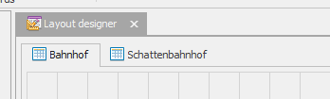

1. From the toolbar, select **Edit switchboard**. It will open the *Switchboard editor* dialogue showing the current information.
2. Edit the values.
3. Press **OK** to create the new switchboard in the current layout.

### Delete switchboard

1. Open the **Layout design** plug-in.
2. Select the switchboard to delete by selecting its tab page.
3. From the toolbar, select **Delete switchboard**. A confirmation dialogue will appear.
4. Press **Yes** to delete the switchboard or **No** to cancel.

# Elements

Each piece of the layout is an **Element**. It can be a single track, a turnout, etc. Some of them also can have one or more added functionalities like *Accessory*, *Feedback*, etc.

## Accessory elements

**Accessory elements** are all elements that could have different status, like turnouts (straight, turned), signals (red, green), etc.

Accessory elements also should be connected to accessory decoder outputs to be able to digitally control these elements through the DCC command control. Each of these connections always has 2 outputs, and these outputs can be active alternatively, never at same time. The following tables show how it works:

|  |  |  |  |
| --- | --- | --- | --- |
|  | **Address 1** | | **Status** |
|  | **P2** | **P1** |
|  | 0 | 1 | 1 |
|  | 1 | 0 | 2 |

|  |  |  |  |  |  |
| --- | --- | --- | --- | --- | --- |
|  | **Address 2** | | **Address 1** | | **Status** |
|  | **P2** | **P1** | **P2** | **P1** |
| Hp 0 (Light) | - | 0 | 0 | 1 | 1 |
| Hp 1 (Light) | - | 0 | 1 | 0 | 2 |
| Hp 2 (Light) | - | 1 | 1 | 0 | 3 |

Each status is defined by the element, so you must study in each case how to wire the accessories according its functionality.

# Themes

Themes are libraries specialized to draw the layout. Each layout can be represented in different ways, depending on the used theme. **RailwayStudio** offers the *Siemens SpDrS60* inspired theme, but 3rd parties can easily develop new themes thanks to the OTC open platform.

The theme is stored in the application settings, not in the project. It means that all layouts will be represented using the same theme until the user change it in the program.

## Selecting the layout theme

To specify the theme used by the layout:

1. Open the **Layout design** plug-in.
2. From the toolbar, select **Manage themes**. It will open the *Manage themes* dialogue:

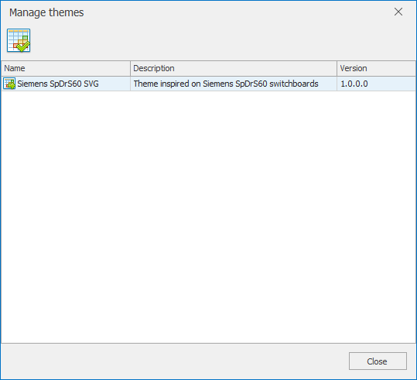

1. Select the desired theme by clicking the corresponding row.
2. Press **Set theme** button.
3. Press **Close** button to close the dialogue.

Also the Manage themes dialogue can be accessed by clicking the **Theme** button in the status bar from the *Layout design* plug-in or in *Layout control* plug-in as well.

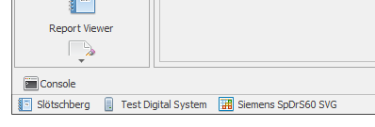

## Installing new themes

All theme drivers (DLL files) must be placed at the folder’s program. **RailwayStudio** will automatically detect the drivers and put them available in the theme’s management dialogue.

# Routes

A route is a section of track, including accessories (turnouts and signals) that can be activated at same time. Usually, the route is used to link two blocks, but it is also possible to create a route with no connection to any block. Routes could include elements from more than on switchboard.

* **Block interconnection**: This kind of routes is used to link two block sections.
* **Accessory group**: This kind of routes is used to activate a group of accessories in a single click (or pressing a single key combination).

When a route is requested, **RailwayStudio** send all requests to the command station and when all accessories are set to the appropriate status, the complete trace is shown in the switchboards, as shown in the following image:

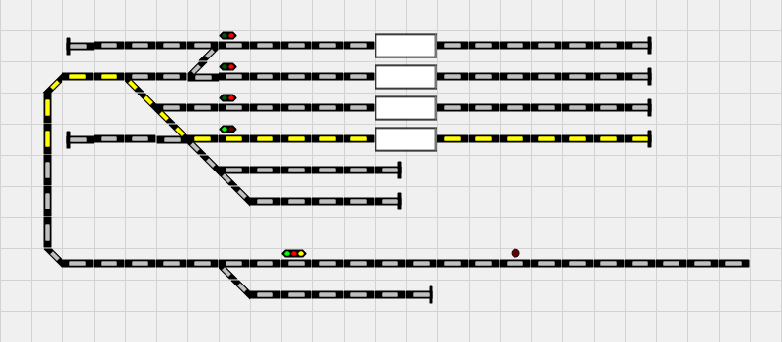

## Designing routes

All routes should be managed using the **Route designer** module. Using this module, all routes can be easily created, modified or removed from the current project.

### Create new route

1. Open the **Route designer** module from the *Modules* toolbox. The routes list will be shown.

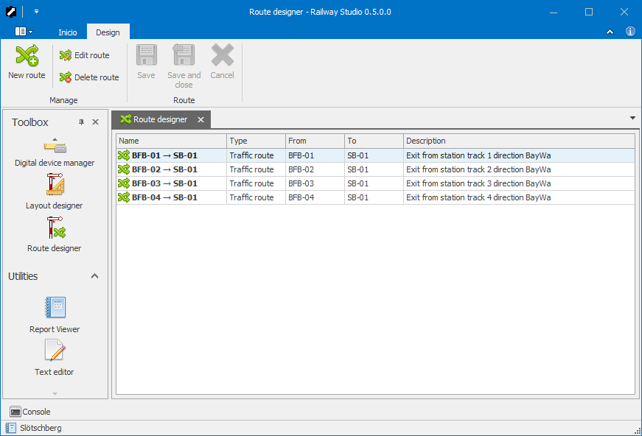

1. Select *New route* from the main toolbar. The route designer will be shown, with an empty route layout.

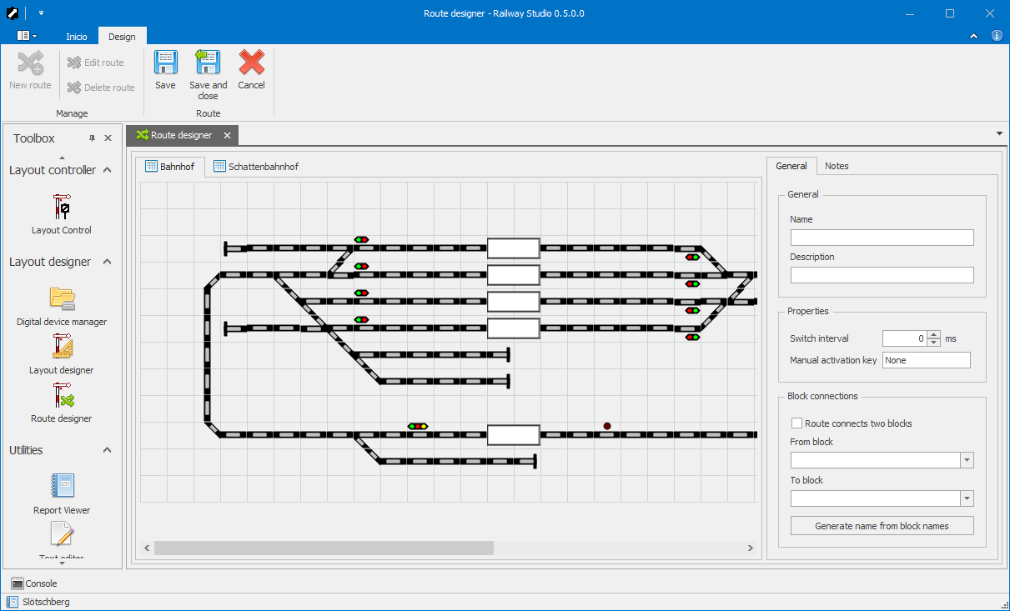

1. Set the elements into the route:
   * Click on single track elements to enable/disable the elements in the route.
   * Click on accessory elements to show the menu:
     + Set the accessory status

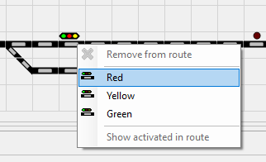

* + - Activate in route (enable/disable the element by showing the yellow marker)

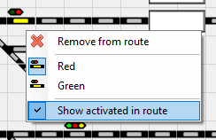

1. From the right side panel, fill the route basic properties.
2. If the current route corresponds to a *block interconnection* route, check the *Route connects two blocks* checkbox and specify the two interconnected blocks in the combo boxes (*From* and *To*).
3. Additionally you can add an explanation notes using tab *Notes*.
4. Select *Save* to save and continue editing the route or *Save and close* to save the current route and come back to routes list.

### Edit exiting route properties

1. Open the **Route designer** module from the *Modules* toolbox. The routes list will be shown.
2. Select the route to edit from the routes list.
3. Select *Edit route* from the main toolbar. The route designer will be shown, with the route represented within the switchboards.
4. Modify the route or the desired properties.
5. Select *Save* (or *Save and close*) to save all changes.
6. Select *Cancel* to close the route without saving and come back to the routes list.

### Delete a route

1. Open the **Route designer** module from the *Modules* toolbox. The routes list will be shown.
2. Select the route to edit from the routes list.
3. Select *Edit route* from the main toolbar. The route designer will be shown, with the route represented within the switchboards.
4. Modify the route or the desired properties.
5. Select *Save* (or *Save and close*) to save all changes.
6. Select *Cancel* to close the route without saving and come back to the routes list.

Operating the layout

Operating the layout is possible using the **Layout** **Control** module.

# Digital system

**RailwayStudio** allows you to connect one command station to the layout. The current versions cannot manage more than one system connected at same time to the layout. It means that your command station must be able to manage accessories and feedback.

## Supported systems

The following table contains all implemented systems. Of course, OTC is an open architecture and allows developing new implementations.

|  |  |
| --- | --- |
| System | Description |
| Test Digital System | This is a built-in dummy system that allows you to test all software functionalities without any physical command station connected to your computer. You can test all functions (some of them, manually). |
| Lenz XpressNet USB | Lenz XpressNet protocol implementation through the LI-USB interface. It should work also with LAN-USB interface (not tested). |

## Selecting the layout digital system

To specify the system used by the layout:

1. Open the **Layout control** plug-in.
2. From the toolbar, select **Manage systems**. It will open the *Manage digital systems* dialogue:

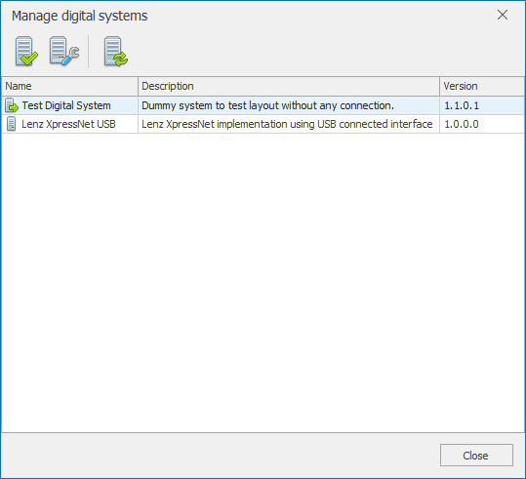

1. Select the desired system by clicking the corresponding row.
2. Press **Set system** button.
3. Optionally you are able to configure the selected system by clicking **System settings** button on the toolbar.
4. Press **Close** button to close the dialogue.

Now, the selected digital system is ready to use.

## Installing new systems

All digital system drivers (DLL files) must be placed at the folder’s program. **RailwayStudio** will automatically detect the drivers and put them available in the system’s management dialogue.

## Configuring the digital system

Each digital system can be configured from both Manage digital systems dialogue and the Layout control plug-in module.

### Lenz XpressNet USB

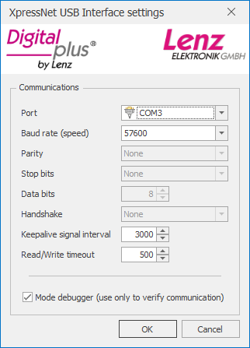

# Layout operations

To operate the layout, the digital system should be selected and properly configured. After this step, the layout could be operated normally. Refer to Digital system section for further information.

## Connecting and disconnecting digital system

Before to start operations the digital system must be connected, also when the operation ends, the digital system must be disconnected.