Unsupervised | Supervised
Dataset unlabeled | Dataset labeled
Classify images based on the similar of image feature | Classify images based on the image label
Using SAE to compute feature space, using Kmean to predict and try to minimize KL divergence by update weight/bias of SAE model after each iterator | Using a number of learnable filters, which slide over each image. Compute the lost based on the label and adjust the filters (bias/weight) through training process called backpropagation
Model trained when KL divergence less than the threshold (0.001 * N) | Model trained when reached the max_iterator configure parameter
Easy to change number of classes to classify | Can’t change number of classes because it depends on labeled dataset
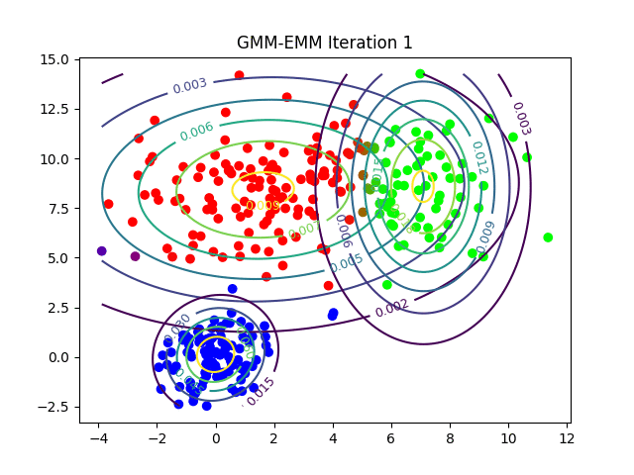 | 