Architecture Design

High Level Design

1) Introduction

1.1) Purpose

This document will explain the architecture of DEM software.

1.2) Developing environment:

OS: linux

Framework: QT(QT quick QML).

3D render library: opengl.

1.3) Use case description:

1.3.1) Usability

1.3.2) Maintenance

1.3.3) Performance

1.3.4) Design contrains

2) Overall Description

2.1) System architecture

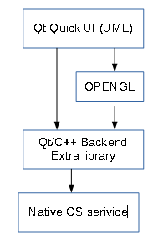

Qt Quick (QML) framework: Build user interface. Handling binding data, view animation.

OPENGL: Provide 3D process library.

Qt/C++: Provide database, file access api.

Extra library: library for processing dem file.

2.2) Software block diagram:

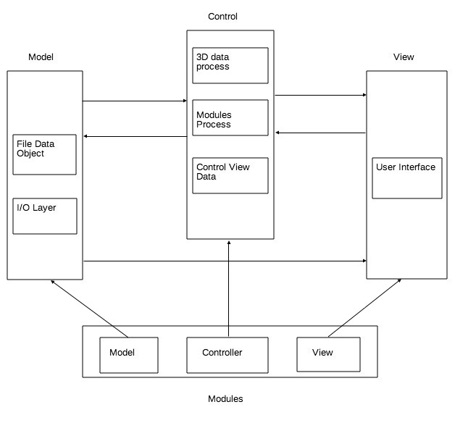

Model: Handle File In/Out include read Dem file or Export. Model also holding Dem file Object

Controller: Control data flow, processing action request from view

View: Show user interface

Modules: a component include Model, Controller & View as part of program such as file module or zoom module

2.4) Data flow

2.4.1) Open DEM file button

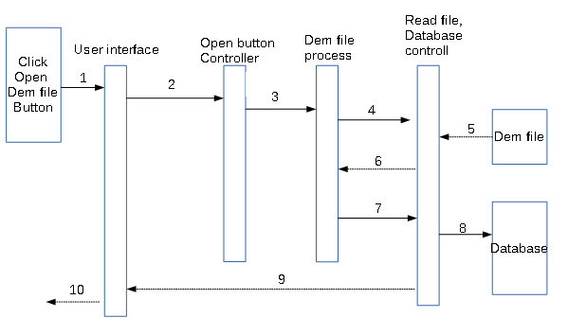

2.3) Class diagram

3) Deployment guide