CaMa-Flood Upstream Inflow Scheme
Authors: Dai Yamazaki
Last Updated: 2026-3-21
This document provides a technical description of CaMa-Flood Upstream Inflow Scheme (v4.31 and later), including:
- Descriptions of Upstream Inflow Scheme
- Sample procedures for preparing map and input data for Upstream Inflow scheme

1. Introduction
The CaMa-Flood Upstream Inflow scheme enables the simulation with “point river discharge timeseries” as upstream inflow boundary data.
Below data should be prepared to execute Upstream Inflow scheme.
- Upstream Inflow CSV: A CSV file containing the location of the inflow points and time-series.
- Modified river map (nextxy): A modified map which exclude the upstream part(s) of the inflow point(s) should be prepared.
The scheme can be used for multiple purposes, for example:
- River hydrodynamics simulation in the downstream region of specific gauge(s), using observed river discharge as an input.
- Calibration of land/river model parameters from upstream to downstream. Calculation cost can be reduced by excluding already-calibrated upstream regions, using upstream inflow scheme.
The sample data and scripts for using Upstream Inflow scheme is prepared in the CaMa-Flood package. Please check etc/upstream_inflow/.

Official resources:
- CaMa-Flood product webpage: https://hydro.iis.u-tokyo.ac.jp/~yamadai/cama-flood/
- CaMa-Flood GitHub repository: https://github.com/global-hydrodynamics/CaMa-Flood_v4
- CaMa-Flood user group (Google Group): https://groups.google.com/g/cama-flood-user

2. Using Upstream Inflow Scheme
A sample script (g02-upst_inflow.sh) to use upstream inflow scheme in 15arcmin simulation of the Mekong River basin (map/mekong_15min/ ; 90-110E, 5-35N) is prepared in etc/upstream_inflow/ directory.
- Upstream Inflow Scheme can be activated by LUPSINF=.TRUE. in the namelist NRUNVER.
- The Inflow Timeseries Data should be prepared and specified by CINFCSV in the namelist NUPSINF.
- The temporal frequency of the Inflow Timeseiries should be specified by IFRQ_INF in the namelist NUPSINF.
A example Inflow Timeseries CSV is prepared (data/mekong_inflow.csv). to use upstream inflow scheme for the Mekong basin is prepared in etc/upstream_inflow/ directory.
1st to 6th lines represents PointName, X grid ID (Fortran), Y grid ID (Fortran), Latitute, Longitude, UpstreamArea [km2], respectively. From 7th line, the time series discharge [m3/s] is listed.
The time should be specified by YYYY-MM-DDThh:mm format (i.e. one character between numbers).
Name,Vientiane,UbonRatchathani
IX_fort,52,60
IY_fort,69,80
Lat,17.92,15.22
Lon,102.62,104.86
Uparea,305453.1,106544.1
2000-01-01T00:00,801.07,47.68
2000-01-01T01:00,800.30,47.51
2000-01-01T02:00,799.52,47.35
2000-01-01T03:00,798.72,47.19

3. Step-by-step procedure for sample Upstream Inflow scheme

3.1 Prepare regionalized mekong_15min map
Go to CaMa-Flood/map/ and create mekong_15min directory.
Goto mekong_15min/ and copy map source codes map/src/src_param/ and map/src/src_region/
% cd $CaMa-Flood/map
% mkdir -p mekong_15min
% cd mekong_15mim
% cp -r ../src/src_param .
% cp -r ../src/src_region .

Regionalize the global map
Go to mekong_15min/src_region/ and edit s01-regional_map.sh for the Mekong basin.
% cd $CaMa-Flood/mep/mekong_15min/src_region/
% vi s01-regional_map.sh
#!/bin/sh

# To regionalize glb_15min to mekong_15min
SOURCE="../../glb_15min/" # !! global map directory
WEST="90.0" # !! west edge (regional)
EAST="110.0" # !! east edge
SOUTH="5.0" # !! south edge
NORTH="35.0" # !! north edge
Compile Fortran90 codes and execute s01-regional_map.sh
% make all
% ./s01-regional_map.sh
The Mekong 15arcmin maps are generated.

Prepare regionalized map parameters
Then, go to mekong_15min/src_param/ , compile Fortran codes, and execute script s01-channel_params.sh
All basic parameter maps are generated.
% cd $CaMa-Flood/mep/mekong_15min/src_param/
% make all
% ./ s01-channel_params.sh

3.2 Find inflow points
In the sample script, two locations are used as Inflow points.
Vientiane Lat=17.92 Lon=102.62
UbonRatchathani Lat=15.22 Lon=104.86

Find corresponding grid XY
The corresponding Grid XY ID and Upstream Area should be checked on the CaMa-Flood map.
This can be done in mekong_15min/src_param/get_rivinfo code. Go to mekong_15min/src_param/ and execute below commands.
% cd $CaMa-Flood/map/mekong_15min/src_param/
% ./get_rivinfo latlon 17.92 102.62

Point Information
Fortran IX,IY: 52 69
Python IX,IY: 51 68

Lat, Lon (Point): 17.9200001 102.620003
Lat, Lon (Grid Center): 17.8750000 102.875000
Lat, Lon (Catchment Outler): 18.0029163 102.970413

River Basin ID: 2
Drainage Area [km2]: 305453.094

% ./get_rivinfo latlon 15.22 104.86

Point Information
Fortran IX,IY: 60 80
Python IX,IY: 59 79

Lat, Lon (Point): 15.2200003 104.860001
Lat, Lon (Grid Center): 15.1250000 104.875000
Lat, Lon (Catchment Outler): 15.3070831 105.111252

River Basin ID: 2
Drainage Area [km2]: 106544.102
The point attributes on the CaMa-Flood river map are shown. If the Upstream Area is strange, the inflow point might correspond to a neighboring grid. Please search the appropriate XY location.

Prepare Inflow Point List file
The PointName, Grid XY ID (Fortran), Lat, Lon, Uparea should be summarized in Inflow Point list file. Sample file is data/list_points.txt
% cat data/list_points.txt

Name IX_fort IY_fort Lat Lon Uparea
Vientiane 52 69 17.92 102.62 305453.1
UbonRatchathani 60 80 15.22 104.86 106544.1
This Inflow Point List is used for generating the modified river map (excluding upstream basin). Please follow the above data format, if you prepare your own inflow point list.

3.3 Prepare modified river map.
The script to generate the modified river map which exclude the upstream basin of the inflow point(s) is prepared.
First, go to etc/upstream_inflow/src/ and compile source code.
% cd $CaMa-Flood/etc/upstream_inflow/src
% make all

Then, edit s00-link.sh and s01-mask_upbasin.sh if needed.
S00 script links mekong_15min map as a symbolic link map/
S01 script mask upstream basins of the inflow points, and generate modified nextxy river map.
% cat s01-mask_upbasin.sh
#!/bin/sh

MAPDIR="./map"
NEXTXY_INP="nextxy.bin"
BASIN_INP="bifbsn.bin" ## basin mask considering bifrucation channel connectivity
#BASIN_INP="./map/basin.bin" ## basin mask without considering bifrucation channel connectivity

NEXTXY_OUT="nextxy_inflow.bin" ## output nextxy
MASK_OUT="upst_mask.bin" ## output basin file

INFLIST="./data/list_points.txt" ## list of inflow points [ NAME, IX, IY, (UPAREA) ]

MODE="default" ## "default" for only keeping basin with inflow points
#MODE="keep" ## "keep" for keeping all basin regardless of inflow points

./src/mask_upbasin $MAPDIR $NEXTXY_INP $BASIN_INP $NEXTXY_OUT $MASK_OUT $INFLIST $MODE

% $CaMa-Flood/etc/upstream_inflow/
% ./s00-link.sh
% ./s01-mask_upbasin.sh

The modified nextxy is saved as nextxy_inflow.bin (default).
The upstream mask map is also generated as upst_mask.bin (default).
-3: other basin, -1: excluded upstream, 0: downstream basin, >0: inflow points
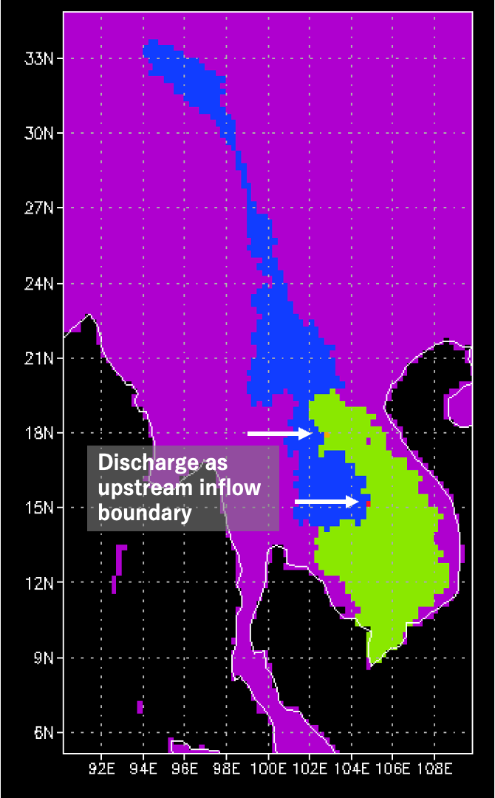
Figure: Example of Upstream_Mask
Note: The inflow point grids (where inflow is treated as additional runoff input) should be kept in the modified river map. Only the upstream grids of the inflow points (blue in the above figure) are excluded.

3.4 Prepare Inflow Timeseries CSV
In the sample data, the CaMa-Flood original simulation (without upstream inflow scheme) is used to as a baseline data for the upstream inflow timeseries data. The goal is to make the simulation results of Upstream Inflow scheme almost same as the original simulation results.

Execute original simulation
First, please execute original simulation using g00-mekong_all.sh
The hourly output data is saved in etc/upstream_inflow/out_ori/ directory.
% $CaMa-Flood/etc/upstream_inflow/
% ./g00-mekong_all.sh
% ls out_ori/
Note: the script g01-upst_mask.sh is test script to execute simulation using masked nextxy river map but without Upstream Inflow scheme. The downstream discharge is expected to be underestimated, because upstream basins are excluded. The simulation results are saved in out_mask/ directory.

Extract discharge at Inflow Points and create Inflow Timeseries CSV
The script s02-extract_outflw_ori.sh extracts the hourly (or daily) discharge from the simulation data.
The yearly discharge timeseries data is stored in gauge/ directory.
% ls gauge/
UbonRatchathani_2000.txt UbonRatchathani_2001.txt
Vientiane_2000.txt Vientiane_2001.txt
In addition, the combined Inflow Timeseries CSV file is generated data/mekong_inflow.csv. This is used as the input inflow CSV for the Upstream Inflow scheme.
% cat ./data/mekong_inflow.csv

Name,Vientiane,UbonRatchathani
IX_fort,52,60
IY_fort,69,80
Lat,17.92,15.22
Lon,102.62,104.86
Uparea,305453.1,106544.1
2000-01-01T00:00,801.07,47.68
2000-01-01T01:00,800.30,47.51
2000-01-01T02:00,799.52,47.35
2000-01-01T03:00,798.72,47.19
This Inflow CSV should be given as the format described above, when you prepare your own Upstream Inflow. Number of the inflow points can be flexible, as long as the CSV format is kept.

3.5 Execute simulation with Upstream Inflow scheme
The script to execute simulation with Upstream Inflow scheme is prepared as g02-upst_inflow.sh
The results is saved in out_upst/ directory. The simulation results are expected to be almost identical to the original simulation in out_ori/ directory.
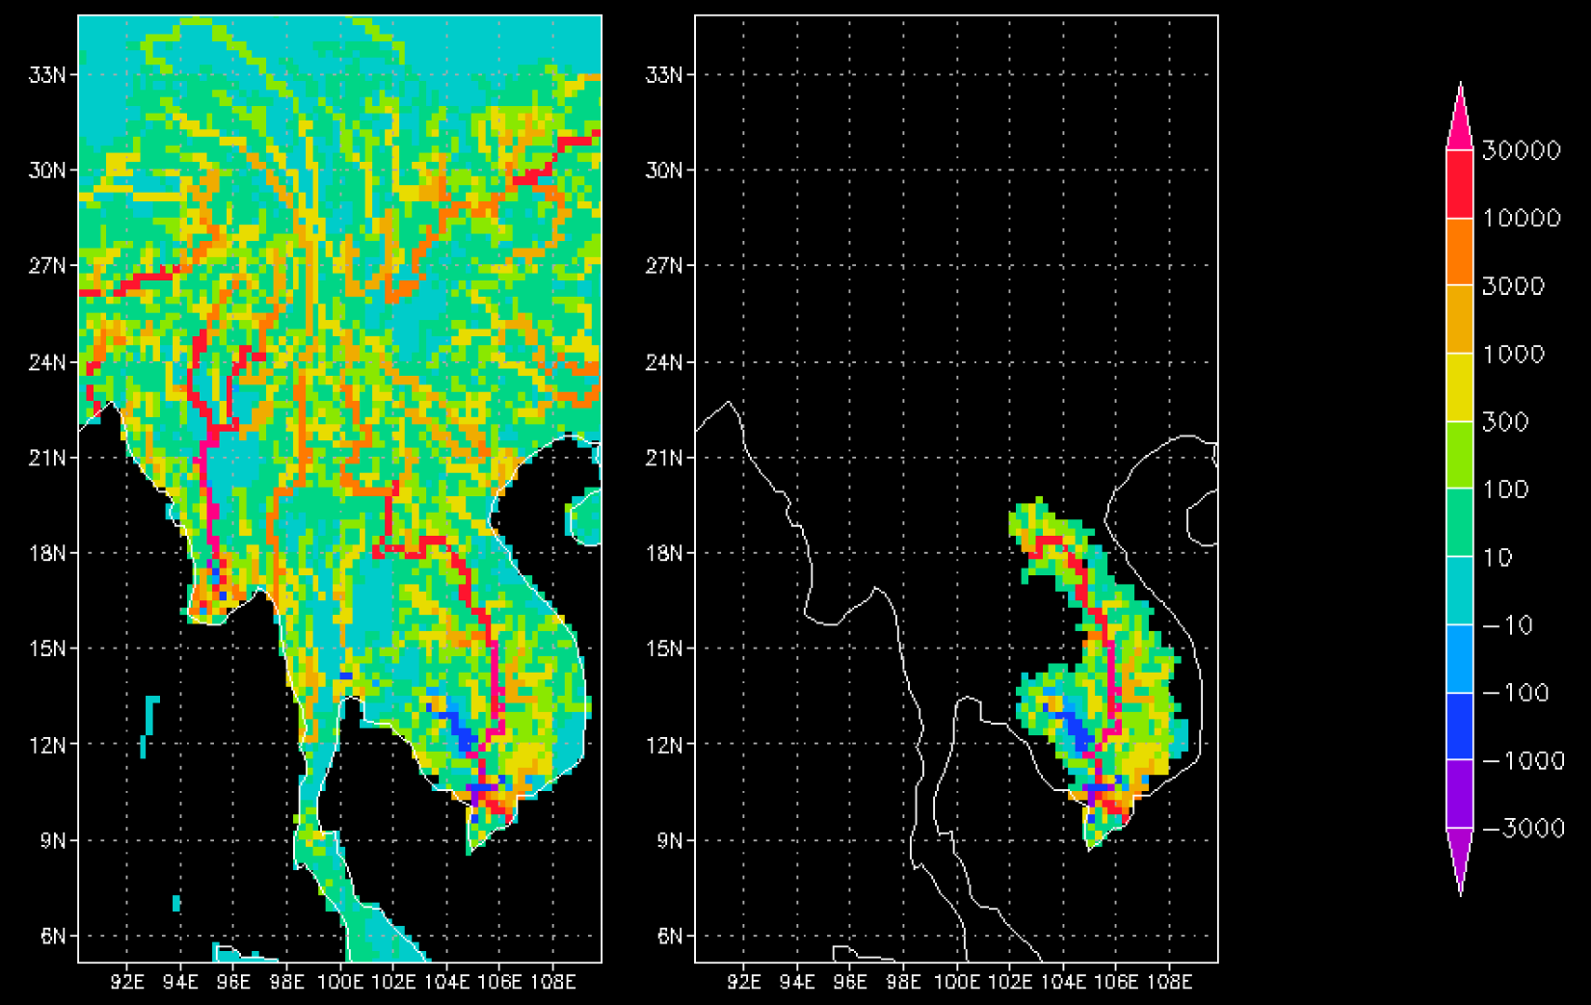
Figure: Sample OUTFLW output (left: original, right: Upstream Inflow scheme)

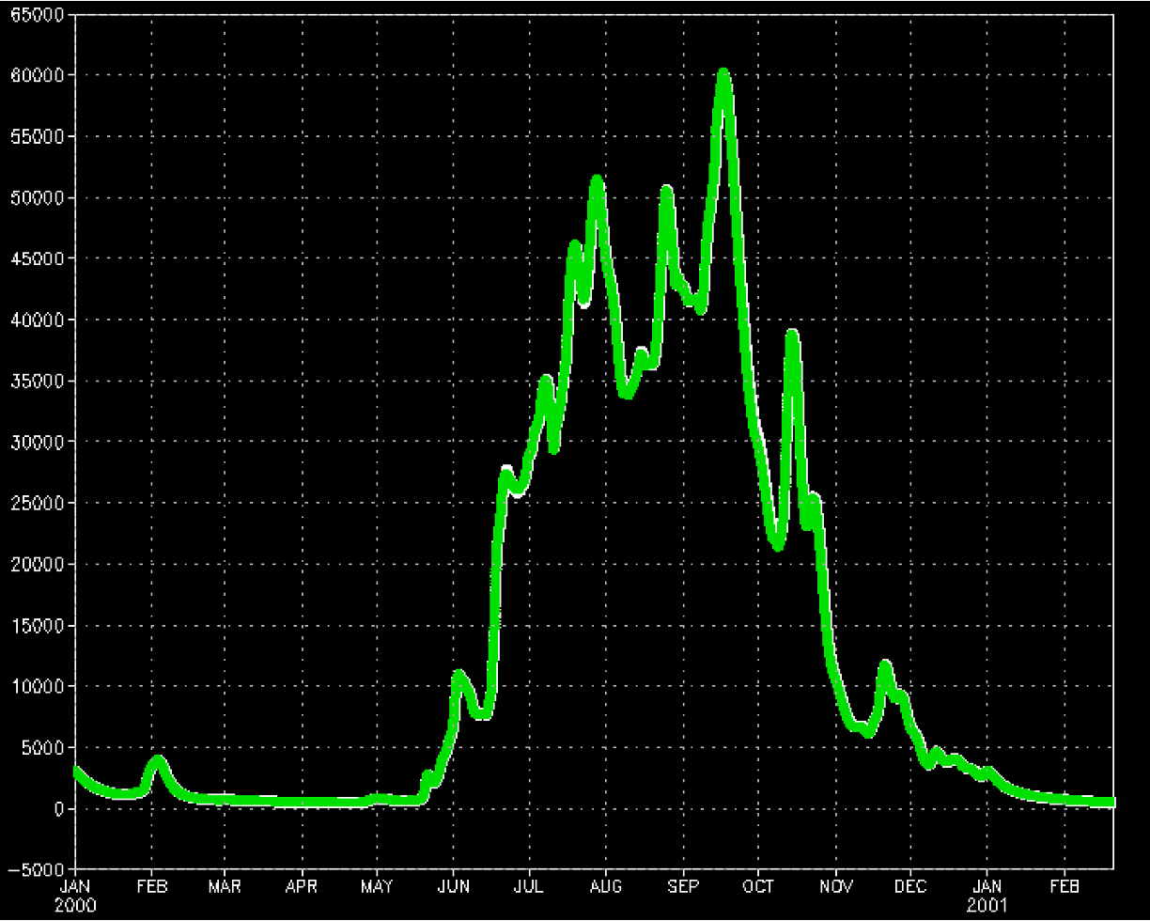
Figure: Simulated discharges are almost identical (white: original, green: Upstream Inflow scheme)

4. Customize Upstream Inflow scheme
If you want to use your own Upstream Inflow data, you can execute the simulation following the above procedures in Section 3.
  - Check the corresponding grids to inflow points on CaMa-Flood river map.
  - Prepare Inflow Point List file.
  - Prepare modified nextxy river map, excluding the upstream basins
  - Prepare Inflow CSV file.
  - Specify “Modified River Map”, “Inflow CSV”, “Inflow Frequency” in shell script.

Note: instead of using simulation-based discharge, another discharge (e.g. observed gauged discharge) can be used, as long as the data format is same.

