CaMa-Flood Levee Parameter Preparation
Authors: Dai Yamazaki, Gang Zhao, Do Ngoc Khanh
Last Updated: 2025-11-25
This document provides a technical description of parameter preparation for the CaMa-Flood Levee Scheme (v4.30 and later), including:
- Descriptions of required input data
- End-to-end workflow using scripts (s01, s02, s03, s04, x01)
- Full parameter definitions and their scientific meaning
- Algorithmic outlines (full mathematical/technical detail kept in Appendix)

1. Introduction
The CaMa-Flood levee scheme enables global representation of levees (river embankments) by assigning two key parameters to each CaMa unit-catchment: levee relative distance (levee unprotected fraction; LEVFRC) and levee crown height relative to the river channel (LEVHGT).
Preparing these parameters requires the following inputs:
- High-resolution river–levee distance: Distance between the river centerline and the levee on the MERIT Hydro / J-FlwDir river map.
- Flood Protection Standard: Return period corresponding to the flood protection level of each catchment (FLOPROS).
- Target CaMa-Flood river network map: The CaMa-Flood river network map to which levee parameters will be added.
The scripts are designed to calculate levee parameters (LEVFRC and LEVHGT) for a CaMa-Flood river network map:
- The sample code is designed for the global 15-min map (glb_15min).
- It can be modified for any user-defined CaMa-Flood map, including regional or custom-resolution maps. → The target map directory is specified in s01-calc_levee_fraction.sh.
The sample levee parameter scripts are prepared within the CaMa-Flood package. Please check etc/levee_params/.

CaMa-Flood levee scheme reference (Zhao et al., 2025, WRR):
Developing a Levee Module for Global Flood Modeling With a Reach‐Level Parameterization Approach Gang Zhao, Dai Yamazaki, Yoshiaki Tanaka, Xudong Zhou, Shuping Li, Yang Hu, Yukiko Hirabayashi, Jeff Neal, Paul Bates Water Resources Research, 61, e2024WR039790, 2025 https://doi.org/10.1029/2024WR039790

Official resources:
- CaMa-Flood product webpage: https://hydro.iis.u-tokyo.ac.jp/~yamadai/cama-flood/
- CaMa-Flood GitHub repository: https://github.com/global-hydrodynamics/CaMa-Flood_v4
- CaMa-Flood user group (Google Group): https://groups.google.com/g/cama-flood-user

2. Workflow Overview
The workflow of the sample package is as follows.
- LEVFRC calculation (s01-calc_levee_fraction.sh)
- FLOPROS resolution conversion (s02-conv_FLOPROS_res.sh)
- Initial simulation with infinite LEVHGT (s03-cycle_sim00.sh)
- Re-simulation using updated LEVHGT parameter (s04-cycle_sim01.sh)
- Internal levee parameter computation (x01-calc_levbaseheight.sh)

s01 and s02 are for pre-process levee fraction (LEVHGT) and protection level. Then, levee height (LEVHGT) is estimated by simulation (s03 and s04). Post-processing script (x01) is optional, and output is not required in simulations.

3. Input Datasets and Variable Definitions

3.1 Levee Distance Dataset
File: data/levdis_Zhao2025_glb3sec.txt
Contains MERIT Hydro 3″ river-centerline pixels and their distance to mapped levees:
lat, lon, drainage_area[km²], distance_to_levee[m], pixel_type
pixel_type definitions: - 0 = land or narrow river pixel - 1 = lake pixel - 3, 4 = river pixel - 6 = ice pixel

Example entries (sample rows):
-51.881 -72.553 1260.951 6426.000 4
-50.225 -72.549 5819.595 12600.000 1
-51.700 -72.549 10140.238 1122.000 3
-50.225 -72.548 5819.897 12600.000 1
-50.992 -72.548 809.103 101.000 0
-50.225 -72.548 5819.925 12510.000 1
These points represent the nearest distance from the river centerline to the levee’s crest line. They are mapped to CaMa unit-catchments by s01-calc_levee_fraction.sh script, to estimate levee presence and levee fraction.

3.2 FLOPROS 30-second dataset
File: data/FLOPROS_shp_V1_30s_filled.tif - Represents protection level (return period) at global scale. The “merged” layer of FLOPROS dataset is used. - Ocean is filled to prevent missing values due to land-sea mask difference. - Regridded to CaMa-Flood grid in s02-conv_FLOPROS_res.sh script.

FLOPROS reference (Scussolini et al., 2016, NHESS):
FLOPROS: an evolving global database of flood protection standards. Scussolini, P., Aerts, J. C., Jongman, B., Bouwer, L. M., Winsemius, H. C., de Moel, H., & Ward, P. J. (2016). Natural Hazards and Earth System Sciences, 16(5), 1049-1061. https://doi.org/10.5194/nhess-16-1049-2016

3.3 CaMa-Flood Map and Required Internal Files
This workflow operates on a CaMa-Flood map directory, which defines the spatial grid, river network, floodplain structure, and all physical parameters needed for the levee scheme.
A sample map (global, 15-minute resolution) is distributed as glb_15min in the CaMa-Flood package from the webpage, but any user-defined map can be used.
The map directory is specified in s01-calc_levee_fraction.sh and must contain the following files:
MAPDIR="../../map/glb_15min/" # map directory
HIGHRES="1min" # high-res file to analyze (default: global=1min, Japan=15sec)

Core CaMa-Flood Map Files
These define the geometry and structure of each CaMa unit-catchment:
File | Meaning
params.txt | Map configuration (nx, ny, gsize, floodplain layers NLFP, domain extent)
uparea.bin | Upstream drainage area [m²]; also used as land/sea mask (−9999 = sea)
rivlen.bin | River channel length in each unit-catchment [m]
rivwth.bin | River width [m]
grdare.bin | Unit-catchment area [m²]
fldhgt.bin | Floodplain elevation layers (NLFP layers per grid cell)
These files are essential because levee parameters depend on: - Channel width (rivwth) → used to constrain minimum levee distance - Catchment width (ctmare / rivlen) → used for LEVFRC normalization - Floodplain elevation structure (fldhgt) → optionally required to compute levee base height and storage (via calc_baseheight.py)

4. Detailed Workflow

4.1 Step 1 - LEVFRC Calculation
Script s01-calc_levee_fraction.sh is used for calculating levee unprotected fraction, LEVFRC using high-resolution levee distance pixels.
Note: The Fortran90 code calc_levfrc.F90 in src/ directory should be compiled by make all command.

The target CaMa-Flood map should be specified in s01-calc_levee_fraction.sh
MAPDIR="../../map/glb_15min/" # map directory
HIGHRES="1min" # high-res file to analyze (default: global=1min, Japan=15sec)

Levee unprotected fraction LEVFRC (or levee relative distance within unit-catchment) is defined as:
LEVFRC = 2 × Average_distance_to_levee / Catchment_width
Value ranges: - 0.0 → levee very close to river - 1.0 → levee absent / very far

Algorithm (simplified):
- Read CaMa-Flood high-resolution map (e.g., glb_15min/1min/)
- Identify mainstem pixels using upstream area threshold (>50% of outlet uparea)
- Read levee distance pixel list
- Map levee distance pixel to CaMa unit-catchment
- Compute levee coverage ratio of the catchment mainstem and determine levee presence
- Calculate average levee distance per catchment
- Calculate levee unprotected fraction LEVFRC, using catchment width (ctmare/rivlen)

Output files:
- levfrc.bin — levee unprotected fraction (or levee relative distance in unit-catchment, 0-1)
- levhgt_sim00.bin — initial “infinite levee height” (default=100 m)

Full Fortran90-level implementation is described in Appendix A1.

4.2 Step 2 — FLOPROS Resolution Conversion
The script s02-conv_FLOPROS_res.sh Interpolates FLOPROS flood protection standard to CaMa-Flood grids.
Reads 30sec FLOPROS geoTiff and CaMa-Flood map
Performs nearest-grid sampling

Outputs:
- protect.tif
- protect.bin (float32, little endian)

Algorithmic details in Appendix A2.

4.3 Step 3 — Initial CaMa-Flood Simulation
The script s03-cycle_sim00.sh runs CaMa-Flood for a long simulation period (e.g., 1980–2010) with initial infinite levees height to obtain river water level timeseries. Then, extreme value analysis is performed to estimate return-period equivalent river water level, and then levee height corresponding to FLOPROS protection level is determined.
The infinite levee height is used to obtain river water levels under “fully protected” condition. (because upstream levee can affect downstream hydrodynamics)

Procedure:
Run CaMa-Flood for all years (e.g., 1980–2010) - Extract daily water levels → annual maxima - Fit Gumbel distribution → estimate RP water level (from FLOPROS)

Output:
- levhgt_sim01.bin — updated levee height

(1) Running CaMa-Flood
The shell script to run CaMa-Flood `t01-run_cmf_levee.sh’ is called, and long-term simulation is executed.

⚠ Required Input: Long-term Runoff Data (e.g. ERA5-Land)
To run CaMa-Flood, users must prepare their own runoff input data. - Recommended datasets: ERA5-Land, Earth2Observe, GRADES or other land surface model outputs - Format: typically NetCDF or CaMa-Flood runoff binary VAR_YYYYMMDD.bin format - Edit the input path in the script t01-run_cmf_levee.sh accordingly
During simulation, CaMa-Flood will: - Read daily/hourly runoff - Route it through the river network - Output water level variables (e.g., rivdph, sfcelv)

Namelist Key Settings
Please specify below to activate levee scheme, and using levee parameter maps.
LLEVEE = .TRUE.
CLEVFRC = map/levfrc.bin
CLEVHGT = map/levhgt_sim00.bin

Output
- Daily water levels

(2) Extreme value analysis
Following the simulation, a script to perform extreme value analysis `t02-calc_levee_height.sh’ is called.

Procedures
- annual maximum water level is calculated from long-term daily water level.
- Extreme value analysis using Gumbel distribution is performed.
- River water level corresponding to the FLOPROS protection standard is calculated.
- The estimated water level is treated as levee height LEVHGT (relative height above river channel).
- The output levee height LEVHGT is saved as: levhgt_sim01.bin This updated LEVHGT is used for the next-cycle simulation.
Full extreme value analysis in Appendix A3.

4.4 Step 4 — Second CaMa-Flood Simulation
The script s04-cycle_sim01.sh repeats Step 3 using updated heights:
CLEVHGT = map/levhgt_sim01.bin
to estimate levee height considering upstream-downstream interactions.

Outputs:
- levhgt_sim02.bin
If needed, repeat until convergence. Once the levee height is converged, save that levee height parameter map as levhgt.bin.

4.5 Step 5 (optional) — Additional Levee Parameter Computation
In this step, x01-calc_levbaseheight.sh transforms LEVFRC + LEVHGT into all internal CaMa levee parameters:
Variable | Meaning
LEVDST | Mean Distance from channel center to levee [m]
LEVBASHGT | Elevation of levee base (ground level at levee position)
LEVPHYHGT | Physical levee height = LEVHGT − LEVBASHGT
LEVHGT_MOD | LEVHGT masked for invalid cells (LEVHGT lower than LEVBASHGT)
LEVBASSTO | Storage at levee base (river-side)
LEVTOPSTO | Storage at levee crest elevation (river-side)
LEVFILSTO | River+Floodplain storage when levee is fully sink
These parameters are internally calculated in CaMa-Flood simulation, but not requirted as input for CaMa-Flood. They can be used for some purposes, such as pre/post-processing flood stage from water storage.

All formulas and layer-integration logic are in Appendix A4.
Generated files are placed in the map directory.

5. Running CaMa-Flood with Levee Scheme

Namelist setting
To activate the levee scheme in CaMa-Flood, modify NAMELIST settings as follows:
LLEVEE = .TRUE.
CLEVFRC = ${FMAP}/levfrc.bin
CLEVHGT = ${FMAP}/levhgt.bin

Adding Levee Variables to Output (CVARSOUT)
When using the levee scheme, additional output variables become available. To write these variables to NetCDF or binary output, they must be explicitly added to CVARSOUT in the NAMELIST.

Example CVARSOUT setting
CVARSOUT = "sfcelv rivdph flddph levsto levdph"
Where: - levsto = Storage on the protected side of the levee - levdph = Water depth in protected side
These variables will not appear in outputs unless listed in CVARSOUT. Example:
CVARSOUT = "sfcelv rivdph levsto levdph"

6. Visualization
To easily inspect parameter maps generated by the levee scheme, a sample visualization script visualize.py is provided. This script reads levee‑related parameters from the CaMa‑Flood map directory and outputs them as PNG images.
visualize.py visualizes the three key levee‑scheme parameter maps:
- LEVFRC (levfrc.bin)
Levee unprotected fraction.
Meaning of values:
  - Close to 0 → Levees are located very near the river channel (strong protection).
  - Close to 1 → No levees or levees located far from the river (weak or no protection).
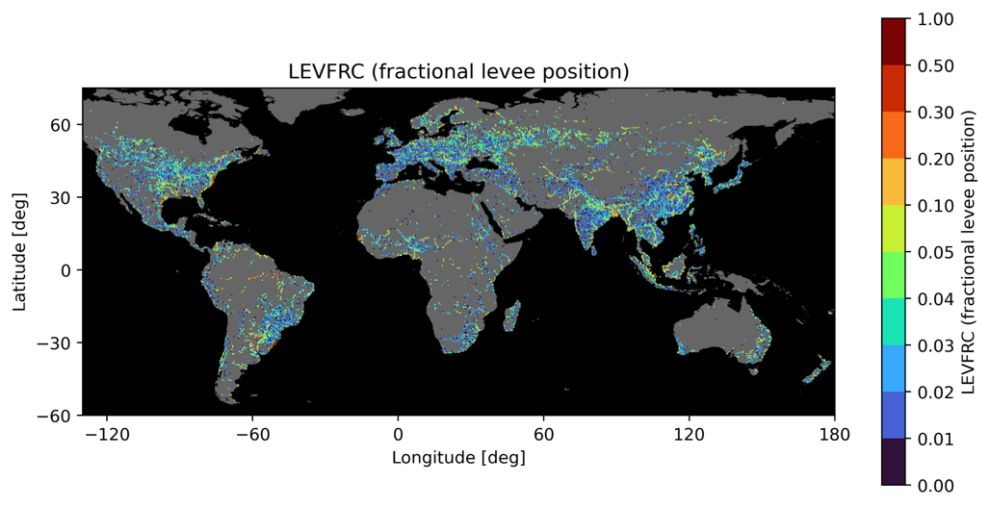
Figure: Levee Unprotected Fraction (LEVFRC)

- LEVHGT (levhgt.bin or levhgt_simXX.bin)
Levee crest height.
Represents the absolute elevation [m] of the levee crest, derived from FLOPROS return‑period water levels combined with CaMa’s river‑reference elevation (rivhgt).
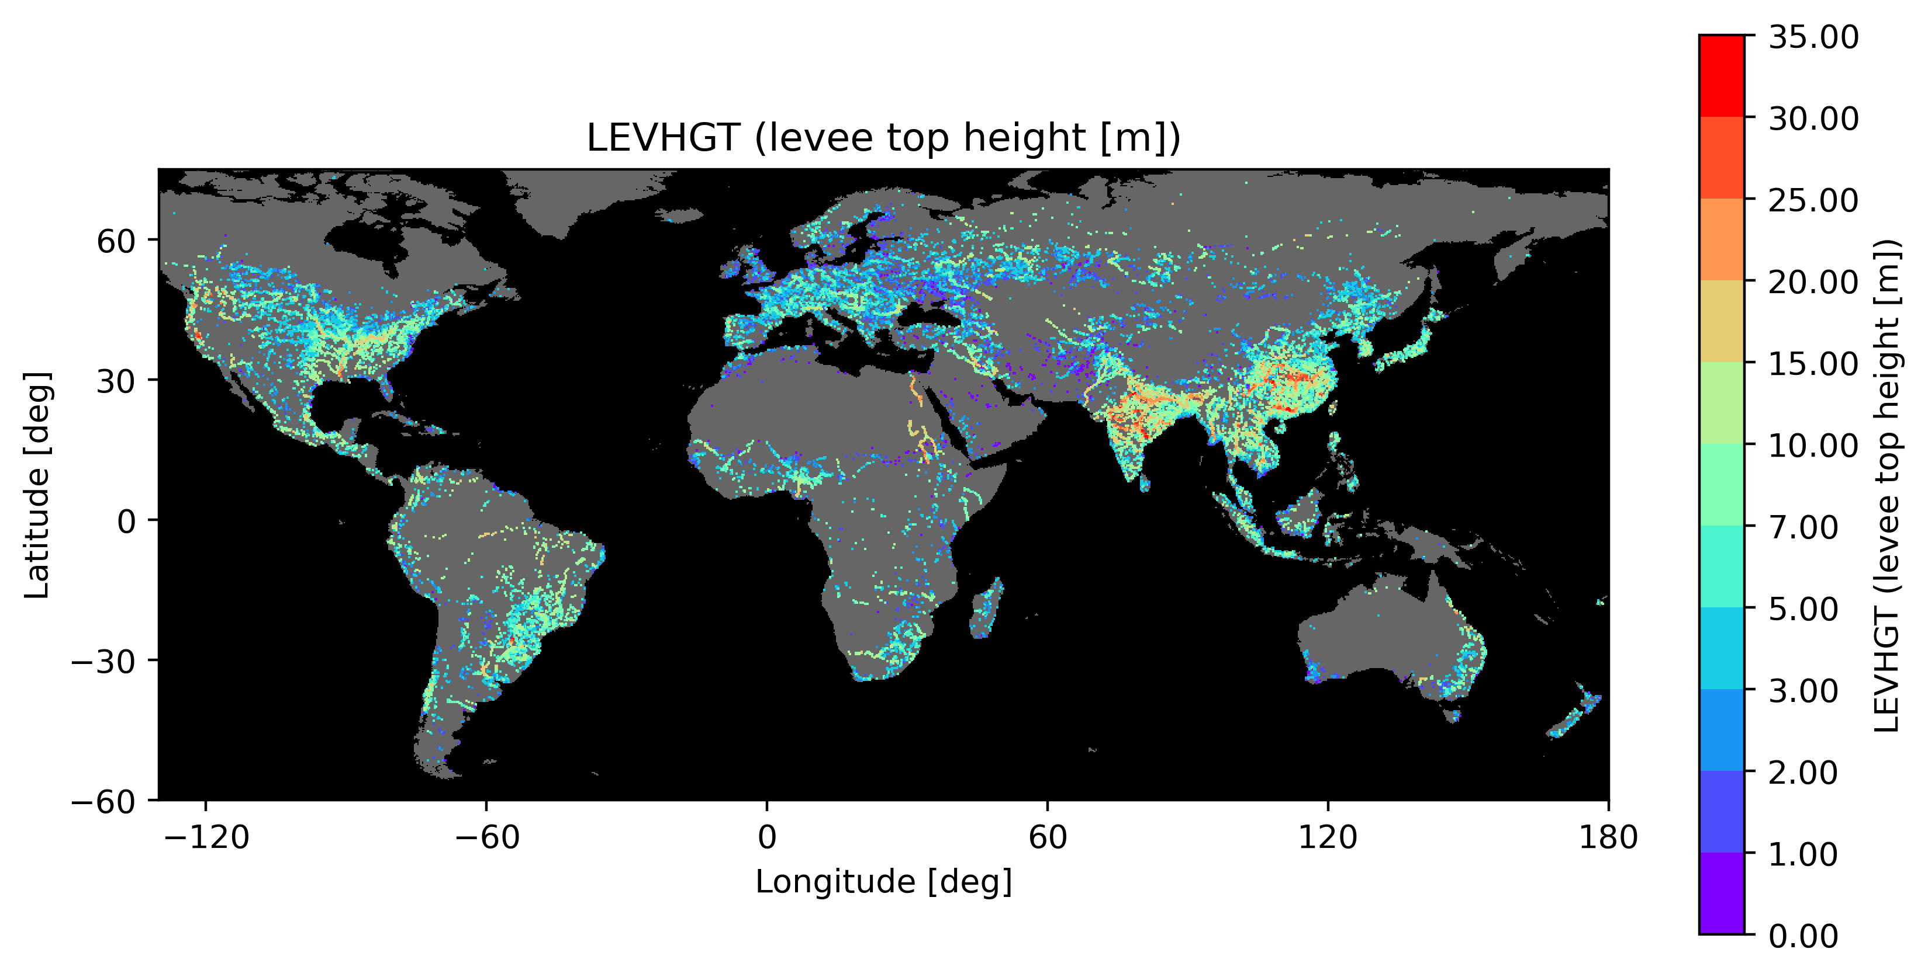
Figure: Levee Crown Height (LEVHGT)

- LEVPHYHGT (levphyhgt.bin)
Physical levee height.
The effective structural height of the levee, calculated as:
- LEVPHYHGT = LEVHGT − LEVBASHGT
- where LEVBASHGT is the ground elevation at the levee base. Values ≤ 0 are treated as “no levee.”
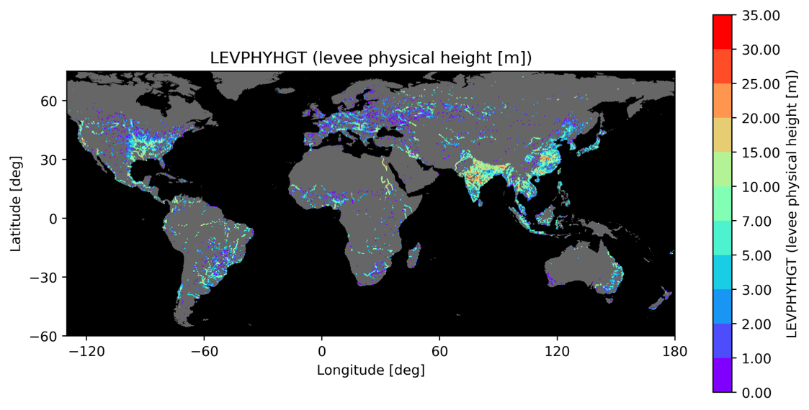
Figure: Levee Physical Height (LEVPHYHGT)

A land–sea mask is drawn using uparea.bin, allowing clear visual distinction between land areas (rivers and floodplains) and ocean cells. is drawn using uparea.bin, allowing clear visual distinction between land areas (rivers and floodplains) and ocean cells.

Appendix — Detailed Algorithms
- A1. calc_levfrc.F90 — full mapping logic and mainstem detection
- A2. FLOPROS resampling — resolution ratio and masking
- A3. calculate_levhgt.py — annual maxima + Gumbel (L-moments)
- A4. calc_baseheight.py — floodplain layer structure and storage integration
- A5. visualize.py — thickening + discrete colormap rules

Appendix 1. Overview of calc_levfrc.F90
The step-1 script s01-calc_levee_fraction.sh calls Fortran90 code calc_lkevfrc.F90.
Note: The Fortran90 code in src/ directory should be compiled in advance, for example using make all.
calc_levfrc.F90 computes the levee-related parameters needed for the CaMa-Flood levee scheme, mainly:
- LEVFRC (levfrc.bin) – levee unprotected fraction
- Initial LEVHGT (levhgt_sim00.bin) – initial “infinite” levee height
The program aggregates high-resolution levee distance data onto the coarse CaMa-Flood unit-catchment grid.

A1.1 Inputs

(1) Command-line arguments
Command-line arguments are specified by s01-calc_levee_fraction.sh.
- High-resolution map resolution (e.g., 1min, 30sec)
- Levee distance list (levlist)
- Contains levee distances at fine resolution:
- lat lon drainage_area[km2] distance_to_levee[m] class
- Resolution of levee list (e.g., 3sec)
- River width file (rivwth_gwdlr.bin)

(2) CaMa-Flood map files
- uparea.bin – upstream drainage area
- ctmare.bin – catchment area
- rivlen.bin – channel length
- rivwth.bin – river width
- class.bin – land/river mask
- High-resolution mapping files catmxy, uparea (e.g. in glb_15min/1min/ directory.)
These allow mapping fine-resolution levee distance pixels to CaMa-Flood unit-catchments.

A1.2 Outputs
- levfrc.bin
Levee unprotected fraction (0–1)
  - 0.0 → levee close to channel
  - 1.0 → levee absent or very far
  - −9999 → ocean or no levee information
- levhgt_sim00.bin
Initial levee height (typically 100 m for levee cells)
- Diagnostic files
  - tmp/levfrc_stat.txt – levee statistics
  - tmp/tmp.bin – intermediate data dump

A1.3 Algorithm Overview

Step 1 — Mainstem identification
Mainstem pixels on high-resolution grid are identified using an upstream-area ratio threshold:
area_highres > 0.5 × uparea(unit-catchment)
These pixels form the reference for levee detection.

Step 2 — Mapping levee pixels
For each levee-list point:
- Convert (lon, lat) → high-res grid index (ix,iy)
- Map to its CaMa-Flood unit-catchment (iXX,iYY) using high-res catchment ID (catmXX, catmYY) data.
- Check if pixel lies on mainstem
- Count levee pixels, excluding lakes/ice (class=1,6)

Step 3 — Compute levee-protected ratio
lev_ratio = num_levee_pixels / (mainstem_pixels × resolution_ratio)
Used as a threshold to determine whether a levee exists in the catchment.

Step 4 — Compute average levee distance
Average distance of levee pixels:
avedst = sum(dist) / num
Minimum distance is constrained by half the river width.

Step 5 — Compute LEVFRC
If levee coverage exceeds thresholds:
LEVFRC = (2 × avedst) / (catchment_width)
catchment_width = ctmare / rivlen
Otherwise:
LEVFRC = −9999

Step 6 — Initial levee height
If LEVFRC indicates levee presence:
levhgt = 100.0 (m)
Else:
levhgt = 0.0 or −9999

Appendix 2. FLOPROS Resampling (conv_FLOPROS_resolution.py)
This module converts the FLOPROS 30‑second protection standard raster to the CaMa-Flood map grid. The method is intentionally simple because FLOPROS values are treated as categorical/nearest-neighbor variables.

A2.1 Inputs
- FLOPROS GeoTIFF (30 sec) — global protection level (return period).
- params.txt — defines CaMa-Flood grid (nx, ny, gsize, domain)
- uparea.bin — used as ocean mask (values = −9999 → ocean)

A2.2 Outputs
- protect.tif — FLOPROS regridded to CaMa resolution
- protect.bin — plain binary (float32) in GRaDS order (north→south, west→east)

A2.3 Algorithm Overview
- Read CaMa-Flood grid definition from params.txt (nx, ny, grid size, domain extent).
- Open source FLOPROS GeoTIFF and extract its georeferencing (pixel size, origin).
- Integer-factor decimation (nearest-neighbor slicing):
- step_x = target_gsize / source_dx
step_y = target_gsize / |source_dy|
dst = src[:, row0: : step_y, col0: : step_x]
- No reprojection is performed.
- Apply ocean mask using uparea.bin:
  - Cells where uparea == −9999 are assigned −9999 in both TIFF and BIN.
- Write GeoTIFF using the CaMa grid transform (Affine object).
- Write plain binary for band 1 in GRaDS-compatible order.
This simple resampling ensures FLOPROS protection values are transferred consistently to the CaMa-Flood grid without introducing interpolation artifacts.

Appendix 3. Calculate Levee Height (calculate_levhgt.py)
This module computes the final levee crest height (LEVHGT) using CaMa‑Flood simulation outputs and protection standards (FLOPROS). This Python script is called from Step-3 and Step-4 shell scripts: s03-cycle_sim00.sh and s04-cycle_sim01.sh
It follows a four‑step workflow.

A3.1 Inputs
- CaMa-Flood simulation output (rivdph) for multiple years (bin or NetCDF)
- Levee unprotected fraction (levfrc.bin)
- River base depth / normal water depth (rivhgt.bin)
- Protection level map (protect.tif, return-period map)
- Map parameters (params.txt)

A3.2 Outputs
- levhgt.bin — final levee crest height (m)
- Intermediate files (annual maxima, probabilistic depth, masked depth) stored in: simXX_calc/

A3.3 Algorithm Overview

Step 1 — Annual maximum river depth
For each simulation year:
- Read daily river depth (rivdph).
- Compute the annual maximum for each grid cell.
- Save as annual_max_*.nc.

Step 2 — Extreme value analysis (Gumbel distribution)
- Collect annual maxima time series for each grid cell.
- Fit Gumbel distribution using L‑moments.
- For each cell, compute the river depth corresponding to its protection level:
- depth_RP = Gumbel_PPF(1 − 1/RP)
- Save as probabilistic depth (2_probabilistic_depth.bin).

Step 3 — Apply levee mask
Use levfrc.bin to keep only levee cells:
masked_depth = probabilistic_depth (if levfrc > 0)
masked_depth = -9999 (otherwise)

Step 4 — Subtract normal river depth to obtain levee crest height
Final levee height is the excess above normal river depth:
LEVHGT = masked_depth − rivhgt
Post‑processing:
- Negative values → 0
- Sea (rivhgt = -9999) → LEVHGT = -9999
The output is written to:
simXX_calc/levhgt.bin
This completes the derivation of levee crest height for each CaMa‑Flood simulation cycle.

Appendix 4. Calculate Levee Base Height (calc_baseheight.py)
This module computes levee base elevation and storage-related parameters using CaMa-Flood floodplain geometry.
This is optional calculation to estimate all levee‑scheme static parameters internally calculated within CaMa-Flood simulations.

A4.1 Inputs
- params.txt — nx, ny, NLFP (number of floodplain layers)
- grdare.bin — grid-cell area [m²]
- rivlen.bin — river-channel length [m]
- rivwth.bin — river width [m]
- rivhgt.bin — riverbed reference elevation (sea = −9999)
- fldhgt.bin — floodplain node heights (NLFP layers)
- levfrc.bin — fractional levee position (0–1)
- levhgt.bin — levee crest height above riverbed

A4.2 Outputs
- levdst.bin — average distance from river to levee [m]
- levbashgt.bin — levee base ground height [m]
- levphyhgt.bin — physical levee height (= LEVHGT − LEVBASHGT) [m]
- levhgt_mod.bin — levee height with invalid levees masked to −9999 (where LEVHGT < LEVBASHGT)
- levbassto.bin — river‑side storage at levee base [m³]
- levtopsto.bin — river‑side storage at levee crest [m³]
- levfilsto.bin — total storage at levee crest (both sides) [m³]

A4.3 Algorithm Overview

Step 1 — Read map geometry and floodplain profile
- fldhgt provides a layered representation of floodplain height.
- Floodplain width increments:
- DWTHINC = GRDARE / RIVLEN / NLFP
- Compute cumulative storage (FLDSTOMAX) and height gradient (FLDGRD) for each layer.

Step 2 — Compute levee distance (LEVDST)
Levee distance from channel centerline:
LEVDST = LEVFRC × DWTHINC × NLFP = LEVFRC × (GRDARE / RIVLEN)

Step 3 — Determine levee base elevation (LEVBASHGT)
- Identify which floodplain layer contains the levee base:
- ILEV = floor(LEVFRC × NLFP) + 1
- Interpolate height within the layer using slope:
- dhgtnow = (horizontal offset) × FLDGRD
LEVBASHGT = dhgtnow + lower_node_height

Step 4 — Compute river‑side storage
- At levee base (LEVBASTO): integrate river width + partial floodplain width.
- At levee top (LEVT0PSTO): extend storage up to levee crest height.

Step 5 — Compute total storage including protected side (LEVFILSTO)
Find the layer containing the levee crest height:
while h_lev > FLDHGT(layer): move to next layer
Then calculate additional floodplain storage above river‑side area.

Step 6 — Compute physical levee height (LEVPHYHGT)
LEVPHYHGT = LEVHGT − LEVBASHGT
Cells where this value ≤ 0 are treated as “no levee.”

Step 7 — Mask invalid cells
Cells are set to −9999 when:
- Sea (rivhgt == −9999)
- No levee (levhgt ≤ 0 or levphyhgt ≤ 0)
Resulting parameters are written as binary float32 files for CaMa-Flood.

Appendix 5. Visualization (visualize.py)
This module provides simple visualization of key levee-scheme parameters. The script outputs static PNG maps for LEVFRC, LEVHGT, and LEVPHYHGT, over a land–sea background.

A5.1 Inputs
- levfrc.bin — levee unprotected fraction
- levhgt.bin — levee crest height
- levphyhgt.bin — physical levee height
- uparea.bin — land/sea mask (uparea > 0 → land)
- params.txt — grid domain and extent

A5.2 Outputs
Saved to the image/ directory:
- levfrc.png — fractional levee position (thickened)
- levhgt.png — levee crest height (discrete classes)
- levphyhgt.png — physical levee height (discrete classes)

A5.3 Algorithm Overview

(1) Land–sea mask
Using uparea.bin:
land = uparea > 0 (gray)
sea = -9999 (black)
This is used as the background layer.

(2) 2×2 Thickening for levee-related rasters
To enhance visibility of narrow levee sections, a 2×2 expansion is applied:
- Each pixel expands to a 2×2 block.
- When overlaps occur, the pixel with larger upstream area is preferred (mainstem priority).
- Applied to LEVFRC, LEVHGT, LEVPHYHGT.

(3) Color classification
- LEVFRC uses discrete fractions:
- [0.00, 0.01, 0.02, 0.03, 0.04, 0.05, 0.10, 0.20, 0.30, 0.50, 1.00]
- LEVHGT and LEVPHYHGT use height classes:
- [0, 1, 2, 3, 5, 7, 10, 15, 20, 25, 30, 35] (m)

(4) Map extent and cropping
To focus on populated regions:
lon range: -130 → 180
aut range: -60 → 75
The map is cropped after rendering.

(5) Rendering
A generic plot_variable() routine handles:
- background rendering
- variable overlay
- cropping

