[Style = Title]
Writing Documents with Style

[ Style = Subtitle ]
26 March, 2024
Dai Yamazaki IIS U-Tokyo
By using this format, you can write a documents which as well structured visually impressive.
It is also possible to convert the MS Word document to Markdown format using pandoc.

From Markdown to DOCX
pandoc target.md -o target.docx --reference-doc=WordStyleTemplate.docx --lua-filter=style-cmf.lua
or
conv_md2docx.sh target.md target.docx

From DOCX to Markdown
pandoc target.docx -t gfm --lua-filter=style-cmf.lua --extract-media=media -o output.md
or
conv_docx2md.sh

[Style = Header #1] Use of Header Level
Please use appropriate Header Level to better structure your document (Chapter, Section, Sub-section, etc)

Style = Header #2: Section
Please think about how to organize Chapter, Section, Sub-section, Items, Sub-items
One Chapter can contain multiple Section,

Style = Header #3: Sub-Section 1
One Section can contain multiple Sub-Section,

Style = Header #3: Sub-Section 2
You can also list items using deeper header level

Style = Header #4: Items 1
If you need to explain about multiple items, using Header #4 (sub-sub section) might work

Style = Header #4: Items 1
Header #5 can be user for further explanation.

Style = header #5 Explanation - 1
Write detailed explanation

Style = header #5 Explanation - 2
Write detailed explanation

CodeBlock
CodeBlock and InlineVariables are also available,
Test ABCDE
Test XYZ

Some text highlighting style is also included.
Below are samples.
- [Step-1] allocate river gauges to high-resolution river map (30sec for global or 5sec for Japan)
- [Step-2] calculate the corresponding grid on the coarse-resolution river map.
The high-resolution river maps (Global MERIT Hydro, Yamazaki et al. 2019; Japan J-FlwDir, Yamazaki et al. 2018) are prepared in this package. Users are expected to first allocate river gauges onto these maps.
Note: the optional code to allocate gauges without drainage area info is also available in this package. More advanced allocation for satellite altimetry gauge AltiMap (Revel et al. 2023) is also developed.
AltiMap: https://essd.copernicus.org/articles/16/75/2024/essd-16-75-2024.html
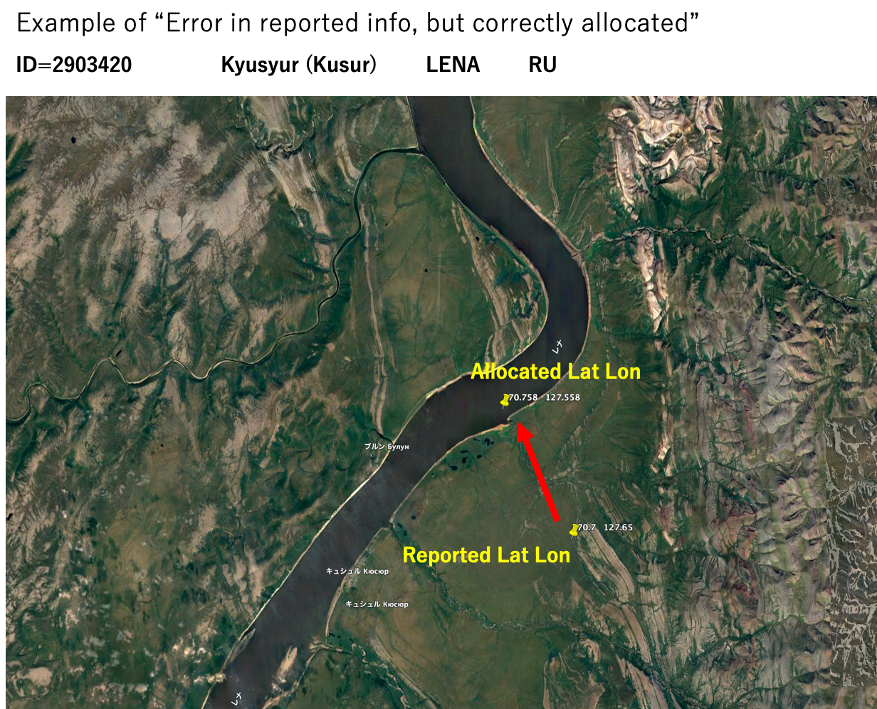
Figure: Example of river gauge allocation.

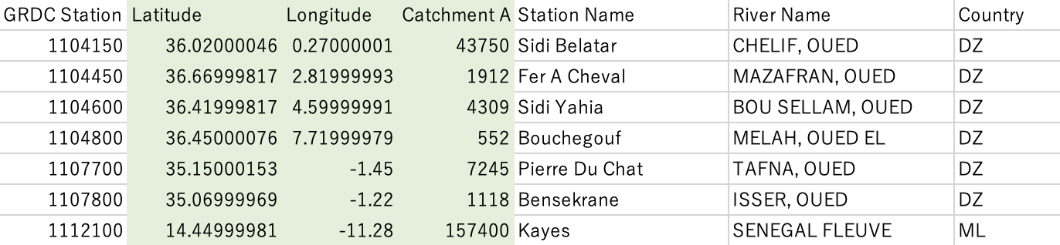
Figure: Example of input data (GRDC_original_2019.csv).

