**Description of “LIE_MaxStep.F90”**

Code to numerically measure maximum acceptable timestep for stable flow simulation using shallow water equation

Dai Yamazaki (University of Tokyo, yamadai@iis.u-tokyo.ac.jp)

Tomohiro Tanaka (Kyoto University, tanaka.tomohiro.7c@kyoto-u.ac.jp)

Code developed on 22Aug 2016

Documentation on 28Feb 2023

1. **Porpoise**

Estimation of maximum acceptable timestep is important to efficiently perform hydraulic and hydrodynamic simulations. However, theoretical estimation of the exact maximum acceptable timestep is complex when shallow water equation is used as a governing equation, because of the nonlinearity of the friction term. For the theoretical/mathematical analysis of the maximum acceptable timestep, knowing the “actual measured value” based on a precise flow simulation is helpful.

This code “LIE_MaxStep.f90” is developed to “numerically measure” the maximum acceptable timestep for shallow water equations (especially, local inertial equation form) for various simulation setting (e.g. slope, depth, friction). The maximum acceptable timestep is precisely measured by repeating simulations with different time steps for a given simulation setting.

1. **Simulation setting**

Flow simulation using local inertial equation for 10 cells on a constant slope is considered (Figure 1). The slope is given by ib, and the cell size is given by dx.

コンピューターの画面

Figure 1: Schematic diagram of simulation setting.

Local inertial equation is expressed by equation (1)

 (1)

where q is flow, g is gravity acceleration, h is water depth, and z is bed elevation, and if is friction slope.

Friction slope is expressed by Manning’s equation (2).

 (2)

where Manning’s roughness coefficient n is given as a parameter.

In simulation, initial depth (hini) should be specified. Then, the upstream initial inflow (qini) is calculated assuming that the initial water depth is uniform and stable for the simulation section (i.e. ).

The maximum acceptable timestep is measured by slightly perturbating the initial condition. The downstream water depth boundary condition is increased by 0.01% (in a default setting), and the upstream inflow boundary condition is modified in order to make the water depth of all cells after adequate time becomes same as the downstream boundary water depth. (i.e. when downstream water level becomes 1.0001 times as large as the initial condition, the inflow should be (1.0001)5/3 times as large as the initial inflow, according to Manning’s equation.

The simulation starts with this modified downstream and upstream conditions, for a specific time step dt. If the simulation is performed stably, the water depth of the all cells becomes equal to the downstream boundary water depth, and flow in all cells becomes equal to the upstream inflow. The error from these expected equilibrium condition is calculated at each calculation time. When the error becomes smaller than a threshold, the simulation is judged to be stable, and adapted dt is judged to be acceptable. Then, another simulation was performed using slightly larger timestep, and the maximum acceptable timestep is estimated.

1. **Experiment setting**

The code is designed to measure maximum acceptable timestep for a given experimental setting. As a default experiment setting, the maximum acceptable timestep is estimated for different spatial resolution dx when other parameters (slope, roughness, depth) are fixed. This experimental setting (which parameters to be variable) can be changed by modifying lines 83-97.

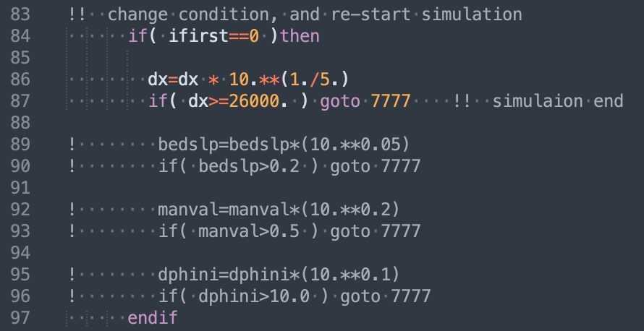

The initial condition (dx, depth, slope, roughness) can be modified in lines 74-77.

黒い背景に白い文字がある

The detailed flow scheme can be modified in the subroutine calc_rivout. For example, the use of Semi-implicit depth and flow cam ne specified in lines 318-345.

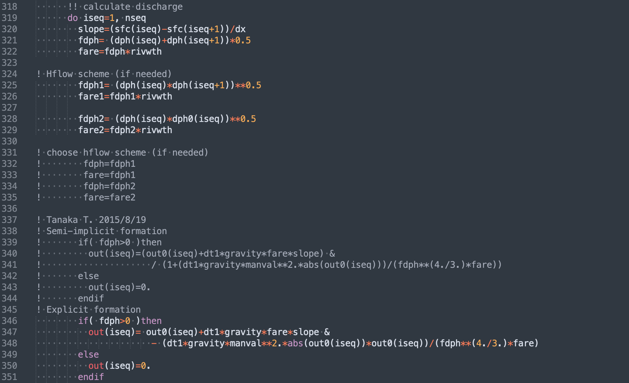

The output of the code is in text format, and it summarize the maximum acceptable timestep (max_dt) along with some parameters (CFL time step, Froude number, discharge) for a given simulation setting.

1. **Related documents**
2. Yamazaki D, Tanaka T, Bates PD (2015): Rapid and Stable Flood Inundation Modelling Using the Local Inertial Equation, J. Japan Soc. Hydrol. and Water Resour. 28(3)

<https://doi.org/10.3178/jjshwr.28.124>

(Technical note in Japanese with English abstract)

1. Tanaka T, Yoshioka H. (2017): Numerical stability analysis of the local inertial equation with semi- and fully implicit friction term treatments: assessment of the maximum allowable time step. Journal of Advanced Simulation in Science and Engineering 4(2): <https://doi.org/10.15748/jasse.4.162>
2. Tanaka T, Yoshioka H, Siev S, Fujii H, Ly S, Yoshimura C. (2019): A consistent finite difference local inertial model for shallow water simulation. Hydrological Research Letters 13(2): 34-40.

<https://doi.org/10.3178/hrl.13.28>