**Beacon Flash procedure**

## Initial Setup

Place 2*AA batteries into battery holder with the board with correct polarity(+ of battery to + of board). To flash the beacon please use windows (XP to windows 8).

## Getting SDK for beacon

1. Download and save the SDK installer application “*CSR_uEnergy_SDK”* on the development PC from FTP (me2u.qualcomm.com) server.

2. Run the SDK installer application from your download location.

## Flashing Application on Beacon

1. Connect shorter SPI cable between Target board and programmer.

2. Connect longer USB cable between programmer and free USB port on PC where you installed the SDK.

3. Uncompress the beacon.zip project. The folder contains beacon.c file which will be flashed on beacon.

4. In SDK open projects → apps → beacon project application. Move given beacon.c file from downloaded beacon.zip project in beacon folder.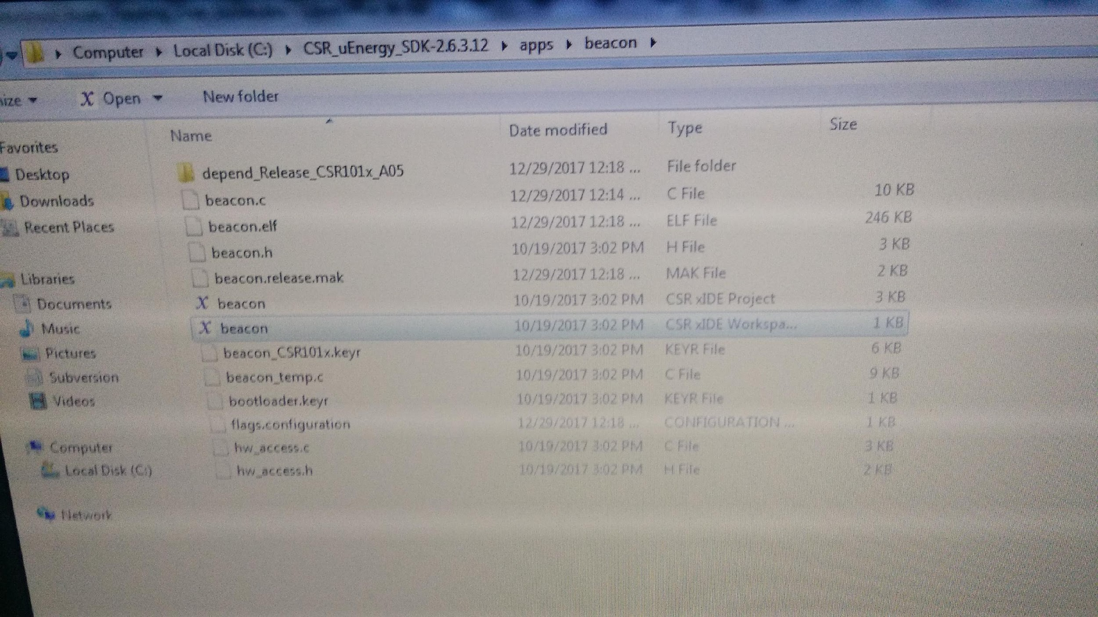

Image – Build project screen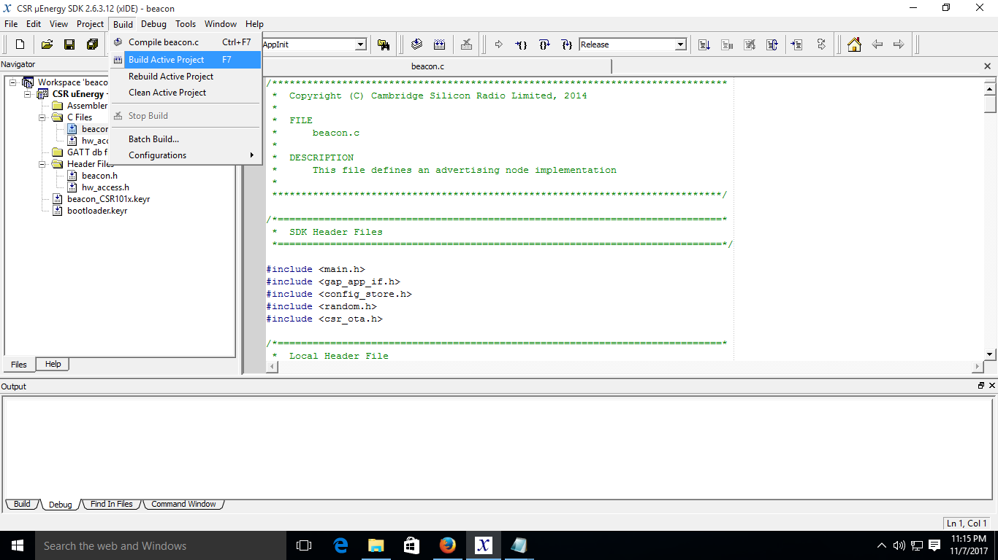

5. Build and run the project. After successful build board will be flashed with the project binary.

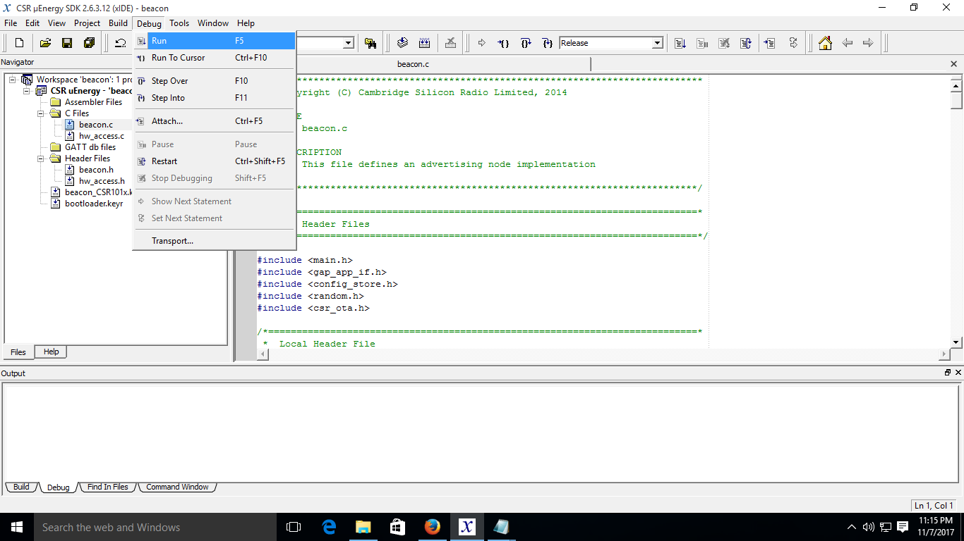

Image – Run project screen

**Gateway Application**

1. Remove existing gateway folder in /home/linaro (Assuming your home path is /home/linaro) folder.

$> rm -rf gateway/

2. Uncompress gateway.zip file in /home/linaro path.

$> unzip gateway.zip

3. The gateway should have working internet connection (so that it will push message to cloud).

4. Switch to root user by executing following command.

$> sudo su

5. Move to the folder where the gateway application resides

$> cd /home/linaro/gateway

6. Now, Please execute the following command to start the gateway application.

$> hciconfig hci0 reset

$> ./bt_scan