Pollution control Board

**1-**

[**http://pcbh.gissoft.net/pollution/regpulldata**](http://pcbh.gissoft.net/pollution/regpulldata)

(Display necessary value for registration page like districts and state)

**Notice: Use GET request**

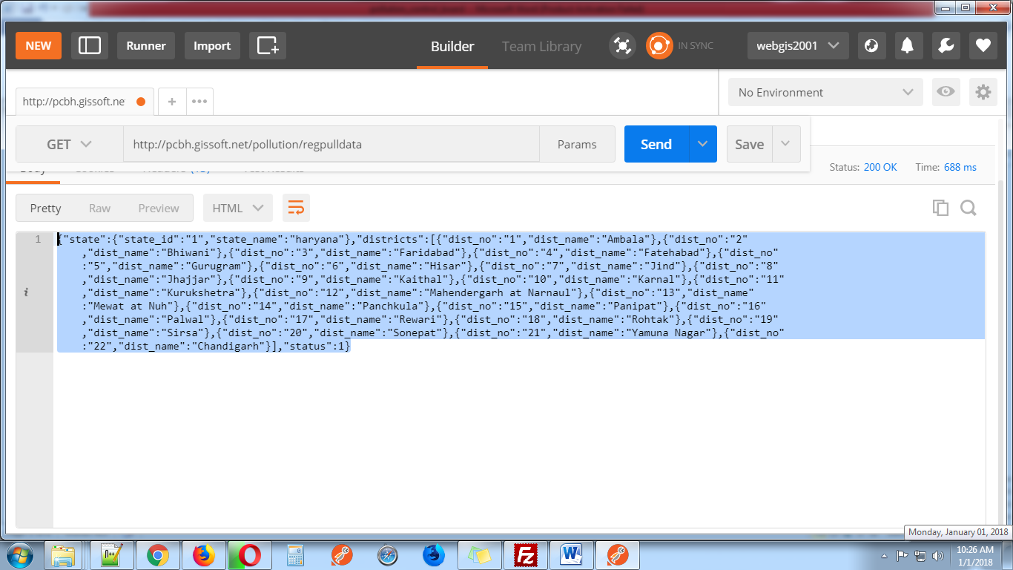

**2-** [**http://pcbh.gissoft.net/pollution/registration**](http://pcbh.gissoft.net/pollution/registration)

(This web service use for member registration this web service use these parameter)

**1-** **organization (pass organization name)**

**2- applicant_name (pass user name)**

**3- father_name (pass user father name)**

**4- address1 (pass user address)**

**5- address2 (pass user second address)**

**6- state(pass state id) (get from first web services)**

**7- district (pass district id)**

**8- applicant_email (pass user email)**

**9- applicant_mobile (pass user mobile number)**

**10- gender (pass member gender)(format: M/F)**

**11-device_token (pass mobile device token)**

**Notice: Send all these parameters with POST request**

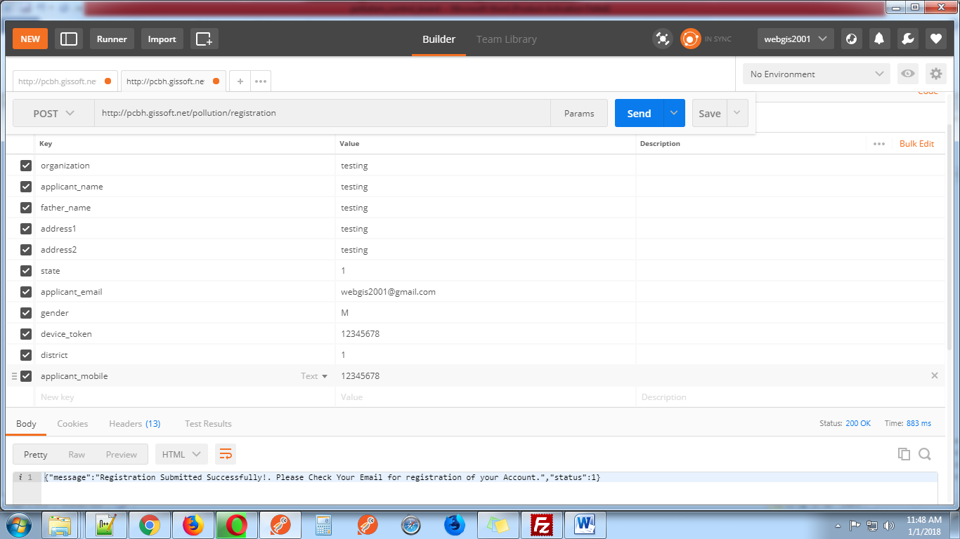

**3-**

[**http://pcbh.gissoft.net/pollution/login**](%20http://pcbh.gissoft.net/pollution/login)

This web services use for login. This web services use these parameter.

**1-** **applicant_email_or_name (Pass user email address or name which send in user email id)**

**2-** **applicant_password (Pass user password)**

**3-** **device_token (Pass device token )**

**Notice: Send these three parameters with POST request**

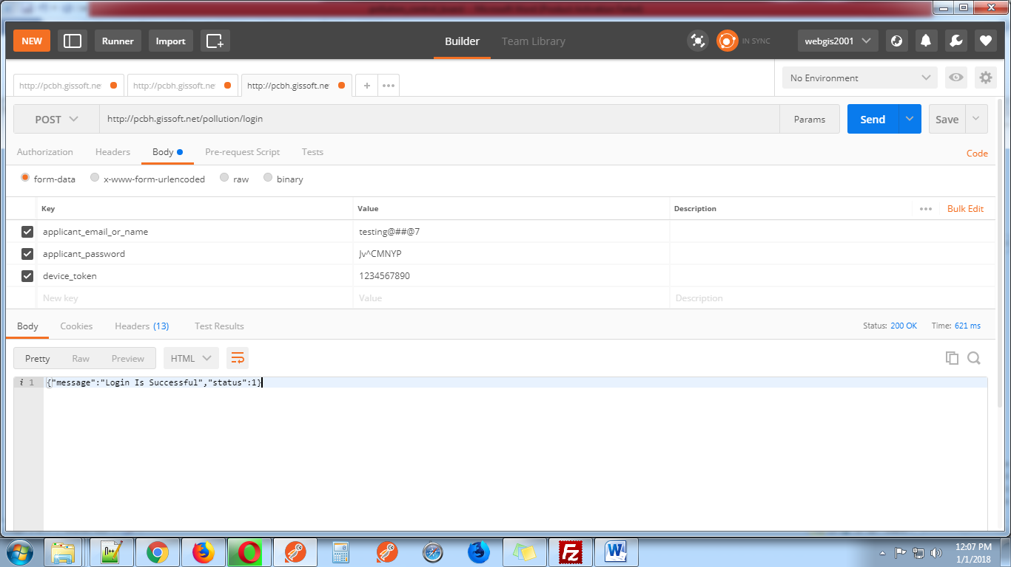

**4-**

[**http://pcbh.gissoft.net/pollution/forget_password**](%20http://pcbh.gissoft.net/pollution/forget_password)

This web services use for forget password. This web services use one parameter.

1. **applicant_email (Pass user email address)**

**Notice: Send parameter with GET request**

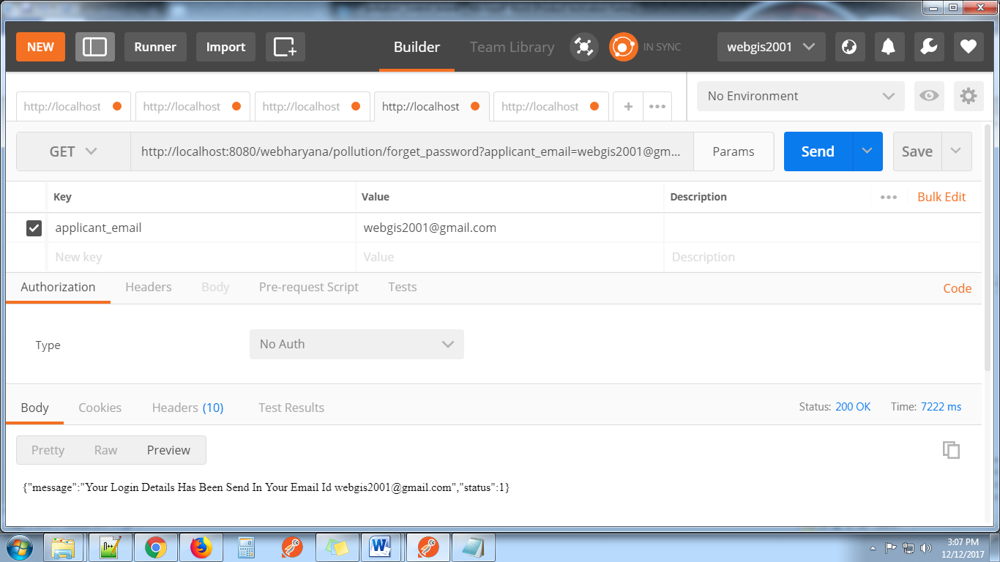

**5-**

[**http://pcbh.gissoft.net/pollution/user_profile**](%20http://pcbh.gissoft.net/pollution/user_profile)

This web services use for display user profile. This web services use two parameters.

1. **applicant_email_or_name (Pass User Email address or User Name which send in user email id)**
2. **device_token(Pass Device Token )**

**Notice: Send both parameters with GET request**

This web services display user details like email id, state, district, organization, name, father name, mobile number, address1,address2,gender

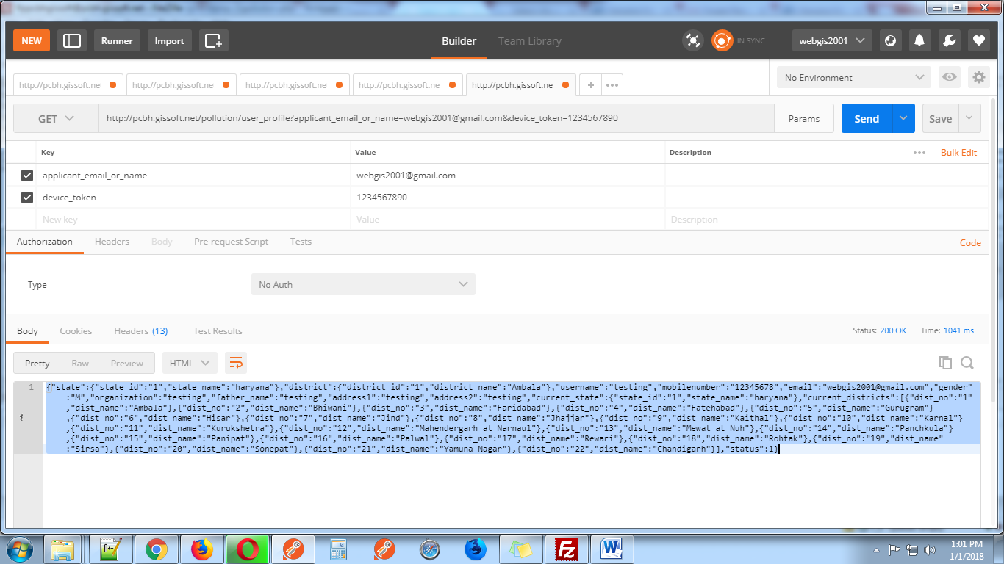

**6-**

[**http://pcbh.gissoft.net/pollution/update_user_profile**](%20http://pcbh.gissoft.net/pollution/update_user_profile)

This web services use for update user profile. This web services use these parameters.

1. **applicant_email_or_name(Pass User Email address or User Name which send in user email id)**
2. **device_token**
3. **district_id**
4. **applicant_name**
5. **applicant_mobile**
6. **gender**
7. **organization**
8. **father_name**
9. **address1**
10. **address2**

**Notice: Send these parameters with POST request. Display user email is not editable.**

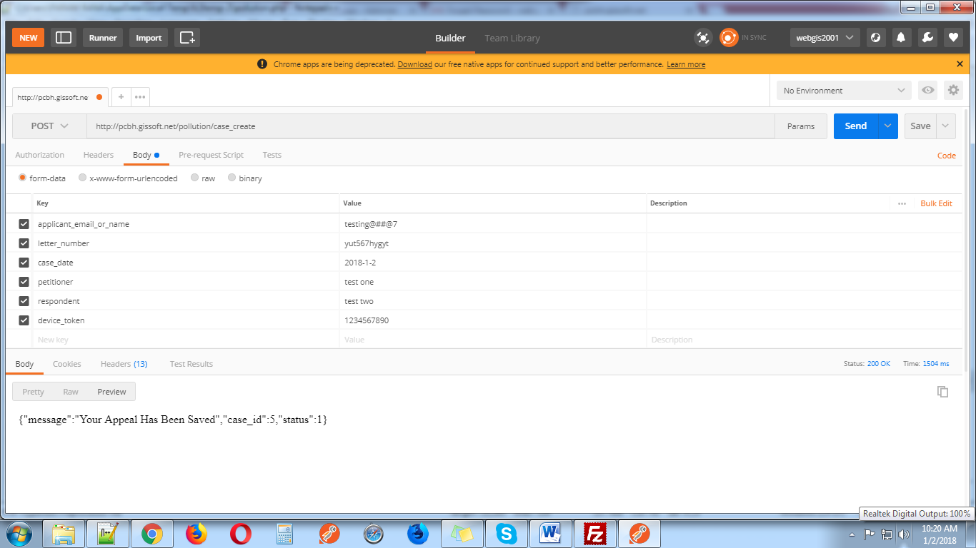

**7-**  [**http://pcbh.gissoft.net/pollution/case_create**](%20http://pcbh.gissoft.net/pollution/case_create)

This web services use for send user Appeal. This web services use these parameters.

1. **applicant_email_or_name (Pass User Email address or User Name which send in user email id)**
2. **device_token**
3. **letter_number (Pass Unique Letter Number)**
4. **case_date (Pass Appeal Date)**
5. **petitioner (Pass petitioner name)**
6. **respondent (Pass respondent name)**

**Notice: Send these parameters with POST request. After send request user got case_id in response.This case_id use for upload attachment.**

**{"message":"Your Appeal Has Been Saved","case_id":1,group_id:3,"status":1}**

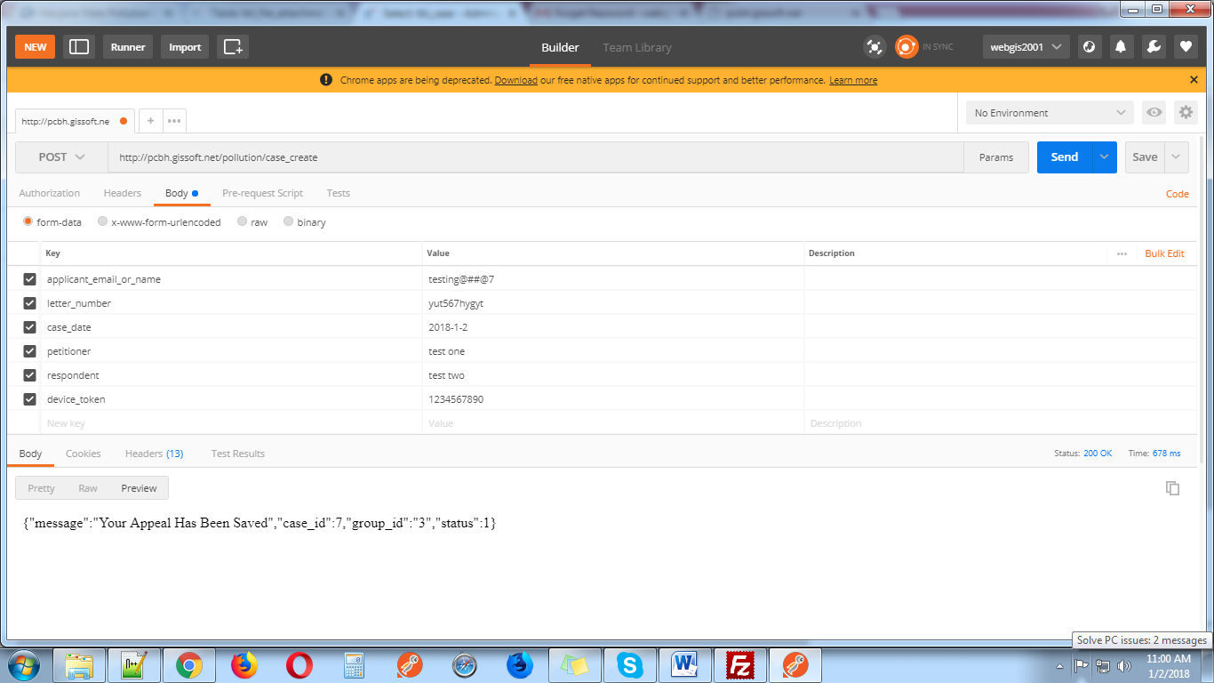

**8-**  [**http://pcbh.gissoft.net /pollution/upload_attechment**](http://localhost:8080/webharyana/pollution/upload_attechment)

This web services use for upload PDF file. This web services use these parameters.

1. **applicant_email_or_name**
2. **device_token**
3. **case_id**
4. **appeal_pdf**

**Notice: Send these parameters with POST request with case_id which get from previous request.**

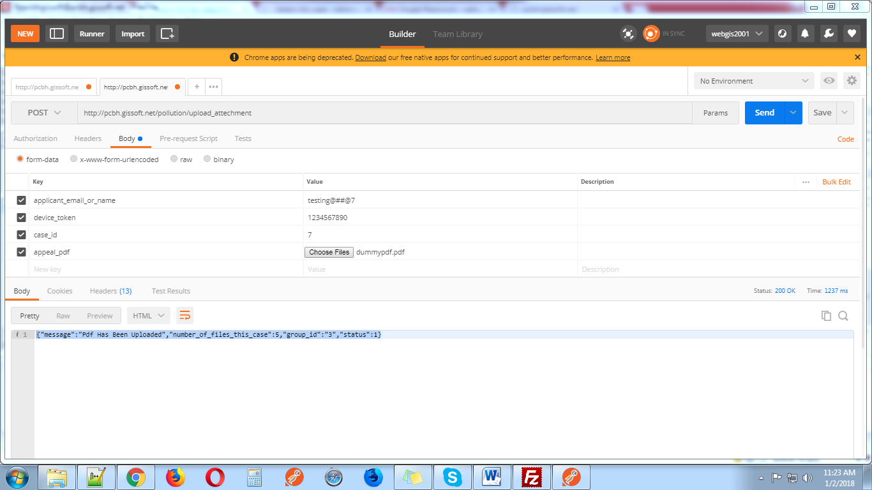

**9-** [**http://pcbh.gissoft.net/pollution/appeal**](http://pcbh.gissoft.net/pollution/appeal)

This web services display case with permission for

1-Super admin can manage all case. He can view, saw attachments, edit ,Assign, Hearing, Dispose Off and Decided the case

2-Admin can work on those case which assign by super admin. He can view, saw attachments, Hearing, Dispose Off and Decided the case

3-Use can view his case and edit case when case status in pending.

This web services use five parameters. These parameters pass with get request.

1. **applicant_email_or_name**
2. **device_token**
3. **group_id** (1 for super admin 2 for admin 3 for user)
4. **offset(for limit first time pass 0)**
5. **limit(for display number of rows)**

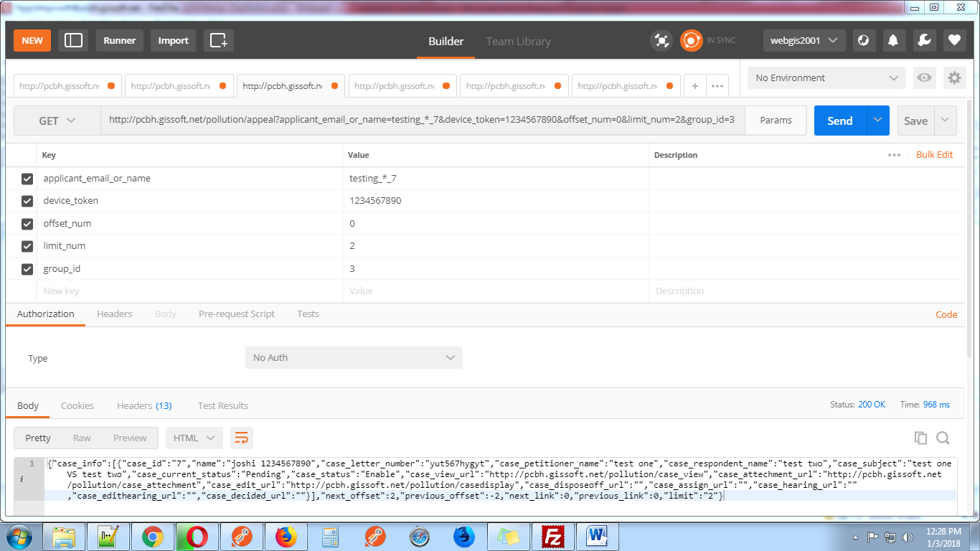

**10-** [**http://pcbh.gissoft.net/pollution/caseview**](http://pcbh.gissoft.net/pollution/caseview)

This web services display case with current status like assign details, hearing details etc.

Parameters details.

1. **applicant_email_or_name**
2. **device_token**
3. **group_id** (1 for super admin 2 for admin 3 for user)
4. **case_id**

These parameters pass with get request.

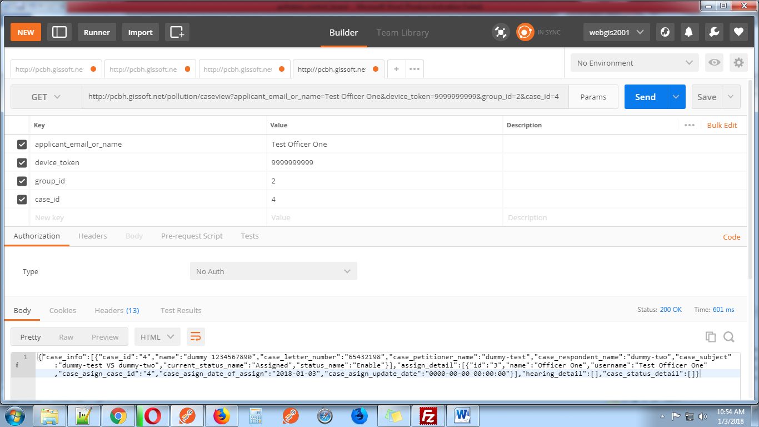

**11-** [**http://pcbh.gissoft.net/pollution/casedisplay**](http://pcbh.gissoft.net/pollution/casedisplay)

This web services display case information for edit when case is pending case edit by user and super admin.

Parameters details.

1. **applicant_email_or_name**
2. **device_token**
3. **group_id** (1 for super admin 2 for admin 3 for user)
4. **case_id**

These parameters pass with get request.

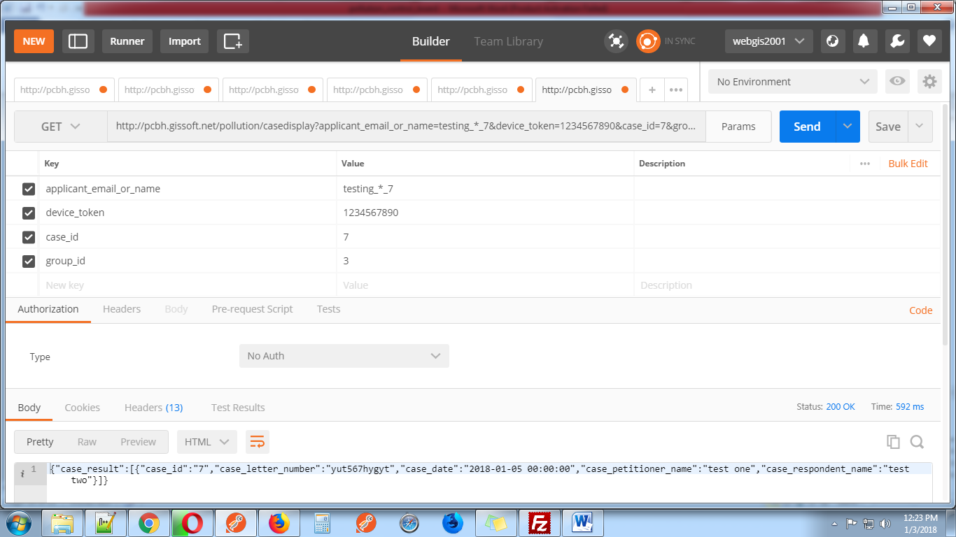

**12-** [**http://pcbh.gissoft.net/pollution/caseedit**](http://pcbh.gissoft.net/pollution/caseedit)

This web services use for edit case for pending case by user and super admin

Parameters details.

1. **applicant_email_or_name**
2. **device_token**
3. **group_id** (1 for super admin 2 for admin 3 for user)
4. **case_id**
5. **case_letter_number**
6. **case_petitioner_name**
7. **case_respondent_name**
8. **case_date**

These parameters pass with post request.

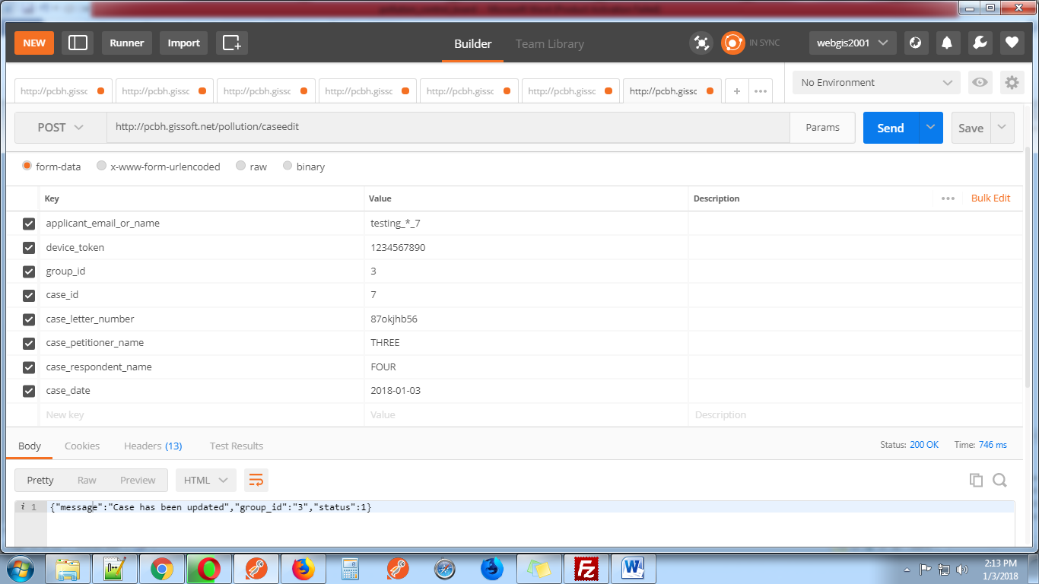

**13-** [**http://pcbh.gissoft.net/pollution/caseattechment**](http://pcbh.gissoft.net/pollution/caseattechment)

This web services display case attachment

Parameters details.

1. **applicant_email_or_name**
2. **device_token**
3. **group_id** (1 for super admin 2 for admin 3 for user)
4. **case_id**

These parameters pass with get request.

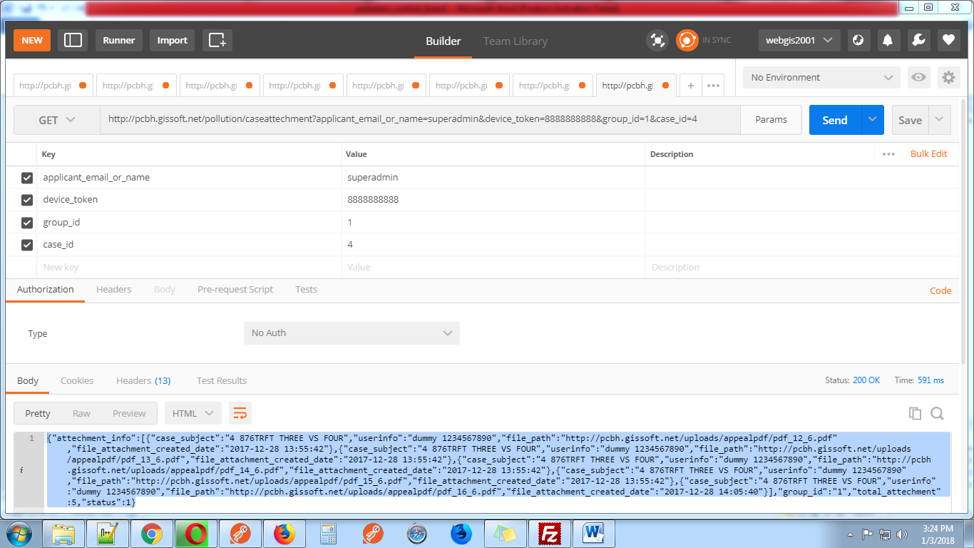

**14-**[**http://pcbh.gissoft.net/pollution/casedisposeoff**](http://pcbh.gissoft.net/pollution/casedisposeoff)

This web services display case info for dispose_off page like case subject (case_id, letter number, subject) and officer name.

Parameters details.

1. **applicant_email_or_name**
2. **device_token**
3. **group_id** (1 for super admin 2 for admin 3 for user)
4. **case_id**

These parameters pass with get request.

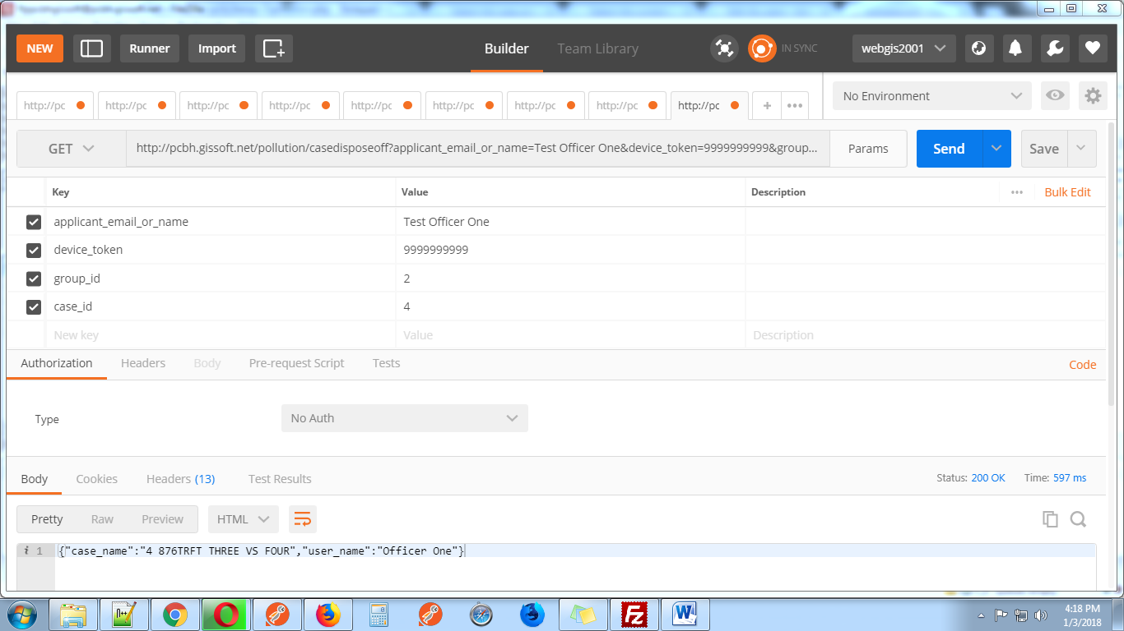

**15-**[**http://pcbh.gissoft.net/pollution/casedecided**](http://pcbh.gissoft.net/pollution/casedisposeoff)

This web services display case info for decided page like case subject (case_id, letter number, subject) and officer name. In this page Pdf Upload show with date and remark.

Parameters details.

1. **applicant_email_or_name**
2. **device_token**
3. **group_id** (1 for super admin 2 for admin 3 for user)
4. **case_id**

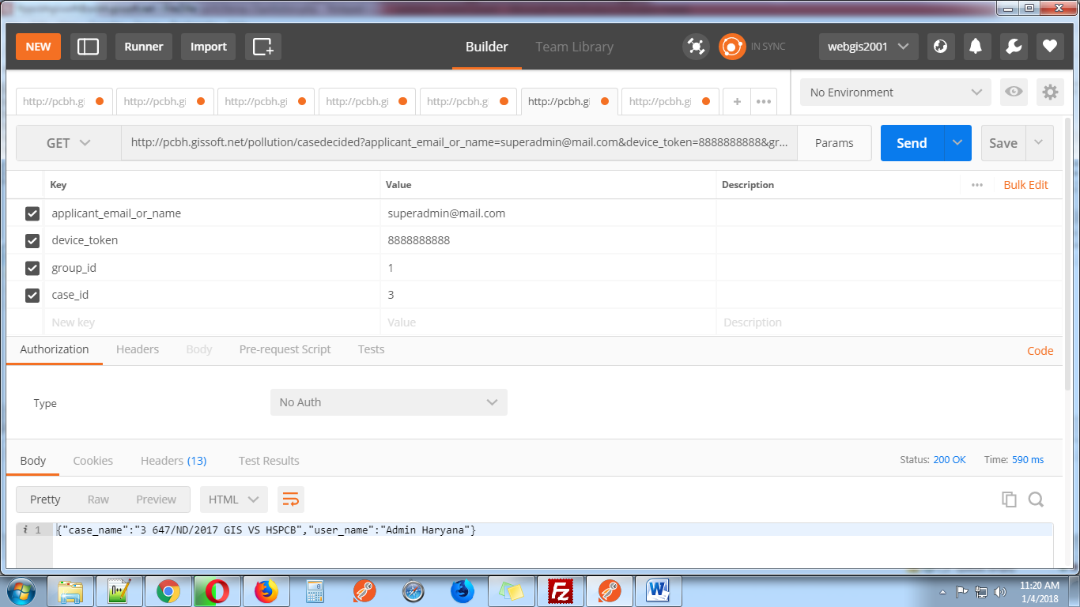

**16-** [**http://pcbh.gissoft.net/pollution/savedisposeoffandcasedecided**](http://pcbh.gissoft.net/pollution/savedisposeoffandcasedecided)

This web services use for action case disposeoff and case decided.

For disposeoff send these parameters with post request.

1. **applicant_email_or_name**
2. **device_token**
3. **group_id** (1 for super admin 2 for admin 3 for user)
4. **case_id**
5. **status_type(disposeoff)**
6. **date (YYYY-mm-dd format)**
7. **remark**

For decided send these parameters with post request.

1. **applicant_email_or_name**
2. **device_token**
3. **group_id** (1 for super admin 2 for admin 3 for user)
4. **case_id**
5. **status_type(decided)**
6. **date (YYYY-mm-dd format)**
7. **attachment(upload only pdf file with less then 5MB)**
8. **remark**

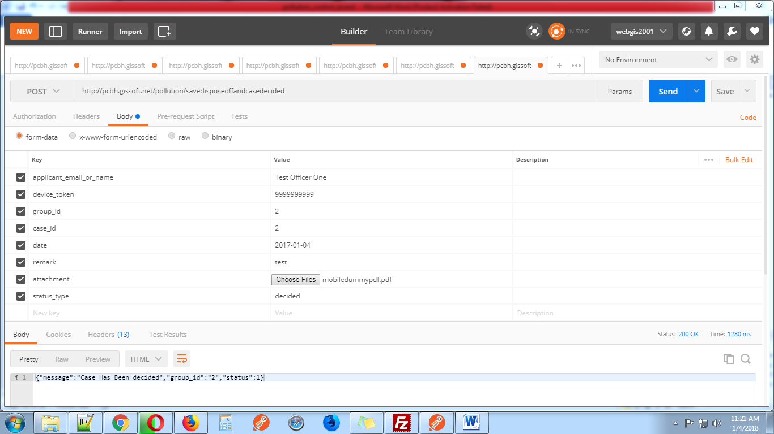

**17-** [**http://pcbh.gissoft.net/pollution/caseassign**](http://pcbh.gissoft.net/pollution/caseassign)

This web services use for display case assign page. This web services display case subject (case_id, letter_number, subject) and officers name with id.

Send these parameters with post request.

1. **applicant_email_or_name**
2. **device_token**
3. **group_id** (1 for super admin 2 for admin 3 for user)
4. **case_id**

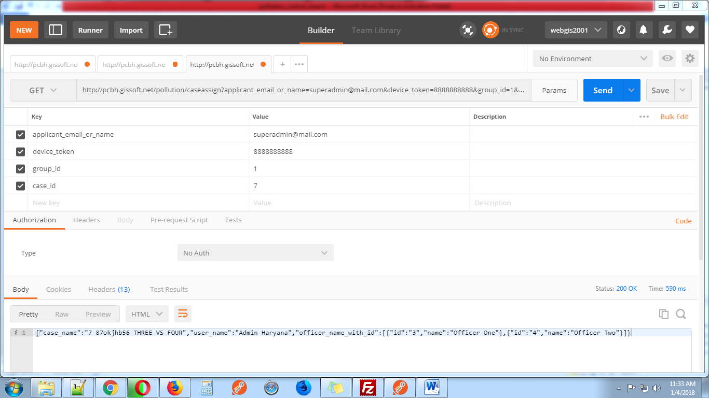

**18-** [**http://pcbh.gissoft.net/pollution/savecaseassign**](http://pcbh.gissoft.net/pollution/savecaseassign)

This web services use for action case assign by super admin

Send these parameters with post request.

1. **applicant_email_or_name**
2. **device_token**
3. **group_id** (1 for super admin 2 for admin 3 for user)
4. **case_id**
5. **officer_id(officer id send from** [**http://pcbh.gissoft.net/pollution/caseassign**](http://pcbh.gissoft.net/pollution/caseassign) **web services)**
6. **case_asign_date_of_assign(YYYY-mm-dd)**

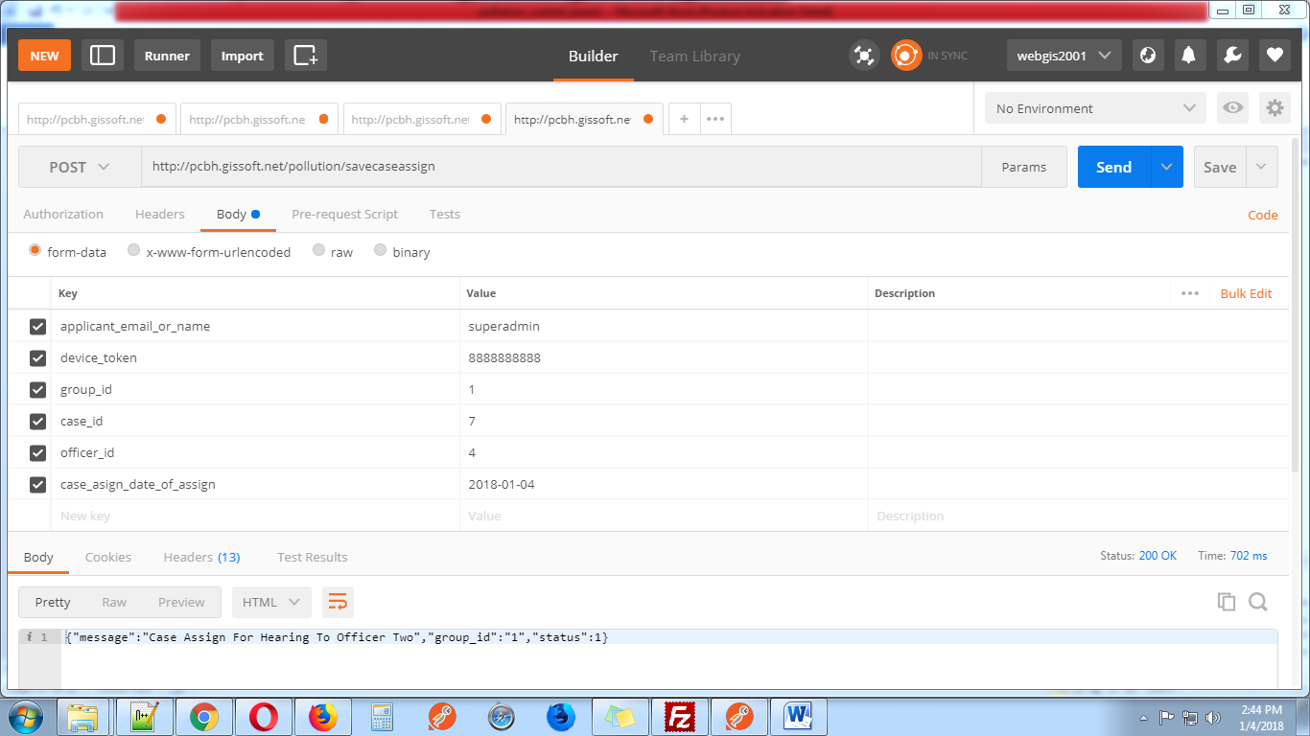

**19-** [**http://pcbh.gissoft.net/pollution/casehearing**](http://pcbh.gissoft.net/pollution/casehearing)

This web services use for display case hearing page. This web services display case subject (case_id, letter_number, subject) and officers name with id, case status with id and addresses with id.

Send these parameters with get request.

1. **applicant_email_or_name**
2. **device_token**
3. **group_id** (1 for super admin 2 for admin 3 for user)
4. **case_id**

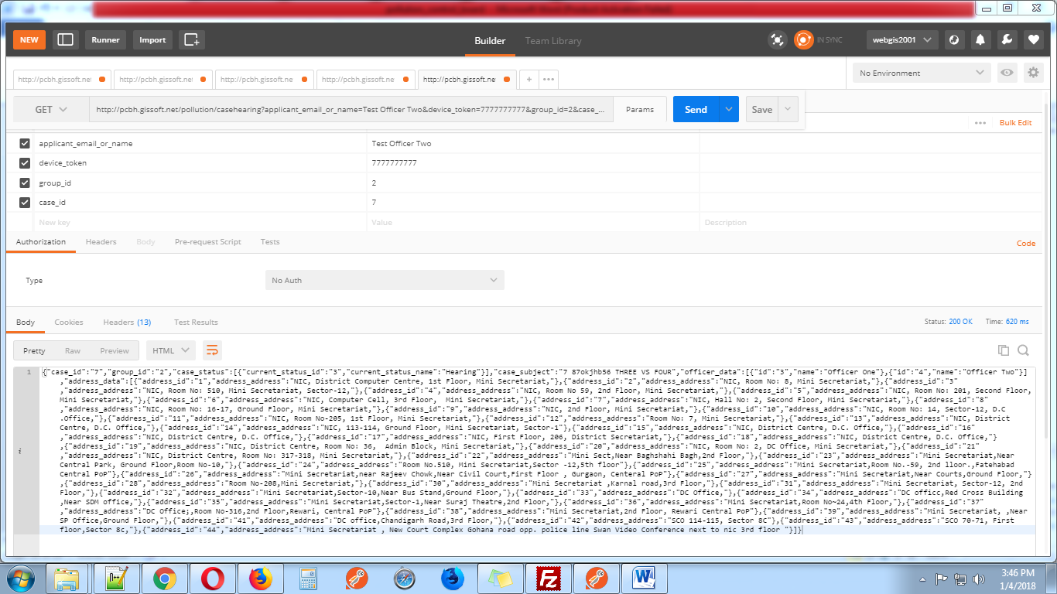

**20-** [**http://pcbh.gissoft.net/pollution/savecasehearing**](http://pcbh.gissoft.net/pollution/savecasehearing)

This web service use to assign case for hearing to officer this action do by super admin or admin

Send these parameters with post request.

1. **applicant_email_or_name**
2. **device_token**
3. **group_id** (1 for super admin 2 for admin 3 for user)
4. **case_id**
5. **current_status_id(pass hearing id 3 this id come from** [**http://pcbh.gissoft.net/pollution/casehearing**](http://pcbh.gissoft.net/pollution/casehearing)**)**
6. **officer_id (pass officer id this id come from** [**http://pcbh.gissoft.net/pollution/casehearing**](http://pcbh.gissoft.net/pollution/casehearing)**)**
7. **date (YYYY-mm-dd)**
8. **time_of_hearing (hh:mm:ss am/pm)**
9. **remark**
10. **address_id (pass address_id this id come from** [**http://pcbh.gissoft.net/pollution/casehearing**](http://pcbh.gissoft.net/pollution/casehearing)**)**

