Kitchen

Management

Development

Proposal

Prepared on: -17/07/2021

### Prepared by:

Manit Soni

### Prepared for:

Kishor Kumar

# Introduction

Hello sir

I am manit soni, I am website developer and I have more experience to develop website,softwares and mobile application, I am working many platform like windows, web and mobile.

I have done my graduate and master in IT field. And now I am developed this type of application to its very user friendly and easy to understand the customer.

Thanks again for the opportunity to earn your business!

Manit Soni

[manitsoni369@gmail.com](mailto:manitsoni369@gmail.com)

9737920098

Ahmedabad-382130

Gujarat,India

## BFAI

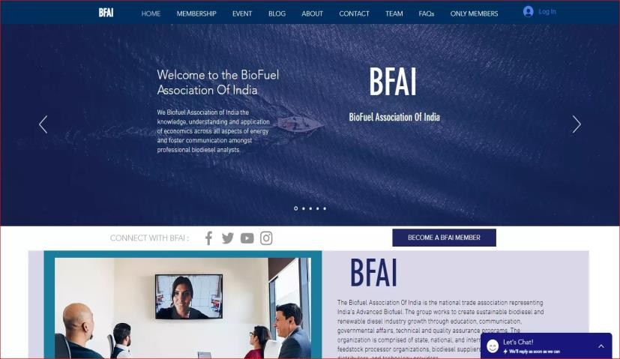The Biofuel Association Of India is the national trade association representing India’s Advanced Biofuel. The organization is comprised of state, national, and international feedstock and feedstock processor organizations, biodiesel suppliers, fuel marketers and distributors, and technology providers.

Link: <https://www.biofuelassociation.com/>

## Aloprof

You can schedule your classes with your private teacher online or in person, face-to-face classes are always better for you to learn in an easier and faster way.

Link: <https://aloprof.com.br/>

## FOOD ON WAY

online food ordering website similar to swiggy. This web is for single wender with differents of category with menues with user interface.

Link: [https://foodonway.com](https://foodonway.com/)

## App Structure

For now it will be similar to the application named “Flipkart”, later will discuss all the possibility and requirements in details

## Key Features

**Admin Panel:**

* Real Time Dashboard option
* Analytics and reports
* CRM software
* Stock management
* Seller subscription free Listing
* Unlimited Product Category
* Responsiveness
* Stock Management Record
* Shipping Systems

### Sellers:

* Seller Control Panel
* Multiple Product Listing
* Specific Vendor Store URL Link
* Seller Profile Social Link

### Shoppers:

* E-mail/Social Login
* Comparison of different product
* Product Review and rating
* Product Filter option
* User-Friendly UI/UX

# Execution Timeline – 1.5 Months

The following table details our projected execution timeline for your application development project.

|  |  |
| --- | --- |
| **Stage** | **Completion Date** |
| Project Kickoff Meeting | 16/07/2021 |
| Initial Design Wireframe | 17/07/2021 |
| Page Mockups | 17/07/2021 |
| Site Copy & Images | - |
| Functional Prototype | - |
| Application Development Complete | - |
| Testing | - |
| Application Launch | - |

Disclaimer: The dates in the table above are estimates based on our experience with similar application development projects. While we strive to accurately estimate project timelines in every proposal, we reserve the right to move delivery dates in response to unforeseen delays or changes to project requirements.

# Project Costs

The table below details the costs associated with this project. Invoices will be sent to SHOPPIFI INDIA PVT LTD on the dates indicated below, are payable via credit card, debit card or wire transfer, and are due on a net-30 basis.

|  |  |  |  |
| --- | --- | --- | --- |
| **Name** | **Percentage** | **Price** | **Subtotal** |
| Advance | 40% | ₹ 5000.00 | ₹ 5000.00 |
| Completion of half project | 30% | ₹ 5000.00 | ₹ 5000.00 |
| After completion of project | 30% | ₹ 5000.00 | ₹ 5000.00 |
|  |  |  | ₹ **15000.00** |
|  |  | Subtotal Discount  Tax  **Total** | ₹ **15000.00**  ₹ **0.00**  ₹ **0.00**  ₹ **15000.00** |
|  |  |  |  |

# Ongoing Fees

The table below details yearly fees which will begin once the application is successfully launched.

|  |  |  |  |
| --- | --- | --- | --- |
| **Name** | **Price** | **QTY** | **Subtotal** |
| Domain & Hosting | ₹ 0.00 | 1 | ₹ 0.00 |
| Standard Business Hours Support | ₹ 0.00 | 1 | ₹ 0.00 |
| [+91 9737920098 & manitsoni369@gmail.com](mailto:+91%209737920098%20&%20manitsoni369@gmail.com)  Support During Business Hours |  |  |  |
|  |  |  | ₹ **0.00** |
|  |  | Subtotal | ₹ **0.00** |
|  |  | Discount | ₹ **0.00** |
|  |  | Tax | ₹ **0.00** |
|  |  | **Total** | ₹ **0.00** |

Note:

Domain hosting will be provided by client.

Domain hosting fees may affect the costing as per clients’ need of server.