DATABASE MANAGEMENT SYSTEM MAY 2017

1) Define physical and logical data independence. (2017)

2) The property/properties of a database is / are . (2017)

A) It is an integrated collection of logically related records. (2017)

B) It consolidates separate files into a common pool of data records. (2017)

C) Data stored in a database is independent of the application programs using it. (2017)

D) All of the above . (2017)

3) The different classes of relations created by the technique for preventing modification anomalies are

Called : (2017)

a) Normal forms.

b) Referential integrity constraints.

c) Functional dependencies.

d) None of the above is correct

4) Which is the subset of SQL commands used to manipulate Oracle Database Structures, including tables? (2017)

A) Data Definition Language

B) Data Manipulation Language

C) Data Described Language

D) Data Retrieval Language

5) A attribute in a relation is a foreign key if the in that relation. key from one relation is used as an attribute.(2017)

a) Candidate

b) Primary

c) Super

d) Sub

6) Differentiate between distributed and client/Server Systems. (2017)

7) Define a basic structure of relation in a Relational model. (2017)

8)Define deadlock.How can we detect deadlock? (2017)

9) Name the key constraints of relational model with examples(2017)

10) List the ACID properties of transaction(2017)

11)

a) Transaction is a unit of program execution consists of operations executed with different states explain it with a neat diagram. (2017)

b) Mention the advantages of DBMS over traditional storage mechanism.

12) a) There are two principal methods for dealing with deadlock problem, use of deadlock prevention and deadlock detection and recovery. By considering appropriate scenarios explain and suggest which the best method is.

b) Differentiate stored procedures and triggers with an example (2017)

**13)** (2017)

**a) With an appropriate example explain two types of orders indices.**

**b) By considering following relations express the queries in relational algebra and SQL Notation.**

**Company**

**Comp_id C_Name Head office location phone number**

**Branch**

**Branch_Id b_Name Location Phone comp_Id**

**Product**

**Pro_Id P_Name Amount Warranty Comp_Id**

1. **Display the details of company, branches and product of the company.**
2. **Find the phone number of all the branches of the company "LG"**

**ⅲ) List the company name and product name which has maximum selling amount.**

**iv) Display names of the company where head office and branch located in same city.**

**v) Print company name, product name that providing longest warrant period for any**

**product.**

**14)** (2017)

**a) Create a database schema design based on the following requirements of the COMPANY**

**Database:**

**The company is organized into DEPARTMENTS. Each department has a name, number and an employee who manages the department. We keep track of the start date of the department manager. A department may have several locations. Each department controls a number of PROJECTS. Each project has a unique name, unique number and is located at a single location We store each EMPLOYEE's social security number, address, salary, sex, and birthdates. Each employee works for one department but may work on several projects. We keep track of the number of hours per week that an employee currently works on each project. We also keep track of the direct supervisor of each employee. Each employee may have a number of DEPENDENTs. For each dependent, we keep track of their name, sex, birthdates, and relationship to the employee.**

**b) Write tabular representation for given E-R diagram**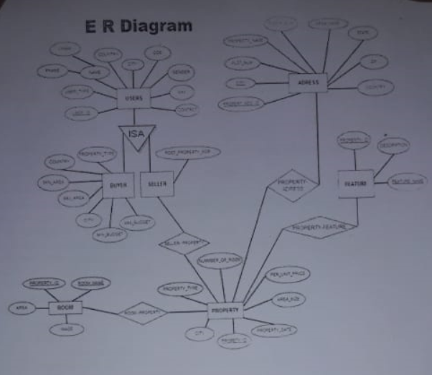

**15)** (2017)

**a) By considering the following example:**

**Std ID StdCity StdClass Offer No OffTerm Off Year EnrGrade Course No Course_Name**

**i) Bring out the anomalies of the given relation**

**ii) Illustrate detailed step involved in bringing given relation to Normal form**