https://globantislabs.com/services/enterprise-web-solutions

Collaborating for Business Excellence
Enterprise applications are the foundation of modern organizations, enabling businesses to operate efficiently, innovate at scale, and respond to evolving market demands. Achieving meaningful digital transformation requires more than technology alone—it demands a strategic, holistic approach supported by a strong ecosystem of trusted partners.
By bringing together industry expertise, intelligent solutions, and complementary capabilities, organizations can accelerate transformation, optimize business processes, and unlock sustainable value across the enterprise.
https://globantislabs.com/industries/cybersecurity

Cybersecurity for Business Resilience
As digital ecosystems continue to expand, organizations face an increasingly complex and evolving threat landscape. Cybersecurity is no longer solely a matter of compliance and risk mitigation—it is a strategic business imperative that enables resilience, protects enterprise value, and supports sustainable growth.

OUR SERVICES, DESIGNED AROUND YOUR BUSINESS
Strengthen your organization with a comprehensive portfolio of consulting, implementation, and managed security services. Our tailored solutions are designed to address your unique business needs, enhance resilience, and enable secure, sustainable growth.

https://globantislabs.com/industries/ecommerce

NAVIGATING THE FUTURE OF RETAIL 4.0
Automation. Experience-led retail. Data-driven intelligence.
Retail is evolving rapidly, driven by emerging technologies, changing customer expectations, and increasingly data-driven business models. Success in Retail 4.0 requires more than adopting new technologies—it requires a strategic approach to identifying the right investments and translating innovation into measurable business value.
Our retail experts help organizations navigate the evolving digital landscape, prioritize technology investments, and maximize return on investment. From hyper-personalized customer experiences to intelligent operations, we enable retailers to build agile, resilient, and future-ready businesses.
With a focus on sustainable innovation, responsible technology adoption, and customer-centric strategies, we help you stay ahead of change and build brands that remain relevant in a rapidly evolving retail environment.
Solution:

Powering the Future of Retail
Transform every aspect of your retail business with intelligent, scalable, and connected technology solutions. From customer engagement and digital commerce to supply chain, analytics, and store operations, our solutions help retailers create seamless experiences and drive sustainable business growth.
Digital Commerce
Build seamless omnichannel shopping experiences across web, mobile, marketplaces, and digital storefronts.
Customer Experience
Deliver personalized, connected experiences that strengthen customer engagement, loyalty, and retention.
Retail Analytics & AI
Turn customer, sales, and operational data into actionable insights with advanced analytics and AI.
Supply Chain & Inventory
Optimize inventory, forecasting, procurement, warehousing, and fulfillment for greater efficiency.
Store Operations
Modernize store operations with intelligent POS, workforce management, automation, and real-time visibility.
Retail ERP & Business Applications
Streamline finance, merchandising, procurement, HR, and core business operations through integrated enterprise platforms.
Product & Merchandising
Improve product planning, pricing, assortment, promotions, and merchandising decisions with data-driven intelligence.
Cloud & Digital Transformation
Modernize legacy retail environments with secure, scalable cloud platforms and next-generation digital technologies.
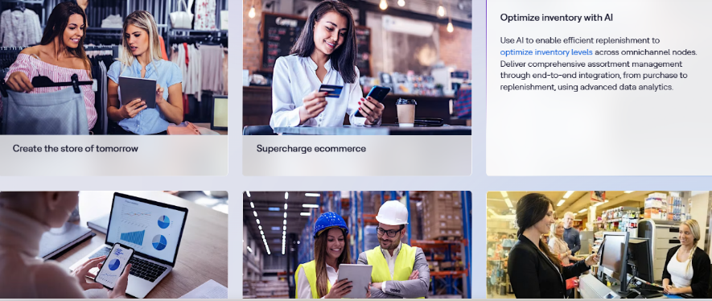 use this type of design , Ref
https://www.hcltech.com/retail-services

https://globantislabs.com/industries/logistics

Accelerating Digital Transformation
We combine deep industry understanding, advanced technology, and a customer-first approach to help travel, transportation, hospitality, and logistics organizations navigate complex challenges and unlock new opportunities.
Our technology capabilities, innovation-driven solutions, industry-focused frameworks, and experienced global teams help businesses accelerate growth, modernize operations, adapt to changing market demands, and deliver connected experiences that keep customers at the center.

Transform Today. Lead Tomorrow

Powering the Next Generation of Travel, Transportation & Hospitality
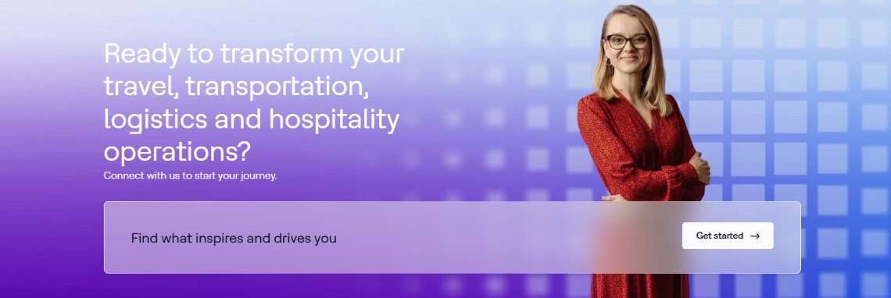 design Reference

Hospitality Designed Around Every Guest
Hospitality businesses are evolving rapidly as they manage diverse brands, franchises, properties, and increasingly connected guest journeys. Today’s travelers expect personalized experiences, seamless digital interactions, and consistent service across every touchpoint.
We help hospitality organizations modernize their customer-facing and operational ecosystems with intelligent digital solutions. From loyalty and omnichannel engagement to digital hotel experiences and connected operations, our technology enables businesses to deliver personalized guest experiences, improve operational efficiency, and build lasting customer relationships across the travel, transportation, logistics, and hospitality landscape.

Logistics Built for Seamless Movement
The logistics industry is evolving rapidly across freight forwarding, third-party logistics, warehousing, distribution, and connected supply chain networks. As customer expectations rise and supply chains become increasingly dynamic, organizations need greater visibility, agility, automation, and operational efficiency.
We help logistics businesses modernize their operations with intelligent, scalable digital solutions that connect people, processes, and technology. From supply chain visibility and warehouse management to transportation optimization and real-time analytics, our solutions enable seamless goods movement, smarter decision-making, and more resilient logistics networks.
Home Page

AI Technologies for Business Transformation

AI That Drives Business Impact
Accelerate your AI and Generative AI journey—from strategy and ideation to enterprise-scale deployment. We help organizations turn intelligent technologies into practical solutions that improve productivity, optimize operations, enhance customer experiences, and create measurable business value.

Welcome to AI That Creates Business Value

Description
The true potential of AI lies not simply in adopting new technologies, but in turning intelligence into measurable business outcomes.
We help enterprises move from AI experimentation to scalable, production-ready solutions. By combining advanced AI capabilities, engineering expertise, industry knowledge, and modern data foundations, we enable organizations to improve productivity, accelerate innovation, optimize operations, and create new opportunities for growth.
From Generative AI and Agentic AI to AI-powered automation, intelligent analytics, AI engineering, data modernization, and industry-specific solutions, our comprehensive capabilities help organizations integrate AI across their business.
Our focus is simple: turn AI from an emerging technology into a practical engine for sustainable business transformation.

From AI Potential to Business Impact.
Design reference : add picture related to AI
https://globantislabs.com/industries/healthcare

Technology Advancing the Future of Healthcare

Overview
Healthcare is evolving rapidly, driven by personalized care, emerging treatment models, rising operational pressures, and an increasingly complex regulatory landscape.
Technology is reshaping how healthcare is delivered, managed, and experienced.
Innovations such as AI-powered diagnostics, telemedicine, connected healthcare, predictive analytics, and digital health platforms are enabling faster decision-making and more personalized patient experiences. Advances in genomics and biotechnology are also opening new possibilities for precision medicine, drug discovery, and next-generation therapies.
At the same time, healthcare organizations continue to navigate critical challenges around affordability, accessibility, interoperability, data privacy, and security.
We help healthcare organizations modernize their digital ecosystems, connect fragmented systems, streamline processes, and enable their people with intelligent technology solutions—creating more connected, efficient, secure, and patient-centric healthcare experiences.

Transform Healthcare. Empower People. Improve Outcomes.

Powering Healthcare Transformation

Description
Healthcare and life sciences organizations are navigating rapid technological change, evolving patient expectations, complex regulatory requirements, and increasing demands for operational efficiency. We help organizations turn these challenges into opportunities for meaningful transformation.
Our industry-focused approach brings together healthcare expertise, digital innovation, advanced technologies, and scalable solutions to help organizations:
- Elevate Patient Experiences through personalized, connected, and accessible digital healthcare journeys.
- Modernize Healthcare Operations with intelligent platforms, automation, analytics, cloud, and next-generation technologies.
- Strengthen Compliance & Security with solutions designed around evolving healthcare regulations, data privacy, and security requirements.
- Connect the Healthcare Ecosystem by integrating systems, data, processes, providers, and patients across the value chain.
- Accelerate Innovation at Scale with flexible technology solutions that support sustainable growth and continuous transformation.
From digital health and patient engagement to data, AI, cloud, and enterprise modernization, we help life sciences and healthcare organizations build smarter, more connected, secure, and patient-centric enterprises.

Reimagine Healthcare. Transform Experiences. Create Lasting Impact.

https://globantislabs.com/services/ai-automation

AI-Powered Automation for Smarter Operations

Automate Processes. Augment Intelligence. Accelerate Growth.
AI is transforming automation from rule-based task execution into intelligent, adaptive business operations. Organizations can now combine artificial intelligence, machine learning, Generative AI, and intelligent agents to automate complex workflows, improve decision-making, and create more responsive customer and employee experiences.
We help enterprises identify high-value automation opportunities and transform them into scalable, AI-powered solutions that improve productivity, reduce operational complexity, and accelerate business outcomes.

Our AI Automation Capabilities
Intelligent Process Automation
Automate repetitive and complex workflows using AI-driven decision-making and intelligent orchestration.
AI-Powered Document Processing
Extract, classify, validate, and process information from documents with intelligent automation.
Generative AI Automation
Leverage GenAI to automate content creation, knowledge processing, summarization, and business workflows.
Agentic AI
Deploy intelligent AI agents capable of understanding objectives, reasoning through tasks, and executing multi-step workflows.
Customer Service Automation
Enhance customer support with AI-powered virtual assistants, conversational AI, intelligent routing, and automated responses.
Business Workflow Automation
Connect applications, systems, data, and people to streamline end-to-end enterprise processes.
Intelligent Decision Support
Combine AI, analytics, and real-time data to provide actionable insights and support faster business decisions.
AI-Driven Operations
Continuously monitor processes, identify inefficiencies, predict issues, and optimize operations with intelligent automation.
use this type of design , Ref

From Automation to Autonomous Operations
We help organizations move beyond traditional automation toward intelligent, connected, and adaptive operations—where AI works alongside people to simplify complexity, accelerate execution, and continuously improve business performance.
Transform Workflows. Empower People. Accelerate Business.

