The annotator experiments: what, why and how
GloBIAS 2026 · Group 5 · Session 06 "Benchmarking". A companion to "Five AI sessions, one 2014 ilastik workflow", for the two sessions that built consensus experiments. Written so the process can be explained and defended.

The question, and what the sessions had
The group's question was "Can consensus become ground truth?": if several people annotate the same images, can combining their annotations stand in for the truth? Two AI sessions (Run 3, Sonnet; Run 4, Opus) were given that question, ilastik's MitoCheck example and nothing else. The example has one movie of dividing nuclei (53 frames) and one set of human labels: 27 small blocks of brush strokes drawn in 2014, 5,157 pixels in all, almost all on the first frame. There is no second annotator and no ground truth for this movie. Run 3 asked whether the group had annotators and was told: "just run it with the existing labels. no human annotators." Run 4 asked nothing and later wrote that one question would have been warranted: whether real human annotations existed.
So both sessions did the only thing that lets the question be studied with this data: they simulated annotators. Run 4 said so in its own list of decisions: "Simulated annotators because no human annotations were provided (largest assumption)." This is the first thing to say when defending the work: the annotators are not people, both sessions knew it, and both said it.
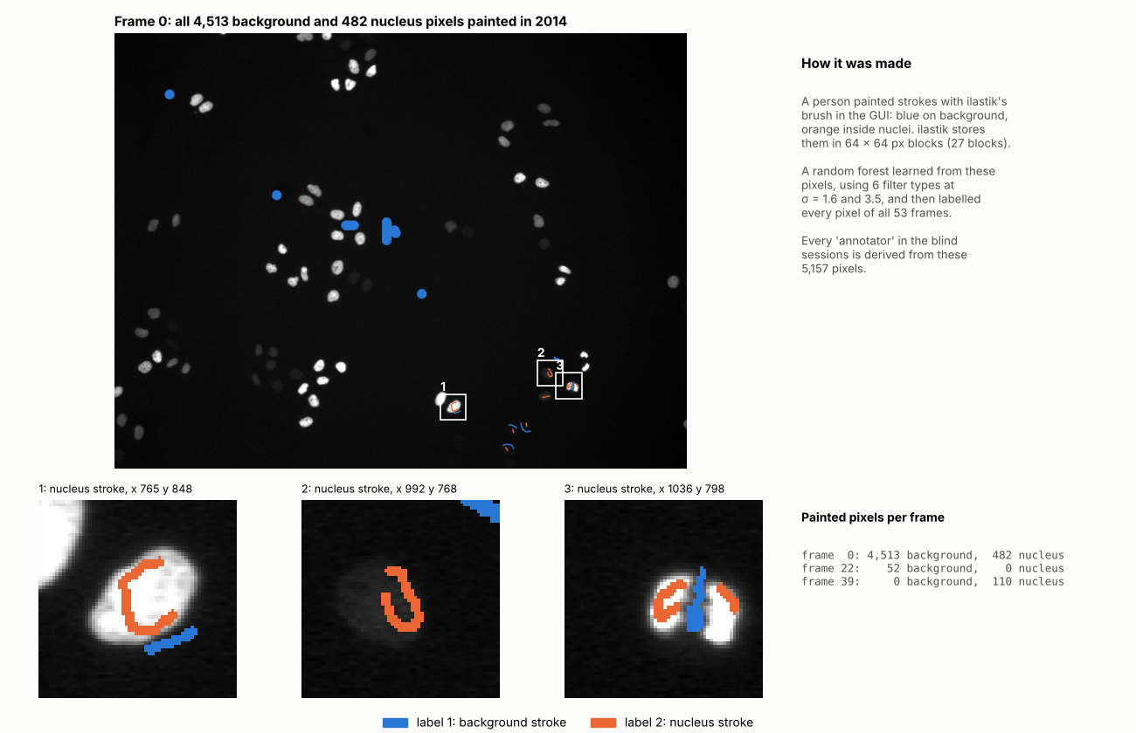
Figure 1. The only real annotation: the 2014 brush strokes, 5,157 pixels (blue = background, orange = nucleus). Nearly all of it is on frame 0; the zooms show thin nucleus strokes just inside the edge, one of them on a dim nucleus, and a background stroke in the gap between two touching nuclei. Everything else in these experiments was built from, or compared with, this.

Run 3: one person's labels, resampled five times
What. Five annotators, each a classifier trained on a different random subset of the 2014 strokes.
How. The 27 label blocks were shuffled; each annotator took 16 of them (60%) for training and kept the other 11 to measure its own accuracy. The classifier was a random forest from a general machine-learning library (scikit-learn), fed with 16 image measurements that approximate ilastik's (smoothing, edges, blob-likeness, at two scales). Predictions were made on seven frames. Nothing was drawn by hand; ilastik itself was never run, because the session believed it needed a window.
Why it matters. All five annotators learned from the same person's strokes, so their disagreements come only from which blocks each one saw. Run 3 wrote this down: "their errors are strongly correlated. The agreement numbers are therefore optimistic." It also wrote that it chose five annotators and the 60% share "arbitrarily". This design can show how much a voting rule changes a result; it cannot show how real annotators differ.

Run 4: the real strokes plus five invented styles
What. Six annotators. A0 is the real 2014 strokes. A1 to A5 are five artificial "people", each with a stated habit, and each one is a separate ilastik classifier retrained on its own strokes.
Why the habits. Run 4 explained the idea in one sentence: "They encode biases I chose on purpose, so the results show mechanisms, not real-world inter-annotator statistics." The habits, in the session's own labels: A1 draws tight boundaries and labels dim nuclei; A2 includes a two-pixel halo as nucleus; A3 treats dim nuclei as background; A4 draws very few strokes, on one frame; A5 draws in the standard style but only on late frames. No source says which real-world behaviour each habit was meant to copy beyond these labels.
How an annotator was made. A program paints the strokes; Figure 2 shows the steps on a real crop.
- Find candidate nuclei. Smooth the frame slightly, subtract the typical background level, and apply an automatic brightness cut-off chosen so that dim nuclei are kept. Drop anything of 30 pixels or less. These candidates only decide where strokes go.
- Mark the dim ones. The dimmest third of the candidates in a frame count as "dim".
- Pick nuclei at random. 12 per frame for A1, A2 and A5; 15 for A3; 3 for A4.
- Paint a stroke in each. Shrink the candidate by two pixels to get its core, draw a straight line between two random points in the core, about three pixels wide, and label it nucleus. For A3, a dim candidate gets no stroke: the whole object is painted background instead.
- Add the habit at the edge. A1 paints half of the outermost ring inside the nucleus as background (tight). A2 paints half of the ring one to two pixels outside as nucleus (halo). The others paint background on part of a ring two to three pixels outside.
- Add background strokes (six per frame, three for A4) in random windows, always more than ten pixels from any candidate.
- Retrain. The strokes are written into a copy of the 2014 project with the old classifier deleted, and ilastik 1.4.2 retrains it headless with the same 16 features. A0 is the 2014 strokes merged into full frames and otherwise unchanged.
- Make the mask. Nucleus probability above 0.5, holes filled, objects of 20 pixels or less removed.
Each annotator uses its own random seed, so the result is repeatable in principle. The totals painted: A1 5,827 pixels, A2 7,222, A3 9,703, A4 922, A5 3,658.
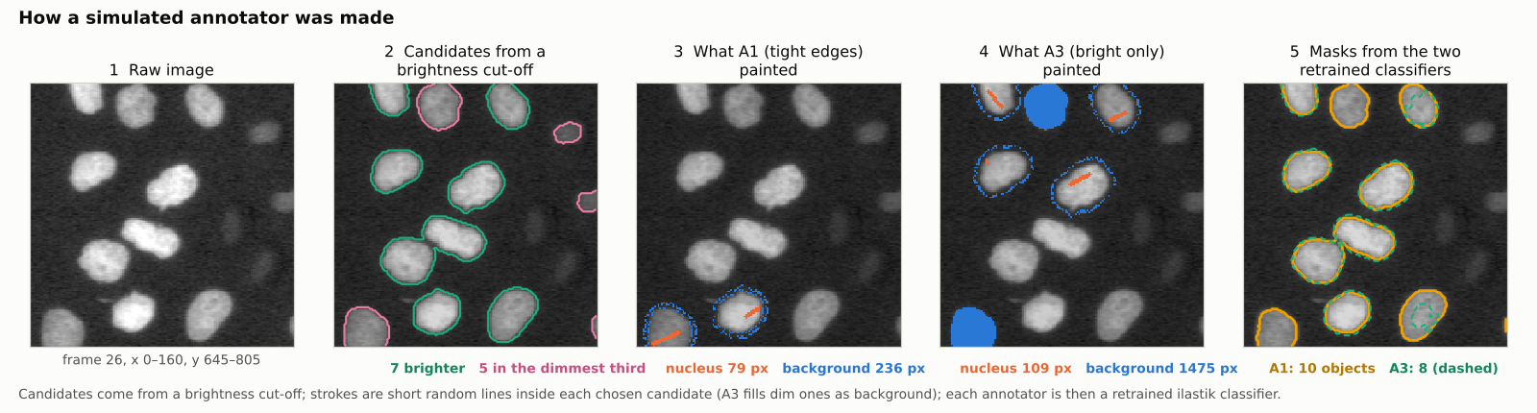
Figure 2. How a simulated annotator was made, on one crop of frame 26. Left to right: the raw image (contrast stretched so dim nuclei show); the 12 candidates found by the brightness cut-off, 5 of them in the dimmest third (pink); the strokes A1 (tight edges) painted, including one on a dim nucleus; the strokes A3 (bright only) painted on the same crop, two dim nuclei filled as background; the masks the two retrained classifiers produced, 10 objects for A1 and 8 for A3. Strokes are read from Run 4's own project files; candidates recomputed with its method.
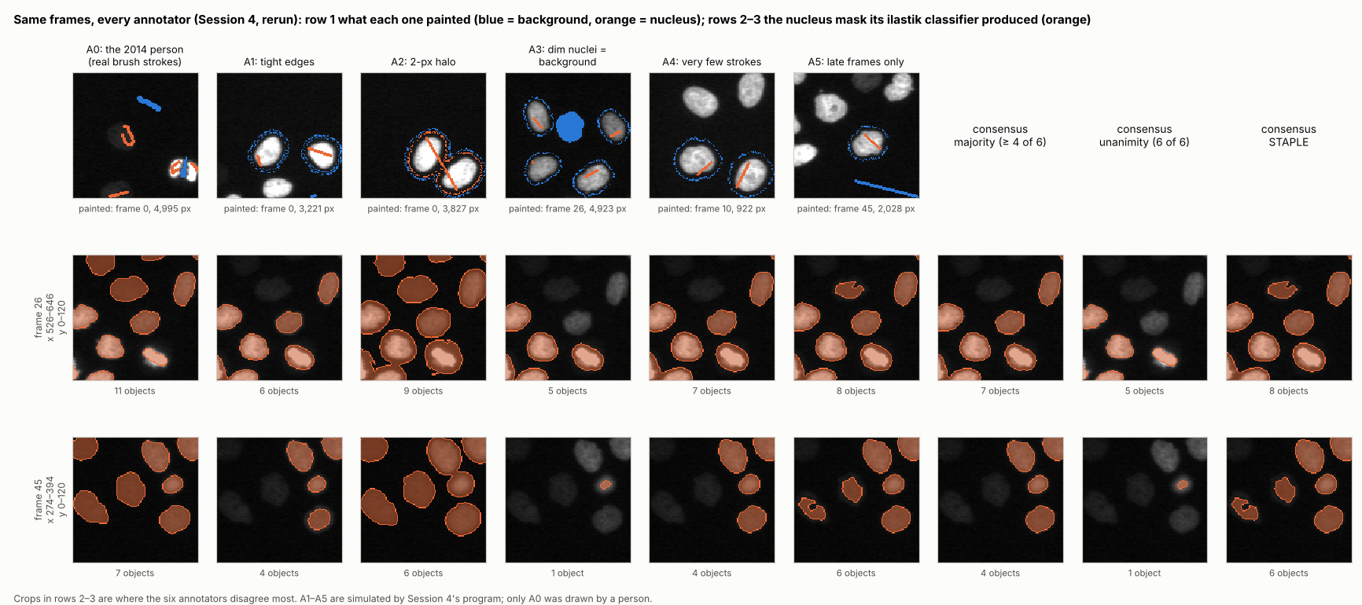
Figure 3. All six annotators on the same two crops (frames 26 and 45). Row 1: what each painted, on the frame it painted most. Rows 2–3: the mask its classifier produced, and three consensus rules. A1, A3 and A4 miss most of the dim nuclei that A0 finds; majority vote drops them.

How the rules vote
Every rule starts from the same thing: for each pixel, count how many annotators called it nucleus. With six annotators that is a number from 0 to 6 (Figure 4). The rules differ only in what they do with that count.
- Union: nucleus if at least one annotator says so. The most generous.
- Majority: nucleus if more than half say so: 4 of 6 in Run 4, 3 of 5 in Run 3.
- Unanimity: nucleus only if all agree. The strictest.
- Mean score: instead of masks, average the six classifiers' confidence values and cut at 0.5.
- Weighted vote: some annotators count more. Run 4 counted A0 twice ("an arbitrary choice of mine", it wrote). Run 3 weighted each annotator by its accuracy on the blocks it had not seen; the weights came out so similar (0.75 to 0.96) that the result equalled plain majority.
- STAPLE: a method that does not fix a threshold in advance. It starts by assuming every annotator is 90% reliable, estimates the "true" mask from the votes, re-estimates each annotator's reliability from how well it matches that mask (how often it says nucleus where the estimate says nucleus, and background where the estimate says background), and repeats, 50 times here. Its reliability scores come from agreement with the others and nothing else.
- Three-way / exclude the uncertain: pixels where all agree are kept as nucleus or background; pixels where they disagree are set aside and left out of every statistic.
- Expert adjudication (Run 3 only): disagreements are settled by ilastik's own 2014 output. Run 3 called this circular, because that output comes from the same strokes.
The measures used alongside: the disputed share (Run 4: pixels with some but not all votes, as a share of all pixels any annotator marked; 66%. Run 3: disputed pixels as a share of the whole frame; 1.9% to 4.8%); a standard agreement score (Fleiss' kappa, Run 3: 0.87–0.88, where 1 is perfect agreement); and overlap between pairs of masks.
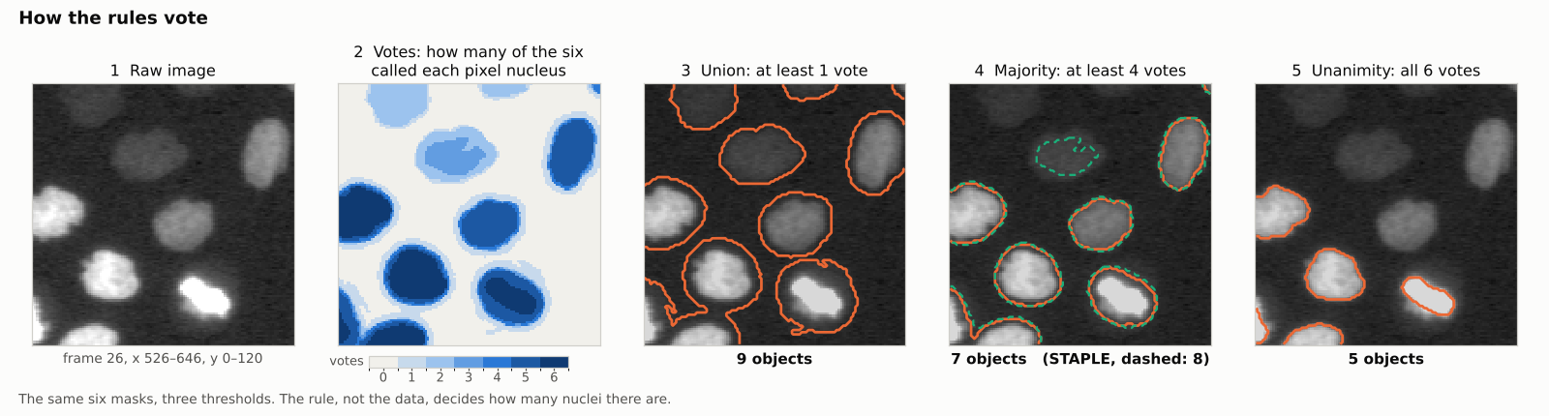
Figure 4. How the rules vote, on the crop of frame 26 where the six annotators disagree most. The vote count (how many of the six called each pixel nucleus), then the mask three thresholds produce: union 9 objects, majority (4 of 6) 7 objects, unanimity 5 objects. STAPLE (dashed, 8 objects) keeps one dim nucleus that majority drops. The same six masks give a different number of nuclei under each rule.

What came out
The rule sets the count. In Run 4's main pool, A0 finds 138 nuclei per frame and the five simulated annotators 77 to 123. Under the rules: union 124, mean score 114, weighted 112, majority 111, STAPLE 109, unanimity 79. Two thirds of all pixels any annotator marked were disputed by at least one other. Run 3 saw the same effect on a smaller scale: unanimity shrank the nucleus area by 4.4% in frame 0, and disagreement grew over the movie as the field filled with cells.
The biased pool. Run 4 then asked the sharper question: what happens when most annotators share the same habit? It made two more "bright-only" annotators (A3b, A3c, same habit, different frames and seeds) and formed a pool of five: A0, A1, A3, A3b, A3c. Three of the five ignore dim nuclei. Majority vote gave 84 nuclei per frame and STAPLE 83, against A0's 138. Worse, the agreement scores ranked A0, the only real annotator, as the least reliable of the five (lowest overlap with the others' majority, 0.66; lowest STAPLE reliability, 0.78). This is the experiment's central result: a habit shared by the majority passes through majority vote, weighted vote and STAPLE, and partly through the mean score, and the agreement-based methods punish the one annotator who disagrees, even though the evidence outside the vote suggests its extra objects are real.
The check outside the vote. Of A0's 7,036 objects in frames 1 to 51, 3,065 were rejected by the biased majority. Were they nuclei? Run 4 looked at evidence the vote does not use: 94% of the rejected objects have A0 pixels at the same place in both neighbouring frames (97% for accepted ones), and their brightness above background is about ten times the image noise, though far below the accepted objects' (76 versus 517 grey levels). Run 4's own wording of what this shows: "rejected objects are real, persistent structures, not that they must be counted as nuclei." Note that the persistence check uses A0's own masks in the neighbouring frames, and the noise estimate comes from a 50 × 50 corner of the image, which the session flagged as rough.
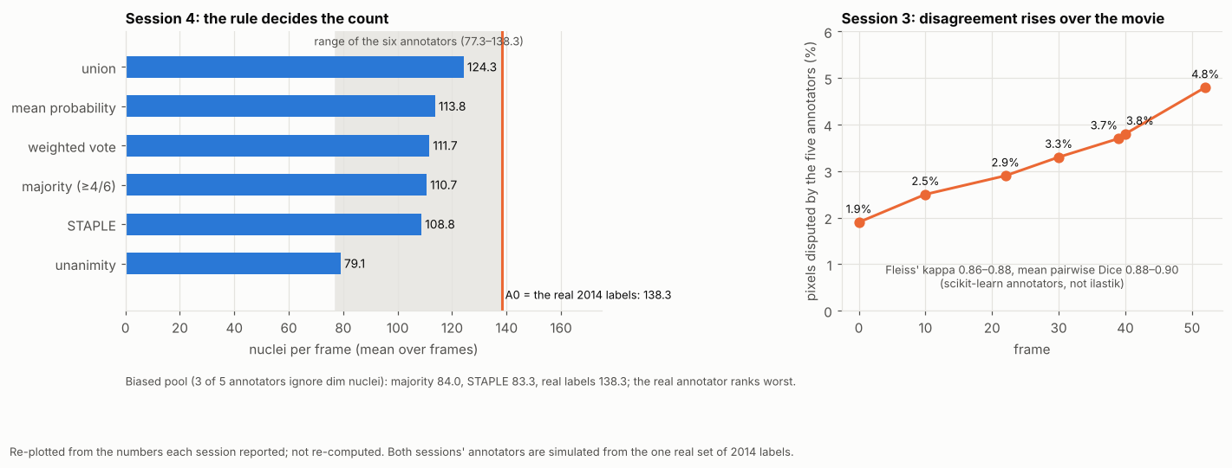
Figure 5. Left, Run 4: nuclei per frame under each rule (blue), the range of the six annotators (grey) and A0 (orange line). Right, Run 3: the share of pixels its five annotators disputed, rising over the movie. Re-plotted from the numbers each session reported.

The limits, as the sessions stated them
Run 3: "Real annotators would differ more than these do"; the agreement numbers are optimistic; "There is no true ground truth for this dataset"; five of its own decisions "can change the numbers". Run 4: "Simulated annotators encode biases I designed; real annotators may disagree differently and less systematically"; annotator variability "is filtered through the random forest"; one movie, one field of view. The benchmark's later review added two points that Run 4's report had not made: Run 4's strokes are placed on objects found by a brightness cut-off, so the retrained classifiers partly learn that cut-off back; and Run 4 treats the 2014 labels as correct without showing it.
Does it reproduce? Run 4's scripts were run again from scratch. A0, A1, A2, A3, A5, union, unanimity, STAPLE, the disputed share and the whole biased-pool result came back within about 1%. Two numbers did not: A4 (108 → 99 nuclei per frame) and the 4-of-6 majority (111 → 102). The likely reason is that A4 was trained on only 922 pixels, so its classifier changes most between retrainings, and one unstable annotator moves a 4-of-6 majority. The central finding does not depend on A4.

Defending the process: likely challenges
- "The annotators are fake." Yes, and both sessions said so. The experiment does not measure how real annotators disagree; Run 4 shows what each voting rule does with a disagreement it designed, and Run 3 with one it sampled. That is a mechanism study, which is what the data allowed in the time given; real annotations of the same movie by the group would be the next step.
- "Then the result is built in." The styles were chosen on purpose, so the direction of the effect was expected. The sizes were not: that majority vote counts 84 nuclei per frame against A0's 138 (3,065 of A0's 7,036 objects rejected), that STAPLE does the same, and that A0 is ranked least reliable were measured, not assumed.
- "Why trust A0?" It is the only human input, but it is a classifier trained on sparse strokes, checked only by eye, never against an independent reference. The evidence outside the vote (persistence across frames, brightness against noise, object size) shows that the rejected objects are real structures, not that they are nuclei.
- "Isn't Run 3 circular?" Partly, and it said so: its "expert" rule used ilastik's own output, and all five annotators share one person's strokes. Its value is the demonstration that the rule alone moves the result.
- "Why 4 of 6? Why count A0 twice? Why 50 iterations?" Choices the sessions made themselves: 4 of 6 is the usual "more than half"; counting A0 twice was called "an arbitrary choice of mine"; 50 iterations is never discussed. The rerun shows the majority threshold is the fragile one.
- "Was it reproduced?" Once, from the same scripts, with one unstable annotator. Not by an independent implementation.
- "What would make this real?" Run 4 listed five things: a written protocol; independent and diverse annotators; publishing the rule, the disagreement map and an "ignore" class with the result; a check against something other than the votes; and testing whether the downstream measurement is sensitive to the rule.

Words used here
- Annotator (here): a classifier trained on one set of brush strokes; "simulated" means the strokes were painted by a program (Run 4) or are a subset of the real strokes (Run 3).
- Mask: a black-and-white image, nucleus or not, for every pixel.
- Vote count: how many annotators' masks call a pixel nucleus.
- Consensus rule: the recipe turning vote counts into one mask.
- STAPLE: a rule that estimates each annotator's reliability from agreement with the others and weights them accordingly.
- Persistence: an object is present at the same place in the frame before and the frame after.
Sources: the session reports and scripts in github.com/globias-2026-group5/agent-benchmark-ilastik-tracking (sessions/session-3-blind-sonnet, sessions/session-4-blind-opus) and that repository's README; figures 2 and 4 are drawn from a rerun of Run 4's unchanged scripts.

