Riviana

Login page

Menu
- Prep
- Mixing
- Packing

Admin
- Sodium / Potassium qty
- Ingredients
- Product
    - Name
    - Ingredients
      - Liters
      - KGS
      - Cups ( 1, ½, ¼, ⅓.¼,, )
      - Qty
    - Instructions to prepare
    - Allergence
    - Solium / potassium table
- Daily Schedule

Mixing
- Pre Start
- Change Over
- Tools Register
- Ph Value
- Ph Calibration ( once in a day )
- Cleaning

Pre Startup first page

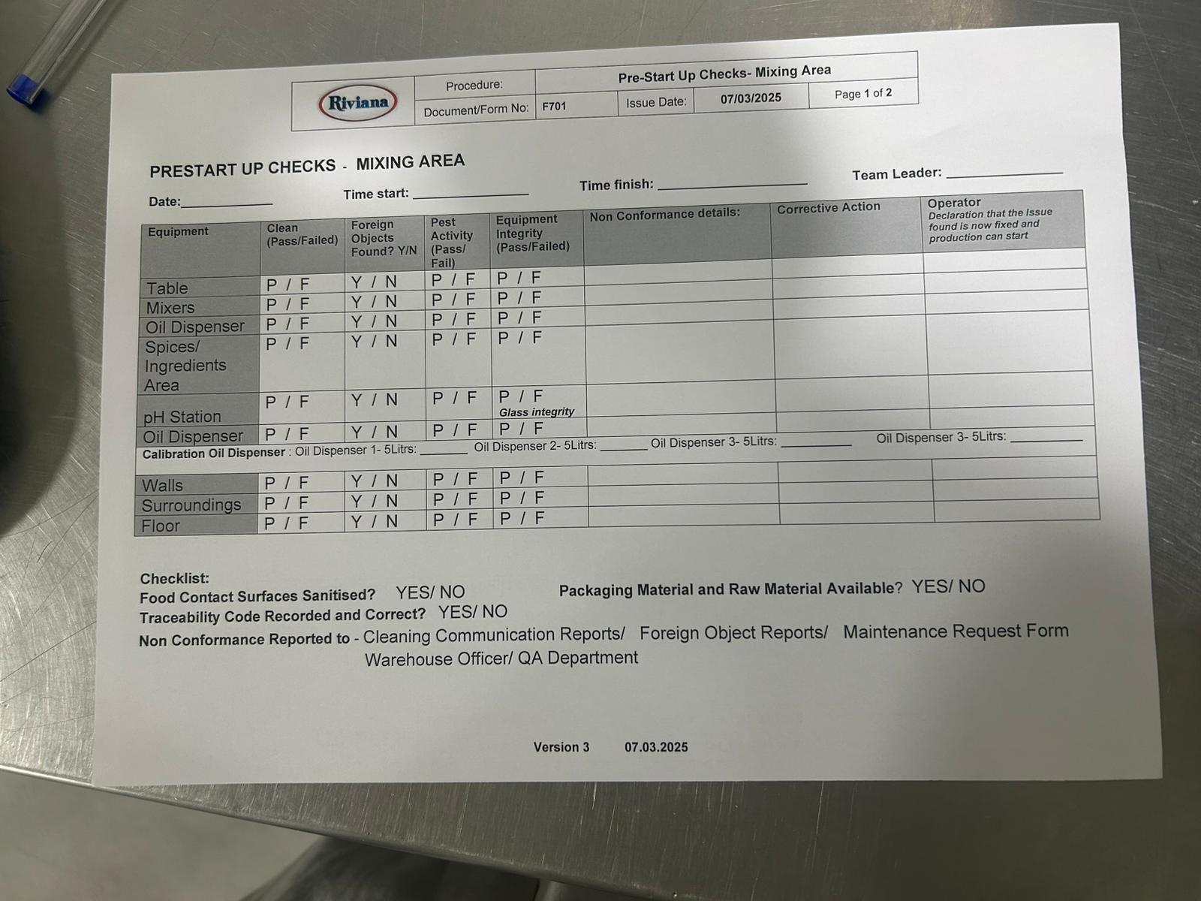

Pre Startup Second Page
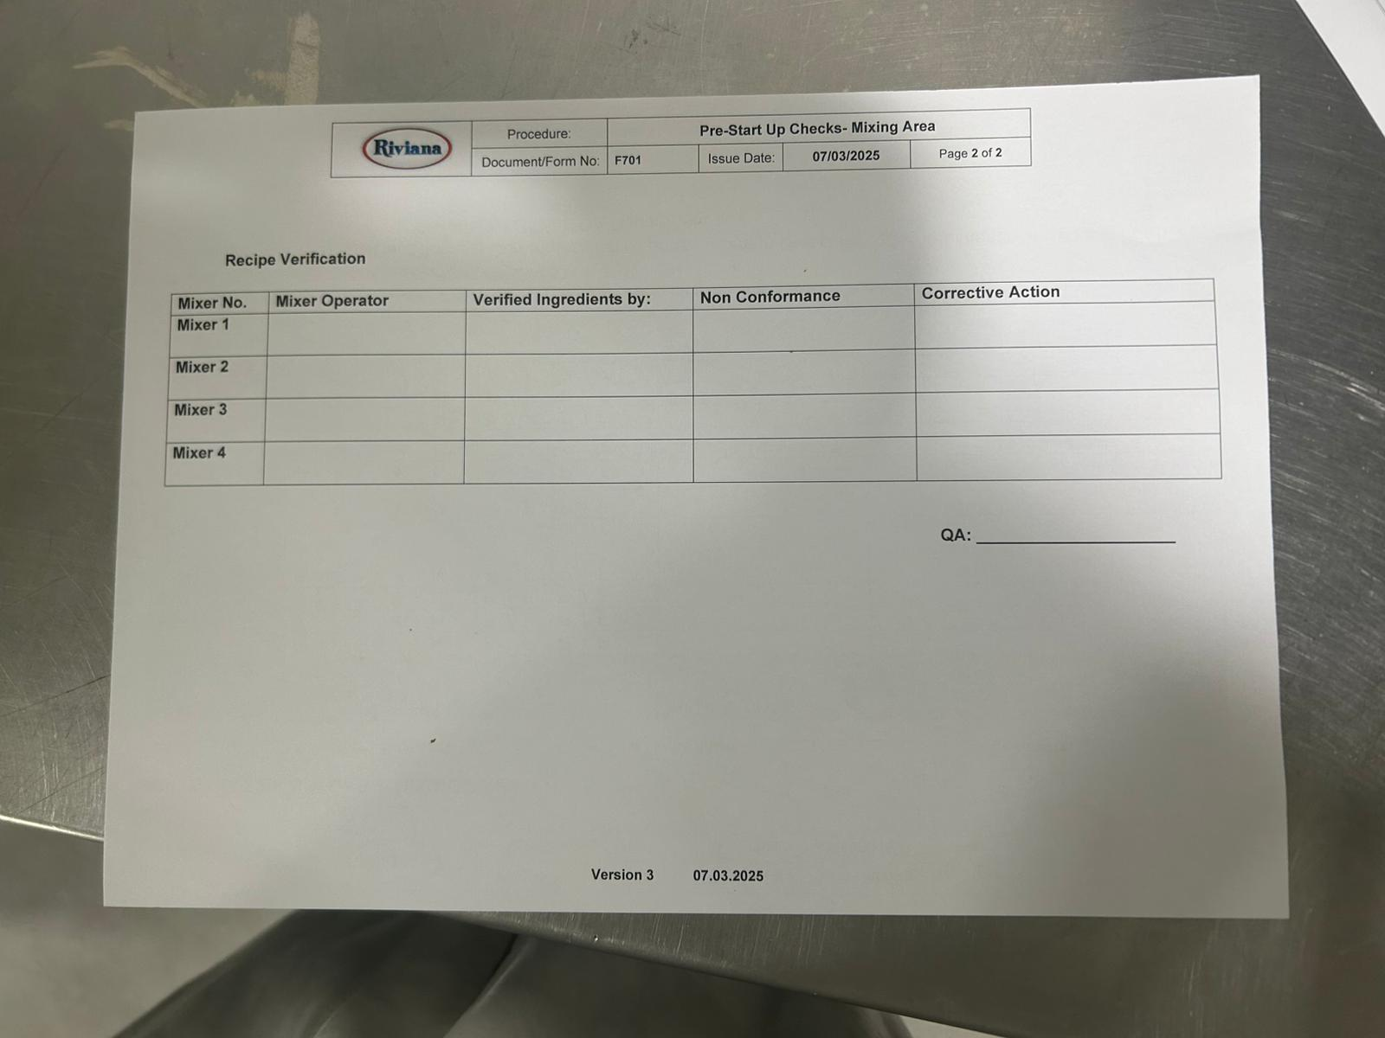

Change Over
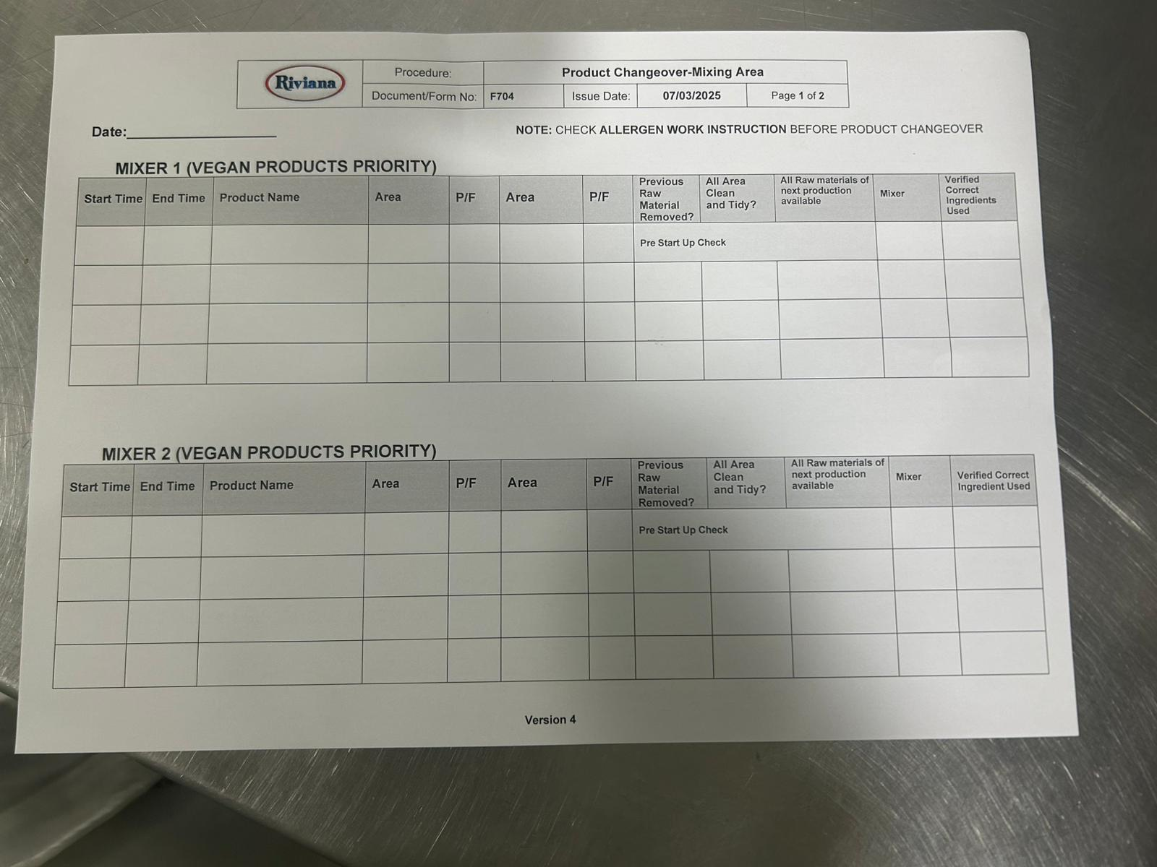

Tools Register

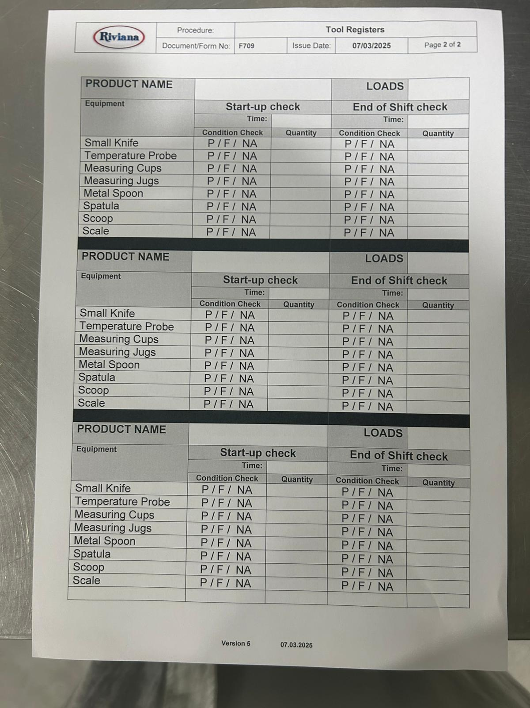

Ph Value
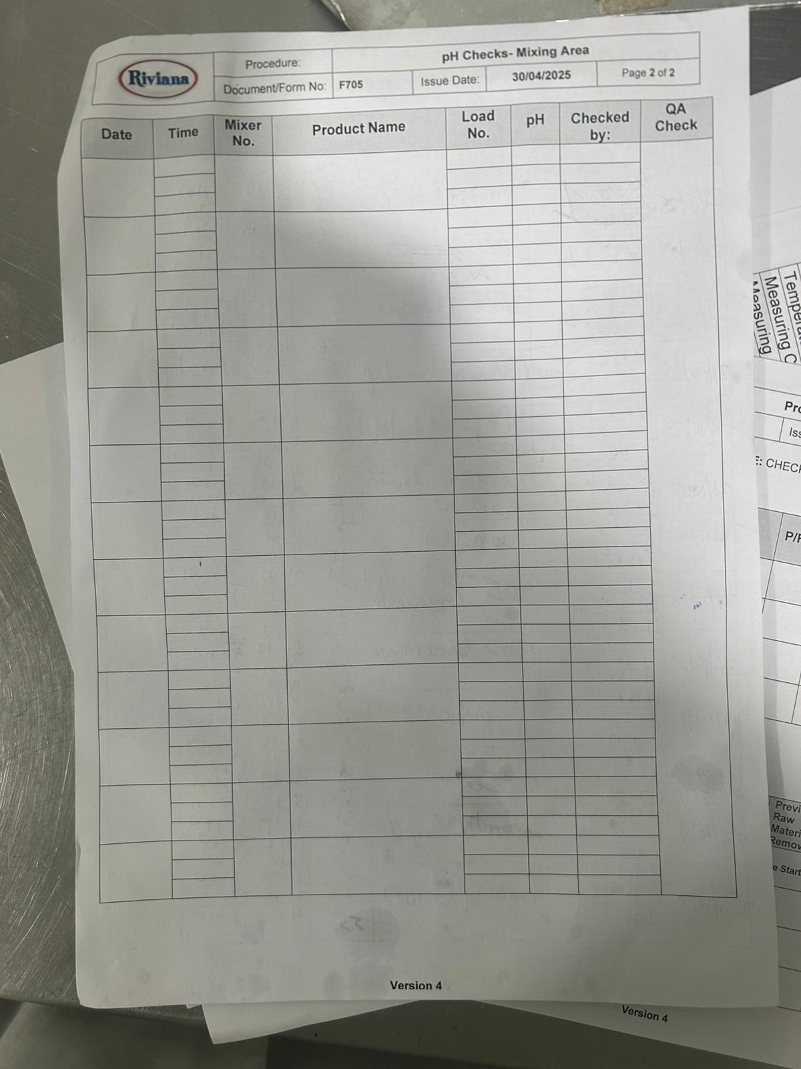

Ph Calibration ( once in a day )

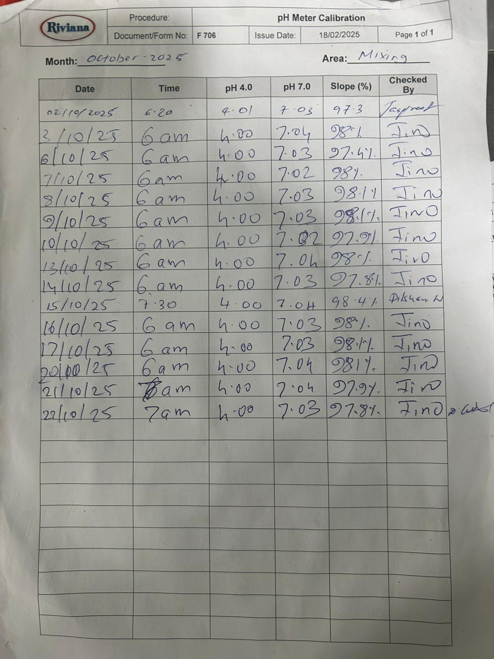

Product Details

