AURORA RAYSERVER
Framework Reference Card
Scaling LLM Inference on HPC — One OpenAI-Compatible Endpoint from N Compute Nodes • github.com/wenyiwang-us/aurora_rayserver
Aurora RayServer is a framework for scaling LLM inference across the compute nodes of an HPC system. From one YAML file and one command, it turns a PBS allocation into a single OpenAI-compatible inference service: it launches a Ray cluster over the allocation, stages model weights to node-local storage with an MPI broadcast, deploys one vLLM (or SGLang) replica per GPU tile as Ray Serve applications, and optionally fronts them with a head-node proxy such as HAProxy. A companion benchmarking harness measures deployments end to end and has validated them at up to 256 nodes (3,072 Intel XPU tiles) on ALCF Aurora.
1 · Why Aurora RayServer?
Existing LLM serving stacks assume cloud environments; HPC systems bring PBS scheduling, MPI-only launch paths, Lustre metadata costs, exotic accelerators, and scale cliffs that only appear past a hundred nodes. Aurora RayServer packages the engineering needed to cross that gap:
Turnkey N-node serving
One YAML file plus one command turns a PBS allocation into an OpenAI-compatible service; clients see the standard API and need no HPC knowledge.
Validated at scale
Deployments measured to 256 nodes / 3,072 replicas behind a production HAProxy front end: 27.1k non-streaming requests/s with Llama-3-8B (one replica per tile) — 96% weak-scaling efficiency at 256 nodes (27.1k of 28.2k offered, 0% errors). A quantified comparison of head-node proxies (HAProxy, Envoy, LiteLLM, Ray Serve proxy) guides the front-end choice.
Frontier-model ready
Multi-node pipeline parallelism serves Llama-3.1-405B (TP8 × PP2, two nodes per replica) with shard-aware weight staging, demonstrated from 2 to 128 replicas (4 to 256 nodes) at 67% weak-scaling efficiency (streaming).
Measurement built in
A declarative benchmark harness generates traces and PBS jobs, replays load through a Go client, and scores per-request TTFT/TBT against latency SLOs.
2 · What’s in a deployment?
A deployment is a small stack of cooperating pieces, all driven from one configuration file:
Component | Description
Launcher | aurora-serve-submit (batch, from a login node) or aurora-launch-cluster (interactive) bring up the whole stack on a PBS allocation
MPI weight staging | One-source-many-sinks MPI broadcast from the shared file system (e.g., Lustre) to node-local storage; shard-aware per pipeline stage for very large models
Inference replicas | vLLM or SGLang replicas as independent Ray Serve applications — one per GPU tile (12 per Aurora node) for single-tile models, or spanning multiple tiles and nodes via tensor/pipeline parallelism for larger models
Head-node proxy | HAProxy, LiteLLM, and others — a single client-facing endpoint with load balancing, plus auth and rate limits with LiteLLM
Site patches | Small Ray/vLLM fixes required at 256+ nodes, applied automatically at launch
Benchmark harness | eval/: declarative specs → traces + PBS jobs → replay → SLO scoring

3 · Installation
The package installs into the Python provided by Aurora’s frameworks module, which already ships Ray, vLLM, MPI, and the oneAPI toolchain; pip adds only the aurora-rayserver package itself.
module load frameworks
git clone https://github.com/wenyiwang-us/aurora_rayserver && cd aurora_rayserver
python3 -m pip install --user .
# console scripts land in a frameworks-versioned bin dir; add it to PATH:
export PATH="$(python3 -c 'import sysconfig; print(sysconfig.get_path("scripts", "posix_user"))'):$PATH"
which aurora-serve-submit # verify

One-time extras, each needed only for the feature that uses it: build HAProxy with scripts/build_haproxy.sh (proxied deployments); create a separate LiteLLM venv (its dependencies conflict with Ray/vLLM); build the benchmark load generator with module load go && bash eval/go_client/build.sh.
4 · Example
One YAML file describes a deployment — the Ray cluster, the model deployment, and the client-facing proxy. Submit it from a login node (no allocation needed), then query the printed URL from anywhere that can reach the head node:
aurora-serve-submit my_config.yaml --project-account YOUR_PROJECT --wait
# 8470123.aurora-pbs-0001... <- PBS job id
# http://x4310c1s0b0n0:4001 <- service URL
curl -sS -X POST "http://x4310c1s0b0n0:4001/v1/chat/completions" \
-H 'Content-Type: application/json' \
-d '{"model":"meta-llama/Meta-Llama-3-8B-Instruct",
"messages":[{"role":"user","content":"hello"}],"max_tokens":8}'
# {"id":"chatcmpl-...","choices":[{"message":{"content":"Hi!"...}}],...}
qdel 8470123 # tear down

The configuration it references: Llama-3-8B on two nodes (24 replicas) behind HAProxy. model_storage_path (your model directory on the shared file system) and local_stage_path (node-local staging) are typically the only fields that vary per user.
# my_config.yaml
ray_cluster_config:
head_ip: "" # filled in at runtime
port: 6379
node_cpus: 64
model_deployment_config:
num_nodes: 2
model_storage_path: /lus/flare/projects/<PROJECT>/<user>/models
local_stage_path: /tmp/hf_home
num_gpus_per_node: 12
model_configs:
- model_id: meta-llama/Meta-Llama-3-8B-Instruct
tensor_parallel_size: 1
pipeline_parallel_size: 1
max_model_len: 4096
size: 8 # billions of params; drives replica planning
gpu_memory_utilization: 0.90
enforce_eager: true
max_num_seqs: 64
proxy_config:
type: haproxy # haproxy | litellm | none
port: 4001 # client-facing port
backend_port: 8000 # Ray Serve HTTP port on each node

Learn more: the README covers interactive launches inside qsub -I, custom PBS integration via --dry-run, and every configuration field (examples/config.reference.yaml is fully annotated).

5 · Scaling to hundreds of nodes
Front-end proxy at scale
All client traffic enters through the head-node proxy. Non-streaming completions scale nearly linearly through a single HAProxy — 27.1k requests/s with Llama-3-8B at 256 nodes / 3,072 single-tile replicas, 0% errors. Streaming (SSE) is harder on a centralized front end: the per-token delivery path saturates the head node’s network at large node counts, so requests still complete but slowly — streaming throughput plateaus around 4.7k requests/s from 128 nodes, and p99 end-to-end latency reaches 17 s at 256 nodes while non-streaming p99 stays near 2 s at every scale. Budget streaming capacity per proxy and prefer non-streaming completions at extreme scale.
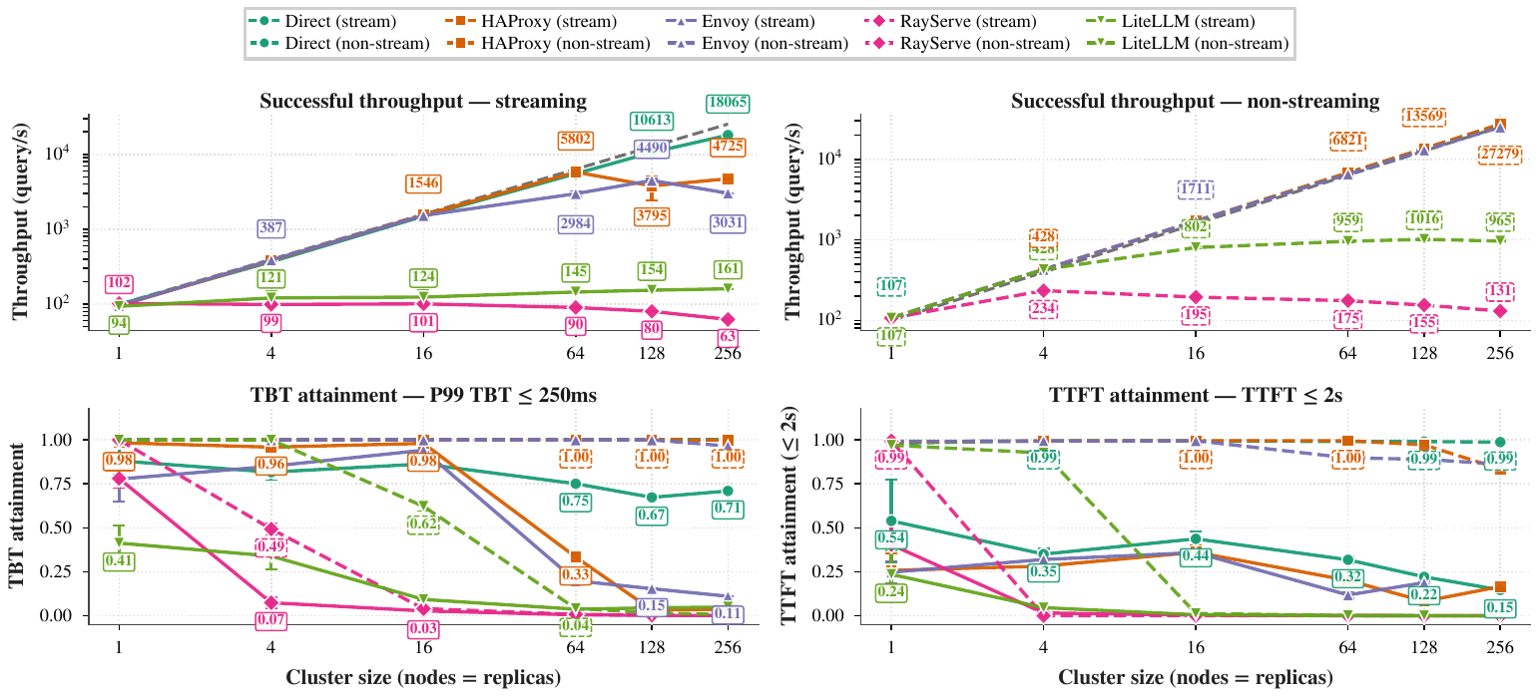
Weak scaling, 1–256 nodes (Llama-3-8B, 64 in / 64 out, 110 QPS/node offered): successful throughput and SLO attainment per front end, streaming (solid) vs non-streaming (dashed). Non-streaming HAProxy reaches 27.1k QPS; streaming through any centralized proxy plateaus or collapses. “Direct” is the benchmark-only backend-isolation diagnostic.
Note: for benchmarking only, the harness’s client can bypass the proxy and dispatch to per-node endpoints (client.dest: direct in a spec) to measure backend capacity without a front end — backends themselves scale linearly to 256 nodes when the proxy is bypassed. This mode exposes one endpoint per node and is not a deployment path.

Multi-node models
Models larger than a node are served with pipeline parallelism across node pairs (Llama-3.1-405B: TP8 within a node × PP2 across two nodes). Shard-aware staging gives each pipeline stage only its own weight shard (~380 GiB, which fits node-local tmpfs) and pins each replica to its nodes. All 405B measurements are streaming: at a fixed per-replica offered rate, aggregate successful throughput grows from 0.7 query/s at 2 replicas to 31.0 query/s at 128 replicas (4 to 256 nodes) — 67% weak-scaling efficiency vs the 4-node base, sublinear rather than linear. Through a single HAProxy the service tracks the proxy-bypass diagnostic up to 64 nodes (9.3 query/s, 80%) before the same head-node streaming ceiling appears; a non-streaming 405B configuration has not been measured.
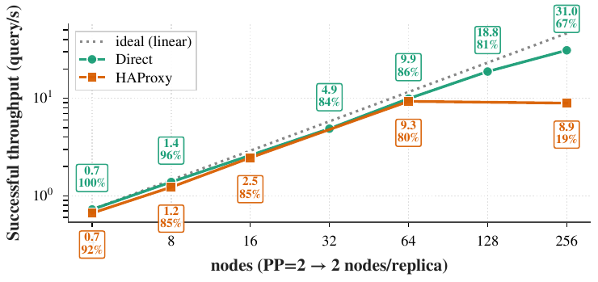
Llama-3.1-405B (TP8 × PP2) weak scaling, 2–128 replicas at a fixed offered rate per replica. Point labels: successful throughput and weak-scaling efficiency vs the 4-node base.
Robustness across workloads and models
Holding the 8B baseline fixed and varying one axis at a time (each row’s offered rate pinned at 90% of its single-node saturation), SLO attainment — the fraction of requests meeting TTFT ≤ 2 s and P99 TBT ≤ 250 ms — holds at 64 nodes for long-context and moderate-rate workloads and for the 120B model. The two rows that degrade (the short/high-rate baseline and Poisson arrivals at the same mean) lose their latency margin at the saturation knee once 64 nodes share the streaming path: the failure is load-shape specific, not model- or workload-specific.
Perturbation | attain (N=1) | attain (N=64) | Δ
(baseline) 8B, 64/64, fixed-interval | 0.91 | 0.43 | −0.48
Workload: ShareGPT 2K/2K | 1.00 | 0.90 | −0.10
Workload: ShareGPT 4K/4K | 1.00 | 1.00 | 0.00
Workload: Code (HumanEval) | 1.00 | 1.00 | 0.00
Workload: Chat (ShareGPT natural) | 0.99 | 0.99 | 0.00
Workload: Summarization | 1.00 | 1.00 | 0.00
Model: 120B (TP=8, rate 9) | 0.98 | 0.97 | −0.01
Arrival: Poisson | 0.89 | 0.35 | −0.54
Arrival: BurstGPT trace † | 0.46 | 0.46 | 0.00

† BurstGPT replays a fixed total arrival rate not scaled by N, so its N=64 cell is not a weak-scaling stress; reported for completeness.
Steady-state serving vs. startup time
Everything above is steady-state serving, measured after the cluster reports ready. Cluster bring-up behaves differently: it does not scale, and this is Ray’s key limitation at HPC scale. Model staging (~50 s for the 8B model), Ray cluster start (~45 s), and first-request warm-up (~8 s) are roughly flat in node count, but Ray Serve’s serve.run phase grows superlinearly — 171 s at 64 nodes, 470 s at 128, and 1,857 s (~31 min) at 256 — and a 512-node bring-up fails outright. The growth is concentrated in the proxy readiness wait: on every deployment broadcast, every Ray Serve proxy resolves every replica handle against the Ray control store (GCS), work that is quadratic in node count and reaches 1.38 million GCS lookups at 256 nodes. Budget PBS walltime as bring-up plus serving window (405B weight loading adds more), and reuse a running cluster across experiments where possible.
Launch-time knobs
Environment variables read by the launcher select engines and staging behavior:
Environment knob | Effect
AURORA_ENGINE=sglang | SGLang instead of vLLM as the inference engine
AURORA_PP_SHARD_AWARE=1 | Shard-aware multi-node pipeline-parallel staging and node-pinned replicas (405B-class models)
AURORA_PP_UMBRELLA=1 | Single root-route ingress over the per-replica PP routes
AURORA_NULL_COMPUTE=1 | Skip the engine and simulate latency — control-plane stress tests
AURORA_CLEAN_STAGE=1 | Wipe node-local staged weights first (cold-start timing)

Scale cliffs and their fixes (Ray/vLLM patches at 256+ nodes, thread-pool clamps) are catalogued in doc/KNOWN_ISSUES.md; the launcher applies the fixes automatically.
6 · Serving agents and OpenAI-compatible clients
The deployment exposes the standard OpenAI API, so any compatible client works unchanged — LangChain’s ChatOpenAI, Academy LLM agents, litellm, or the openai SDK — by pointing the usual environment variables at the service URL. This makes the framework the self-hosted, on-machine complement to a hosted gateway such as MAG: the same agent code runs against either.
export OPENAI_BASE_URL=http://<head_node>:4001/v1
export OPENAI_API_KEY=EMPTY

There is no authentication by default; use proxy_config.type: litellm to add API keys, rate limiting, and usage tracking.
7 · Examples and Resources
Runnable configurations and benchmark specifications live in the repository; code is linked rather than copied here. Paths are relative to github.com/wenyiwang-us/aurora_rayserver.
Resource | Location
Source code | github.com/wenyiwang-us/aurora_rayserver
Documentation | README.md — install, configuration, console-script reference
Machine-actionable card | doc/aurora_rayserver.md — markdown version of this card for coding agents
Deployment templates | examples/ — HAProxy, LiteLLM, and a fully annotated reference config
Benchmark specs | eval/specs/refcard/ — the smoke, weak-scaling, and 405B pipeline-parallel specs referenced in this card
Scaling analyses | findings/ and doc/KNOWN_ISSUES.md — root-cause write-ups, scale cliffs and fixes

8 · Citation
The system and its 1–256-node evaluation are described in an SC26 workshop paper (in preparation):
@misc{wang2026aurorarayserver,
title = {Aurora Ray Server: Deploying and Measuring Large-Scale
Ray Serve for LLM Inference on Aurora System},
author = {Wenyi Wang and Shu Shi and Yadu Nand Babuji and
Ian Foster and Kyle Chard},
note = {SC26 workshop paper, in preparation},
year = {2026}
}

