GT4 WS Java Core Design

November 1, 2004
Jarek Gawor {gawor@mcs.anl.gov}
Sam Meder {meder@mcs.anl.gov}

Table of Contents

1 Web Service Implementation and Design 3
1.1 Lifecycle 3
1.2 Operation Dispatching 3
2 Resource Implementation and Design 3
2.1 Discovery 4
2.2 Activation 5
2.3 Lifecycle 5
2.3.1 Creation 5
2.3.2 Destruction (Removal) 5
2.3.3 Scheduled Destruction 5
2.3.4 Loading and Storing Resources 6
2.4 Resource Properties 6
2.4.1 ResourceProperties 7
2.4.2 ResourcePropertySet 7
2.4.3 ResourceProperty 8
2.4.4 ResourcePropertyMetaData 8
2.4.5 QueryEngine 8
2.4.6 ExpressionEvaluator 9
3 Client API 9
4 Notifications 10
4.1 Subscriptions 11
4.2 Notifications 11
4.3 GetCurrentMessage 12
4.4 Topics 13
4.4.1 Creating a new topic 13
4.4.2 Internal representation of a concrete topic path 13
4.4.3 Topic references 13
4.4.4 Demand-based creation of topics 13
4.4.5 Topics and resource properties 14
4.4.6 Topics and TopicListeners 14
4.5 TopicExpressionEngine and TopicExpressionEvaluators 14
4.6 Performance 15
4.7 Lifetime 15
5 Background Tasks 15
5.1 Timer 15
5.2 WorkManager 15
6 The Container Registry 15
7 Unresolved Issues 16
7.1 Accessing the same resource via different web services 16
7.1.1 Synchronization 16
7.1.2 Resource Properties 16
8 Miscellaneous Issues 16
8.1 WSDL bindings 16
8.2 Issues Not Addressed 17
8.3 Features Not Supported 17

Web Service Implementation and Design

In Java, a simple web service is just a plain Java object. In our design, we allow a web service to be composed of one or more reusable Java objects called operation providers. Each operation provider can implement one or more web service functions.

This allows one to, for example, implement one generic GetResourceProperty operation provider and reuse it in multiple services. The operation provider concept in this design follows the same idea as in GT3.

Lifecycle

A web service might implement the standard JAX-RPC ServiceLifecycle interface. The lifecycle methods will be called appropriately depending on scope setting of the web service. If Request scope is used, a new service object is created for each SOAP request that comes in for the service. With this scope setting the lifecycle methods will be called on each request. If Application scope is used, only a single instance of the service object is created and used for all SOAP requests that come in for the service. With this scope setting the init() method will be called on container startup (or first invocation of the service) and destroy() method will be called on container shutdown.

Operation Dispatching

When the service utilizes operation providers for some of its operations, the container will need figure out which object to use for invoking a given operation. This step is currently handled in the dispatcher. The dispatcher looks up the web service properties in the Axis service descriptor and uses that information to find the right operation provider class for the requested operation.

Resource Implementation and Design

A resource is an entity that encapsulates the state of a stateful web service. Generally, each resource is a separate object but in certain cases it might be a singleton. A resource may just be a front end for state kept in an external entity, such as a file in a file system, a row in a database or an entity bean in a J2EE container.

Discovery

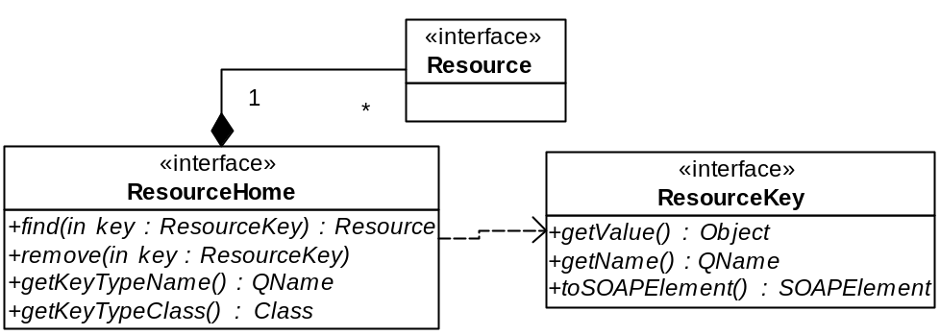

A resource key is represented by a ResourceKey interface. It is a combination of a key name and the actual key value.

A resource is represented by a Resource interface. It is a marker interface without any method defined. All resource objects must implement this interface.

Resources are managed by an object that implements the ResourceHome interface. The ResourceHome interface provides methods for finding and removing resources as well as methods for identifying the SOAP header element and class for the resource key. In addition to the methods specified by the interface, ResourceHome implementations will generally provide an implementation-specific create() call or any other methods that operate on a set of resources.

When an operation on a WS-Resource is invoked, the WS-Addressing SOAP headers need to be resolved into an actual resource instance:
- The first step in the resolution process is to look up the ResourceHome instance associated with the service in the container registry.

- The lookup is followed by discovering the QName of the SOAP header element containing the resource key from the resource home and deserializing the header into an instance of the resource key class.
- The resulting resource key instance is then used to look up the resource using the find() operation of the ResourceHome.

Activation

ResourceHome will be activated on the first access through the registry. Depending on configuration activation will usually occur on container start up or on a first invocation of the service associated with this ResourceHome. If the service is configured with a security descriptor, the appropriate JAAS security subject will be associated with activation thread.

Lifecycle

Creation

Resources may, as previously mentioned, be created by invoking an implementation-specific create method on a ResourceHome instance.

Resources may also be created two other ways:
- Resources may be instantiated on-demand (for example, the creation of a temporary representation of an external resource as a result of a ResourceHome find() call.)
- Resources may be created when the ResourceHome is instantiated (for example, the population of the ResourceHome with resources previously check-pointed to permanent storage when recovering from a container crash.)

Destruction (Removal)
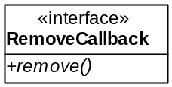

Resource instances are destroyed through the ResourceHome remove() operation. Resources may implement the RemoveCallback interface, which allows resources to clean up connected state prior to their removal.

ResourceHome implementations must call the RemoveCallback remove() operation prior to removing the resource if the resource implements this interface.

Scheduled Destruction

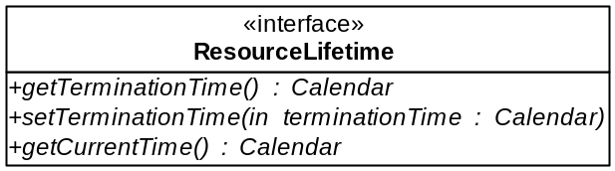

Web services that utilize the operations defined in the WS-ResourceLifetime ScheduledResourceTermination port type should implement the ResourceLifetime interface. It allows for generic mechanisms for removing expired resources.

Loading and Storing Resources

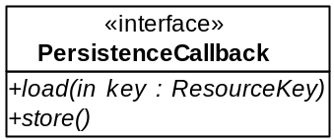

If a resource needs to be persisted to and loaded from permanent storage, then it should implement the PersistenceCallback interface. This interface provides methods for loading and storing the resource. A resource that implements the PersistenceResource interface must have a default constructor. It must also define at least one create() operation. The create operations are used to create new resource instances while the load() operation is there to retrieve the resource state from disk. The resource implementation is responsible for making sure its state in memory is synchronized with the state on disk.
Currently, only the ResourceHomeImpl implementation can be used with resources that implement the PersistenceCallback interface.

Resource Properties

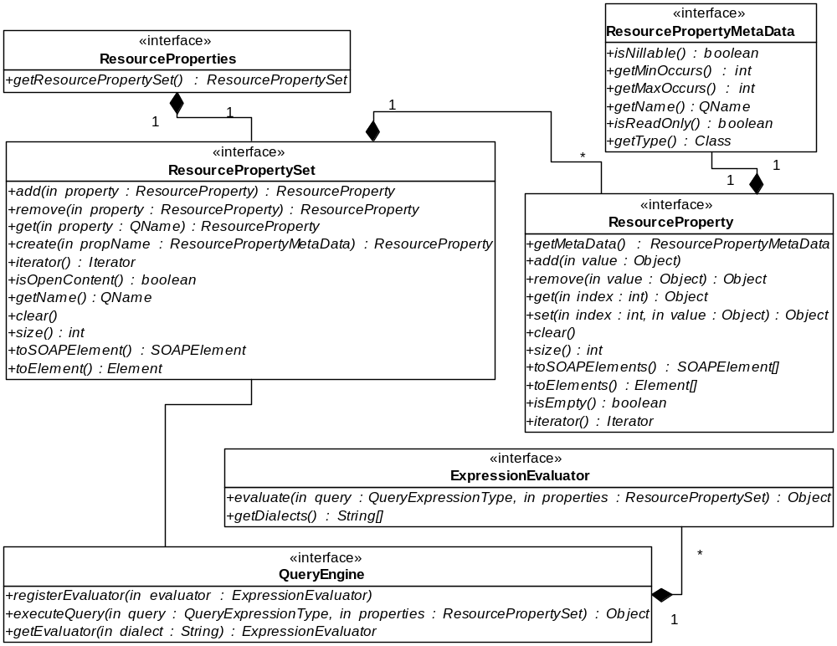

Resources may have resource properties. Resource properties are declared in the WSDL of the service as elements of a resource property document. The content of the document may potentially be open.

Resources that expose resource properties are required to implement the ResourceProperties interface and to register their resource properties with the ResourcePropertySet interface implementation returned by their implementation of the ResourceProperties getResourcePropertySet() method.

ResourceProperties

The ResourceProperties interface contains a single accessor method for retrieving the ResourcePropertySet from a resource. It must be implemented by all resources that want to expose resource properties.

ResourcePropertySet

The ResourcePropertySet is the representation of the resource property document associated with the resource. It contains methods for managing the set of resource properties, e.g. adding and removing resource properties, and for discovering properties of the document itself, e.g. its name.

ResourceProperty

The ResourceProperty interface needs to be implemented by all resource properties. It contains methods for:
- managing the set of values associated with the resource property.
- discovering properties of the resource property element.
- serializing the resource property to a array of SOAP or DOM elements.

ResourcePropertyMetaData

The ResourcePropertyMetaData interface contains metadata information about a RessourceProperty such as resource property name, cardinality, etc.

QueryEngine

The QueryEngine interface provides a dialect-neutral mechanism for evaluating queries on a ResourcePropertySet. It determines the dialect from the query expression and calls the ExpressionEvaluator registered for the dialect to perform the dialect-specific query operation.

ExpressionEvaluator

The ExpressionEvaluator interface is used for implementing dialect-specific query operations. Implementations of this interface are meant to be registered with an implementation of the QueryEngine interface.

Client API

The client-programming model will be very close to the programming model in GT3. For example, instead of passing HandleType or LocatorType to get a client stub for a given service, a client will be able to pass a WS-Addressing EndpointReferenceType to get the stub. Appropriate client JAX-RPC handlers will be used to automatically put the right WS-Addressing SOAP headers in the request.
Clients will also able to start an embedded hosting environment for the purpose of running a notification consumer service. This will allow clients to easily receive notifications.

Notifications

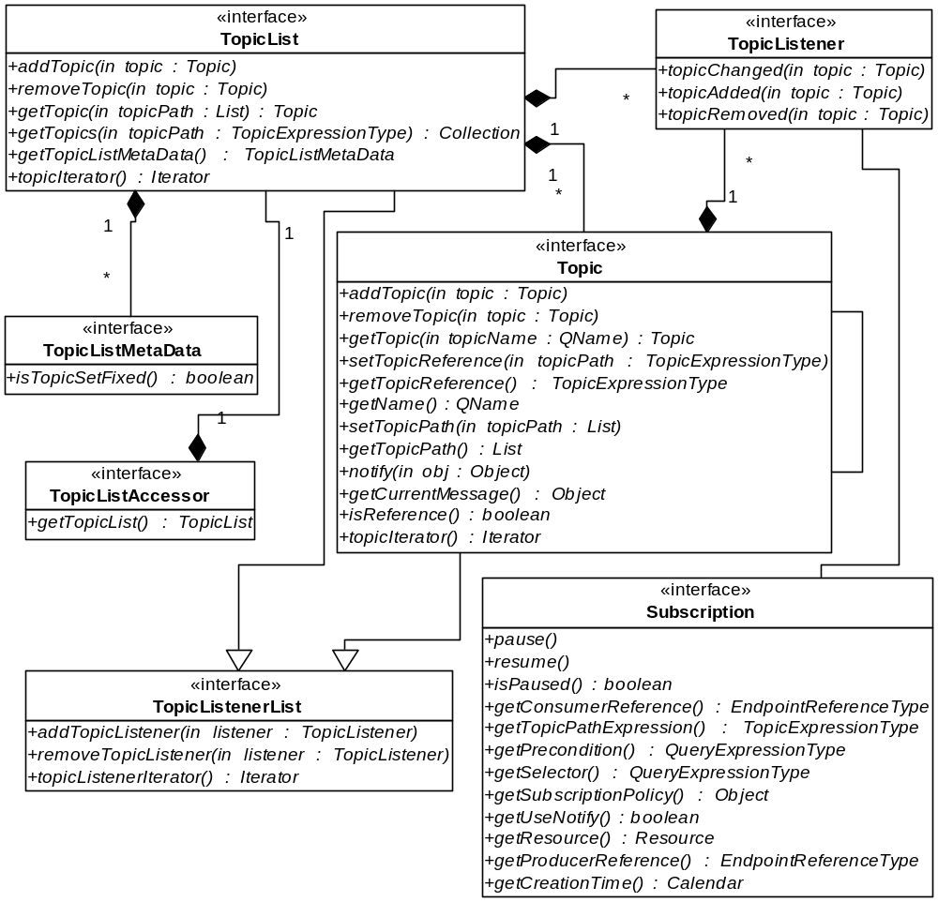

Subscriptions
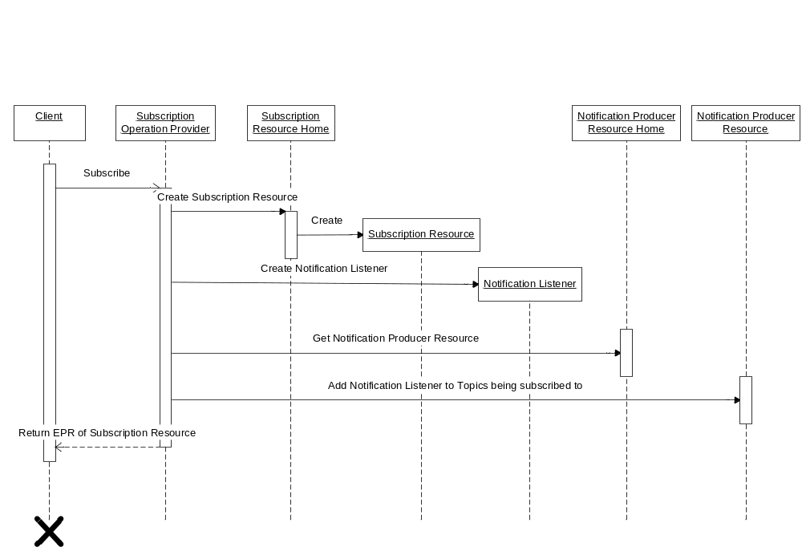

The following describes the intended flow of events:
- A client invokes the subscribe operation, which gets routed to the subscribe operation provider.
- The subscribe provider discovers the resource home for subscription resource from the registry and creates a subscription resource (i.e. an object that implements the Subscription and ResourceProperties interfaces.)
- It then associates the created subscription resource with a TopicListener instance and registers the TopicListener with the topics the subscription applies to (via the TopicListenerList interface.)
- The set of topics a subscription applies to is generated by resolving the subscription topic expression to a set of concrete topics via a call to the getTopics(topicExpression) method on an object implementing the TopicList interface, i.e. the notification producer resource.

Notifications

A situation (for example, a resource property change) is represented by an object that implements the Topic interface. Now assume that the situation occurs. Notification of the situation may be sent either:
- implicitly by automatically invoking the notify() method from within the method that caused the situation.
We leave it up to the implementer of the method that causes a situation to support for the implicit notify()call.
- explicitly by invoking the notify() method after the situation occurred.
The explicit mechanism will always be provided as part of the Topic interface. Also, an explicit notify() can be used to send a notification even if the state has not changed.

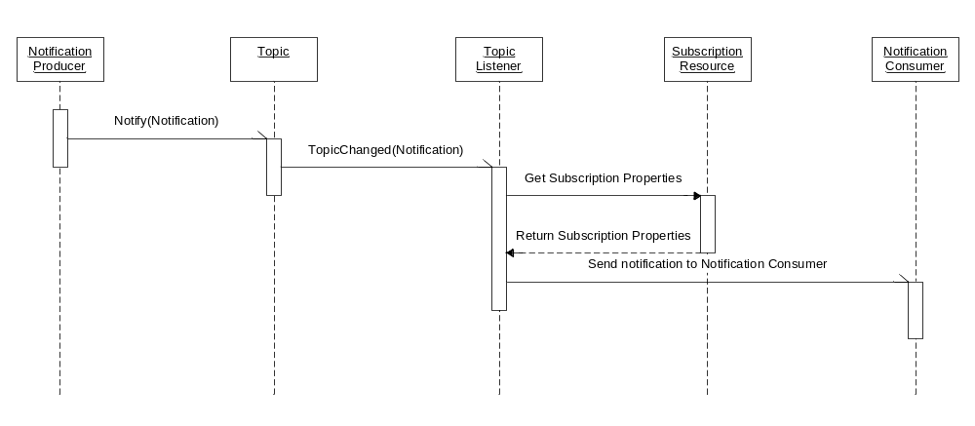

The notify() call itself is responsible for:
- Traversing the list of TopicListeners associated with a Topic interface.
- Calling the topicChanged() method on each listener.
- This triggers the actual sending of a notification message, either immediately or after certain (configurable) events (referred to as non-immediate.)
Non-immediate notification only sends a message after either a given number of situations have occurred or a given amount of time has passed. This option should be used in latency insensitive scenarios, where it is more efficient to aggregate notification messages before sending them.

GetCurrentMessage

The current message for a given topic/resource may be obtained by invoking the getCurrentMessage() method on the topic in question.

Topics

Creating a new topic

Service implementers may create a new topic by:
- Getting an instance of an object that implements the Topic interface.
- Then, adding that topic either:
  - to an existing topic tree (also represented by an object that implements the Topic interface) or
  - by registering it as a new root topic with an object implementing the TopicList interface.

We expect that not all topic objects represent actual situations; some may be used for the sole purpose of building a topic hierarchy.

We may in the future support child topics with the name ‘*’ to indicate that while we support subscription to any child topic, we are unable to instantiate all of these child topics in the topic space structure. Real child topics would only be created upon subscription to said child topic.

Internal representation of a concrete topic path

Concrete topic paths are represented using a list of QNames, only the first of which is fully qualified.

Topic references

A topic reference is equivalent to a named topic path expression. Topic references are objects that implement the Topic interface and that contain a topic path expression set via the setTopicReference() method. One can determine whether a given topic is a reference by invoking the isReference() method.

Demand-based creation of topics

Even though we made the assumption that we will not support on-demand creation of topics, this should still be achievable by implementing a Topic that automatically instantiates child topics when queried for specific child topics via the getTopic() method.

Topics and resource properties

Resource properties can be exposed as topics in several ways. The approach we have taken to date is to combine implementations of the Topic and ResourceProperty interfaces using delegation. Other approaches, such as inheriting and extending, are equally possible.

Topics and TopicListeners

Topics as well as the TopicList allow for a list of TopicListeners. TopicListeners are used for:
- notification of changes in the topic hierarchy (for example, when child and root topics have been added or removed.)
- changes in the topic “value” (such as the occurrence of a situation.)

TopicListeners currently connect topics with subscription resources as well as construct and update the Topic resource property. In the future, they may also be able to automatically associate existing subscriptions with newly added topics.

TopicExpressionEngine and TopicExpressionEvaluators

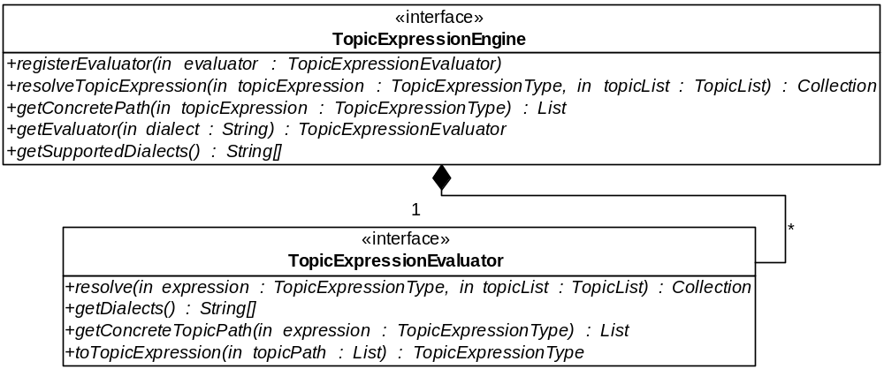

We previously mentioned that topic expressions are resolved to a set of topics by invoking the getTopics() method defined in the TopicList interface. In practice, this method delegates the actual resolution to a TopicExpressionEngine implementation.

The TopicExpressionEngine interface provides a mechanism for delegating the resolution to a dialect-specific TopicExpressionEvaluator implementation. This allows for the easy and transparent addition of new topic expression dialects.

Performance

We may want to cache topic path expression evaluations, especially once we start supporting more complex ones. The problem there is figuring out an efficient mechanism for triggering invalidation. One could conceivably add a change timestamp scheme or something similar.

Other performance improvements under consideration are the previously mentioned mechanism for throttling and aggregating notifications and implementing notifications that send only partial messages rather than the full notification message.

Lifetime

The lifetime of the subscription resource is independent of the lifetime of the WS-Resource producing the notifications.

Background Tasks

Services commonly need to run background tasks outside of the execution context of a specific web service operation. To accommodate this need and to provide the environment with a mechanism for controlling the resource used by background tasks. we provide implementations of two APIs (Timer & WorkManager) proposed by BEA and IBM for use in J2EE environments.

Timer

The Timer API provides the same schedule methods as the java.util.Timer API with the added ability of suspending and resuming all timer tasks. The Timer API is implemented using a configurable pool of java.util.Timer objects. A default TimerManager instance is discoverable in the registry.

WorkManager

The WorkManager API provides methods for running non-periodic background tasks. It provides for short as well as long running tasks by allowing the user to either schedule the task using threads from a thread pool (for short tasks), or start a new daemon thread (for long running tasks.)

It also provides several methods for waiting on task completion, both synchronous and asynchronous. Similar to the TimeManager, the container provides a default WorkManager, which is discoverable in the registry.

The Container Registry

Parts of the Core design rely heavily on the concept of a container registry for discovering preconfigured resources, such as ResourceHome instances, the default WorkManager, QueryEngine, etc. implementations. The registry must accessible through JNDI APIs.

JNDI provides the service developer and administrator with a convenient way of configuring both simple resources (e.g. configuration information) as well as complex resources (e.g. a database connection cache).

Our registry implementation is based on the JNDI implementation found in Apache Tomcat. We attempted to keep the configuration format for specifying JNDI entries as similar to the format used in Tomcat as possible; however, minor modifications were required due to the different architectures.

Unresolved Issues

Accessing the same resource via different web services

Synchronization
It is up to the resource implementer to make sure that the state encapsulated by the resource object is properly synchronized.

Resource Properties
When the services sharing the resource expose different closed content resource properties documents, there needs to be some sort of filtering when executing operations against those resource properties. We aim to support this filtering in the operation providers for these operations.

Miscellaneous Issues

WSDL bindings

The new WSRF specifications use standard document/literal binding. The OGSI specification used wrapped/literal binding. A wrapped/literal binding is a subset of document/literal binding with certain naming conventions in the WSDL.

We used the wrapped/literal binding in OGSI because .NET supports it by default and also API generated by the tooling is much more developer-friendly then plain document/literal. For example if an operation takes two parameters, with a wrapped/literal binding, a generated method signature would look like the following:

foo(int a, int b);

With document/literal the generated method signature would look like the following:

foo(FooIn in);

Where FooIn is an object that would have two getters for each of the parameters.

Obviously, the wrapped/literal signature is more logical and friendly. The problem with the wrapped/literal conventions is that they are not standardized.

Because OGSI and WSRF are using different WSDL binding styles, the existing OGSI clients and services might need to be updated to conform to the document/literal binding and method signatures.

Issues Not Addressed

This document does not address any transitioning issues such as GWSDL to WSRF WSDL translation tools.

Features Not Supported

- WS-BrokeredNotification
- Dialects other than the simple topic dialect. This implies that we will initially only support a flat topic space.
- Support for raw notification messages
- The optional elements in the subscribe operation, such as selector and precondition.

