Grid Resource Identity Mapper (GRIM)
Frank Siebenlist,
Von Welch, John Bresnahan
{franks, welch, bresnahan}@mcs.anl.gov

Draft-05
July 25, 2003

Problem Statement
In OGSA transient services are routinely created. Clients external to the resource connect to these services and use them to perform various tasks. Authorization between the services and clients is bi-directional, in that the services need to authorize the clients making requests of them and the clients making the requests need assurance that they are connecting to the appropriate service since they will often trust these services with delegated credentials or other sensitive information.

This implies that these services will need credentials in order to authenticate themselves to the client and assert that they are appropriate to the client's needs. Since these services are dynamically created, manual methods of administrative granting of credentials is not a viable option.

GT2 Implementation
GT2 solved this problem by granting the GT2 versions of factories (i.e. GridFTPd and the Gatekeeper) direct access to the host credentials. Clients connected to these factories, which spawned transient instances to handle the client request. These transient services then inherited the factory's connection to the client. Clients established trust in the factories due to their use of the host credentials and then trusted the factories to properly connect them to an appropriate instance.
This approach has the problem that these services in GT2 have direct access to the long-term credentials of that host. Since they are services that accept connections and data over the network, they are open to possible attacks (e.g. buffer overflows). Since they have access to the host credentials this leads to a route for potential compromise of the host credentials.
In GT3 it also will not be possible to follow the GT2 solution of the instance inheriting the factory's existing connection to the client since in the OGSA architecture instances will often be entirely separate services running in different hosting environments.

Overview of GT3 Solution

In GT3 we introduce the Grid Resource Identity Mapper (GRIM). GRIM acts as a resource facility for transient services to get Grid credentials based on their unix identities (uid and gids). In the GRIM architecture there exists a set of host credentials that act as the trust root for the resource. There credentials stored in an administrative account (not necessarily root) with limited access.
GRIM itself is a setuid program called by services to request a set of credentials. The setuid attribute of this program allows it to access the resource's policy information and the host credentials themselves. This elevated privilege allows it to generate a set of credentials for the requested service, which take the form of GSI proxy credentials with a policy restriction identifying the host's policy for the account in which the requesting service is running.

Benefits of this scheme are:
- It removes direct access of host credentials from any service accepting network connections. This means that a services compromised by attack over the network does not grant immediate access to these credentials.
- The credentials for each service have fine-grained authorization assertions associated with them. This allows users to be assured that not only is a service on the appropriate resource, but that it is running in an appropriate account.
- Services may use the policy information in the credentials to make their own authorization decisions.

Details of approach
As mentioned in the previous overview section, GRIM provides a setuid program to generate proxy credentials for transient services. These proxy credentials contain a policy asserting the host's policy for the account in which the service is running.
Figure 1 shows how GRIM operates. This procedure is initiated on a regular basis by a hosting environment to keep a fresh set of credentials.
- A hosting environment containing a service (e.g. RFT or the Local Job Manager Service Factory) invokes GRIM. The GRIM program is setuid enabling it to access policy and credentials stored in the GRIM account. This account is typically root in a normal GT3 installation, but could be any account that has read access to the needed credentials and policy configuration file.
- Using this access privilege GRIM consults the grid-mapfile to determine the Grid identities that have access to the account under which the requesting hosting environment is running.
- GRIM pulls a list of portTypes the account the requesting service is authorized to run from the portType-policy file.
- GRIM uses the host credentials to create a set of proxy credentials for the requesting service.
- GRIM returns these credentials to the service.
In this section we give the details on the policy sources GRIM uses to build this assertion, the grid-mapfile and portType-policy, and details about how this policy assertion is encoded.
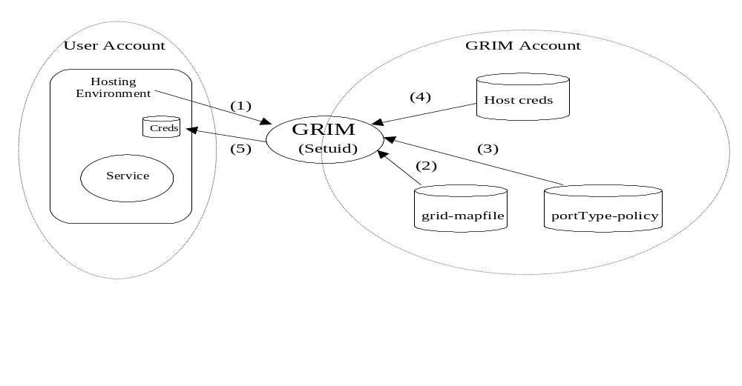
Figure 1: GRIM Architecture. Steps are described in the text.

The GRIM configuration file
The GRIM configuration is an xml file that contains information usedd in configuring grim. The grim is run with the effective userid of root, then this file will be found at /etc/grid-security/grim-conf.xml. If the euid is not root then it will be found at $HOME/.globus/grim-conf.xml. If no configuration file is found all default values are used. The default values follow:
gridmap file: /etc/grid-security/grid-mapfile
ca_cert_directory: /etc/grid-security/certificates/
certficate file: /etc/grid-security/hostcert.pem
key file: /etc/grid-security/hostkey.pem
port type file: /etc/grid-security/port_type.xml
max time: 14400 [10 days in minutes]
default time: 1440 [1 day in minutes]
key bits: 512

An example config file:
<?xml version="1.0" encoding="UTF-8"?>
<grim_conf>
<conf max_time="240"/>
<conf default_time="24"/>
<conf key_bits="512"/>
<conf cert_filename="/homes/bresnaha/.globus/usercert.pem"/>
<conf key_filename="/tmp/x509up_u589"/>
<conf gridmap_filename="/etc/grid-security/grid-mapfile"/>
<conf port_type_filename="/etc/grid-security/port_type.xml"/>
</grim_conf>

grid-mapfile
GRIM uses the standard Globus Toolkit grid-mapfile to find a list of all Grid identities (e.g. DNs) that are allowed to access the requesting service's account.

portType-policy
[Note: While GRIM does encode the policy information from the portType file, it is currently unused by any GT3 client and it is unclear if it will ever be used due to uncertainty of its usefulness. Anyone considering using the portType information in a GRIM assertion should consult with the authors of this document first.]
The portType-policy file is a new file to support GRIM. This file contains mappings from local accounts and/or groups to list of portTypes that those accounts or accounts in those groups are authorized to run.
GRIM uses this file to determine all the portTypes the account in which the requesting service resides is authorized to run and embed these into the resulting credential. This allows clients to verify that the service they are communicating with is residing in an account intended to run the service by the resource administration.
The port type file contains mapping of port types to what users and groups are allowed acces to these port types.
An example port type file:
<?xml version="1.0" encoding="UTF-8"?>
<authorized_port_types>
<port_type username="bresnaha">port type.html</port_type>
<port_type username="bresnaha">port type</port_type>
<port_type group="xraycmt">xray group</port_type>
<port_type group="mcsz">mcsz group</port_type>
<port_type group="bad">bad group</port_type>
<port_type username="bresnaha">port type again</port_type>
<port_type username="bresnaha">port type.html last</port_type>
</authorized_port_types>

Policy format
The policy embedded in the proxy credentials returned by the GRIM program contains the following assetions:
- DNs: A list of DNs the Unix account is intended to serve
- Username: the Unix username of the account
- PortTypes: A list of portTypes the account is authorized to host
The schema for the grim assertion is as follows:
<element name="GRIMAssertion">
<element name="Version" type="integer"/>
<element name="ServiceGridId" type="saml:NameIdentifierType"/>
<element name="ServiceLocalId" type="saml:NameIdentifierType"/>
<elementname="AuthorizedClientId" type="saml:NameIdentifierType"
maxOccurs="unbounded"/>
<element name="AuthorizedPortType" type="QName" maxOccurs="unbounded"/>
</element>

Client-side authorization examples
This section describes how GT3 clients use the assertions in the credentials given by GRIM to services to authorize those services.

GRAM
The hosting environment of the LJMFS is started in requesting user's account and runs the GRIM to get credentials.
GRIM will return a credential with the following assertions:
- The DN(s) of the user(s) who are allowed to access this service,
- Username of the account where the hosting environment runs,
- LJMFS and JMS portTypes [Unused]
The GRAM client should authorize the service by doing the following after authentication and before any service invocation:
- Verifying the proxy with issued by a DN suitable for the host it is connecting to - i.e. checking for the FQDN in the CN as in GT2.
- Checking for its own DN being asserted in the service credentials,
- Checking the username assertion if it cares - i.e. the user specified a particular username, which is not currently a supported feature with GRAM,

RFT
Unlike the JMS factories, the RTF factory runs in an admin account along with all of the instances it creates. The RTF factory will use GRIM to get as credential that will be shared by all of its instances. This
Ccredential will have following contens:
o DN since the RFT factory is running in an admin account which does not appear in the grid-mapfile (at least has no reason to),
- Username of admin account (note that this account name is probably meaningless to clients),
- RFT and RFT factory portTypes since this admin account will need to appear in the portType-policy file as a legitimate host for these portTypes. [Unused]
In this case the client authorization consists of the following:
- Verifying the proxy with issued by a DN suitable for the host it is connecting to - i.e. checking for the FQDN in the CN as in GT2,

