GT3 Grid Security Infrastructure Overview
Jarek Gawor, Sam Meder, Frank Siebenlist, Von Welch
{gawor, meder, franks, welch}@mcs.anl.gov

Introduction
This document gives an overview of the Grid Security Infrastructure (GSI) implementation in Globus Toolkit version 3 (GT3). Section 2 and Section 3 describe the similarities and differences, respectively, between GT3 GSI implementation and the GSI implementation in Globus Toolkit version 2 (GT2) and serve as a quick summary for someone already familiar with GT2 GSI. Section 4 gives an overview of GT3 security independent from GT2 security.

What hasn’t changed in GT3 Security
A number of key features of security in the GT3 release have not changed from the GT2 series of releases. This section highlights some key non-changes in GT3 security.

User and Service Credentials
GT3 uses the same X.509 identity certificates as GT2 for both users and services. Current users and services with GT2 credentials can continue to use their credentials with GT3. Additionally this means that public key infrastructures and certification authorities established to support GT2-based Grids, will effectively support GT3-based Grids.
GT3 continues to use X.509 Proxy Certificates to support delegation and single sign-on. While the format of GT3 proxy certificates have changed (see Section 3.1), the user's interface for creating (the grid-proxy-init program) and interacting with these proxies (the grid-proxy-info program) remain unchanged. Java versions of these programs are now also available to compliment the Unix command-line versions

Resource Authorization: Grid-mapfile
GT2 used a file known as the grid-mapfile to map Grid identities (the distinguished name from a user's X.509 identity certificate) to a local identity associated with a Unix account. A GT3 installation uses the same grid-mapfile as used by a GT2 installation. This will allow GT2-based grids to continue to use their existing infrastructure to manage grid-mapfiles.

Application Interfaces
The GT3 security library is still accessible through the Generic Security Service API (GSSAPI), as defined by RFC 2743 and JSR 72 with extensions as defined by the Global Grid Forum GSS-extensions document.

What has improved in GT3 Security
GT3 GSI implements a number of improvements in security. This section highlights a number of key changes.

Proxy Certificates format
The GT3 GSI libraries support Proxy Certificates as specified in the latest IETF/Global Grid Forum draft (draft-ietf-pkix-proxy-03.txt). This includes support for both impersonation and independent proxy certificates and a framework that allows for the support of other delegation policies.
The GT3 GSI libraries are also backwards compatible with GT2 proxies, in that they will accept GT2 proxies and treat them as GT3 impersonation proxies.

Web Services Protocol
GT2 used the Secure Socket Layer (SSL) protocol for its authentication and message protection. GT3, which is based on the emerging Web Services technologies and the Open Grid Services Architecture, leverages Web Services for these functions. GT3 implements a session based security service similar to what is described in the preliminary WS-Trust and WS-SecureConversation documents. We plan to make this implementation compliant with the above to documents once they enter a standards body. Our implementation (GSI-SecureConversation) allows for GSI's SSL-based authentication to take place over standard Web Services SOAP messages, which in turn allows for the use of OASIS’ W3C’s Web Services security specifications for message protection (WS-Security, XML-Encryption and XML-Signature). In addition to the session based security mechanism GT3 also provides WS-Security and XML-Signature based per-message security using standard public key cryptography (GSI-SecureMessage).

Improved resource security model
GT3 services which accept connections from the network do not run with any special local privileges, instead they use two specific setuid programs to perform the actions requiring privileges. This produces two benefits:
- A compromised network service won’t give the attacker any special privileges on the local system (as it would if the service was running as 'root' for example). While it does allow them to run the setuid programs available to the services, these are tightly constrained in what they do. Denial of service would be the only possible consequence of such an attack.
- It reduces the amount of privileged code. This allows for easier code reviews and security audits.
Details on this new architecture can be found in Section 4.

Removal of network services from trust model
Services that accept network connections are more prone to attack simply because they are accessible to attackers on the network. In GT3 these services are removed from the trust model, in that a user does not need to explicitly trust these services to do the right thing. Instead, as described in Section 4, these services invoke other services as requested by the user. These services in turn acquire credentials from trusted local services, allowing users to authenticate directly to the service

GT3 Security Architecture

Overview
This section gives an overview of the GT3 security architecture by showing how a typical GT3 service invocation occurs and how GT3 secures the invocation both from the point of view of the resource and the user.
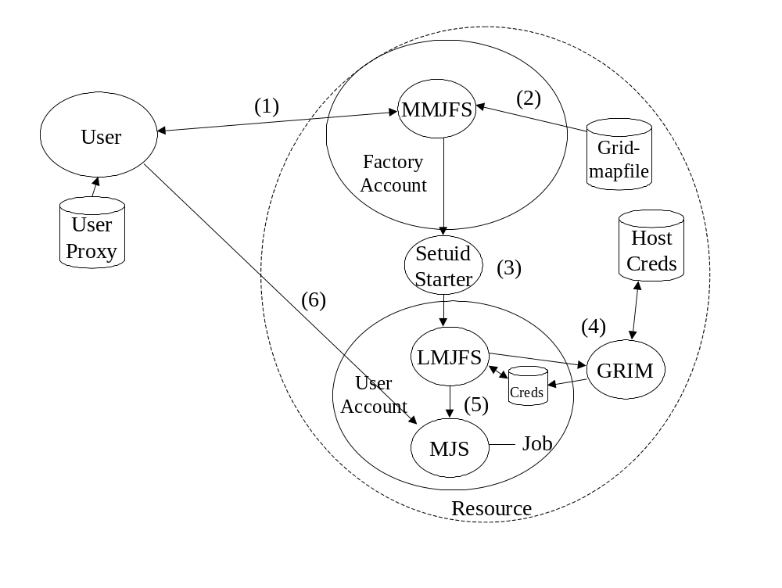
Figure 1: GT3 Job Invocation
Figure 1 shows a user invoking a job on a resource with GT3 installed. The steps in this process, and their security components, are:
- The user generates a job instantiation request with a description of the job to be started. The user then signs this request with their GSI proxy credentials and sends the signed request to the Master Managed Job Factory Service (MMJFS) on the resource.
- The MMJFS runs in a non-privileged account. It verifies the signature on the request and establishes the identity of the user who sent it. It then determines the local account in which the job should be run. Currently this is done by using the grid-mapfile and user's grid identity.
- Assuming the user does not already have a Local Managed Job Factory Service (LMJFS) running in their account, the MMJFS invokes the setuid starter process to start one. The setuid starter is a small setuid program running with root privileges that has the sole function of starting LMJFS in user's account.
- Once the LMJFS starts up, it uses the Grid Resource Identity Mapper (GRIM) to acquire a set of credentials. GRIM is a setuid program that accesses the local host credentials and from them generates a proxy for the LMJFS. This proxy credential has embedded in it the user's Grid identity, local account name and local policy about the user. The latter policy is obtained from the Grid map file entries that apply to that local account.
- The MMJFS then forwards the original user-signed job instantiation request from the user to the LMJFS. The LMJFS verifies the signature on the request to make sure it has not been tampered with and to make sure it was created by a user that is authorized to run in the local user account. Once these checks are successfully completed, the LMJFS instantiates a Managed Job Service (MJS), presents it with the user’s request, and returns a reference to the MJS to the user.
- The user then connects to the MJS. The user and MJS then perform mutual authentication, the user using their proxy and the MJS using the credentials acquired from GRIM. The MJS authorizes the user as a valid user to access the local account it is running in. The user authorizes the MJS as having a credential issued from a appropriate host credential and containing a Grid identity matching it's own, thus verifying the MJS it is talking to is running not only on the right host, but in an appropriate account. The user would then delegate GSI credentials to the MJS for the job to use and start the job running.

Server Side Security
This section aims to describe the message flow and processing that occurs for a security-enabled service. Figure 2 shows the JAX-RPC handlers that are involved in security related message processing on a server.
Server Hosting Environment
Client
WS-Security Handler
Sec Conv Msg Handler
JAAS
Security Policy Handler
Service
Authorization Handler
SecConv Service
Sec Msg Handler
Figure 2 Server Side Message Flow

GT3 provides two mechanisms, GSI Secure Session based and GSI Secure Message security, for authentication and secure communication.
In the GSI Secure Session approach the client establishes a context with the server before sending any data. This context serves to authenticate the client identity to the server and establish a shared secret using a collocated GSI Secure Conversation Service. Once this context establishment is complete the client can securely invoke an operation on the service by signing or encrypting outgoing messages using the shared secret in the context.
The GSI Secure Message approach differs in that no context is established before invoking an operation. The client simply uses existing keying material, such as an X509 end entity certificate, to secure messages and authenticate itself to the service.
The securing of messages in the GSI Secure Session approach using the shared secret requires less computational effort than using existing keying material in the GSI Secure Message approach. This allows the client to trade off the extra step of establishing a context to enable more efficient securing of messages once that context is established.

Message Processing
When a message arrives from the client the SOAP engine invokes several security related handlers as follows.
The first of these handlers, the WS-Security handler, searches the message for any WS-Security headers. From those headers it extracts any keying material, which can be either in the form of an X509 certificate and associated certificate chain or a reference to a previously established secure conversation session. It also checks any signatures and/or decrypts elements in the SOAP body. The handler then populates a peer JAAS subject object with principals and any associated keying material whose veracity was ascertained during the signature checking or decryption step.
The next handler that gets invoked, the security policy handler, checks that incoming messages fulfill any security requirements the service may have. These requirements are specified, on a per-operation basis, as part of a security descriptor during deployment. The security policy handler will also identify the correct JAAS subject to associate with the current thread of execution. Generally this means choosing between the peer subject populated by the WS-Security handler, the subject associated with the hosting environment and the subject associated with the service itself. The actual association is done by the pivot handler, a non-security handler not shown in the figure that handles the details of delivering the message the service.
The security policy handler is followed by an authorization handler. This handler verifies that the principal established by the WS-Security handler is authorized to invoke the service. The type of authorization that is performed is specified as part of a deployment descriptor. We currently support three authorization modes: the self explanatory “none”, “self”, which authorizes incoming messages whose associated principal/identity coincides with the service owner and “gridmap”, which looks up authorized principal/identities in a file-based access control list.
Once the message has passed the authorization handler it is finally handed off to the actual service for processing (discounting any non security related handlers outside the scope of this document).
Replies from the service back to the client are processed by two outbound handlers: the GSI Secure Conversation message handler and the GSI Secure Message handler. The GSI Secure Conversation message handler deals with encrypting and signing messages using a previously established security context, whereas the GSI Secure Message handler deals with messages without an established contact by signing the messages using X509 certificates. The operations that are actually performed depend on the message properties associated with the message by the inbound handlers, i.e. outbound messages will have the same security attributes as inbound messages. That being said, a service has the option of modifying the message properties if so desired. These handlers are identical to the client side handlers described in the following section.

Client Side Security
This section describes the message processing for Java-based GT3 clients. The GT3 C client architecture is conceptually similar to Java one. The C client has no well defined notion of a hosting environment, but there is an almost one to one mapping of the Java client handlers onto gSOAP io plugins.
In contrast to the server side, where security is specified via deployment descriptors, client side security configuration is handled by the application. This means that a client side application has to explicitly pass information to the client side handlers on what type of security to use. This is also true for the case of services acting as clients.
Client Hosting Environment
Client
Service
Sec Conv Service Handler
SecConv Service
SecConv MessageHandler
Sec Msg Handler
WS-Sec Client Handler

Server Hosting Environment
Figure 3 Client Side Message Flow

Message Processing
The client side application can specify to use either the GSI Secure Session or GSI Secure Message security approaches. It does this by setting a per message property that is processed by the client side security handlers.
There are three outbound client side security handlers:
The secure conversation service handler is only operational if GSI Secure Session mode is in use. It establishes a security session with a secure conversation service collocated with the service to which the client aims to communicate. When the client sends the initial message to the service with a property indicating that session based security is required this handler intercepts the message and establishes a security session. It will also authorize the service by comparing the service’s principal/subject obtained during session establishment with a value provided by the client application. Once the session has been established the handler passes on the original message.
The next handler in the chain, the secure message handler, is only operational if GSI Secure Session mode is in use. It signs and/or encrypts messages using an security session established by the first handler.
The third outbound handler is operational only if GSI Secure Message mode is in use. It handles signing of messages in GSI Secure Message operation.
The client side inbound handler (the WS-Security client handler) deals with verifying and decrypting any signed and/or encrypted incoming messages. In the case of GSI Secure Message operation it will also authorize the remote side in a similar fashion to the outbound secure conversation service handler.

